Launching a New Venture

Ninth Edition

Module 2
Small Business Marketing
Branding, Website, Message, Collateral material, Traditional mass media, Digital
mass media, Targeted Media, Sales

Entrepreneurship Foundation, Inc.

Launching a New Venture
Edition 9.0

Module 2 - Small Business Marketing

ISBN: 978-0-9967327-9-6

ALL MODULES IN THE SERIES

Module 1 - Entrepreneurship
Startup Checklist, Business Modeling, Problem-Solution Fit, MVP, Product-Market Fit, Competition, Lean BMC, Pricing, Landing Page, Company Name, Protecting IP, Legal Structure, Regulatory Matters, Raising Startup Capital

Module 2 – Small Business Marketing
Branding, Website, Message, Collateral Material, Traditional Mass Media, Digital Mass Media, Targeted Media, Sales

Module 3 – Entrepreneurial Finance
Production and Distribution, HR, Space Requirements, Risk Management, Budgeting, Accounting, Buying a business, Banking, Raising Growth Capital, Pitching business plans

Module 4 - Business Planning
Content, Style

Editor@EntrepreneurshipFoundation.org
© Academy Publishing, 2012, 2014, 2016, 2020, 2023, 2024, 2025 All rights reserved.
DISCLAIMER: The contents of this work are for general informational purposes only and do not constitute legal advice. You should not act or refrain from acting on the basis of any content without seeking professional legal advice. This site contains links to other web sites. We are not responsible for the privacy practices or the content of such web sites, and we do not endorse such sites.
Table of Contents

2.1 – Branding 5
2.1.1 Brand Strategy 6
2.1.2 Company NAME 7
2.1.3 design standards 10
2.1.4 Logo 13
2.1.5 Packaging 14
2.1.6 Labeling 15
2.1.7 PHONE Number 16
2.1.8 Business Email Address 17
2.2 – Website 18
2.2.1 Choosing A DOMAIN NAME 19
2.2.2 SELECTING A WEBSITE HOSTING Service 20
2.2.3 WEBSITE EVALUATION 21
2.2.4 SEARCH ENGINE OPTIMIZATION (SEO) 22
2.3 – Marketing (The Message) 23
2.3.1 Marketing Strategy 24
2.3.2 PRESENTING PRICES TO BEST ADVANTAGE 25
2.3.3 Posting Prices in a Compelling Manner 26
2.3.4 Content for Ads 27
2.3.5 USING AI To Draft Ad Copy 28
2.3.6 PHOTOGRAPHS 29
2.3.7 MARKETING Plan and BUDGET 30
2.4 – Marketing (Collateral Material) 31
2.4.1 Business cards 32
2.4.2 POSTERS 33
2.4.3 FLYERS AND BROCHURES 35
2.4.4 Printing Through a Cloud-Based Service 36
2.4.5 Marketing Videos 37
2.5 – Marketing (Traditional Mass Media) 40
2.5.1 Publicity 41
2.5.2 TV ADVERTISING 43
2.5.3 RADIO ADVERTISING 44
2.5.4 BILLBOARDS 45
2.5.5 KIOSKS 46
2.5.6 NEWSPAPERS 47
2.5.7 MAGAZINES 48
2.6 – Marketing (Digital Mass Media) 50
2.6.1 FREE WEB ADVERTISING (local SEARCH DirectorieS) 51
2.6.2 PAID Web Advertising: Search Engine Marketing (SEM) 52
2.6.3 Social Media MARKETING (smm) 53
2.6.4 SOCIAL MEDIA INFLUENCERS 54
2.7 – Marketing (Targeted Media) 55
2.7.1 DIRECT MAIL MARKETING 56
2.7.2 EMAIL MARKETING 57
2.8 – Direct Sales (Online and In Person) 62
2.8.1 Online Sales 63
2.8.2 TRADE SHOWS, FLEA MARKETS AND POP-UPS 64
2.8.3 SELLING FROM BEHIND A TABLE 65
2.8.4 NETWORKING TO GENERATE LEADS (B-B) 66
2.8.5 The Sales Call (B-B) 67
2.8.6 Indirect Selling (To Distributors, Reps, and Retailers) 68
2.8.7 ACCEPTING ELECTRONIC PAYMENTS 69

\ Module 2 - Marketing Checklist

MARKETING CHECKLIST

Click on a topic to go to that secion in the book.

- □ Formulate Brand Strategy
- □ Resolve Best Name for Company
- □ Establish Corporate Design Standards
- □ Create Logo
- □ Choose a Domain Name
- □ Select a Hosting Service
- □ Build a Website
- □ Create an Ad for a Social Media Banner, Billboard, or Magazine
- □ Prepare Marketing Plan and Budget

Module 2 - Marketing Chapter 1 – Branding

2.1 – Branding

2.1.1 Brand Strategy

2.1.2 Company Name

2.1.3 Design Standards

2.1.4 Logo

2.1.5 Packaging

2.1.6 Labeling

2.1.7 Phone Number

2.1.8 Business Email Address

“The action that follows deliberation should be
quick, but deliberation should be slow.”
— Aristotle

Module 2 - Marketing Chapter 1 – Branding

2.1.1 Brand Strategy

Your brand is your style, attitude and promise to your customers. Also known as your “Brand Image” or “Brand Promise,” it is the sum of what customers can rely upon. Think of companies you trust. Why? How have they convinced you that their brand promise is the real deal?

Your branding extends beyond the look and feel of your company name, logo, website, and advertisements. It is also how you behave toward customers and what they care about. For customers to believe in your brand promise, you have to live it.

Your decisions about every customer touchpoint: logo, typestyle in ads, website, even the way you and your employees dress will affect how people think about your company.

TO BUILD A BRAND IMAGE, START BY DECIDING THE KIND OF COMPANY YOU WANT TO BE. Lowest price? highest quality? best personal service? most durable products? fastest delivery? most liberal trial basis? greenest?
OUR BRAND STRATEGY:
When reviewing our company online, we want customers to say …

We sincerely want customers to rely on that we will ….

BRAINSTORM WORDS AND IMAGES TO REPRESENT YOUR BRAND PROMISE in tag lines and ad copy.
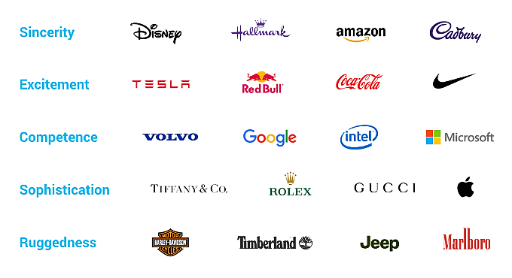
Branding interpretations by the Logo Company, custom logo designers https://thelogocompany.net/
Module 2 - Marketing Chapter 1 – Branding

2.1.2 Company NAME
This segment also appears in Module #1 (Entrepreneurship) in an abbreviated form.

DO NOT rush this decision. It has far-reaching effects on the business and is difficult to change after the company launches because of all the places a company name appears:
- Letterhead and business cards
- Signage
- URL and email address
- Legal documents
- Bank accounts and checks
Your company or product name will be a potential customer’s first impression. Entrepreneur Magazine suggests, “Your name should convey the expertise, value and uniqueness of the product or service you have developed.” If you were starting a bakery, which of these company names is more likely to arouse positive emotions: “Anderson’s Bread Shop” or “Open Hearth Breads”?
CRITERIA FOR THE PERFECT NAME INCLUDE...
- Short and easy to remember (easy to type into a web browser).
  - Of the 100 most visited websites, 72% have six or fewer letters; only 3% have more than 15.
No one wants to type www.TheWorldsMostWonderfulWidget.com. As evidence that shorter is better, consider that United Parcel Service goes by UPS, International Business Machines as IBM, Hewlett-Packard legally changed its name to HP Inc., and International House of Pancakes changed its name to Ihop.
  - Single words. All things being equal, a one-word name is better than two or three words, so “Panera” for a bakery trumps mouthfuls like “Open Hearth Breads”, which is also a long string to type into a browser. Short, simple words are also easier to remember (Apple, Google, Skype, Madonna).
  - Conjoined words are the next best (Netflix, Microsoft, StubHub, FedEx, Hotmail). They become unique new words and therefore are relatively easy to trademark.
- Describes what service you provide or the type of products you sell. Most people now use search engines to find products or services online or that are available locally. Does the name allow you to be found by search engines? Which is better for a bookstore, “Jane’s Place” or “Academy Books”?

But the name is not too specific. Diversifying might become awkward. Which is better: Acme Garage Doors or Acme Manufacturing? Consider a made-up name like Exxon, Xerox, or Google. An advantage of a word you make up is that it is easy to trademark (it is not likely anyone else will have registered it.)
- Name conveys the sense of a stable, reliable company. Some words suggest quality and inspire confidence. Some do not. Jennifer Fitzgerald, founder of Policygenius (an insurance advisory service) suggests asking yourself if you can imagine saying your company name to a Wall Street Journal reporter.
- Spelling is easy and unambiguous. Do not get clever with words like “Muunglow”. Select a name that people will spell correctly the first time, so they find you in a search, and not your competitor.

Module 2 - Marketing Chapter 1 – Branding

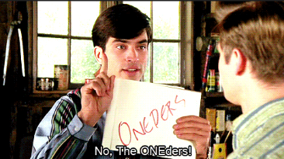
- Pronunciation is obvious. The movie, That Thing You Do, was built around a disastrous homonymous name for a musical group called the Oneders. Band members thought fans would pronounce it as the “Wonders,” but they were always introduced as the “Oh-Needers”.

- It is not geographically limiting. An exception is if you want to evoke a regional culture or food (e.g. - Kentucky Fried Chicken).
- Does not have a negative meaning in another language. Examples of unfortunate translations include:
  - Chevy Nova. “No va” means “No go” in Spanish.
  - Nature’s Gift aromatherapy products. “Gift” means “poison” in German.
- It conforms to legal requirements and restrictions.
  - You cannot use LLC, Corp, Corporation, Ltd, Inc. or Incorporated unless your company is organized under that legal structure.
  - On the other hand, if the business is an LLC, then the company must disclose this fact by placing "LLC" or "Limited Liability Company" at the end of its name. The purpose is to advise the public about the type of business organization. You cannot use Corp, Corporation, Ltd, Inc. or Incorporated in the name of an LLC as those adjectives designate and are restricted to full corporations.
  - The name cannot include words prohibited by state law (e.g., "Bank" or “Insurance” in some states). The prohibited words vary from state to state.

- The Domain name is available. A .com is usually the best choice for a commercial enterprise (com is short for commercial). If buyers know your company name, they will probably assume you are a .com and type that ending. When the top-level domain is not typed in, the default is .com. That is, if someone types in just a company name without a suffix, search engines will deliver the searcher to the .com version. Do not adopt a name if you cannot secure the domain name. If someone else owns it, all your marketing will just benefit them. For more, see “Choosing a Domain Name”

- Name is Easy to Trademark: Of the following different types of names, the higher it is on the list, the easier it will be to trademark.
  - Your personal name (This is usually safe unless your name is J. C. Penney, and do not even think about using McDonalds for the name of a restaurant, even if your name really is Ronald McDonald. Examples of companies based on the names of their founders include Ford Motor Company, Smuckers, Firestone, and Ben and Jerry’s.
  - Fanciful (made up) words like “Google” and “eBay” were chosen because no one anywhere in the world was using them.
  - Combinations (Linking two words to make a new word): Kickstarter, LinkedIn.
  - Arbitrary (using a common word out of context): Apple computer, Twitter.
  - Suggestive (These can help establish your brand): Coppertone suntan lotion
  - Descriptive (The name explains what you do): Freightliner, International Business Machines.
Trademark Horror Stories
Two young entrepreneurs were sued for $1 million by a company who claimed their use of the name “HypeWipes” (for their mobile phone cleaning pad) conflicted with its long-standing trademark “Hype-Wipe” for a hospital disinfecting wipe. Lesson: check hyphenated and plural spellings when conducting a trademark search.
Facebook sued a company for using the name DesignBook. Lesson: Do not kick big dogs.

Module 2 - Marketing Chapter 1 – Branding

BRAINSTORMING NAME IDEAS.

- For insights into the psychology of words see: kolenda.io/guides/brand-names.
- Consider ancient Greek or Latin words (Nike, Volvo). The right word may be evocative of what you do or the customers you want to attract.
- Use a Name-Generator Site. Free name-generator sites, useful for getting the creative process going. Note: you do not have to purchase your URL through these sites. See ”Where to Buy Domain”.
  - www.123Finder.com,
  - http://www.shopify.com/tools/business-name-generator
  - http://www.NameStation.com
CLEARING THE NAME. Make sure the name is not used by a competitor in your current or future market area. (For web-based companies, remember your market is the universe.) Do not worry if another company has a similar name if they are in another industry, as it would be unlikely that your use of the name will create confusion. For example, there are over 30 companies with the word “Sterling” in their name. However, before you buy that $20,000 sign for your building, check with an attorney. Confirm availability of each potential company name against the checklist on the following page.
- □ Google search (may uncover an unregistered trademark or competitor already using the name.)
Search name as two words (Whole Foods) and as one word (Wholefoods). .
- □ Check Secretary of State for your state (Has a company reserved or currently using the name?)
- □ Check social media. Is another company using the name on FB, IG, YouTube, X, TikTok?
- □ Domain name is available
These free AI services can suggest names as well as check for domain and trademark availability
  - www.Namify.tech Checks to see if domain, social media username and trademark are available
  - https://namelix.com/ Checks for domain availability
  - http://www.godaddy.com/offers/airo Checks for domain availability

PROTECTING THE NAME
- Buy the URL. Many registrars charge only $11 or $12 to purchase a domain name (but read the fine print, some services charge $35 or more for renewals). For low-cost sources, see “Selecting a Domain Name”
- Purchase the URL for your product name as well if it is different from the company name.
- Use TM (if a product) or SM if a service when you use your trade name. This puts others on notice that you claim the name as your trademark. For more information, see the “Trademarks” section of this text.

SUMMARY: Picking the perfect name is probably the most important decision you will make. Don’t get clever – pick a straightforward name anyone can understand, pronounce, spell, and find on a search engine.
- Brainstorm Names that evoke the right impression among your target demographic
- Test your short list on potential customers
- Verify that the name is not already being used
- Protect the name

Module 2 - Marketing Chapter 1 – Branding

2.1.3 design standards

Now that you have settled on a name and know how you want to be perceived in the marketplace, you can set design and branding rules so that you present a consistent look and feel to everything: logo, website, packaging, ads, flyers, even the product or service itself (sleek, rugged, colorful?).

The visible elements that are part of your branding include IMAGES and GRAPHICAL ELEMENTS, TYPE FONT, and COLOR SCHEME.

Images and Graphics

PRINCIPLES OF DESIGN EXCELLENCE
- Contrast. Make sure it is legible.
- Clarity and Simplicity. Avoid cluttering. Leave ample white space as a margin so message stands out.
- Consistency. All elements of the message are in harmony.


BACKGROUND REMOVAL. If you have the perfect photo but need to remove distracting background from an image, https://www.remove.bg/ has a free online service that takes less than 5 seconds.

FIXING FLAWS. See https://www.gimp.org/ for a free downloadable program to manipulate photos at the pixel level or create completely new graphic elements.

USING AI TO CREATE ORIGINAL IMAGES. Caution: AI might copy an image from someone else’s website. If you do not use AI to build up an image from scratch, one element at a time, making changes along the way; direct the AI image generator to make a series of changes, in style color pattern, focus, arrangement, characters, etc., so the final result is indistinguishable from the first iteration, in case it was based on a copyrighted work.
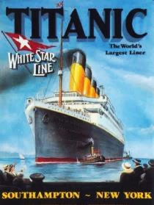
Free AI images generators include:
- https://openai.com/index/dall-e-3/
- https://leonardo.ai/
- https://www.canva.com/ai

This message has it all: contrast, clarity, clean design, consistency.
Everything works together to project an aura of confidence and safety:
- The bold stand-up type font,
- The massive ship contrasted with the tiny tug boat;
- The tag line “World’s Largest Liner”.
All elements reinforce the brand promise: “We’ll get you there.”
Incidentally, this image is in the public domain,
as it was produced more than 95 years ago.

Module 2 - Marketing Chapter 1 – Branding

Font. The typestyle you select for your company name will be part of your business personality. It should reflect the style and customs of your target demographic. Are your potential clients more likely to be retired librarians or bikers? Do you want it to be …
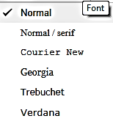
- Modern,
- Playful,
- Theatrical,
- Business-like
Google uses the font menu at the right
in its website building app

COMPATIBILITY. Pick a common font so that it will print on most desktop printers. Not all printers recognize every font. You are probably safe picking one of the stock fonts that comes with Word.

To see how the name looks in various styles, type it in Microsoft Word, then highlight the name and scroll through the drop-down list of fonts. Your company name will appear in each font as you scroll over the font name.

SIZE How does the typestyle look when small, as on a business card; or enlarged, as on a sign or billboard?

KERNING. You can also change the appearance of your company name by kerning the type, which is changing the spacing between letters. In Microsoft Word, click on “Font”, then “Advanced/ Character Spacing”.
Narrow (condensed) Spacing
Normal Spacing
Wide(expanded) Spacing

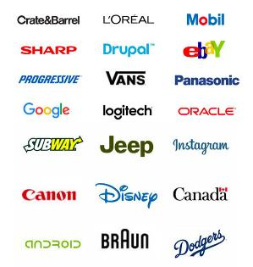

Some brands exude their brand image
with type alone.
Module 2 - Marketing Chapter 1 – Branding

Color Palette. Select colors that are widely available in the programs you will use in your business, such as Word, Publisher, and Illustrator.

Keep it simple: a maximum of two colors. Your logo should also be able to stand alone in one color (for outputting to a black-and-white printer or a newspaper). Note that all the logos in the chart below can be printed in one color.

Colors convey image and emotion. What company attributes do you want your color scheme to exude?
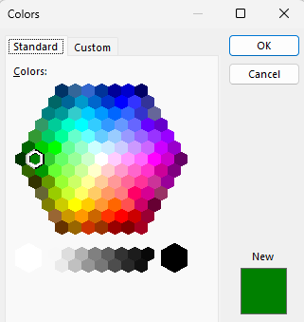
Microsoft Color Pallet. Some applications may require you to provide the formula for a color in an RGB or HEX format which indicate the amount of Red, Blue and Green in the selected color. To find these formulas click on the “Custom” tab. See sample below for a specific shade of green.
 | BURGUNDY - Vigor, elegance, richness, | 
 | RED - Energy, urgency
 | PINK - Romance, femininity
 | ORANGE - Fun, energy, warmth
 | YELLOW - Optimism. Grab attention
 | GREEN - Wealth, nature,
 | TEAL - Luxury, uniqueness
 | PALE BLUE - Tranquility, coolness, purity
 | ROYAL BLUE - Trust, loyalty, confidence,
 | NAVY BLUE - Dignity, credibility, tradition
 | PURPLE – Calming. Women like
 | WHITE - Fresh, light, pure, clean, cool
 | GRAY - Classic, quality, corporate | 
 | BLACK - Powerful, sleek

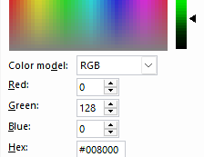
To try different color schemes, go to www.colorexplorer.com/.
Before committing to a color scheme, check to see how it looks printed on a color printer and in black and white. Many colors with complex formulas look dirty or dull when printed.

And of course, know your customers: red is not a good color for marketing in China, or for medical products

Printers may ask you for the CMYK color code so they can mix the inks to the exact shade. CMYK stands for Cyan, Magenta, Yellow, and Black To find the CMYK values, go to https://convertacolor.com
Module 2 - Marketing Chapter 1 – Branding

2.1.4 Logo

Often, the consistent use of a font and color scheme is sufficient to establish a memorable identity. The following logos are just words, but they are recognizable because they always appear in the same font and colors.

SYMBOL. If you will have clientele that do not all speak the same language, you may wish to add a unifying and recognizable symbol to help identity your brand.

Also, look in popular symbol fonts. If you pick one of these special characters, it will always be at your fingertips. Font symbols are also very crisp and blow up well. Here are some examples:
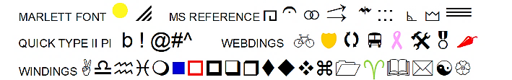
Arrow
You can also create a logo with graphic “Shapes” or “Word Art” available in Word. The “Arrow” logo at right was created in 5 minutes with a Shape and text.

DIY LOGO CREATION SITE. https://looka.com/logo-maker/

IF YOU WANT SOME HELP, there are sites where you can post a project, set a budget range, and review portfolios and proposals from a variety of freelancers. You will often receive several designs to choose from, and costs are surprisingly low, sometimes only $5 to $25 for a logo; and turnaround is usually in a few days, if not hours. Check out the following online services:
www.freelancer.com
www.designcrowd.com Design Crowd has a 2-minute video explaining the process.

Logo Tag Line: a memorable one-liner that summaries the brand image you want to project:
- Fifteen minutes could save you 15% or more on car insurance.
- Just Do It!
- When it absolutely, positively, has to be there overnight.
- When you care enough to send the very best.
Based on their tag lines, how do you think these companies want customers to feel about them?

Module 2 - Marketing Chapter 1 – Branding

2.1.5 Packaging

The inner packaging is a box, bottle or blister pack suitable for a shelf. Retail packaging is typically not durable enough for shipping. Its purpose is to catch the eye of the shopper and sell the product.

Talk to the managers of the type of stores you hope will buy your goods. How do they want products packaged?
- In boxes to display on shelves?
- In packaging to hang from slat-wall panels?
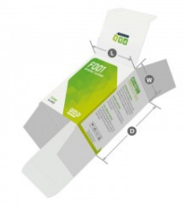
- In bulk bins?
RETAIL PAPERBOARD PACKAGING. There are specialty-printing houses that just make fold-up
boxes. See https://pakfactory.com/ or https://boxprinting4less.com for ideas and price quotations.
Printed boxes can be expensive in “small” quantities, but prices decline as volume increases.
- BoxPrinting4Less.com quoted $629 delivered (2025) for 1000 of the 6x3x3 printed
carton shown at right.

Initially, you could order a small quantity of a stock blank box and apply a label to it.
Uline.com offers a variety of standard sizes of blank boxes in white. An unprinted
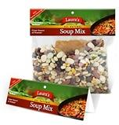
box is $39 for 100 plus approximately $21 for freight or about $.60 delivered (2025).

BAG HEADERS. www.uprinting.com will print 100 five-inch-wide header cards for $62 including shipping (2025). www.printrunner.com charges $40 including shipping (as of 2025) for 25 headers, but only $80 for 1000.
The bags you can buy at a grocery store for a few pennies each.

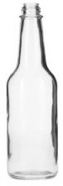

BOTTLES and JARS. This 10 oz. glass bottle is $.62 (in 2025) with white screw-on cap, in cartons of 12, plus freight, from www.bottlestore.com. Plastic containers cost about the same as glass.

The container is part of the product and will help attract or deter buyers. Research shows that a tall thin container seems larger than a short squat one. A tall bottle also appears rational and purposeful, a fat bottle friendlier. Taller appears lighter, healthier, luxurious (low-cal beverages); a squat jar heavy (ice cream). A tall bottle is harder to ship than a more compact short container. A small package can seem intense: Red Bull.

Since bottles do not fold flat for shipping, like paperboard boxes, find a bottle supplier near you to save on freight, which will probably be more than the cost of the item for small orders. Look for a nearby source so that you can pick them up yourself. This also allows for just-in-time inventory.



Whatever your product, there is a container designed for it.
Module 2 - Marketing Chapter 1 – Branding

2.1.6 Labeling

Whether the inner (retail) packaging is a bottle, jar or box, you can save a great deal on test runs by using a label that you print yourself.
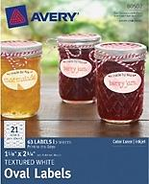
DO-IT-YOURSELF ADHESIVE LABELS.
Both www.Avery.com and www.onlinelabels.com offer 8.5” x 11” sheets of blank
die-cut labels in various shapes and sizes, in matte white, glossy, and clear.
OnlineLabels. 100 sheets (10 white labels 2”x4” per sheet) $18 delivered (2025).
Avery.com is more expensive, at $32 for the same 100 sheets. Avery labels are usually stocked at office supply stores, so you can pick them up quickly.

Both stock label makers offer free design templates.

CUSTOM PRINTED LABELS. If you search for “printed labels”, you will get 100 million hits, so you will not have difficulty finding a source. The key is to find a supplier with stock shapes and sizes, so you do not have to pay for dies.

One source is https://www.printrunner.com/stickers-and-labels where 1000 rectangular labels 2” x 4” printed in four colors will run $120 or $.12 each (2025).


Avery offers a starter supply of 48 pre-printed labels, 2” x 4”, is $.77 each ($37 total) delivered (2025). The price drops to $.25 each ($248) at 1000 labels. See https://www.avery.com/custom-printing

Labels are available in different shapes, sizes, and materials: including clear vinyl—so your product shows through—and silver and gold foil. The paper labels are available in matte and glossy finish. If using paper, go for glossy, as it is easier to keep clean.

[below] Some of the stock shapes available from Avery.

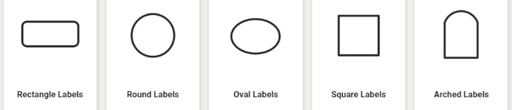


FOOD LABELS. Food product labels must display:
- a statement of identity,
- the product’s net weight,
- manufacturer’s address,
- nutrition facts, and
- ingredients list
An easy-to-follow resource for food labeling may be found at www.foodpackaginglabels.net

Module 2 - Marketing Chapter 1 – Branding

2.1.7 PHONE Number

After spending your hard-earned money and time to create a slick logo and dazzling website, you can still pop the image bubble of your company if your prospective customers are greeted with “Hey Homie, wazzup?” when calling to place an order. One option is to record a message that tells callers they have reached the XYZ company. (Your family and friends will know about your business and will still leave personal messages.) Alternatively, you can install a separate phone number for your business.

VIRTUAL CLOUD-BASED PHONE SYSTEMS. Several companies offer virtual phone numbers for your business that will take messages or forward calls to your phone. You will not know if the caller rang your virtual business phone number or if they called your direct number. That is, you still will not know if it is a business or personal call. However, with caller ID, you should have a good idea. You can also move all your friends to a group in your contacts to receive your personal greeting, and all others the business greeting.

For laid-back businesses, some entrepreneurs just answer their mobile phone with their name, regardless of the caller; and a generic recording: “You’ve reached the phone of (name), please leave a message.”

Ring Central. www.RingCentral.com. $20 per month per user (as of 2025) for an office system with multiple users. With the full-service package, calls can be answered with something like “You have reached the offices of [Ourco], your source for [our products]. For sales, press 1; for customer service press 2; to leave a message, press 3.” Ring Central will forward the call to the cell phone of the appropriate member of the management team. You can of course keep the same roaming system when you set up a permanent office but continue to use this cloud-based phone system rather than an expensive network in the office. Includes conference calling and a toll-free number.

Google Voice. www.Google.com/voice offers a “one-number” service for $10 per user per month (2025). Anyone calling the number will be forwarded to the phone you specify: a mobile phone, your home phone, or all three. You can also search the Google number database for a number that spells your business name. The number will follow you wherever you are. If you cannot take the call, you will receive a voice message (or if you prefer, a text transcription of the message).

Nextiva. www.Nextiva.com with rates starting at $30 a month (2025).

Virtual phone number acquired ____________________________

Module 2 - Marketing Chapter 1 – Branding

2.1.8 Business Email Address

YourName@YourCompany.com is the most professional email an entrepreneur can have; and most hosting services provide free email accounts as part of the hosting package.

Do not make customers type in a long, difficult-to-spell name. Use your first and last name, but remember, customers have to remember how to spell your name then type it to reach you. If your first name is Alexander, consider using Alex in your email handle. If your last name is Solthzenitzhenson, maybe just go with Alex.

For trial launches, a free Gmail account will suffice for many companies; but switch to a custom-domain email address when you launch your business full time.

See “Website” section of this text for suppliers of domains, email services, and website hosting.

Business email address acquired: ____________________@_____________________________.________

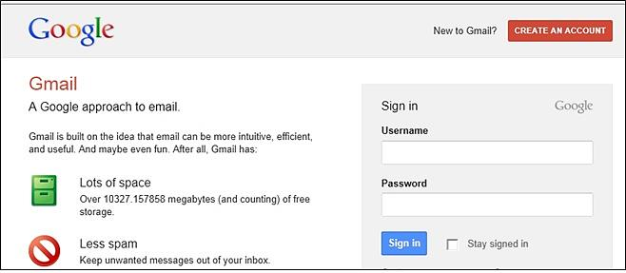
Module 2 - Marketing Chapter 2 – Website

2.2 – Website
This chapter also appears in Module #1 (Business Modeling) in an abbreviated form.

2.2.1 Choosing a Domain Name and Hosting Service

2.2.2 Selecting a Website Hosting Service

2.2.3 Website Evaluation

2.2.4 Search Engine Optimization (SEO)

Yes, you need a website. This is where people assume they can go to find pricing and see your full range of products or services. You will also need the all-important “buy”
button or shopping cart and a contact page so potential customers can ask questions.

Module 2 - Marketing Chapter 2 – Website

2.2.1 Choosing A DOMAIN NAME

Of the top 100 most visited sites in the United States, all are dotcoms. Some newer endings are growing in popularity, especially .co, but this should be a distant second choice. If you type in the name of a company in your browser, as the default, you will be taken to the company with the .com suffix.

Protecting Your Brand. Pirates have been known to register a name similar to a popular site and then clone the content. To protect yourself, consider registering...

- Alternative spellings: If you have drjones.com, you might want to buy doctorjones.com, as well.

- Additional extensions: if you own the .net or .co, consider registering the .com as a defensive measure.
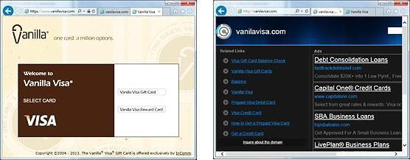

InComm launched a pre-paid Visa card called Vanilla Visa. They registered VanillaVisa.com but did not purchase VanilaVisa.com (a common misspelling), or VisaVanilla. As a result, another company registered those URLs to take advantage of InComm’s advertising and siphon off clients who had not won spelling bees. Wise entrepreneurs register likely mistypings as well as possible misspellings. If you type “Goddady.com” into a browser, you will arrive at “Godaddy.com”. Smart daddy.

Where to Buy Domain. NameCheap.com $11 first year/ $17 on renewal. GoDaddy.com charges $.01 first year/ $22 on renewal. Wix.com Free first year with hosting/ $19.35 on renewal. (All prices are for .COM domains (2025).

Subdomains. Some web hosting services offer free hosting if you use a subdomain of their domain name. A domain would be www.YourCompanyName.com. A subdomain might be www.YourCompanyName.Wix.com.

Module 2 - Marketing Chapter 2 – Website

2.2.2 SELECTING A WEBSITE HOSTING Service

The following hosting services provide a wide range of options and have been in business for at least a decade. All hosting services offer DIY website Content Management Systems (CMS), design templates, and blogging software as part of their hosting packages.
Prices subject to change. Check the fine print. “Free” usually is not forever. Also, most plans automatically renew, so record the date and cancel ahead of time if you do not want to renew.

(Rates as of 2025) |   Weebly.com | Wix.com | 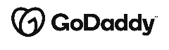  GoDaddy.com | Hostinger.com
Domain (.com) registration | Free for 1 year with paid hosting | Free for 1 year with paid hosting | $.01 for 1 year with paid hosting | Free for 1 year with paid hosting
CMS site builder with templates | Free with hosting | Free with hosting | Included. With GoDaddy, you pay for the CMS, and the hosting is free. | Free with hosting
Web Hosting only + email addresses | Free as subdomain, with ads.  Own domain  $144 yr. No ads.  Unlimited storage.  Online store. | Free as a Wix subdomain.  (OK for student projects, demos  or temporary sites)  $17/mo. with own domain. No Wix branding. 2 GB storage.  $29/mo. ($348/ yr.) for store + 50GB | “Website Builder” “Commerce” plan $21/mo. ($252/yr.) renews $420 yr. | 25 GB storage.  2 email boxes free for one year.  $2.99/mo. 4-year contract ($144); then $576 for next 4 years)
Email service | Not available | Not available | Free with paid hosting | Free with paid hosting
Database | No | Yes. with forms | Yes, with forms | Yes, with forms
Free Ad Words | No | No | No | No
Security Certificate | SSL security included | SSL security included | SSL security included | SSL security included
Single Item Credit Card Sales | Incl. with $144/yr. version | Incl. with $348/ yr. version | Yes | No
PayPal Integration | Incl. with $144/yr. version | Incl. with $348/ yr. version | Yes | No
Shopping Cart (multiple item sales) | Incl. with $348/ yr. version | Incl. with $348/ yr. version | Yes | No
Mobile friendly | No | Yes | Yes | Yes
Other |  |  | 100,000 email sends per month
Favicon | Yes | Yes | Yes | Yes
Module 2 - Marketing Chapter 2 – Website

2.2.3 WEBSITE EVALUATION

Feature | Pts |  | Comments
DOMAIN NAME IS EASY TO REMEMBER AND SPELL | 5
SITE STABILITY. It does not crash. | 5
MOBILE FRIENDLY. Easy to navigate on a phone | 5
STYLE. Appropriate to target audience | 5
DESIGN THEME CONSISTENT THROUGHOUT SITE | 5
COLOR SCHEME appropriate | 5
FONT. Appropriate selection and consistent usage | 5
SPELLING. | 5
GRAMMAR. | 5
WHITE SPACE. Pages are open and pleasing to the eye (not busy and cramped) | 5
BRANDING. You know whose site this is, or at least the product—no matter what page you are on. | 5
SEO is effective. Site shows up near top of search results | 5
PAGE LAYOUT. Placement of graphic elements and text guide the user’s eyes to important information and links. (You do not have to hunt to find what you want.) | 5
SITE ARCHITECTURE. The material is organized into pages and sections in a logical and easy to follow topology. Sequential content flows logically and smoothly. | 5
NAVIGATION. It is easy to find your way around within the site. You do not get lost. | 5
MENUS. Well-organized and easy to figure out. | 5
LINKS. No missing or broken links (No 404s) | 5
IT WORKS. Can you tell what the site was built to do (promote a candidate, sell widgets?) and does it do that | 5
PURCHASING IS EASY, with multiple payment options | 5
STICKINESS. Site encourages visitors to linger and return | 5
TOTAL | 100
Module 2 - Marketing Chapter 2 – Website

2.2.4 SEARCH ENGINE OPTIMIZATION (SEO)

So, your website shows up in search results when consumers look for your solution.
See also SEM (Search Engine Marketing): paying for higher placement on results page, or an ad.

When a web surfer enters a search term in a browser such as Google, Bing, or Firefox, the search engine looks for those terms in website meta tags and page descriptions.

META TAGS are key words and phrases that you include on your website. All hosting services allow for metatags and have clear instructions on how to add them.

The important thing is to guess accurately what words a customer might use to find products like yours. If you were selling cooking utensils, what words might someone enter in Google to find them? Certainly, “Cooking utensils,” but someone might enter “cooking aids”, or “kitchen aids”, “Gourmet”, “Crock pot”. These are all good metatags.

Be creative. Add some recipes to your site; then add “recipe” as a metatag (and perhaps sell that deep fryer mentioned in one of the recipes.)

The list of websites using the same metatags (which probably includes your competitors) are ranked by criteria called algorithms. Your site will place higher in search results if it is...

- Referenced on Other Sites with links back to your site.
- Mobile-friendly. (You can check to see if Google considers it so by entering your site’s URL here: http://www.google.com/webmasters/tools/mobile-friendly.)
- Secure (HTTPS prefix). For this, you will need to obtain a Secure Certificate from your web host.
- Not Top-heavy; that is, it does not contain too many ads at the top of the screen.
- Contains High Quality Content. It does not contain copies of articles from other sites. The content on your site is fresh and unique and adds to the body of knowledge on the web. Proper spelling, grammar, and readability also help. Short, simple sentences with common words beat out sesquipedalian pedantry.
- The URL and Page Names Describe the Content. For example, if you are selling baseball cards, “JacksBaseballCards.com” will place higher than “JacksShack.com.” If you have a page that lists 2010 Dodger cards, a web crawling robot or human searcher will understand this clearly if you name the page “JacksBaseballCards.com/2010/Dodgers.” Remember, the actual page URL appears in search listings. A search for “Dodgers baseball cards” returned the following on the first page of Google results:

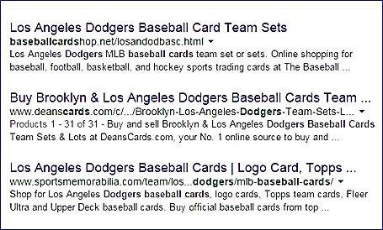
The top return included a large portion of the search string “baseballcards” in the domain.
The second-place domain name (deanscards.com) was less clear about what the shop sold, but the page name included the work “Dodgers” which was part of the search string.

Module 2 - Marketing Chapter 3 – The Message

2.3 – Marketing
(The Message)

2.3.1 Marketing Strategy
2.3.2 Presenting Prices to Best Advantage
2.3.3 Posting Prices in a Compelling Manner
2.3.4 Content for Ads
2.3.5 Using AI to Draft Ad Copy
2.3.8 Photographs
2.3.7 Marketing Plan and Budget

Module 2 - Marketing Chapter 3 – The Message

2.3.1 Marketing Strategy

Advertising Channels. How will customers find out about your product, its features and benefits? This is especially critical if you are relying on intermediaries (retail stores, distributors, contractors, app stores, etc.) as delivery channels. Ask for advice from salespeople at media you are considering. (Do they have any current deals? Best time to advertise? etc.) They are experts so can also suggest other cost-effective media to add to your mix.
- Paid print media advertising (magazines and newspapers)
- Free public relations. Local papers are eager to publish stories about new companies in their area. Contact your local city or business editor.
- TV advertising
- Radio ads
- Direct mail. For mailing list, contact a magazine serving your market, as subscription lists are usually current.
- Trade shows. Search for “Trade shows for [your industry]”
- Email marketing
- Web advertising (purchasing keywords)
- Social Media Influencers (bloggers, instagrammers, tweeters, and podcasters).

Whatever media you select, run a test. To confirm impact, add an identifier like “ Use promo code “TV.”
Sales Channels. (How will you sell your products or services?)
- Directly to consumers
- Through retail stores? (You will need to sell the storeowners as well as the ultimate consumer.)
- Through distributors or manufacturers’ reps? They will sell to retail stores for you, for a commission—but beware; they only want to rep proven winners.
- By bidding on contracts?

Delivery Channels. (How will you deliver your products or services?)
- Via mail?
- Through Fulfillment by Amazon (FBA)? See http://services.amazon.com
- The App Store?

Who will use the product? (The USER) _________________________________________________________

Who will pay you for it? (The CUSTOMER) _____________________________________________________
(e.g. -- if you sell cereal, the users may be children, but the customers will be the parents.)

Whom do you want to reach and what is the Call to Action? (Visit website, download coupon, complete survey?)

What Advertising Channels will you use to reach out to potential customers?

How will you incentivize prospects to respond to the Call to Action?

Module 2 - Marketing Chapter 3 – The Message

2.3.2 PRESENTING PRICES TO BEST ADVANTAGE

Subscription Pricing.

SERVICES. Subscription payment is the norm among a number of service industries, including Software as a Service (SaaS), magazines, cable TV, phone service, education (most schools charge by the semester instead of per class), business services, house cleaning, lawn care. Even some services traditionally acquired when needed, such as haircuts and car washes are now being offered on a subscription basis. Almost any service can be sold as a subscription.

PRODUCTS. We are also seeing more products offered on a subscription basis. Order anything from Amazon and you will be offered a discount (typically 5%) to set up a subscription to receive a quantity each month. This works well with consumable like laundry soap, paper towels, pet food. But even farmers are offering subscriptions to fresh vegetables.

WHY OFFER A SUBSCRIPTION RATHER THAN BILL ON AN AS-NEEDED BASIS? Granted, you may wind up providing more value to some customers than you receive in return. This certainly happens with car insurers when someone does have an accident. But this is an attraction to customers for subscription pricing: they know, no matter how much of the service they will need, their cost is fixed and predictable. Plus, there are upsides to the business to selling products and services on subscription:

- It creates brand loyalty. If customers order goods or services regularly, they may research alternatives.
- Subscriptions provide more predictable cash flow forecasting.

Knowing how much product or service you need to deliver helps in planning your own inventory purchases and production. Although monthly subscriptions can usually be cancelled, it is unlikely that all customers will cancel at the same time.

ANNUAL VERSUS MONTHLY PRICING. Most companies offer both options, with the annual plan typically 20% lower than the monthly plan over the course of a year (https://guybarner.medium.com/) Another obvious advantage to the company of the annual plan also relates to cash flow since the annual plan is paid up front.

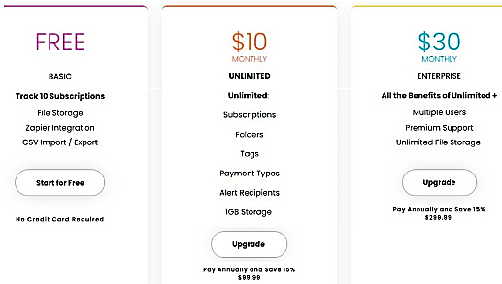
Pricing plan from TrackMySubs.com, a company that helps users track their subscriptions.

This example is uncluttered and easy to understand. If you have a lot of features, list them and then indicate with checkmarks which plans offer each. Or just list only the major features and a link to “See all features.”

Could you offer your product or service as a subscription? Try some options with potential customers.

Module 2 - Marketing Chapter 3 – The Message

2.3.3 Posting Prices in a Compelling Manner

This advice is from Nick Kolenda whose blog condenses academic studies into key takeaways for entrepreneurs. For more suggestions see https://www.kolenda.io/

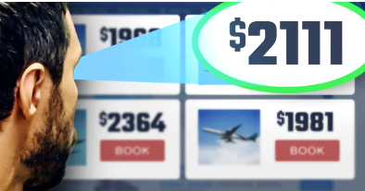
Reduce the Size of Currency Symbols.
Also reduce the Left Digit by One ...

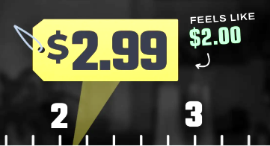

Except for high prices. The left-digit effect would backfire for a $2000 item (reduced to $1999) because customers will focus on the later digits. Instead use $2111. This reduces the digit averages, and the repeated numbers grab attention.



Remove commas from prices

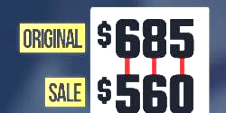

Reduce every digit in a discounted price

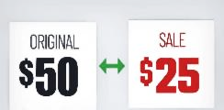

Distinguish a sale price by font color (red attracts
attention), size (a small font suggests small price), and style
Also add gap between original and discount price.
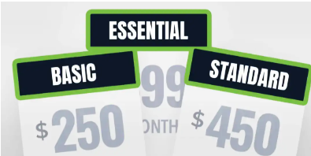

For Pricing Plans use simple names like Starter, Basic, Essential to imply a social norm. Customers avoid prestige names (e.g. Gold ot Platinum.)

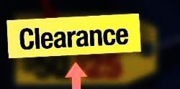

Provide a reason for the discount

Module 2 - Marketing Chapter 3 – The Message

2.3.4 Content for Ads

To attract and engage customers, include information that clearly communicates your value proposition and resonates with your target audience. Winning copy includes:

1. Attention-Grabbing Headline that is …
- Clear, compelling, strong and crisp.
- Communicates the key message.
- Relevant to the target market.
2. Clear Value Proposition: how your product or service provides value by solving a problem or fulfilling a need.

3. Clearly communicate what differentiates your product or service from competitors. "They'll fight over it when you're dead" tagline for Saddleback Leather highlights its durability.
I
love
saving
people
money
4. Active verbs (Acme products catch roadrunners).
5. A human touch. Show how much you enjoy helping people, like the Gecko.
4. Compelling Call to Action (CTA): "Save Now," "Learn More".
4. Trust and Credibility Elements: testimonials, customer reviews, or case studies .
5. Supporting Visual to capture attention, demonstrate benefits, and reinforce branding.
7. Business Information:
- Business name or logo. (And clarify what you do, if necessary.)
- Contact information like your phone number, website, or physical address.

Summary example: Instead of "Marketing Services," try "Unlock 50% More Leads with These Proven Marketing Tactics—Get Started Now!"

HOW TO BE MEMORABLE. Use humor as in the 1966 VW ad below. The company understands exactly who their buyers were. Can you reverse engineer buyer attitudes from this ad?

Or get clever. What is the message of the Lego ad (which incidentally translates into every language)? What is the brand promise of the BMW ad? When BMW talks about the power within, they’re not taling about the car are they?



Module 2 - Marketing Chapter 3 – The Message

2.3.5 USING AI To Draft Ad Copy

Typing a prompt into ChatGbt or other AI copy generator will provide some suggestions for ad content. However, there are some downsides. You need to stay in control and make sure the final product is accurate and appropriate. Some deficiencies in AI-generated copy include:

- All the Warmth of a Robot. AI cannot empathize well with your customers desperate desire to solve a problem. Text can come across as wooden, so add a human touch or rewrite using your voice. You can improve the AI output somewhat by telling it to “build rapport with the viewer” or “show empathy”.
- Lack of Originality. AI only knows what has already been published, so it can sound derivative. And after a while all your ads will sound alike, as AI is not very creative.
- Just Plain Wrong. AI can make mistakes. It does not know if the data it is learning from is correct. So, fact check any data or claims. We cannot blame incorrect information in an ad or website on the robot any more than we can get away with blaming it on the computer. Buck stops with us humans.
- Copyright Violation. AI has the ethics of an office copier. A lot of what it will deliver will be copyrighted by someone else. To screen copy, type into a free plagiarism checker like:
- https://www.grammarly.com/plagiarism-checker
- https://justdone.com/plagiarism-checker
- https://www.duplichecker.com/

AI PLATFORMS THAT CAN GENERATE CONTENT FOR ADS, WEBSITES OR BLOGS.

- ChatGBT https://chatgpt.com/
- Claude https://claude.ai/
- Copy.ai https://www.copy.ai/
- ClickUp https://clickup.com/
-----------------------------------------------------------------------------------------------------------------------------------------
Below is an ad generated in seconds with free version of ChatGbt.com. The PROMPT was
“Write an ad for a food-ordering app. Use persuavive tone, encourage trust, and close with call to action.”

🍽️ CraveEase — Delicious Food, Delivered with Care
Hungry? CraveEase brings your favorite meals from trusted local restaurants straight to your door — in minutes. Whether you're craving comfort food or gourmet dishes, enjoy a seamless experience every time.
Why you’ll love CraveEase:
- Unmatched convenience — Tap, order, and track your delivery in real time.
- Trusted Quality — Partnered with top-rated restaurants you know and love.
- Secure Payments — Safe and reliable checkout — no surprises.
- 24⁄7 Support — Friendly help available anytime, every step of the way.
- Loyalty Rewards & Exclusive Offers — Earn discounts and unlock perks just for ordering.
Join thousands of happy customers who rely on CraveEase for consistent freshness, speedy service, and total reliability.
Try CraveEase today — download the app, place your first order, and get 20% off with code FIRSTBITE.
Satisfy your appetite now. Trust CraveEase to bring food you love — when and where you want.
Module 2 - Marketing Chapter 3 – The Message

2.3.6 PHOTOGRAPHS

A photo—whether one you take yourself or download from a photo library—can convey a great deal of information quickly to busy customers surfing social, driving past a billboard, or thumbing through a newspaper. A great photo can stop them in their tracks.

TAKING PICS. It’s all about the lighting. Natural sunlight is the best as it has the right “color” as well as being bright. (Fluorescent lamps give a greenish tint to photos.) If you do shoot indoors do so near a window during the day. If you are getting distracting shadows, add a light to fill in the dark areas. A light on each side of the subject should suffice.

WHICH CAMERA. If you own a $5000 Hasselblad, great. If not, any smart phone camera will be quite adequate and allow editing of the shots.

Shot with an iPhone
COMPOSITION.

- Keep it simple.
- Consider the angle. Shooting upward makes the product look powerful. A viewpoint from above makes the product appear easy to manage, non-threatening.
- Remove humans from shots with products. Allow prospects to take ownership of the product. They do not want to see someone else using their bath towel. An exception to this rule is for a supporting shot showing people enjoying a product, like a grill at a backyard party.
- Non-distracting background. Better yet, no background. See https://www.remove.bg/
STOCK PHOTOS. If you don’t have the budget or time for a photo shoot, you can download a free stock photo from: www.Pixabay.com, www.flickr.com/creativecommons, or https://commons.wikimedia.org. But check the fine print. There may be some restrictions or attribution requirement.

You might also try searching the web for “images” of the key words you selected to define your brand. Anything you find that is at least 95 years old is in the public domain and you are free to use it. However, you cannot use an image of the American Flag—owned by the U.S. government—for commercial purposes. Nor will Disney look kindly on you appropriating Mickey Mouse.

USE AI TO CREATE IMAGES BASED ON YOUR DESCRIPTION. These services are free:
https://openart.ai/, https://www.midjourney.com/home, https://www.midjourney.com/home
Module 2 - Marketing Chapter 3 – The Message

2.3.7 MARKETING Plan and BUDGET

This worksheet will inform your budget, capital needs and cash flow forecast. The following chapters provide details on each heading in the budget:

- Marketing (Collateral Material)
- Marketing (Traditional Mass Media)
- Marketing (Digital Mass Media)
- Marketing (Targeted Media)
- Sales (Online and In Person)
Backdate from when you want to launch your product or service. Is seasonality a factor?

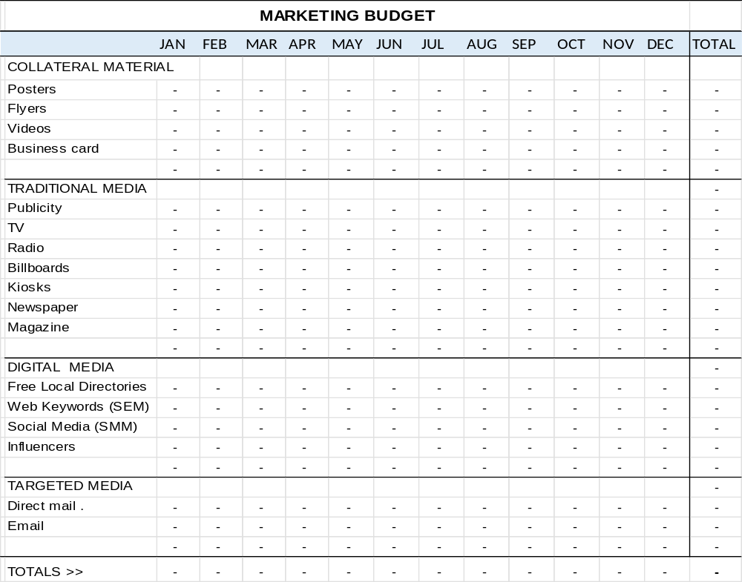
Module 2 - Marketing Chapter 4 – Collateral Material

2.4 – Marketing
(Collateral Material)

2.4.1 Business Cards
2.4.2 Posters
2.4.3 Flyers and Brochures
2.4.4 Printing Through a Cloud-Based Service
2.4.5 Marketing Videos

Module 2 - Marketing Chapter 4 – Collateral Material

2.4.1 Business cards

A business card gives suppliers, investors, customers, and co-founders an easy way to remember you, what you do, your website, and how to reach you. It is also a lasting impression of your brand.
ELEMENTS OF EFFECTIVE BUSINESS CARDS...
- TITLE (give yourself a title). It looks more professional. If a one-person startup, you are the CEO.
- EMAIL. Short and professional. See previous section in this text on “Business Email Address.”
- ADDRESS. This can get tricky. Some people do not want to advertise where they live; and Steve Jobs probably did not want it widely known that Apple was initially headquartered in his parents’ garage. If that is the case, rent a P.O. Box or list your city without a street address. Prospective investors, employees and online customers just need a general idea of where you are located.
- DESIGN. Use matte (not shiny) card stock and a light-colored background and plenty of white space so the recipient can make notes. Keep it simple. Nothing says amateur like a busy card or a photo background.
- PHONE NUMBER. (See previous section in this text dealing with the “Phone number.”)
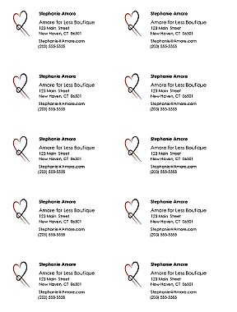
PRINTING BUSINESS CARDS YOURSELF

- Use Avery® “Clean-edge” punch-out card stock. A pack of 200 white cards (20 sheets, 10-up) sells at most office-supply stores for $25 (2025) or online for the same price: https://www.avery.com/products/cards/8871
- For business card templates in Microsoft Word, see File >New>Business Cards. Consider only designs that are in a “10-up” format as these match the layout of the Avery pre-perforated sheets. Here is a link to additional 10-up business card templates online:
https://create.microsoft.com/en-us
- Your 10-up artwork should look like the sample at right.

USING A QUICK-PRINT OUTLET such as Staples, Office Depot, or Kinkos-FedEx.

- Save artwork as a PDF to avoid conversion charges and to ensure your artwork is not corrupted when transferring to the printer’s computer.

- The chart below shows typical prices for business card printing. Note: for 2-color printing, black counts as an ink color. Kinkos does not divulge prices unless you first login and create a design.

ITEM | SPECS | QTY | STOCK | Staples | Kinkos/FedEx | UPrinting.com
Business Cards | Full color  Full color | 250  500 | 14 pt.(100 lb.)  14 pt.(100 lb.)  . | $ 30 del.  $ 34 del. | $38 del.  $50 del. | $ 31 del.  $ 35 del.

Module 2 - Marketing Chapter 4 – Collateral Material

2.4.2 POSTERS


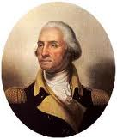
Use a design program like Microsoft Publisher, Adobe Illustrator, or Quark to create documents larger than 8.5x11. Microsoft Word does not allow for a layout larger than 22” in either direction. Theoretically, for an 18 x 24 poster, you could create the design in Word using dimensions of 9 x 12 and instruct the printer to blow it up 100% (print at 200% of the original size) to create an 18 x 24 poster. However, photos may appear fuzzy, graphics and fonts may break up and appear pixilated, and round and diagonal lines may show stair-stepping.

The photo of Washington on the left is the original. The version on the right is a smaller version blown up to twice the original size.

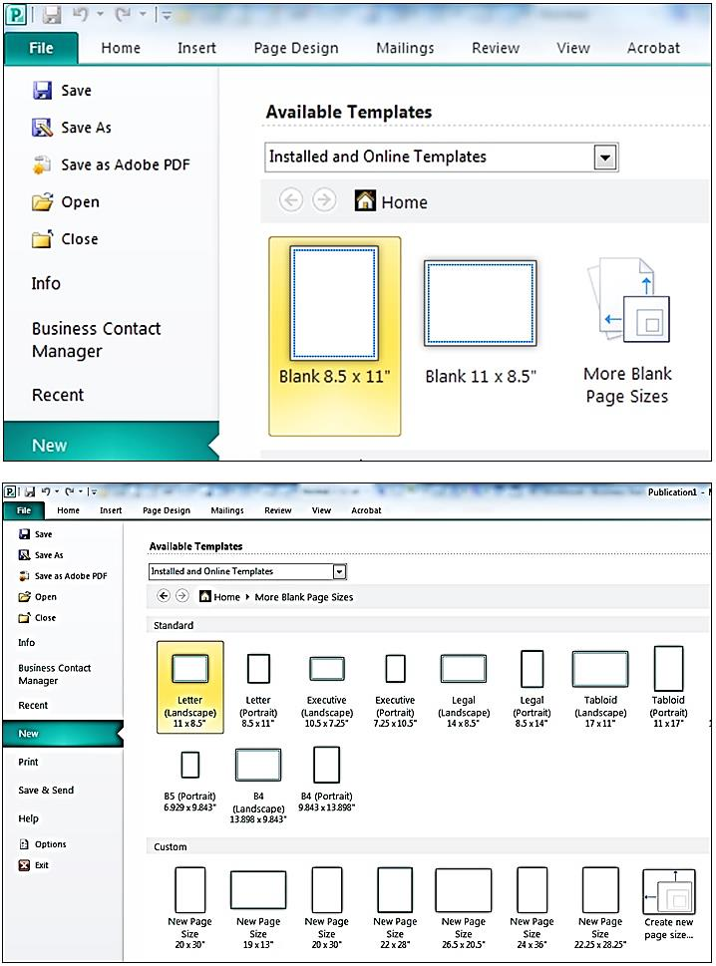

Designing a poster in Microsoft Publisher

On the first screen, click on “More Blank Page Sizes.”

On the next screen, create a template for the desired size by clicking on “Create new page size” (shown in lower right of the partial screen shot at left). A good compromise between size and cost is 18” x 24”. This is a stock printing size at Staples and Office Depot.

Module 2 - Marketing Chapter 4 – Collateral Material

On the next screen, give your new template a name and specify the width and height. Note that we’ve set the margin guides at ¼” all around. This is about as close to the edge of the paper that you can print. The guides will help you stay within these borders. If you want your design to run to the very edge of the paper, just ask the printer to trim off these margins. After trimming the poster will be 17.5” x 23.5”.

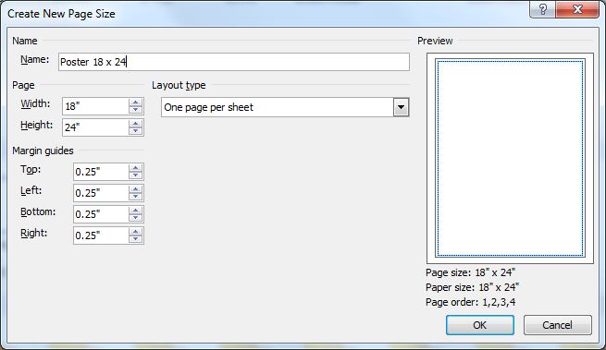


After clicking “OK”, click on the small “Create” button on the extreme right of the screen.

Content. Less is more in poster design. People will be walking by your exhibit table or store window, thinking about something else, so you will only have a half second to gain their attention, pique their interest, and effectively convey your message. Most billboards and print ads do this well. Try to mimic their simplicity in design and text.

Also, to give your posters a long useful life, do not include information that may change, like pricing. Do include:

- Name of company and product
- How it will improve the life of the customer (key benefit)
- How to buy it (website url, phone number, and/or store address). Posters and billboards are another reason to use a short, easy to remember, easy to spell domain name.
- Call to action

Module 2 - Marketing Chapter 4 – Collateral Material

2.4.3 FLYERS AND BROCHURES

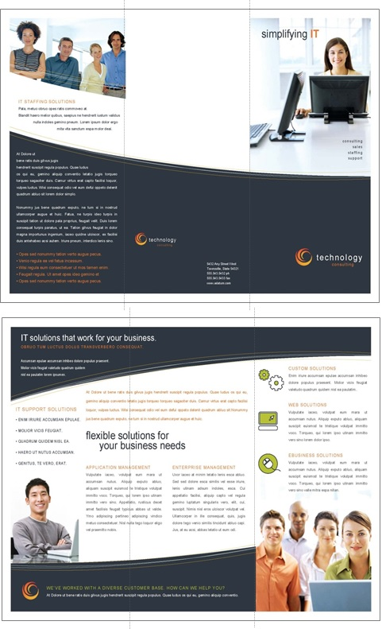
Microsoft Word offers a variety of templates for flyers and brochures. You may find that a simple one-sided flat 8.5 x11 flyer is just as effective as a complex
tri-fold brochure.

The sample on the right shows the outside (top) and inside spread (bottom) of a tri-fold (6-panel) brochure. The designs are printed on the front and back of a standard 8.5 x 11 sheet, which is then folded in thirds, to fit into a stock brochure rack or #10 business envelopes.

If you do want a tri-fold brochure, we suggest you start with a stock Word or Publisher template. (A brochure layout is more complicated than it looks.) First, there are six pages, each with four margins. Second, the right panel on the top section (the cover) must be slightly wider than the middle panel, which in turn must be wider than the panel on the left. Otherwise, the brochure will not fold neatly and lie flat.
Do not worry if the layout or color scheme of the template is not to your taste.
Everything is editable.
PS - Design the brochure to make it easy to fold accurately (NOT like this one. Note how the fold in the lower right is along the seam of two design elements. Good luck folding that neatly every time.

Fold lines >

Module 2 - Marketing Chapter 4 – Collateral Material

2.4.4 Printing Through a Cloud-Based Service

UPLOADING ELECTRONIC FILES. In all cases, you will need to create an online account with login and password. This will allow you to upload files from your computer or to design materials on the printer’s website.

FORMAT. Each printer lists on its website the formats it will accept. The safest is PDF, as what you see is what you will get. Otherwise, if you use a font that is not on the printer's computer, a different font will be substituted. In addition, positioning of graphic elements can shift if you do not use a PDF format.

DELIVERY. In some cases, you can pick up the printed materials at a store near you, thus saving the freight charges. However, sometimes the in-store price is different from the online price, so you may want to confirm the charges before ordering.

PRICING. Use the chart below for budgeting purposes only. Check websites for current pricing. Printing is full color, except as noted (Prices below are current as of 2025)

ITEM | SPECS | QTY | STOCK | Staples | FedEx/ Kinkos | Office Depot
Poster | 18 x 24 | 1 | Matte finish | $ 16.50  on paper  $ 25.50 on foam board | $17.25  on paper  $32.25  on foam board | $ 15  not mounted
Flyer (full color)  1-side printing | 8.5 x 11 | 50  100 | 32 lb.  32 lb. | na | $ 40.00  $ 65.00 | $ 17  $ 32
  Brochure  (Tri-fold) | 8.5 x 3.67 | 25  50  100 | 32 lb.  32 lb.  32 lb.. | na | $ 32.50  $ 60.00  $ 95.00 | na

STAPLES www.Staples.com/copyandprint
- Free delivery on orders of $60 or more
- No access to pricing on flyers or brochures until you have opened an account and uploaded artwork. .
KINKOS/FEDEX https://www.office.fedex.com/default/all-print-products.html

OFFICE DEPOT/ OFFICE MAX www.officedepot.com/a/design-print-and-ship
- Free delivery on all orders of $45 or more.
- No access to pricing on brochures until after you have opened an account and uploaded artwork.
Note: average rating by 73 customers was 2.2 on a scale of 5.

Module 2 - Marketing Chapter 4 – Collateral Material

2.4.5 Marketing Videos

Marketing videos are now a staple in the sales tool kit. One well-done production can serve multiple roles:
- Launching a product on Kickstarter or Indiegogo
- Building buzz on YouTube, Facebook and Instagram.
- Selling on Shopify or Etsy
- Posting on your website to explain how your product or service works
- Used as TV commercial
For marketing videos, keep it to 30 seconds or less. Same for TV. (Would you watch a two-minute infomercial?) Tutorial videos can be 1 or 2 minutes.

BEST PRACTICES WHEN DESIGNING A VIDEO
- Use a strong voiceover.
- Grab interest in the first three seconds
- Tell a compelling story: Show what you are saying. Include examples and testimonials.
- Constantly reinforce these marketing components on the screen to double your conversion rate:
  - Your CTA (call to action),
  - Who you are so viewers remember you (logo, company name, and/or product name), and
  - URL so customers know how to find you


PROFESSIONAL VIDEO PRODUCERS
There are probably several production houses close to you. Search “Video production near me.” An online source that uses animation is www.Promoshin.com. The process is cheaper than live action, and it is easy to make edits after the vid is in the can since you do not have to get the crew back together if you need to reshoot a scene. Control-click on image at right to see a sample animated video

For budgeting purposes, expect a pro to charge $1000 to $3500 for a marketing vid or TV ad. If this is beyond your means, and you do not feel comfortable doing it yourself, the going rate for video by a film or communications student is $300 to 500 for 30 seconds, including music and voice over.

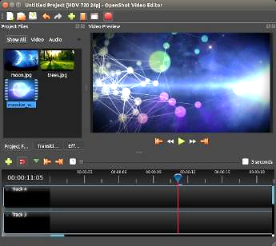
FREE VIDEO EDITORS FOR COMPUTERS
All are Windows and Mac compatible; and you do not need four years of film school.

Shotcut https://shotcut.org/

Avidemux http://fixounet.free.fr/avidemux

Openshot https://www.openshot.org/

Dashboard of Openshot
video editing platform

Module 2 - Marketing Chapter 4 – Collateral Material

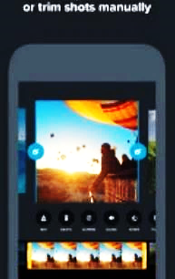
VIDEO EDITORS FOR MOBILE PHONES. The iPhone 11 has an excellent video editor built in. There are also free off-the-shelf editors available for iOS and Android that are easy to use and Instagram friendly:
Trim shots, add text and sync music

Vimeo https://vimeo.com/upgrade-plan Scroll down for free plan

GoPro Quik https://gopro.com/en/us/shop/quik-app-video-photo-editor

GoPro Quik for iPhone or Android

PREPARING THE SHOOT.
- Shoot in a quiet place. Turn off HVAC blowers.
- Use a tripod for a steady shot.
- For light, use LED panels that are 5000 Kelvin (natural light) and have adjustable brightness. Place them on both sides of the subject. (A pair of 45-watt LED lights are available on Amazon for $175 (as of 2025).
- Include the product in the background or company logo, or both. Make every second count.
ADDING A MUSIC TRACK. Download a free music track from https://pixabay.com/music/, https://freemusicarchive.org/, https://www.jamendo.com/, or https://archive.org/details/audio

MEDIA PRODUCTION SPEC REQUIREMENTS
The following technical specifications are accepted by broadcast and cable TV, YouTube, and most streaming services (including Hulu, Roku, Tubi, Peacock, and Sling).

Aspect Ratio 16:9
Screen width versus height

Display Resolution 1920x1080 pixels or Full HD (High Definition).
Ultra-high Definition (UHD) is 3840 x 2160 pixels becoming more popular and can
now be reproduced on the TV sets in most U.S. household. However, most media
outlets are still using 1920x1080.

Length in Seconds 30 seconds is optimal and offers the best return on advertising dollar.
Some media accept ads from 6 to 60 seconds, but ALL accept 30 seconds, and a 60-second ad will cost approximately twice as much to produce and air as a 60-second spot but will not generate twice the number of sales.

15 seconds is the maximum length for a non-skippable ad on YouTube.

Max File Size for Ad 10 GB (Roku file limit is 200 MB, Sling is 300 MB), but almost all others are 10GB.

Bitrate 15-30 Mbps (Megabits per second download speed)

Frames per Second 29.97 per second. This is the screen refresh rate, and while some media offer a
variety of options from 23.98 per sec. to 30.00, almost all accept 29.97 per sec.

File Format .mov or .mp4 (Tubi accepts only .mp4)

Technology evolves constantly and every media platform has unique requirements or restrictions, so it is advisable to check with the media outlet you are thinking about using. Ask for a Media Kit.

Module 2 - Marketing Chapter 4 – Collateral Material

USING AI TO PRODUCE VIDEOS

AI is still learning how to generate convincing videos, but if you are willing to put in the time to learn how to use it as a creative tool, you can produce competitive marketing videos and ads at no cost.

The downside is that AI videos still need a lot of editing by a human—like any AI creation—and computer-generated images of humans can seem a little stiff (even creepy according to some viewers.) One workaround is to use animation, animals (e.g. - Geico gecko), or just the product with voice over.

Still from an award-winning beverage ad made with AI,
that only showed the product.

FREE AI VIDEO PLATFORMS. For additional platforms see https://zapier.com/blog/best-ai-video-generator

Runway Advanced, with longer learning curve that most. https://runwayml.com/
Canva's video editor has generative AI powered by Runway.

Descript Intuitive. Video can be edited by editing the script https://www.descript.com/

Synthesia Uses avatars. Multilingual. Intended for employee training. https://www.synthesia.io/home

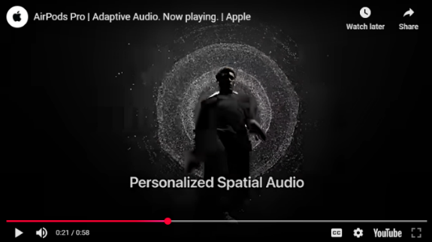
AirPods YouTube commercial created with Descript

Module 2 - Marketing Chapter 5 – Traditional Mass Media

2.5 – Marketing
(Traditional Mass Media)
2.5.1 Publicity
2.5.2 TV Advertising
2.5.3 Radio Advertising
2.5.4 Billboards
2.5.5 Kiosks
2.5.6 Newspapers
2.5.7 Magazines

Module 2 - Marketing Chapter 5 – Traditional Mass Media

2.5.1 Publicity

Public relations is free exposure that appears in the editorial sections of print, blogs and broadcast media. The objective of editorial departments is to provide value to viewers–as opposed to advertisers. Here are a few tips that will increase your free media coverage.

DIRECT PROMOTION: SEND A PRESS RELEASE ABOUT A NEW PRODUCT OR SERVICE

- Do some research. Find the outlets that cover your industry. If you have a restaurant, which media have a section on food? Search the websites for the names and contact information of the department heads or staff writers that cover your beat. Read some of their articles to identify common themes.
- Get Personal. Journalists get pitched constantly, so do not expect a cold email to get their attention. Be personal in your overture: comment on a recent article or invite the journalist to attend your grand opening.
- Talk about yourself, local connections, and why you opened the business, passion for your solution.
- Lead Time. A 10-day lead time is considered good practice for events like product launches.
AI AIDE: https://newswriter.ai/ will draft a press release for free, based on your description.

INDIRECT PROMOTION: Guest blog post, letter to editor, or article that demonstrates your expertise.

- Offer fresh relevant content. If you are a food wholesaler, explain why the price of a particular commodity is going up. You are the expert. If you have an accounting service, write an article in March about overlooked tax deductions. (It is OK to insert at the end of the article “[Your name] is president of Jane’s Tax Services. She can be reached at Jane@Doe.com.”
- Be the Journalists Assistant. Get to know the editors, writers, podcasters. In what form do they want content? How many words? Be aware that some journalists prefer to write the stories themselves, in their voice. In which case, just provide some bullet points.
- Be prepared for special editions. Check the website for upcoming special features like “Back-to-School”, for which your new backpack with a built-in phone tracker would be perfect.
- Be preemptive. By the time an event breaks, it may be too late to write something for the six o’clock news. Prepare some articles in advance: “How to secure your home against a hurricane,” so it is ready to run at the same time as the storm alert. This is creepy, but news media prepare obits for people who are still (barely) alive. Guess who’s going to be first with the half-hour retrospective of what’s-his-name who we all loved as a kid?
- Be on call. When a story breaks, media do not have time to find out who might be an expert. They have a rolodex for that. Write to the appropriate media and give them a list of the topics for which you have expertise, plus your credentials (why they should take your word for it). And—most importantly—let them know you are available 23/7/365 and give them your cell and email.

Module 2 - Marketing Chapter 5 – Traditional Mass Media

Press Release Format. For templates see https://www.ereleases.com/press-release-template/ Check for grammar and spelling and ask someone outside your company to read it to make sure it’s clear.

There are services that distribute press releases to over 100,000 digital and print outlets nationally.
Fees range from $150 to $400. See https://www.einpresswire.com/, https://www.newswire.com/, and https://www.ereleases.com

FOR IMMEDIATE RELEASE
[If you don’t won’t to appear immediately, say “Embargoed until [date]”

Compelling Headline
[Titles like “10 Ways to …” or “How to…” are popular with media as they suggest useful
information for their followers. For search engines, include keywords in first 60 characters.]

Subhead in sentence format
[Get to the point. Pique interest with a crisp summary]

[Dateline] Dateline: CITY, State, Month Day, Year

[Content] Keep to one page. Insert two blank lines between paragraphs to allow for editing. Focus on how you are different and what will be useful to readers. Avoid jargon (industry terms the average person will not know) and hype: “We’re proud to announce…” Omit self-promoting adjectives: “greatest, cheapest.” That is only permitted in paid ads.” Stick to the facts

Provide the who, what, when, where, why and how. Use active voice and focus on how this news impacts the lives of the medium’s followers. Include a story that reveals the need for your solution.
[Quotes] Include quote by CEO, an expert or customer to support solution and humanize the release..

[Photograph] Add image of product, person or business to convey information efficiently, as well as emotion. A photo also shows you are real and adds interest.

[Call to Action] Close with a summary and call-to-action to direct the reader to more information, such as a link to website for a study about the problem addressed by the company.
[Boilerplate] A short paragraph that explains the identity of the company, what it does exactly, mission, website, year founded, and noteworthy achievements.

###
[This is the customary way to indicate the end of the release.]

[Contact information] Who the media should call with questions
Name
Title
Company
Phone, Email

Module 2 - Marketing Chapter 5 – Traditional Mass Media

2.5.2 TV ADVERTISING

Despite the rise of digital media, television advertising – on local network stations, cable channels and streaming media – remains one of the most effective ways to engage buyers. The following are typical costs for a 30-second commercial. For more information see https://www.simulmedia.com/blog/how-much-do-tv-ads-cost

Broadcast Networks (ABC, NBC, CBS, FOX)
Prime time (8-11 PM): $200,000 - $1 million (2025)
Popular shows ~$882,000 (e.g. - NFL Sunday Night Football)
Daytime: $40,000 - $200,000
Late night: $50,000 - $250,000

Cable Networks
National cable average: $1,000 - $50,000 (2025)
Premium networks (ESPN, TNT): $20,000 - $150,000
Niche channels: $1,000 - $20,000

Local TV Rates vary by market size: Small, mid-sized, and large Designated Market Areas (DMAs)
Small Markets (DMAs 151-210): $200 - $1,500 e.g. - Bangor, Billings, Laredo. Meridian, Helena
Mid-Size (DMAs 51-150): $500 - $3,000 Spokane, Omaha, Syracuse, Reno, Lansing, Topeka
Large Markets (DMAs 1-50): $2,000 - $10,000 Charlotte, Baltimore, Memphis, Las Vegas
Top 10 Markets $5,000 - $50,000+ NYC, LA, Chicago

Time Slot also Impacts Costs. Drive times and prime time (7-11 pm) are at a premium, daytime (9 am to 4 pm) and late night (11 pm to 2 am) are less expensive.

Streaming TV (CTV) rates are higher than linear TV (Broadcast and cable) due to high completion rates, audience targeting capabilities, measurable results, and higher engagement. Typical rates are:
Netflix and Amazon Prime: $30-40 CPM (2025)
Hulu: $10-30 CPM
YouTube TV: $20-25 CPM

Seasonal Cost Variations. Ad costs can be 20%-50% higher during the winter holidays, sports playoffs, award shows, and political debates. On the other hand, there are also bargain seasons:
January-February: 20-30% off
Summer months: 10-20% off
Post-election periods: 15-25% off

Media Kit. Since technical requirements for ads can vary among stations, check the website of any medium you are considering for their most current Media Kit or Advertising Specifications. This will also include …
- Viewership: The number of viewers at each time of the day, and the metrics used to support the data.
- Demographics of Viewers: Age, gender, income, education, and lifestyle.
- Programming: Show listings, with air dates and times, summaries and target audiences.
- Ad Rates in terms of CPM (cost per thousand people your ad will reach) If the CPM is $10 for a 30-sec spot at a time when there are typically 100,000 viewers, your spot will cost $1000
________________________________________________________________________________________________________________________________________________________

Recommended Approach for a Small Business with a TV budget of $3000 to $15,000 is to …
- Focus on local TV in smaller markets
- Use off-peak time slots
- Consider remnant inventory
- Leverage AI tools for production
- Test with limited cable TV campaigns

Module 2 - Marketing Chapter 5 – Traditional Mass Media

2.5.3 RADIO ADVERTISING

Local radio advertising remains a powerful and cost-effective way to reach targeted audiences. Sub-media include:
- AM/FM stations
- Satellite radio
- Digital streaming platforms
- Podcasts
Ads categories:
- Traditional Spots – Standard 15, 30, or 60-second commercials played during breaks.
- Live Reads – DJ personally endorse your product or service on air.
- Sponsorships – Your brand sponsors a segment, such as traffic updates or weather reports.
Advantages:
- Highly Targeted Ads can be tailored to specific regions and demographics.
- Cost-Effective Generally more affordable than TV or digital advertising.
- Flexible & Timely Ads can be adjusted quickly for promotions and urgent updates.
Radio Ad Rates depend on station popularity, time slot, and ad length. Here are general estimates:
- 15-second ad: $100 – $500 per spot on local stations.
- 30-second ad: $200 – $1,000, with drive-time slots costing more.
Podcast Ad Rates (According to https://adopter.media/podcast-advertising-rates-explained/)
- Pre-roll ad: $15 - $30 CPM (2025)
- Mid-roll ad: $25 - $40 CPM

For more on podcast advertising see https://adopter.media/podcast-advertising-guide/.
To find podcasters whose followers match your target market, browse Spotify categories at https://open.spotify.com/genre/podcasts-web or Google “Podcasters near me”.

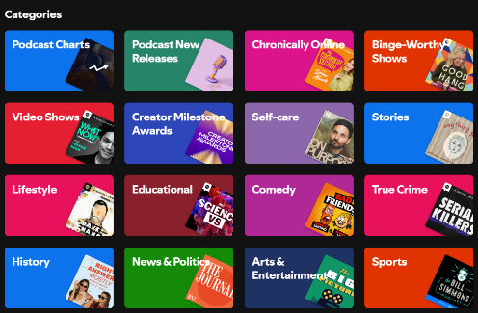
Spotify Podcast Categories

Each category has sub-categories. For example, “Lifestyle” includes podcasts on Food, Beauty, Fashion, Fitness, Health, Hobbies and more.

An advantage of podcast ads is you can fine-tune your targeting.

For more information on podcast advertising see https://ads.spotify.com/en-US/ad-formats/

Module 2 - Marketing Chapter 5 – Traditional Mass Media

2.5.4 BILLBOARDS

Billboards are the most common form of outdoor advertising (termed out-of-home or simply OOH in the ad industry). Other forms of OOH ads include kiosks in public places and transit ads in buses and trains.

The advantage of OOH ads for “”people on the go” is that they are non-skippable, you cannot avoid noticing them; and they are in a fixed location, so ideal for place-based businesses like restaurants or entertainment venues who need hyper-local targeting.

Types of Billboards.

- STATIC, or traditional paper or vinyl billboards are less expensive to rent, but have higher one-time costs for printing and mounting.

- DIGITAL Billboards are becoming more common, but still represent only about 20% of the billboard inventory. They are more expensive to rent due to their higher cost to manufacture and maintain. However, the additional cost may be worth it for businesses who want to change their message frequently, like music venues.

Costs. Rental prices for ad space can vary depending on demand. Billboard bargains can be found after election day, when lots of ads become obsolete. Empty billboards are embarrassing to the owner because they are concerned that a blank or expired billboard means they are no longer in demand. After school starts is another good time to bargain, as all the back-to-school ads need to come down.

- STATIC Billboards: Printing a standard 14’ x 48’ highway billboard in vinyl will run about $1680 or $2.50 a square foot. Add $200 to $1000 for installation. Rental fees average:
  - Small to mid-size cities: $1,000 to $5,000 per month (2025)
  - Large cities and premium locations: $14,000+ per month
- DIGITAL Billboards:
  - General range: $1,200 to $15,000+ per month (2025)
  - Premium locations and spectacular formats: $10,000 to $50,000+ per month

For relative costs by metro area see https://www.adquick.com/billboard-cost

Design. Keep it simple. A billboard message should be grasped in 3 seconds. Make it eye-catching ad.
Keep the message simple, bold, and visually striking. Use large fonts and high-contrast colors.

For more information see https://fitsmallbusiness.com/how-much-does-billboard-advertising-cost/

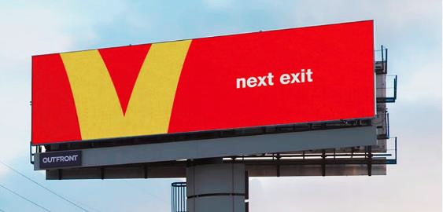

Need one say more?
Module 2 - Marketing Chapter 5 – Traditional Mass Media

2.5.5 KIOSKS

Kiosks are another form of out-of-home ads. They appear in public spaces: on busy sidewalks, in malls, airports, or stadiums to reach specific audiences. Think of them as billboards for pedestrians.

They have the same advantages of billboards, as you know where the viewers are when they see your ad. With digital kiosks, knowing the location also enables programmed advertising: tailoring the ad to the day of week (churches), time of day (restaurant dinner specials), and even the weather (McDonald’s promotes iced coffee on hot days).

Dwell time. Unlike billboards, kiosks can be read at a somewhat more leisurely pace. An add could take up to 10 seconds to read and still be effective. However, you’ll still need to catch the attention of frenetic urban walkers at first glance if you want them to continue reading. Use eye-popping graphics or clever copy.

Costs. The monthly cost of kiosk advertising can vary widely, ranging from $750 to $2500, depending on amount of traffic at location.

Shopping Mall Kiosks: $750 to $2500 per month. (2025)

Newsstand kiosks: $2,000 to $15,000 per month.

Urban sidewalk panels or bike stations: $750 to $3,000 per month.

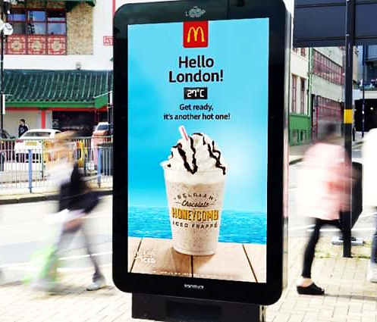
Urban kiosk with built-in thermometer that displays ads based on the weather.
Module 2 - Marketing Chapter 5 – Traditional Mass Media

2.5.6 NEWSPAPERS

Measurable Performance Metrics. Print advertising can deliver highly measurable results by using unique phone numbers, custom landing pages, and various special offer codes to conduct A-B testing to determine the most effective ad size, placement, day of week, or headline text.

Niche Marketing. Newspapers also provide excellent targeting opportunities. Since they are generally purchased through subscriptions, publishers know who their subscribers are and where they live. To find the demographics of a particular publication, check their Media Kit, which you can generally find on their website. They may request your contact information before providing access to the data so they can follow up with you. The Media Kit will include not only number of subscribers (to both print and digital formats), but also household incomes, education levels, home ownership, and other useful data to determine if the paper is a good fit for your product or service.

Newspapers also allow you to drill down to your demographic. You can request that the ad appear in a specific section, say “Food” if you are selling hot sauce, or “Sports” to promote a sporting event.

Formats. Newspaper ads come in two formats: Display ads (that you design and may contain graphics and images) and Classified ads (small, text-only).

Newspaper Ad Rates. Costs typically range from a few hundred dollars in local newspapers to many thousands of dollars for full-page advertisements in national publications. The day of the week also impacts pricing, with Sunday editions generally commanding premium rates due to higher readership.

Newspapers charge by the column inch, which is one column wide (note: not all newspaper columns are the same width) x one inch deep (meaning high). Typical costs are:

CLASSIFIED ADS: $50 – $500 per listing, depending on word count and duration. (2025)

DISPLAY ADS:
Quarter-page $ 200 – $ 1,500 (2025)
Half-page $ 500 – $ 3,000
Full-page $1,000 – $10,000

Media Kit. Search the websites of media you are considering for Media Kit or Advertising. This will include …
- Circulation. Number of subscribers (with demographics) and newsstand sales.
- Sections. Some features may appear only one day a week, like New York Times “Book Review”.
- Page size and ad sizes and rates
- Production specs (how the ad is to be prepared and transmitted to the paper). Below are the production specs for one newspaper, with explanations in blue:
- Offset printing (as opposed to letterpress that uses “hot” lead type)
  - Halftones - 85-line screen (photographs will appear as black dots, 85 per inch).
  - Full page image area: 10.25" x 20.25" (area of the page that is printed: the size of a full-page ad)
  - Color - CYMK (Cyan, Magenta, Yellow, and Black, the four ink colors used in color printing. Word uses RGB (Red, Blue, Green), the color scheme used for computer screens. If you design your ad in Word, you will need Photoshop or Illustrator to convert the colors to CMYK.)
  - Submission Format: PDF (This prevents anything from getting changed accidentally).
  - Fonts. Embed all fonts in artwork. (If your ad looks correct after you convert it to a pdf, then your fonts are embedded.)
To view a full sample guide for newspaper advertisers, with rates, see https://www.nashuatelegraph.com/advertise

Module 2 - Marketing Chapter 5 – Traditional Mass Media

2.5.7 MAGAZINES

For a small business with a small or local market, two categories of magazines provide an attractive ROI on advertising: local lifestyle publications and niche magazines for B-C; and industry trade journals for B-C.

a) Local Lifestyle Magazines offer an opportunity to connect with affluent consumers. Since they are locally focused, they are an ideal medium to promote an apparel boutique, restaurant, wellness service, lawn care, kitchen remodeling, furniture stores, private schools, and personal services. These slick publications provide high-quality brand exposure. Additional Benefits include:
- High-Quality Presentation – Glossy, well-designed layouts enhance brand perception.
- Long Shelf Life – Magazines are often kept and revisited, extending ad exposure.
- Multi-Platform Reach – Many magazines offer digital versions, increasing visibility.

ADVERTISING COSTS. Ad rates reflect the buying power of the target demographic: typically, homeowners in upscale neighborhoods. Depending on circulation, ads will typically run:
- Quarter-page ad: $500 – $2,500 per issue. (2025)
- Half-page ad: $1,000 – $5,000
- Full-page ad: $2,500 – $15,000
- Two-page spread: $5,000 – $25,000
- Cover sponsorship: $10,000 – $50,000 depending on prominence.

b) National Niche Consumer Publications. Like local lifestyle pubs, these magazines focus on a narrow interest group, like organic foods, music, education, almost any topic two or more people have an interest in. Check out your local library and flip through some mags that appear to cater to your market. Who’s advertising? If it seems like a fit, look them up online to find ad rates, publication dates and any special issues coming up that may be a perfect fit for your custom-brewed organic beers.

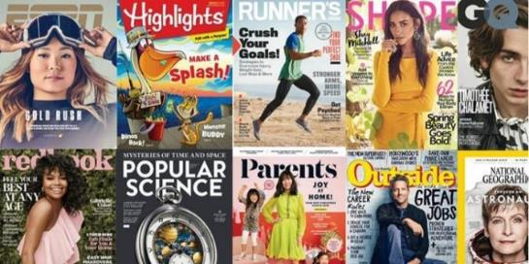
For every interest there is a magazine. Treasure hunting? Model railroading? Emu farming? Elevator tech? Miniature donkeys? Yep, all those and more.

Module 2 - Marketing Chapter 5 – Traditional Mass Media

c) Trade Journals

Trade journals are specialized publications that cater to professionals within specific industries, making them an effective tool for B2B marketing.

ADVERTISING COSTS
- Quarter-page ad: $ 500 – $ 2,500 per issue. (2025)
- Half-page ad: $1,000 – $ 5,000 per issue.
- Full-page ad: $2,500 – $10,000 per issue.
- Two-page spread: $5,000 – $20,000 per issue.
- Cover sponsorships: $5,000 – $25,000, depending on prominence.

As an example, here are excerpts from the Media Kit of the Rhode Island Beverage Journal.

Size/Glossy | 1X | 6X | 12X
4/C Full Page | $ 1,352 | 1,144 | 1,105
1/2 Page 4/C | 811 | 686 | 663
1/3 Page 4/C | 541 | 458 | 442
MECHANICAL SPECIFICATIONS. Advertisements are accepted in hi-res PDF format. Space reservations are due the 5th of month prior to the publication date. Specs are:
- Full Page Image Area: 7.25” x 9.875; Trim Size: 8.25 x 10.875; Bleed Size: 8.75 x 11.375
- Other Advertisement Dimensions: 1/2 page: 7.25w x 4.9375h; 1/3 page: 7.25” x 3.25″ horizonal
- Preferred Materials: High-Resolution PDF

REGULAR COLUMNS OFFER ALIGNMENT OPPORTUNITIES:
- Around Town: Local launches, events, products and faces
- New Products & Promotions
- Association News: Topics from local trade associations
- Retail Review: A look at off-premise sellers
- The Find: A compendium of trends and products
___________________________________________________________________________

Examples of trade journals across various industries:

- Marketing Advertising Age
- Education Education Week
- Law Enforcement Police Chief
- Technology Engineering News Record
- Healthcare Medical Laboratory Observer
- Business Harvard Business Review
- Public Relations PR News
- Fashion WWD
- Music Billboard
- Automotive Automotive News

Module 2 - Marketing Chapter 6 – Digital Mass Media

2.6 – Marketing
(Digital Mass Media)

2.6.1 Free Web Advertising (Local Search Directories)
2.6.2 Paid Web Advertising: Search Engine Marketing (SEM)
2.6.3 Social Media Marketing (SMM)
2.6.4 Social Media Influencers

Module 2 - Marketing Chapter 6 – Digital Mass Media

2.6.1 FREE WEB ADVERTISING (local SEARCH DirectorieS)

The following Local Search Directories are free. Note: the more search directories you are listed in, the higher you will rank on Google search results.

Apple Maps
Bing.com
Brownbook.net
Elocal.com Pay per call
EZlocal.com
Google My Business
InsiderPages.com
LinkedIn Company Directory
Local.com
LocalStack.com
Manta .com
MapQuest.com
Merchant Circle.com
Mylocalservices.com (for service providers)
Super Pages.com
Thumbtack (For home improvement providers. Pay per lead)
Tupalo.com
Yelp.com

This website will do a quick search of 35 Local Directories to see which ones you are listed on and to make sure your information is current: https://uberall.com
Module 2 - Marketing Chapter 6 – Digital Mass Media

2.6.2 PAID Web Advertising: Search Engine Marketing (SEM)

Google, Yahoo, and other search engines allow companies to buy keywords. If you decorate blue jeans, and you buy hits for the search term “blue jeans”, when someone searches for the term, a brief sales message for your product and a link to your site will appear in the margin of the page displaying the search results.

Ads might run from $.50 to $2.50 per appearance, but you can set a limit on the monthly spend.

Try different keywords and install Google Analytics to see which lead the most searchers to your site. https://analytics.google.com/analytics/web

The screenshot below shows the results of a search for “Football tickets”. The left column contains the normal returns. The right column contains the results for companies that paid for the keywords “Football tickets”.
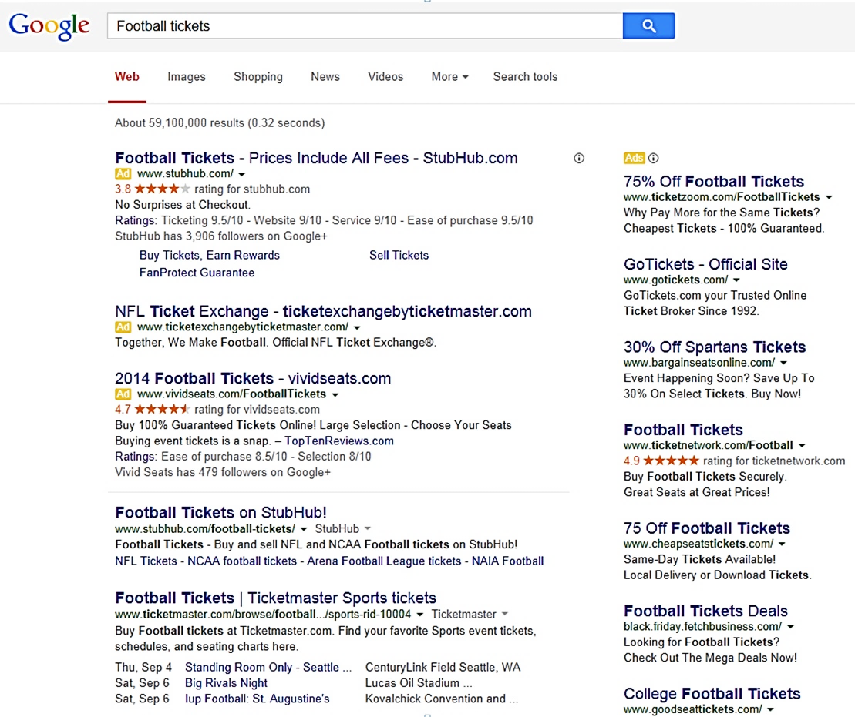

Module 2 - Marketing Chapter 6 – Digital Mass Media

2.6.3 Social Media MARKETING (smm)

Check with your local SCORE or SBDC office for free seminars on Social Media Marketing.
Choose the right Social Media Platforms for your Business. Birth years are for the largest user groups.
- B2C (born 1990-2000) Facebook (3 bb monthly users)
2. B2C (born 1990-2007) Instagram (2 bb monthly users), TikTok (1.6 bb), X (586 mm)
3. B2C (born 1990-2007) YouTube (2.5 bb). Also useful to demo products and services
4. B2C (born 2000-2012) Snapchat (850 mm monthly users)
5. B2C Millennials /Gen Z (born 1981-2012) What’sApp (3 bb monthly users)
6. B2C Impulse buyers Pinterest (537 mm monthly users)
7. Business clients LinkedIn (1.2 bb members)
8. Entertainment Media Myspace

The best social media advertising is the kind you don’t pay for. Consider the following tactics:

- COORDINATE SMM CAMPAINGS with free tools at www.Hootsuite.com or www.Buffer.com.
- SET UP FACEBOOK, INSTAGRAM and MYSPACE pages for your company or product. Link to your website so people can obtain more information about your product, and place orders.
- ENGAGE VISITORS. Invite customers to post their own pics and experiences. This is especially valuable to restaurants, bed and breakfasts, entertainment venues and experience services.
- PROVIDE HELPFUL CONTENT: Tweet tips. Upload how-to videos to YouTube. Join a facebook group.

- JOIN A LINKEDIN GROUP (if B-B) and share leading-edge information and answer questions of members to establish your credentials as an expert in the field.
- ADD FACEBOOK “LIKE” BUTTON to your website and blog.

- WRITE A BLOG for people with the problem you solve. Note: articles with images receive almost twice as many views as text-only posts. Engage followers: ask them for their opinions and experiences. Content must be informative, unique and entertaining—and not all self-serving. The purpose of the content is to project your company as a knowledgeable expert concerned for the well-being of the customer. Share content on the web during high traffic hours in the U.S. (Times are EST.)
  - Facebook 1 pm to 4 pm
  - Twitter 1 pm to 3 pm
  - LinkedIn 7 am to 9 am, and 5 pm to 6 pm (business execs use LinkedIn)
  - Google+ 9 am to 11 am
  - Pinterest 2 pm to 4 pm, and 8 pm to 1 am
- POST COMMENTS TO SITES VISITED BY YOUR CUSTOMERS.
- COUNTER NEGATIVE ONLINE PUBLICITY. To find out when someone says something about you or your company online (positive or negative), sign up for Google Alerts: www.google.com/alerts.

Module 2 - Marketing Chapter 6 – Digital Mass Media

2.6.4 SOCIAL MEDIA INFLUENCERS

Ever since Honus Wagner allowed Hillerich and Bradly to use his name on one of their Louisville Slugger bats in 1905, companies have been using celebrities to endorse their products. Today, a pacesetter is just as likely to be a middle-schooler with a loyal following for her fashion advice. Influence does not come in just celebrity size anymore.

Bloggers have discovered they have power to influence buying decisions; and consumers seem to trust their favorite trendsetters—even if they know the plug is a paid ad.

A startup can tap into the influencer phenomenon to create awareness. Factors that drive influencer costs are …
- Industry
- Platform
- Celebrity
- Number of followers of the influencer
But bigger is not always better. According to Tara Johnson of CPC Strategy, the influencers with the smaller audiences offer the most authority in a specific niche and can deliver high levels of engagement among their dedicated following. Ignite Visibility, a digital marketing agency, adds “If the audience is not in line with your brand, the message will not resonate, no matter how many people hear or see it.

Cost Per Influencer Post (2025) for popular influencer media.
Tier Followers | INSTAGRAM | YOUTUBE | SNAPCHAT | TIKTOK
FORMAT >> | PHOTO or VIDEO | VIDEO | PHOTO or VIDEO | VIDEO
PAY PER >> | Post | Post | View | Post
Nano 500-10,000 | $10 to $100 | $20 to $200 | $200 to $1000 | $5 to $25
Micro 10,000-50,000 | $100 to $500 | $200 to $2500 | $1000 to $5000 | $25 to $125
Mid-tier 50,000-100,000 | $500 to $5000 | $2500 to $10000 | $5000 to $20000 | $125 to $1250
Macro 100,000-500,000 | $5000 to $10000 | $10000 to $20000 | $20000 to $35000 | $1250 to $2500
Mega 500,000 and up | $10000+ per post | $20000+ | $35000+ | $2500+

Module 2 - Marketing Chapter 7 – Targeted Media

2.7 – Marketing
(Targeted Media)

2.7.1 Direct Mail Marketing
2.7.2 Email Marketing

Module 2 - Marketing Chapter 7 – Targeted Media

2.7.1 DIRECT MAIL MARKETING

POSTCARD CAMPAIGN. A postcard campaign can be used to build up an email prospect list for follow-up. You can buy a mailing list of potential customers (by zip code and demographics) and include a call-to-action on the card to visit your website for a free report, sample, or discount coupon. And postcards, unlike emails are always “opened” and at least glanced at. (So, make the headline a grabber.)

STANDARD POSTCARD SIZE is 4” x 6” (or 4.25” x 6”) and typically 14 pt (111 lb.) card stock or heavier.

MAILING SERVICES (Companies that print, address and mail postcards can guarantee the Post Office will not reject your entire mailing because you used the wrong postage, the date is incorrect, or you violated the margin requirement for the address. (Yes, that is a thing.) Plus, these firms receive quantity discounts on postage, so the cost may not be much more than buying stamps from the post office (and you probably do not want to lick all those stamps anyway). Another savings is you will not need to buy a bulk permit from the Post Office ($245 in 2025); you can use the permit of the mailing service.

COMPANIES that will print, address, and mail postcards:
https://www.postcardmania.com/
https://www.gotprint.com/products/postcards
https://www.modernpostcard.com/

COSTS FOR A POSTCARD CAMPAIGN. Most companies will require a minimum of 500 to 1000 postcards to make it worth their while to process an order. Typical costs per card for 1000 postcards will run …

Design $ 0 each Assuming you design yourself. Most services have templates
Mailing List $ .25 each Assuming a $250 minimum
Printing $ .10 each Assuming 4 colors on the front and black only on the address side
Processing fee $ .15 each This is usually a flat fee to upload and sort a mailing list
Addressing $ .07 each To run cards through an addressing machine
Postage $ .40 each Pre-sorted bulk
TOTAL $ .97 each = $970 for 1000 postcards
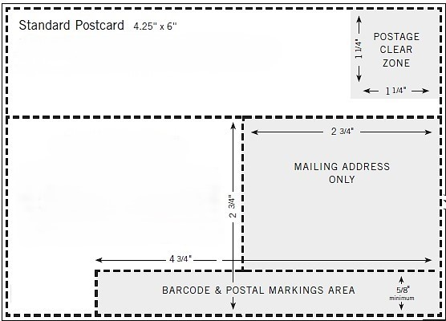

Template from Modern Postcard company.
Do not place any ad copy in a shaded area or Post Office will reject.
Module 2 - Marketing Chapter 7 – Targeted Media

2.7.2 EMAIL MARKETING

Collecting Names to Build an Email Prospect List.

- AT FACE-TO-FACE MARKETING FORUMS (Trade shows, exhibits, sampling tables in retail outlets). Take a clipboard and invite people to join your emailing list. You will collect more emails if you offer to send a sample, free-trial access code, or discount coupon.
- ON YOUR WEBSITE. Add a “sign-up for announcements of sales” button in a prominent location on your site. As an incentive, offer something immediately to anyone who opts in, like a discount off the first purchase.

Sending Emails to Customers. You can send emails from Outlook yourself for free, but DO NOT send more than 39 at one time or you will be blocked as a spammer. For a $79 one-time payment (as of 2025) you can download EmailMerge for Outlook (available from www.standss.com/emailmerge), that allows you to send individual personalized emails from an Outlook address book or Excel database. So, if you have 40 recipients on your customer list, and you use EmailMerge, the receiving servers will see the campaign as 40 individual emails, rather than a 40-email blast.

Alternatively, you can use a paid email service that sends emails out one at a time.
A free email marketing service is available at http://mailchimp.com/, with a limit of 500 names and 1000 emails per month (and no more than 500 per day). Alternative platforms include ...
- https://kit.com/ Designed for creators. Free for basic service up to 10,000 subscribers.
- Brevo.com. There is no fixed monthly fee. You only pay per email sent. 300 emails may be sent per month for free. 500 contacts and 5000 emails per month is $9 a month.
- Woodpecker.co Allows up to 6000 emails per month to 600 different contacts for $20 per month. Woodpecker also checks for invalid addresses prior to sending.
- ConstantContact.com, a competing service, charges $12 per month, which allows for 500 contacts and 5000 emails per month (as of 2025). Pricing is not clear and site not very user friendly, but inexpensive.
- Campaigner.com. Prices range from $59 per month for up to 5000 contacts (as of 2025).

Module 2 - Marketing Chapter 7 – Targeted Media

Increasing Open Rates of Email Marketing Campaigns

- RESTRICT NUMBER OF CAMPAIGNS to three or four a year—certainly no more than once a month—or you will receive as many unsubscribes as opt-ins. Moreover, do not send every email to every person in your database. If you are holding a sale for homeowners in Chicago, filter your list for Chicago zip codes.

- PROVIDE REAL VALUE TO CUSTOMERS IN MESSAGES. Make them want to open your emails because they know you have sent them another great idea. If it is just another sales pitch every month, they will soon opt out.
- WRITE AN ENGAGING SUBJECT LINE. The more people who open your email, the better your sender reputation and future deliverability. Forster Perelsztejn of Prospect.io offers some approaches to crafting a subject line that beckons to be opened:
- Pose a question: “Do you need help with (your message topic).” A question prompts a moment’s thought about the topic.
- Simply use the name of your product or service. This engenders for him a 75% open rate. Perelsztejn says, “If you research your audience and their pain points well enough and are able to determine what kind of solution they might need, presenting it bluntly can be a good way to grab your prospect's attention.”
If you need help creating subject lines, check out ActiveCampaign’s subject-line generator at
https://www.activecampaign.com/free-marketing-tools/subject-line-generator#generator.

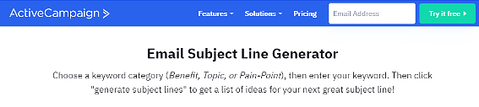

- BUT KEEP THE HEADLINE SHORT. Open rates drop from 24% to 17% on average when subject lines exceed 35 characters.
- SEGMENT LIST BY PRODUCT AND DEMOGRAPHICS and tailor the message to each group. Even better, craft each email to the situation and need of each person: “Kate, I see that you haven’t purchased toner in 6 months for your H-P 4800…”, using dynamic content to pull up customer information from a database. Personalized emails always produce a higher open rate.
- CHECK YOUR SPELLING AND GRAMMAR. Poor English is a clue for scam-checkers that an email may not really be from a princess who desperately wants you to hold her family fortune in your personal bank account. A Radicati Group study found that 80% of people surveyed feel grammar and spelling errors make a sender seem unreliable and untrustworthy; with 70% stating that even one error was “unacceptable”.¹
- BEST DAY AND TIME TO SEND EMAIL. Monday or Friday at 10:00 am.
For more email marketing tips see https://financesonline.com/email-marketing-software-statistics/
Module 2 - Marketing Chapter 7 – Targeted Media

Improving Delivery Rates

Even a well-crafted email with valuable content will not be read if caught in the inbound mail server’s spam filter. According to Statistica.com (2025), 46% of email traffic in 2023 was spam. Email service providers know that their customers do not want to waste time on inbox clutter, so they continually refine their algorithms to screen out probable spam. Unfortunately, the filters can also block your email if it looks like spam. So, what can you do to avoid ending up in the spam net?

- KEEP YOUR LIST UP TO DATE. If your addressees have been unresponsive, the wasted emails are not just costing you 1 or 2 cents; they are affecting your reputation with email service providers. Mail servers notice when recipients consistently ignore overtures from your IP address and learn to categorize your emails as spam.
To keep your list current and populated by engaged recipients, send a message that asks for a response. Rachel Burns of ActiveCampaign suggests…
When a contact has not engaged for 60 days (or the period of time that makes sense for you), trigger a “last chance” engagement email. Then remove contacts who do not interact.
Learn more about re-engagement emails in this post: www.activecampaign.com/blog/re-engagement-email .

Also remove hard bounces from your list. Bounce rates are a factor service providers use to determine your sender reputation. When you receive an “Undeliverable” notification delete the problem email from your list.

- VALIDATE EMAILS YOU HAVE NOT COMMUNICATED WITH IN A WHILE to make sure they are still valid. There are services that will screen your list for a fee. https://emaillistverify.com/pricing charges $5 per thousand. Hunter https://hunter.io/bulks/email-verifier allows validating up to 50 emails per day for free. (2025)
- USE DOUBLE OPT-IN. Ask newsletter subscribers to double opt-in by sending them an email to verify their email address (erroneous or fake email addresses will drive up your score as a likely spammer because they will not get delivered and thus increase your bounce rate).
- MAKE IT EASY TO UNSUBSCRIBE, and honor all opt-out requests immediately. (It’s the law.)
- ASK RECIPIENTS TO ADD YOU TO THEIR ADDRESS BOOKS. This process, called whitelisting, indicates to spam filters that you are a trusted sender.
- INDICATE WHERE YOU ARE LOCATED. Spam filters figure (rightly) that a shady character is not going to reveal how they can be found.
- DO NOT EMBED FORMS. Forms represent a security risk and are not usually supported across common email clients. Just include a link to the form on your website, Dropbox or Google Drive.
- DON’T ATTACH FILES. They are a red flag for spam filters. Reputable email services will not allow you to attach files. Instead, include a link to the file on your website.
- DON'T CLAIM YOUR EMAIL ISN'T SPAM. Spam filters will think you “doth protest too much.”
- KEEP TEXT SIMPLE AND STRAIGHTFORWARD, as if you were writing a business letter. Do not use "cute" spellings, S P A C E out words, or insert character$ in words.
- MAKE SURE YOUR LINKS WORK. Clickable images and redirection to a landing page have become standard practice.
- AVOID URL SHORTENERS. Their use by spammers (to hide their true domain names) got bit.ly and other URL converters branded as risky, so could cause your e-mails to be trapped by spam filters.

Module 2 - Marketing Chapter 7 – Targeted Media

- COMPOSE THE EMAIL IN TEXT. But do not copy and paste formatted text from Word. Select “Paste without formatting” or Ctrl + SHIFT + V (Shift + Option + Command + V on Macs) when pasting text into your email marketing software. And do not use email templates. These use HTML and thereby soak up a lot of kilobytes. If you use an email distribution service, start with a blank page. If you insist you need HTML at least do the following to reduce email size and increase open rates.
- Under no circumstances paste from Microsoft Word. Code generated by MS Word and similar composing tools may appear unorthodox to spam filters. (SpamAssassin calls Word “Horrendous” for emails.)
- Make sure that your code is correct. If your email includes broken or incomplete tags, spam filters may prevent it from reaching the desired inbox. (Sloppy coding is an indicator of spam.)
- Make it look like text (and therefore not look like junk to the spam filter or to the recipient). And do not send in HTML without a text-delivery option. (If your email newsletter is in HTML and it does not automatically switch to text for readers who cannot receive HTML, it will be filtered out.)
- Reduce the size (in pixels) of images and logos before inserting into an email.
- Minimize your code with tools like HTML Minifier and HTML compressor. Do this last because code is hard to read and work with once it is minimized.

- KEEP EMAILS LEAN. No one reads a long email. Link to your website for details. Another reason to keep emails short and sweet is that Gmail clips messages longer than 102kb, to save screen space and the time needed by their customers to preview (and quickly dismiss) incoming messages. Clipping creates multiple problems for email marketing:
- Gmail users will not see your whole email, unless they click “View entire message”.
- You might not be able to track open rates because the tracking code is usually at the bottom of an email.
- The Unsubscribe link is also located at the bottom of emails. If recipients want to opt out of your emails and do not see the (clipped off) Unsubscribe link, they may take the easy route of just marking the email as spam; which will have a negative impact on future deliverability. If a certain number of Gmail users mark your emails as spam, future emails will be filtered out automatically and not just to the recipients who labeled you as a spammer, but to ALL Gmail accounts.
- DIAL BACK ON THE VISUAL HYPE.

Avoid all caps. Subject lines written in uppercase attract spam filters. And in the etiquette of email communication using upper case is usually seen as shouting.

A jumble of font colors and sizes also raises the antennae of spam filters.

Do not use exclamation points!!!! Unless you want to look like a loud-mouthed huckster.

Avoid rich media content. Most email clients do not allow the ability to view rich media content such as video embeds and Flash. If the media content is essential to your campaign, put it on your website and insert a link. Also, avoid using JavaScript and other dynamic scripts, as they attract the attention of spam filters.

Limit the number of images. Lots of images, or large images increase load time and can affect deliverability rates. Also, images will not show correctly to users who block them, which may make your email look spammy.

- AIM FOR AN OPEN RATE OF 20%. Below that and you are leaving sales on the table; and falling below this may be a red flag to Internet Service Providers.
Module 2 - Marketing Chapter 7 – Targeted Media

- USE A RECOGNIZABLE SENDER NAME. It is good practice to always strive to send emails from an email address that contains your personal name with your brand name so that recipients recognize you. A study by Finances Online shows that 45% of email recipients decide whether an email is spam based solely on the information in the “From” field (name and email address).
- BEST Firstname.Lastname@YourCompany.com
- BETTER YourCompanyName@Gmail.com
- AMATEURISH Fred2700@Gmail.com
- DUMB Sales@YourCompany.com
- DO NOT BUY BULK EMAILS. Lists degrade quickly. Purchased lists usually have a high percentage of bad addresses, which leads to high bounce rates and banning. If the addresses have been harvested, they may even contain spam traps, fictitious emails planted in websites to catch spammers. If your email hits such an address, your IP address will be blocked by Internet service providers.
- BE VISIBLE AND “PUBLIC” IN YOUR DOMAIN AND HOSTING REGISTRATIONS. If your registration is "private", some may assume you are a spammer hiding from an outraged public.
Make sure you have an active and monitored abuse@email and register it with http://www.abuse.net.
Make sure your privacy policy and contact information are easily found and clearly stated on your website. It is a good idea to show in your email where to find this information.

- AVOID SPAM TRIGGER WORDS. Stay clear of dubious enticements and questionable claims:
- “Don’t delete this email!”
- “Have you been turned down?”
- “No experience necessary”
- “Absolutely free”
- “No obligation”
There are hundreds of words and phrases that will make spam filters suspicious of your intentions, but the algorithms will not kick you out for using one or two promotional phrases. Spam filters weigh several of the indicators discussed in this section to assign an email spam-probability score. Rachel Burns of ActiveCampaign says …
If you stuff a ton of spam keywords into your email; Use all caps, bright red font, and lots of exclamation points; and you already have a low delivery rate…you are going to be in trouble. But if you use one or two of the words and phrases in context, code your emails well, and have a low bounce rate…you will be fine.

But rather than agonize about whether an email will be filtered out, send one to yourself to see how it looks in an inbox; and run it though a free email Spam Testing Tool: https://www.mail-tester.com.

If your spam score is low, but your open rates are also low, you or your sending URL may have been blocked due to complaints. To check your status, go to https://mxtoolbox.com/blacklists.aspx and enter the IP address or domain name of the sender. If you don’t know the IP address you can look it up at https://mxtoolbox.com/.

Module 2 - Marketing Chapter 8 – Direct Sales

2.8 – Direct Sales
(Online and In Person)

8.1 Online Sales
8.2 Trade Shows, Flea Markets and Pop-Ups
8.3 Selling from Behind a Table
8.4 Networking to Generate Leads (B-B)
8.5 The Sales Call (B-B)
8.6 Indirect Selling (to Distributors, Reps, and Retailers)
8.7 Accepting Electronic Payments

Module 2 - Marketing Chapter 7 – Targeted Media

2.8.1 Online Sales

SELLING FROM YOUR WEBSITE. The major payment services will provide online checkout. For a comparison of rates and the types of payments accepted see “Accepting Electronic Payments.”

To add a PayPal buton to your website, visit PayPal.com and click “Sign-up”. Select the “Business” option and click “Get Started.” After opening a “Business Account” look for the “Pay Links and Buttons” icon. Follow the prompts to create your payment button. In the final step, PayPal will provide HTML code for you to paste into your website. Almost all Content Management Systems (CMS) include an option to insert payment buttons. You do not need to know how to code to do this yourself. For step-by-step instructions see
https://www.fulfillrite.com/blog/how-to-add-a-paypal-button-to-your-website/

SELLING THROUGH THIRD-PARTY ONLINE PLATFORMS. Shopify, eBay, Etsy and Amazon will handle the payment collection and processing. See chart below for rates. You will still need to pick, pack and ship the order; or use a Third-Party Logistics (3PL) company to warehouse, fulfill and ship orders.
.
Online Marketing Platforms (Fees as of 2025)
 | Fees | Permitted Items | Notes
EBAY.com | 250 free listings per month  (This includes items that did not sell in the previous month and were automatically relisted). Then $.35 per item over 250.  + commission of 13.6% of amount collected (including sales tax and shipping) + $.30 to $.40 per order.  + PayPal transaction fee of 2.9% + $.30 | Anything legal | 134 million active buyers.
ETSY.com | $.20 listing fee per item plus 6.5% commission on sales, plus payment processing of 3% + $.25 per transaction. | Goods made by you, vintage items, craft supplies | 96 million buyers in 2025. Discounts on postage.
SHOPIFY.com | $29 per month, plus 2.9% + $.30 per transaction. | Anything legal | 875 million buyers in 2024.  Discounts on shipping. Supports sales on Instagram and Face book with a “Buy” button.

Module 2 - Marketing Chapter 7 – Targeted Media

2.8.2 TRADE SHOWS, FLEA MARKETS AND POP-UPS

Trade Shows (B-B) focus on specific industries (trades) and therefore ensure exhibitors that they will be able to demo their products to the right buyers, as well as research competitors and network with industry leaders. When planning your exhibit and literature, keep in mind that the purpose of a trade show is to generate leads (so make sure you capture contact info of booth visitors), and not to sell products. (No one is going to take your back-yard grill back with them on the plane.)
Trade shows attract buyers from across the country, if not the world, but also involve a range of expenses (2025):
- Booth Space Rental $ 1,000 – 10,000 for a standard 10’ x 10’ pipe-and-drape booth, and table.
- Extras $ 100 for electricity in booth (bring an extension cord); $200 for Internet
- Signage: $250 for roll-up and easel-backed signs.
- Promotional Materials $200 – $2,000
- Bling $ 250 e.g. – thumb drives or stress balls with your logo.
- Drawing $ 300 for prize. Set out a clear bowl with a sign that reads: “Drop your card for a
drawing for a free __. You do not have to be present to win”
- Travel $ 50 per person or more, depending on distance
- Pre-event Advertising $ 500 – $5,000

For more on trade show budgeting, and tips to reduce costs, see
https://www.moddisplays.com/post/unveiling-the-hidden-trade-show-costs-you-need-to-consider

To find a trade shows for your industry see https://tradefest.io/en/home
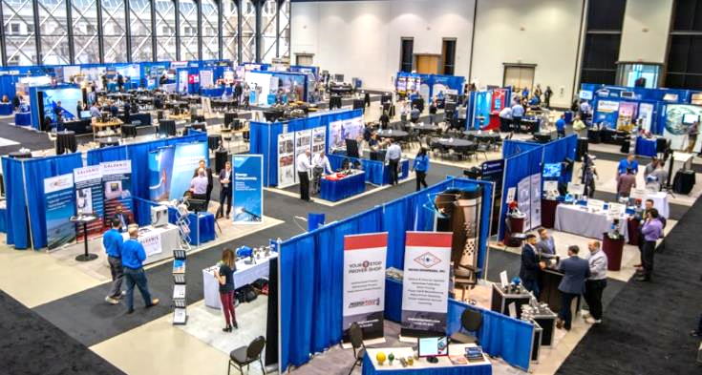

Trade Show
with 10x10
pipe-and-drape booths.

Do not forget to bring a tablecloth. (These are not supplied.) And a water bottle (unless you want to pay five dollars for one
at the show.)

Flea Markets (B-C) are generally local or regional, and therefore considerably less expensive (2025):
- Space Rental $100 – $300 for space for one table (check to see if you have to supply the table.)
- Signage $200 (for roll-up and easel-backed signs)
- Promotional Materials $200
For a directory of Flea Markets see http://www.keysfleamarket.com/fleamarket/state/
Pop-up Shops (B-C) are typically smaller and irregular (hence the term pop-up) and last only a few hours.
Costs range from zero to $100 at most for a table. To find pop-ups search online for “Pop-up shops near me.”

Module 2 - Marketing Chapter 7 – Targeted Media

2.8.3 SELLING FROM BEHIND A TABLE

ASK QUESTIONS OF THE ORGANIZER SO THERE ARE NO SURPRISES:
- Will a table be supplied? How big?
- Is it indoors? If not, will a tent be suppled?
- Is Internet available (Is there an extra charge?)
- Electricity? (Is there an extra charge?)
- What are the set-up and tear-down times?
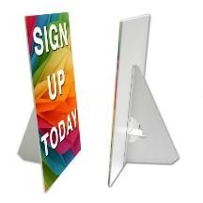
- Where will your table be located? Not next to the guy with the megaphone, I hope. If so, ask to be moved. It will be too late when you get there.
WHAT TO BRING
- Tablecloth
- Extension cord if you need electricity
(it may be supplied, but not right to your table)
- Easel-backed Counter Card (at least 17” tall, to be seen easily)
and/or pull-up signs
- Business cards
- Literature
- Email sign-up sheet (for digital coupon)
TIPS FROM THE PROS
- Do not sit. This says, “Don’t bother me.”
- Stay off the phone. (See #1 above.)
- Smile. Look like you want to be there.
- Put out some bling. This does not have to be pricey. Candy, mints, cookies, mini packs of pretzels are fine.
THE PITCH. Don’t be aggressive. Just explain what your product does and how it will benefit the customer. Do not drone on. Keep your opening to what you can comfortably say in one breath. Practice this, until it becomes natural. “Hi, we offer fresh-baked brownies, pre-wrapped for school lunches.” Then follow up with a question to engage the prospect—and probe for possible objections. “Do you have kids in school?” Or “Would you like to try a sample?” Then “What do you think?” Let the customer get a word in edgewise, because their response will contain clues to reasons they may not purchase.

THE CLOSE. Ask a whether question “Would you like to take it with you OR would you prefer we ship it?” – not an if question “Would you like to buy one today?” The later allows an easy “No” reply.

Use this box to draft a brief sales pitch

Module 2 - Marketing Chapter 7 – Targeted Media

2.8.4 NETWORKING TO GENERATE LEADS (B-B)

You never know where your first employee or next sale will come from, but you greatly increase your chances of success by getting out and pressing the flesh. The more people you meet the greater your odds.

Take business cards that tell what you do and include your tag line (how you do it better), and if someone hands you a card make a note on it to remind you what the person looks like and how you might help each other.

Join the local trade association for your industry. Find the nearest one at https://www.directoryofassociations.com. Attend meetings to get to know the members and then start a Mutual Referral Campaign with the professionals who have a solid reputation for reliability and integrity.

It may sound counterintuitive to attend a meeting of, say; fellow contractors or lawyers, but they all will not share your specialty. For example, a builder who does garages may not build fireplaces. If you build fireplaces and a client mentions they need a garage, refer them to the other builder, who might reciprocate if a homeowner mentions they want to add a fireplace. Same with lawyers: a divorce attorney will not do real estate closings.

To find business networking events in your area, check out www.Meetup.com.

For more advice on networking, see https://www.themuse.com/advice/an-introverts-guide-to-networking



Module 2 - Marketing Chapter 7 – Targeted Media

2.8.5 The Sales Call (B-B)

For high-priced products services, advertising and trade shows will typically just provide leads: an expression of interest or request for details. Someone still has to close the sale.

GETTING TO YES. SELLING TIPS FROM THE PROS. First, sell yourself. Prospects must believe in you before they will believe in your product or service. Be open and honest about your product limitations.

Second, you need to be your company’s lead salesperson, to set the example, and more importantly to stay in touch with your customers and their needs. It’s not difficult. Just follow these tried-and-true steps:
1. Prepare. Learn about the prospect's company, industry, and potential needs or pain points.
- Define Your Objective for the call. Is it to set up a meeting, gather more information, or close a deal?
- Outline Talking Points for the call: benefits and how they address prospect's likely challenges.
2. Make the call.
- Identify Yourself Clearly: State your name and company name. State the Reason for Your Call.
- Start with a friendly greeting and ensure you have not caught the prospect at a bad time. A little chit-chat to build report is OK but remember they are busy. Get to the point quickly.
3. Engage and Qualify.
- Ask open-ended questions to gather information about challenges; and follow up with clarifying questions to fully understand their situation. Let the customer talk. Sales result from sympathetic listening.
- Salesforce suggests asking “Has anything changed since the last time we talked?” This allows you to adjust your talking points to meet their current needs.
4. Present Your Solution. Explain how your product or service solves their specific problem and brings value.
5. Handle Objections.
- Be prepared for common objections about price or timing. Know your competition and your advantages.
- Try to discern any underlying—but perhaps unspoken—reason for the objection. Ask a clarifying question to show concern and interest in their issue. Do not be defensive. You have probably heard the adage: “Win the argument but lose the sale.”
- Respond Empathically: Show that you understand their perspective.
- Offer a solution that may satisfy their concern or overcome an obstacle. Use positive language.
For a free guide to handling objections see https://offers.hubspot.com/prospecting-objection-handling
6. Close the Sale.
- Ask for the order.
- If the answer is YES, confirm the details and discuss how payment will be made. Do they require an invoice, or will they send a purchase order? How and when will you deliver the product or service?
- If the answer is NO, thank the prospect for their time and let them know if you can meet their specific needs in the future, you will let them know.
- If the reply is MAYBE, ask for a time to give a demo, or offer to send additional information and then follow up in a few days. To be productive, you can only spend so much time with one prospect. (Some people will never say “no”; but they will never say “yes” either.) Proceed to the next prospect. Selling is a numbers game: it is not how much time you can spend per prospect; success is about talking with as many prospects as possible in the time you have.
7. Follow Up with an email. Summarize the conversation and reiterate the next steps.

For more insights into successful selling see www.salesforce.com/ca/blog/sales-language-affects-bottom-line/

Module 2 - Marketing Chapter 7 – Targeted Media

2.8.6 Indirect Selling (To Distributors, Reps, and Retailers)

For a product to earn you a living you will need help selling. Considers reaching out to intermediaries:
- RETAILERS. Companies that sell products through brick-and-mortar or online stores. They will expect a 30% to 50% margin of profit on the retail price.
- CATALOGUERS. Similar to retailers, and great way to get national exposures.
- DISTRIBUTORS. Intermediaries that buy from you, warehouse products and resell to retailers. They will want at least a 20% margin of the wholesale price (price paid by retailers). If you are just starting out, few distributors will want to handle just one product from a supplier. (Too much paperwork for too little volume.)
- MANUFACTURERS’ REPS (SALES AGENCIES). These are independent agents that act as salespeople for you, but you still need to do all the warehousing, shipping, and invoicing of retailers. Their commission is usually 7-15% of wholesale.
But to be taken seriously by any of these sales channels, you will first need to generate sales on your own and demonstrate that customers will repeat. Distributors need to see that it is worth the time to set up an account and take up space in their warehouse. Retailers need to know you have a winner that will not just collect dust on their shelves. To win over intermediaries …

1. OFFER COMPETITIVE RETAIL PRICING WITH COMFORTABLE MARGINS FOR EACH LEVEL.
Note that some traditionally seasonal or fashion-fickle industries have higher retail margins to absorb losses on products that never sell, or must be deeply discounted to move off the shelves:
- Fashion: Retail is typically 2.2 to 3 times the wholesale price. (If a store pays $10 wholesale for a summer dress that retails for $30; they can still make money when they clear out their summer stock at “half price”.)
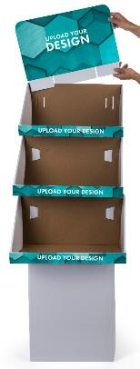
- Cosmetics: Retail is generally 1.6 to 1.8 times wholesale.
- Gifts: Retail is generally 2 times wholesale.
- Jewelry: 3 times wholesale.

2. PROVIDE MERCHANDISING SUPPORT MATERIALS:
Offer attractive displays and promotional brochures.
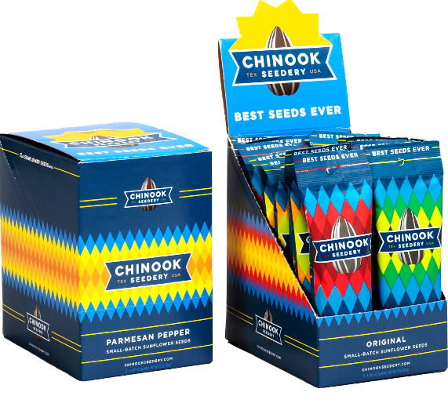
The display at left fits in
a shipping carton and provides in-store signage to help maximize sales.

At right is a customizable display available from www.Displays2go.com.
This display has the added attraction to retailers of not taking valuable shelf space
since it is free-standing.
Module 2 - Marketing Chapter 7 – Targeted Media

2.8.7 ACCEPTING ELECTRONIC PAYMENTS

All services allow ONLINE as well as IN-PERSON payments. All services offer a card reader to collect payments in person by swiping a card or accessing a digital wallet on a phone. (Note: the cost of the readers varies widely.)

Most providers also offer a free Tap-to-Pay app that allows businesses to capture payments phone-to-phone without the need for a physical card reader. But some only offer Tap-to-Pay for iPhones. The more digital wallets you can accept, the broader your market appeal.

Data below is from 2025 but subject to change; click column headers to check for current fees and features.

 | PayPal | Intuit | Square | Stripe
Credit Card Reader to plug into phone. Also accepts contactless digital wallets. Internet connection required.   | Yes  $29  Accepts  cards that  require pin | Yes  $49 | Yes  $399 | Yes  $59
Tap-to-Pay. Contactless payment  by credit/debit card or digital wallets  Without the need for a card reader.  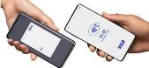 | Yes  iPhone  OR Android. | iPhone only.  Requires QuickBooks  at $420/yr.  + Internet  connection | Yes | Only through card reader or terminal; not through phone.  See also “Fees” below.
Allows multi-users so others  can accept payments for you | Yes | Yes | Yes | Yes
Links to QuickBooks | Yes | Yes | Yes | No, but data downloadable to QuickBooks
Digital Wallets Accepted  - Apple Pay  - Google Pay  - Cash App  - PayPal  - Venmo  - Samsung Wallet | x | x | x  x
Transaction Fees  For in-person transactions.  Keyed-in payments  Online store checkout  Invoices paid online | 2.3% + 9¢  3.5% + 9¢  3.5% +49¢  3.5% +49¢ | 2.5% *  3.5% *  3.0% *  3.0% * | 2.6% +15¢  3.5% +15¢  2.9% +30¢  3.3% +30¢ | 2.7% + 5¢  2.7% + 5¢**  2.9% +30¢***  2.9% +30¢
* Intuit also charges a monthly fee if total amount processed is less than $2500. Contact Intuit for details.
** 10¢ addl. transaction fee for Tap to Pay. *** $10 per month in addition to transaction fees

Entrepreneur.com/article/21774
https://www.entrepreneur.com/article/21774
Jason Calacanis. http://blog.launch.co/blog/how-to-name-your-startup-and-land-the-perfect-domain.html)
Jason Feifer (May 2018). “Did You Pick the Right Name?” Entrepreneur.com (print), p. 28.
www.quantcast.com/top-sites-1
https://www.statista.com/statistics/272014/global-social-networks-ranked-by-number-of-users/ data as of 2025
https://ignitevisibility.com/much-social-media-influencer-marketing-cost/
Rates gleaned from several sources, including https://influencermarketinghub.com/influencer-rates/ https://www.shopify.com/blog/influencer-pricing#8 https://impact.com/influencer/how-much-do-influencers-charge-per-post/
https://blog.hubspot.com/marketing/email-writing-mistakes-data
https://mailchimp.com/ (2025)
According to digital marketing platform GetGist https://getgist.com/how-to-avoid-spam-filters/
https://fulcrumtech.net/resources/preventing-gmail-from-clipping-your-emails/
https://www.inman.com/next/gmails-spam-filter-is-killing-your-drip-campaign-top-tips-to-get-personal/
https://financesonline.com/email-marketing-statistics/
https://cwiki.apache.org/confluence/display/SPAMASSASSIN/AvoidingFpsForSenders

