Entrepreneurship and
Small Business Management

Eighth Edition

Entrepreneurship Foundation, Inc.

Entrepreneurship
and
Small Business Management

Edition 8.0

ISBN-13: 978-0-9967327-4-1

Contact: Roer@EntrepreneurshipFoundation.org
© Academy Publishing, 2012, 2013, 2014, 2015, 2016, 2019, 2020, 2024

Table of Contents

Introduction to Entrepreneurship 6
A. PERSONAL goals 7
B. Company Goals: The Startup Checklist 8
1– Lean Launch Methodology 9
A. BUSINESS MODELING 10
B. Lessons Learned 11
C. INCREMENTAL Launch STRATEGY 12
2 – Concept Development 13
A. IDEATION 14
B. PATENT SEARCH 16
C. Feasibility Analysis of Ideas 17
D. FINAL CONCEPT (Product, or Service) 21
3 – Competitive Positioning 22
A. COMPETITIon Research 23
B. CoMparison of Features to Competitor Products 24
C. Industry Analysis 25
D. Target Market Niche 26
E. Size of Target Market 27
F. COMPETITIVE STRATEGY 28
g. Barriers to Entry 29
4 – Business Model Canvas 30
A. LEAN Business Model Canvas 31
B. Assess skill needs 34
C. Project Management (Team Collaboration) 35
D. MARKET RESEARCH: SURVEY CUSTOMERS TO verify assumptions 36
E. VALIDATE DEMAND (The Landing page) 38
F. PIVOT RECORD 40
5 – Designing the Product or Service 41
A. Minimum Viable Product or Service 42
B. PhysICal Product Prototyping 43
c. Resources for PRODUCT Prototyping and Manufacturing 45
D. Electronic product protoyping 46
E. Software and Mobile App Rapid Prototyping 48
F. Software and Mobile App FINAL DEVELOPMENT 49
G. Market TESTING THE PRODUCT OR SERVICE 50
6 – Insurance 51
A. TYPES OF Business Insurance 52
B. typical Business Insurance rates and COVERAGES 54
7 – Location 56
A. Sourcing Physical LocationS 57
B. Comparing Locations 58
8 – Pricing the Product or Service 60
A. Final PRoduct Costing 61
B. Shipping AND HANDLING COSTS 62
C. Pricing a Product that You Manufacture 64
D. PRICING MULTIPLE PRODUCTS FOR RESALE 65
E. Pricing of SERVICES 66
F. Break Even Calculation for A Product or service 68
9 – Budgeting and Accounting 69
A. Personal Expense Budget 70
B. Business BUDGETIng and Accounting 71
10 – Management 75
A. BUILDING THE Management Team 76
B. Incentivizing THE MANAGEMENT TEAM 78
C. ADVISORY COMMITTEE (Non-paid Members of the Team) 80
D. Selecting an Attorney 81
11 – Brand Image 83
A. Company NAME 84
B. Logo 88
C. Packaging 91
D. Labeling 92
E. PHONE Number 93
F. Business Email Address 94
G. Business cards 95
12 – Website 96
A. SELECTING A DOMAIN NAME and HOSTING Service 97
B. WEBSITE EVALUATION 100
C. SEARCH ENGINE OPTIMIZATION (SEO) 101
D. Credit Card Processing Services 102
E. Adding A Payment Link to a Website 103
13 – Marketing 104
A. Marketing Strategy and Plan 105
B. Credit and Collections Policies and Procedures 106
C. Posters FOR TRADE SHOWS AND POP-UP VENUES 108
D. Flyers and Brochures 111
E. PAID Web Advertising (BUYING Adwords) 112
F. FREE WEB ADVERTISING (local SEARCH DirectorieS) 113
G. BUILDING A Social Media PRESENCE 114
H. UTILIZING SOCIAL MEDIA INFLUENCERS 116
I. Marketing Videos 117
J. Email Marketing 118
K. NETWORKING to Generate Leads 119
14 – Production and Distribution: Supply Chain Management 120
A. Producing Goods and Bringing Them into Inventory 121
B. IMPORTING Goods Into Inventory 123
C. Distribution: Processing Orders and Delivering Goods from Inventory 126
15 – Protecting Intellectual Property 128
A. Trademarks 129
B. Patents 131
C. Trade Secrets 135
d. CopyrightS 135
16 – Legal and Regulatory Matters 136
A. ALTERNATIVE Legal STRUCTUREs 137
B. Selecting the right structure for your business 138
C. NAICS CODE 146
D. FEIN Number 147
E. STEPS TO SETTING UP the Business 149
F. Business Licenses 153
g. REPORTING Pass-Through BUSINESS INCOME 154
H. Self-Employment Payroll Taxes 157
17 – Raising Startup Capital 158
A. Determining Startup capital requirements 159
B. Sources of Startup Capital 160
18 – Crowdfunding 161
A. FORMS OF CROWDFUNDING 162
B. CROWDFUNDING TIPS 164
19 – Raising Growth Capital 165
A. Types of Growth Capital 166
B. Determining GROWTH Capital Requirements 167
C. Sources of Equity Capital 168
D. VALUATION (Putting a price on Your Company) 169
E. OWNERSHIP RETENTION WHEN RAISING EQUITY CAPITAL 171
F. Equity CAPITALIZATION SCHEDULE (CAP TABLE) 172
G. Exit Strategy 173
20 – Pitching Business Plans to Competition Judges and Capital Providers 174
A. Oral Presentations 175
B. Substance (Content of Presentation or Written PLan) 179
C. Questions You Should Be Prepared to Answer 182
D. Style: Creating Clear and Convincing Presentations 185
21 - Banking 187
A. Selecting the Right Bank 188
B. Opening the Bank Account 190
C. Ordering Checks and Banking Supplies 191
Glossary 193
Appendices 196
Summary of hotlinks 197
Alternative Osterwalder Business Model Canvas 200
Employer and Employee PAYROLL TAXES 203
Non-Disclosure Agreement (NDA) 204
EntrepreneurSHIP aPTITUDE Self-Assessment 206
Index 214
Introduction

Introduction to Entrepreneurship

Entrepreneurship is the art of designing, launching and growing a new business.

An entrepreneur is someone with the ability to identify problems and to find or develop novel solutions. Successful entrepreneurs also have the ability to organize capital, talent, and other resources into a sustainable business model to deliver those solutions.

The exploitation of entrepreneurial opportunities may include:
- Identifying real problems
- Conceiving and validating solutions
- Finding a sustainable business model, through trial and error, to deliver solutions
- Acquiring financial resources
- Recruiting talent
- Providing leadership and accepting the responsibility for the success of the venture

Launching a new venture also requires a willingness to assume risk and deal with uncertainty. For those who are risk averse or who require a more predictable income, through traditional employment, will still benefit from learning entrepreneurship skills.

INTRAPRENEURSHIP. The entrepreneurial approach to problem solving is being adopted by an increasing number of established companies to exploit new opportunities for growth and expansion into new markets. The skills you will acquire in this course will help you to advance if you choose to join another business instead of starting your own. Entrepreneurship within an existing firm is referred to as intrapreneurship.
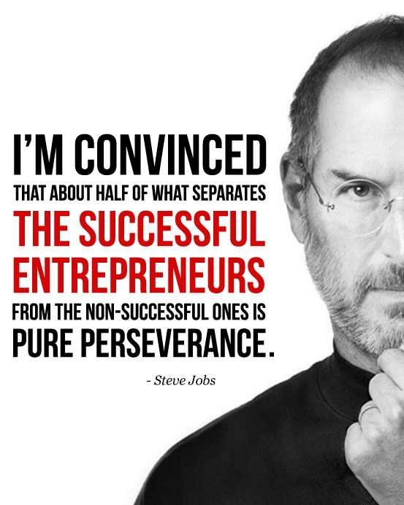

A good place to start is to set some personal goals, and decide whether starting a new venture of your own or working for someone else as an intrapreneur is right for you.

If you think you would like to launch your own business, the following pages will guide you on the adventure.

Introduction

A. PERSONAL goals

Your business will be a part of your life; along with family, hobbies, sports, travel and learning. How much time do you want to allocate to each? If you plan to start a highly competitive business with ambitious goals, you can pretty much scratch off everything else on the previous list; at least until can afford to hire others to help.

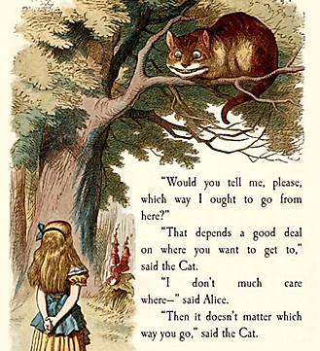

Being an entrepreneur is a career choice; a lifestyle. You gain more control over your life and time; but will work harder and longer, and for probably less pay. (It hs been said that an entrepreneur has the toughest boss.) But there are upsides besides independence. You have the chance to provide a living for others and to become a respected leader in your community; and to use your hard-earned profits to make the world a better place.

DO YOU WANT TO OWN A PERSONAL BUSINESS OR A VENTURE ENTERPRISE? WHICH OF THE FOLLOWING BEST DESCRIBES YOUR VISION?

ASPECT OF BUSINESS | PERSONAL BUSINESS | VENTURE ENTERPRISE
Business is Scalable (average product cost declines as volume increases) | No (e.g. – If it takes 3 people to roof one house, it takes 6 to roof 2 houses) | Yes (e.g.– software or music. The orignal may cost $100,000 to create; but the second is only $.50)
Annual Sales Potential | $100,000 to $500,000 | $50,000,000 (amount necessary to attract investors)
Geographic Range of Market | Neighborhood or Town | State, country or world
Capital needed to launch | $5000 to $500,000 | $50,000 to $250,000
Typical Sources of Startup Capital | Savings, credit cards, family | Savings, credit cards, family
Growth Capital Needed (once profitable business model discovered) | None. Can usually bootstrap (re-investing profits) | $1,000,000 to $20,000,000
Sources of Growth Capital | Business profits | Angel investors and venture capitalists
Management Structure | Horizontal (everyone works for you) | Hierarchical (every 5 employees has a boss; and every 5 bosses has a boss, etc.)
“Creative Quotient + Passion Quotient > Intelligence Quotient” -- Tom Friedman

Introduction

B. Company Goals: The Startup Checklist

Launching a new business can seem a daunting challenge. This text divides the process into manageable steps: Just click on a step to go to the applicable how-to section.

MILESTONES TARGET DATES for KEY MILESTONES (Month/Year)

PHASE 1 - Conceive and validate a winning concept
- □ Conceptualize ideas for a business ______/______
- □ Conduct a Patent Search if a product
- □ Conduct a Feasibility Analyses of ideas
- □ Recruit co-founders as needed
- □ Survey customers to verify demand
- □ Draft a Business Model Canvas
- □ Design Minimum Viable Product ______/______
- □ Analyze Competition
- □ Select location for business
- □ Compute product price and Break-Even
- □ Create business plan competition pitch ______/______
PHASE 2 - Prepare to launch business

- □ Choose legal structure
- □ Determine NAICS code and obtain FEIN
- □ Protect intellectual property
- □ Select name and build brand image
- □ Formulate marketing plan
- □ Create Website to establish presence ______/______
- □ Build Minimum Viable Product or Service
- □ Conduct trial launches ______/______
PHASE 3 - Launch business

- □ File legal documents to set up business ______/______
- □ Open commercial bank account
- □ Prepare Marketing Video
- □ Decide how to produce/ deliver product
- □ Launch on crowdfunding site ______/______
- □ Commence production
- □ Purchase Insurance as needed
- □ Retain talent as needed
PHASE 4 - Grow the business to full potential
- □ Prepare budget
- □ Pitcn to potential capital providers ______/______

Lean Startup Method

1– Lean Launch Methodology
The New Approach to Starting a Business

A. Business Modeling
B. Lessons Learned
C. Incremental Launch Strategy

The LEAN STARTUP METHOD was developed by Eric Ries, based on lean manufacturing methods. It is designed to rapidly discover if a proposed business idea is viable.

This is accomplished through pre-launch market research and then testing limited versions of the product or service with customers to determine which (if any) product features and benefits are most important to buyers.

The Lean Method will save a new company significant time and money to discover and perfect a profitable and sustainable business concept.

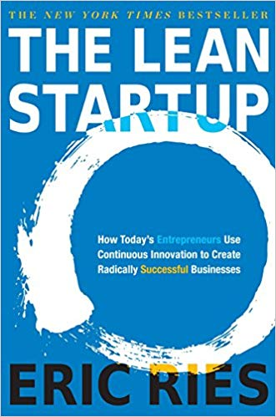
Click on the link below for a 9-minute explanation
of the key elements of the Lean Startup Method.
VIDELINK The Lean Startup.
https://www.youtube.com/watch?v=QaoVWtLX038

Lean Startup Method

A. BUSINESS MODELING

The new approach to startup entrepreneurship

Unlike many venerable disciplines, the art and science of Entrepreneurship continues to evolve and adapt to an ever changning business and economic environment. With the advent of the information age, it has become easier to start a new business. Software products and mobile apps do not require capital-intensive factories or long lead-times to market; and with the explosive growth of 3-D printing, many physical products can be protoyped and market-tested at prices affordable to even startup entrepreneurs.

A recent refinement within entrepreneurship curricula that is gaining broad acceptance is BUSINESS MODELING. The premise being that traditional business planning is not suited to new ventures. Formal business plans and pro forma financials presume the new venture must immediately support the founder on a full-time permanent basis (a legacy from large-company planning). But for a startup ...

- ​​Long-range financial forecasts are largely discounted by investors. According to John Seiffer, former president of the Angel Investor Forum, "It is not an efficient use of time and energy to prepare elaborate 20-page pro formas on untested concepts."
- A new business concept is really a set of unproven hypotheses. Typically, these include: demand per price point, production costs, feasible distribution channels, cost for post-purchase customer service, production lead times, repeat sales rates, customer retention, and preferred features.

Champions of business modeling Bob Dorf (Columbia), Steve Blank (Stanford) and Thomas Eisenmann (Harvard) assert that startups need a plan to FIND a sustainable business model. Nathan Furr, a contibuting writer to Forbes, differentiates the two approaches this way: “In a business plan, you are trying to plan, inside the building, the optimal solution that you can execute. In a business model process you recognize that everything is a guess that has to be tested, outside the building, with the goal of learning” what will work.

According to Eisenmann, “Most startups fail—usually due to lack of customer demand, not product development problems. These new ventures burn through their capital, wasting money on engineering and marketing before discovering they have built a product no one wants.” These new ventures fail not because the innovation did not work; but because the founders did not appreciate the market’s ability or willingness to adopt it.

“Startups are more likely to succeed when they rapidly and iteratively test assumptions about a new venture’s business model based on customer feedback, then quickly refine promising concepts and ruthlessly cull the flops. New ventures that follow this approach are lean startups, derived from Toyota’s management philosophy: short production cycles to reduce inventory and eliminate waste. Lean startups similarly rely on short product development cycles to eliminate waste and gain rapid market feedback.”

TRADITIONAL BUSINESS PLAN. But once you do arrive at a sustainable business model, you will need a comprehensive business plan to to secure growth financing. Still, as serial investor David Rose warns: “A real business plan is never done.” Tim Perry refers to the continuing updating process as PRRR: Plan, Run the plan, Review the plan based on results and customer feedback, and Revise as needed.
Lean Startup Method

B. Lessons Learned

Successful entrepreneurs have arrived
at a number of conclusions regarding the fine art of launching a new venture.

1. THE SCIENTIFIC METHOD APPLIES TO ENTREPRENEURSHIP, suggesting...

- The need for well-structured experiments to confirm or disprove hypotheses about business model elements.
- The need for metrics to gauge whether hypotheses have been validated, (e.g., click-through rates.)
- The advisability of initially building a minimum viable product (MVP).

2. THREE HEADS ARE BETTER THAN ONE. Based on the experience of business accelerators, teams composed of diverse skills are more successful than solopreneurs.

3. ANGEL AND BANK FINANCING ARE NOT REALISTIC FOR PURE STARTUPS.
- Investors will not risk their money on ventures without a proven revenue and profit model to achieve the financial goals. The time to pitch investors is after a successful business model has been established.

- More realistically, the initial capital to test your concept will probably come from personal savings, friends and family, and crowdfunding.
- However, entrepreneurs should avoid large investments in marketing and infrastructure until business model hypotheses are validated.

4. LAUNCHING A BUSINESS IS A NON-LINEAR PROCESS. As entrepreneurs work through one aspect of the business model (for example, optimal product price), in searching for a sustainable business model, an entrepreneur may have to go back periodically and revise budgets, production plans, distribution channels, or even the product itself.

5. NDAS (NON-DISCLOSURE AGREEMENTS ARE NOT ALWAYS OBTAINABLE). If your product is not patented, you may want to ask for a Non-Disclosure Agreement (NDA) before discussing details with a prospective employee, supplier, or financier. A boilerplate form appears in the appendices.

However, it is a rare investor who will sign an NDA. Their concern is the same as film studios that do not accept unsolicited (“over the transom”) screenplays. The producer will return the scripts unopened because they may have a very similar film already in production. The producers assume, probably rightly, that the writer would not believe it was just a coincidence, and so the studio will have to spend time and money in court to defend itself against charges of plagiarism. Investors assume the same Russian roulette. If they sign enough NDAs, eventually they will agree not to disclose an idea they have already invested in, and that is about to be released into the market.
The culture of most collaborative forums (Startup Weekends and entrepreneurship classes, to name two) is to operate on an open basis, assuming everyone will honor each other’s confidential information. As business modeling guru Steve Blank points out, discussing an idea openly in his Stanford University class risks intellectual property theft, but the upside is lots of feedback. He does not use NDAs in his class.

Lean Startup Method

C. INCREMENTAL Launch STRATEGY

The strategy recommended in this text is to establish a new business in stages, with each milestone achieved confirming the assumptions necessary to advance to the next.
START SMALL. Bootstrap the business with what you can save or borrow comfortably. If your dream is a restaurant, start with a food cart, second-hand. Consider what you can start while still a student. (Your personal overhead will never be this low.)

GROW ORGANICALLY. Use the proceeds from your first sales to buy the materials for your second round of sales. You may be able to gradually increase the volume of purchasing and production to grow without ever having to raise outside capital.

LAUNCH LEAN. If you do need outside investment, raise only the amount of capital required at each stage, rather than raising in advance the entire amount necessary to take an idea to profitability. Successfully mastering each stage before raising funds for the next will allow you to negotiate more favorable financing terms.

This incremental approach reduces risk. The process of launching a startup is divided into capitalization tranches, corresponding to the stages of development of the business. The incremental approach allows the entrepreneur or investor the opportunity to withdraw from the venture at an interim stage if expected results are not attained. For example, an investor might agree to provide a total of $250,000 to bring a new idea into the market, provided interim milestones are achieved. Initially, the investor might provide $25,000 to apply for a patent, but if the patent is not received, the investor would then not be obligated to provide the balance of the capital.

TYPICAL LAUNCH STAGES

Stage 1: Advance the idea on paper—without financing—to the furtherest extent possible.
Stage 2: Save your own money in a business savings account jn order to build, bench test, and market test a minimum viable product, performing as much of the work yourself to conserve capital.
Stage 3: Raise seed capital from crowd sources to launch business on a part-time basis. (Don’t quit the day job just yet.) Once you can live comfortably off the profits from the business, give the boss two weeks notice.
Stage 4: Raise growth capital from an angel, VC or bank once the business proves itself as a long-term source of incrreasing revenue.

“The goal of an entrepreneur is to find a repeatable and scalable model.” – Steve Blank

“Fail fast; Succeed sooner” – Peter Drucker
Concept Development


Pixabay.com

2 – Concept Development

- Ideation
- Patent Search
- Feasibility Analysis of Ideas
- Final Concept
If you do not yet have an idea for a product or business, start by investigating a market in which you have an interest. It might be a sport you follow like auto racing (one innovator developed a product to filter out carbon monoxide from the air drivers breathe); a hobby like drone photography, a career pursuit such as financial management or programming, or a social need.

What is the state of the industry? Who is successful now and why? What is missing? What problem persists? Which customer segment is still not been adequately served?

All successful companies start with identifying a problem, and then brainstorming and testing possible solutions until they discover a sustainable business model.

There is a tide in the affairs of men
Which taken at the flood, leads on to fortune

There is a tide in the affairs of men [and women]
Which taken at the flood, leads on to fortune
-- William Shakespeare
Concept Development

A. IDEATION

Conceiving winning products and services.

TYPES OF INNOVATION.

What problem (customer pain) does each of these products solve?

Solving Problems. Jane Porter, writing in Entrepreneur magazine, asks, “What bugs you?” then, “Do something about it!”

Many new solutions in turn create new problems (entrepreneurs see these as opportunities). For example, better interstate roads in the 1950s solved one problem: long delivery times for goods shipped by truck. The Interstate system also enticed more people to vacation to distant locations by automobile. This created a shortage of affordable places to eat and rest along the way, ushering in the motel (motor hotel) industry.

What problems or opportunities have been created by recent technological advances?

An example of an innovation that created a new problem is the mobile phone. The problem was the cost and inconvenience of having to replace one if dropped. What was the solution that thousands of entrepreneurs created?

Improving Existing Products or Services by making them...
  - Cheaper (Model T Ford),
  - Faster (McDonalds hamburgers, Amazon delivery),
  - Better (Starbucks coffee, Google search),
  - Customized or personalized (American Girl dolls)
  - Supported by superior customer service
What successful businesses can you think of that did not invent the concept, but rather improved upon an existing one?

Bringing new efficiencies to mature industries. Find a business category lacking recent innovations.

Combining two products to make something new. Steve Wozniak wired a TV screen to a digital computer to invent the PC.

Finding Untapped Market Niches. Major corporations target a new product or service to the largest buying demographic. However, one size does not typically fit all consumers.

Is there a need for a left-handed version, foreign-language version, disposable version (Pampers), or an unexploited market niche (SeniorPeopleMeet.com)?

Concept Development


Leapfrogging. What opportunities will emerging technologies create when they become commonplace. It may be foolhardy to compete with Google and Tesla in the self-driving car realm; but perhaps you can predict a spin-off opportunity. For example, we might send our car on errands to pick up cleaning or dinner; and stop at the ATM. But how, exactly, would this work?
DO NOT GET WIPED OUT. Catch the start of the wave. If you wait too long you will have to compete with dozens of other better mousetraps fighting over the scraps left by the first mover.

KEEP IT REAL: Place-based businesses (restaurants, retail stores, gyms) may require $150,000 or more; and raising money from a bank or investors for a startup is not realistic. So pick something that you can fund now, or open a bank account in the name of the business and set aside $50 a week, $1000 per month, or whatever you can afford. And do not touch this money. It’s for your future.

BRAINSTORMING IDEAS: Here are a couple of links to sites that will get your creative juices flowing: http://www.entrepreneur.com/businessideas, http://www.Kickstarter.com

- SWOT. Due an analysis of your Strengths, Weaknesses, Opportunities, and Threats. What are you good at doing? It’s probably what you like to do, what gets you up in the morning.

- Greenlighting. Jot down ideas as quickly as they come to you. Then go back over the list and narrow to a manageable number to research. Think about innovation during down time: while driving, in the shower.

- Talk to consumers about what they feel is missing or needs improvement. Do not worry about someone stealing your idea. Ideas do not matter; only developing, validating and executing matter.
- Seek insights from suppliers and service providers to your industry. If you are planning a restaurant, talk to the food and beverage distributors; they will know what sells in your area.
- Outsighting. Talk to people outside your industry or area of expertise to gain fresh insights into to problems.
- Surf media:
- Amazon: what are the top nonfiction books (what problems are people trying to solve?)
- Wired magazine (a publication that monitors the future)
- Trending Google searches: http://www.google.com/trends/hottrends and http://www.google.com/trends/topcharts

Do not confuse a fad for a lasting trend. A June 19, 2019,
Wall Street Journal headline revealed the sobering reality of getting it wrong: “Sorry, collectors, nobody wants your beanie babies anymore.”
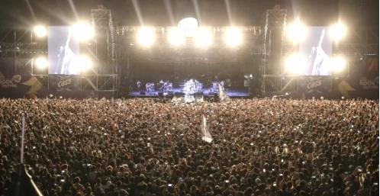
But don't dismiss a lasting trend, thinking it’s just a fad: “It’ll be gone by June.”–
Variety Magazine on Rock n’ Roll, 1955.

“There is a worldwide market for maybe five computers.” – Thomas Watson, IBM, 1943.
Concept Development

B. PATENT SEARCH

If your idea is a product, make sure you have the right to make it (it is not patented). You can conduct a patent search at patents.Google.com (do not type www), or www.USPTO.gov The Patent office has guides on how to use their site for searches at https://ppubs.uspto.gov/pubwebapp/static/pages/quick-reference-guides.html

Whether or not you shoud seek a patent is a very different question that you can postpone until you have verified that your idea is feasible and that there is adequate demand. For more information see section on Patents.

Give some thought to your search words and phrases. For example, if you have an idea for a better mousetrap, you would want to search for mouse, mousetrap, mouse capture, mouse eradicator, rodent trap, pest control, etc.
Enter below the terms you used to search for patents related to your ideas.
PRODUCT IDEA A __________________________________________________________________________
PRODUCT IDEA B __________________________________________________________________________

If you don’t find something it could be because...
- YOUR IDEA HAS NOT BEEN PATENTED by anyone else and therefor patentable; unless ...
- THE PRODUCT HAS NOT BEEN PATENTED BECAUSE IT IS “OBVIOUS,” and therefor not patentable. The non-obvious requirement is defined by the Patent Office as an invention or improvement that would not have been obvious "to a person having ordinary skill in the art to which the claimed invention pertains." For example, adding an external cursor controller (a mouse) to a computer was not obvious, but adding a battery to a computer to make it portable is an obvious improvement.
- THE IDEA HAS BEEN PATENTED, BUT YOU DID NOT USE THE RIGHT SEARCH TERM TO FIND IT.

HOW TO LOOK FOR SOMETHING YOU HOPE NOT TO FIND. This is probably the hardest thing for an innovator to do. Not finding an existing patent can be extremely expensive in terms of wasted time and capital. Several ways to reduce the chances of missing something in your patent search are:
- Have a disinterested party do the search for you. A patent attorney might charge $500 or more for this service.
- Try every conceivable search term for your product or service, and their synonyms. For example, for a tic-tac-toe game for mobile phones, try mobile app, mobile application, mobile game, phone game, electronic games, tic-tac-toe, tic tac toe, and “noughts and crosses” (an early name for the game).
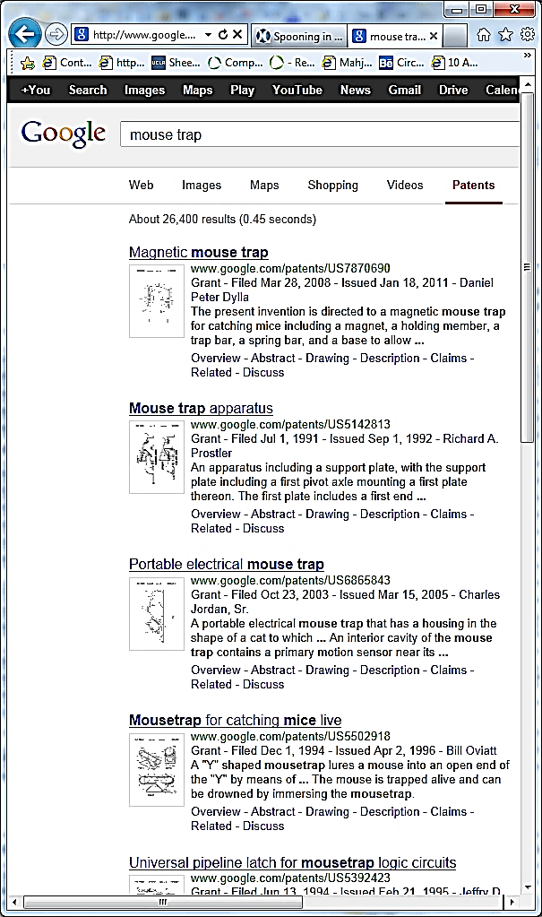
IF YOU DO FIND A PRIOR PATENT, Share the first page of your search results with your professor or a patent attorney. Your product may still be—or with some modification, could be—different enough from the original to not violate the existing patent. For example, if you search for a better mousetrap, you will find that thousands of patents have already been issued for mousetraps. So just because a mousetrap has been patented does not mean there isn’t room for your better mousetrap.

26,400 hits for “Mouse trap”

EVALUATION GUANTLET. At each stage, advance, pivot (modify the productor plan), or go back to square 1
1-IDEATION | 2-PATENT SEARCH | 3-FEASIBILITY ANALYSIS | 4-MARKET VALIDATION | 5-MVP TEST | LAUNCH
HOW MANY HITS FOR YOUR IDEAS Idea A Idea B
Goolge search ………………………….. ____________________ ____________________

Patent search ………………………….. ____________________ ____________________
Concept Development

C. Feasibility Analysis of Ideas

Evaluating your ideas to identify the one most likely to succeed.

Complete a feasibility analysis for each idea. Verify assumptions through research and discussion with other entrepreneurs and advisers. Total the score for each idea and enter on the Summary page at end of this section.

A. Industry and Competition (Variables affecting potential success of concept)
 |  | +1 | 0 | -1
1 | Growth rate of market:  companies in industry are typically...  The Risk Management Association publishes financial data on over 700 industries.  Ask if your library has the RMA Annual Statement Studies. | ...New and adding employees (check help wanted ads). | Stable or growing slowly. Busy, but no lines at registers. | Mature or declining. Advertising copy reveals desperation.
2 | Dependency on suppliers | Many alternative suppliers | Few suppliers, but prices have been stable for years. | Only a few suppliers who set prices (e.g.- DeBeers diamonds)
3 | Competition in market niche | No direct competitors. | A few small competitors, and most are new | Market crowded and some competitors have deep pockets
4 | Industry profitability  PERSONAL BUSINESSES  See www.bizbuysell.com for offering prices for businesses like the one you want to start.  The site indicates the annual “cash flow” (amount owner earns before taxes). | Adequate to live on and repay a loan for startup costs. | Profits adequate to live on | Many similar businesses available for purchase.
4 | VENTURE ENTERPRISES | Net profit of at least 10%; and adequate  to repay investors 10 times in 5 years | Industry profits are a few percentage points above prime rate | Industry profits are at or near Consumer Price Index

B. Market Niche
1 | Annual sales potential  PERSONAL BUSINESSES  VENTURE ENTERPRISES | $ 1,000,000  $ 100,000,000 | $ 500,000  $ 50,000,000 | $ 250,000  $10,000,000
2 | Market trend (Growth or decline in total sales within industry year over year) | A hot new trend | Demand has settled down but market still growing by 1% to 5% annually | Stagnant. Item is passé; or anyone  who wanted one has one
3 | Purchase frequency. Do customers tend to make repeat purchases (as in banking, gyms, food products)? | You sell blades that fit only your razor. Customers buy monthly. | Customers buy quarterly but not necessarily with you. | Your product lasts a year or longer (when was last time you bought a hammer?).
4 | Customer pain intensity | Customers feel real pain or solution is a must-have: Food | Customers desire the product. Ice cream | Customers are ambivalent. Banana
Concept Development

C. Customers (Liklihood they’ll adopt new idea)
 |  | +1 | 0 | -1
1 | Customer Inertia. IF A NEW SOLUTION, to what degree will customers have to change practices or habits to adopt? | Little or no change to habits necessary. | Moderate change necessary for adoption. | Substantial change in habits necessary for customers to try idea.
1 | IF AN IMPROVED VERSION OF EXISTING PRODUCT, how willing are people in target market to  adopt new ideas and solutions? | Customers are early adopters, tech savvy, unafraid or eager to try new ideas. | Neither averse to nor eager to try new things. | Customers tend to show brand loyalty, are risk averse, or tied to old ways.
2 | Customer satisfaction with current solutions and alternatives | Desperate for a better solution. | Ambivalent. | Content with current solutions.
4 | Customer budget for product category | High. | Medium. | Low
4 | Customer bargaining power  relative to yours (Walmart tells you price they will pay) | Enough potential customers that you will only have to sell 1% or fewer to reach goal. | You will have to sell 5% of customer base to reach goal. | One or only a few customers

D. Concept
1 | Stage of Development (degree to which technology risk has been mitigated) | Product or service has been tested with beta customers | Product has undergone alpha testing (lab testing) | Concept is a new, untested idea
2 | Degree of improvement of new  idea over existing products or services | Market disruptor; earth shaking improvement. | Somewhat better than alternatives. | Equal to, but different from current solutions.
3 | Your can erect “barriers to Entry into your market” to keep other companies from copying your concept (can you protect your idea, your Intellectual Property?  ) | Patentable or you have an exclusive  Contract. | Secret sauce (process difficult to reverse engineer); or you have first-mover advantage. | No way to protect your idea.
4 | Scale advantage. Is each successive product or service cheaper to produce and deliver? | Cost of each additional product is lower than first (e.g.-software). | There is some gain in efficiency from experience and volume production. | No. Each product costs as much as the one before (e.g.-kitchen remodeling).

Concept Development

E. Costs
 |  | +1 | 0 | -1
1 | Startup cost: the amount of capital required to launch business  FOR PERSONAL BUSINESS | Well within your personal budget. No need to raise capital. | Significant amount, but loan payments manageable – even  if business fails | You risk losing home if business fails.
1 | FOR VENTURE ENTERPRISE  Initial capital for proof of concept >  Additional to reach break-even > | $ 10,000 or less  $ 250,000 | $ 25,000  $ 500,000 | $ 100,000  $ 1,000,000
2 | Space costs | Can work out of your home. | Only need small office or shared space. | Would need to sign a  five-year lease for necessary space.
3 | Labor cost | Plentiful low-cost talent available. | Moderate cost (e.g.-salespeople). | High-cost (e.g. – MBAs  or proven marketers) or rare (e.g. programmers)
4 | Advertising cost (Customer acquisition cost) | Free. Only need social media | Affordable; only local advertising needed. | Expensive. Slick ads, broadcast media, or national exposure required.

F. Team (Relevant Skills and Experiences of Founders)
1 | Team passion for industry | It’s why you get  up in the morning. Nothing is more important. | This is a deal breaker. If you would not crawl through a desert to make this business a success, pick something else or do not be an entrepreneur.
2 | Skills | Highly skilled in technology or service. | Average skill level. | None or almost none.
3 | Experience | Successful management and marketing experience. | Some management or marketing experience. | Little or no experience.
4 | Industry connections | Well known in industry; strong connections with suppliers and resellers. | Connections with a critical supplier or marketing outlet. | None or minimal.

Concept Development

Summary (Overall Potential of the Idea.) Add up scores from preceding pages. Then brainstorm ways to raise low scores. That is, how might you modify the concept so that it becomes realistically doable? If the idea is just not viable, no problem, just go back to the drawing board. You haven’t spent a lot of time or any money on the idea.

 | CATEGORY | SCORE | WAYS SCORE MIGHT BE IMPROVED
A | Industry and Competition | 4 max
B | Market Niche | 4 max
C | Customers | 4 max
D | Concept | 4 max
E | Costs | 4 max
F | Team | 4 max
 | TOTAL (24 max)

EVALUATION GUANTLET. At each stage, advance, pivot (modify the productor plan), or go back to square 1
1-IDEATION | 2-PATENT SEARCH | 3-FEASIBILITY ANALYSIS | 4-MARKET VALIDATION | 5-MVP TEST | LAUNCH
Concept Development

“One thing”!

D. FINAL CONCEPT (Product, or Service)

Caution: Do not get married to an idea until you are sure it’s the one.

PROBLEM (Customer pain or desire)

SOLUTION: product or service (the painkiller)

PRODUCT OR SERVICE FEATURES, especially innovations that make it unique and competitive.
This is usually a zero-sum game; that is, to make a sale, you will have to take a customer away from a competitor. To do this you must offer either: a) lower price, b) better performance, c) greater variety, d) faster delivery,
e) more liberal return privileges, f) better customer service, or g) serve a new market niche.

BENEFITS. What are the benefits your product/service provides to the customers in your target market?
(Benefits are the answer to “So what?” for every feature you listed above.)

Competitive Positioning

3 – Competitive Positioning

A. Competiton Research

B. Comparison of Features to Competitor Products

C. Industry Analysis

D. Target Market Niche

E. Size of Target Market

F. Competitive Strategy

G. Barriers to Entry

Competitive Positioning

A. COMPETITIon Research

In the space below, list the companies in your market area with similar products that have features or pricing that pose a potential threat to your company. According to Cliff Ennico, “Competitors are all companies going after the same customers, even if the product (solution to the problem) is different. For example, if you are planning to open a pizza parlor, other pizza restaurants in your market radius are clearly competitors, but so are all other restaurants, as they also offer a solution to problem you solve: hunger.

A. ______________________________________________ URL_________________________

Address__________________________________________ City _________________________

Their competitive strategy _________________________________________________________

B. ______________________________________________ URL_________________________

Address__________________________________________ City _________________________

Their competitive strategy _________________________________________________________

C. ______________________________________________ URL_________________________

Address__________________________________________ City _________________________

Their competitive strategy _________________________________________________________

TO IDENTIFY LOCAL COMPETITORS, Google the name of the industry you want to research and add “near me” (e.g. - “pizza parlors near me”.) Here are some other ways to gather intelligence about competition:
- If a store, count the number of cars in the parking lot or count the number of people who walk in during different days of the week and times of the day. (Do they walk out with packages?)
- Talk to suppliers of your industry. They will know who is doing well, and who is not.
- Talk to buyers in your industry. Ask then what criteria they use to make decisions.
- Google the competition. Have they been in the news? What are people saying about them on their website and local search directories?
TO SEARCH FOR NATIONAL COMPETITORS …
Hoovers, a division of Dun & Bradstreet, maintains a database of companies that includes industry, location, sales, employees and other variables. You can access Hoovers at most universities and the main branch of city libraries. Search for “Hoovers” under the “research” or “online resources” tab of the library website. Within Hoovers, click on “Company Dossier.” You will see a search form that will allow you to create a list of potential competitors in your industry and service area.
Bizminer.com. Market and financial research on thousands of small businesses. Reports cost $100 or more, so check to see if your local public library or university has a subscription.
Crunchbase.com is a free site where you can search for companies in hot industries. www.crunchbase.com


If you do not find any competitors in your search, this is not necessarily a good thing. It may mean that there is not adequate demand in the marketplace to support the product or service.

Competitive Positioning

B. CoMparison of Features to Competitor Products

STAND OUT! Look for an opportunity for an “ONLINESS” STATEMENT: “We are the only company that______”
For example, “We are the only pizza parlor that keeps your pie heated and drinks chilled during delivery.”

 | Point of comparison | Your product | Competitor A  ______________ | Competitor B  ______________ | Competitor C  ______________
 | FEATURES
1 | Price | $ | $ | $ | $
2 | Quantity Discount
3 | Shipping and Handling
4 | Delivery Time
5 | Product Options
6
7
 | STRENGTHS
8
9
10
 | WEAKNESSES
11
12
13

Competitive Positioning

C. Industry Analysis

Michael Porter of Harvard developed the Five Forces to analyze the competitive effects with an industry to judge the likelihood that a new entrant will be profitable. Market attractiveness in this context refers to the overall industry profitability. An "unattractive" industry is one in which the combination of these five forces acts to drive down prices and therefor profitability.

THE FIVE FORCES ATTRACTIVENESS
OF YOUR INDUSTRY
1. Supplier power. An assessment of how easy it is for suppliers to drive up prices. This is dependent upon:
1 2 3 4 5

5 = very attractive

1 2 3 4 5

1 2 3 4 5

1 2 3 4 5

1 2 3 4 5

- the number of suppliers of essential components
- relative size of the suppliers
- cost to buyers of switching suppliers
2. Buyer bargaining power. An assessment of how easy it is for buyers to drive prices downward. Because of:
- the number of buyers in the market (a few number of buyers may collude to suppress prices)
- buyer information availability
- ease of switching suppliers
3. Competitive rivalry. A large number of competitors, offering essentially interchangeable products will tend to keep prices low and make it difficult for new entrants into the market to become profitable.
4. Threat of substitution. If substitutes are readily available, the power of suppliers is lower and prices and profits in the industry will be low.
5. Threat of new entries. Profitable markets attract new suppliers, which creates more competition and erodes profitability. Unless incumbents have strong and durable barriers to entry (patents, economies of scale, large capital requirements to enter market, or government protection), then profitability will decline to a competitive rate as the market becomes saturated with suppliers. An example of existing suppliers keeping out new entrants is the auto industry. Manufacturers and dealers have lobbied state legislatures to prevent new auto manufacturers like Tesla from selling directly to consumers. This forces new auto companies to undertake the expensive and time-consuming process of setting up networks of local dealerships

FOR THE INDUSTRY YOU ARE CONTEMPLATING ENTERING, CONSIDER...
Buyer Bargaining Power. Do your potential buyers have the edge in negotiations (force # 2)? What can you do to level the playing field? (In the premium business, catalogs have secret codes that allow dealers to know the wholesale cost, without the customer knowing. And we all know how auto dealers obscure their true costs, and that advertised “dealer costs” aren’t.)

Competitive Rivalry and the Threats of Substitution and New Entrants (like you). What can you do (ethically) to counter the potential for competitors to depress prices and therefor the probability of you earning an adequate profit to justify your investment? Can you change your product in some way to make it unique? add a feature no one else has? cater to an underserved market? Question for discussion: name companies that have employed techniques to make their products more distinguisable.

Competitive Positioning

D. Target Market Niche

Positioning your company within competitive landscape.

Market Niche. Who needs your product, and why? How can you fit into the competitive landscape to carve out a beachhead in the marketplace?

Mediamark Reporter and Simmons Oneview are databases that contain demographic information about users of specific consumer products, including what they use, income and educational level, what types of media they use to search for those products. Information is fee-based, but check with your university library; they may have a subscription.
Your Market Niche

Demographics of Target Customers
- Age _________
- Gender _________
- Where they live, work ___________________________________
- Educational level ___________________________________
- Income level $ _____________ to $ ________________
- Any other pertinent descriptors (e.g. -- home ownership) ___________________________________
_________________________________________________________________________________

Target Customer Buying Habits.

Who do they buy from now? ________________________________________________________________

_________________________________________________________________________________________

How often do they buy? ___________________________________________________________________

In what quantities? _______________________________________________________________________

How much are they accustomerd to spending? ___________________________________________________

Competitive Positioning

E. Size of Target Market

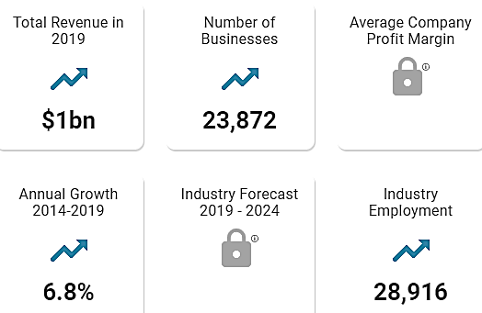
It is important to know the size of the market for your industry (the number of buyers and the amount they spend annually) as this is one indication of the potential success of your business. This data will help you decide whether to start a new company in the industry. Investors and lenders will want to know this as well as it helps them gauge the probability of your success.
Market size data on every imaginable industry is available at www.IbisWorld.com. Although a full industry report is approximately $1000 (2019), enough data is available free to glean some very useful information. For example, a search on “Food trucks” provided the following:
From the public data on the IbisWorld site, the average food truck is a one-person business grossing $42,000 per year. “Total Revenue” looks like a guess, so I would not rely on the revenue data

Calculating TAM SAM SOM. These are short-hand expressions of measures of your market size.

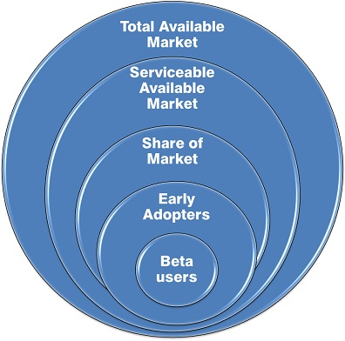
TAM: TOTAL AVAILABLE MARKET. Everyone with problem in world. (If product is left-handed scissors, how many left-handed people are in the world?)

SAM: SERVICEABLE AVAILABLE MARKET. The market segment served by
your solution. (If your scissors are designed primarily for cutting cloth, how
many left-handed tailors, clothes designers, seamstresses, crafters, and
people who make their own cloths from patterns are there?)

SOM: SHARE OF MARKET that you can aquire, realistically, based on your:
- Technology
- Geography
- Features
- Price
- Capacity
If your scissors are priced at $100, but have ball bearings to prevent fatique
by employees in the the clothing industry, you will probably have to eliminate
do-it-youselfers. Also, as a startup, you may not be able to reach all markets.

Your TAM SAM SOM

TAM Units per year _______________ $_______________

SAM Units per year _______________ $_______________

SOM Units per year _______________ $_______________

Goal for number of beta testers _______

How did you arrive at your TAM SAM SOM numbers? What are your sources of information?

Competitive Positioning

F. COMPETITIVE STRATEGY

HOW WILL YOU DIFFERENTIATE YOUR PRODUCT OR SERVICE? Your options are:
- Lower price. To maintain this competitive advantage you will need to purge every excess cost from the supply chain. (Examples: Walmart, Bob’s Discount Furniture.)

- Superior product. Better quality materials, more aesthetically pleasing design, better performance, more feature options. (Apple).

- Superior service. On-site repairs, longer warrantee, 24-hour phone support, returns accepted for full credit and with no questions asked. Some online apparel sellers ship in cartons that can be used to return unwanted merchandise.

- Unique Market Niche. A sub-group of customers not adequately served.

YOUR COMPETITIVE STRATEGY:

________________________________________________________________________________________

________________________________________________________________________________________

________________________________________________________________________________________

________________________________________________________________________________________

________________________________________________________________________________________

________________________________________________________________________________________

________________________________________________________________________________________

________________________________________________________________________________________

________________________________________________________________________________________

________________________________________________________________________________________

Before settling on your Competitive Strategy, you might want to read some advice from other entrepreneurs who have been down the same path. Entrepreneur Magazine has published guides (at under $20 each) for starting businesses in more than 60 different industries. For titles, see
https://bookstore.entrepreneur.com/product-category/starting-a-business/start-your-own-series/?orderby=menu_order
Competitive Positioning

g. Barriers to Entry

(How you’ll prevent—or retard--other people copying your idea)

Business Modeling

4 – Business Model Canvas

- Lean Business Model Canvas
B. Assess Skill Needs

C. Project Management (Team Collaboration)

D. Market Research: Survey Customers to Verify Assumptions

E. Validate Demand (The Landing Page)
F. Pivot Record
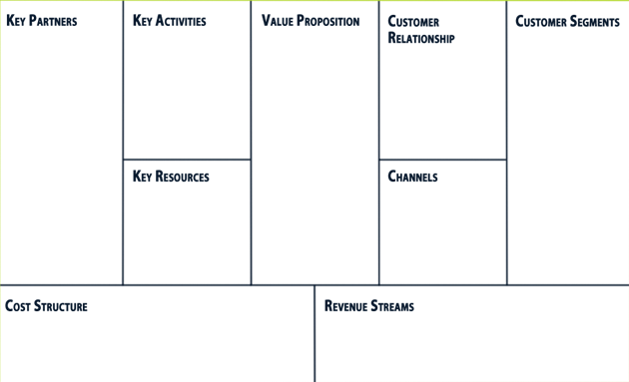

A Business Model Canvas (BMC) is a shorthand approach to business planning, whereby the entrepreneur lays out assumptions about the market and tentative plans all on one page; and then tests those assumptions through surveys and prototype testing with potential customers. The premise is that you will find some false hypotheses, some customer reactions you did not expect; and it is a lot better to discover flaws in the business concept before you create detailed plans and invest in the concept.

Shown above is the original Canvas, developed by Alexander Osterwalder in 2008 to help businesses bring new products to market quickly and economically.
In this text, we use the newer Lean Canvas, created by Ash Maurya, as it assumes the business is a startup, and not an established company. If you prefer to use the Osterwalder BMC, we have included it as well, in the appendices. Click here to access.

Business Modeling

A. LEAN Business Model Canvas

The Business Model Canvas (BMC) is a useful process for thinking through the business model for a new enterprise. The BMC helps you

- Quickly explain your idea to others
- Identify who has the problem that you are trying to solve
- Get to Product Market Fit (the degree to which a product serves a strong market demand) by Asking, Listening and Learning.

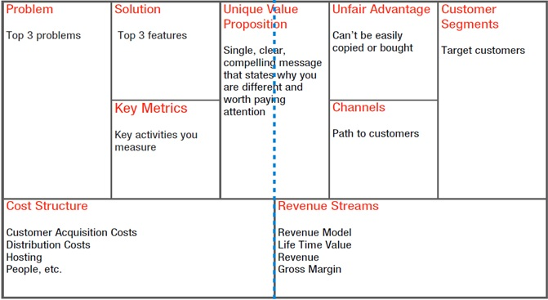
FINANCE
Gross Margin
Existing Alternative Sound bite: Early Adopters
Solutions
PRODUCT
MARKET

Click here to access a fillable Lean BMC on Google Docs: https://docs.google.com/drawings/d/16uOd158UzJM9oqGWgJOtbppzGNPmZ4fWMSV6_xBz3Z8/edit
As you pivot (modify your plan), go back online and update your BMC, and print out the new iteration.

See “Project Management (Team Collaboration)” section for free online canvasses that all team members can access.

VIDELINK Eight-minute overview on how to fill out a Lean BMC, using Uber as an example.
https://www.youtube.com/watch?v=pvIN9STpzCQ

Here is a 16-minute video if you want more details
https://www.youtube.com/watch?v=uE34HsmT6E0

Business Modeling

THE NINE SEGMENTS OF THE LEAN CANVAS

By Ash Maurya

Problem. Most startups fail, not because they fail to build what they set out to build, but because they waste time, money, and effort building the wrong product. I attribute a significant contributor to this failure to a lack of proper “problem understanding” from the start. “A problem well stated is a problem half-solved.” - Charles Kettering

Solution. Once you understand the problem, you are then in the best position to define a possible solution. That said, I purposefully wanted to constrain entrepreneurs (by using a small box on the canvas) because the solution is what we are most passionate about. Left unchecked, we often fall in love with our first solution and end up cornering ourselves into legacy. Keeping the solution box small also aligns well with the concept of a Minimum Viable Product (MVP).

Value Proposition. The value you provide versus the cost to the customer: the amount you charge and any indirect expense, like retraining employees on a new system, having to pay to park, or other inconvenience.

Key Metrics. Startups often drown in a sea of numbers in an attempt to bring order to the chaos of uncertainty. At any given point in time though, there are only a few key actions (or key macro metrics) that matter. “A startup can only focus on only one metric. So you have to decide what that is and ignore everything else.” - Noah Kagan.

Failure to identify the right key metric can be catastrophic–leading to wasteful activities like premature optimization or running out of resources while chasing the wrong goal. Initially these key metrics should center on your value metrics and later they should shift towards your key engines of growth.

I was cognizant of the fact that few startups have a true unfair advantage on day one, which means this box would be blank. “A true unfair advantage is something that cannot be easily copied or bought.”- Jason Cohen

Customer Segments. The users of Cocoa Puffs are children, but are they the ones who make the buying decisions (the customers)?

a) Who is the ultimate user? Who are the decision makers in the buying process?
b) Demographics of Market Niche (potential customers you will appeal to).
- Age
- Gender
- Where they live, work
- Educational level
- Income level
- Any other pertinent descriptors (e.g. -- home ownership)
What are their Buying Habits?
Whom do they buy from now? Why?

Channels. How will you deliver the product or service to the customer? How will the user become aware of the product? How will you support customers after purchasing and delivery?

Cost Structure.
a) How much it will cost you to provide product/ service.
b) Pricing Model (e.g. – low-volume, high margin)

Revenue Streams.
a) Who will pay you (distributor, wholesaler, end user)?
b) How will you collect the money?

Lean Business Model Canvas Product ________________________

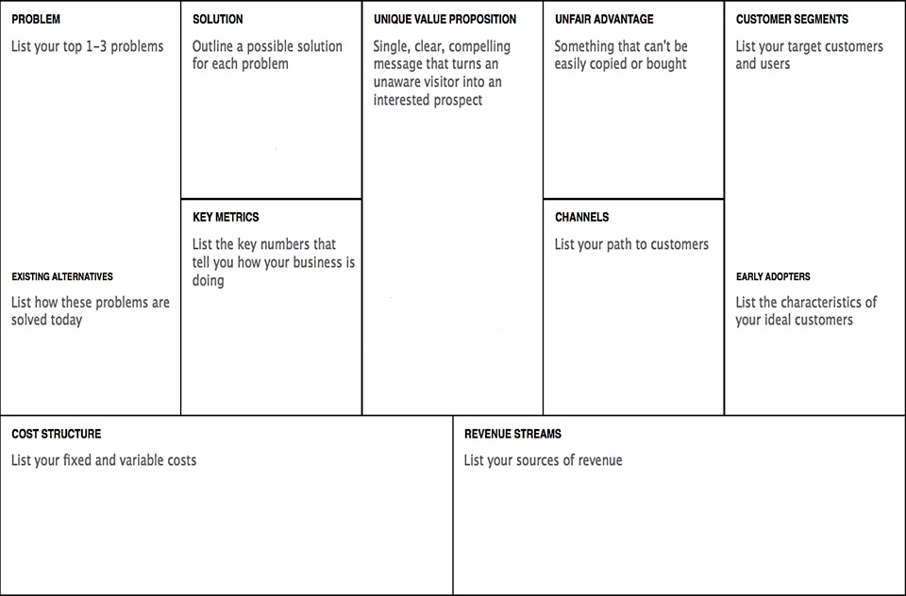

Click on a colored section to add text. Slide color block to side to see explanation of section.

Business Modeling

B. Assess skill needs

At this point in the process, your professor or facilitator may want to form the group into project teams of 2 to 5 individuals to reduce the field to a manageable number of viable concepts.
When ready to assemble a permanent team, see “Management” section.

1. Skill categories needed for any business team to be successful
- project management

- industry experience
- technical
- market research
- marketing
- finance and accounting

2. Skills needed for my project

□ writing,

□ fluency in __________,

□ graphic design,

□ web design,

□ software or app development,

□ accounting,

□ marketing,

□ market research

□ other _______________________________________

3. Skills I can contribute to a team

Business Modeling

C. Project Management (Team Collaboration)

It can be challenging for teams to communicate and work collectively on a Business Model Canvas, product prototype, website, or other activity that requires participation from multiple members. Project Management tools can literally keep everyone on the same page, set priorities and goals, and let everyone know what is expected of them, with due dates. Following are some free online PM platforms you may want to check out.

LeanStack.com Free to students with an .edu email; otherwise $10/ month for a team of 5 (as of 2019).

Canvanizer.com Templates for both the Lean Canvas and the Osterwalder model. To go directly to the Lean Canvas see https://canvanizer.com/new/lean-canvas

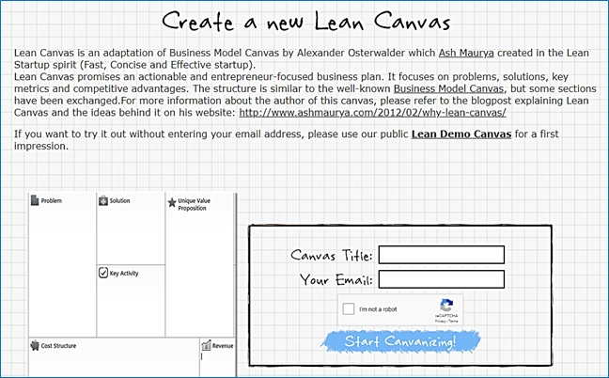

THE FOLLOWING ARE FREE PROJECT MANAGEMENT PLATFORMS, BUT THEY DO NOT OFFER A BUSINESS MODEL CANVAS TEMPLATE.

Zoho.com This SAAS provider offers a free platform. Click on “Pricing” and then scroll down to the “Free Plan” that allows up to five users. This two-minute YouTube video clearly explains how to use the software: https://www.youtube.com/watch?v=NfZ3rwLxzNs.

Asana.com Designed to manage marketing campaigns. The “Basic” plan is free. As with Zoho, you can assign tasks and deadlines to team members.

Trello.com Uses digital 3x5 cards to help you and your team keep track of tasks.

Business Modeling

D. MARKET RESEARCH: SURVEY CUSTOMERS TO verify assumptions

VIDELINK Surveying customers to validate business concept: https://hitenism.com/business-ideas/

Start with face-to-face surveys. People will be more likely to volunteer additional information in person, or to ask you questions that may give new clues to their concerns as potential users.

Before jumping into the Q&A, give the survey prospect your elevator pitch, to put your questions in context.

Do not assume that you already understand the true nature of the customer points of pain. Probe them for details during the interview; ask follow up questions: “Why is that important?” Your objective is to validate pain points, not to validate your solution.
Once you have surveyed 20 or more people live, you can confirm some of your conclusions and drill down on issues with an email or online survey.

FREE SURVEY SERVICES. www.SurveyMonkey.com, www.QuestionPro.com offer free surveying (up to 10 questions and 100 respondents that you supply). Survey your Facebook friends and Twitter followers if they match the demographics of your intended customers. Students in an entrepreneurship class can also answer each other’s questions.

FEE-BASED SURVEY SERVICES. Google and Amazon will provide survey-takers for you, for a fee. Google Surveys offers partly filtered paid responses ($.10 per respondent for 1 question, $1.00 per person for up to 10 questions (as of 2019). See https://support.google.com/surveys/answer/2447244 for details.

Amazon’s www.MTurk.com is also fee-based, but you can set the amount you are willing to pay. MTurk then adds 25%. Be sure to request “Masters” (respondents with verified demographics and high ratings from prior surveyors). Otherwise, you will wind up paying Nepalese Sherpas for opinions on your new hip-hop release.
MAXIMIZING THE LIKELIHOOD PEOPLE WILL TAKE THE TIME TO RESPOND.
- Start with simple, non-threatening questions to qualify the respondent. A qualified respondent is someone who is representative of your target customers. For example, if you are launching a roofing company, you will probably want to know if the respondent is a homeowner.
- Put the demographic identifiers you might need (gender, age, occupation, etc.) at end of survey.
- Keep question wording short, and limit number of questions to no more than five. If you need more feedback, do two surveys.
INSURING RELIABILITY OF RESULTS.
- Use multiple-choice questions (no more than five options) or yes/no questions. Keep it simple.
- Avoid absolutes like “Always” and “Never” as answer options. Be specific. If question is how much time a person spends in the car, use choices such as “Less than 10 minutes a day, 10-30 minutes, 31-60 minutes, 61-120 minutes, over 120 minutes.” Note, every possible situation is covered, and answers do not overlap. Vague answer choices like “A lot of time” may mean 30 minutes to 1 person and 2 hours to another.
- Make sure words are simple and unambiguous (not subject to more than one interpretation), To make sure the questions and answer choices mean to others what they mean to you, ask your friends the questions and answer choices and then ask them to explain to you what they mean. You may be surprised at the answers you receive.
For additional surveying tips see https://support.google.com/consumersurveys.

Business Modeling

CUSTOMER SURVEY. At this stage, what you need to find are current buying habits for your solution:
- Amount customers would be willing to pay
- Where customers would want to purchase (in store, online, other)
- How customers expect to find out about a new product or service
- Opinion of your offering versus alternatives
- Most valued and least valued features

Respondent Demographics Estimate age >> | M – F  Age~___ | M – F  Age~___ | M – F  Age~__ | M – F  Age~___ | M – F  Age~__
A. What would most affect your buying decision?
Price, convenience, fast delivery, choice of styles/colors/sizes, other.
B. How would you improve
upon the product?
C. How much would you
be willing to pay?

D. Would you use product?
5 = definitely,
4 = probably
3 = maybe
2 = probably not
1 = definitely not
E. If you are not likely to use product, why not?

If potential customers are not as enthusiastic as you hoped, probe to find out why; how would they solve the problem you are trying to address?

Business Modeling

E. VALIDATE DEMAND (The Landing page)

The only way to be certain that customers will actually buy your product, at the advertised price, and with the intended featured, is to ask them to take out their credit card. You may find that even your friends may vanish into a fog of non-commitment.

To obtain honest opinions you might want to set up a Landing Page, a temporary website to accept pre-orders or to obtain emails of potential clients who want to be notified when you launch. According to Unbounce.com a landing page is a one-page website created specifically for the purposes of test marketing. It’s where a visitor lands when they click on a Google ad or a link in an email sent by you to prospects.

Landing pages have a single objective – known as a Call to Action (CTA). As such, they do not have additional pages, as does a traditional web site. Any other information is a potential distraction from the laser-focus of the CTA. Typical Calls to Action are:
- Pre-order product not yet manufactured. Reward-based crowdfunding sites like Kickstarter and Indiegogo are landing pages. Of course, you have to share the platform with other companies (potential distractions to your customers) and pay about 8% to the platform provider as a commission and to cover payment-processing fees). Pre-selling your product or service may give you—and your investors—the confidence you need to press forward with your plans. Moreover, it helps with the cash flow if you collect all or part of the purchase price in advance. Just make sure you can and do deliver when you promise. Entrepreneurs keep their word.
For details, see section in this text on “Reward-Based Crowdfunding.”
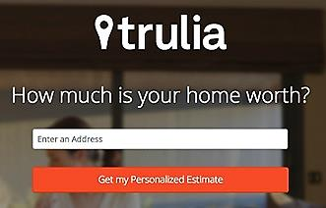
- Sign up to be notified when a product or service will be available. You might be able to gauge whether there is enough potential demand to invest funds in R&D, inventory and marketing; and you can survey prospects as to which features are most important.
Get a free estimate
Enter an address
You can also throw up this notification form on your main web site to capture contact information of anyone who discovers you from a web search.
- Provide contact information in exchange for a free report, webinar or free trial. The offer shown here by Trulia, an online real estate agency, is an example of a lead-generation landing page.

Flea Markets and local fairs are an easy and low-cost ($15 to $25) way to test market a product or service, or to obtain feedback on a prototype. People love to give their opinion. Take along some printed surveys and product samples and find out what consumers do and do not like. Think of it as a brick-and-mortar landing page

To find flea markets near you, go to...
http://www.keysfleamarket.com/fleamarket/state/

Business Modeling

A/B TESTING. You can create multiple landing pages to try different …
- Marketing copy,
- Product names,
- Package designs
- Price discounts (does two for $1.98 outperform $.99 each?)
- Customer preference for feature A versus feature B
- SEO metatags
- Adwords
The A/B tests will allow you to see which options convert more ad readers to ad clickers, and more website or landing-page visitors to buyers.

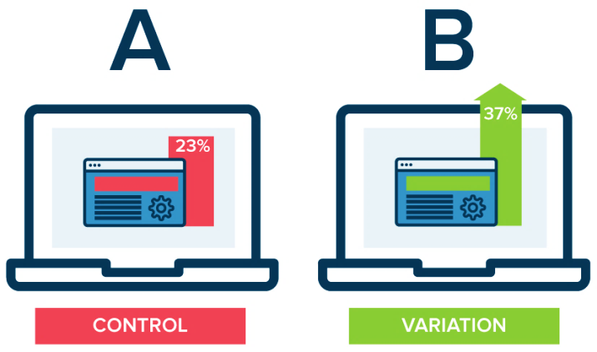
A hypothetical example by Optimizely.com comparing conversions between landing pages, one with a red color scheme, the other green.

A seemingly trivial change can sometimes result in very different conversion results. In a real test of 2000 visitors, a red “get started now” button converted 21% more visitors to a landing page. That is, 21% more visitors clicked through when the Call-to-Action button was red.


LANDING PAGE PLATFORMS. Most provide a free basic service. Analytics are sometimes extra.

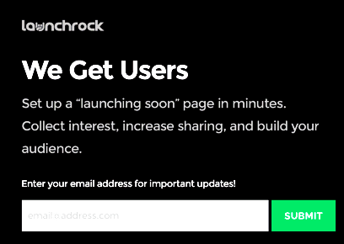
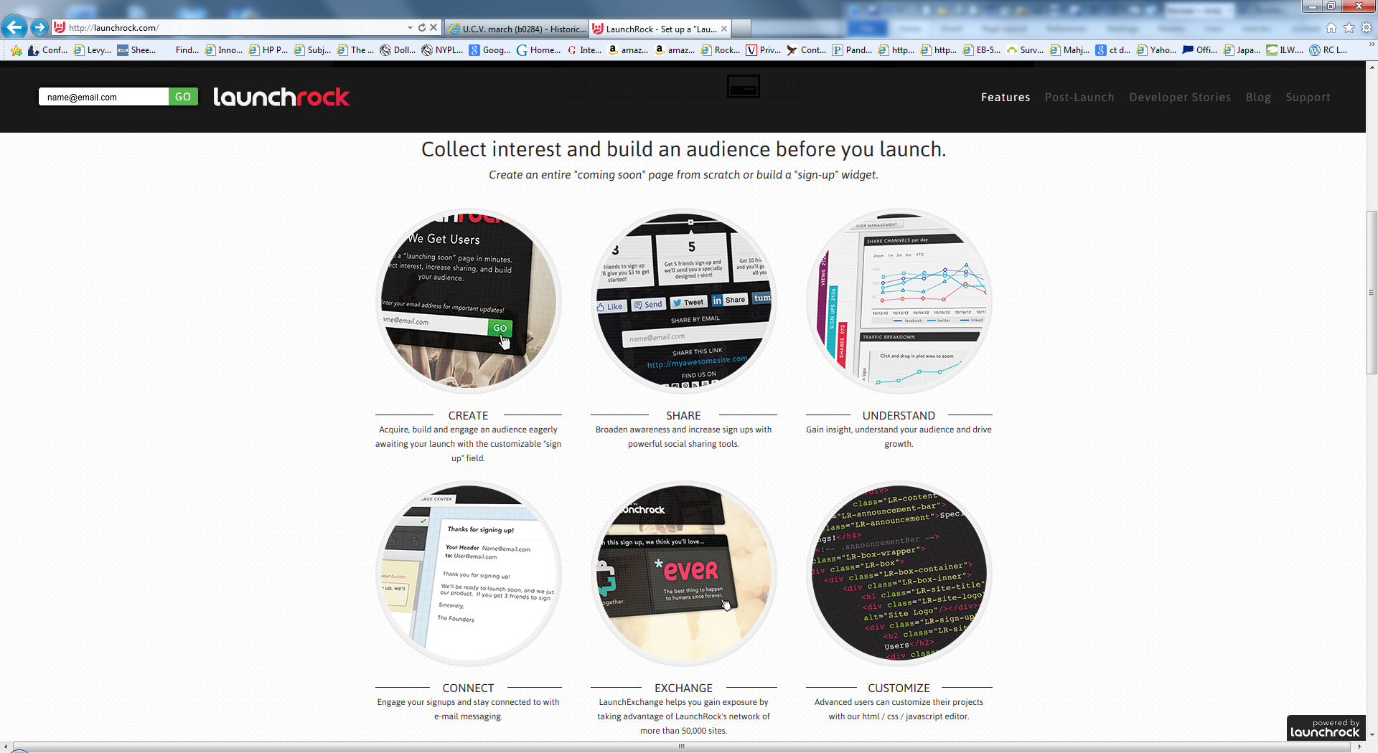
LaunchRock.com Helps new companies acquire beta testers and customers. (LaunchRock practices what they preach; the Call-to-Action [right] is from their website.)

Mailchimp.com Free basic landing page, plus free email marketing platform.

SquareSpace.com $26 month, including online store (as of 2019).

Wix.com. They are a traditional web hosting service, cheap and easy to use, and you can create a one-page landing page (www.Wix.com/YourCompanyName).

Leadsanity.com Free.

Landerapp.com $49 month ($16 month if one year paid In advance, as of 2019). Their website offers great advice, such as this article by Tom Starley on improving conversion rates: https://landerapp.com/blog/conversion-psychology-landing-pages-improvement/

Unbounce.com Expensive but great how-to articles. Perhaps a good fit after you reach your first million in sales.

Quickmvp.com/ $60 a month (as of 2019)

Business Modeling

F. PIVOT RECORD

Indicate date and nature of each refinement made to BMC or plan

1. Date ___________ [ ] Product/Service [ ] Target Market [ ] Marketing
[ ] Distribution channel [ ] Price [ ] Business Model [ ] Other____________________
__________________________________________________________________________
__________________________________________________________________________
__________________________________________________________________________
__________________________________________________________________________

2. Date ___________ [ ] Product/Service [ ] Target Market [ ] Marketing
[ ] Distribution channel [ ] Price [ ] Business Model [ ] Other___________________
__________________________________________________________________________
__________________________________________________________________________
__________________________________________________________________________
__________________________________________________________________________

3. Date ___________ [ ] Product/Service [ ] Target Market [ ] Marketing
[ ] Distribution channel [ ] Price [ ] Business Model [ ] Other___________________
__________________________________________________________________________
__________________________________________________________________________
__________________________________________________________________________
__________________________________________________________________________

EVALUATION GUANTLET. At each stage, advance, pivot (modify the productor plan), or go back to square 1
1-IDEATION | 2-PATENT SEARCH | 3-FEASIBILITY ANALYSIS | 4-MARKET VALIDATION | 5-MVP TEST | LAUNCH

Designing the Product or Service

5 – Designing the
Product or Service

DESIGN > PROTOTYPE > ALPHA TEST by entrepreneur > BETA TEST by customers

A. Minimum Viable Product or Service

B. Physical Product Prototyping

C. Resources for Product Prototyping and Manufacturing

D. Electronic Product Prototyping

E. Software and Mobile App Rapid Prototyping

F. Software and Mobile App Final Development

G. Market Testing the Product or Service

Designing the Product or Service

A. Minimum Viable Product or Service

A MINIMUM VIABLE PRODUCT [or SERVICE] (MVP) is one with the fewest set of features necessary to test basic functionality, measure customer acceptance, and determine investor interest. MVPs can be counter-intuitive since full-featured products are considered easier to sell as they have something for everyone. However, building more features than necessary risks wasting time and money on functionality no one wants. It can also be difficult to determine why a customer rejected an iteration that incorporated many features or simultaneous changes.
In the business R&D phase, founders rapidly evolve the MVP based on customer feedback obtained through interviews, focus groups, and usability tests.

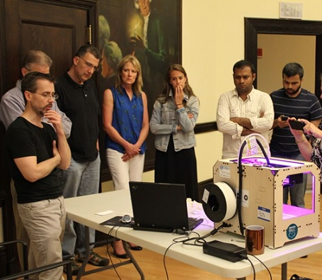

A 3-D printer mesmerizing onlookers

Designing the Product or Service

B. PhysICal Product Prototyping

Develop the product in stages to conserve capital and reduce risk.

- First-Stage Prototype. A prototype that demonstrates proof of principle: that your idea will work. It does not have to be pretty, and it may not even be fully functional.
- Second-Stage Prototype. A product iteration that can be produced in small quantities and with a level of quality adequate to assess market reaction. The manufacturing method does not need to be the optamum method for later volume production.
A common mistake at this stage is to attempt to produce a test supply of from 10 to 100 samples at the eventual projected cost. It is hard for entrepreneurs to accept the idea of losing money on a production run for market testing. However, if you try to bring your costs in line with your eventual goal you will wind up producing far too many, and the marketplace may reject model 1.0.

Plan on losing money on every product until you have iterated to the perfect design and set of features. Then research methods of economical production that will allow the product to be sold at a competitive price and still earn a gross margin of 40% to 70%.

  - DESIGN AND ENGINEERING ASSISTANCE. If, as is usually the case, you need engineering and design help before approaching a manufacturer, you may wish to work with a component maker with design capability or go to a design house like BigBang, with offices in New Haven and Atlanta. They have major corporations as clients but also work with startups and know how to engineer products for efficient production at varying volumes.

  - BUILD OR BUY. If you are willing and able to serve as general contractor and perform the final assembly, you can utilize multiple component manufacturers to reduce costs.
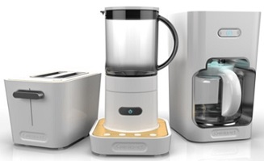
No matter how many manufacturers you ultimately work with, development of your second-stage prototype will likely require some trial and error before you arrive at a functional, aesthetic and economically viable product. This process will offer a good guide for tooling costs and unit pricing over some volume range, but it may not represent the costs for tooling optimized for higher volume production.

Products designed by
Big Bang for Cuisinart.

- Third-Stage Prototype. After you have evaluated the performance of the second-stage prototype in the market and decided you want to proceed, the next step is to prepare the production prototype. The production prototype should be designed in such a way as to be able to be manufactured in volume at the lowest possible price while maintaining the most important features and quality that customers expect.
Reward-based crowdfunding (e.g. Kickstarter.com or Indiegogo.com) is a great way to underwrite the cost of tools and dies and your initial production run. To arrive at a realistic fundraising goal for this stage, prepare a comprehensive cost accounting of all the component parts and labor.

Designing the Product or Service

ESTIMATING COST OF THE THIRD STAGE (FULL-PRODUCTION) PROTOTYPE

Although the product or service features may change as a result of market research interviews and feedback from user testing, you will want to do a quick estimate of costs in order to give potential buyers an estimate of their price when the product rolls out officially.

As a rule of thumb, most retail prices are 3 to 4imes costs (to allow for competitive margins for wholesalers and retailers.

This is an interactive spreadsheet. To open, right-click on the form, click on “Worksheet Object” and then on "Open.” This spreadsheet shows data for an example company. To use form for your company, delete sample data in shaded fields. (Do not delete data in white boxes as these contain formulas.) You can download a copy of this form at http://www.EntrepreneurshipFoundation.org/spreadsheets.html

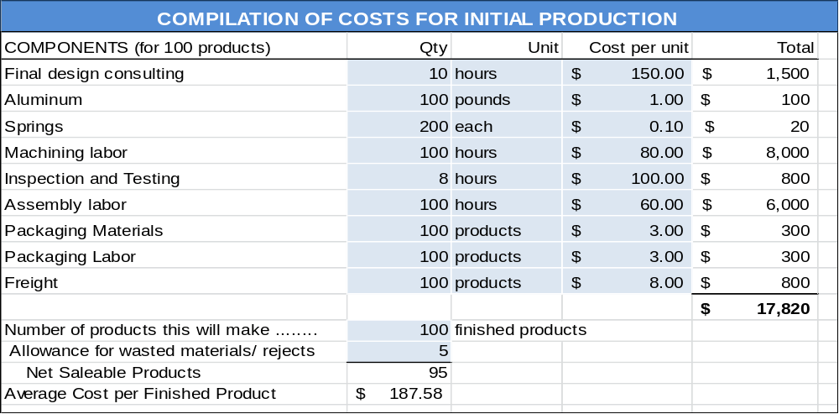

SELECTING A MANUFACTURER FOR VOLUME PRODUCTION. If you plan to use a domestic manufacturer, you will continue either with the manufacturer that made your second-stage prototype or find another that is more capable of manufacturing in the volumes you are now considering.

If you plan to use a manufacturer in a low-cost country, make certain you have assessed the issues associated with offshore sourcing. Offshore manufacturers often rely on large-volume production and make deliveries only when they can ship large quantities in order to minimize freight costs.

MEETING WITH MANUFACTURERS. The best approach to take when meeting with manufacturers to discuss prototyping, larger-scale production, cost estimates or possible collaboration is candor. Express your needs and expectations clearly, provide as much detail about the product as possible and offer market projections based on professional market research. Also, be clear about how you expect to pay for the services you need.

Keep in mind that most small manufacturers are wary of startups. They do not want to waste their time working with startups that have a poor understanding of their markets and anticipated production volumes. They will expect you to have market research to support your claims.

Designing the Product or Service

c. Resources for PRODUCT Prototyping and Manufacturing

1. Prototyping. Many colleges and universities have 3-D printers that are excellent for prototyping. There are also maker and hacker clubs that may offer assistance.

METAL COMPONENTS SOURCE. Metals Depot will ship “any size, any quantity, anywhere”: http://www.metalsdepot.com/index.php. The company will also fabricate parts.

FASTENERS AND OTHER STOCK PARTS. www.McMaster.com is an excellent source for a wide variety (550,000 items in stock) for prototyping and initial short runs for market testing. Stock parts include nuts and bolts, shims, spacers, threaded inserts, metal stock for machining, tubing, bearings, motors, belts, gears, etc.

PLASTIC COMPONENTS SOURCE. Check out Modern Plastics. They will sell small quantities and offer fabrication services. http://www.modernplastics.com.

2. Production. You will need to provide a professional drawing or sketch for manufacturers.

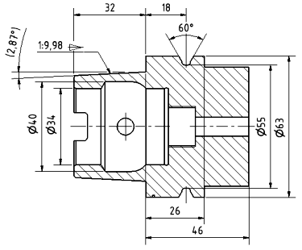
To cost out components and materials, or to find a company that can manufacture the complete product, consult the Thomas Register, a directory of 700,000 manufacturers. See www.thomasnet.com

Designing the Product or Service

D. Electronic product protoyping

The easiest way to create a prototype of an electronic product is to purchase an off-the-shelf “breadboard” kit. With this type of board, components are connected manually. When you are ready to mass-produce, use a “surface mount” board. Surface mounted parts are glued to a “printed circuit board.” The boards are then put into an oven to melt the solder for the electrical connections.
The two most popular breadboard systems for prototyping are the Arduino and Raspberry Pi brands. An Arduino is a microcontroller motherboard with a simple computer that can run one program at a time, repeatedly. It is very easy to use. A Raspberry Pi is a general-purpose computer, usually with a Linux operating system, with the ability to run multiple programs.
According to MakeZine, an Arduino is best used for simple repetitive tasks: opening and closing a garage door, reading the outside temperature and reporting it to Twitter, driving a simple robot. Raspberry Pi is best used when you need to drive a complicated robot, perform multiple tasks or compute complex calculations (such as needed for encrypting). Think about what you want your project to do. If you can describe it using the word “and” two or fewer times, get an Arduino; otherwise you will probably need a Raspberry Pi. For more information, see http://makezine.com/2015/12/04/admittedly-simplistic-guide-raspberry-pi-vs-arduino/

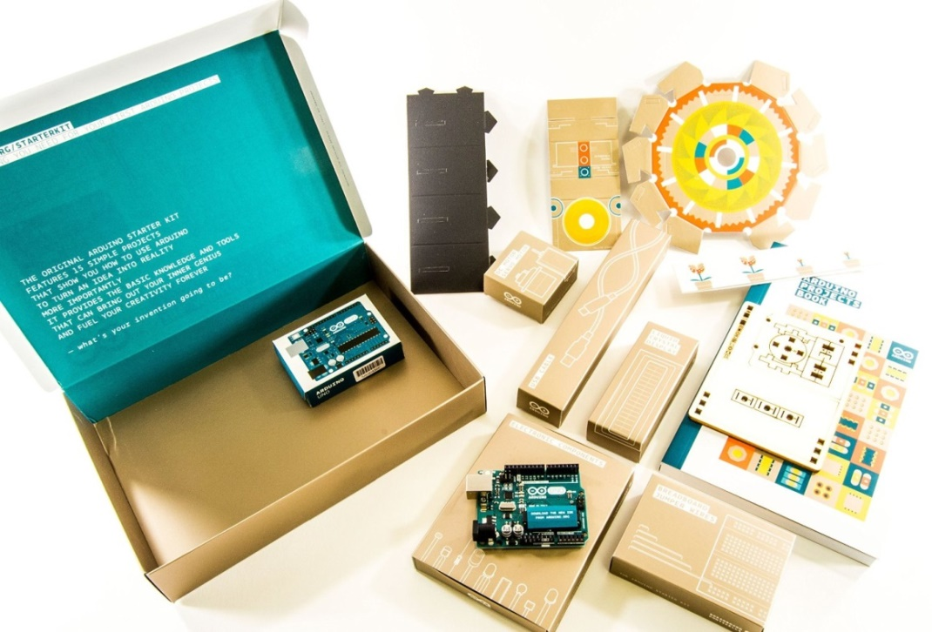
Arduino Starter Kit K000007
by Arduino.org
$69.48 at Amazon (2019)
- Step-by-step tutorials
- Breadboard
- Led lights
- Capacitors
- Photoresistors
- Resistors
- Diodes
- Potentiometers
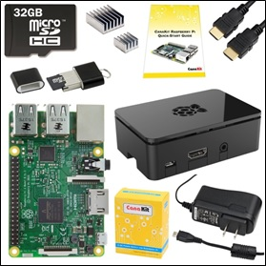
- Push button
- Servo motor
- LCD display
- Temp and tilt sensors
- USB cable

Raspberry Pi 3 Complete Starter Kit - 32 GB
By CanaKit.
$75 at Amazon.com. (2019)

- Quad-Core 1.2 GHz
- 1 GB RAM
- On-board Wi-Fi and Bluetooth connectivity
- Project case

Designing the Product or Service

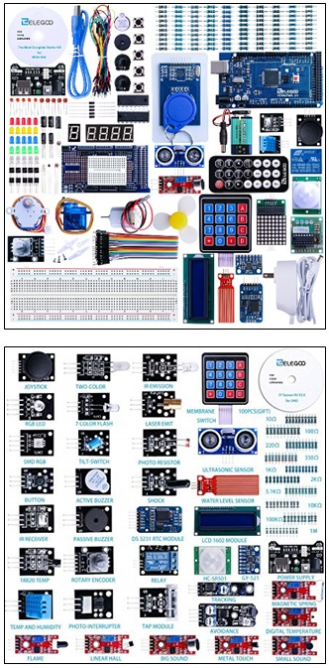

For projects that are more complex, you may need an add-on package.

Elegoo EL-Kit-008 Starter Kit for Arduino
Mega2560 UNO Nano
$60 (2019) at Amazon.com
- 200+ pieces including UNO board
- Well packaging with divider tray
- Includes keypad, remote, and readouts
Note: there are two breadboards in this kit.

Elegoo 37 Sensors compatible with R3 Arduino Mega2560 UNO
$30 at Amazon (2019)

Designing the Product or Service

E. Software and Mobile App Rapid Prototyping

If you or a co-founder is skilled at coding, great, you will save time and money doing the development yourselves. To insure that the CEO, CMO and CTO are all on the same page, it will be helpful to create a mock-up showing how the software is to work, especially the user experience (UX), with screen shots and working links to navigate between pages.

If you plan to outsource the development, the demo model will help to explain what you are expecting in the finished product; which will save developer’s time and you money; and prevent rework due to misunderstandings.

A demo version also allows you to show competition judges, investors and potential customers (for market research) exactly how your software or mobile app will function.

There are a number of free and low-cost tools available that anyone who can use to create remarkably convincing prototypes. No coding required.

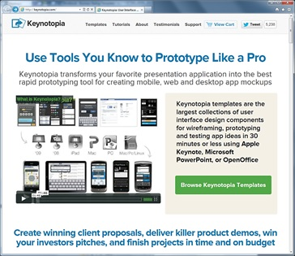
- MICROSOFT PowerPoint and Apple Keynote both support clickable links to jump to other slides (posing as web pages), embedded video, and slide transitions to simulate animation.

- KEYNOTOPIA.COM provides templates for rapid application prototyping in Keynote. See http://www.apple.com/iwork/keynote.

- ADOBE XD. For website wireframing and creating interactive click-through prototypes for mobile apps. For macOS, Windows, iOS, and Android. Freemium.
https://www.adobe.com/products/xd.html

3. PROTO. iPhone and Android App development: www.Proto.io. Free for 15 days, then $12/mo. for students (2019).

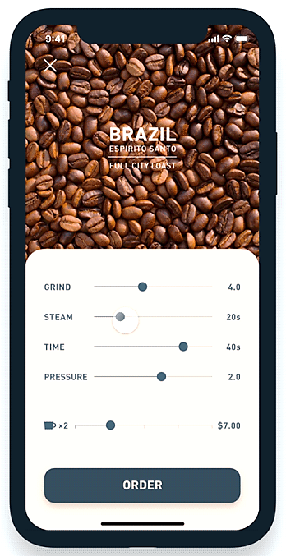
4. FLINTO.COM. Free for 30 days, then $99 per year (2019). For iPhone or Android. http://www.Flinto.com

5. Balsamiq. For quick software mockups. Web-based. $89 one-time license fee (2019). www.balsamiq.com
6. ForeUI. Mock up and simulate an app in a browser. PC/Mac. $150 for permanent license (2019). http://www.foreui.com

Mockup of Coffee-ordering app developed by Shingo Suzuki on Adobe XD

Designing the Product or Service

F. Software and Mobile App FINAL DEVELOPMENT

If you have created a prototype, and shown it to prospective users to:

a) Verify that it solves a real problem for which people would be willing to pay you to solve; and

b) Satisfy yourself that users will intuitively know how to use the software product or app and not get all befuddled and annoyed because it does not work the way they expect it to…

… then you are ready to develop the final version to sell—although on a limited basis until you are certain you have worked out all the bugs.

WHERE TO FIND DEVELOPERS. If you want to find those near you, just search online for “developers” (or “programmers” or “coders”) near [your city]. The advantage of buying local is you can interview the person face-to-face; or if a company, visit the office to meet the people who will be working on your account.

You can also access developers through freelancing sites like www.elance.com, www.freelancer.com, www.upwork.com, and www.fivrr.com where you can review samples of their work. Many of the freelancers work in countries where wage rates are lower, but communications may not be as good unless you speak the same language and are awake at 5 am when they are. Someone working for $10 per hour, but who takes longer (because of misunderstandings) can be more expensive than someone nearby who charges $30 an hour.

It may be wise to work through a local company who in turn works with employees in other countries, as they can translate your needs accurately.

The freelance sites usually allow you to set a budget limit, which protects you from cost overruns, but may not be fair to the freelancer if they have to redo work because your instructions were vague, or they just did not understand correctly because of language differences. The best solution is a written set of very detailed specifications from you, so the freelancer can make an informed estimate of the time required and therefore give you a firm quote you can both live with. This is an ETHICAL question for all employers of contract employees

FREE TEMPLATES TO SPEC SOFTWARE AND APP PROJECTS.

Software Requirements Documents (SRD)
https://krazytech.com/projects/sample-software-requirements-specificationsrs-report-airline-database
App Requirements Documents (ARD)
- http://www.creativesparksolutions.com/blog/how-to-create-a-requirements-document-for-your-mobile-app-steps-and-tips/
- https://clearbridgemobile.com/product-requirements-document-free-template/

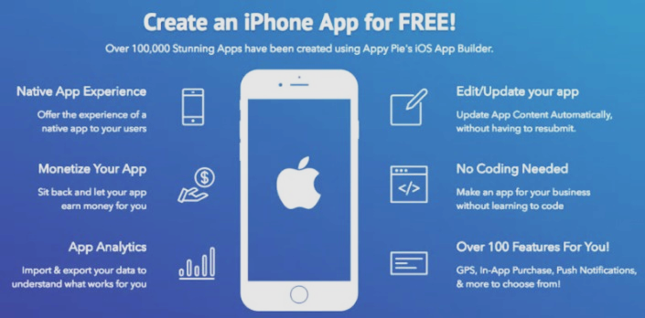
WHAT TO BUDGET FOR DEVELOPMENT
- APP -- $5,000 to $50,000 depending on complexity of software and credentials of developer
- SOFTWARE -- $50,000 to $150,000
Double these amounts if your SRD or ARD is unclear or incomplete.
DIY App development dashboard
https://www.appypie.com/.

DIY APP MAKERS. There are now programs that allow you to create actual finished products, even if you are not a coder. If you do know how to code, these aids can save you time on simple routines, and you can still add your own HTML. Most of these DIY programs cost $50 to $100 per month, plus a one-time fees of $99 and $25 paid to Apple and Google (respectively) for the right to develop apps for their platforms. For an excellent review of platforms see https://mashable.com/article/build-mobile-apps/ by Jake Krol (August 2018).

Designing the Product or Service

G. Market TESTING THE PRODUCT OR SERVICE

All new products and services must go through two testing periods before release for sale:
- ALPHA TESTING. This is testing in the lab. Does product work as intended? How well does it hold up with normal handling? What if it gets wet, cold or hot? For software, use it extensively to catch as many bugs as possible before allowing customers to try it. For services, practice on friends and family.



Auto
test
track

- BETA TESTING. Early adopters, customers willing to try new things, perform this testing. Ethically, you should warn customers that the product has not been fully vetted. Typically, beta testers use the product free of charge.

HOW TO KNOW WHEN YOUR PRODUCT IS CONSUMER-READY: THE NET PROMOTER SCORE (NPS)
This simple test, developed by Satmetrix, has a lot of research behind it. It consists of asking only one question: “How likely is it that you would recommend our company to a friend or colleague?” Users choose an answer along a scale from zero to ten, with zero meaning “not likely at all”, and ten “Extremely likely”.

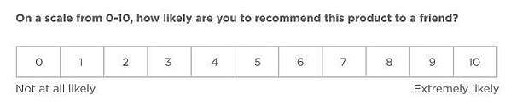

Research shows that responses of
- 9 or 10 are “Promoters”, people who will repurchase and actually refer others
- 7-8 are “”Passives” who are satisfied but easily drawn away by competitors
- 0-6 are “Detractors” who are unhappy and may damage you brand through negative word-of-mouth
Subtract the percentage of Detractor responses from the percentage of Promoter responses to arrive at your NPS.
NUMBER OF PEOPLE YOU SURVEYED #_____
PROMOTORS #_____ (_____%) DETRACTORS #_____ (_____%) YOUR NPS = _________

Highly successful companies operate in the 50-80 range. To find out the average NPS for competitors in your industry, see https://www.satmetrix.com/nps-benchmarks/. Some examples of industry leaders are:
- Airlines – Southwest with a Net Promoter Score of 71
- Credit cards – Amex 55 NPS
- Cell Phone Service – Cricket 55 NPS
- Department Stores – Costco 74 NPS
- Health Insurance – Kaiser Permanente 33 NPS
Insurance

6 – Insurance

A. Types of Business Insurance

B. Typical Business Insurance Rates and Coverage

Insurance

A. TYPES OF Business Insurance

As soon as you commence operations, you company are liable for injuries sustained by employees and customers resulting from business activities. Each of the following types of insurance may or may not be necessary, depending upon your risk exposure and state regulations.

Click here to find the link to your state’s insurance department http://www.naic.org/state_web_map.htm.

This can all be a bit overwhelming, so we recommend as a first step that you find a trustworthy local insurance agent to advise you on which policies are mandatory, which are advisable, and which may not be necessary until you are larger.

GENERAL LIABILITY. Also known simply as liability insurance, this coverage protects the business against most damage claims resulting from injuries or property damage, or even non-physical acts like libel. You should obtain this insurance coincident to starting operations. Any lease for space will certainly contain a clause that you provide the property owner with proof of liability insurance; and in some cases, you will need to have the property owner named as a co-insured in the policy. Claim examples include…
- A cable installer who works for you breaks a piece of furniture while running cable in a home.
- A competitor sues for libel based on the content of your website.

PRODUCT LIABILITY INSURANCE. Companies that manufacture, distribute or retail a product may be liable for its safety. Insurance rates are dependent on the type of product and predicted annual sales. Product coverage is often included in General Liability Insurance. Claim example…
- A child chokes on a toy that you have manufactured.

WORKERS’ COMPENSATION INSURANCE. Workers’ Comp covers medical treatment, disability and death benefits for an employee injured on the job. Workers Compensation insurance is required in most states as soon as you hire your first employee (not counting yourself). Claim examples…
- An employee slips and falls on a wet office restroom floor.
- An employee contracts carpal tunnel syndrome.

Rates vary by industry and state, but you can look them up here: https://classcodes.com/

EMPLOYEE DISABILITY INSURANCE. Some states require employers to provide partial wage replacement insurance coverage to their eligible employees for non-work related sickness or injury. Currently, if your employees are located in any of the following states, you are required to purchase disability insurance:
- California: Employment Development Department
- Hawaii: Unemployment Insurance Division
- New Jersey: Department of Labor and Workforce Development
- New York: New York State Workers' Compensation Board
- Puerto Rico: Department of Labor and Human Resources
- Rhode Island: Rhode Island Department of Labor and Training

EMPLOYMENT PRACTICES LIABILITY. EPLI covers claims related to hiring, firing, or disciplinary action. Claim examples…
- Lawsuits for violating employment laws regarding race/gender/age discrimination...
- Sexual harassment or hostile work environment lawsuits.
- Wrongful termination lawsuits.

Insurance

ERRORS AND OMISSIONS. E&O covers claims against you and your company for problems with your product or service that cause a financial loss to the user. The problem can be professional (doctor’s malpractice) or technical (defective software). This is one of the most important policies for tech startups, particularly in the B2B SaaS space. Claim examples…
- A bug in sales platform that causes users to lose money. For example, sales leads entered are not saved.
- A customer claims you have violated the terms of the user agreement. Even if the allegation is frivolous, you will still have to pay a lawyer to deal with it. E&O policies cover those costs.

CYBER LIABILITY. Cyber liability insurance reduces the cost of data breach incidents and the loss or theft of third-party data. Expenses covered can include lawsuits, forensic costs, data restoration and breach notification costs. Claim examples…
- Your database is hacked and your users sue you for leaking information.
- An employee leaves a laptop in a cab that is then picked up by someone who leaks private user data.

VEHICLE INSURANCE (COMMERCIAL AUTO INSURANCE). If employees are using their own cars for business, their personal insurance might cover them in the event of an accident (unless they are delivering goods or services for a fee). You will of course require this insurance if you have company vehicles.

D&O (DIRECTORS AND OFFICERS) LIABILITY COVERAGE. A D&O policy shields the personal assets of officers and directors of the company. Most people who agree to be on your board will not want their personal assets to be at risk if the company is sued. (You might not either.) Claim examples…
- A shareholder sues the board for violating fiduciary duties.
- Alleged misrepresentations in a prospectus.

KEY PERSON INSURANCE. A life insurance policy that pays the company if the insured dies or is incapacitated. This is to compensate for the expense of searching for a replacement and potential losses during the interim.

PERSONAL PROPERTY INSURANCE. This covers equipment, signage, inventory and furniture in the event of a fire, storm or theft. If you have a lot of expensive electronic equipment, that if destroyed or stolen would put you out of business, you may want to consider insuring these critical assets. Note: damage from floods and earthquakes is generally not covered.

EMPLOYEE HEALTH INSURANCE. Although you are not required to purchase healthcare for your employees (until you have 50), all individuals are required by the Affordable Care Act of 2013 to have health insurance per the “Individual Mandate,” or face fines. Helping your employees obtain health insurance may in turn help you to attract the best and brightest; and small business tax credits are available for healthcare.
---------------------------------------------------------------------------------------------------------------------------------------------------

For more information see:
- The SBA “Five Tips for Buying Business Insurance”
https://www.sba.gov/managing-business/running-business/insurance
- National Federation of Independent Business (NFIB).
http://www.nfib.com/business-resources/insurance-healthcare/
Insurance

B. typical Business Insurance rates and COVERAGES

For budgeting purposes, verify rates with your insurance representative.
Some rates vary widely among industries.

INSURANCE | Annual Cost | Recommended Coverage | When Needed
WORKERS’ COMP | $300-$500 per salaried employee. Hourly-worker rates depend on industry and total amount of payroll. Check rates at https://classcodes.com/ | $1M | Recommended when you hire first employee (other than yourself). Required by law if you have 5 or more employees.
GENERAL LIABILITY | $ 500 - $1000 for a startup | $1M per occurrence /  $2M in aggregate | When operational.
PRODUCT LIABILITY | .26 per $100 of anticipated sales; more or less, depending on danger | $1 million to start. Alert insurer when you introduce or modify products. | When you start selling products.
EMPLOYMENT PRACTICES LIABILITY | $2,000 initially (Increases with size of work force) | $1M to start | Recommended when you hire employees, essential if you have more than 10 employees.
ERRORS & OMISSIONS | $1,500  (with $25k deductible) | $1M to start | When you launch your service.
CYBER LIABILITY INSURANCE | Included with most E&O policies | $1M to start | When you collect user data. Laws requiring insurance vary by state.
DIRECTORS AND OFFICERS (D&0) | $1,000 to $3,000 per year for a startup | $1M to start. Consider increasing when you raise additional capital. | When you have Investors or outside directors (who will usually request the protection).
KEY PERSON | Varies by health and age of key person(s) | $1M to $2M per member of management team who is vital to success business | Usually demanded by banks or VCs when they provide capital.
PERSONAL PROPERTY | Depends on value of equipment covered | Replacement cost | When you feel you can afford it; or equipment is so critical to success you cannot afford not to.
EMPLOYEE HEALTH CARE | Varies by coverage | Varies | Mandatory when you have 50 or more employees.

Insurance

BUSINESS INSURANCE RESEARCH

Company ______________________ Industry ____________________ Product [ ] Service [ ]

Planned date to hire first employee __________ Date product/service available for sale _________

Solicit competing quotes and advice from two or three agencies. (Ask other entrepreneurs for recommendations or Google “insurance agents” and your zip code).

Company |  | Agent name |  | Email |  | Phone
A.
B.
C.

INSURANCE | Annual Cost | Coverage | When to start coverage
WORKERS’ COMP
GENERAL LIABILITY
PRODUCT LIABILITY
EMPLOYMENT PRACTICES
ERRORS & OMISSIONS
CYBER LIABILITY INSURANCE
DIRECTORS AND OFFICERS (D&0)
KEY PERSON
PERSONAL PROPERTY
EMPLOYEE HEALTH CARE

Location

7 – Location

A. Sourcing Physical Locations

B. Comparing Locations

Location

A. Sourcing Physical LocationS

You may have a virtual company, such as a software product, that you can run from your home, in which case skip this section and enter zero for space in your budget. If you have a dedicated room in your home for your business office, you can write off a pro-rata share of the cost as a business expense on your personal taxes, up to the amount of business income. However, if you have a retail or manufacturing business, read on.

The best way to get a feel for a location is to talk to other businesses in the area. Visit the locale at a time your business will be open; notice the amount of parking, traffic congestion, and noise from other businesses.

INCUBATORS are multi-tenant facilities that offer small spaces, and short term leases of one year or less. Note: a “small” working space at some incubators is 100 s.f., at others 5000 s.f. A dedicated office or starter manufacturing space will run $500 to $1000 per month, gross (including utilities and taxes). Shop around.

Your best deal is a short term lease of only a few months but with an option to renew for a longer period of time (so you can bail if the business fails, but lock in a favorable rate if it suceeds). You may also want to ask for a month-to-month lease, which means you can leave with only one month notice.

Another negotiating strategem is to ask for a number of free months rent up front, especially if you will need to expend time and money to make the space suitable for your purpose.

CO-WORKING OFFICE SPACES. These have lately become very popular. The rates are typically low, usually only $75 to $250 per month for office space that includes access to a conference room, coffee pot, printer and copier. However, the space may be at a table shared by others, or desk space on a first-come, first-served basis. Hence the term co-working.

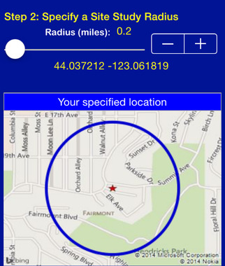
MAKER SPACES. Sometimes called hacker spaces, these are shared spaces for research and development, protoyping, and short production runs for customer (beta) testing. Most maker spaces have woodworking and metalworking equipment, soldering irons, and 3-D printers.

RETAIL/ RESTAURANT. Three things matter: traffic flow past the location, neighborhood demographics (income, housing, lifestyle), and parking. Your state department of transporation web site should have some data on traffic flow. For some urban locations and malls, auto traffic may not be as important as foot traffic.

For eateries located in a mall, there are some common lease clauses you may not expect, such as right to approve your menu, no handing out samples in the mall proper, and you can’t open another restaurant nearby (as this may take traffic from the mall).

www.EASIdemographics.com offers a free app [right] called Easi, that will provide demographics of surrounding area of different sites you may be considering.

Location

B. Comparing Locations

A. Address____________________________________________ City ______________________

B. Address____________________________________________ City ______________________

C. Address____________________________________________ City ______________________

This is an interactive spreadsheet. To open, right-click on spreadsheet, click “Worksheet Object” and then "Open.” You need enter data in shaded fields only; the totals will be computed for you. You can download a copy of this form at http://www.EntrepreneurshipFoundation.org/spreadsheets.html

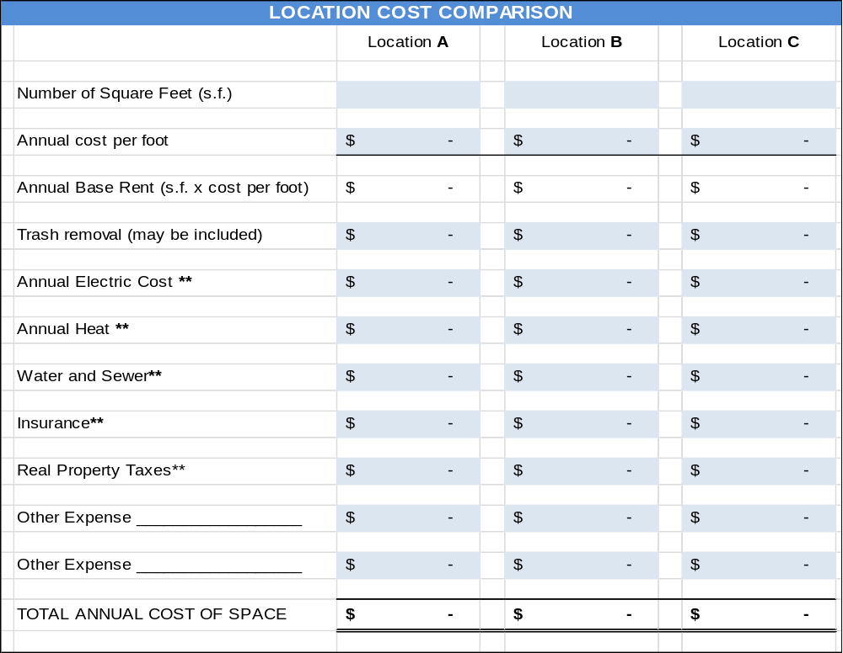

** If rent is advertised as gross, then utilities, real property taxes, and property insurance are covered by the property owner. If the rate is triple net (sometimes advertised as nnn), then the tenant is responsible for these costs. The property owner should have prior utility bills for the space. If actual costs are not available, estimate $2.00 per year per square foot for electric and gas, and $.50 for property taxes. In some cases, the property owner will pay the taxes and property insurance. (Note: in any case, you will need to purchase liability insurance to cover “slips and falls” in your space.)

Location

Comparison of Other Factors | Location A | Location B | Location C
CITY OR STREET >>
Zoned to allow your type of business. (Check with town planning office.)
Free parking spaces for employees
Parking spaces for customers
Traffic Flow (Number of cars or foot traffic passing the location daily. Critical for retail.)
Signage rights (Can you put sign on building? By street?)
Safety. Employees and customers will feel safe in the neighborhood.
Location Selected
Reason for selection

Pricing the Product or Service

8 – Pricing the Product
or Service

A. Final Product Costing

B. Shipping and Handling Costs

C. Pricing a Product that You Manufacture

D. Pricing Multiple Products for Resale

E. Pricing of Services

F. Break-Even Calculation for a Product or Service

Pricing the Product or Service

A. Final PRoduct Costing

Use the spreadsheet below to compile the cost of components at various production levels: samples for in-house (alpha) testing, small production runs for customer (beta) testing, and full production runs.

This is an interactive spreadsheet. To open, right-click on spreadsheet, click “Worksheet Object” and then "Open.” You need enter data in shaded fields only; the totals will be computed for you. You can download a copy of this form athttp://www.EntrepreneurshipFoundation.org/spreadsheets.html
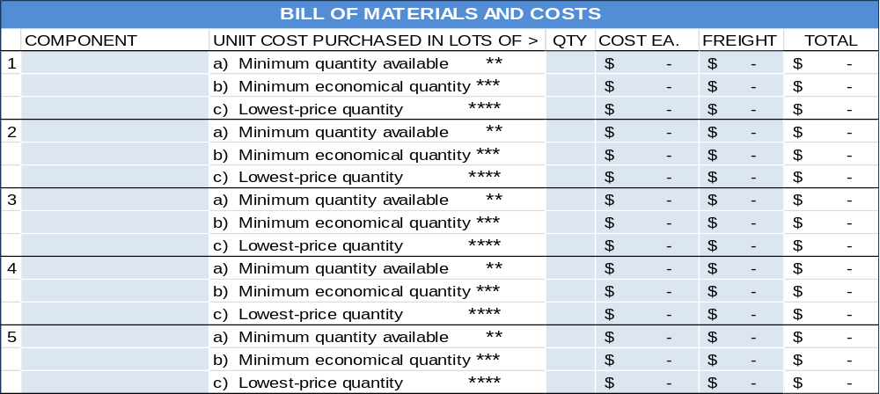
* Components. Everything that goes into the making of your product or service is a “component.” Do not forget assembly labor, packaging and labeling, allowance for scrap due to defects, freight in, shipping and handling costs to deliver the product to the customer.
** Minimum Quantity you can purchase, at any price. Typically, manufacturers and wholesalers will not “break carton lots.” However, most suppliers will provide free samples for testing, and even help you choose the right grade of material.
*** Minimum Economical Quantity. A balance between the minimum quantities you can purchase at a time (that conserves cash, but will be the highest price) and the absolute lowest-price quantity (requiring the largest commitment). Most suppliers publish a price list showing the price breaks. You will quickly notice that there is a diminishing return. Buying 10 instead of just one might save 50% per unit, 100 versus 10 another 20%; but the next price break at 1000 might only save 2%. The MEQ is 100.
You may want to back into this quantity by first researching the traditional retail price for products like yours, then determining the most you can pay per unit to be profitable. However, the minimum economical quantity may require a large cash outlay (and risk, if the products are not well received).
**** Lowest-Price Quantity. The quantity that will allow you to purchase the component at the lowest possible price. Knowing this quantity price break enables you to predict the profit potential of the business if it really takes off. Hint: you can probably negotiate a commitment to purchase the lowest-price quantity over time. Not having to take delivery of all the material at one time will allow you to recycle your capital and minimize the cost of storing raw materials and components.

Pricing the Product or Service

B. Shipping AND HANDLING COSTS

1. Shipping

FREIGHT OUT AND HANDLING ON SALES TO RESELLERS. Retailers typically pay the actual freight costs on products shipped to their stores. However, be sure to make this clear in your sales literature. The term used is F.O.B., shorthand for free on board, meaning the freight is free to the destination named.
If your terms state “FOB customer’s warehouse,” then you are saying you will pay the freight. If your terms state “FOB factory” or “FOB [city where products are made or warehoused] then you are advising the customer that they will be billed freight costs from that point to their store or warehouse. It is not customary to charge retailers for handling and packaging. That is on you – so do not forget to include packaging and handling when figuring your product cost.

FREIGHT OUT AND HANDLING ON DIRECT SALES TO CONSUMERS. Decide if you want to absorb the freight costs (for simplicity and to better compete with retail stores) or pass these expenses along to the buyer. In either event, you will want to know what they are, as these expenses can be a large part of your total product cost.

2. Handling labor (The “H” in “S&H”)
A. Number of shipments that one person can process per hour # _______
b. Wage per hour (including payroll taxes of approximately 10%) $ _______
c. Cost per order (b / a) .......................................................... $ _______

3. Cost of Shipping Materials (See following page for hints on what to order)
MASTER CARTON for bulk shipments
Cost each $_______ in quantities of ______________ Best source: _____________________________
INNER CARTON for bulk shipments
Cost each $_______ in quantities of ______________ Best source: _____________________________
CARTON TO SHIP ONE ITEM (Corrugated mailer or padded bag)
Cost each $_______ in quantities of ______________ Best source: _____________________________
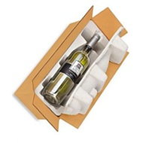

Whatever you are planning to ship directly to customers, rest assured there is a container designed just for it.

Pricing the Product or Service

SHIPPING CARTONS FOR BULK SHIPMENTS TO BRICK AND MORTAR STORES

To save money on freight charges most companies ship products in Master cartons that hold an economical quantity for shipping, but still a reasonable number to expect a store to purchase. However, a master carton for shampoo (as an example) that could hold 48 bottles would probably result in complaints from stores, as the bottles would jostle about loose in a large carton. The answer is to add smaller inner cartons that hold fewer products each, such as six bottles. The two carton sizes also allow you to sell a smaller quantity to a store (or even to an online purchaser who wants to save money by buying in quantity).

A master carton with eight inner cartons, each containing 6 bottles of shampoo. Allowing sales in quantities of 48, 6, or even 12 (two sub-cartons taped together).

Obviously, you have a better chance of a store carrying your product if the buyer has a range of quantity/price options. By knowing preferred quantities (and designing cartons for them) will keep your handing costs low. Broken carton shipments require more work to open a carton, take out a non-standard quantity, and then custom package the shipment. Moreover, this leaves you with an odd quantity that will be difficult to sell.

SHIPPING CARTONS FOR SAMPLES AND DIRECT SHIPMENTS TO ONLINE CUSTOMERS.
Regardless of who ships the small individual orders directly to online customers, order a supply of individual mailers that can serve as shipping cartons so the shipper just has to add a label and mail.
Standard mailers are available in a variety of stock sizes, and as such may be purchased in small quantities as needed. These sturdy shipping boxes will arrive flat and can be easily set up without tape or glue.
When ordering these single-product cartons, do not forget to allow room for instructions or bubble wrap, if needed. Ask for free samples (vendors will be happy to provide them) so you can make sure everyghing fits.
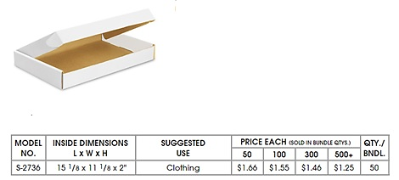
Sample mailer from Uline online catalog available at http://www.uline.com/Cls_04/Boxes-Corrugated
The shipping terms are FOB factory (so you pay the freight), but this supplier has eight warehouses in the U.S. Still, boxes are heavy and bulky, so figure at least 20% additional for delivery.

Packaging Price also sells fold-up boxes in small quantities https://www.packagingprice.com/boxes/white.html
Pricing the Product or Service

C. Pricing a Product that You Manufacture

Assume material and production labor is based on the Minimum Economical Quantity. In the spreadsheet below, enter amounts in shaded boxes. The spreadsheet will calculate the other amounts.

This is an interactive spreadsheet. To open, right-click on spreadsheet, click “Worksheet Object” and then "Open.” You need enter data in shaded fields only; the totals will be computed for you. You can download a copy of this form at http://www.EntrepreneurshipFoundation.org/spreadsheets.html

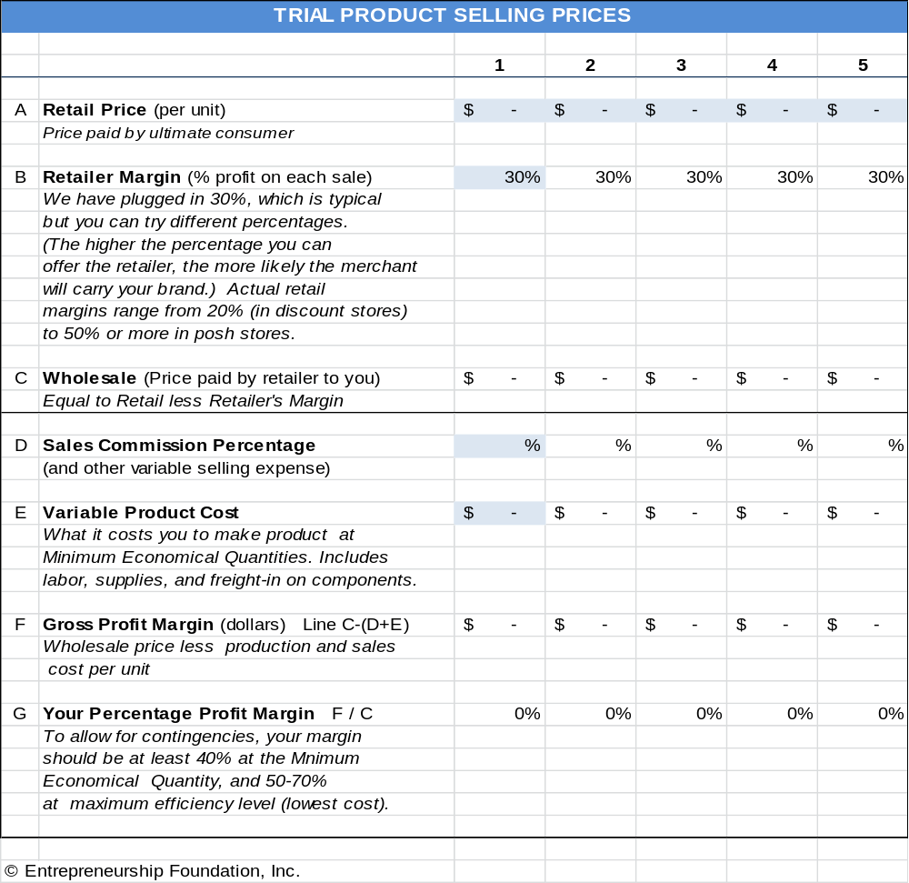

A term often confused with Margin is Markup. Margin is the gross profit margin on each sale, whereas Markup is the percentage of the company’s cost that is added to arrive at the selling price. If a product costs $.50 and sells for $1, the Markup is 100%, or $.50; the margin is also $.50, but is 50% because it is a percentage of the selling price, not the cost.
Pricing the Product or Service

D. PRICING MULTIPLE PRODUCTS FOR RESALE

This is an interactive spreadsheet. To open, right-click on spreadsheet, click “Worksheet Object” and then "Open.” You need enter data in shaded fields only; the totals will be computed for you. You can download a copy of this form athttp://www.EntrepreneurshipFoundation.org/spreadsheets.html

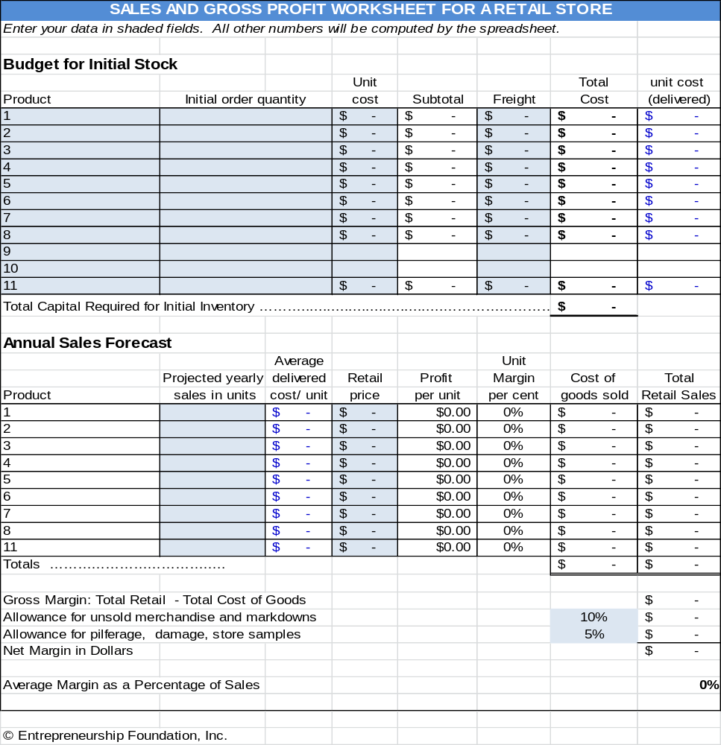

Pricing the Product or Service

E. Pricing of SERVICES

If you are providing a service as an individual, without employees or an office, then the total of the fees you collect will be your personal annual income.

1. Take-Home Income Goals. How much do you need to earn from your business each year? According to the Washington Examiner, It now takes a $22.10 hourly wage to afford the typical modest two-bedroom rental, assuming you spend 30% of your income on housing. Of course, rates will vary with locale. However, as a rough rule of thumb, this would equate to $40,000 to $50,000 per year.
To determine how much you will need, see the “Personal Expense Budget” section in this text.

EXAMPLE YOU
A. ULTIMATELY, full-time to live solely off the business …............. $ 50,000 per year $_________

B. INITIALLY, as a part-time endeavor …………………………….… $ 10,000 per year $_________
Therefore, how much do you need to earn (gross) to take home these amounts? You will need to earn more than the target numbers above to allow for Payroll and Income Taxes.

2. Allowance for Taxes.

PAYROLL TAXES. See table of “Payroll Taxes.” As a self-employed individual, you have to pay the employer and employee shares of all payroll taxes. As a rule of thumb, assume you will pay the government approximately 16% of your earnings for Social Security, Medicare, and Federal and State Unemployment Insurance (FUTA and SUTA). Do not forget to report the income and pay the taxes. When you are self-employed, no one will be doing this for you.

PERSONAL INCOME TAXES. H&R Block has a free tax calculator at
http://www.hrblock.com/free-tax-tips-calculators/index.html

- FEDERAL INCOME TAX. For a quick estimate of the FIT, use 10%.

- STATE INCOME TAX. Look up your state’s personal income tax rate at http://www.tax-brackets.org.
For quick budgeting assume your total personal taxes (payroll taxes and Income taxes) will amount to approximately 30% of your gross earnings.
3. Calculating Your Tax Multiplier. To arrive at the business revenue necessary for you to net your personal income goal, you will need to multiply your target number by 142.88%. (This may be counter-intuitive.) You may assume you need to add 30% to your target personal net income if you have determined that your taxes will be 30% of your income. Nope. Say your goal is $100,000 per year take-home. If you multiple $100,000 by 130%, this equals $130,000 gross; but a 30% tax bill on $130,000 income = $39,000, leaving you with only $91,000 take-home pay for the year.

Pricing the Product or Service

Now try multiplying the example target gross income goal of $10,000 by 142.86%. The result = $14,286. This amount multiplied by 30% as an allowance for taxes = (30% x $14,286) = $4286. $14286 minus $4286 = $10,000, the take-home goal. Incidentally, you can use 143% instead of the more cumbersome 142.86% and still be close enough for government work, which this is.

The correct MULTIPLIER for your TARGET TAKE-HOME AMOUNT to arrive at your GROSS INCOME TARGET will not always be 143%. That works for a combined tax rate of 30%. To find your MULTIPLIER, divide 100 by (100% - your combined federal and state tax rate %). In the example, this would be 100 / (100% - 30%) = 100 / 70% = 143%.

4. Calculating Service-Business Revenue Goals EXAMPLE YOU
A. ULTIMATELY, to live on the business revenue alone ……..$ 71,500 per year $_________

B. INITIALLY, as a part-time endeavor to test the concept …. $ 14,300 per year $_________
For the example company, I multiplied the Take-Home Goals by 143%, assuming an aggregate tax rate of 30%. (But remember, the take-home pay multiplier for your combined tax rate = 100 / (100% - tax rate %).

5. Calculating Amount to Charge Clients per Hour. First, determine the number of hours you will work in a typical year. Full-time, you may want to assume 40 hours per week x 50 weeks, allowing for 2 weeks for vacation (and to make the math easier) = 2000 hours per year. For the initial part-time launch, estimate how many hours you will be able to devote to the business, after allowing for school, work, family, etc. For the example below, We assumed 8 hours each Saturday plus one evening per week for 4 hours, for a total of 12 hours per week. Times 50 weeks = 600 hours part-time.
A. ULTIMATELY, to live on the business revenue alone ……40 hours / week x 50 weeks #______hours
= 2000 hours /year

B. INITIALLY, as a part-time endeavor to test the concept …12 hours / week x 50 weeks #______hours
= 600 hours /yea

Divide the Business Revenue Goals (step #4 above) by the number of hours per year to arrive at AVERAGE HOURLY INCOME.
A. ULTIMATELY, to live on the business revenue alone …….. $ 35.75 per hour $_______ hr.

B. INITIALLY, as a part-time endeavor to test the concept …. $ 23.83 per hour $_______ hr.

6. Allowance for Uncollectibles. Some unscrupulous buyers, knowing you are a small startup without a battery of lawyers, and knowing you cannot take back the service once you deliver it, will take advantage of that situation and simply not pay unless you take them to court. So, before you have a read on which clients are honorable and which are not, assume that 10% of sales will be uncollectible.

7. Allowance for Non-Billable Hours and Office Supplies. The above hourly customer rates assume a perfect world where you always have work and the kids do not get sick. You also need to budget non-earning time for bookkeeping, filing tax returns, and marketing. In addition, of course you will have some modest expense for office supplies.

8. Adjusting Your Hourly Fee to Cover Uncollectibles, Non-Billable Hours, and Office Supplies. To arrive at a realistic fee to charge clients per hour, multiply the amount you need to earn per hour (as calculated in step 5 above) by three. The example business then would need to charge $107 per hour to meet the entrepreneur’s personal full-time income goal. You may be able to start out with only a 2x multiplier, but when you begin to grow and hire associates, you will need 3x or 4x to cover office space and other overhead.

Failing to add multipliers to allow for taxes and non-billable hours is the single most common reasons service businesses fail.
Pricing the Product or Service

F. Break Even Calculation for A Product or service

Break-even occurs at the point where total revenue equals total costs. Use the following spreadsheet to compute your break-even point. Only enter amounts in the shaded boxes. The other amounts will be computed for you.

This is an interactive spreadsheet. To open, right-click and select “Worksheet Object” and then "Open.” You need enter data in shaded fields only; the totals will be computed for you. You can download a copy of this form at
http://www.EntrepreneurshipFoundation.org/spreadsheets.html

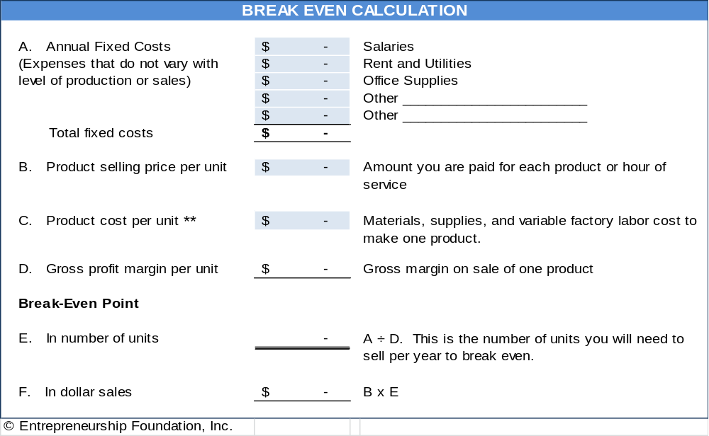

** Note: you do not have to pay sales tax on materials or components that you purchase that go into the products you manufacture.

Reality checkS:
- Are the unit and dollar sales numbers realistic?
- Can you make and sell this many products: or if a service business, can you realistically provide the number of hours required?
EVALUATION GUANTLET. At each stage, advance, pivot (modify the productor plan), or go back to square 1
1-IDEATION | 2-PATENT SEARCH | 3-FEASIBILITY ANALYSIS | 4-MARKET VALIDATION | 5-MVP TEST | LAUNCH

Budgeting and Accounting

9 – Budgeting and Accounting

A. Personal Expense Budget

B. Business Budgeting and Accounting

Budgeting and Accounting

A. Personal Expense Budget

The most expensive line item for new businesses is the personal living expenses of the founder. You may therefore want to find a day job that leaves you with time--and some spare cash--to invest in your business. If not, your living expenses for 6 to 12 months will need to be factored into the amount of start-up capital you will need.

This is an interactive spreadsheet. To open, right-click then select “Worksheet Object” and “Open.” You can download a copy of this form athttp://www.EntrepreneurshipFoundation.org/spreadsheets.html

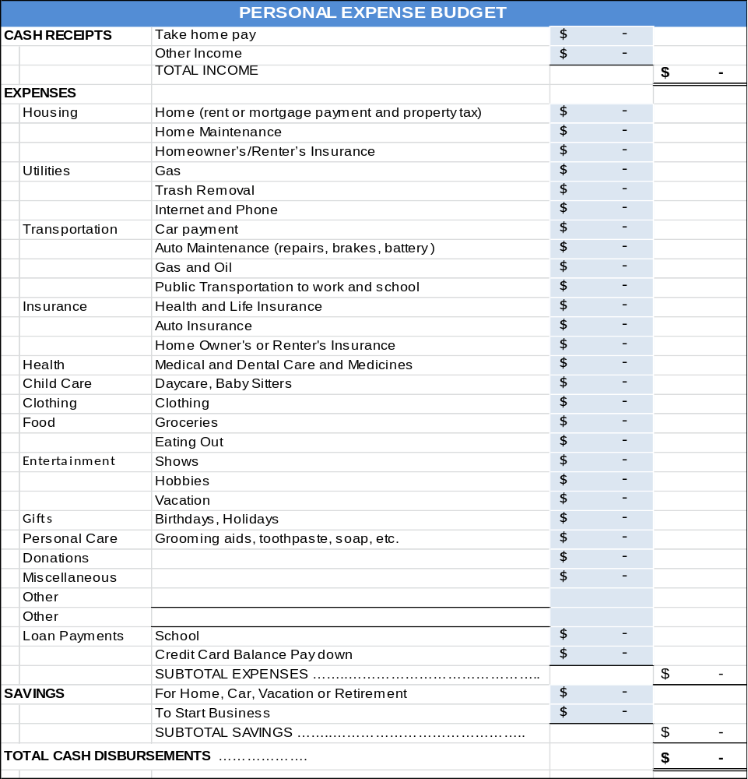
Budgeting and Accounting

B. Business BUDGETIng and Accounting

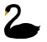
Do not forget to allow for black swans: unpredictable events that could have a negative impact on sales or costs. No business goes according to plan, so build in a contingency for surprise expenses; if you are certain your sales will be $1 million the first year, budget for $500,000. If you can at least break even at 50% of your sales forecast, then those black swans will not put you out of business.
WAGE RATES. Search the web for “minimum wage for [your state]” or check with your state Department of Labor.

ACCOUNTING. Waveapps.com offers a free cloud-based accounting package for entrepreneurs.

- Unlimited bank and credit card connections
- Invoice in any currency
- Send estimates and turn them into invoices upon approval
- Professional invoice templates
- Receipt scanning with free iOS or Android app. Receipts are automatically added into accounting record.
- Optional Credit card processing: 2.9% + 30¢ per transaction
- Optional payroll processing. $20-$35 monthly + $4 per employee or independent contractor paid. Note, you still have to send payroll taxes and 941 form to state and IRS; but Wave will advise how much send.
Keeping your own books allows you to monitor cash flow and know how the business is doing in real time.
BUDGET SAMPLE AND DOWNLOADABLE WORKSHEET. On the following five pages is a sample Excel workbook. You can download a blank form from http://www.EntrepreneurshipFoundation.org/spreadsheets.html.
The five-year forecasting worksheet contains imbedded formulas to compute totals. The tabs are Revenue, Cost of Goods Sold, Salary Schedule, Startup Capital, and Profit And Loss Forecast. Decisions made on one tab (e.g. Salary Schedule) are automatically reflected in the other worksheet tabs.
(The sample below and on following pages is not live.)

REVENUE |  | Year 1 |  | Year 2 |  | Year 3 |  | Year 4 | Year 5
Inflation Price Escalator | 4%
Annual Sales Growth Escalator | 20%
Product Group 1
Unit Sales | # | 5,000 | 6,000 |  | 7,200 |  | 8,640 |  | 10,368
Retail Price per Unit | $ | $ 25.00 | $26.00 |  | $27.04 |  | $28.12 |  | $29.25
TOTAL SALES |  | $125,000 | $ 156,000 |  | $ 194,688 |  | $ 242,971 |  | $ 303,227
Product Group 2
Unit Sales | # | 500 | 600 |  | 720 |  | 864 |  | 1,037
Retail Price per Unit | $ | $ 30.00 | $31.20 |  | $32.45 |  | $33.75 |  | $35.10
TOTAL SALES |  | $ 15,000 | $ 18,720 |  | $ 23,363 |  | $ 29,156 |  | $ 36,387
Grand Total Sales………………… |  | $ 140,000 | $ 174,720 |  | $ 218,051 |  | $ 272,127 |  | $ 339,615

Budgeting and Accounting

COST of GOODS SOLD |  | Year 1 | Year 2 | Year 3 | Year 4 | Year 5
Inflation Price Escalator | 4%
Wage Rate per Hour | $ 15.00 | $ 15.00 | $15.60 | $16.22 | $16.87 | $17.55
FICA (6.2% on first $132,900) | 6.2% | $ 0.93 | $ 0.97 | $ 1.01 | $ 1.05 | $ 1.09
Medicare (1.45% with no limit) | 1.45% | $ 0.22 | $ 0.23 | $ 0.24 | $ 0.24 | $ 0.25
FUTA (.6% of first $7000) | 0.6% | $ 0.09 | $ 0.09 | $ 0.10 | $ 0.10 | $ 0.11
SUTA (4.2% on first $15,000 ) | 4.2% | $ 0.63 | $ 0.66 | $ 0.68 | $ 0.71 | $ 0.74
Benefits | 10% | $ 1.50 | $ 1.56 | $ 1.62 | $ 1.69 | $ 1.75
Workers Comp | 2% | $ 0.30 | $ 0.31 | $ 0.32 | $ 0.34 | $ 0.35
TOTAL VARIABLE LABOR |  | 18.67 | 19.41 | 20.19 | 21.00 | 21.84
Product Group 1
Cost per Unit
Component A | $ | $ 4.00 | $4.16 | $4.33 | $4.50 | $4.68
Component B | $ | $ 1.00 | $1.04 | $1.08 | $1.12 | $1.17
Component C | $ | $ - | $0.00 | $0.00 | $0.00 | $0.00
MATERIAL COST PER PRODUCT |  | $ 5.00 | $ 5.00 | $ 5.20 | $ 5.41 | $ 5.62
Hours of Labor Needed | # | 0.25 | 0.25 | 0.25 | 0.25 | 0.25
LABOR COST PER PRODUCT |  | $ 4.67 | $ 4.85 | $ 5.05 | $ 5.25 | $ 5.46
TOTAL COST Per Product (Matl. and Labor) |  | $ 9.87 | $ 9.67 | $ 10.05 | $ 10.46 | $ 10.87
TOTAL UNIT SALES Product Group 1 |  | 5,000 | 5,000 | 6,000 | 7,200 | 8,640
TOTAL COST OF GOODS SOLD |  | $ 48,334 | $ 60,321 | $ 75,281 | $ 93,951 | $117,250
Product Group 2
Cost per Unit
Component A | $ | $ 6.00 | $6.24 | $6.49 | $6.75 | $7.02
Component B | $ | $ 1.00 | $1.04 | $1.08 | $1.12 | $1.17
Component C | $ | $ - | $0.00 | $0.00 | $0.00 | $0.00
MATERIAL COST PER PRODUCT |  | $ 7.00 | $ 7.00 | $ 7.28 | $ 7.57 | $ 7.87
Hours of Labor Needed to Produce | # | 0.50 | 0.50 | 0.50 | 0.50 | 0.50
LABOR COST PER PRODUCT | $ | $ 9.33 | $ 9.71 | $ 10.10 | $ 10.50 | $ 10.92
TOTAL COST Per Product (Matl. and Labor) |  | $ 16.74 | $ 16.33 | $ 16.99 | $ 17.67 | $ 18.37
TOTAL UNIT SALES Product Group 2 |  | 500 | 500 | 600 | 720 | 864
TOTAL COST OF GOODS SOLD |  | $ 8,167 | $ 10,192 | $ 12,720 | $ 15,874 | $ 19,811
Subtotal Materials Cost |  | $ 28,500 | $ 35,568 | $ 44,389 | $ 55,397 | $ 69,136
Grand Total Cost of Goods Sold |  | $ 56,501 | $ 70,514 | $ 88,001 | $ 109,825 | $ 137,062
Gross Profit |  | $ 83,499 | $ 104,206 | $ 130,050 | $ 162,302 | $ 202,553

Note: this is a sample spreadsheet and cannot be opened within the text.

Budgeting and Accounting

SALARY SCHEDULE |  |  | PT/FT | % | Year 1 | Year 2 | Year 3 | Year 4 | Year 5
Inflation Escalator |  |  |  | 4% | ANNUALIZED RATE
GENERAL MANAGEMENT
 | CEO |  | P/T |  | 25,000 | 26,000 | 27,040 | 28,122 | 29,246
 |  | Bookkeeper | P/T |  | 6,000 | 6,240 | 6,490 | 6,749 | 7,019
 |  |  |  |  |  | - | - | - | -
 |  |  |  |  |  | - | - | - | -
MARKETING
 | CMO |  | P/T |  | 20,000 | 20,800 | 21,632 | 22,497 | 23,397
 |  | Salesperson # 1 |  |  |  | - | - | - | -
 |  | Salesperson # 2 |  |  |  | - | - | - | -
 |  | Salesperson # 3 |  |  |  | - | - | - | -
OPERATIONS
 | COO |  | P/T |  | 20,000 | 20,800 | 21,632 | 22,497 | 23,397
 | CTO |  |  |  |  | - | - | - | -
 |  |  |  |  |  | - | - | - | -
 |  |  |  |  |  | - | - | - | -
 | TOTAL SALARIES |  |  |  | 71,000 | 73,840 | 76,794 | 79,865 | 83,060
 | Number of Salaried Employees |  |  |  | 4 | 4 | 4 | 4 | 4
Payroll Taxes and Benefits
 |  | FICA (6.2% on first $132,900) |  | 6.2% | 4,402 | 4,578 | 4,761 | 4,952 | 5,150
 |  | Medicare (1.45% with no limit) |  | 1.45% | 1,030 | 1,071 | 1,114 | 1,158 | 1,204
 |  | FUTA (.6% of first $7000 of salary) |  | $ 42 | 168 | 168 | 168 | 168 | 168
 |  | SUTA (4.9% on first $15,000 ) |  | $ 735 | 2,940 | 2,940 | 2,940 | 2,940 | 2,940
 |  | Subtotal Payroll Taxes……………… |  |  | 8,540 | 8,757 | 8,983 | 9,218 | 9,462
 |  | Benefits |  | 5% | 3,550 | 3,692 | 3,840 | 3,993 | 4,153
 |  | Workers Compensation |  | 1% | 710 | 738 | 768 | 799 | 831
TOTAL EXPENSE: SALARIED EMPLOYEES |  |  |  |  | 83,800 | 87,027 | 90,384 | 93,875 | 97,506

Note: this is a sample spreadsheet and cannot be opened within the text.

Budgeting and Accounting

PROFIT and LOSS FORECAST |  |  |  | Rate | Year 1 | Year 2 | Year 3 | Year 4 | Year 5
Inflation Escalator |  |  |  | 4%
REVENUE |  |  |  |  | 140,000 | 174,720 | 218,051 | 272,127 | 339,615
 | Cost of Goods Sold, Including Labor |  |  |  | 56,501 | 70,514 | 88,001 | 109,825 | 137,062
GROSS PROFIT |  |  |  |  | 83,499 | 104,206 | 130,050 | 162,302 | 202,553
OVERHEAD
 | SALARIES, Incl. Taxes and Benefits |  |  |  | 5,312 | 88,539 | 91,896 | 95,387 | 99,018
 | RENT |  |  |  | 10,000 | 10,400 | 10,816 | 11,249 | 11,699
 | UTILITIES (est. $2 per square foot/ year) |  |  |  | 1,000 | 1,040 | 1,082 | 1,125 | 1,170
 | MARKETING
 |  | Trade Show Booth |  |  | 500 | 520 | 541 | 562 | 585
 |  | Trade Show Signage |  |  | 200 | 208 | 216 | 225 | 234
 |  | Web Site Hosting |  |  | 50 | 52 | 54 | 56 | 58
 |  | Web Site URL Purchase |  |  | 10
 |  | Flyers |  |  | 200 | 208 | 216 | 225 | 234
 |  | Purchase of Prospect Lists |  |  | 265 | 276 | 287 | 298 | 310
 |  | Direct Mail ($1 ea. Incl. postage) |  |  | 500 | 520 | 541 | 562 | 585
 |  |  | Subtotal Marketing Expense |  | 1,725 | 1,784 | 1,855 | 1,929 | 2,006
 | OFFICE EXPENSE
 |  | OFFICE SUPPLIES |  |  | 2,400 | 2,496 | 2,596 | 2,700 | 2,808
 |  | COMPUTERS and OFFICE EQUIP. |  |  | 1,000 | - | - | - | -
 |  | COMPUTER REPAIRS |  |  | 150 | 156 | 162 | 169 | 175
 |  | POSTAGE and FREIGHT |  |  | 200 | 208 | 216 | 225 | 234
 |  | PAYROLL SERVICE |  |  | 500 | 520 | 541 | 562 | 585
 |  | Subtotal Office Expense |  |  | 4,250 | 3,380 | 3,515 | 3,656 | 3,802
 | TELEPHONE |  |  |  | 250 | 260 | 270 | 281 | 292
 | INTERNET CONNECTION |  |  |  | 1,200 | 1,248 | 1,298 | 1,350 | 1,404
 | TRAVEL (Excluding Mileage) |  |  |  | 500 | 520 | 541 | 562 | 585
 | TRAVEL (Mileage) |  |  |  | 1,000 | 1,040 | 1,082 | 1,125 | 1,170
 | PRODUCTION EQUIP. MAINTENANCE |  |  |  | 250 | 260 | 270 | 281 | 292
 | PROPERTY TAXES (Equip.) |  |  | 3.5% | 56 | 42 | 28 | 14 | -
 | ACCOUNTING SERVICES |  |  |  | 1,000 | 1,040 | 1,082 | 1,125 | 1,170
 | LEGAL FEES |  |  |  | 500 | - | - | - | -
 | OTHER OUTSIDE SERVICES |  |  |  | 250 | 260 | 270 | 281 | 292
 | INTEREST ON BUSINESS LOAN |  |  | 4.0% | - | - | - | - | -
 | INSURANCE: Property |  |  |  | - | - | - | - | -
 | INSURANCE: Liability |  |  |  | 2,000 | 2,080 | 2,163 | 2,250 | 2,340
 | INSURANCE: Business Vehicles |  |  |  | - | - | - | - | -
 | BAD DEBT EXPENSE |  |  | 1.0% | 1,400 | 1,747 | 2,181 | 2,721 | 3,396
 | OTHER |  |  |  | 1,000 | 1,040 | 1,082 | 1,125 | 1,170
 | CONTINGENCY |  |  |  | 1,000 | 1,040 | 1,082 | 1,125 | 1,170
TOTAL OVERHEAD |  |  |  |  | 111,181 | 114,208 | 119,000 | 124,074 | 129,464
EBITDA |  |  |  |  | (27,682) | (10,002) | 11,050 | 38,228 | 73,089
 | DEPRECIATION |  |  |  | 400 | 400 | 400 | 400 | 400
NET PROFIT BEFORE TAXES |  |  |  |  | (28,082) | (10,402) | 10,650 | 37,828 | 72,689
 | 21% |  |  |  | - | - | 2,236 | 7,944 | 15,265
 | 6.0% |  |  |  | - | - | 639 | 2,270 | 4,361
NET PROFIT AFTER TAXES |  |  |  |  | (28,082) | (10,402) | 7,774 | 27,615 | 53,063

Management

10 – Management

A. Building the Management Team

B. Incentivizing the Management Team

C. Advisory Committee (Non-paid members of the team)

D. Selecting an Attorney

Management

A. BUILDING THE Management Team

When you have accumulated capital and have prepared to launch the venture, you are ready to build out your launch team. Look for people with the same aspirations and ideals. Having to dissolve a business because you find, too late, that your styles and priorities are not compatible, can be just as messy—and as expensive—as a divorce. Fortunately, there are matching sites like https://www.cofounderslab.com/ to help you find compatible partners for your venture.

Of course, you can always choose to go it alone and keep all the proceeds and credit. However, the success rates of solopreneurs--who might be great at one function, like programming or marketing--have not been as high as that of comprehensive management teams. Co-founders also provide motivation (no one wants to be the one to let the team down by not doing their share), reality checks (people to bounce ideas off just to make sure they’re not completely crazy; and moral support (people with whom to discuss concerns and share the agony of defeat and the thrill of doubling the number of monthly hits to your web site). When casting about for co-founders or early hires, try to find others who ..

- Are true entrepreneurs willing to take risks with careers and savings, not pretenders who really want a guaranteed weekly check and benefits. Partners with an “employee” mentality will bolt at the first setback.
- Are team players.
- Self-motivate, self-direct, and do not need to be told what to do every minute.
- Have similar working styles. Do you like to get up at 5:00 am, jog for an hour and then work from 6:00 am to 5:00 pm? You probably will never see your partners if they are ex-rockers accustomed to rising at noon or taking month-long vacations. Sorry, did we fail to mention that entrepreneurs work 70 hours a week and do not get vacations or sick days.
- Share a common vision and commitment. If you want to feed the world’s poor, and he or she wants to make billions selling food to the third world, you will never agree.
- Are honest. If your new partner has ideas on how to hide income from the IRS, he will also steal from you the first chance he gets. Integrity is not a relative term.
- Have complementary skills. If everyone on the team is expert at coding, in a year you will have a warehouse full of great but unsold software. Assemble a well-rounded team that can cover all the bases.
To stay alert for telltale signs of bad partners, read https://www.entrepreneur.com/article/202434

Dynamic Duos  How many can you name? | 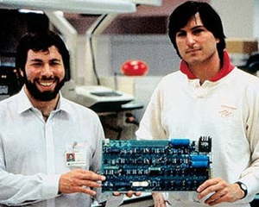 | 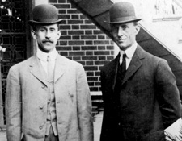
  1 | 2
  3 | 4
Slide this label out of the way to reveal answers  1 Steve Jobs/ Steve Wozniak  2 Orville Wright/ Wilbur Wright  3 Sergay Brin / Larry Page  4 David Packard/ Bill Hewlett |  | 
Management

Note: not all functions have to be filled by employees or partners. Consider other resources, such as consultants, outsourcing, contract workers, subcontractors, or advisory committee members.

FUNCTION | PERSON | RELEVANT SKILLS, EXPERIENCE, and/or EDUCATION
General Management
(CEO)
Operations
(COO)
Technology and IT (CTO)
Marketing
(CMO)
Accounting and Finance
(CFO)

Management

B. Incentivizing THE MANAGEMENT TEAM

By default, the one with the original idea starts out with 100% of the ownership. However, if you have ambitious plans, you will probably need to give up shares to attract investors (startups are risky) and the critical skills you need to compete and grow. (At the outset, co-founders and key employees must be willing to work long hours for little or no pay). Although the shares you offer as incentives to others may leave you with a shrinking percentage of ownership, the total value of your shares should increase as the company grows. How many shares should you set aside for members of the management team?

First, rank the importance of the people who are helping you (not based on who is working the most hours, but their long-term value to growing the company).
- Primary founder and management team leader
- Co-Founders (See https://cofounders.gust.com/ for a formula to assign a value to the predicted contribution of each co-founder.)
- Key Employees, including future hires, in consideration of their critical skills or influence
A Sample Division of Ownership
STAGE OF COMPANY DEVELOPMENT | Founder | Co-Founders  Shares granted upon incorporation | Key employees  Shares Allocated for discounted stock-purchase options | Investors
Concept stage | 100%
Development and Testing stage (Proof of Concept Stage) | 80% | 20% *
Startup (Seed stage) | 40%  (=4/7 of non-investor shares) | 20%  (=2/7 of non-investor shares) | 10% **  (=1/7 of non-  investor shares) | 30% *** to friends, family and angels
Series A Financing Round (Early stage) | 29%  (=4/7 of non-investor shares) | 14%  (=2/7 of non-investor shares) | 7%  (=1/7 of non-  investor shares) | 50% after VC investment
Series B Financing Round (Growth stage) | 17%  (=4/7 of non-investor shares) | 9%  (=2/7 of non-investor shares) | 4%  (=1/7 of non-  investor shares) | 70%
* Co-founder shares should be vested (that is, earned gradually over time). For example, a co-founder might be allowed 4% ownership, but the shares would be earned at the rate of 1% per year over the next 4 years (a common length of time for vesting) if the co-founder has worked full time and satisfactorily. This prevents a co-founder—who might be long on promises but short on delivery— from running off with 5% of the company without making an equally valuable contribution.
** Assumes you will use a large portion of seed round to hire additional key employees, who will also need shares as
incentives to climb aboard a young company. The investors will no doubt insist that you set aside shares to attract and
motivate the additional staff needed to grow the company.
*** Reduce initial share for investors to 20% if a high-tech, high-growth-potential enterprise.
See also “Capitalization Table” in this text for another example of allocation of shares.
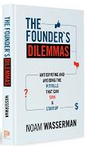
Management

For more information on this topic see…

- https://www.startuplessonslearned.com/search?q=founders+dilemmas by Eric Reis
- www.businessinsider.com/splitting-startup-equity-for-your-piece-of-the-pie-2010-11
- The Founder's Dilemmas by Noam Wasserman
- Online class by Fred Wilson of Silicon Valley Ventures (SVP) on “Employee Equity” https://livestream.com/Skillsharelive/MBAMondays/videos/490550

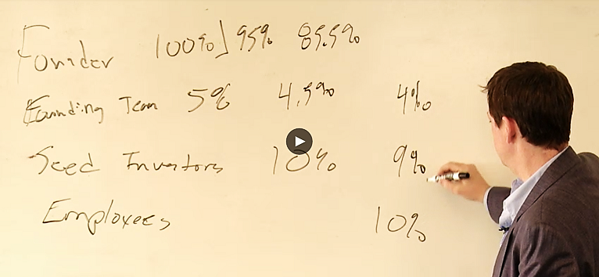
Fred Wilson gives an example whereby co-founders receive 5% and investors only 10%. However, this is in Silicon Valley where investors are very confident of their ability to pick winners, and thus will accept a smaller share of ownership, because they do not believe they will have many losers in their portfolio that will need to be offset by high profits on the winners.

>> Consult a lawyer for advice, as early decisions can negatively affect your ability to raise growth capital. <<

ALTERNATIVE INDUCEMENTS. Before offering shares of stock or options to key individuals, give some thought to alternative enticements; thus keeping the ownership structure simple and reserving a greater number of shares to exchange with equity investors for growth capital. This is known as “keeping your powder dry.”

  - Contingent Deferred Compensation. This is basically an IOU that is redeemable if (the contingency) and when (the deferment) the company achieves sales and/or cash-balance milestones. Future payouts should be greater than the perceived value of their work, in consideration of the fact that they will have to wait to be paid, and if the enterprise fails to thrive, perhaps not at all.
  - Royalties. This is a way to pay someone a percentage of profits (as common stock does) without actually issuing any shares. Royalty obligations usually have a total dollar cap and expiration date. For example, in exchange for developing a mobile app, you contract to pay the developer a modest amount plus 20% of the sales for the first five years, or $50,000, whichever comes first.
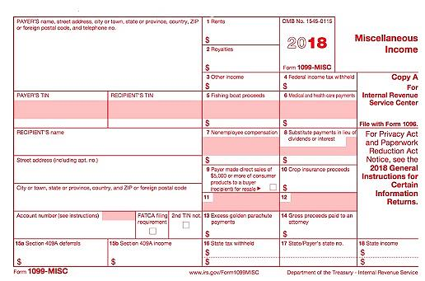
COMPENSATING OTHER INDIVIDUALS. If you do need to pay helpers, try to retain them as Independent Contractors. You will avoid a lot of paperwork. For contractors paid $600 or more, you will still have to provide a 1099-MISC form at the end of the year, showing how much they were paid; and send a copy to the IRS. (Enter amount in box 7 “Nonemployee Compensation.”) Note: to treat someone as an independent contractor they must have control over their time and work; otherwise, they are an employee under the law.

You can obtain 25 government-approved 1099-MISC forms, with mailing envelopes, on Amazon for about $15. Make sure you order a set that includes at least one form 1096, as you also have to send this summary to the IRS.

Sample 1099-MISC.
Management

C. ADVISORY COMMITTEE (Non-paid Members of the Team)

A group of volunteer advisors can bring valuable experience and contacts. Although most entrepreneurs like the idea of an advisory committee, few know how to form one—who to ask, what to ask of them, or how to recognize advisors for their services.
The difference between an advisory committee and a board of directors. A board of directors is a legal entity responsible and liable for decisions and actions of the company. If you have investors who own at least 10 per cent of the company, they will expect to be on the board.
An advisory committee, on the other hand, is informal. Advisors have no legal authority and assume no liability. There are no set rules, such as how often they have to meet.
If you are looking for outside funding, an advisory committee shows potential investor that you have consulted with experts to help you form the strategies of the company and that you are taking advantage of free resources. The names of the committee members and their backgrounds should be an integral part of the management section of the business model or plan.

The right number of advisors: two to five. You do not have to ask everybody at once; you can add advisors as you progress, but you should have two or three to start.
How often should you meet? Perhaps never. If the committee is diverse and selected to give guidance in many different areas, one-on-one discussions may yield better results and in less time than meetings of the entire committee. One member might help draft financial statements, another help shape marketing efforts, while others could introduce you to client prospects.
Be careful not to call on them too often. Advisors are not signing up for a job. Nevertheless, keep them informed with copies of e-mail announcements and invitations to company events.
Building a company can be lonely work. An advisory committee can be a great source of help and comfort. They can give you guidance, contacts, friendship as well as credibility with potential investors.

Management

D. Selecting an Attorney

Your business lawyer will be a critical member of your management team. In fact, be sure to list your attorney and accountant in the “Management Team” section of your pitch deck and eventual business plan. (Serious investors will expect you to have these key advisers to keep you and the investors out of trouble with the IRS and regulatory agencies.)

HOW TO FIND AN ATTORNEY. www.avvo.com and www.martindale.com both provide databases of user-rated attorneys that are searchable by “practice area” (legal specialty) and location (state, and in some cases, city). There is no charge for these services.

Your local (state, county and city) bar association will also host a directory of attorneys by practice area. Google “bar associations near me”. They will not recommend an attorney or provide any ratings.

HOW TO SELECT AN ATTORNEY. This is vitally important, and could be a life-long relationship, so take a little time with the decision. Filter names of attorneys using the following criteria:

- PROXIMITY. Start with the nearest firms. The closer they are the easier it will be to meet or stop by to sign papers.
- SPECIALTY within practice area. Naturally, you want a “corporate” “business” or “Small Business” attorney, but there are categories within these broad terms. What is most important to you? For example, if you are an inventor, you probably want an “Intellectual Property” attorney, versed on patents. If you have a proven company with a million dollars in sales, and want to raise money from investors, you will want an attorney who specializes in “Venture Capital.” Common specialties within business law include:
  - General business law
  - Contracts (leases, purchase contracts, employment contracts, NDAs)
  - Intellectual property (patents, trademarks and copyrights)
  - Venture Capital (you are raising equity financing)
  - Mergers and Acquisitions, aka M&A (you are thinking of buying a company)
  - Litigation (you are being sued)
  - Employment law (you have a troublesome employee)

Note: you will not find all these skills in a super-lawyer, so focus on the one most important to your company. A large law firm is more expensive than a solo practitioner is but may have enough depth in its team to provide all the services you will need.

Once you have compiled a short list of attorneys that are close and knowledgeable about the type of advice you will need, do some due diligence:
- Contact the law firm and ask for the names of current business clients. Then call the clients to ask about their experiences. (Remember, entrepreneurs help other entrepreneurs.)
- Google the firm and the attorney whose practice area fits your needs. Are there lawsuits pending from former clients? Any other red flags?
- Check their website for “Events.” Is an attorney to speak at an entrepreneur event near you? This is a great way to check them out without any awkwardness.
- Check their bios. Do they have experience in your industry? You do not want an attorney who knows drug patenting if you are opening a restaurant, or vice versa.
- You are just starting out. Find someone who can grow with you. Younger attorneys are less experienced, but less costly per hour. Moreover, by the time you make your first million, she will have the experience to help you with those more complex issues.

Management

Select the right attorney and schedule a face-to-face meet to explore whether this will be a good fit. You will not be billed, but do not abuse the by soaking up their valuable time to gain as much free advice as possible. A one-half hour introductory meeting is appropriate. Talk about your business and the help you think you will need:
- Lease?
- Employment contracts?
- Non-disclosure agreements?
- LLC formation? Incorporation?
- Patent searches? Provisional patent filings? Full patent filing?
- Trademark registration?

He are she will be frank about their knowledge and experience in the areas in which you need help.

Now the hard part. Ask for an estimate of the cost of each service you expect you will need; and the hourly rate for assistance you do not yet know you need. If they demur “Well, it depends…” be pushy. Some services are routine, like an LLC filing. If the attorney will not give you a firm price for something that simple, go to the second choice on your short list of possible attorneys.

HOLDING LEGAL EXPENSES TO A MINIMUM. Prepare a draft of legal documents for your attorney to review. This will save them time and their time is (your) money. A first draft prepared by you will also give your attorney a clearer idea of your intentions and what you need.

A variety of legal templates can be downloaded for free at https://law4startups.com.



Brand Image – Company Name

11 – Brand Image

A. Company Name

B. Logo

C. Packaging

D. Labeling

E. Phone Number

F. Business Email Address

G. Business cards

Your brand is your style, attitude and promised virtues of the company. Also known as your “Brand Promise,” it is the sum total of what customers can rely upon. Think of companies you trust. Why? How have they convinced you that their brand promise is the real deal?

Your branding extends beyond the look and feel of your company name, logo, website, and advertisements. It is also how you behave toward customers and what they care about. For customers to believe in your brand promise, you have to live it.

Your decisions about every customer touchpoint: logo, typestyle in ads, website, even the way you and your employees dress will affect how people think about your company.

TO BUILD A BRAND IMAGE, START BY DECIDING THE KIND OF COMPANY YOU WANT TO BE …Lowest price, highest quality, best personal service, most durable products, fastest delivery, most liberal trial basis, most loyal to a specific demographic, greenest, etc.

THEN BRAINSTORM WORDS THAT DEMONSTRATE THOSE QUALITIES to use in the company name, slogan and advertising copy.

Brand Image – Company Name

A. Company NAME

DO NOT rush this decision. It has far-reaching effects on the business and is difficult to change after the company launches because of all the places a company name appears:
- Letterhead and business cards
- Signage
- URL and email address
- Legal documents
- Bank accounts and checks
WHAT MAKES FOR A GOOD COMPANY NAME? The personality of the words in your company name will color public opinion. Your company or product name will be a potential customer’s first impression. Entrepreneur Magazine suggests, “Your name should convey the expertise, value and uniqueness of the product or service you have developed.” If you were starting a bakery, which of these company names is more likely to arouse positive emotions: “Anderson’s Bread Shop” or “Open Hearth Breads”?

All things being equal, a one-word name is better than two or three words, so “Panera” for a bakery trumps mouthfuls like “Open Hearth Breads”, which is also a long string to type into a browser. Short, simple words are also easier to remember (Apple, Google, Skype, Madonna).

Next best are conjoined word (Netflix, Microsoft, StubHub, FedEx, Hotmail) that become unique new words, and therefore relatively easy to trademark. As evidence that the fewer words the better, consider that United Parcel Service goes by UPS, International Business Machines as IBM, Hewlett-Packard legally changed its name to HP Inc., and International House of Pancakes changed its name to Ihop.
Some words suggest quality and inspire confidence. Some do not. Jennifer Fitzgerald, founder of Policygenius (an insurance advisory service) suggests asking yourself if you can imagine saying your company name to a Wall Street Journal reporter.
In naming the company or product, start by listing key words that evoke the qualities you want your product and business to live up to: How you would like customers to describe you and your company. Try out a few different names with prospective clients. Ask them what qualities it suggests. Ask your friends how they would spell it.
Criteria for the perfect name include...
- Describes what service you provide or the type of products you sell. Most people now use search engines to find products or services online or that are available locally. Does the name allow you to be found by search engines? Which is better for a bookstore, “Jane’s Place” or “Academy Books”?

- Be careful not to be too specific. Diversifying might become awkward. Which is better: Acme Garage Doors or Acme Manufacturing? Consider a made-up name, like Exxon, Xerox, or Google (that began life as Backrub. Backrub?). An advantage of a word you make up is that it is easy to trademark (it’s not likely anyone else will already have registered it.)

Brand Image – Company Name

- Short and easy to remember (easy to type into a web browser).
  - Of the 100 most visited websites, 72% have six or fewer letters; only 3% have more than 15.
  - No one wants to type www.TheWorldsMostWonderfulWidget.com.
- Pronunciation is obvious. The movie, That Thing You Do, was built around a disastrous homonymous name for a musical group called the Oneders. Band members thought fans would pronounce it as the “Wonders,” but they were always introduced as the “Oh-Needers”.

- Does not have a negative meaning in another language. Examples of unfortunate translations include:
  - Chevy Nova. “No va” means “No go” in Spanish.
  - Nature’s Gift aromatherapy products. “Gift” means “poison” in German.
- It conforms to legal requirements and restrictions.
  - You cannot use LLC, Corp, Corporation, Ltd, Inc. or Incorporated unless your company is organized under that legal structure.
  - On the other hand, if the business is an LLC, then the company must disclose this fact by placing "LLC" or "Limited Liability Company" at the end of its name. The purpose is to advise the public about the type of business organization. You cannot use Corp, Corporation, Ltd, Inc. or Incorporated in the name of an LLC as those adjectives designate and are restricted to full corporations.
  - The name cannot include words prohibited by state law (e.g. "Bank" or “Insurance” in some states). The prohibited words vary from state to state.

- It is not geographically limiting. An exception is if you want to evoke a regional culture or food (e.g. - Kentucky Fried Chicken).

- Spelling is easy and unambiguous. Do not get clever with words like “Muunglow”. Select a name that people will spell correctly the first time, so they find you in a search, and not your competitor.

- The Domain name is available. For the top level of the domain .com is usually the best choice for a commercial enterprise (com is short for commercial). If buyers know your company name, they will probably assume you are a .com and type that ending. When the top-level domain is not typed in, the default is .com. That is, if someone types in just a company name without a suffix, search engines will deliver the searcher to the .com version. For more, see “Selecting a Domain Name”.

Brand Image – Company Name

NAME BRAINSTORMING: Of the following different types of names, the higher it is on the list, the easier it will be to trademark.
- Your personal name (This is usually safe unless your name is J. C. Penney, and do not even think about using McDonalds for the name of a restaurant, even if your name really is Ronald McDonald. Examples of companies based on the names of their founders include Ford Motor Company, Smuckers, Firestone, and Ben and Jerry’s.
- Fanciful (made up words) like “Google” and “eBay” were chosen because no one anywhere in the world was using them.
- Combinations (Linking two words to make a new word): Kickstarter, LinkedIn.
- Arbitrary (using a common word out of context): Apple computer, Twitter.
- Suggestive (These can help establish your brand): Coppertone suntan lotion, Superior Cleaners.
- Descriptive (The name explains what you do): Freightliner, International Business Machines.
Consider ancient Greek or Latin words (Nike, Volvo). The right word may be evocative of what you do or the customers you want to attract.

Free name-generator sites, useful for getting the creative process going, may be found at www.123Finder.com, http://www.shopify.com/tools/business-name-generator and http://www.NameStation.com. Note: you do not have to purchase your URL through these sites. Instead, see ”Where to Buy Domain” in this text.

CLEARING THE NAME. Make sure the name is not used by a competitor in your current or future market area. (For web-based companies, remember your market is the universe.) Do not worry if another company has a similar name if they are in another industry, as it would be unlikely that your use of the name will create confusion. For example, there are over 30 companies with the word “Sterling” in their name. However, before you buy that $20,000 sign for your building, check with an attorney, and send the trademark owner a letter to ask if they might object.

Confirm availability of each potential company name against the checklist on the following page.

PROTECTING YOUR NAME
- Buy the URL. Many registrars charge only $11 or $12 to purchase a domain name (but read the fine print, some services charge $35 or more for renewals). For low-cost sources, see “Selecting a Domain Name” section in this text.
- Purchase the URL for your product name as well, if it is different from the company name.
- Use TM (if a product) or SM if a service when you use your trade name. This puts others on notice that you claim the name as your trademark. For more information, see the “Trademarks” section of this text.

Trademark Horror Stories
Two young girls (the eldest was 14) were sued for $1 million by an Indiana company who claimed the young entrepreneurs’ use of the name “HypeWipes” (for their mobile phone cleaning pad) conflicted with its long-standing trademark “Hype-Wipe” for a hospital disinfecting wipe. Dishearteningly, the startup had paid $1000 for a trademark search. -- Len Besthoff, www.nbcconnecticut.com, 11/7/2014.
Lesson: Do not forget to check hyphenated versions of two-word trademarks and plural spellings.
Facebook sued a Burlington, Vermont, company for using the name DesignBook. – Ruth Simon, Wall Street Journal, June 10, 2015.
Lesson: Do not kick big dogs.

Brand Image – Company Name

SUMMARY: THREE STEPS TO SELECTING THE PERFECT NAME
- Brainstorm Names that evoke the right impression among your target demographic
- Test your short list on potential customers
- Verify that the name is not already being used

CONFIRMING AVAILABILITY OF POTENTIAL COMPANY NAMES

NAME IDEA 1 ___________________________________
[ ] Checked Secretary of State for your state
[ ] Google search (just typing the word into Google may uncover some unregistered marks or companies).
Search name as two words (Whole Foods) and as one word (Wholefoods). .
[ ] URL availability. To see if name is available as a URL and trademark see www.KnowEm.com
(Search name as one word: Wholefoods) .com___ .co___ .net___ .us ___
[ ] Facebook [ ] Twitter [ ] LinkedIn

NAME IDEA 2 __________________________________
[ ] Checked Secretary of State for your state
[ ] Google search (just typing the word into Google may uncover some unregistered marks or companies).
Search name as two words (Whole Foods) and as one word (Wholefoods). .
[ ] URL availability. To see if name is available as a URL and trademark see www.KnowEm.com
(Search name as one word: Wholefoods) .com___ .co___ .net___ .us ___
[ ] Facebook [ ] Twitter [ ] LinkedIn

NAME IDEA 3 ___________________________________
[ ] Checked Secretary of State for your state
[ ] Google search (just typing the word into Google may uncover some unregistered marks or companies).
Search name as two words (Whole Foods) and as one word (Wholefoods). .
[ ] URL availability. To see if name is available as a URL and trademark see www.KnowEm.com
(Search name as one word: Wholefoods) .com___ .co___ .net___ .us ___
[ ] Facebook [ ] Twitter [ ] LinkedIn

Brand Image – Logo

B. Logo

Often, merely the consistent use of a type font and color scheme is sufficient to establish a memorable corporate identity. The following logos are just words, but they are recognizable logos because the words always appear in the same font, with the same spacing between letters (kerning), and in the same colors.

SYMBOL. If you will have clientele that do not all speak the same language, you may wish to add a unifying and recognizable symbol to help identity your brand. To search for a graphic element, see www.Pixabay.com, www.flickr.com/creativecommons, or https://commons.wikimedia.org. There are millions of searchable images on these sites that are free under a Creative Commons license. This means the originator still owns the copyright but will permit others to use the image. The downside is that you will not own the symbol and therefore cannot trademark the logo. However, this is a quick and easy way to create a logo for the market-testing phase of your business.

You might also try searching for “images” of the key words you selected to define your brand. Anything you find that is at least 75 years old is in the public domain and you are free to use it. Just make sure someone else does not own the subject matter. For example, you cannot use an image of the American Flag--owned by the U.S. government—for commercial purposes.

If you want to remove the background of an image, you can do so free at www.pixelbin.io with a limit of 45 images per month (as of 2022). If size is not an issue, https://www.remove.bg/ allows one free hi-res download per month, plus 50 low-res “previews”.



Also, look in popular symbol fonts. If you pick one of these special characters, it will always be at your fingertips. Font symbols are also very crisp and blow up well. Here are some examples:
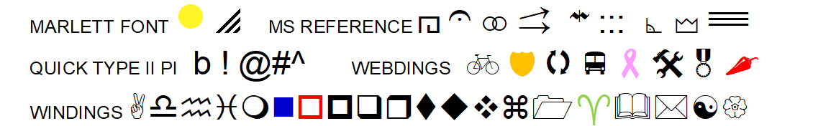
Arrow
You can also create a logo with graphic “Shapes” or “Word Art” available in Word. The “Arrow” logo at right was created in 5 minutes with a Shape and text.

DIY LOGO CREATION SITES. A number of sites allow you to choose among a number of graphic symbols and then add your company name. Some of them charge a modest fee to download the resulting logo in a variety of sizes and formats. Note: rights to the design are not always exclusive.
www.FreeLogoDesign.org. $39 (as of 2019) to download hi-res artwork. Low-res, which is adequate for a website, is free.
www.FreeLogoServices.com. Hundreds of designs and you can add a tag line. $40.

Brand Image – Logo

IF YOU WANT SOMEONE WITH DESIGN EXPERIENCE TO HELP, there are sites where you can post a project, set a budget range, and review portfolios and proposals from a variety of freelancers. You will often receive several designs to choose from and costs are surprisingly low, sometimes only $5 to $25 for a logo; and turnaround is usually in a few days, if not hours. Check out the following online services:
www.freelancer.com
www.fiverr.com Fiverr offers voice over and translations as well as design services.
www.designcrowd.com Design Crowd has a 2-minute video explaining the process.

Logo Tag Line: a memorable one-liner that summaries the brand image you want to project:
- Fifteen minutes could save you 15% or more on car insurance.
- Just Do It!
- When it absolutely, positively, has to be there overnight.
- When you care enough to send the very best.
You can name all these companies, right? Based on their tag lines, how do you think these companies want customers to feel about them?

Font. The typestyle you select for your company name will be part of your business personality. It should reflect the style and customs of your target demographic. Are your potential clients more likely to be retired librarians or bikers? Do you want it to be …
- Modern,
- Playful,
- Theatrical,
- Business-like?
Pick a common font so that it will print on most desktop printers. (Not all printers recognize every font; there are thousands. Therefore, if you select an uncommon font, you risk it not printing on all desktop printers.) You are probably safe picking one of the stock fonts that comes with Word.

To see how the name looks in various styles, type it in Microsoft Word, then highlight the name and scroll through the drop-down list of fonts. Your company name will appear in each font as you scroll over it.

How does the typestyle look when small, as on a business card or letterhead? How does it look enlarges, as on a sign or billboard?
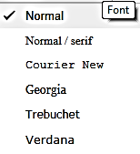
Make sure it looks good in print, on screen, and on the web (view in Internet Explorer, Firefox, and Google Chrome at a minimum).

KERNING. You can also change the appearance of your company name by kerning the type, which is changing the spacing between letters. In Microsoft Word, click on “Font”, then “Advanced/ Character Spacing”.
Narrow (condensed) Spacing
Normal Spacing
Wide(expanded) Spacing
Google uses the font menu at the right in its website building app.
Brand Image – Logo

Color Palette. Select colors that are widely available in a variety of programs you will use in your business, such as Word, Publisher, and Illustrator.

Keep it simple: a maximum of two colors. Your logo should also be able to stand alone in one color (such as when outputting to a black-and-white printer or when published in a newspaper). Note that all the logos in the chart below can be printed in one color. (Most are.) Less is more.

“Standard” colors available in Microsoft Word. Stick with these and you cannot go wrong. You will always be able to duplicate the colors consistently.

Colors convey image and emotion. What company attributes do you want your color scheme to exude?

Burgundy | Vigor, elegance, richness, maturity. | 
Red | Energy, urgency | 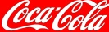
Pink | Romance, femininity | 
Orange | Fun, energy, warmth | 
Yellow | Optimism. Grabs attention | 
Green | Wealth, nature, stability, relaxation. | 
Teal | Luxury, uniqueness | 
Light Blue | Tranquility, coolness, purity | 
Royal Blue | Trust, loyalty, confidence, security | 
Navy | Dignity, credibility, tradition | 
Purple | Calming. (Women like/ men don’t) | 
White | Fresh, light, pure, clean, cool | 
Gray | Classic, quality, corporate | 
Black | Powerful, sleek. | 

To experiment with color schemes, go to www.colorexplorer.com/. Do not forget to write down the RGB code (amount of red, green and blue that go into the color mix) and the 6-digit Hex code. You will need the Hex code for some web design software.
Before committing to a color scheme, check to see how it looks printed on a color printer and in black and white. Many colors with complex formulas look dirty or dull when printed.

Check the colors on a PC and Mac.

And of course, know your customers: red is not a good color for marketing in China, or for medical products.

COLOR SCHEME SELECTED

Color Name RGB Formula HEX Formula*** ,

Primary ____________________ R____ G____ B____ _____ _____ ____

Secondary ____________________ R____ G____ B____ _____ _____ ____

*** To convert RGB to Hex, go to www.RGBtoHex.net

Brand Image – Packaging and Labeling

C. Packaging

The inner packaging is a box, bottle or blister pack suitable for a shelf. Retail packaging is typically not durable enough for shipping. Its purpose is to catch the eye of the shopper and sell the product. For information about shipping cartons (outer cartons) see Shipping and Handling in finance chapter.

Talk to the managers of the type of stores you hope will buy your goods. How do they want products packaged?
- In boxes to display on shelves?
- In packaging to hang from slat-boards?
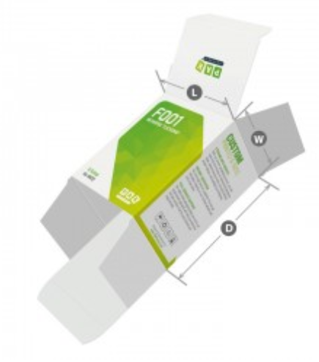
- In bulk bins?

RETAIL PAPERBOARD PACKAGING. There are specialty-printing houses that just make fold-up
boxes. See https://pakfactory.com/ or https://boxprinting4less.com for ideas and quotation.
Printed boxes can be expensive in “small” quantities.
PakFactory quoted $1000 (2019) for 1000 of the carton shown at right.

Initially, you may want to order a small quantity of a stock blank box and apply a label to it.
Uline.com offers a variety of standard sizes in white. A 3x3x6 white gloss paperboard
box similar to the printed one shown at right, is $32 for 100 plus approximately $13 for
Freight or about $.45 all in: very reasonable for test marketing.
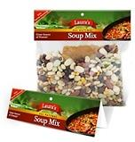


BAG HEADERS. www.uprinting.com will print 25 five-inch wide header cards for $25. This is a dollar each, but a low total for market testing or to have samples to photograph for a website. www.printrunner.com charges $27 (as of 2019) for 25 headers, but the price drops to about $.06 each for 1000. The bags you can buy at a grocery store.

BOTTLES and JARS. This 5 oz. glass sauce bottle is $.46 each in cartons of 12, plus freight, from www.bottlestore.com. Note: caps are usually sold separately.

Plastic containers run about the same as glass.

Since bottles do not fold flat for shipping, like paperboard boxes, find a bottle supplier near you to save on freight. You can probably find one close enough that you can pick them up yourself. This also allows for just-in-time inventory.


Whatever your product, there is a special container designed for it.
Brand Image – Packaging and Labeling

D. Labeling

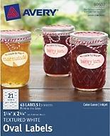
Whether the inner (retail) packaging is a bottle, jar or box, you can save a great deal on short runs for testing by using blanks and adding a label that you print yourself or order.

DO-IT-YOURSELF ADHESIVE LABELS.
Both www.Avery.com and www.onlinelabels.com offer 8.5” x 11” sheets of die-cut labels in various shapes and sizes, in matte white, glossy, and clear.

The cost at OnlineLabels is around $.40 per sheet (for 4 to 12 labels per sheet, depending on size and shape). Avery is more expensive, at about $.70 per sheet in quantities of 100 sheets. Avery labels are usually stocked at office supply stores, so you can always get more quickly if you need them—and of course save on shipping by picking them up yourself. Add about $15 for freight for a package of 100 sheets from either supplier to have them shipped to you. Prices are current as of 2019.

Both of the stock label makers offer free design templates.

CUSTOM PRINTED LABELS. If you search for “printed labels”, you will get 100 million hits, so you will not have difficulty finding a source. The key is to find a supplier with stock shapes and sizes so you do not have to pay for dies. Avery is one company that offers short runs of custom-printed labels, at www.avery.com/custom-printing.

Another source is www.printrunner.com/sheet-label.html where a thousand 3.5” wide rectangular labels run $.10 each. However, short runs are considerably more per label. You might start with one supplier and switch to a high-volume printer as you grow.

A starter supply of 48 Avery pre-printed labels, 3” wide, is $25, delivered. The price drops to a little over $.30 each at 1000 labels. By contrast, a rectangular label of the same width is about $.24 each (2019).

Labels are available in different shapes, sizes, and materials: including clear vinyl—so your product shows through—and silver and gold foil. The paper labels are available in matte and glossy finish. If using paper, go for glossy, as it is easier to keep clean.

[below] Some of the stock shapes available from Avery..

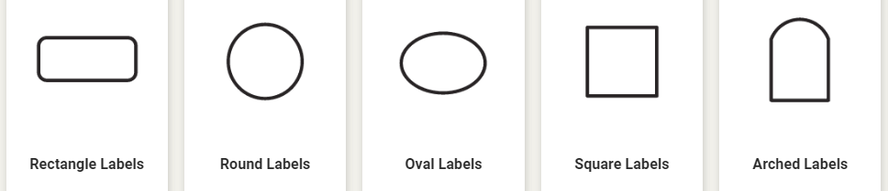


FOOD LABELS. Food product labels must display:
- A statement of identity,
- the product’s net weight,
- manufacturer’s address,
- nutrition facts, and
- ingredients list
An easy to follow resource for food labeling may be found at www.foodpackaginglabels.net

Brand Image – Phone Number

E. PHONE Number

After spending your hard-earned money and time to create a slick logo and dazzling website, you can still pop the image bubble of your company if your prospective customers are greeted with “Hey Homie, wazzup?” when calling to place an order. One option is to record a message that tells callers they have reached the XYZ company. (Your family and real friends will know about your business and will still leave personal messages.) Alternatively, you can install a separate phone number for your business.

1. VIRTUAL PHONE SYSTEMS. A number of companies offer virtual phone numbers for your business that will take messages or forward calls to your phone. You will not know if the caller rang your virtual business phone number or if they called your direct number. That is, you still will not know if it is a business or personal call. However, with caller ID, you should have a good idea. You can also move all your friends to a group in your contacts to receive your personal greeting, and all others the business greeting.

For laid-back businesses, some entrepreneurs just answer their mobile phone with their name, regardless of the caller; and a generic recording: “You’ve reached the phone of (name), please leave a message.”

Ring Central. www.RingCentral.com. $25 per month (as of 2019) for an office system with multiple users. With the full service package, calls can be answered with something like “You’ve reached the offices of [Ourco], your source for [our products]. For sales, press 1; for customer service press 2; to leave a message, press 3.” Ring Central will forward the call to the cell phone of the member of the management team. You can of course keep the same roaming system when you set up a permanent office, but continue to use this cloud-based phone system rather than an expensive network in the office.

Google Voice. www.Google.com/voice offers a free “one-number” service. Anyone calling the number will be forwarded to the phone you specify: a mobile phone, your home phone, or all three. You can also search the Google number database for a number that spells your business name. The number will follow you wherever you are. If you cannot take the call, you will receive a voice message (or if you prefer, a text transcription of the message). The Google service is free.

Nextiva. www.Nextiva.com with rates starting at $20 a month (2019). The web host iPage offers free Nextiva service with up to 100 minutes per month.

Virtual phone number acquired ____________________________

2. FAX SERVICE. www.RingCentral.com also provides incoming fax-to-email service with a toll-free number for $6.95 per month. You can also use it for outgoing faxes.

For companies that rarely send faxes, http://faxzero.com/ offers a $1.99 per fax option.

Fax Number _________________________________
Brand Image – Email Address

F. Business Email Address

To project a professional image, acquire an email account for your company. The best entrepreneurial email—because it shows your company is real—is to acquire your own domain. YourName@YourCompany.com is the most professional email an entrepreneur can have; and most hosting services provide free email accounts as part of the hosting package.

Do not make customers type in a long, difficult-to-spell name. Use your first or last name, whichever is shorter.
Keep it simple and easy to remember.

For trial launches of most companies, a free Gmail account will suffice; but switch to a custom-domain email address when you launch your business full time.

See “Website” section of this text for more information on suppliers of domains, email services, and website hosting.

Business email address acquired: ____________________@_____________________________.________

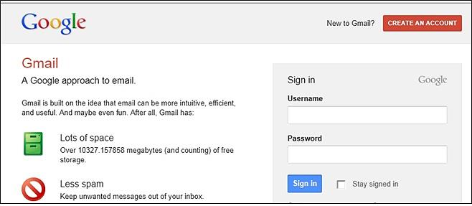
Brand Image – Business Cards

G. Business cards

The purpose of a business card is to give potential suppliers, investors, customers, and co-founders an easy way to remember what you do, how to find your website, and how to reach you. It is also a lasting impression of your brand.
ELEMENTS OF EFFECTIVE BUSINESS CARDS...
- TITLE (give yourself a title). It looks more professional. If a one-person startup, you are the CEO.
- EMAIL. Short and professional. See previous section in this text on “Business Email Address.”
- ADDRESS. This can get tricky. Some people do not want to advertise where they live; and Steve Jobs probably did not want it widely known that Apple was initially headquartered in his parents’ garage. If that is the case, rent a P.O. Box; or list your city without a street address. Prospective investors, employees and online customers just need a general idea of where you are located.
- DESIGN. Use matte (not shiny) card stock and a light-colored background and plenty of white space so the recipient can make notes. Keep it simple. Nothing says amateur like a busy card or a photo background.
- PHONE NUMBER. (See previous section in this text dealing with the “Phone number.”)

PRINTING BUSINESS CARDS YOURSELF

- Use Avery® “Clean-edge” punch-out card stock, available in white or ivory. You can obtain a pack of 200 white cards (20 sheets, 10-up) at most office-supply stores for around $22 (as of 2019).
- For business card templates in Microsoft Word, see File >New>Business Cards. Consider only designs that are in a “10-up” format as these match the layout of the Avery pre-perforated sheets. Here is a link to additional 10-up business card templates online:
https://templates.office.com/en-US/Business-cards-10-per-page-TM02807620
- Your artwork should look like the sample at right.

USING A QUICK-PRINT OUTLET such as Staples, Office Depot, or Kinkos-Fedex.

- Save artwork as a PDF to avoid conversion charges and to ensure your artwork is not corrupted when transferring to the printer’s computer.

- The chart below shows typical prices for business card printing. Note: for 2-color printing, black counts as an ink color. Kinkos does not divulge prices unless you first login and create a design.
ITEM | SPECS | QTY | STOCK | Staples | Kinkos/FedEx | Office Depot
Business Cards | Full color  Full color  2-color | 100  250  250 | “Economy”  80 lb.  80 lb. | $ 20+frt. | na  $30 del.  $20 del. | $ 10 del.  $ 40 del.  $ 25 del.
Website

12 – Website

A. Selecting a Domain Name and Hosting Service

B. Website Evaluation

C. Search Engine Optimization (SEO)

D Credit Card Processing Services

E. Adding a Payment Link to a Website

Yes, you need a website. It is now expected. This is where people who want to buy from you assume they can go to find out about pricing and see your full range of products or services. You will also need the all-important “buy” button or shopping cart and a contact page so potential customers can ask questions.

In other words, every company needs a website to organize the minutia that will not fit in your banner ad, email blast, direct mail postcard, or on your business card.

Website

A. SELECTING A DOMAIN NAME and HOSTING Service

Top Level Domain (URL Suffix). Of the top 100 most visited sites in the United States, all are dotcoms. Some newer endings are growing in popularity, especially .co, but this should be a distant second choice. If you type in the name of a company in your browser, as the default, you will be taken to the company with the .com suffix.

Protecting Your Brand. Pirates have been known to register a name similar to a popular site, and then clone the content. To protect yourself, consider registering...

- Alternative spellings: If you have drjones.com, you might want to buy doctorjones.com, as well.

- Alternative extensions: if you own the .net or .co versions, consider registering the .com ending as a defensive measure.
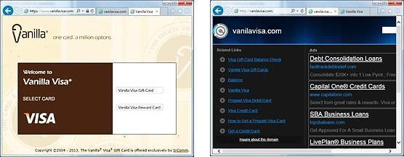

InComm launched a pre-paid Visa card called Vanilla Visa. They registered VanillaVisa.com, but did not purchase VanilaVisa.com (a common misspelling), or VisaVanilla. As a result, another company registered those URLs to take advantage of InComm’s advertising and siphon off clients who had not won spelling bees. Wise entrepreneurs register likely mistypings as well as possible misspellings. If you type “Goddady.com” into a browser, you will arrive at “Godaddy.com”.

Where to Buy Domain. NameCheap.com $9 first year/ $13 on renewal. IPage $10 first year/ $20 on renewal. GoDaddy.com charges $12 first year/ $19 on renewal. Registrar.com is $35 per year. (All prices as of November, 2021). iPage is the most upfront and transparent about pricing.

Subdomains. Some web hosting services offer free hosting if you use a subdomain of their domain name. A domain would be www.YourCompanyName.com. A subdomain might be www.YourCompanyName.Wix.com.

Hosting. There are many website hosting services from which to choose. The authors of this text have researched over 20 sites and consulted a number of rating services to prepare the chart of hosting services on the following pages. Prices range from free for a subdomain site and a limited number of pages to $130 per year for virtually unlimited pages and storage space.

All hosting services offer DIY website Content Management Systems (CMS), design templates, and blogging software as part of their hosting packages. The paid packages are free of ads and offer online help.

Website

Hosting and CMS Options  (Rates as of 2019) |   000WebHost.com |  Moonfruit  Moonfruit.com |   iPage.com | FatCow  FatCow.com |   smallbusiness.yahoo.com
Domain (.com) registration | Free with paid Hosting | Free with paid Hosting | Free with paid Hosting | Free with paid Hosting | Free with hosting
CMS site builder with templates | Free | Free with hosting | Free WordPress with hosting | Free with hosting. WordPress and Joomla | Free with hosting
Web Hosting only + email addresses | Free  1 GB storage  (and no ads!)  $24 - $144 year  20 GB storage | Free, as subdomain:  20 MB storage.  (15 pages).  $48 yr. for domain 500 MB | $24 for 1 yr. (as of 2019)  Then $120 per year.  Unlimited storage | $49 yr. 1st yr. (as of June 2016)  Then $180 yr.  Virtually unlimited | $31 year
Email service | Free with paid hosting | No | Free. Can be forwarded | Free with paid hosting | Free with paid hosting
Database | Free | Free | Unlimited | Unlimited MySQL | Included, unlimited
Free Ad Words | No | No | $200 w you spend $25 | $200 if you spend $25
Security Certificate | Shared SSL certificate. Unique certificate is  $70 - $192 year | SSL secure payments | Free SSL Certificate | Incl. (shared) | Free SSL Certificate
Single Item Credit Card Sales | No | Free | Incl. | Incl. | Incl.
PayPal Integration | No | Free | Incl. | Incl. | Incl.
Shopping Cart (multiple item sales) | No | Free. + pushes out to Facebook | Free | ShopSite included | $132 year for store
Phone Number included, with call routing /forwarding | No | Not available | Free. 100 min. per mo. | No | Not available
Mobile friendly | Yes | Created automatically | Not mentioned | Not mentioned | Yes
Other | WordPress installer included | Social media savvy. Very flexible, but size limit of 15 pages | Cool design features and many extras.
Favicon |  | Yes | With Joomla | With Joomla | Yes
Website

Hosting and CMS Options | Weebly.com | Wix.com | Yola.com | GoDaddy | _________
Domain (.com) registration | Free with paid hosting | Free 1 year with paid hosting | Free with paid hosting | $12 first year, then $18 year
CMS site builder with templates | Free | Free, and easy to use | Free | “Website Builder” $60 year includes hosting
Web Hosting + email addresses | Free as subdomain, with ads.  Own domain  $60 yr.  500 MB storage | $156 year  3 GB storage | Free as subdomain.  Own domain $120 (Silver package)  5 GB storage | Included. Don’t order hosting as it is included with Website builder
Email service | Not available | Not available | $10 yr. | $60
Database | No | No | No | MySQL Linux or MS SQL
Free Ad Words | No | No | No | No
SSL Security | Included | No | No. Hosted in cloud. | SSL security included
Single Item Credit Card Sales | Incl. | No |  | No
PayPal Integration | Incl. | No | $20 mo. extra | $48 per year additional
Shopping Cart (multiple item sales) | Store $84 additional | $126 year additional | $120 year additional | $180 year more than basic Website Builder
Phone Number included | No | No | No | No
Mobile friendly | Yes, automatic | Yes | Yes | Yes
Other |  | Site mirrored on Facebook. HTML5 capable | Site mirrored on Facebook.
Favicon |  | Yes | Yes | Yes
Website

B. WEBSITE EVALUATION

Feature | Pts |  | Comments
UPLOADED PROPERLY. Site visible online | 5
SITE STABILITY. It does not crash. | 5
STYLE. Appropriate to target audience | 5
GRAPHIC STANDARDS.  Consistent use of a design theme | 5
COLOR SCHEME appropriate | 5
FONT. Appropriate selection and consistent usage | 5
BRANDING. You know whose site this is, or at least what product it is selling—no matter what page you are on. Putting the logo on every page and the use of style sheets helps to remind users of the company and brand identity. | 5
LOGO APPROPRIATENESS. Evokes the right image and emotion. Web design style and logo are compatible | 5
LOGO DESIGN. Simple and easily recognized in a crowd. | 5
WHITE SPACE. Pages are open and pleasing to the eye (not busy and cramped) | 5
PAGE LAYOUT. Placement and organization of graphic elements and text guide the user’s eyes to important information and links.  (You do not have to hunt to find what you want.) | 10
SITE ARCHITECTURE. The material is organized into pages and sections in a logical and easy to follow topology. Sequential content flows logically and smoothly. | 5
NAVIGATION. It is easy to find your way around within the site. You do not get lost. | 5
MENUS. Well-organized and easy to figure out. | 5
LINKS. No missing or broken links: 404s | 5
SPELLING. | 5
GRAMMAR. | 5
IT WORKS. Can you tell what the site was built to do (promote a candidate, sell widgets, aggregate data, etc.) and does it do that? For example, a site created to sell a product should have a “Buy now” button and it should be easy to find and use. | 5
STICKINESS. Site encourage visitors to linger and return | 5
TOTAL | 100
Website

C. SEARCH ENGINE OPTIMIZATION (SEO)

Increasing website hits

When a web surfer enters a search term in a web browser such as Google, Bing, or Firefox, the search engine looks for those terms in website meta tags and page descriptions.

META TAGS are simply key words and phrases that you include on your website. Almost all hosting services allow for metatags and have clear instructions on how to add them.

The important thing is to guess accurately what words a customer might use to find products like yours. If you were selling cooking utensils, what words might someone enter in Google to find them? Certainly, “Cooking utensils,” but perhaps someone might enter “cooking aids”, or “kitchen aids”, “Gourmet”, “Crock pot”, or a brand name like “Cuisinart”. These would all be good metatags.

Be creative. Add some recipes to your site; then add “recipe” as a metatag (and perhaps sell that deep fryer mentioned in one of the recipes.)

The list of websites using the same metatags (which probably includes your competitors) are ranked by criteria called algorithms. Your site will place higher in search results if it is...

- Referenced on Other Sites with links back to your site.
- Mobile-friendly. (You can check to see if Google considers it so by entering your site’s URL here: http://www.google.com/webmasters/tools/mobile-friendly.)
- Secure (HTTPS prefix). For this, you will need to obtain a Secure Certificate from your web host.
- Not Top-heavy; that is, it does not contain too many ads above the fold (portion of the screen that can be seen without scrolling down).
- Contains High Quality Content. It does not contain copies of articles from other sites, that is, the content on your site is fresh and unique, and adds to the total body of knowledge on the web. Proper spelling, grammar, and readability also help. Short, simple sentences with common words beat out sesquipedalian pedantry.
- The URL and Page Names Describe the Content. For example, if you are selling baseball cards, “JacksBaseballCards.com” will place higher than “JacksShack.com.” If you have a page that lists 2010 Dodger cards, a webcrawling robot or human searcher will understand this clearly, if you name the page “JacksBaseballCards.com/2010/Dodgers.” Remember, the actual page URL appears in search listings. A search for “Dodgers baseball cards” returned the following on the first page of Google results:
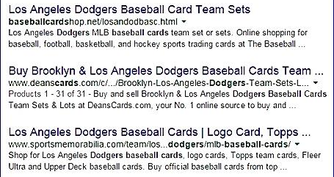
The top return included a large portion of the search string was in the domain (“baseballcardshop.net”) even though the specific page has a poor name (“losanddodbasc”).
The second place domain name (deanscards.com) was less clear about what the shop sold, but the page name made this seller easy to find for the Google search robot.

Website

D. Credit Card Processing Services

 | PayPal | Intuit | Square | Stripe | PayAnywhere
Free Mobile App | Yes | Yes | Yes | Yes | Yes
Free Credit Card Reader | Yes | Yes | Yes | Available from third party for additional fee | Yes
Processes checks | Yes | x | x | x | x
Allows multi-users so others can accept payments for you | Yes | Yes | x | Yes | x
Live customer phone support | Yes | Yes | x | Yes | Yes
You can open a merchant account  without a credit check | x | x | Yes | x | x
Links to QuickBooks | x | Yes | x | You can download data into a file format QuickBooks will accept | x
Transaction Fees | 2.7 % | $12.95/ mo.  + 1.75% to 2.75%  per transaction | 2.75 % or  $275/mo. | 2.9% + $.30  (2.7% + $05  with terminal) | 2.69 %

Also, check the fine print at the payment processor’s website before making a final decision. Fees may vary by type of card and by type of transaction. For example, credit cards that are keyed in by you to process phone orders—where you do not have a card to swipe—may incur an additional fee. For more information, visit...
- Intuit GoPayment http://payments.intuit.com/mobile-credit-card-processing/
- PayPal “Here” https://www.paypal.com/webapps/mpp/credit-card-reader
- Square Best for brick-and-mortar https://squareup.com/
- Stripe Best for online. Easy interface to website and flat fee. https://stripe.com
- PayAnywhere.com http://www.payanywhere.com/

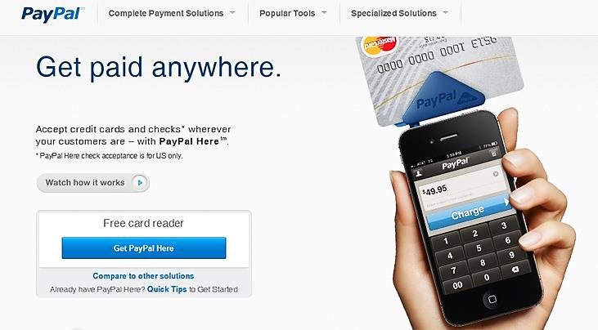

Mobile Phone Adapter
to Swipe Credit Cards

When you set up your Square or PayPal Merchant Account, you can request this free add-on that will allow you to swipe credit cards for face-to-face sales. Square and Intuit also offer phone plug-ins and software to process credit cards in brick-and-mortar settings. See comparison chart above.
Website

E. Adding A Payment Link to a Website

After opening a merchant credit card account, you will be able collect payments on your website. The following will walk you through how to add PayPal buttons to a website. The procedure will work with almost any web content management systems (CMS) or payment processing service.

- Sign into your website and PayPal Merchant accounts.

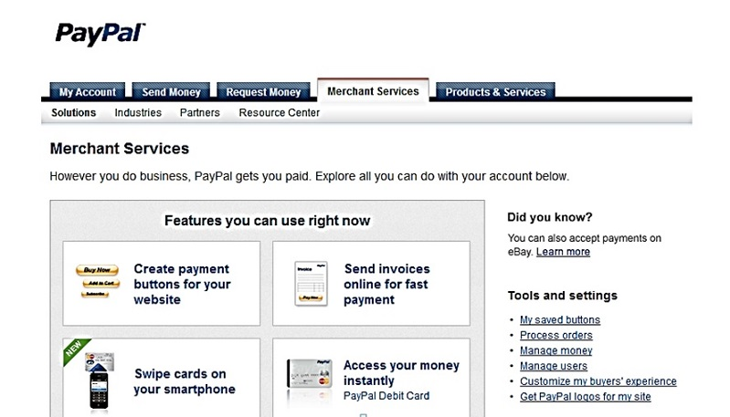
- In Pay Pal go to Account Merchant Services.
- Click “Create
payment“ option
- Follow the prompts to design your payment window.
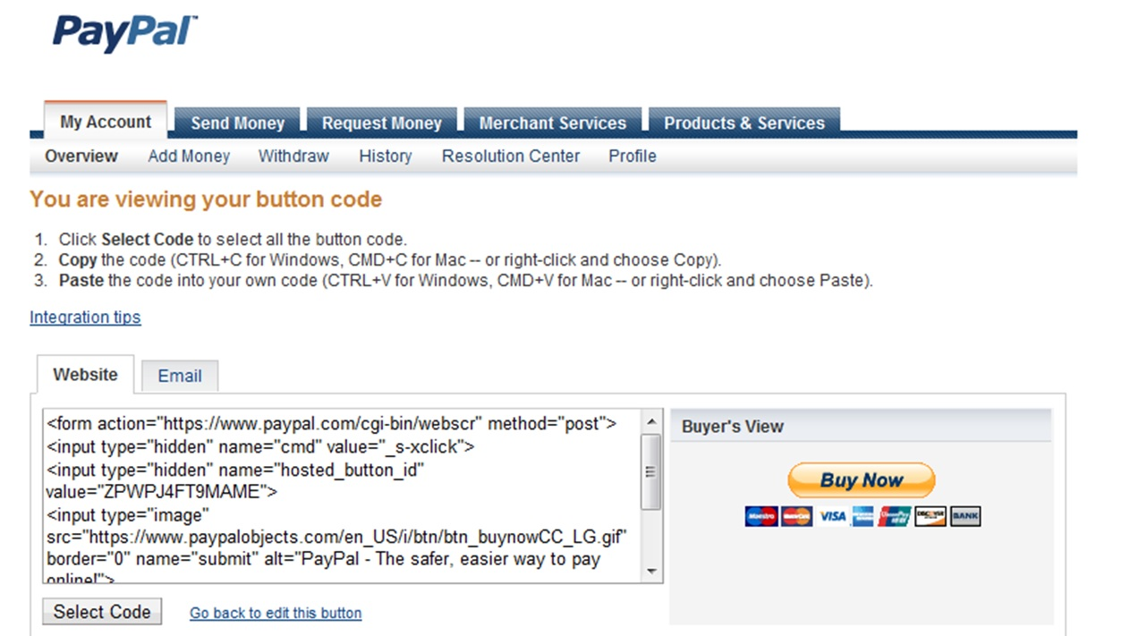
- Click “create”, then copy and paste the HTML code into your website.

Marketing

13 – Marketing

A. Marketing Strategy and Plan

B. Credit and Collections Policies and Procedures

C. Posters for Trade Shows and Pop-up Venues

D. Flyers and Brochures

E. Paid Web Advertising (Purchasing Adwords)

F. Free Web Advertising (Local Search Directories)

G. Building a Social Media Presence

H. Utilizing Social Media Influencers

I. Marketing Videos

J. Email Marketing

K. Networking to Generate Leads

Marketing

A. Marketing Strategy and Plan

Who will use the product? (The USER) ___________________________________________________________

Who will pay you for it? (The CUSTOMER) ________________________________________________
(e.g. -- if you sell cereal, the users may be children, but the customers will be parents.)

Whom do you want to reach and exactly what do you want them to do (go to your website? download a coupon? complete a survey?)

How will you reach out and connect with your potential customers?

How will you incentivize prospects to take the desired action?

Advertising and Promotion Channels. How will customers find out about your product, its features and benefits? This is especially critical if you are relying on an intermediary (retail store, wholesale distributor, contractor, app store, etc.) as the delivery channel. Your advertising mix might include some or all of the following:
- Paid print media advertising (magazines and newspapers)
- Free public relations through journalists who write about new products and companies. Local papers are also eager to publish stories about new companies in their area. Contact your local city or business editor.
- Radio and TV advertising
- Direct mail. List brokers sell addresses for specific demographics. However, these lists often have miscoded demographics and 20-50% outdated addresses. Instead, contact a publication serving your target market, as subscription lists are usually more current.
- Trade shows. Google “Trade shows [your industry]”
- Email marketing
- Web advertising (purchasing adwords)
- Social Media Influencers (bloggers, instagrammers, tweeters, or podcasters).

Sales Channels. (How will you sell your products or services?)
- Directly to consumers
- Through retail stores? (You will need to sell the storeowners as well as the ultimate consumer.)
- Through distributors, wholesalers or manufacturers’ reps? They will sell to retail stores for you, for a 6-8% commission—but beware; they are as difficult to sell as the stores themselves. They only want to rep proven winners.
- Through your own sales force?
- By bidding on contracts?

Delivery Channels. (How will you deliver you products or services?)
- Via mail, UPS or FedEx.
- Through Fulfillment by Amazon (FBA)? See http://services.amazon.com
- The App Store?
Marketing

B. Credit and Collections Policies and Procedures

Whether to Extend Credit to Clients: The Problem of Slow- or Non-Payment
Credit terms (not having to pay in advance or upon delivery) should be a privilege that customers earn by establishing a prompt-payment history with your company (no bounced checks, declined credit cards, frequent returns, or chronic complaints and attempts to inveigle invoice adjustments). Be especially wary of temporary businesses such as political campaign headquarters—and require full payment in advance from these clients. Even when extended to worthy repeat clients, credit limits should be meted out gradually.

Moreover, do not assume that a large, well-known company is a safe risk. Large companies can and do fail: Arthur Andersen, Enron, WorldCom, and Lehman Brothers.
They can be the slowest payers, as the president, insulated by layers of financial bodyguards, never has to look you in the eye
The best credit policy for a startup is C.O.D. (Cash on Delivery), for a number of reasons. The longer it takes to receive payment, the more capital will be tied up in receivables. Extending credit will also introduce uncertainties into your cash flow projections, since it is difficult to predict exactly when customers will pay for your goods and services. Finally, you will probably spend more time, aggravation and money on paperwork and collections than the value of the additional sales that extending credit might bring.

If You Do Offer Credit, Here Are Some Simple Guidelines to Reduce Bad Debts
- Offer only small amounts of credit for short periods.
- Never extend more credit to any one customer than you can afford to shrug off.
- Never extend additional credit to a company in arrears to you. I realize you are hoping to maintain a cordial relationship and help the debtor turnaround; but you are probably only throwing good money after bad. Do not get desperate; sometimes it is better to turn down a sale.
- If your service is expensive, you will probably want to do a credit check. Ask for references of other suppliers in your industry and call the bookkeepers of those firms to find out how well the prospective client pays and what credit limits the other firms offer. Bookkeepers, even at competing firms, do not see themselves as competitors. Indeed, they want to help each other. Their job is not sales; it is collecting on sales.
- Do not let companies fall in arrears without regular phone, email and written “overdue” reminders at least every two weeks.
- For custom-made products that you cannot take back to resell (printed stationery, t-shirts) require at least a 50% deposit. The same for services like house painting.
How to State Your Payment Terms on Invoices and Quotations
Traditionally, payment terms are written in shorthand, such as “Net 15.” This means the bill is due in 15 days. Invoices are generally dated and mailed when the job or product is completed and accepted by the customer.
The terms on the invoice should match the terms on your written quote. (Confirming in writing when you will be paid is one reason to ask customers to sign quotes.)
STAYING COMPETITIVE. Check the terms used by other companies in your field to determine what is customary. In most industries, it is net 30 days. Of course, buyers look at price and terms together, so if your prices are lower, you might be able to get away with requiring quicker payment terms or even COD (cash on delivery).

Marketing

According to a study by FreshBooks of small business collections, the terms that generated the fastest payment were net 21. They also suggest stating the terms in polite non-accounting language, such as “Thank you for your business. Please send payment within 21 days.” One explanation by the FreshBooks analysts was that some unsophisticated clients do not know what “Net 21” means.

DISCOUNT FOR PROMPt PAYMENT. If you wish to offer your customers a discount for early payment, you might state your terms as “2% 10 net 30” or “2-10, net 30” indicating that the payer may deduct 2% from the bill if it is paid within 10 days of the invoice date; or pay the full amount in 30 days. Again, you may want to spell this out in plain language, as few people have a clue “2-10, net 30” means.

PENALTY FOR LATE PAYMENT. The FreshBooks researchers also found that a 1.5% monthly interest penalty for late payment also helped to shorten the payment cycle.

TALK TO YOUR CUSTOMERS. Of course, this whole discussion of payment terms is academic. There is no guarantee your customers will adhere to the terms. You may therefore find it productive to involve customers in the planning of your policy on terms and conditions for payment. When do they pay their bills now (weekly, end of month)? How do they like to pay (by check, credit card)? How important is price versus time to pay versus other terms, such as the right to return items?

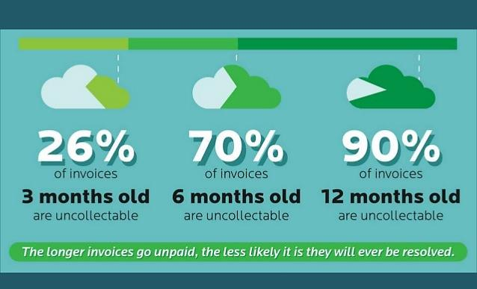
Chart by E2B Teknologies

Marketing

C. Posters FOR TRADE SHOWS AND POP-UP VENUES


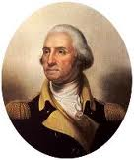
Use a design program like Microsoft Publisher, Adobe Illustrator, or Quark to create documents larger than 8.5x11. Microsoft Word does not allow for a layout larger than 22” in either direction. Theoretically, for an 18 x 24 poster, you could create the design in Word using dimensions of 9 x 12, and instruct the printer to blow it up 100% (print at 200% of the original size) to create an 18 x 24 poster. However, photos may appear fuzzy, graphics and fonts may break up and appear pixilated, and round and diagonal lines may show stair-stepping.

The photo on the left is same size as the original. The version on the right is a smaller version blown up to twice its original size.

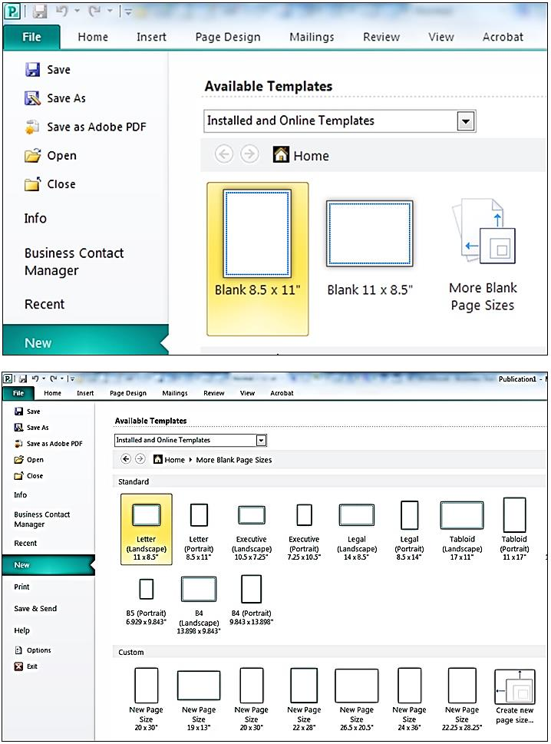

Designing a poster in Microsoft Publisher

On the first screen, click on “More Blank Page Sizes.”

On the next screen, create a template for the desired size by clicking on “Create new page size” (shown in lower right of the partial screen shot at left). A good compromise between size and cost is 18” x 24”. This is a stock printing size at Staples and Office Depot.

Marketing

On the next screen, give your new template a name and specify the width and height. Note that we’ve set the margin guides at ¼” all around. This is about as close to the edge of the paper that you can print. The guides will help you stay within these borders. If you want your design to run to the very edge of the paper, just ask the printer to trim off these margins. The result will be a poster 17.5 x 23.5.

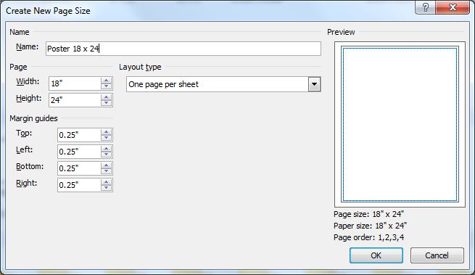
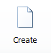

After clicking “OK”, click on the small “Create” button on the extreme right of the screen.

Content

Less really is more in poster design. People will be walking by your exhibit table or store window, thinking about something else, so you’ll only have about a half second to gain their attention, pique their interest, and effectively convey your message. Most billboards and print ads do this well. Try to mimic their simplicity in design and text.

Also, to give your posters a long useful life, don’t include information that is likely to change, like pricing.

Do include the basics:
- product
- how it will improve the life of the customer (key benefit)
- how to buy it (website url, phone number, and/or store address). Posters are another reason to use a short, easy to remember, easy to spell domain name. People are probably not going to take out pen and paper to write down you website address; you have to rely on them remembering it
- name of company

Marketing

Printing Color Posters, Brochures and Business Cards through a Cloud-Based Service.

UPLOADING ELECTRONIC FILES. In all cases, you will need to create an online account with a login and password. This will allow you to upload files from your computer or to design materials on the printer’s website.

FORMAT. Each printer lists on its website the formats it will accept. The safest is PDF, as what you see is what you will get. Otherwise, if you use a font that is not on the printer's computer, a different font will be substituted. In addition, positioning of graphic elements can shift if you do not use a PDF format.

DELIVERY. In some cases, you can pick up the printed materials at a store near you, thus saving the freight charges. However, sometimes the in-store price is different from the online price, so you may want to confirm the charges before ordering.

PRICING. Use the chart below for budgeting purposes only. Check websites for current pricing. Printing is full color, except as noted. (Prices below are current as of 2019)

ITEM | SPECS | QTY | STOCK | Staples | Kinkos | Office Depot
Poster | 18 x 24 | 1 | Photo gloss | $ 10 paper  $ 14 on poster board | $22  $40  on foam board | $ 15  not mounted
Flyer (full color)  1-side printed | 8.5 x 11 | 25  50  100 | 100 lb.  100 lb.  100 lb. | $ 20  $ 39  $ 65 | na  $ 30  $ 60 | $ 17.  $ 32  $ 59
  Brochure | 8.5 x 3.67 | 25  50  100 | 100 lb.  100 lb.  100 lb. | $ 26  $ 46  $ 81 | $ 40  $ 68  $136 | na
KINKOS/FEDEX www.fedex.com/printonline
- Free delivery on orders over $100
- No access to pricing until after you have opened an account and uploaded artwork (so not very user friendly).

STAPLES www.Staples.com/copyandprint
- Free delivery on orders over $50
- Good prices.
- Clunky website.

OFFICE DEPOT www.officedepot.com/a/design-print-and-ship
- Free delivery on all orders. For pricing see http://customprinting.officedepot.com
Marketing

D. Flyers and Brochures


Microsoft Word offers a variety of templates for flyers and brochures. The sample at right shows the outside (top) and inside spread (bottom) of a tri-fold (6-panel) brochure. The designs are printed on the front and back of a standard 8.5 x 11 sheet, which is then folded in thirds, to fit into a stock brochure rack or #10 business envelopes.

It is not advisable to design a brochure with little margin for folding error, as this one. Note how the fold in the lower right is along the abutment of two design elements. Good luck getting that right every time.

You will find that a simple one-sided flat 8.5 x11 flyer is just as effective as a complex
tri-fold brochure. If you do want a tri-fold brochure, we suggest you start with a stock Word or Publisher template. (A brochure layout is more complicated than it looks.) First, there are six pages, each with four margins. Second, the right panel on the top section (the cover) must be slightly wider than the middle panel, which in turn must be wider than the panel on the left. Otherwise, the brochure will not fold neatly and lie flat.
Do not worry if the layout or color scheme of the template is not to your taste. Everything is editable.

Fold lines (added by author)

Marketing

E. PAID Web Advertising (BUYING Adwords)

Google, Yahoo, and other search engines allow companies to buy adwords. If you decorate blue jeans, and you buy hits for the search term “blue jeans”, when someone searches for blue jeans, a brief sales message for your product and a link to your site will appear in the margin of the page displaying the search results.

Ads might run $.50 to $2.50 per appearance, but you can set a limit of how much you want to spend each month.

Try different adwords and offers to see which ones draw the most traffic to your website. Install Google Analytics to see which key words led searchers to your site. https://analytics.google.com/analytics/web. It is free. Google will even provide advice by phone to new users: 877-721-1743.

The screenshot below shows the results of a search for “Football” the left column contains the normal returns by the Google search engine. The right column contains the results from companies that paid for the adwords “Football tickets”.
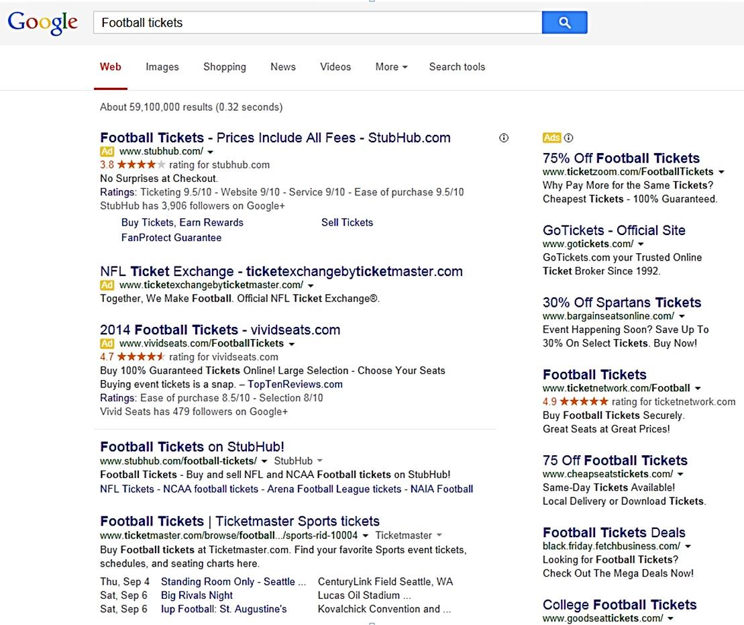
Marketing

F. FREE WEB ADVERTISING (local SEARCH DirectorieS)

The following Local Search Directories are free.

The more search directories you are listed on, the higher you will rank on Google.

Apple Maps
Bing.com
Brownbook.net
Communitywalk.com
Elocal.com (for service providers)
EZlocal.com
Foursquare.com
Google My Business
InsiderPages.com
LinkedIn Company Directory
Local.com
LocalStack.com
Manta .com
MapQuest.com
Merchant Circle.com
Mylocalservices.com (for service providers)
Super Pages.com
Thumbtack (for service providers)
Tupalo.com
Yahoo! Local
YaSabe.com (Spanish)
Yellow Book.com
Yellow Pages.com
YP.com
Yelp.com

This website will do a quick search of 35 Local Directory Sites to see which ones you are listed on and to make sure your information is current: https://uberall.com
Marketing

G. BUILDING A Social Media PRESENCE

To advertise on Facebook, see https://www.facebook.com/advertising/. This is an art; start slow and learn all you can. There are many free and low-cost seminars on how to market through social media.

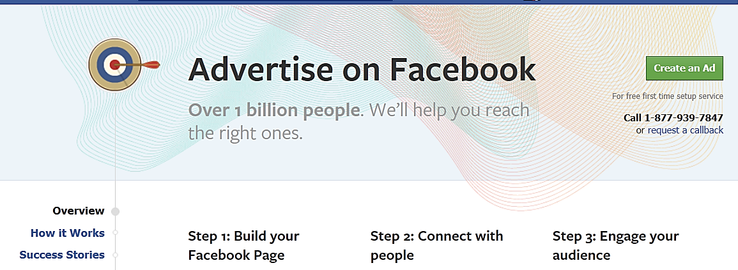

Choose the right Social Media Platforms for your Business: Start with one platform and do it well, before moving on to others.
- B2C (Consumer product or Service) Facebook (especially for entrenched prior generations)
- B2C (Consumer product or Service) Instagram, TikTok (over 2 billion downloads), and YouTube
(especially for 18-24 year olds and visual products). YouTube is
also useful to demo services or show how to use, set up or
repair a product.
- B2B (Business clients) LinkedIn
- Impulse buyers Pinterest, Instagram
- Entertainment Media Myspace
The best social media advertising is the kind you don’t pay for. Consider doing the following:

- SET UP FACEBOOK AND MYSPACE pages for your company or product. MySpace, while overshadowed by Facebook, still has over 100 million users world-wide.
- CREATE A PROFILE ON INSTAGRAM and post photos that tell the story of your business
- ENGAGE VISITORS. Invite customers to post their own pics and experiences. This is especially valuable to restaurants, bed and breakfasts, entertainment venues and experience services.
- TWEET tips to your clients. Twitter has roughly 70 million users each month in the U.S. and 275 million worldwide. Companies with 51-100 Twitter followers generate twice as much traffic to their website as companies with less than 25 followers.

Marketing

- WRITE A BLOG for potential customers (people that have the problem you are solving). If you have a product to help people stop smoking, start an “I wish I could stop smoking” blog and website. Engage your followers: ask them for their opinions and experiences. Web content must be informative, unique and entertaining—and not all self-serving. Granted you will have a shopping basket on your site, but the purpose of the content is to project your company as a knowledgeable expert concerned for the well-being of the customer. Share content on the web during high traffic hours in the U.S. (Times are EST.)⁵
  - Facebook 1 pm to 4 pm
  - Twitter 1 pm to 3 pm
  - LinkedIn 7 am to 9 am, and 5 pm to 6 pm (business execs use LinkedIn)
  - Google+ 9 am to 11 am
  - Pinterest 2 pm to 4 pm, and 8 pm to 1 am

Articles with images receive almost twice as many views as text-only posts.

Don’t forget to send comments to other bloggers in your industry; and post to sites visited by your customers.

- COUNTER NEGATIVE ONLINE PUBLICITY. To find out when someone says something about you or your company online (positive or negative), sign up for Google Alerts: www.google.com/alerts.
- LINK YOUR SOCIAL MEDIA SPACES TO YOUR WEBSITE (where people can obtain more information about your product and place orders).

- JOIN A FACEBOOK GROUP (if B-C) or a LINKEDIN GROUP (if B-B) and share leading-edge information and answer questions of members to establish your credentials as an expert in the field.

- ADD FACEBOOK “LIKE” BUTTON to your website and blog. Business websites gain 185% more traffic after receiving 1000 likes.⁵

- ADD GOOGLE+ BUTTON TO YOUR SITE AND BLOG.

For instruction on adding Google+ and Facebook “Like” buttons see...
http://support.addthis.com/customer/portal/articles/381237-third-party-buttons
Make it EASY for customers to buy after they reach your site.
- Offer the option of paying via PayPal. This alone will add 15% to your sales volume. See https://www.paypal.com/us/webapps/mpp/merchant.

- An Amazon Payments button will add another 18%. See https://payments.amazon.com/home.
- Build a mobile app version of your website.
- 80% of smartphone users use mobile phones for shopping research.
- More Google searches take place on mobile devices than on computers.
Read more about online marketing at http://succeedinginyourbusiness.com/

Marketing

H. UTILIZING SOCIAL MEDIA INFLUENCERS

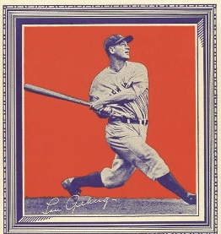
Ever since Honus Wagner allowed Hillerich and Bradly to use his name on one of their Louisville Slugger bats in 1905, companies have been using celebrities to endorse their products. Today, a pacesetter is just as likely to be a middle-schooler with a loyal following of her advice on how to dress. Influence does not come in just celebrity size anymore.

Bloggers have discovered they have power to influence buying decisions; and consumers seem to trust their favorite trendsetters—even if they know the plug is a paid ad.
Lou Gehrig on a 1934 Wheaties box.

A startup can easily tap into the influencer phenomenon to create awareness. Just as newspaper print ads vary in price, depending on circulation, the rates charged by influence peddlers depends on the size of their following. According to Tara Johnson of CPC Strategy, “Micro influencers offer the most authority in a specific and narrow audience niche. These influencers have a smaller, yet intensely dedicated following of 10,000 or fewer. Micro influencers are a hot commodity because they are affordable and have high levels of engagement.”

Here is some additional advice from John Lincoln of Ignite Visibility, a digital marketing agency:
- If the audience is not in line with your brand, the message will not resonate, no matter how many people hear or see it.
- The Big Three channels are Instagram, YouTube, and Snapchat.


Cost Per Post
INSTAGRAM. $.01 to $.05 per follower. The micro-influencers (1000 to 10,000 followers) are on the high end of the scale because their followers are more ardent and homogenous. In fact, even within the micro influencer category, impact declines as the number of followers increases. The fall-off is about half from 1000 followers to 10,000. The sweet spot for most marketers appears to be around 10,000 followers, as the most common price paid for a post is $250-$270.

Kim Kardashian promoting morning sickness
drug on Instagram
YOUTUBE. $.02 per subscriber ($20 per 1000) as of 2019.
SNAPCHAT. $.10 to $.35 per view (as of 2019).

Marketing

I. Marketing Videos

Marketing videos are now a staple in the sales tool kit. One well-done production can serve multiple roles:
- Launching a product on Kickstarter or Indiegogo
- Building buzz on YouTube, Facebook and Instagram.
- Selling on Shopify or Etsy
- Posting on your website to explain how your product or service works
For marketing videos, keep it to 30 seconds or less. (Think about it: would you watch a two-minute infomercial if you didn’t have to.) Explanatory and tutorial videos can be longer.


PROFESSIONAL VIDEO PRODUCERS. There are probably several production houses close to you. Google “Video production near me.” One online source we like is www.Promoshin.com. They use animation which is cheaper than live action, and it’s easy to make edits after the vid is in the can, since you don’t have to get the crew back together to reshoot that 5 seconds that is no longer correct because of last-minute changes you made to the product or marketing strategy.

For budgeting purposes, expect a pro to charge $1000 to $2500 for a marketing vid. If this is beyond your means, and you do not feel comfortable doing it yourself, the going rate for video by a film or communications student is $300 to 500 for 30 seconds, including music and voice over.
Animated 30-second marketing video

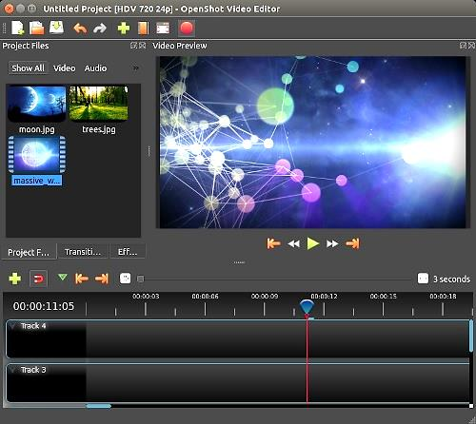
FREE DOWNLOADABLE VIDEO EDITORS – All are Windows and Mac compatible; and you do not need four years of film school.

Shotcut https://shotcut.org/
Supports 4K HD resolution

Avidemux http://fixounet.free.fr/avidemux/

Openshot https://www.openshot.org/

Dashboard of Openshot
video editing platform

FREE VIDEO EDITORS FOR USE ON MOBILE PHONES.
Available on iOS and Android. Easy to use and Instagram friendly.

Magisto https://www.magisto.com/

FilmoraGo https://filmora.wondershare.com/filmorago-video-editing-app/

Marketing

J. Email Marketing

Collecting Names to Build an Email Prospect List.

- AT FACE-TO-FACE MARKETING FORUMS (Trade shows, exhibits, sampling tables in retail outlets). Take a clipboard and invite people to join your emailing list. You will collect more emails if you offer to send a sample, free-trial access code, or discount coupon.
- ON YOUR WEBSITE. Add a “sign-up for announcements of sales” button in a prominent location on your site. As an incentive, offer something immediately to anyone who opts in, like a discount off the first purchase.

Distributing Emails Announcements to Customers. A free email marketing service is available at http://mailchimp.com/. The free service is limited to 2000 names, but that is a lot of opt-ins. You probably will not exceed that for at least a year. Alternative platforms for email marketing include...

- ConstantContact.com, a competing service, charges $20 per month up to 500 contacts, $45 up to 2500 contacts, and $55 for up to 5000 contacts (as of 2019).

- Campaigner.com is another popular service. Prices range from $20 for up to 1000 contacts, $30 up to 3500 contacts, $50 for up to 5000 contacts (as of 2019).
Restrict blasts to three or four a year—certainly no more than once per month—or you will receive as many unsubscribes as opt-ins. Moreover, do not send every email to every prospect on your list. If you are holding a sale for homeowners in Chicago, take the time to filter your list to only Chicago zip codes or area codes.

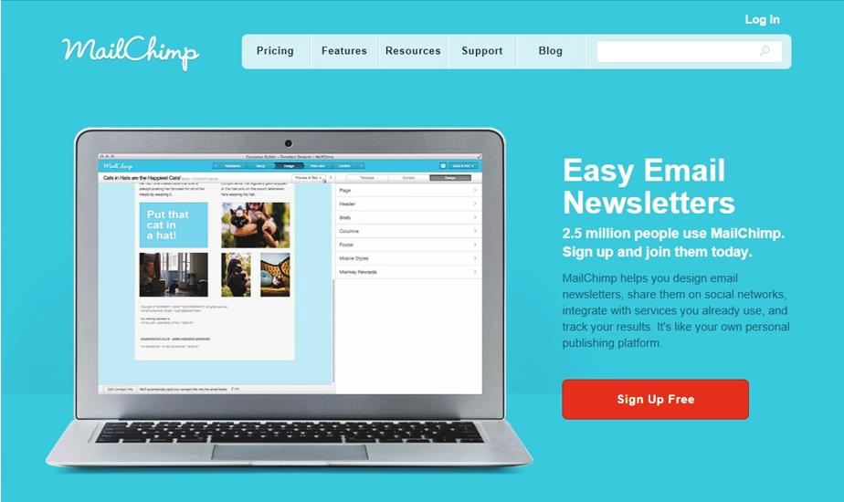

Marketing

K. NETWORKING to Generate Leads

You never know where your first employee or next sale will come from, but you greatly increase your chances of success by getting out and pressing the flesh. The more people you meet the greater your odds.

Take business cards, and if someone hands you a card make a note on it to remind you what the person looks like and how you might help each other.

Join the local trade association for your industry. Find the nearest one at https://www.directoryofassociations.com. Attend meetings to get to know the members and then start a Mutual Referral Campaign with the professionals who have solid reputations for reliability and integrity.

It may sound counterintuitive to attend a meeting of, say; fellow contractors or lawyers, but they all will not share your same specialty. For example, a builder who does garages probably does not do fireplaces. If you do fireplaces and a client mentions they are thinking about a garage, refer them the other builder. He or she may reciprocate if a homeowner mentions they want to add a fireplace. Same with lawyers: a divorce attorney will not do investment agreements.

For opportunities for general business networking in your area, check out…

- www.Meetup.com for special interest business gatherings.

- www.mitef.org.

For more advice on networking, see https://www.themuse.com/advice/an-introverts-guide-to-networking


Production and Distribution

14 – Production
and Distribution:
Supply Chain Management

A. Producing Goods and Bringing Them into Inventory

B. Importing Goods into Inventory

C. Distribution: Processing Orders and Delivering Goods from Inventory

Once you have a market-tested business concept you need a strategy to produce and distribute in quantity. This is relatively easy for a service business (although the management may become quite challenging once you grow to the point where you personally cannot serve every customer). Virtual products, such as mobile apps, music, and digital images are also easy to distribute via a website, iTunes and the Google Store. However, a physical product requires a bit more research and planning to manage your Supply Chain: the movement and storage of components and finished goods from points of origin to points of consumption.

The goal of Supply Chain Management is to minimize inventory, while maintaining adequate supplies to keep retailers adequately supplied and online consumers satisfied with delivery time. A successful strategy will include answers to the following:

- Will the product be sold online and shipped direct to the consumer?
- Will you also distribute through retail establishments?
- Who will produce the product? (Will you do the manufacturing or job it out?)
- Where will you store the finished goods until delivered?
- Who will pick, pack and ship the orders?

Production and Distribution

THE SUPPLY CHAIN
 | Make | Store | Process  orders | Ship | Service
Perform function  In house | You manufacture | You retain goods | You take orders: in person, by phone and online | You package and ship to stores and consumers | You answer service phone number
Outsource | Contract manufacturer | Factory sends goods to fulfillment center | Fulfillment house takes orders and collects payment | Fulfillment Center ships goods to all buyers ** | Fulfillment house answers customer questions and complaints
** Alternatively, the factory may ship full cartons directly to distributors and retail stores; leaving fulfillment house to deal only with the individual shipments to online customers.

A. Producing Goods and Bringing Them into Inventory

If you want to conserve capital and keep your overhead costs at an absolute minimum, you may want to outsource the manufacturing process. Fortunately, there are companies that specialize in manufacturing goods for other businesses to sell. These providers are called Contract Manufacturers, Private Labelers, White Labelers, or Contract Packagers (AKA Copackers). These terms are sometimes used interchangeably, so verify with your supplier in writing exactly what services will be provided.

- CONTRACT MANUFACTURERS are companies that produce custom products (e.g. electronic products, auto parts, kitchen aids) according to your specifications. You retain ownership of designs and patents (make sure this is confirmed in your contract), but you are responsible for the cost of all tooling and dies required.
Note, contract manufacturers typically do not want to store your finished goods, and will want to send them all to your warehouse or distributor as soon as completed.
- WHITE LABELERS (AKA PRIVATE LABELERS) are makers of generic products like corn flakes, shampoo, and men’s’ suits. You are usually restricted to their designs and formulations, but do not have to pay for custom dies or raw materials purchased for a specific formulation. Moreover, the turn-around time is much quicker than a fully custom product. The finished goods will still display your label. Store branding is usually referred to a private labeling although the term means the same as white labeling.

- CONTRACT PACKAGERS (COPACKERS), manufacture food, beverages and supplement products. Copackers will generally mix and prepare ingredients to your specifications, package and label products.

For advice from entrepreneurs using copackers view https://www.youtube.com/watch?v=erjLVRQiMwI.

CSD Copackers a cold-fill bottling facility in Scranton, PA

Production and Distribution

Outsourcing Manufacturing
ADVANTAGES | DISADVANTAGES
No need for manufacturing space and equipment | Less control over quality
No need for employees with manufacturing expertise | Lack of legal protections if outsourced overseas
You can focus your attention on marketing | Theft of intellectual property. (The manufacturer will know how much demand there is for your idea.)
Overall costs may be lower due to volume efficiency

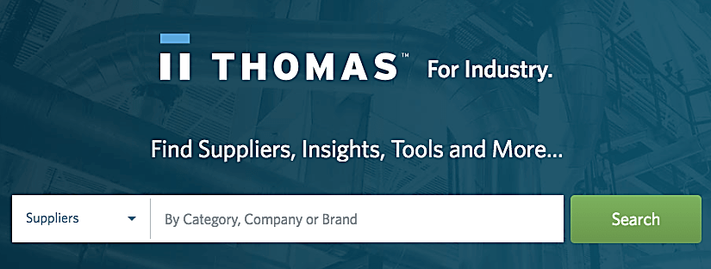
How to Find Contract Manufacturers.
Contract manufacturers and private label firms abound. Search for your product category at any of these free databases:

- www.ThomasNet.com
- www.Alibaba.com (for imports)
For additional information on outsourcing and a few recommended suppliers, see… https://www.ecommerceceo.com/private-label-manufacturers/#how-to-find-private-label-manufacturers

What to Look for in a Contract Manufacturer
- ISO Certification
- Direct delivery to wholesalers and retailers
- Good reputation in market. (Ask the contractor for the names of other companies they produce for and call those CEOs. They will be willing to share their experiences with a fellow entrepreneur.)
- Clean manufacturing and storage facilities (Don’t take their word for it; visit)
If a manufacturer is also building for a competitor, they still may be the right manufacturer for your needs.
Theft of intellectual property. To prevent a manufacturer selling the same or similar product, make sure the contract includes provisions of recourse and remedies if this occurs. Ask a lawyer to look over the contract before you sign it.



Outsourced iPhone manufacturing

Production and Distribution

B. IMPORTING Goods Into Inventory


You may find less expensive goods outside the U.S., but the import duties and freight costs could make it more attractive to buy locally. Delivery time is generally longer from overseas as well. As a result, you may wind up ordering more than you want. When starting out it is wise to order small batches until you have adequate feedback from actual users in order to feel secure in ordering a large quantity.

INCOTERMS. To reduce misunderstandings between buyers and sellers, the International Chamber of Commerce has published a set of pre-defined commercial terms for use in purchase agreements. Importers and exporters worldwide use these definitions to spell out who is responsible for the shipping, insurance, and tariffs.
Most purchase agreements use one of the following terms:

- DAP (Delivered-at-place) indicates the seller agrees to pay all costs and suffer any losses of goods in moving them to the agreed-upon place.
- DAT (Delivered at Terminal) indicates the seller will deliver the goods to a terminal and assume all the risk and transportation costs until the goods arrive and have been unloaded. After that, the buyer assumes the risk and transportation costs of the goods from the terminal to the final destination.
- DDP (Delivered Duty Paid) indicates the seller assumes all the risk and transportation costs. The seller must also clear the goods for export and import and pay export and import duties.
- EXW (Ex Works) indicates the seller is only required to make the goods available for pickup at the seller's business location. Under EXW, the buyer assumes all the risk and transportation costs.
- CPT (Carriage Paid To) indicates the seller will clear the goods for export and deliver them to a carrier of his choice, at which point the buyer bears all risks and other costs from that moment on.
- CFR (Cost and Freight) indicates the seller will clear the goods for export and place them aboard the ship. Costs and responsibility transfer to the buyer at that point.
- CIF (Cost, Insurance, and Freight) indicates the seller must deliver the goods to a designated port and load them on a specified vessel, assuming responsibility for paying all transportation, insurance, and loading costs. The buyer assumes the cost and risk to transport the goods from the port to its business.
- FCA (Free Carrier) indicates the seller will deliver the goods, cleared for export, to the carrier nominated by the buyer, at a named location.
- FOB (Free on Board). If the goods are sold “FOB factory” or “FOB [shipping point]”, the buyer assumes all freight costs and liability for goods from that point on. If “FOB [destination point]", then the shipper accepts the costs and responsibility until the goods arrive at the stated destination. Note: “destination” does not necessarily mean inside your warehouse. It may mean the port of entry, or the dock. Read the fine print carefully.
Production and Distribution

The following graphic comparing Incoterms is by Cyprus Global Logistics www.cyprusgloballogistics.com/incoterms
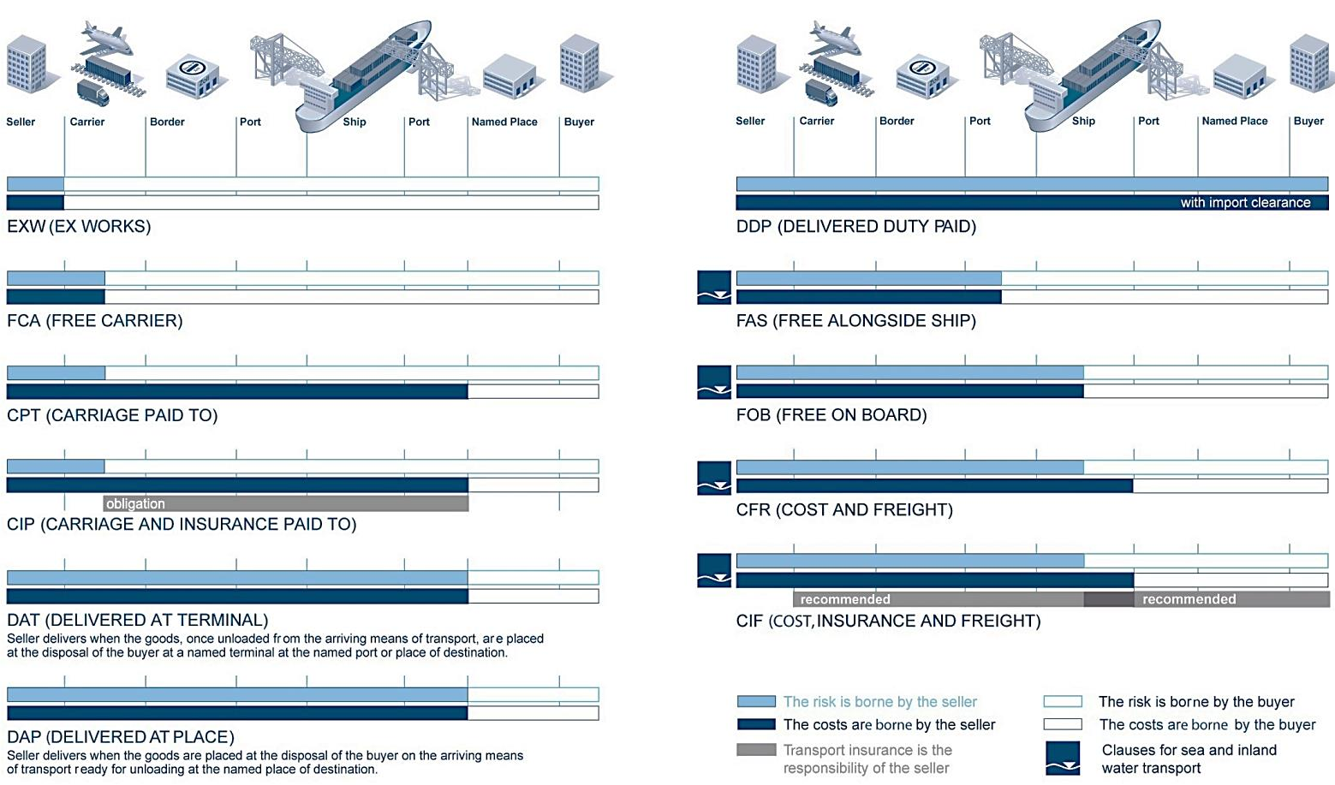

FREIGHT FORWARDERS. If you are new to importing, you might want to employ a Freight Forwarder: an experienced professional who knows how to get your products through customs.

A freight forwarder (or forwarding agent) organizes shipments to get goods from the manufacturer or producer to the customer or final point of distribution. A freight forwarder does not actually move the freight, but rather acts as an intermediary between the seller and various transportation services such as cargo ships or airfreight.

In selecting a forwarding agent, find one that is familiar with …
- YOUR INDUSTRY (an agent that specializes in importing coffee from Brazil may not be the best person to help you import plastic housings from Canada).
- COUNTRY from which you are importing.
THE RIGHT BANK. Arrange for payment to the exporter though a financial institution that understands Letters of Credit (LOCs), currency exchange rates, and wire transfers. Most major banks have departments that specialize in international transactions. You should be safe with Bank of America, CitiGroup, HSBC, J.P. Morgan Chase, or Silicon Valley Bank (SVP). Find the closest branch with an import-export specialist, so you can meet personally with the representative. He or she may recommend a freight forwarder and offer advice on shipment insurance. Having a nearby branch will also speed paperwork.

CARGO INSURANCE. The point at which you take possession of goods (become responsible for losses) will inform your decision to insure them during passage. The cost of the insurance usually runs about 1 percent of the insured value, although this varies with the type of goods and method of shipping.

Production and Distribution

Import Duties. Depending on the context, import duties may be known as customs duties, tariffs, import taxes or import tariffs. Rates differ depending on the exporting countries' trade relations with the U.S. To look up the import tariff rates for components and raw materials, search for the item in the database of the Harmonized Tariff Schedule of the of the U.S. International Trade Commission at https://hts.usitc.gov/. Write down the full 10-digit HTS number, as you will need this on your importing documents.
As an example, a student wanted to import “Hair Extensions”. Searching for this term produced no results. However, searching for “Human Hair” returned HTS 6703.00.30.00 “Human hair…for use in making wigs or the like.” Bingo. The rate is “free”, that is, no duty on imports. The lesson is that you may have to start with a general category and then drill down to terms that are more precise.

Here is a second example. Say you are producing a product that includes a small electric motor and want to know what the import duties would be if you purchased this component overseas. Searching under Electric Motors returned all results with the word Electric or Motor (electric fans, motor oil, and a thousand more we did not want.) However, searching for “Electric Motors” in quotes took us right to what we were looking for. (See screen shot below.)

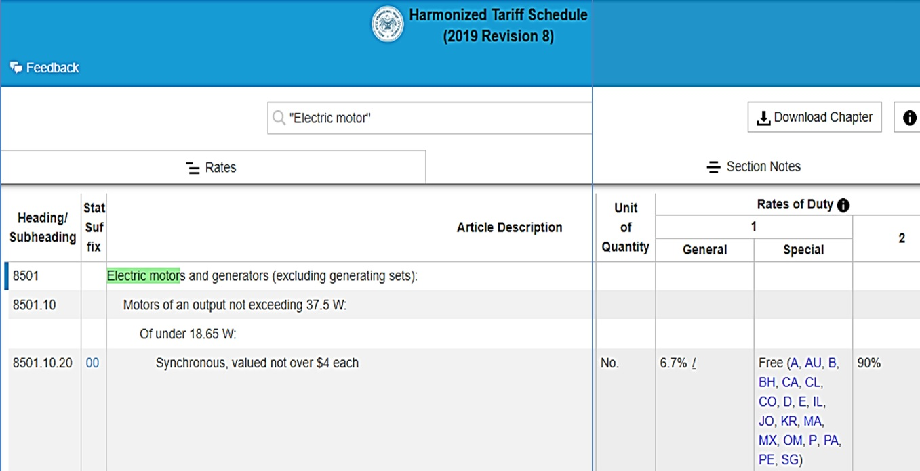

The HTS number for a small motor is 8501.10.20.00. The tarrif will be 6.7% of the purchase price (according to the Column 1-General under “Rates of Duty”; unless you purchase the goods from a country with which the U.S. has a trading agreement, in which case there is no tarrif. To find out which countries are included, scroll over the two-digit codes. Some of the codes refer to specific countries (e.g. - “AU” Australia) but other refer to trade agreements with multiple countries.

However, “A” is the Generalized System of Preferences (GSP) trade agreement with many developing countries. (For a list of countries, see https://ustr.gov/sites/default/files/gsp/Beneficiary%20countries%20March%202018.pdf.) It would be time-consuming to check all the applicable treaties for the country you want to import from; so for budgeting purposes, just ask the company providng the quote to indicate the import duties to the U.S,. and for the name of the applicable trade agreement. But before you actually send the purchase order, check with a freight forwarder to verify the tarrif rate. For a search guide see https://www.usitc.gov/documents/hts_external_guide.pdf.

Production and Distribution

C. Distribution: Processing Orders and
Delivering Goods from Inventory

ONLINE MARKETING PLATFORMS

Online Marketing Platforms (Fees as of 2019)
 | Fees | Permitted Items | Notes
EBAY.com | 50 free listings per month; then $.50 to list items for $10 or more; $.75 for up to $50, and  $1.00 if $50 or more.  Plus commission of 9% to 15% of sales price;  plus PayPal transaction fee of 2.9% + $.30 | Anything legal | 170 million buyers.
ETSY.com | $.20 listing fee per item plus 5% commission on sales, plus payment processing of 3% + $.25 per transaction. | Goods handmade by you, vintage items, craft supplies | 33 million buyers in 2017.  Discounts on postage.
SHOPIFY.com | $39 per month, plus 2.9% + $.30 per transaction. | Anything legal | Discounts on shipping. Supports sales on Instagram and Face book with a “Buy” button.

FULFILLMENT HOUSES (someone else does the warehousing, packing and shipping).

Fulfillment houses, also known as Drop-Shippers, accept finished goods from manufacturers into their inventory warehouses, and then reship the products, whether in bulk to stores, or individually to consumers. The process is called Fulfillment or Drop Shipping.

If you want to outsource the functions of warehousing and shipping (so you can put your car in your garage), just Google “fulfillment houses”, or fill out a form on the website of Intelligent Connections. The company will forward your needs to the fulfillment houses in their database to obtain competitive quotes for you. You can specify the general location of the warehouse and if you need storage, shipping, or both. See http://thebest3plcompanies.com/lead_widgets/insightquote/http:/fitsmallbusiness.com/

The business-advice website FitSmallBusiness compares six fulfillment companies (February 20, 2019). See: https://fitsmallbusiness.com/best-fulfillment-warehouse/. FinancesOnlilne.com has reviews of 20 fulfillment services (as of 2019) at https://financesonline.com/top-20-order-fulfillment-services/

For imprinted products (e.g. - T-shits, mugs) Shopify suggested these firms: https://www.shopify.com/blog/print-on-demand-companies?utm_source=exacttarget&utm_medium=email&utm_campaign=digest&utm_content=digest
Take all online reviews with a grain of salt as they often receive finder’s fees from listed companies for click-throughs. Do your research. Order a product from a competitor that uses a fulfillment service you are considering, and evaluate your own user experience.

Production and Distribution

Typical Fulfillment Fees:
- One-time charge to set up account ($0 to $250)
- Account maintenance ($40 per month)
- Storage (about $15 to $40 per pallet per month).
- Order Pick and Pack (FedEx, as an example, charges $1.80 to $2.64 per order + $.30 to $.40 per item in the order)
For additional fees, most services also offer
- Acceptance of customer returns
- Gift wrapping for an additional fee
- Kitting (assembling a variety of items into a kit; such as a travel or tool kit)
Most services offer discounts on shipping rates due to their overall large volume; but you will need high margins (at least 50%, and perhaps 75-80%) to cover the costs of the fulfillment center.

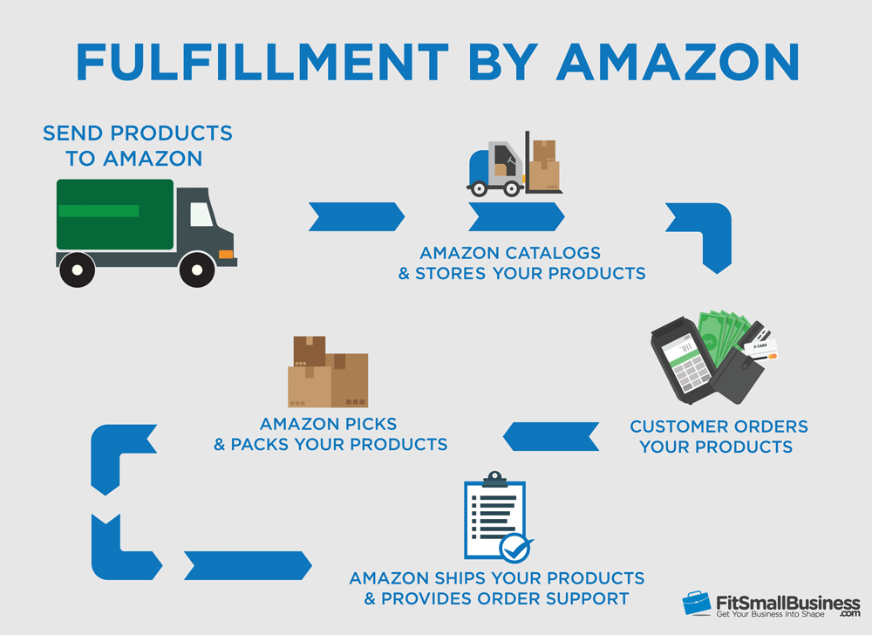

Intellectual Property

15 – Protecting Intellectual Property

A. Trademarks

B. Patents

C. Trade Secrets

D. Copyrights

Intellectual Property
The law provides three means for you to protect your intellectual property from those who would unfairly capitalize on your efforts:

A Trademark protects a brand name, product logo or other feature that distinguishes one company’s products from its competitors. The intent of the law is to protect consumers from buying a look-alike, assuming it to be the real McCoy. A trademark of a service is sometimes referred to as a Service mark.

A Patent is an intellectual property right granted by the government to an inventor to exclude others from making, using, selling or importing the invention for a limited time, in exchange for public disclosure of the invention. See www.USPTO.gov.

A Copyright protects original works of authorship including books, scripts, music, art and design, and computer software.

. Contact them at iplawclinic@law.uconn.edu.

A. Trademarks

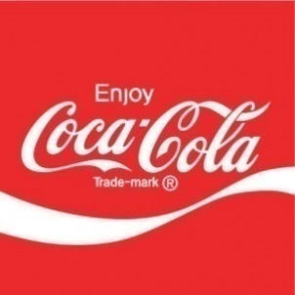
Product names and logos may be protected with a trademark, and in some cases, you can register a color, or even a sound that is connected to your product or service. NBC’s distinctive three-note musical theme G-E-C (for General Electric Corporation) is trademarked.
The Coca-Cola Company has trademarked not only “Coca-Cola” and “Coke”, but also the typestyle, the swash below the name, and the color scheme as well. Even the distinctive hourglass bottle shape is trademarked.
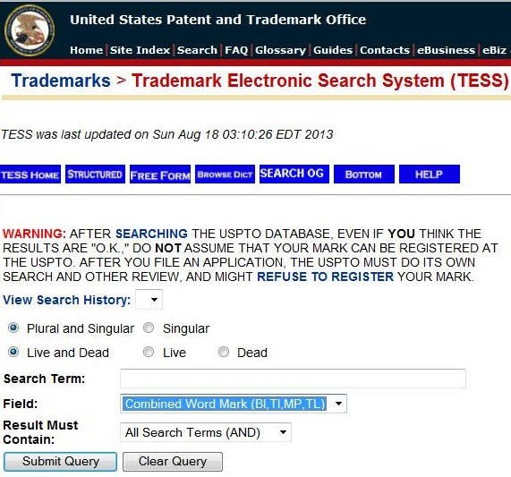
Where to start. Before adopting a trade name for your product or company, make sure it is not already registered for your class of product or service. If you search “Hilton”, you will of course find that it is registered as the name for a chain of hotels. However, this would not prevent you from using or even registering the name Hilton as a brand name for a hockey stick. The Hilton Company could not claim that you are confusing customers shopping for a hotel room.

Steve Jobs named his company Apple because he admired the Beatles. (The Beatles record label was Apple.) The Beatles did not object—until Apple Computers entered the music business with iTunes. The Beatles sued for trademark infringement, which resulted in a $500 million payment to the musicians.

To access the trademark search page at the U.S. Patent and Trademark Office website (shown above) see...
http://www.uspto.gov/trademark
Trade Dress. There are ways to identify your product other than through it name (tradename) or logo (trademark). It could be the general design of a chain of restaurants, like Hard Rock cafes, or the layout of a magazine cover, or the ribs on a Coke bottle, or the brown trucks used by UPS. The intent of the law is to prevent consumers from being fooled into buying a product thinking it was something else. For example, if you saw a bracelet in a powder blue box, you would probably assume it from Tiffany’s, or a soda in an hourglass bottle was “The Real Thing.” Protection of trade dress may be applied for in the same manner as a trademark.

Intellectual Property

Do you have to register a mark in order to use it? No. You can assert your claim to a trade name (the name of your company or product) or trademark (logo) by placing a "tm" (trademark) or "sm" (Service mark) designation next to the name or symbol. This is a common-law convention and does not require registration with the U.S. Patent and Trademark Office.
Under the law, you even have some protection for an unregistered mark or trade dress, although a registered mark does provide greater protection and clearer title of ownership. Priority ownership goes to the first person to use the mark not the first to file (as with patents). In short, you can delay the formal process of registering a mark until your business is in a stronger financial position.
In any case, consult an attorney for professional advice.
For more information about trademark law, see https://www.law.cornell.edu/uscode/text/15/1125

While it is not necessary that you register a mark, there are several advantages of doing so:
- Official public notice that your claim of ownership has been registered
- The ability to sue for infringement
- An official registration may be used as the basis to obtain registration in other countries
- The ability to record the registration with the U.S. Customs and Border Protection Service to prevent importation of infringing foreign goods;
- The right to use the federal registration symbol ®; and
- Listing in the United States Patent and Trademark Office’s online database, where other entrepreneurs will see that you have already registered the mark.
Trademark Protection Overseas. The Madrid Protocol allows a holder of a U.S. registration to file for protection of a mark in multiple countries with a single application, in English, and for only one set of fees. The World Intellectual Property Organization's International Bureau administers the Madrid System. For details, see http://www.uspto.gov/trademarks/law/madrid/index.jsp
Trademark Filing Fees. The application filing fee for the TEAS (Trademark/Service mark Electronic Application System) plus form is $275 to $375 per class of goods and/or services. For example, if you intend to use the mark on computer hardware and T-Shirts, then you will have to pay a filing fee for each of the two classes. Budget an additional $700 for attorney fees. For more information, see http://www.uspto.gov/trademarks/index.jsp



Trademarks.
Note that the Starbucks mark is not registered.
Intellectual Property

B. Patents

First to File Versus First to Invent

As of March 16, 2013, the law was changed in the U.S. to award patents based on who was the first to file for a patent, as opposed to the previous method of granting a patent to the original inventor. Unfortunately, it is now easier to “steal” an idea. The “poor man’s patent”—mailing plans to yourself to prove when you developed an invention—is now immaterial.

How Can an Inventor Protect an Idea Before It Is Patented?
- DO NOT DIVULGE THE Formula for your SECRET SAUCE when selling your idea to supporters. Just reveal the benefits of the innovation: “Our new beverage beats Coke and Pepsi in taste tests, has double the daily requirement of vitamin C, and has zero calories.”
- LIMIT THE EXPOSURE. Pick out one or two people you feel you can trust: an attorney, potential investor, or beta testers (early customers you allow to use the product for free to determine if the design needs more development), or entrepreneurs and consultants to discuss how best to move the project forward.
- USE A non-disclosure agreement (NDA) when possible. If someone does need to see enough of a product to be convinced, and this would allow the viewer to replicate the product, ask the person to sign an NDA. That said, prospective investors will not sign NDAs just to evaluate an idea. With potential financial backers, you need to trust your instincts as to their character. You can ask for references; that is, names of other innovators or entrepreneurs that the investor has worked with. Then call these individuals and ask about their experiences.
- FILE A Temporary PROVISIONAL PATENT. This requires less paperwork than a full patent and will buy you a year to refine the final product, but still establishes your precedence as the first to file. You will be able to use the term patent pending in conjunction with the product during the 12-month pendency period.

The costs to file for the provisional patent are the same as for a full patent. (See section on “Patent Office Fees.”)

Note: you must file for a full (non-provisional) patent within 12 months or risk losing the right to patent. You will incur the regular expenses when filing for the permanent patent.

For more on provisional patents, see http://www.uspto.gov/patents/resources/types/provapp.jsp

To Patent or Not to Patent

Generally, if the product or process is patentable (adequately different from what is already patented to be unique), then it may be advisable to expend the funds and time to obtain a patent. Reasons to patent include:

- To Build Investor Confidence. If you need funding to launch your idea, outside investors will want to see a patent, as this shows that indeed the idea is unique; and that you are bringing something of value into the bargain. Investors do not value ideas by themselves. They look for patents, working prototypes, proof of profit potential, and evidence of satisfied beta testers. A patent also provides some business life insurance; if the business fails, but the idea is still a good one, the investors may be able to salvage some of their investment by selling the patent.

Intellectual Property

- DISCOURAGING KNOCK-OFFS.

- To prevent someone else from PATENTING THE IDEA. It does not matter that you were the inventor. If someone patents the idea before you do, then that person will own it and can prevent you from marketing the product.

Reasons not to patent:

- TheRE ARE OTHER FASTER AND LESS EXPENSIVE STRATEGIES TO CREATE A BARRIER TO COMPETITORS. The opposite strategy to patenting and then enforcing your rights in the courts is called the First to Market or First Mover strategy; that is, to establish your platform or methods as the standard. This strategy may be the most feasible even if your intellectual property is not obscured within a secret sauce. Many companies, without patents, have been very successful with a first-to-market strategy. Indeed, most new businesses are based on ideas that are not patentable in any event. For example, McDonalds Restaurants (fast, cheap, limited menus, no ambience), Starbucks (good quality coffee), or FedEx shipping services (overnight delivery) are not patentable concepts, but those companies were the first to market nationally and they set new standards.

The Secret Sauce Approach. If you really do have a secret sauce, like Coca-Cola, and it is unlikely anyone will figure it out, then the value of the patent might be more than offset by the fact that to obtain a patent you would have to divulge the formula, thereby aiding the unscrupulous who will not honor your patent rights anyway. Coca-Cola has not been patented and never will be for just this reason. Other secret sauces whose very secrecy can sometimes be more valuable than patents (which are online for all to see), include many software products. For example, only Google knows exactly what algorithms it uses to determine which web pages to return during a search.
For more on the just-keep-it-secret strategy versus patenting, see Trade Secrets in this text.

The Case Where a PRODUCTS MARKET LIFE IS LESS THAN THE TIME NEEDED TO OBTAIN A Patent. For some software or electronic products, the useful life may be shorter than the time it takes the U.S. patent office to approve it. In this case, you would be better off going to market immediately. Otherwise, the invention may become obsolete or go out of style before a patent is granted.

Time and Expense to File and Defend a Patent. Attorney fees can run $10,000 to 30,000 or more, depending on complexity of invention. A patent requires typically three or more years to obtain; and applicants are not always successful.

PATENT OFFICE FEES. There are four types of fees paid to the U.S. government:
- Basic Filing Fee,
- Patent Search Fee,
- Patent Examination Fee, and
- Patent Issue Fee.
DISCOUNTS FOR SMALL AND MICRO ENTITIES. Independent inventors, Small Business Entities (under 500 employees), and non-profit organizations are eligible for a 50% discount on most fees; as long as the filer “has not assigned, granted, conveyed, or licensed (and is under no obligation to do so) any rights in the invention to” a for-profit company with over 500 employees.
If a filer meets the Small Entity criteria, and was named on no more than four prior filings, and has a gross income no larger than 3 times the national median, the filer would be entitled to pay even lower fees a Micro Entity. As of 2011, the most recent year for which data is available, this would mean the investor or company could not have earned more than $150,162. For more information about discount eligibility, see
http://www.uspto.gov/aia_implementation/AC54_Small_Entity_Compliance_Guide_Final.pdf
Intellectual Property

DISCOUNT AMOUNTS. For an inventor or Small Entity to file a utility patent electronically the charges will total $1285; for a Micro Entity, $680. These totals, current as of 2019, include the “Application filing fee”, “Search Fee”, “Patent Examination Fee”, and “Issue Fee (if the patent application is approved).
However, to maintain the patent, a Small Entity must pay additional fees of $800 after 3.5 years, $1800 after 7.5 years, and $3700 after 11.5 years. (A Micro Entity will pay half these amounts.) If the product is not successful, the filer has the option of avoiding paying the maintenance fees by abandoning the patent.
For a full schedule of filing fees see http://www.uspto.gov/web/offices/ac/qs/ope/fee031913.htm

WHERE TO START
- CONDUCT A PATENT SEARCH to confirm that no one else has patented the product, process or design. You can conduct a search at the www.USPTO.gov website. Google also has an easy-to-use patent search function at https://www.google.com/?tbm=pts

If you do not find anything, before committing any funds to developing your product idea, you may want to have a professional patent attorney or patent agent (they are less expensive) conduct a professional search for you.
- DECIDE WHEN AND IF TO FILE. Seek professional advice, as this is a complex decision.
- DECIDE ON WHICH TYPE OF PATENT TO FILE:
  - Provisional. A preliminary and relatively easy application process designed to establish precedence. A standard non-provisional utility patent must be filed within 12 months.

a. Utility (Non-Provisional). Granted for a new and useful process, machine, article of manufacture, or composition of matter, or any new and useful improvement thereof.

c. Design (for a new, original, and ornamental design for an article of manufacture). Design patents are good for 14 years. Apple patented the design of its iPhone, which has rounded corners. When Samsung introduced its smartphone, with rounded corners, Apple sued for violation of its design patent.

Utility Patents are good for 20 years. To be granted, the product, process or software “must be sufficiently different from what has been used or described before that it may be said to be non-obvious to a person having ordinary skill in the area of technology related to the invention. For example, substitutions of one color for another, or changes in size, are ordinarily not patentable.”

For more on patents, see http://www.uspto.gov/patents-getting-started/patent-basics/types-patent-applicationsproceedings

A Note on Software: Copyright versus Patent. While software may be copyrighted, patenting is becoming a more popular choice of protection. With a copyright, it is difficult to prove plagiarism of specific “expression.” Moreover, the code may not be understood by the courts.

Intellectual Property

Summary: the Patenting Process (source: www.USPTO.gov)
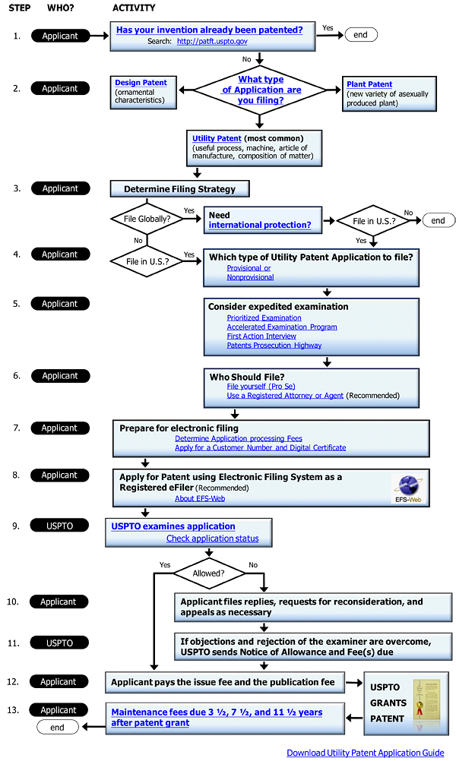
Intellectual Property

C. Trade Secrets

An alternative to patenting is the Trade Secret. Information about the product or process is not filed with the government, as then it would be available to the public and, well, no longer a secret. The common law behind the concept is that if you literally had a secret sauce, you could take legal action against someone who sells the identical sauce if you can prove they would have had to obtain the information illegally.
To prove the information could have only been obtained surreptitiously, you would have to document that you had a formal procedure to prevent disclosure of the trade secret. The percentage of each ingredient or the process you use to mix and cook them cannot appear in any sales literature, website or even relayed in a conversation to a customer. It must be kept secret. Proof of your safeguarding procedures might include:
- Security of business office and manufacturing location
- Procedures to keep vital information under lock and key
- Non-disclosure agreements with employees and suppliers

A patent is more expensive, but as a government document is easier to defend in court than a Trade Secret claim.

d. CopyrightS
A copyright protects works of authorship, such as writings, music, and works of art.
Before 1989, US copyright law required creators to publish works with a copyright notice, and before 1978, creators had to file for a copyright renewal after the initial 28-year term. However, obtaining and retaining copyright is now an automatic practice. Under the current US statute (US Code Title 17), you own a copyright on your work from the moment you create it, and the copyright lasts for the life of the author plus 70 years.
Although you do not have to register works to protect them, if you wish to bring a lawsuit for infringement of your work, you will have to produce a registration certificate.
Registration Fee. If you choose to register your work, the fee to do so online is only $35 (as of 2019). To file online, see https://eco.copyright.gov.
Protection in Other Countries. The United States has reciprocal copyright agreements with most, but not all countries. For a listing of countries and their copyright relations with the United States, see Circular 38a, International Copyright Relations of the United States.
For More Information on Copyrights, see www.copyright.gov.


Examples of copyrightable works. The Vevet Underground album embodies three types of copyright examples: 1) the banana cover design by Andy Warhol, 2) the liner notes on the back of the album, and 3) the music itself.
Legal and Regulatory Matters

16 – Legal and Regulatory Matters

A. Legal Structures

B. Selecting the Right Structure for Your Business

C. NAICS Code

D. FEIN Number

E. Steps to Setting up the Business

F. Business Licenses

G. Reporting Pass-Through Business Income on Tax Return

H. Self-Employment Payroll Taxes

Legal and Regulatory Matters

A wide variety of legal templates can be downloaded for free at

https://law4startups.com


A. ALTERNATIVE Legal STRUCTUREs

One of the first decisions you will need to make is the choice of a legal form for your company. There are a number of options, each with advantages and disadvantages. The basic business structures are:
- Sole Proprietorship – You and you alone own and control the company and are responsible for its debts and other liabilities. Earnings are taxed as personal income and are subject to self-employment taxes (Social Security and Medicare taxes).
- General Partnership – Two or more owners with equal responsibility and financial liability. Partner earnings pass through directly without first being taxed at the company level, and are subject to self-employment taxes (Social Security and Medicare). Partners are also personally liable for the debts and other liabilities of the company.
- Limited Partnership (LP) – Allows for two classes of owners: general partners, who control the company and bear the burden of paying obligations the company is not able to meet, including debts and legal judgments; and limited partners who are silent partners with no financial risk beyond their original investment. Partner earnings pass through directly without first being taxed at the company level.
- Limited Liability Partnership (LLP) – All owners are equal and have limited risk.
- Limited Liability Company (LLC) – Like a Partnership, an LLC allows for multiple owners, but with the limited personal financial liability of a Corporation structure. However, an LLC is not subject to the requirements to elect a board and hold regular meetings with minutes, as required under the Corporation structure. An LLC, after it is formed, can elect to be taxed as a corporation by filing form 8832. This is useful, if the company is profitable and you want to reinvest the earnings to grow the business. The LLC form is popular with startups.
- C Corporation – A traditional corporation; also called a C Corp. Managed by a Board of Directors that is elected by the shareholders. The shareholders and Board must meet at least annually and keep minutes of important decisions. Corporate profits are taxed by the IRS and the states. Dividends (which can only be distributed from after-tax profits) are reported on the individual tax returns of the shareholders. Owners are therefore double-taxed on income from the company.
- S Corporation – Similar to the traditional C Corporation. However, company profits pass through directly to the owner without first being taxed at the company level. Earnings from the business are reported as income on the owner’s personal income tax return.
- Non-Profit Corporation – A tax-exempt organization established under section 501c3 of the IRS tax code. There are no owners. The entity is controlled by a board of directors, who receive the same financial protection, as do the owners of a traditional C Corporation. The purpose of the entity must be charitable, religious, educational, scientific, literary, artistic, recreational, fostering national or international amateur sports competition, testing for public safety, or preventing cruelty to children or animals. Charitable includes relief of the poor, civil rights and combating community deterioration and juvenile delinquency.
- Benefit Corporation – A for-profit C Corp structure with a binding obligation to making a material positive impact on society and the environment. Boards of directors are required to consider the consequences of all key actions as they affect all society stakeholders, not just shareholders. Benefit corporations must file annual reports detailing their positive social and environmental impact.

Legal and Regulatory Matters

B. Selecting the right structure for your business

The structure you select will affect:
- risk to your personal assets (savings, home) if the business loses money or is sued
- control you will have over the business
- taxes you will pay on business profits
- effort and expense necessary to start the business (government paperwork and fees)
- relative ease of raising capital

The two most common structures employed by startups are the LLC and Sole Proprietorship. The LLC provides some protection of personal assets of the owner in case of lawsuits, but requires annual filing fees and in many states a minimum annual tax.
LLC vs. C-Corp: Fundraising Implications
VCs will want you to be a C-Corp. It is much easier to distribute shares to equity investors in exchange for their cash infusion into the company. (Unlike “C” Corporations, LLCs do not have stockholders.)

In addition, VCs are generally not structured to be flow-through tax entities. If your company were an LLC, your tax situation would flow through to the VC, creating all kinds of tax headaches and implications for the VC investors, and tax paperwork headaches for you. To prevent this problem, VCs invest only in C-corps

However, you can start as an LLC, and then convert to a C Corp when you are ready for professional equity financing.

LLC State Filing Fees. The one-time fee to register an new LLC ranges from $50 to around $500 per state, with most in the $100 to $200 range. To find the filing fee for your state see
https://www.upcounsel.com/annual-llc-fees-by-state

Minimum State Business Income Taxes. Almost all states levy taxes on business income, ranging from 4% to 12%, but what a startup needs to know for budgeting purposes and deciding what legal structure to use, is whether their lurks in the tax code of his or her state a minimum Business Entity Tax, Franchise Tax, Annual Filing Fee, or other term for a minimum tax. Although LLCs allow business income to pass through to the owner(s), so that the owner or owners are not be taxed twice, some states still expect the business entity to pay a minimum income taxes--even if it didn’t have any income. For information on state corporate tax rates, see
https://taxfoundation.org/center/state-tax-policy/

The federal government does not levy a minimum tax on companies that break even or lose money.

COMPARATIVE ADVANTAGES
The following tables organize the decision variables for comparison. Before you make a decision, it is advisable to consult with a business attorney and an accountant.
Sole Proprietorship. Sometimes referred to as a DBA (Doing Business As). You are the business and the sole owner. You can operate under your own name or adopt a company name. If you chose “Acme Distributors” as a company name, you would then be John Smith DBA Acme Distributors. A Sole Proprietorship is not an entity legally separate from its owner. Therefore, the owner is personally liable for the company and its debt and income is added on the owner personal tax return (pass-through taxation).
ADVANTAGES  - Ease and low cost of setting up  - No sharing of income or control  - Pass through entity. Business profit or loss reported on personal tax returns of the owner (therefor, no double taxation) | DISADVANTAGES  - Owner personally liable for debts and legal judgments against the business  - Difficult to raise capital from outside investors  - Less incentive for co-workers, who will not have an ownership stake in the company
Partnership. A traditional partnership of two or more owners. With the right people, a partnership can be very dynamic, taking on more challenging projects than could be managed by one person. However, if the principals quarrel over every decision and who is doing the most work, it can be like a bad marriage. It is therefore advisable to spell out rights and responsibilities in a Partnership Agreement. The Agreement should include:
- The rights and duties of the partners under the Agreement
- Amount of capital each partner is to pay in and when
- How profits or losses will be shared (if the company loses money, the partners may have to pay in additional capital)
- How money may be withdrawn from the company by partners and in what form (salary, draw, commission, distribution of profits at year-end, etc.)
- Terms for adding a partner, a member withdrawing from the partnership, or dissolving the partnership
- Lines of authority and how disputes will be resolved

ADVANTAGES  - Easy to form  - Pass through entity. Business profit or loss reported on personal tax returns of the partners (therefor, no “double taxation”)  - Easier to attract talented executives since they will be able to share in the financial rewards | DISADVANTAGES  - Owners (partners) are personally liable for debts and legal judgments against the business  - Less authority and control for founder, and possible confusion and conflicts over decisions
Limited Partnership (LP). Similar to a traditional Partnership, except that it has two classes of owners: a General Partner and one or more Limited Partners. The General Partner is a full partner who manages the company and assumes all of the risk. Limited Partners have limited rights and influence over decisions, and limited exposure to risk. (Only their original investment is at risk. They do not have to cover losses with additional capital investment.) Sometimes called limiteds, the Limited Partners are silent partners.
ADVANTAGES  - Pass through entity. Business profit or loss reported on personal tax returns of the partners (therefor, no double taxation)  - Easier to attract talented executives since they will be able to share in the financial rewards |  | DISADVANTAGES  - The General Partner is personally liable for debts and legal judgments against the business  - Difficult for owners to exit (recoup investment and any appreciation, by selling ownership interest to someone else)
Limited Liability Partnership (LLP). Similar to a Limited Partnership, except that all partners are equal and have limited financial exposure

ADVANTAGES  - Protects personal assets  - Pass through entity. Business profit or loss reported on personal tax returns of the partners (therefor, no double taxation)  - Easier to attract talented executives since they will be able to share in the financial rewards |  | DISADVANTAGES  - Difficult for owners to exit (recoup investment and any appreciation, by selling ownership interest)  - Less authority and control for founder, and possible confusion and conflicts over decisions
Limited Liability Company (LLC). After it is formed and registered with a state, an LLC may elect to be taxed as a Corporation, as a Sole Proprietorship, or one of the Partnership structures. An LLC is a hybrid of a corporation and a partnership. It provides for a simple management form and pass-through taxation (if desired), and with the liability protection of a Corporation. Also like a corporation, an LLC is a separate legal entity, but no stock is issued. The owners are called Members. Control and management of an LLC is governed by an Operating Agreement.

ADVANTAGES  - Protects personal assets  - Can elect pass-through taxation  - Allows for one or unlimited number of owners  - Simple structure (does not require shareholders, directors and officers)  - No mandatory annual meeting of shareholders, or minutes, as required of “C” Corp  - Easier to transfer ownership (easier exit for investors) than with a partnership  - Less financial disclosure required of owners |  | DISADVANTAGES  - Cannot issue stock  - Will cost $500 to $1000 to set up, depending on state fees and attorney fees  - More paperwork and compliance issues than for a Sole Proprietorship  - Other states in which the company operates may require each owner to file a state tax return  - If one of the owners is forced to withdraw due to death or other cause, this can create financial problems for remaining owners
C Corporation
A Corporation is a distinct legal entity, separate from its owners. As such, it can incur debts, sue or be sued. This structure protects the owners from liability for company debts or judgments, unless owners provide personal guarantees, which are typically required to obtain a company credit card, telephone service, bank loan, or lease.
Under a Corporate structure, shareholders own the corporation and elect a Board of Directors to look out for their investments. Responsibilities of the board include the hiring and oversight of Officers to manage the company day-to-day.
The shareholders must meet at least once a year, to elect the board. The board must meet at least annually and keep Minutes, showing when and where the meeting took place, who attended, and important decisions that were made at the meeting.
The rules governing these activities and details of the organization structure are contained in Corporate By-Laws adopted by the board.
If you organize as a C Corp, you can elect to be taxed as an S Corp. (See S Corporation).

ADVANTAGES  - Protects personal assets  - Business is a perpetual entity, and this gives some additional confidence to potential employees, vendors, customers, and investors (versus a Sole Proprietorship that would cease to exist with the death of the owner)  - May issue stock to raise capital  - Easier to transfer ownership than with a Partnership structure. Owners can exit by selling their shares to another person. (However, a ready buyer may not always be available, unless the stock is actively traded on a stock exchange)  - Because of relative ease of transferring ownership, it is also easier to raise capital (than under Sole Proprietorship, LLC or Partnership structures)  - Company expenses for employee healthcare, travel and entertainment are deductible when computing taxable corporate income. (See also Double Taxation under Disadvantages.) | DISADVANTAGES  - Must hold annual meeting of shareholders and keep minutes of important decisions at shareholder and board meetings. This is not onerous for a small company with only one or a few shareholders  - Double Taxation (Company profits are taxed by the states and IRS, and then if any remaining after-tax profits are distributed to the owners as dividends, these are taxed on the shareholders’ individual returns)  U.S. FEDERAL CORPORATE TAX  Since January 2018, the federal corporate tax is now a flat 21%. However, most states also levy a tax on corporate income that averages around 6% but ranges as high as 12%.  To find your state tax rate, see  https://taxfoundation.org/us-corporate-income-tax-more-competitive/
Subchapter “S” Corporation (also referred to as an s Corp or Sub S).
After formation, a corporation may elect S-Corporation Status by submitting a form to the IRS. The corporation is then taxed like a sole proprietorship (if there is only one owner) or partnership (if there are multiple owners). Income passes through to the shareholder(s) to be added as earnings on their personal tax returns. The Sub-S structure is popular with small businesses with one owner, because it avoids double taxation. An S-Corp can always revert to a C-Corp.
ADVANTAGES  - Protects personal assets, like a C Corp  - Business profit (or loss) reported on personal tax returns of owners |  |  | DISADVANTAGES  - Limited to 100 owners, who must all be U.S. citizens or residents  - Must hold annual meeting of shareholders and keep minutes of shareholder and board meetings  - Cannot deduct some health insurance, travel or entertainment expenses
Nonprofit Corporation Also known as a 501c3, a reference to the section of the IRS tax code that defines eligibility. Some entrepreneurs feel that if their mission is to make the world a better place they should or need to form a non-profit. However, the government makes it difficult to obtain non-profit status because the designation has been abused to avoid paying taxes on profitable activities. Individuals have set up sham foundations and then contributed most of their earnings to the non-profit during high-income years to avoid paying taxes, and then paid themselves a salary as head of the foundation in lower-income years. Because of healthy government skepticism, there is now a lot more paperwork than for a C Corporation.
ADVANTAGES  - Protects personal assets, as does a C Corp for-profit structure  - Exempt from federal income tax  - Eligible to receive government grants and grants from private foundations  - Contributions are tax-deductible by the donors  - Perpetual existence  - Exempt from property taxes in some locales  - Lower postage costs |  |  | DISADVANTAGES  - Cannot issue shares of stock to raise investment capital  - Founder(s) can extract earnings only as salary or fees for contracted services. A non-profit cannot distribute surpluses in the form of dividends.  - The scope of activities a non-profit may engage in is limited  - Earnings cannot pass to any individual.  5. If entity is liquidated, assets must be turned over to another non-profit

Benefit Corporation (See also C Corporation).

A class of C Corporation legally obligated to make a material positive impact on society and the environment. Boards of directors are required to consider the consequences of all key actions as they affect all society stakeholders, not just shareholders. For more information, see http://benefitcorp.net.

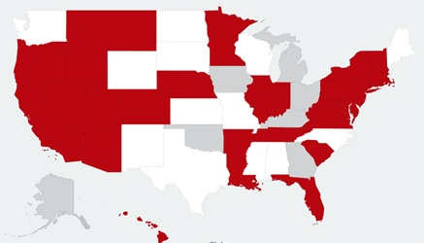
States that allow Benefit Corporations. Dark states have enabling legislations in place; shaded states are “working on it.” For an updated map go to http://benefitcorp.net/policymakers/state-by-state-status
ADVANTAGES  - PR value in attracting and retaining employees and socially conscious investors  - Differentiation from competitors  - Alternative to a non-profit structure | DISADVANTAGES  - Additional paperwork to set up and more detailed annual reports  - Annual paperwork and fees associated with a C Corp.
B Corp (Sometimes confused with Benefit Corporation)

A B-Corp is a certified Benefit Corporation that pays a fee to B Lab, a non-profit that confirms that the company has met its legal obligations as to Measurable Social Performance, Accountability, Transparency, and Measurable Environmental Performance.

Part of the confirmation process is the B Corp Impact Assessment that measures the areas of Community, Workers, Governance and Environment. The B Corp must achieve a minimum score to retain certification.

Certification fees range from $500 to $25,000 per year (as of 2019), depending on the size of the company.
Since a B Corp designation is voluntary, it may be discontinued at any time.
To learn more about B Corp certification, visit www.bcorporation.net

SUMMARY OF OWNERSHIP IMPACT OF LEGAL STRUCTURES
 |  | Sole Proprietor-  ship  (DBA) |  | General Partnership |  | Limited Partnership  (LP) |  | Limited Liability Partnership  (LLP) |  | Limited Liability Company (LLC) |  | C Corporation (Including Benefit Corp) |  | S Corporation |  |  | Non-Profit Corporation (501c3)
Owned by |  | An individual |  | Partners |  | General and  Limited partners |  | Partners |  | Its “Members” |  | Shareholders (stockholders) |  | Shareholders (stockholders) |  |  | na
Number of owners |  | One maximum |  | Two or more |  | Unlimited, but at least 1 General and  1 Limited Partner |  | Two or more |  | One or more (but can get unwieldy with a large number) |  | One or more |  | One or more, with an upper limit (Check current IRS regulations) |  |  | none
Controlled by |  | The individual owner |  | Partners, according to the Partnership Agreement |  | Partners, according to the Partnership Agreement |  | Partners, according to the Partnership Agreement |  | Members |  | Board of Directors elected by Shareholders |  | Board of Directors elected by Shareholders |  |  | Board of Directors
Managed day to day by |  | The individual owner |  | Managing Partner, elected from among the partners |  | General Partner |  | Managing Partner, elected from among the partners |  | Members or a hired manager, per Operating Agreement |  | President or CEO, elected by Board |  | President or CEO, elected by Board |  |  | President (or Executive Director) appointed by Board
Owner(s) liable for business debts |  | Yes |  | Yes. All partners are liable, jointly and severally |  | No, but banks and credit card companies require personal guarantees |  | No, but banks and credit card companies require personal guarantees |  | No, but banks and credit card companies require personal guarantees |  | No, but banks and credit card companies require personal guarantees |  | No, but banks and credit card companies require personal guarantees |  | No, but banks and credit card companies require personal guarantees
 | SUMMARY OF TAX IMPLICATIONS OF LEGAL STRUCTURES
 |  |  | Sole Proprietor-  ship  (DBA) |  | General Partnership |  | Limited Partnership  (LP) |  | Limited Liability Partnership  (LLP) |  | Limited Liability Company (LLC) |  | C Corporation (Including Benefit Corp) |  | S Corporation |  |  | Non-Profit Corporation (501c3)
 | Federal Income Tax on company profit |  | Taxed as personal income |  | Each partner’s share taxed as personal income |  | Each partner’s share taxed as personal income |  | Each partner’s share taxed as personal income |  | May elect to be taxed as Corporation or Partnership |  | Company taxed on profits; *** owners on dividends and gain on stock sales. |  | Taxed as personal income |  |  | na
 | Company losses deductible on personal taxes |  | Yes, up to amount invested |  | Yes, up to amount invested |  | Yes, up to amount invested by each partner |  | Yes, up to amount invested by each partner |  | Yes, up to amount invested, if company elects to be taxed as a partnership |  | Yes, if stock is sold at a loss or written off |  | Yes, up to amount invested |  |  | na
 | Minimum Federal  tax |  | None |  | None |  | None |  | None |  | None |  | None |  | None |  |  | None
 | Required to pay Estimated Federal Tax each quarter  to IRS  (see www.  irs.gov)  ** |  | Yes, if you expect to owe $1000 or more. Due 15th of month following end of each quarter  (See form 1040-ES) |  | Yes, if you expect to owe $1000 or more. Due 15th of month following end of each quarter  (See form 1040-ES) |  | Yes, if you expect to owe $1000 or more.  Due 15th of month following end of each quarter  (See form 1040-ES) |  | Yes, if you expect to owe $1000 or more. Due 15th of month following end of each quarter  (See form 1040-ES) |  | Yes, use form 1040-ES if company is taxed as a partnership; form 1120-W if taxed as a corporation |  | Yes, if you expect to owe $500 or more. Due 15th of month following end of each quarter  (See form 1120-W) |  | Yes, if you expect to owe $1000 or more. Due 15th of month following end of each quarter  (See form 1040-ES) |  |  | na
** Rates and regulations subject to change and interpretation. CONSULT WITH AN ATTORNEY SPECIALIZING IN TAX LAW.
*** May elect to be treated as an S Corp.

Legal and Regulatory Matters

C. NAICS CODE

NAICS (North American Industry Classification System) codes have replaced SIC (Standard Industry Classification) codes as the standard for identifying a company’s industry. To find the NAICS (rhymes with rakes) code for your business, go to www.naics.com. You will need this code number for many government documents and on trade association membership applications. If you need help figuring out your NAICS code, email naics@census.gov. (Include your telephone number in your email message in case the staff needs to call you for more information.)

1. Type of business Retail Service Manufacturing Other _______________

2. Terms used in the search for your NAICS code:

A. _____________________________________________________________________

B. _____________________________________________________________________

C. _____________________________________________________________________

D. _____________________________________________________________________

E. _____________________________________________________________________

F. _____________________________________________________________________

G. _____________________________________________________________________

3. NAICS Code(s) and Definition. Note: a company may have more than one code.
_______________ ______________________________________________________

_______________ ______________________________________________________

_______________ ______________________________________________________

_______________ ______________________________________________________

_______________ ______________________________________________________

Legal and Regulatory Matters

D. FEIN Number

(Federal Employer Identification Number)

You will need to complete an FEIN Application (form SS-4) to establish an LLC or corporation, hire employees, or open a bank account for your business. You will also be prompted for an FEIN on numerous government forms, credit applications and insurance applications; and if you do not have an FEIN, you will have to provide your Social Security number instead. Besides, it’s free and having an FEIN number makes your startup look more grownup.

You can even apply online at https://sa.www4.irs.gov/modiein/individual/legal-structure.jsp and receive your number within 24 hours.

However, we suggest you first complete a hard copy of the one page application to review with your professor or an attorney and to discuss any questions you are not sure how to answer. To access a fillable pdf double-click on the form on the next page or go to www.irs.gov/pub/irs-pdf/fss4.pdf. If you prefer, instead of then completing the online application, you can simply fax the form to the IRS at 859-669-5987, or mail it to Internal Revenue Service Center, EIN International Operation; Cincinnati, OH 45999.

Here are suggested answers to some of the more ambiguous questions on the FEIN application:

No. | QUESTION | PROBABLE CORRECT ANSWER
3 | Executor, Administrator, trustee etc. | Leave blank
6 | Location of business | Use your home address if you do not have a business location, or if it is likely the business will move.
8a | Is this application for an LLC? | If you are intending to organize as an LLC, but have not yet filed the papers, that’s OK, answer YES.
8b | Number of members in the LLC | You may not know how many co-founders you will have. Make as good a guess as you can. It has been years since anyone was shot for getting this wrong. If you plan to go it alone, enter “1”.
8c | Was the LLC organized in the U.S.? | If not organized yet, but you do plan to establish in the U.S., answer “Yes.”
9a | Type of Entity | If you will be organizing as an LLC, check the “Other” box and write in “Disregarded entity.”
11 | Date business started. | Businesses are like people. When they are young they want to appear older. So give yourself the earliest possible birthdate: enter today’s date.
12 | Closing month of accounting year | Enter “December” so your fiscal year will match the calendar year. This is not like tattoos. You don’t want to be different. If you enter a month other than December, you’ll reget it when you have to issue financial reports to investors or tax returns for Uncle Sam.
14 | Check the box if you want to file the short, easy income tax form | If you don’t know the answer, you’re not an entrepreneur. Check the box! Check the box!
15 | Date you will have employees | Guess, but know that it won’t be a soon as you think
18 | Has this entity filed for an FEIN before? | Answer is “No.” Leave the next section blank “Third Party Designee,” unless you want someone else—like your attorney—to receive government notices.

Legal and Regulatory Matters

To open this fillable pdf FEIN application double-click on the form.
After you complete the application, save it on your computer or click “File” to email it to yourself . (If you receive an error message when attempting to open this form, just click “OK” and double-click on form again.)

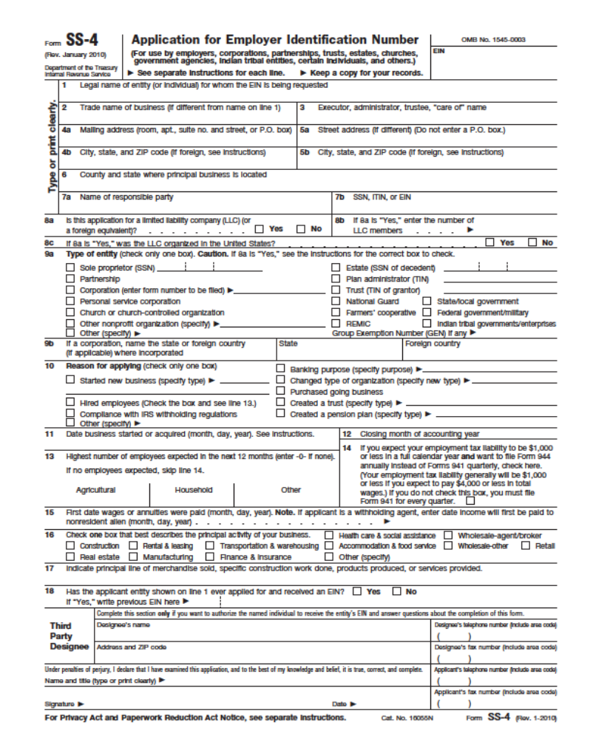
Legal and Regulatory Matters

STEPS TO SETTING UP AN LLC

1. Make sure the Company Name is available. Check with your Secretary of State to see if another business has registered the name. Go to www.KnowEm.com to see if the trademark and URL are available. For more information see the section in the text on Company Name.

2. Arrive at an agreement among the founders as to what percentage each of you will own. (You can form an LLC as the sole member.)

3. Prepare an Operating Agreement. This agreement governs the operation of the LLC and defines the rights and obligations of the Members to each other and to the LLC. It is similar in function to a Partnership Agreement. The LLC Operating Agreement is not the document you file with the state when creating an LLC. The filing document is the Articles of Organization. A boilerplate LLC Operating Agreement appears on the following pages. We recommend that you review the document with a business attorney, but you will save the lawyer time (and you money) by preparing a draft. An online template that will guide your through the process (for $25) may be found at http://www.legalcontract.com/contracts/llc-operating-agreement/.

4. File Articles of Organization with your Secretary of State We recommend you register in the state where your company is located. While some states have laws very favorable for companies, there are additional fees and to register in another state. Once you reach $10,000,000 in sales, then consider registering in Delaware.

5. Register your company with the Town Clerk’s office of each municipality in which you will operate. For most companies this will be your headquarters location. However, a consumer service business such as a roofing company will need to register in every town that it has customers. A Google search of “[city] Town Clerk” should connect you to the appropriate web site where you will most likely find a simple one-page form.

6. Obtain a Sales Tax License through your state department of revenue services. (Google “Sales taxes” and the name of your state.) Some municipalities, like New York City, also require you to collect sales taxes on their behalf, so also check with the city administration in the town where your business is headquartered.
For a listing of sales tax rates by state, see http://www.salestaxinstitute.com/resources/rates or go to http://taxfoundation.org/. The following site has a map you can zoom in on to see combined city/county/state sales tax rates. You can only do three searches before being asked to register, although it is free to do so http://salestax.avalara.com/

Since you will be obligated to submit periodic reports after you register for a sales tax permit, you may want to wait until you have actual sales before doing so.

Legal and Regulatory Matters

Sample LLC Operating Agreement

This is a Limited Liability Company Operating Agreement (the "Agreement") made on [DATE]_______________. Its Members are as follows:

Name _______________________________________________ _____ %

Name _______________________________________________ _____ %

Name _______________________________________________ _____ %

The Members to this Agreement agree to the following:

Name: This Limited Liability Company will be known as Your Company (the "LLC").

The LLC:

a) The Members have formed a Limited Liability Company.
b) The terms and conditions of their LLC will be outlined in this Agreement.
c) If the Agreement is executed, the LLC Operating Agreement will be in effect on _____.
d) The LLC will only be terminated as outlined in this Agreement.
e) The LLC's primary place of business will be _____________________________________________.
f) The LLC will be governed under the laws of the state of _________________.
g) The LLC's primary purpose is _________________.

Contributions: The Members will make an initial contribution to the LLC as follows:

Name _______________________________________________ Amount $________

Name _______________________________________________ Amount $________

Name _______________________________________________ Amount $________

Contributions will be submitted no later than _________________. All capital contributions are final unless all Members give written consent of withdrawal. All contributions will be deposited into a joint capital account.

Interest: The Members' ownership interest in the LLC will be as follows:

Name _______________________________________________ _____ %

Name _______________________________________________ _____ %

Name _______________________________________________ _____ %

Legal and Regulatory Matters

Costs: The Members will share costs according to the following percentages:

Name _______________________________________________ _____ %

Name _______________________________________________ _____ %

Profits: The Members will share the net profits of the LLC according to the following :
- The Members' profit allocation will be apportioned by ________________ according to the above percentages after the costs of the LLC have been paid or calculated according to the above “costs” percentages.
- Profit allocations will be distributed 1 time per year.
- Each member must receive at least ____% of their profit allocation each year from the LLC, although percentages greater than the above listed may be distributed according to a member vote.
- The members are allowed to withdraw from their profit allocation at any time.
- All members will receive enough funds from the LLC to cover their income taxes for total profit allocation by the LLC.

Members and Managers:

- The liability of the Members is limited according to the Limited Liability statutes for the state of ____________.
- No Member shall be an agent of any other Member by reason of being a Member of the Company.
- All Members of the LLC, by majority vote of Member interest, will maintain 1 Manager(s) to be reelected every _________________. All Members will vote in each election.
- Members that are not elected as Managers shall not have any control or vote in the operation of the Company's affairs and shall have no power to bind the Company.
- The Managers' authority will be defined by the following unless otherwise stated in the Agreement: All decisions for contract or otherwise will be made based on a majority vote of percent of ownership. Each Manager will have the authority based on their percent ownership outlined above in the Agreement.

Liability of Members and Managers: All debts, obligations and liabilities of the LLC, whether arising in contract, tort or otherwise, shall be solely the debts, obligations and liabilities of the LLC, and no Member shall be obligated personally for any such debt, obligation or liability of the LLC solely by reason of being a Member. This section does not prevent an LLC Member, should they so choose, from separately agreeing to guaranty or otherwise become liable for a debt which is also of the LLC.

Accounting:

- All accounts related to the LLC, including contribution and distribution accounts will be audited every 6 months.
- All Members will maintain a joint contribution account. All Members will maintain a joint distribution account. Members will keep accurate and complete books of account for all accounts related to the LLC. Any Member, whether majority or minority, will be allowed to review all books of account at any time they request.
- Accounting records will be kept on a cash basis.
- All financial records including tax returns and financial statements will be held at the LLC's primary business address and will be accessible to all members.
- The fiscal year will be complete on the last day of December of each year. All Members will present their position on the state of the LLC within two weeks of the completion of each fiscal year.
- The following Members will be able to sign checks from any joint Member account:

Legal and Regulatory Matters

New Members: The LLC will amend this agreement to include new Members upon the written and unanimous vote of all Members.

The name of the LLC may be amended if a new Member is added to the LLC upon the written and unanimous vote of all Members.

Withdrawal or Death: The Members hereby reserve the right to withdraw from the LLC at any time. Should a Member withdraw from the LLC because of choice or death, the remaining Members will have the option to buy out the remaining shares of the LLC. Should the Members agree to buy out the shares, the shares will be bought in equal amounts by all Members. The Members agree to hire an outside firm to assess the value of the remaining shares. The Members will have 60 days to decide if they want to buy the remaining shares together and disperse them equally. If all Members do not agree to buy the shares, individual Members will then have the right to buy the shares individually. If more than one Member requests to buy the remaining shares, the shares will be split equally among those Members wishing to purchase the shares. If all Members agree by unanimous vote, the LLC may choose to allow a non-Member to buy the shares thereby replacing the previous Member.

If no individual Member(s) finalize a purchase agreement by 60 days, the LLC will be dissolved.

The name of the LLC may be amended upon the written and unanimous vote of all Members if a Member is successfully bought out.

Dissolution: Should the LLC be dissolved by majority vote or otherwise, the LLC will be liquidated, and the debts will be paid. All remaining funds after debts have been paid will be distributed based on the percentage of ownership interest outlined in this Agreement.

Amendments:

- Amendments may be made hereto upon the unanimous and written consent of all Members.
- Amendments must be expressly written and have the original signatures of all Members.

Settling Disputes: All Members agree to enter into mediation before filing suit against any other Member or the LLC for any dispute arising from this Agreement or LLC. Members agree to attend one session of mediation before filing suit. If any Member does not attend mediation, or the dispute is not settled after one session of mediation, the Members are free to file suit. Any law suits will be under the jurisdiction of the state of

_________________.

All Members signed hereto agree to the above stated Agreement.

Signed this _______ day of ________________, 20____

______________________________________________

______________________________________________

Legal and Regulatory Matters

F. Business Licenses

Check with your town clerk to ascertain what permits and licenses may be required. For most businesses, cities will require only that you register. The cost usually ranges from $25 to $50. Certain types of businesses will also need state licenses, including, but no limited to...

- Food service or manufacturing
- Energy
- Recycling
- Day care
- Gambling
- Firearms
- Tobacco
- Alcohol
- Spas and beauty parlors
- Broadcasting

When you visit your town clerk to register your business, check to see if your business location is zoned to permit your type of business; and what limitations there might be on signage, noise, use of hazardous materials, minimum parking spaces required; and if a food service business, the health department codes.

State Business License Offices
(Source: https://www.sba.gov/starting-business/business-licenses-permits/state-licenses-permits)

Alabama  Alaska  Arizona  Arkansas  California  Colorado  Connecticut  Delaware  District of Columbia  Florida  Georgia  Guam  Hawaii  Idaho  Illinois  Indiana  Iowa  Kansas | Kentucky  Louisiana  Maine  Maryland  Massachusetts  Michigan  Minnesota  Mississippi  Missouri  Montana  Nebraska  Nevada  New Hampshire  New Jersey  New Mexico  New York  North Carolina  North Dakota | Ohio  Oklahoma  Oregon  Pennsylvania  Puerto Rico  Rhode Island  South Carolina  South Dakota  Tennessee  Texas  U.S. Virgin Islands  Utah  Vermont  Virginia  Washington  West Virginia  Wisconsin  Wyoming

Legal and Regulatory Matters

g. REPORTING Pass-Through BUSINESS INCOME

If you are an LLC, Sole Proprietorship, or Partnership your business income passes through to you to be reported on your personal tax return. You can download form 1040 and instructions at www.IRS.gov If you are a Corporation, you will have to pay taxes on the business separately (profits do not pass through).
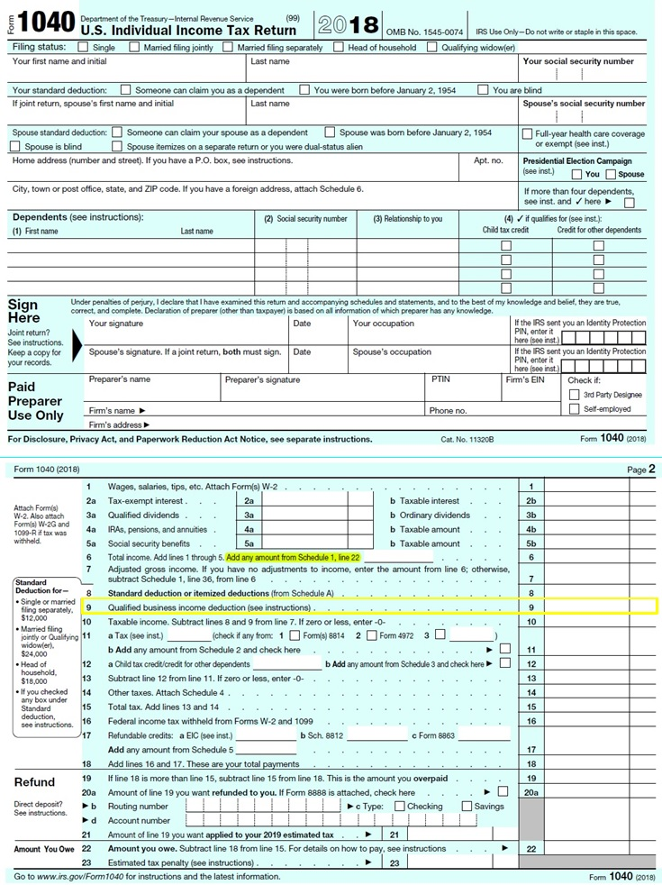

Form 1040

Use a 1040 Schedule C (sample on next page) to detail income and expense for the business.
(If there is more than one member in the LLC consult with a CPA.)

Then post the profit or lost from Schedule C to
Schedule 1
(See sample following Schedule C) and then
enter the profit or loss from the business to line 6 of form 1040.

SOME GOOD NEWS:
As part of the new taxes law of 2018, entrepreneurs with pass-through business can deduct 20% of the business income from their
Taxable income. Enter 20% of line 6 on line 9

Legal and Regulatory Matters

Sample 1040 Schedule C. Attach to federal personal tax return to report pass-through business profits. Also, report the business income on form 1040, Schedule 1 (sample on next page).
You can download the form here https://www.irs.gov/pub/irs-pdf/f1040sc.pdf.

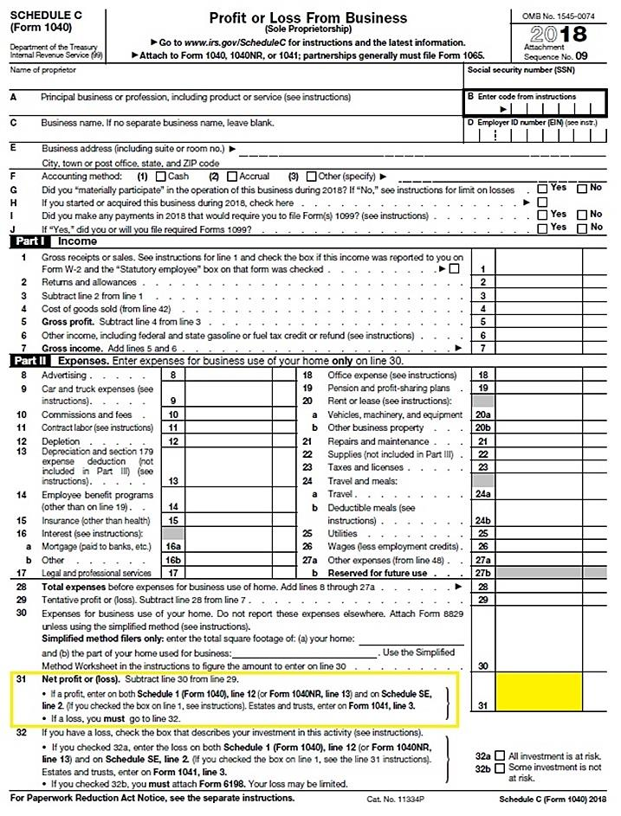
Legal and Regulatory Matters

Sample 1040 Schedule 1. Attach to federal personal tax return.
You can download the form from https://www.irs.gov/pub/irs-pdf/f1040s1.pdf

Post business profits (or losses) from Schedule C to line 12 of Schedule 1, and to line 6 of form 1040.
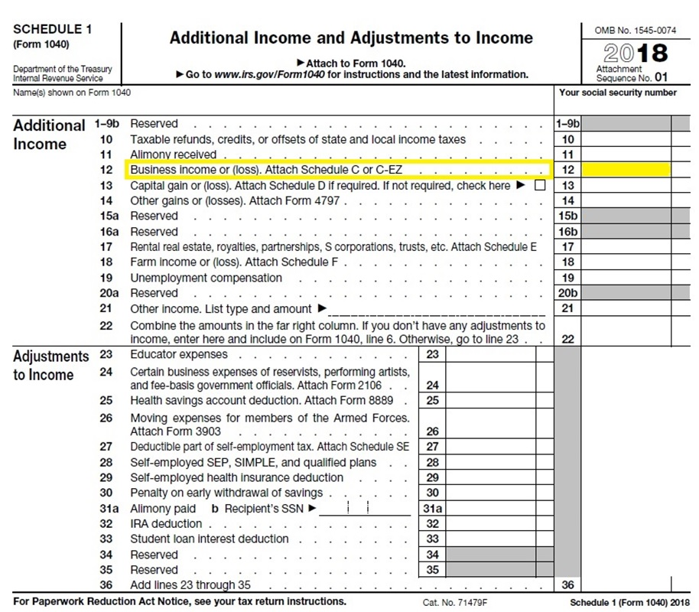

Legal and Regulatory Matters

H. Self-Employment Payroll Taxes

As a sole proprietor or LLC that has elected to be taxed as an individual, you are considered a self-employed person. As such, you need to pay the employee and employer share of Social Security and Medicare taxes. This amounts to 15.3% of your business income (as of 2019).

Post the business income you reported on line 31 of Schedule C to line 2 of Schedule SE (sample below).
Follow the instructions on lines 1 to 5 of Schedule SE (below) to compute the Self-Employment tax, and
post to line 6 of Schedule SE, and to line 27 of form 1040. Attach Schedule SE to your 1040.

You can download a copy of Schedule SE at https://www.irs.gov/pub/irs-pdf/f1040sse.pdf

The Motley Fool has an excellent explanation of the Self-Employment tax and a tax calculator at https://www.fool.com/retirement/self-employment-tax-calculator-how-much-will-i-owe.aspx
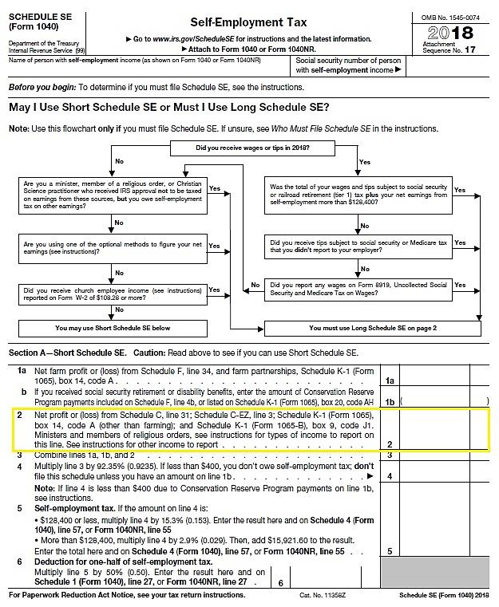

Raising Startup Capital

17 – Raising Startup Capital

A. Determining Startup Capital Requirements

B. Sources of Startup Capital

RAISING CAPITAL to launch or grow a new venture is a complex process that always takes more time than entrepreneurs assume. Even for investment-ready companies, it usually takes 6 to 12 months to get a proposal in front of investors and for the capital providers to conduct due diligence. The steps in the process are:
- COMPUTE HOW MUCH CAPITAL YOU NEED at each stage of development. (If your launch is successful and you achieve break-even quickly, you may want to accept additional outside capital to grow the company more quickly than would be possible by relying solely on profits to fund growth.) The key is to allow for periodic infusions of equity capital, and resulting dilution of the founders’ ownership position. The company that captures the most market share wins the race.
- DETERMINE THE RIGHT TYPE OF CAPITAL: personal saving, borrowing, equity, grants, or combination thereof for each stage of growth.

Raising Startup Capital

A. Determining Startup capital requirements

THE CAPITAL REQUIREMENT is the amount of cash you will need to cover startup expenses and operating expenses until the company is cash-flow positive. Do not overlook general liability and product insurance. Even if you are selling products made by other companies. You still may be liable if a customer has an injury related to the product.

MINIMIZING CAPITAL NEEDS. The lower the capital requirement, the easier it will be attract investment. To reduce investor risk, break down capital requirement into tranches for each plateau of development (e.g. – R&D, prototyping, lab testing, patenting, beta testing with customers, full market launch, and runway to break-even). Investors prefer to mete out cash when (and if) interim goals are met.

You may be able to reduce your total capital needs with tight cash-management techniques:
    - REQUIRE PREPAYMENT at time of order, at least enough to cover the raw materials you will need to purchase. This is a common practice in the home remodeling industry.
    - LEASE VERSUS PURCHASE. Leasing a car or truck for a business instead of purchasing it conserves cash. There are also leasing agents and finance companies that will purchase manufacturing equipment and then lease it back to you.

This is an interactive spreadsheet. To open, right-click on spreadsheet, click “Worksheet Object” and then "Open.”
You need enter data in shaded fields only; the totals will be computed for you. You can download a copy of this form at http://www.EntrepreneurshipFoundation.org/spreadsheets.html

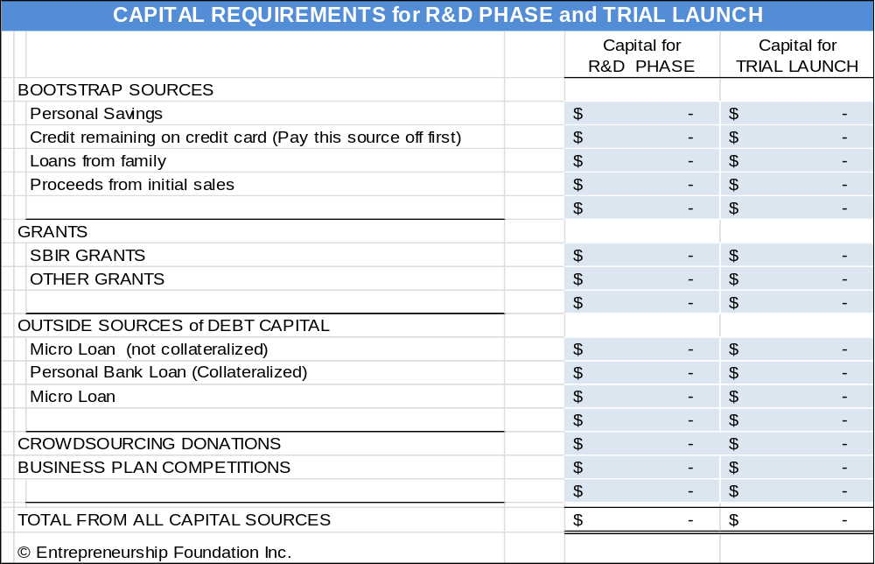

Raising Startup Capital

B. Sources of Startup Capital

- Personal Savings. The more money you personally invest in your business, the easier it will be to attract outside financing. Banks and outside investors feel confident you will stick with the venture if you have “skin in the game.” In addition, your personal investment leverages their investment. Investors will only consider cash contributions on your part, not the value of your time. Only invest what you can afford to lose. Determine how much capital you need to start the business and set that as your savings goal, plus a reserve for contingencies. (Do not forget to include twelve months of living expenses in your capital needs. You probably will not be able to draw money out of the business for at least that long.)
- Family and Friends. Along with personal savings, this is the most common source of capital for new businesses. Often, these loans are forgivable. Family members and friends may not require personal guarantees and therefore will not foreclose on your home, but be careful not to risk more family and friends than you can afford to lose.
- Government Lenders. The SBA offers a Microloan Program (amounts up to $50,000). The average has been around $13.000 per loan. To find out more, go to www.sba.gov/loans-grants/see-what-sba-offers/sba-loan-programs/microloan-program
- Crowdfunding Platforms. (See following chapter.)
- Small Business Innovation Research (SBIR) Grant Program. The Small Business Innovation Research Program (SBIR) awards federal grants to small high-tech businesses in the U.S... See www.sba.gov/loans-grants/see-what-sba-offers/sba-loan-programs/microloan-program
Phase I awards are typically $100,000 and Phase II awards $750,000. This R&D funding does not have to be repaid. The program has awarded over $20 billion since its inception in 1982.

The Small Business Technology Transfer program (STTR) is a sister program that awards federal funds to small businesses that subcontract R&D to universities or research institutions.

If you are a small technology business, majority US-owned, with less than 500 employees—or if you are a manufacturer willing to work with a small high tech company—find out how to apply at https://www.sbir.gov/#.


Business Competitions. Google “Business plan competitions” and “business model competitions” to find opportunities that you might qualify to enter. If you are a student, search your school’s website to see if it holds an annual competition.

See Capital Providers in Connecticut in the appendices.

Crowdfunding

18 – Crowdfunding

A. Forms of Crowdfunding

B. Crowdfunding Tips

Crowdfunding is by definition: raising small sums each from a large number or of people (the “crowd”). There are several forms of crowdfunding, based on the consideration (the value the capital provider receives from the company). These include:

- Donor- Based www.ef.hubbub.net, www.GoFundMe.com
- Debt-Based www.LendingClub.com, www.Prosper.com.
- Reward-Based www.Kickstarter.com, www.indiegogo.com
- Equity-Based www.fundable.com

Crowdfunding

A. FORMS OF CROWDFUNDING


- DONOR-BASED CROWDFUNDING. RECOMMENDED GOAL: $100 to $500. (The capital provider receives nothing in return save for the satisfaction of helping—or in the case of a social enterprise, contributing to making the world a better place). Still, to maintain goodwill with alumni, friends, family and other donors, the entrepreneur will want to provide some form of recognition (for example, a t-shirt or mug with the company name and the word “supporter”). Intangible awards can be just as meaningful, such as listing on the company web site.

SUITABLE STARTUP EXPENSES. Donor-based crowdfunding is ideal for a preliminary Proof-of-Concept round to determine whether the idea will even work. Appropriate expenses could include:
- Creating an MVP
- Lab testing the MVP
- Professional patent search (~$500)
- Filing a provisional patent (advisable to do prior to launching on a reward-based crowdfunding platform). At the donor stage, the details of the innovation should be vague enough not to enable someone to file a pre-emptive patent. “We’re working on a method to produce recyclable fast-food serving containers” does not reveal the how.

Donor-based crowd-funded project
at the University of Maryland.

CHARACTERISTICS OF WINNERS. The amount you able to raise depends on not only the effectiveness and reach of the promotional efforts by the team, but the appeal of the product or service. A company raising funds for a green product that reduces water consumption will raise more than a proposal for a car wash.

- DEBT-BASED CROWDFUNDING, also known as peer-to-peer lending. As with any loan, capital providers must be paid back, with interest. The mathematical probability of being approved for a loan is only 1 in 10. In addition, if you are approved, expect to pay a hefty interest rate and processing fee. The exact interest rate depends upon the personal credit rating of the entrepreneur (a startup has no credit rating).
The advantage of debt-based versus equity-based crowd-funding is that you are legally obligated to repay the loan, plus interest, even if the business fails; so do not incur debt unless the risk is very low, such as to purchase inventory to fill orders already in hand.

Online crowd-lending platforms generally allow loans from $1000 to $35,000 and charge between 6% and 36% annual interest, plus a one-time loan-processing fee (so read the fine print carefully). For budgeting purposes, if you have a limited credit history, assume 18% interest.

Crowdfunding

- REWARD-BASED CROWDFUNDING. RECOMMENDED GOAL: $5000 to $50,000. The funds in this instance are actually coming from customers paying for the product well in advance of it being available for delivery. The buyers are told how long it will be (usually months) before the product will be distributed.

The “reward” is typically one or more of the products. However, for amounts less than the value of the product, the reward might be a token of appreciation, such as a mention on the company website.

There are two types of reward-based crowdfunding:
- Keep-it-All (KIA): the entrepreneur publishes a goal on the crowdfunding website and keeps the entire amount raised regardless of whether or not they meet their goal. This is the Indiegogo model.
- All-or-nothing (AON) where the entrepreneur receives nothing unless the goal is met. This is the Kickstarter model. A study by Inc. Magazine concluded that all-or-nothing fundraising campaigns “were much more likely to be successful at achieving their goals… and potential investors are more inclined to support ‘all-or-nothing’ strategy initiatives, whereby a substandard product will not be released if the funding goal is not achieved.” So set your official goal as the number you need to produce and deliver the Minimum Economical Quantity (MEQ). You can always go over.

For a free how-to guide see https://entrepreneur.indiegogo.com/how-it-works/

FULFILLMENT: Some fulfillment houses specialize in getting rewards to backers. Contact the services for pricing, which naturally depends on the variety and difficulty in storing and shipping your physical rewards. Make sure they can link to the crowdfunding platform you intend to use, as that is how they access the names, addresses and awards earned by your backers.

SHIPBOB https://www.shipbob.com/crowdfunding-fulfillment-services/
SHIPMONK https://www.shipmonk.com/fulfillment-services/crowdfunding-fulfillment
FULFILLRITE https://fulfillrite.com/crowdfunding
For a detailed discussion of the fulfillment service industry, see the section on “Fulfillment”.

Platform | KIA or aon | COMMISSION FEE | PAYMENT PROCESSING | FULFILLMENT  OFFERED | COMMON  PRODUCTS
Kickstarter.com | AON | 5% | 3.0% + $ .20 | No | Creative arts
Indiegogo.com | KIA | 5% | 2.9% + $ .30 | No | Innovation and creative arts
CrowdSupply.com | AON | 5% | 2.9% + $ .30 | Yes | Computer hardware

- EQUITY-BASED CROWDFUNDING. RECOMMENDED GOAL: $10,000 to $1,000,000. (Capital providers receive a share in the ownership of the company). The advantage of equity capital over debt capital is that you are not legally bound to repay the investment if the business fails.
An example of an equity crowdfunding platform is www.fundable.com. The company charges a flat rate of $179 per month for its service (as of 2019).

Equity fundraising is complicated and subject to SEC regulations. You will need competent legal advice. To prepare for an equity campaign, establish the valuation of the company, draft investment terms, prepare a business plan with financial projections and a statement of the intended use of funds to be raised, and draft deal terms and closing documents. For a thorough discussion of equity fundraising see the Raising Growth Capital.

Crowdfunding

B. CROWDFUNDING TIPS

Start with DONOR-BASED crowdfunding to raise capital to build trial products and test with beta customers. Then advance to REWARD-BASED crowdfunding to underwrite an initial production run at a high enough volume to cover the costs of tools and dies, production and delivery—and still make a profit.
- GENERATING BUZZ
  - Promote via email and social media to other students, alums, and parents.
    - Use www.Hootsuite.com to coordinate campaign on up to five social media sites (free). A similar platform is www.Buffer.com.
    - www.MailChimp.com allows entrepreneurs to send 12,000 emails to 2000 subscribers free.
  - Insure momentum by alerting your strongest supporters at least a month in advance of the launch.
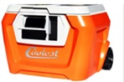
  - Advertise in alumni magazine and newsletter
  - Hold live kick-off event on campus
  - Set a deadline for giving: 30 days suggested (60 if equity crowdfunding)
  - In crowdfunding, it is all about the video. In 2014, Ryan Grepper raised
over $13,000,000 for the Coolest cooler with the following video
.
For access to videography resources, free DIY software as well as professional producers, see section on “Marketing Videos”.
VIDELINK This video raised $13,000,000 on Kickstarter https://d2pq0u4uni88oo.cloudfront.net/projects/730019/video-414581-h264_high.mp4

- DONOR-BASED CAMPAIGN
  - Do not offer donation levels below $5 to $20.
  - Sell project to donors on benefits to society (energy efficiency, job creation, etc.)
  - Offer varying rewards depending on level of giving. For donor reward suggestions see http://files.hubbub.net/HubbubRewardsGuide.pdf.

- REWARD-BASED CAMPAIGN
  - Make sure you know the cost and source of every product component and process before you launch a campaign: (Manufacturing 1000 products--like a cool cooler--is nothing like making one prototype on a 3-D printer.
  - Factor in the additional cost to ship overseas and price separately for U.S. and foreign buyers. If you have a heavy or bulky product, you may want to limit buyers to the U.S. For international postage rates (and weight and size limits) see http://ircalc.usps.com/. Note, for Kickstarter, you have to set one price for all foreign buyers, including freight, so guess high.
  - Keep accurate cost-accounting records to make sure you will make money at each level after factoring in the cost of the reward. The following is a link to a Google doc to do just that: https://docs.google.com/spreadsheets/d/1_nNBz-TheExh8rxeQCffu3U2fJJBkRDBdnUgpKDrmk0/edit#gid=0.
  - Include reward levels under $20 regardless of product selling price. For example, offer donor levels at $5 and $10. Some people may give you money because they like the idea, especially if a social enterprise.

Raising Growth Capital

19 – Raising Growth Capital

A. Types of Growth Capital

B. Determining Capital Requirements

C. Sources of Equity Capital

D. Valuation (Putting a price on your company)

E. Ownership Retention When Raising Equity Capital

F. Equity Capitalization Schedule (Cap Table)

G. Exit Strategy

Raising Growth Capital

A. Types of Growth Capital

- Debt Capital (a loan) carries with it a legal obligation to repay the investment within a specified time period, with interest. Commercial lenders will generally require collateral or the borrower's personal guarantee in case of default. This protects the lender and ensures that the borrower has a sufficient personal interest at stake to work diligently at the business. Lending sources include …

- U.S. Small Business Administration. The SBA’s Basic 7(a) Loan is program to help small companies obtain financing when they might not be eligible for business loans through conventional lending channels. Loans may be used for most business purposes including working capital, machinery and equipment, furniture and fixtures, building renovation or construction, and debt refinancing (under special conditions. Loan maturity is up to ten years for working capital and up to 25 years for fixed assets. Interest rates range from 7% to 10% (as of 2019).
For more information, see https://www.sba.gov/loans-grants.

- COMMERCIAL BANKS. Once you have achieved profitability, and thereby lowered the risk for banks to an acceptable level, you may be able to access growth capital through a traditional commercial bank, and thus avoid diluting the shares of your equity investors by selling more shares. You will still need a convincing business plan, a five-year financial forecast, including at least 3 years of month-by-month cash flow projections. Do not forget to show the payments to the bank in the forecasts. Interest rates for well-established businesses range 6% to 13% (as of 2019).

- Equity Capital (investment of cash in exchange for shares of stock in a company). Unlike loans, you are not legally obligated to refund an equity investment if the business fails. However, if the business is successful, you may wind up paying back more than you would have with a loan. A loan calls for a specific interest rate, no more and no less. However, an equity agreement provides the investors with a percentage of ownership (and therefore of the profits).
On the other hand, an equity investment can be especially useful if the company is already carrying a large amount of debt. Loading up with increasing amounts of debt may eventually drive the company into insolvency. Banks can call in overdue loans and force the company to liquidate its assets in order to pay down debt.
Preparation to pitch to equity investors involves the following steps:
- COMPUTE GROWTH CAPITAL REQUIREMENTS for each stage of your growth plan.
- ESTABLISH A REASONABLE AND DEFENSIBLE VALUATION OF YOUR COMPANY prior to entering the capital marketplace. You are, in effect, selling a portion of your business. So what is it worth? What price is fair for you and the capital providers? This process is part objective math, part hyperbole, and mostly negotiation—because you are really trying to arrive at a reasonable price today based on how profitable the business will be in the future.
- PREPARE A CAP TABLE showing the rounds of new capital you project you will need (including the month and year and amount of each round), type of capital, source, and resulting dilution (amount prior investors will be crammed down, that is, how much their ownership percentages will be reduced).
- DECIDE ON AN EXIT STRATEGY to allow equity investors to harvest their money and share of the gains. Exiting applies only to equity investors (banks would be happy if you kept their money and paid them interest forever, although they do like to see the loan paid down to zero once a year so they can sleep better). Equity investors (angels and VCs who provide capital for shares of stock) do not typically receive interest, so they need you to sell the company (exit) so they can have their payday. They will want to see that day arrive ideally 3 to 8 years after investing.

Raising Growth Capital

B. Determining GROWTH Capital Requirements

First, determine how much capital you will need to achieve the sales and profit goals in your business plan. Then break the total into tranches, or incremental investments spread over time, and due when you meet interim milestones, such as $1 in sales. This allows the investors to conserve cash until you actually need it, and reduces their risk, as they can withdraw from the agreement if you do not achieve a milestone within the agree upon time.

This is an interactive spreadsheet. To open, right-click on spreadsheet, click “Worksheet Object” and then "Open.” You need enter data in shaded fields only; the totals will be computed for you. You can download a copy of this form athttp://www.EntrepreneurshipFoundation.org/spreadsheets.html

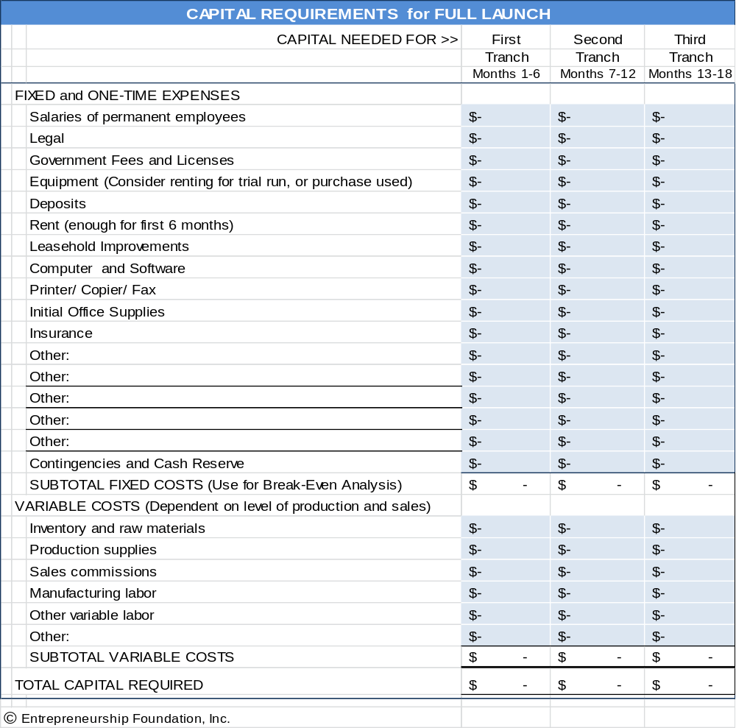

Raising Growth Capital

C. Sources of Equity Capital

Equity investors provide capital to private companies in exchange for share of stock in the venture. Their intent is to recoup 10- to 20-times their investment within 3 to 8 years by helping you sell the company or floating an initial public stock offering (IPO), and then selling their shares to the public on a stock market exchange.

- Private Individual Investors (Angels). A private investor operates like a venture capitalist. Typically, angels are successful former entrepreneurs themselves looking to reinvest some of their winnings helping others. An angel investor may desire to be actively involved in the management of the business. This can bring a wealth of free expertise and assistance, but also the frictions attendant to even the most harmonious of marriages. So, do not get engaged on the first date. It is important for you and the angel investor to get to know each other, test compatibility, and to understand each other’s expectations through preliminary meetings.
ANGEL INVESTOR CLUBS. A group of angel investors that invest individually or collectively through a common fund. The advantage of approaching a club versus an individual investor is that the club has greater investment resources. Although it is almost impossible to find one private individual who will commit to provide $500,000 in capital, a group of individuals could.

To find an angel investor club near you see http://www.angelcapitalassociation.org/directory/#1

- VENTURE CAPITAL (VC) FIRMS. VCs are equity investment firms, with offices, websites and paid staffs of analysts. A VC firm will specialize in a specific range of investment dollar size, industry and geography.

THE RIGHT STAGE TO CONSIDER VENTURE CAPITAL. VCs invest other people’s money and are therefore very conservative: they do NOT invest in startups, so wait until you have returning paying customers and are ready to scale up before seeking funding from this asset class. You may want to introduce yourself at regional VC events to seek advice, but do not press the issue until you are at or near profitability.

When you believe you are ready for prime time, find a VC firm that is...
- Near you. No one likes to travel more than two hours to check up on their investments
- Has a history of investing in your industry (a VC will not invest in an industry that he/she does not know a lot about).
- Invests the amount of money you need. If you need $1 million, do not go to a firm with $1 billion under management. That firm cannot afford to do deals as small as $1 million as that would mean they would wind up with 1000 investments to keep track of. Similarly, do not approach a firm with only $5 million under management, as no firm would invest 20% of its funds into one deal.
WHERE TO FIND THE RIGHT VC FIRM FOR YOU. There are a number of directories that list VC firms, the industries they invest in, stage, and typical amount of investment per deal.

- Pratt’s Guide to Private Equity and Venture Capital Sources. The main library of a city with a population of 150,000 will probably have a copy. The directory sells for $1000 so I would not expect your library to by a new edition every year. However, do not be concerned if it is 2 or 3 years old, as you will probably want to work with a firm that has a few years of experience anyway.
- The National Venture Capital Association (NVCA) website lists state and regional associations http://nvca.org/ecosystem/regional-groups. These membership associations typically hold monthly events that entrepreneurs may attend to learn more about sources of capital in their regions and the process to access funding resources.

Raising Growth Capital

D. VALUATION (Putting a price on Your Company)

If you plan to raise equity capital, you will need to assign a value to your business. Valuation is the art and science of estimating the worth of a business based on its potential future earnings.
Since a startup has no record of accomplishment, future earnings are difficult to estimate, and here is where it gets tricky. You (the eternal optimist) will project a high growth rate and the assumption that nothing will go wrong. The investors, however, will likely assume a lower growth rate and that everything that can go wrong will.
However, for the sake of argument, let us assume that after much polite negotiation you and your investors arrive at a 5-year projection of $10,000,000 in sales, with a net profit after tax of $1,000,000. So what is the business worth? Here is how the staff at Fundable.com foresees how the negotiation might play out:

The Valuation depends on the Earnings Multiplier agreed to. Again, you and the investor may begin the negotiations with markedly differing views. You will point to average stock market P/E ratios of say 8 for your industry, giving your business a valuation of $8,000,000. The investor will argue that those are proven businesses with real sales and profit margins. Your profits are hypothetical. The investor will counter with 1 or 2 times earnings, or a valuation of $1,000,000 to $2,000,000.

The investors will also argue that their money will be tied up and at risk for years. In addition, investing in established companies is less risky as they generally have tangible assets that can be sold off in a bankruptcy. The key to making money—for the equity investor—depends more on reducing exposure than picking home-run hitters.

The state of the economy at the time you enter the capital markets will also affect the cost of money. It is more difficult to launch and grow a company during a recession when potential customers are cutting back. Investors may therefore discount your valuation even further during a recession.

Other factors that will raise or lower the prospects for success, and therefore the value of your offering are:
- Extent of prior industry experience of your management team
- Connections you have to buyers (through management team or board of directors)
- Strength and number of competitors
- Expanding or shrinking market
- Rate of sales growth
For more on Private Company Valuation, see http://pages.stern.nyu.edu/~adamodar/pdfiles/ovhds/inv2E/PvtFirm.pdf

In the end, let us assume you all agree to value the company at $1,000,000 pre-money (that is, before the capital infusion). However, after the company receives the $1,000,000 in cash from the investors, its balance sheet would now show that it has $2,000,000 in assets (the original value plus the new capital). This is called post-money valuation.

Therefore, mathematically, the investors would be entitled to half the stock and you would retain half ownership. In this example, you are bringing to the bargaining table a company worth $1,000,000 (pre-money), and the investors are providing $1,000,000 in cash. The combined (post-investment) value would be $2,000,000.
The preliminary written agreement between you and the investors is called a Term Sheet. The document should also contain clauses to protect the interests of the investors and entrepreneur and stipulate how the proceeds are to be distributed if the company is dissolved or sold. Obviously, it would help for both the investors and you to each have experienced attorneys guiding you through the process.”

Raising Growth Capital
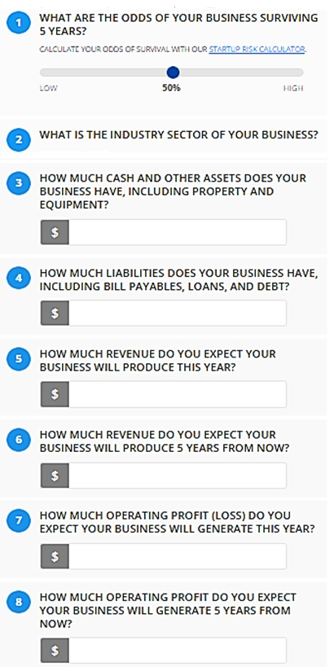
CALCULATE VALUATION >

Startup Valuation Calculator

1. Cayenne Consulting has a free comprehensive valuation calculator at www.caycon.com/valuation.php#

2. EquityNet [right]. This shorter 8-question calculator can help you estimate and better understand your business valuation. The results are based on market data gathered from over 3,000 businesses. To access EquityNet calculator, go to...

https://www.equitynet.com/crowdfunding-tools/startup-valuation-calculator.aspx
NOTE TO INNOVATORS

You may expect your years of toil and brilliant inspiration to count toward the Valuation of your business. Unfortunately, this is a sunk cost to you. To investors, the value of your business idea, invention, or patent is not how much time and expense you put into it, but instead its potential for earning in the future.

Your business will be valued like a company listed on a stock exchange. The price of the stock is the present value of the firms predicted future earnings—not the sum that has been invested into the company.

Raising Growth Capital

E. OWNERSHIP RETENTION WHEN RAISING EQUITY CAPITAL

The following chart illustrates the concept that an equity investor will expect a percentage of ownership in relation to the perceived risk. The more advanced the development of your product and business, the less ownership the investors will require in order to balance their risk.

MORE RISK FOR INVESTORS LESS RISK FOR INVESTORS

There are additional factors that may affect the percentages in the preceding chart. These variables may exert an upward pull on the percentage of ownership the entrepreneur might retain (dotted line); or they may lower the ownership percentage the entrepreneur should expect to retain.
External factors (variables not within your control):
        - The Economy
        - Investor Confidence
        - Total amount of capital available in the investment market
Internal Factors (variables under your control):
        - Newness or uniqueness of product or service
        - Prior experience (Serial entrepreneurs can retain a larger share of ownership)
        - Profit potential

Raising Growth Capital

F. Equity CAPITALIZATION SCHEDULE (CAP TABLE)

A Cap Table is the capitalization plan necessary to fund a venture to its full potential. Note that as new money is invested, the prior investors, including the founders, get crammed down. For the “A” round (first venture capital round) in the example below, both the angel investors and the founders each had to take a 33% haircut to make up the 33% ownership necessary to give the venture capitalists in return for their $1,000,000 cash infusion. What percentage ownership was retained by the angels? (Answer at bottom of page.)

Use the blank Excel spreadsheet below to try different Cap Table scenarios for your company.

CAPITALIZATION PLAN (CAP TABLE) for FULL LAUNCH - EXAMPLE

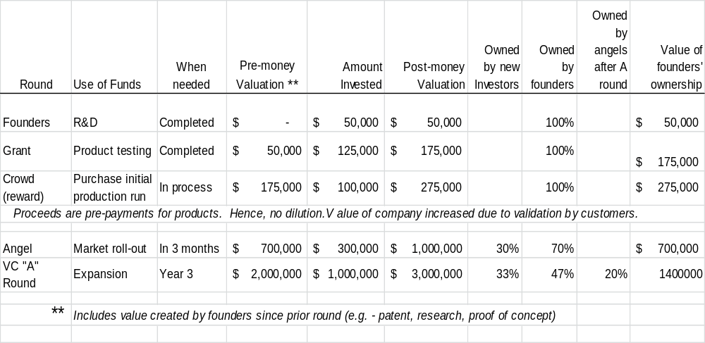

BLANK CAP TABLE WORKSHEET
This is an interactive spreadsheet. To open, right-click on spreadsheet, click “Worksheet Object” and then "Open.” You need enter data in shaded fields only; the totals will be computed for you. You can download a copy of this form athttp://www.EntrepreneurshipFoundation.org/spreadsheets.html

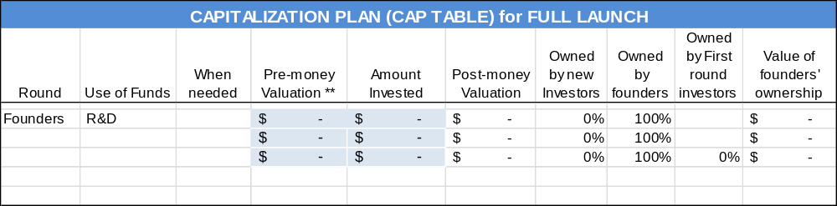
20%

Raising Growth Capital

G. Exit Strategy

If you are planning to keep the business as your job for life, then you will not have to think about an exit strategy for a while. However, if you accept equity capital, the investors will insist that you have a reasonable plan for them to exit the business. They will not have your love for the business. They just want to get their cash out as soon as possible, with a profit of 10 times the amount invested. You might still be able to stay on as president, or become a serial entrepreneur and start another business. Exit strategies in common use are:
- Buy-back by Founders through an LBO (Leveraged Buy-Out).
- Acquisition. Sell the company to a larger firm that can leverage your technology, patents, goodwill, or customer base. If this is your intended exit strategy, be prepared to name logical buy-out candidates in your pitch to investors.
- Private Equity. Private Equity Firms purchase companies to own outright and manage, typically when potential portfolio companies reach an annual profit level of $5 to $20 million.
- Initial Public Offering (IPO). Issuing stock to the public creates a market for the stock you and the investors own. It is difficult to sell new stocks in a recessionary economy, so do not suggest this exit strategy in a down market. Also, be advised that neither you nor your investors will be able to sell your shares immediately. (That would drive your stock value down precipitously.) You will have to cash out over time. If this is your intended harvesting strategy, be prepared to give examples of similar companies that have launched successful IPOs and the market value of the outstanding stock. (This Market Cap[italization] should be equal to or greater than the Business Valuation as claimed by you in your business plan–or your valuation will not be credible.)
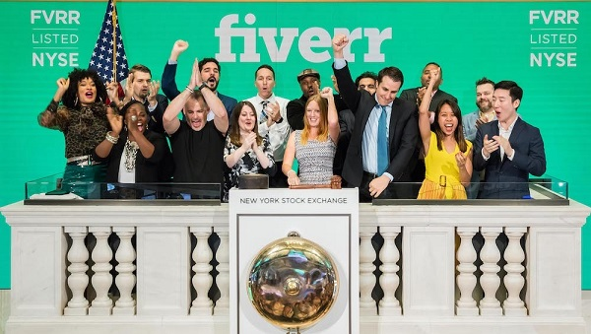
Fiverr celebrating having made it, June 13, 2019. Companies approved to list their stock on the New York Stock Exchange are traditionally allowed to ring the opening bell, signaling the start of trading for the day.
Pitching Capital Providers

20 – Pitching Business Plans to Competition Judges and Capital Providers

A. Oral Presentations

B. Substance: (Content of Presentation)

C. Questions You Should Be Prepared to Answer

D. Style: Creating Understandable and Convincing Presentations

Pitching Capital Providers

“The value of a killer technology is zero unless you can show how it can be turned into a profitable business.”
— W. Daniel Mothersill

A. Oral Presentations

There are several levels (in terms of detail and time length) of oral presentations to investors.

1. Elevator Pitch

FIVE-SECOND SOUND BITE. This is a statement about your investment opportunity that you can get out in one breath. The place to use this is at a business-networking event where someone asks, “What do you do?” You never know who you might meet, so assume everyone you talk to is a potential investor or knows someone who is. (A brief but engaging introduction about what you do is also valuable when recruiting employees or clients.)
No one writes a check in an elevator. The sole purpose of the elevator pitch is to pique the interest of the investor so they want more information. Success is an exchange of business cards and an offer for you to call and set up an appointment for an in-depth interview.

The elevator pitch forces you to achieve clarity. At a minimum, the pitch should include YOUR NAME, COMPANY NAME, PROBLEM, and YOUR SOLUTION.

The elevator pitch should be memorized and rehearsed enough so that you can give it without it sounding rehearsed. You never know where you might meet a potential investor: at a cocktail reception, football game, even in an elevator. An 8-second elevator pitch might sound like this:
“Sugarcoate Systems reduces the time to bring new drugs to market by 20%.”
“We make flameproof fabrics for aircraft interiors.”
“We make cupcake decorating kits.”

You have to convey all the essential information in a clear, concise, credible, and convincing in a manner that is natural but passionate.

Remember, the elevator pitch is not designed to take the place of a solid business proposal, but is simply intended to capture the attention of a potential investor. If you achieve that, you may have a chance to present your idea in more detail later. For more on mastering the elevator pitch see...
http://www.inc.com/guides/2010/05/mastering-business-elevator-pitch.html.

30-to-60-SECOND PITCH. At some events, such as a pitch competition, you may have an opportunity to give a longer but still informal pitch (no audiovisuals). Consider opening with a dramatic statement to capture the attention of the audience. Address the following points clearly and succinctly:

        - Big idea (customer problem and your solution)
        - Status of the idea or business
        - Competition and why do you believe you have an advantage
        - Revenue model (e-commerce, wholesale, etc.)
        - Rock stars are on the team who will insure success
        - Long-term vision for the business and the projected return for investors. (For example, "the business will distribute X per cent return to investors from cash flow by year Y", or "we expect the business will be acquired by a larger company. Similar businesses have recently sold for three times revenue.”)
        - Total funding required to launch the business full time, and how much do you need initially to develop the Minimum Viable Product and test the concept in the marketplace?
You will probably be one of many presenters, so be memorable.

Pitching Capital Providers

SAMPLE SCRIPT. "Our company, WorkBoots.com, is an e-commerce website that sells brand-name construction boots. There are currently no companies serving this niche exclusively. We will drive traffic to our site by linking to other websites catering to the construction industry as well as through word-of-mouth. In industry surveys, over 90% of construction workers have these three traits: 1) they have a favorite brand of boots, 2) they know their size, and 3) they hate shopping at stores. In our own polling, over 70% indicated that they would prefer to buy their boots online and have them delivered. We need a total of $500,000 in funding to reach break-even. This should happen in the middle of our second year. I am the CEO with lots of operational experience and deep contacts with boot manufacturers. Our Marketing Director was instrumental in the growth and recent sale of a very successful e-commerce clothing company. Our goal is to sell WorkBoots.com to a 'brick and mortar' retailer in 3 years."
VIDELINKS Sample elevator pitches:
MIT Pitch competition https://youtu.be/n0BKBcSZaA0

YOUR 8-SECOND PITCH:

YOUR 60-SECOND PITCH:

Pitching Capital Providers

 |  | ELEVATOR PITCH RATING SHEET USED IN COMPETITIONS
 |  |  | S c o r e
 |  |  | NO | < -- > |  |  | YES
 | 1. PRODUCT or SERVICE: Do you know what it is and what it will do? |  | 1 | 2 | 3 | 4 | 5
 | Compelling value proposition or solution to customer problem?
 | 2. COMPETITION: Is product unique, or superior to alternatives? |  | 1 | 2 | 3 | 4 | 5
 | 3. TARGET MARKET: Clearly defined? Adequate to support business? |  | 1 | 2 | 3 | 4 | 5
 | 4. MANAGEMENT: Was presenter knowledgeable, polished, confident? |  | 1 | 2 | 3 | 4 | 5
 | 5. FINANCE: Do you know how the company will make money? |  | 1 | 2 | 3 | 4 | 5
 | 6. FUNDING: Do you know how much company needs to launch? |  | 1 | 2 | 3 | 4 | 5
 | TOTAL (Maximum 30) ………………………………………………………..
FEEDBACK _____________________________________________________________________________

_____________________________________________________________________________

_____________________________________________________________________________

_____________________________________________________________________________

 | Presentation Style: Speak louder. Speak slower.

Pitching Capital Providers

2. Formal Presentation at a Venture Fair or Business Proposal Competition (3-10 minutes). You will probably be expected to have a PowerPoint presentation to support your verbal commentary.
There may be Q&A during or after the presentation. You can cover a lot more in 3 to 10 minutes than in an elevator pitch, but generally, there will not be time to cover financial projections in detail or the resumes of the management team. For finances, cover sales and profit projections and funding sought; for the management team, mention only relevant experiences of team members. For more on formal presentations, see the following sections on Content and Style.
3. Private Interview (15 minutes) in the office of the equity investor or lender. (This is what you hope an elevator pitch leads to.)
- If meeting with a VC firm, be prepared to present to an investment team of 3 to 5 people. Plan to give a formal presentation. Expect to be interrupted with questions.

- Ask about logistics at the time you receive the invitation, or at least prior to the meeting, so you know what to expect:
  - How many people will be in the audience?
  - Who are the decision makers? (Look up their bios on investor’s website.)
  - Can you (should you) deliver a PowerPoint presentation?
  - What is the total amount of time allotted for the interview?
  - Anything you should particularly be prepared to cover? (The answer might reveal their biggest concern.)
- Research the firm. What companies have they invested in?
- Would a relationship with your firm strengthen any of their portfolio companies? Are there any potential synergies?
- Call some of the CEOs of the portfolio companies.
    - What advice do they have?
    - What is it like working with the investor or lender?
- What is their sweet spot for investing? $100,000, $1 million, $5 million?

- Bring to the private meeting:
- Copies of executive summary for all attendees.
- Copies of the full plan to leave behind. Exclude confidential information, trade secrets, or content that might be useful to competitors until you obtain a signed NDA (non-disclosure agreement). Discuss the process and timing with your venture-finance or intellectual-property attorney.
- Any purchase orders or contracts you have.
- If you are meeting with a lender, bring a list of assets that you can pledge as collateral. Show the date of each asset was manufactured, purchase price, and current market value.
- Business cards
If you make it through this round, you will probably be called back to answer more detailed questions and begin negotiations over the term sheet (a preliminary draft of the investment contract).

Pitching Capital Providers

B. Substance (Content of Presentation or Written PLan)

The following is a comprehensive outline for an oral presentation. Adjust the amount of detail to the time allotted. Investors are looking for clear, compelling and credible information.
Be concise but comprehensive. Remember the five “P”s:

1. Product

INTRODUCE SELF AND COMPANY

OPEN WITH A STRONG STATEMENT TO GRAB ATTENTION. Bait the hook.
“Eighty per cent of organ transplants are rejected within three years. Compatico has developed immune therapeutics to reduce rejections to 50%. The annual market for our new drug, once approved, is $200 million.”

PRODUCT/SERVICE DESCRIPTION and How it is New and Different
- Describe what creates the demand for your solution:
  - Pain?
  - Desire?
  - High cost of alternatives?
- Explain the value proposition
  - How much customers need or want your solution. Give dramatic examples.
  - What it is worth to them, literally? Prove it.

Product/Service Development STAGE
- Current development status
- Patent status, if applicable
- Work, timeline and expense remaining before the product achieves full functionality
- Remaining development risks or challenges (what might still go wrong?)

2. Potential

What is you market niche?
  - Define the characteristics of the companies or consumers that need a solution
  - How many potential customers are there? Is number growing or declining? Why?
  - How many customers do you have now?

What is the potential dollar sales annually in your MARKET niche?
Marketing and Sales Strategy. Briefly explain the expected selling cycle: how you propose to reach your targeted customers
  - Marketing – to raise awareness of product and stimulate buying
  - Sales – to give decision-makers a convenient way to learn details and place order
  - Support – to help customers understand your product during installation and in use

Pitching Capital Providers

If you rely on indirect channels, explain:
- Your approach to reaching distributors
- Whose responsibility it is to raise awareness and generate demand among end-customers
- Who will provide sales and customer support?
- Describe special sales incentive programs for distributors (if any)

3. Positioning Versus Competition and Alternative Solutions
Technology edge. [Do not delve into too much detail. Not everyone gets excited about dual-phase ether shifts.] Just explain that it will allow jets to save 50% on fuel costs. That they will understand.
COMPETITION and how your company is better.
How will large COMPANIES THAT HAVE established relationships with your target customers REACT TO YOUR INITIATIVES?
How will you overcome Market Inertia? (What will it take to get customers to change what they are using today?)
Are there companies that might leapfrog your solution with better technologies?
barriers to entry that you will erect to prevent potential competitors from entering your market niche.
- Patents – Received or pending. US and abroad.
- Black box technologies – Is your technology difficult to reverse engineer?
- Lead time advantage – Would it take competitors years to reproduce your technology?
- Major Customers locked in with exclusive long-term agreements
- Critical suppliers locked in

4. People
MANAGEMENT TEAM [Skills should be varied and include individuals with business as well as technical backgrounds.] Has anyone on team led a similar company to a successful IPO or buy-out?
- CEO (Chief Executive Officer) – Prior entrepreneurial experience in similar business. You may know your technology, but how do investors know you can run a business?
- CTO (Technology) – Proven know-how in your core technology
- CMO (Marketing) – Proven knowledge of the target market; strong relationships with distributors or key customers
- CFO (Financial) – Prior IPO or acquisition experience

Identify who is full-time and who is part-time or on the sidelines waiting funding.
board members or advisers who add strategic value.

Pitching Capital Providers

5. Profit Potential (This is not the place to go into detail.)

FINANCIAL FORECAST SUMMARY.

This is an interactive spreadsheet. Double click on form to open.

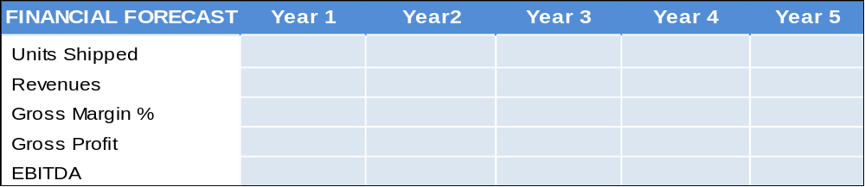

Funding Plan
  - Funding received previously
  - Investment by founders (skin in the game)
  - Amount of new funding needed. How long will it last? (To what milestone?)
  - Intended use of funds
Exit Strategy. Investors naturally want to know what is in it for them. Tell them how much they can make in 3 to 5 years, and how they will cash out. If you are seeking equity capital, how will the investors get their money back? When? How? If you anticipate being acquired…

- Identify the two or three most likely buyers
- Explain why they would be interested
- If possible, describe recent acquisitions of comparable companies and the deal values

- Describe any relationships you already have with potential acquirers and investment banks or VCs that might facilitate your exit plan.

6. To Conclude, Summarize the Most Compelling Arguments:
- Accomplishments. Milestones already reached. Show momentum.
- Why is this an exciting investment opportunity? Allow for pitch decay. A week later, your audience will probably only remember about 10% of your presentation. So make sure what they recall are your strongest points:
  - Reason to invest in us #1 (e.g. - Strategic alliances.)
        - Reason to invest in us #2
Pitching Capital Providers

C. Questions You Should Be Prepared to Answer

You should expect questions. The first one will probably be the one you were hoping would not be asked. However, you can ensure that you will appear professional and competent if you spend some time trying to anticipate questions and prepare clear, concise answers. Do not try to memorize responses word-for-word, but do commit to memory important statistics.

Finally, be open to advice from your audience. Investors want to collaborate with someone who is easy to get along with and who will consider their ideas for the company.

1. Market Opportunity
- Who specifically is the customer?
- Why is the customer's problem important?
- How do we know the market exists? What evidence can you cite, such as independent market research?

- For industrial products…
  - What 2-3 industries comprise the most important prospects in Year-1? In Year-3?
  - What are the job titles of the buyers (decision-makers) in these prospect companies?
- For consumer products…
  - What are the demographics of the two or three most important customer segments?

2. Solution: Product/Service
- What, specifically, is the product?
- What does the product do?
- Why would the customer buy this product?
- What makes the product unique or special?
- How is the product better than other products or alternative methods of solving the problem?
- How much better is it than other solutions?
- Can you prove the product is cost effective?
- What special issues relate to manufacturing the product? Any special materials or processes needed?
- What special equipment or facilities are required?
- What investment is required to set up manufacturing? For what capacity?
- How do you know you can manufacture the product at a cost that will yield acceptable gross margins?

Pitching Capital Providers

3. Competitive Positioning
- How else can the customer solve the problem?
- How do you compare to each alternative solution?
  - How are you better?
  - In what ways are you worse?
- Who are the vendors of these other solutions?
- How do they compete with each other?
- Where will you fit into the industry?
- Why will you be able to compete effectively against them long term?

4. Barriers to Entry into the Market by Competitors
- Why are you confident that no new entrant will come along with a better solution?
- Why do you think you can dominate your market niche?
- What, if any, proprietary technologies are used to make the product?
- Are there patents? If so, what, specifically, do they protect?

5. Product/Service Development
- What needs to be done to finish your first product? What is your next step?
- How much of the development process does your company perform?
  - How much do you rely on outside contractors?
  - How much do you license from others?
- What expertise do you have at developing this kind of product?
- What development challenges are most difficult to overcome? How do you intend to do so?

6. Marketing and Sales
- What channels of distribution will you use to deliver your products to customers?
- How will these channels be established? By whom? When?
- What expertise does your company have to execute the marketing and sales program?
- How are you going to stand out among established competitors?
- How can you boil down the advantages of your sophisticated technology so prospects will understand it quickly and easily?

7. Management Team
- What is your background and previous experience?
- Where did the idea for the company come from?
- How did you get involved with the company?
- Who is presently involved in managing the company? What are their credentials?
- Why will the management team be able to build a successful company?
- If not all management spots are filled, what is the plan for filling them?
- What kind of people are you seeking?

Pitching Capital Providers

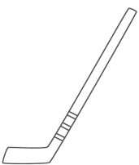

8. Financials
- Be prepared to explain dramatic numbers, such as:
  - Hockey stick growth (i.e. – exponential growth)
  - Unprecedented margins
  - Long periods of negative cash flow. (Goodness is positive cash flow in 6 to 12 months)
- What investment is required to carry the company to the next major level of valuation?
- When do you expect the next rounds of financing to take place?
        - What specific tasks need to be accomplished to do that?
        - How long will it take? (Try to identify a next level that can be achieved in less than 18 months.)
- What investment will be required beyond that?
- To the extent possible, explain key assumptions behind your forecast. In addition, make sure the forecast relates in a logical way to the market forecasts you described previously.

9. Requested Funding and Intended Use of Funds
- How much hard-money (cash) have the founders put in?
- How much cash have directors and advisory board members invested?
- What equity is available to recruit key executives?
- How did you arrive at your pre-money valuation for this round?

10. Exit Strategy
- What comparables are you using for your proposed IPO/exit round?

11. Summary and general
- When did the company begin operations?
- What exactly does the company do? (This is different from the question: “What does the product do?”)
- What is your long-term vision for the company?
- How has it been funded to date?
- Where does it stand today?
- What are the important strategies for building the business?
- What kind of business will it be? (Manufacturing, service, distribution, software, combination?)
- What is the business model? (What will produce the company’s revenue?)
- What kind of gross margins will the company have?
- What expense levels are required to run the business?
- Do you have any corporate partnerships in place?
- Do you plan to put any in place?
- What are the significant risks your business faces?

Pitching Capital Providers

D. Style: Creating Clear and Convincing Presentations

1. The Delivery

- You should lead the presentation so that investors can judge your knowledge of the industry, and that you know how to present and think on your feet.
- Take bulging items out of your pockets.
- Stand up; face the audience, not the screen.
- Speak confidently. Do not be self-deprecating in an attempt to gain the audience’s sympathy. Would you have confidence in someone who prefaced their talk with “I’m so nervous!” or “I’m not used to speaking in front of people”? You probably are nervous; everyone is when giving a talk; but you probably do not look it, so no need to let on. If you really want to feel more confident, rehearse the speech until it becomes second nature.
- Grab their attention. Lead with your strongest suit, a surprising statistic, or a 15-second story that shows how much customers need your product.
- Pause occasionally so your listeners can catch up.
- Vary your voice, especially when you want to emphasize a point.
- Avoid sales representative’s talk: “This is going to be the hottest selling product,” “We’re going to replace Google,” etc. Stick to what you can prove, or you will lose credibility.
- Avoid tech talk. Keep your language simple and accessible. Remember your audience.
- Do not fall into the common trap of droning on about how wonderful your technology is and details of how it works. The investors do not care how the watch works (at least not at this stage); just tell them how they will make money by helping you make watches.
- Practice – practice – practice. It does make a difference.
- Videotape your rehearsal. Do you make distracting gestures?
- Be PASSIONATE! Show that you believe in your concept and that you are determined for it to succeed.
- Be forthcoming about weaknesses or threats inherent in your proposal. Paul Graham, founder of Y-Combinator, advises to be upfront about obstacles. Business competition judges and investors are expert in spotting the dangers a new idea will face; so if you do not reveal them, they will think you are trying to hide the bad news and will not trust you. On the other hand, if you are the one to point out the challenges, they will see you as realistic, insightful, and most importantly, honest.
VIDELINKS Examples of 3-5 minute presentations by student teams.

Spyce MIT https://youtu.be/EeaGT9lMYUA
Shizzlr UConn https://youtu.be/1AaAyKjn3lE
Green Splinter University of Bridgeport https://youtu.be/6gG01wT2bZ4
SilvaTerra Yale https://youtu.be/Lqp1y0ZMMFA
Checked Twice Yale https://youtu.be/tUt_CQTZlxI
Seratis Harvard https://youtu.be/rrCBsLbt4BY

Pitching Capital Providers

2. The Slides

So that no one forgets who you are, put company name and logo on every slide. (This is especially important in a competitive environment with other presenters, as at a venture fair or business competition.)
- DO NOT waste real estate. Use selling slide titles, like “Why 90% of our customers come back for more” instead of “Customer data.”
- Use Large Type (24 points or larger).
  - Limit slides to 7 lines and 7 words per line.
  - Audience friendly font like Arial or Helvetica.
  - Substitute symbols [=, %, >] for words.
  - If the audience cannot read your material, you will lose their attention.
  - Use phrases instead of sentences.
- USE A HIGH-CONTRAST COLOR SCHEME.
- Keep The Show Moving. One slide every 30 to 60 seconds is about right. Uncover points on your slides one at a time.
- Use text on slides only to supplement, reinforce or offer examples of claims made in your talk. (Do not put your speech on the slides. Nothing is more annoying and boring than having to listen to someone read a speech.)
- SPELLCHECK!
- Clarity. Do not get clever. This is not a design competition. Which of the following charts is easier to read? Make sure labels are large and legible. Viewers should be able to grasp slide message in two seconds.
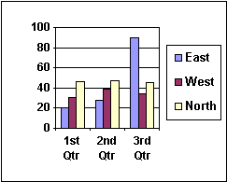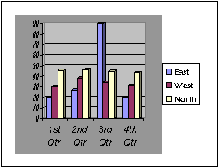
If you cannot read the PowerPoint or overhead slides from 15 feet away, your audience will not be able to read them when projected onto a screen.

Banking

21 - Banking

A. Selecting the Right Bank

B. Opening the Bank Account

C. Ordering Checks and Banking Supplies

Banking

A. Selecting the Right Bank

LOCATION. Your business banking needs will most likely occur during normal business hours, so consider banks near your office instead of where you live. In any case, the bank around the corner from your home that you use for your personal needs may not offer the services your business will need.

If you were working out of your home, think about a likely area, you would move to when you outgrow the garage.

TYPE OF INSTITUTION. By law, savings and loan institutions (S&Ls) cannot allocate more than 20% of their assets for commercial loans, and only half of that can be placed with small businesses. Savings institutions are designed to service individuals, not companies. So pick a full-service commercial bank.

SERVICES AVAILABLE. Will you be making many cash deposits? If so, how late is the bank open (some close their windows at 3:00 pm)? If you have a retail store, you will need to obtain rolls of coins and small bills. Will you be doing a lot of importing and exporting? If so you will want a bank with international experience or correspondent banks in the countries where you will be doing business. HSBC stands for Hong Kong and Singapore Bank of China. This is a bank worth talking with if you are considering doing business in the Pacific Rim.

Think about the services you may need in the future, such as payroll processing or a business loan. You will not build a relationship if you have to change banks every few years.

SERVICE FEES. Some banks will offer a free or low-cost checking/savings plan and then nickel and dime you on related services. Determine the total annual cost of doing business at the different banks that fit your needs.


These ads describe what you want
in a bank.
Talk to the bankers
to find out if the hype is true.
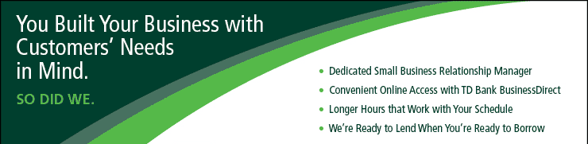

Banking

BANK RESEARCH | Bank A | B | C
Name of bank representative
Email of bank rep
Free business checking? | Yes / No | Yes / No | Yes / No
Minimum balance to maintain free checking | $ | $ | $
Interest on savings account | % | % | %
Overdraft fee | $ | $ | $
Will bank take money out of savings automatically to cover insufficient funds in the checking account (thus avoiding inadvertent overdrafts)? | Yes / No | Yes / No | Yes / No
Printed monthly statement? | Yes / No | Yes / No | Yes / No
Able to check online for balance and see which checks have cleared? | Yes / No | Yes / No | Yes / No
Import/ Export experience? | Yes / No | Yes / No | Yes / No
Experience with Letters of Credit? | Yes / No | Yes / No | Yes / No
Experience with wire transfers? | Yes / No | Yes / No | Yes / No
Cost for 250 checks, binder, and book of carbonized deposit tickets | $ | $ | $
Is the bank an SBA lender? | Yes / No | Yes / No | Yes / No
What is the range of the size of business loans that the bank makes? | $____k to $____M | $____k to $____M | $____k to $____M
How many business loans does the bank make in a typical year? | # | # | #

Banking

B. Opening the Bank Account

WHY YOU WILL NEED A BUSINESS ACCOUNT. It is generally a good idea to keep business funds separate from family money. In addition, when you pay bills, using checks with a business name shows you are serious and this is not just a hobby. Any check made out to the name of a business must be deposited in an account of that name. If you intend to operate as a sole proprietorship, you can open the account as a d/b/a (doing business as) “[Your personal name] d/b/a [your company name]”. Make sure the business name is available and register it with your town clerk before opening the account and purchasing checks.

DECIDE WHO YOU WANT AUTHORIZED TO SIGN CHECKS. You might have a bookkeeper who prepares your checks, but to maintain a prudent system of checks and balances, you should be the only one authorized to sign. If a partnership, you may want to tell the check printer to show two signature lines with the following text over the signing area: “Checks over $500 must have two signatures.” The bank will ask all authorized signers to sign a signature card.

WHAT YOU NEED TO OPEN AN ACCOUNT. For a sole proprietorship, you will need a Social Security number or FEIN; If an LLC, LLP, LP, or C Corp, form the entity first, and then bring the following to the bank:

- Federal Employment Identification Number (FEIN).
- Articles of Organization (for LLC), Partnership Agreement (for LLP), Articles of Incorporation (for C Corp);
- If a C Corp, you will also need a Corporate Resolution by your board authorizing you to open a checking and savings account and to sign checks. A boilerplate Banking Corporate Resolution can be downloaded free from https://www.docracy.com/0xq519bgf3k/corporate-resolution-banking-ppdd.
Template for Banking Corporate Resolution
I, Enter the name of the secretary of the corporation, Secretary of Enter the name of the corporation, referred to as corporation, certifies that the following is a true copy of resolutions adopted by the Board of Directors of this corporation at a meeting held on proper notice, a quorum being present, on Enter the date of the corporate meeting, and that such resolutions are now in full force and effect.
Resolved that the Enter the name of the bank Bank of Enter city, state of the bank is designated a depository of this corporation; and
Further resolved, that all drafts, checks, and other instruments or orders for the payment of money drawn against the account or accounts of this corporation with such depository shall be signed by any Enter number of signatories on checks of the following:
Enter the names of the authorized signatories
Further resolved, that such depository is authorized to place to the credit of the account, or any of the accounts of this corporation, funds, drafts, checks, bills of exchange, or other property whomever delivered to such depository for deposit for account of this corporation, endorsed with the name of this corporation by rubber stamp, facsimile, mechanical, manual or other signature (and any such endorsement by whomever affixed shall be the endorsement of this corporation), or otherwise endorsed, or un-endorsed, provided that if any such draft, check or other property shall bear, or be accompanied by, directions (by whomever made) for deposit to a specific account then such deposit shall be to the credit of such specific account; and
Further resolved, that such depository is directed to accept, and/or pay and/or apply any draft, check, instrument or order for the payment of money, or any proceeds thereof, drawn on such account or accounts when signed as required by these resolutions without limits as to amount, without inquiry, and without regard to the disposition of any such item or proceeds thereof, and such depository shall not be liable in connect therewith notwithstanding that such item may be payable to the order of a person whose signature appears thereon or of any other officer or officers, agent or agents of this corporation, or such item or any proceeds thereof may be used for the personal credit or account of any such person or person with the depository or used in payment of the individual obligation of any such person or persons to the depository or otherwise.
Further resolved, that such depository is authorized to deduct from the accounts of the corporation the regular promulgated service charges and fees for accounts and other services rendered to the corporation.
Dated: _________________ Signed by its Secretary ________________________________________________

Banking

C. Ordering Checks and Banking Supplies

CHECK STYLE. Puppies and balloons are right out, unless of course you are opening a pet store or party supply business. Order businesslike checks with subdued hues and no decoration. Order the large size (3” x 8.25” plus stub) that comes in a ring binder.

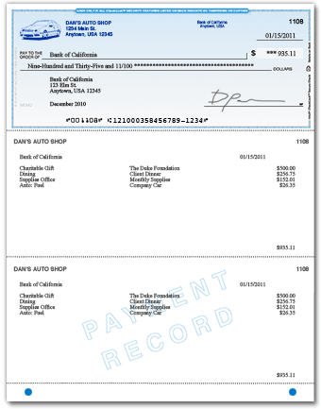
You might feel a wallet-size checkbook is more convenient, but larger checks and stubs allow for more-detailed record keeping and help convince suppliers that you have outgrown the sidewalk lemonade stand.

Checks will come pre-numbered and printed with your business name and address, the routing number that identifies your bank, and your bank account number.

You will have a choice between manual checks [below] or laser checks [right] designed for accounting software—like QuickBooks—and intended to be over-printed with the payee and amount. The imprintable checks save time and help you look more professional. They are a bit more expensive, however.
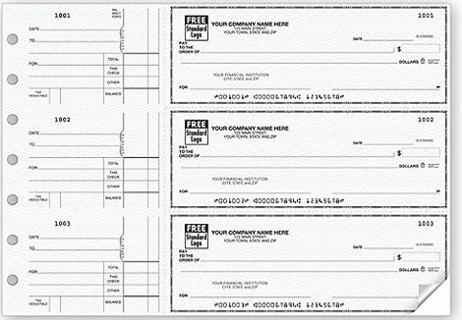

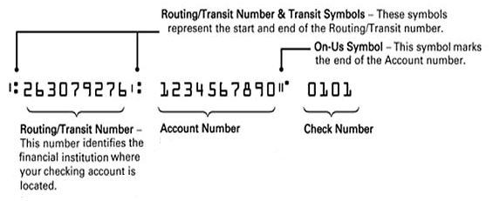
WHAT YOU NEED TO ORDER CHECKS: Your checking account number and the routing number for your bank. This is an identification number that tells the receiving bank how to route the canceled check back to your bank to be reimbursed. The routing number will appear at the bottom of the check, before the account number.

Banking

WHERE TO BUY CHECKS. You can purchase your checks from your bank when you open the account, but check their prices. It may pay to buy your checks directly from one of the following check printers. Whomever you buy from, resist the offer of a free stock logo. These are from the 1950s. Go with no logo (you’ll look very businesslike) or see the section in this book on how to create your own logo.

Deluxe Check printers and Harland Clark are well-known suppliers of quality printed checks, but difficult to deal with as they will not divulge pricing until you login and give them your bank account information.

Intuit (https://intuitmarket.intuit.com/bvc) is the producer of the QuickBooks accounting software, so you know the checks will line up with their software templates. $112 for 250 checks (as of 2019). Go with the 1-up “voucher” version instead of three-up because you will not always be issuing checks in exact multiples of three.

Walmart (http://www.walmartchecks.com/index.aspx) is the least expensive. 500 one-up LASER CHECKS for computer printing are $50. 300 MANUAL CHECKS $23 (as of 2019). Also available through Walmart are matching…

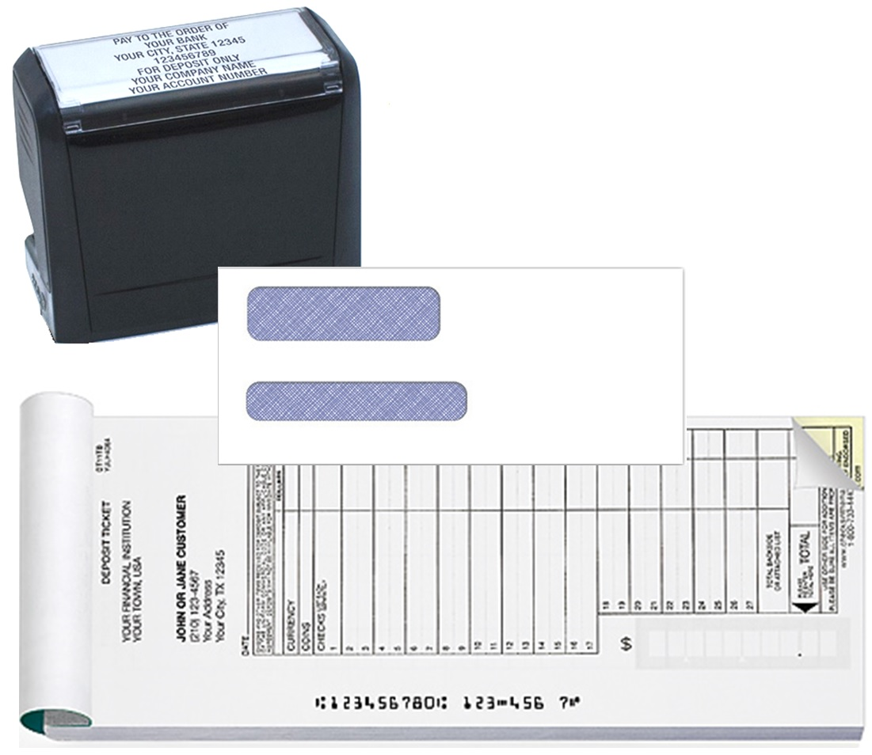
WINDOW ENVELOPES (to save addressing) $25 for 250.
A pad of 200 2-part carbonized pre-printed DEPOSIT TICKETS (with company name and account number) $15.
STAMP with company name and account number $12 (as of 2019). The stamp saves time endorsing checks. The stamp also indicates that the check is being presented “For Deposit Only” to prevent the bank from applying the funds to an outstanding loan.

Glossary

Glossary

Glossary

ACCREDITED INVESTOR. Potential investors who meet certain minimum net worth or income tests (as determined by the SEC) as they relate to certain exempt offerings. See also Sophisticated Investor, and consult with your legal counsel for further clarification.
ANGEL INVESTOR (ANGEL). Individuals who invest in businesses looking for a higher return than they would see from more traditional investments. In return for their investment, they often are highly involved in the business. Usually they are the bridge from the self-funded stage of the business to the point that the business needs the level of funding that a venture capitalist would offer. Funding estimates vary, but usually range from $50,000 to $1.5 million.
BLUE SKY LAWS. The name applied to the securities laws of various states enacted to protect investors. While the SEC regulations are national in application, various states have securities laws that affect private and/or public offerings.
BROKER. A commonly used term applied to individuals or firms that trade securities. Brokers execute trades of securities between buyers and sellers in return for a fee or commission. Brokers typically do not own the securities in which they trade and, accordingly, do not share in the risks or rewards of ownership.
BUSINESS VALUATION. An estimate of the worth of a business entity and its assets.
CLOSELY HELD COMPANY. A company where a few shareholders hold the equity interests.
DUE DILIGENCE. An investigation conducted by investors that the assumptions state in a business plan are reasonable and that sales data, profit projections, listed assets, liabilities and other factors contain no misleading information and that no material information has been omitted. For high-tech ventures, due diligence will include a feasibility review of critical technologies (will the gadget really do what the inventor claims and is the product or process superior to alternatives?) and whether the owner of the intellectual property holds an iron-clad patent protecting the company’s exclusive rights to the technology.
EARLY STAGE. Seed Financing, Startup Financing and First-Stage Financing
GOING PUBLIC. The process of a privately owned company selling its ownership shares to the investing public. See Initial Public Offering.
INITIAL PUBLIC OFFERING (IPO). The offering or sale of a company's securities to the investing public for the first time (i.e., converting a company from private to public ownership).
INSTITUTIONAL INVESTORS. Non-individual shareholders that invest on a regular basis. Institutional investors include pension funds, mutual funds, and trusts.
INTRASTATE OFFERING. A securities offering limited to investors residing in the state in which the issuer is doing a significant portion of its business. Such offerings are usually exempt from registration with the SEC.
INVESTMENT BANKER. A person or (usually) a firm that, among other things, underwrites securities, functions as a broker/dealer, and performs corporate finance and merger-and-acquisition advisory services. Investment bankers are usually full-service firms that perform a range of services, as opposed to an underwriter or broker/dealer, which only provides one specific service. Investment bankers typically are not direct investors but find investors for a fee, usually a percentage of the amount raised. There may also be a fixed fee or minimum charge for their services.
JOINT VENTURE. An arrangement whereby two or more parties (the venturers) jointly control a specific business undertaking and contribute resources towards its accomplishment.
LEVERAGED BUYOUT. An acquisition of a company financed largely by debt.
LIMITED OFFERING. An offering of securities exempt from registration due to exemptions for the limited size of the offering and the limited number of purchasers.
MERGERS. A business combination where one entity becomes a part of another entity.
OFFERING CIRCULAR. Sometimes referred to as a private offering memorandum. A document used in certain securities offerings that are exempt from SEC registration requirements.

Glossary

OPTIONS. A security giving its owner the right to purchase or sell a company's shares at a fixed date and agreed-upon price. (See also Warrant.)

PRIVATE PLACEMENT. An offering that is exempt from the requirements of registration and is limited in distribution.
PRO FORMA. Financial statements or financial tables prepared as though certain transactions had already occurred. For example, a registration statement might include a pro forma balance sheet that reflects the anticipated results of the offering.
PROSPECTUS. The primary selling document in an offering distributed to potential investors. The prospectus provides information about the company and the offering. See also Preliminary Prospectus and Final Prospectus.
ROAD SHOW. A presentation to potential investors, brokers, and dealers by the company's management and underwriters in order to facilitate a securities offering.
RULE 144A. An SEC exemption permitting the sale of certain restricted stock without registration.
RULE 504. A rule under Regulation D that permits an issuer to raise up to $1,000,000 within a 12-month period. Under Rule 504, a company may offer securities to an unlimited number of investors and need not provide an offering circular to them.
RULE 505. A rule under Regulation D that exempts from registration offers and sales of securities of up to $5,000,000 during any 12-month period. Rule 505 limits the number of non-accredited investors to 35; however, there can be an unlimited amount of accredited investors.
RULE 506. A rule under Regulation D that allows for the private placement of securities with an unlimited number of accredited investors and up to 35 sophisticated non-accredited investors regardless of the amount of the raise.
S CORPORATIONS. Corporations that have 35 or fewer shareholders and meet certain other requirements of the Internal Revenue Code. An S corporation is taxed by the federal government and some states in a manner similar, but not identical, to a partnership.
SAFE HARBOR RULE. SEC provisions that protect issuers from legal action if specified requirements have been satisfied or, in certain cases, if a good-faith effort has been made to comply with specified requirements.
Second-stage Financing. Growth financing for market penetration following the initial financing round.
SECONDARY OFFERING. An offering by the company's shareholders to sell some or all of their stock to the public. The proceeds of a secondary offering are received by the selling shareholders, not by the company.
SECURITIES ACT OF 1933 (1933 ACT). Under the 1933 Act, a registration statement containing required disclosures must be filed with the SEC before securities can be offered for sale in interstate commerce or through the mail. The 1933 Act also contains antifraud provisions that apply to offerings of securities.
SECURITIES AND EXCHANGE COMMISSION (SEC). The federal agency responsible for regulating sales and trading of securities through its administration of the federal securities laws, including the 1933 and 1934 Acts.
SECURITIES EXCHANGE ACT OF 1934 (1934 ACT). The 1934 Act requires companies registered under the 1933 Act to file periodic reports (e.g., Forms 10-K and 10-Q) with the SEC and to disclose certain information to shareholders. Companies traded over the counter with 500 or more shareholders and total assets of more than $10 million and companies that elect to be listed on a national stock exchange must file a registration statement to register under the Act.
Seed Financing. Second Stage Financing, Third Stage Financing and Going Public.
SOPHISTICATED INVESTOR. Potential investors who are capable of evaluating the merits of the investment venture as related to certain exempt offerings. See also Accredited Investor, and consult with your legal counsel for further clarification.
VALUATION. An estimate of the worth of a business entity and its assets.
WARRANT. A security entitling its owner to purchase shares in a company. An option is a form of warrant.

Appendices

Appendices

Summary of Hotlinks

Alternative Osterwalder Business Model Canvas

Employer and Employee Payroll Taxes

Non-Disclosure Agreement (NDA)

Entrepreneurship Aptitude Self-Assessment

Hotlinks

Summary of hotlinks
(“V” indicates video.)

Angel investor clubs http://www.angelcapitalassociation.org/directory/#1

Branding, colors www.colorexplorer.com
Branding, colors www.RGBtoHex.net (converting RGB to HEX code)
Branding, graphic design services www.Freelancer.com, www.Fivrr.com
Branding, logo – images www.Google.com/images Pixabay.com
Branding, logo design www.freelogodesign.org, www.logologo.com, www.freelogoservices.com
Business Modeling https://www.youtube.com/watch?v=W-I9sW-Bk68

Capital sources – SBA loans/ grants https://www.sba.gov/loans-grants
Capital sources – SBA microloans https://www.sba.gov/loans-grants/see-what-sba-offers/sba-loan-programs/microloan-program
Capital sources – SBIR grants https://www.sbir.gov/#
Check sources – Walmart http://www.walmartchecks.com/index.aspx
Check sources – Intuit (QuickBooks) https://intuitmarket.intuit.com/bvc
Content management Systems http://www.Yola.com GoDaddy
Content management Systems Sites.Google.com Moonfruit.com iPage.com FatCow.com
Content management Systems smallbusiness.yahoo.com Weebly.com Wix.com
Copyright www.copyright.gov
Copyright, online filing https://eco.copyright.gov/
Copyright, international Circular 38a
Corporate Resolution – Docracy https://www.docracy.com/0xq519bgf3k/corporate-resolution-banking-ppdd
Corporate tax rates, by state https://taxfoundation.org/state-tax/corporate-income-taxes/
Crowdfunding – Rewards http://files.hubbub.net/HubbubRewardsGuide.pdf
Crowdfunding platforms, debt www.LendingClub.com
Crowdfunding platforms, donor www.ef.hubbub.net, www.GoFundMe.com
Crowdfunding platforms, equity www.fundable.com
Crowdfunding platforms, reward www.Kickstarter.com
Crowdfunding social media campaign www.Hootsuite.com to coordinate campaign on five social media sites Crowdfunding social media campaign www.Buffer.com

Elevator pitch examples V https://youtu.be/n0BKBcSZaA0
Elevator pitch http://www.inc.com/guides/2010/05/mastering-business-elevator-pitch.html
Email marketing, platform http://mailchimp.com/
Excel worksheets, finance http://www.EntrepreneurshipFoundation.org/spreadsheets.html

FEIN number – Fillable PDF www.irs.gov/pub/irs-pdf/fss4.pdf
FEIN number – Online application https://sa.www4.irs.gov/modiein/individual/legal-structure.jsp
Financial spreadsheets http://www.EntrepreneurshipFoundation.org/spreadsheets.html
Flea Markets – database http://www.keysfleamarket.com/fleamarket/state/

Google search trends http://www.google.com/trends/hottrends
Grants See “Capital sources”

Ideation – Brainstorming ideas http://www.entrepreneur.com/businessideas and
Ideation – Brainstorming ideas http://www.mysmallbiz.com/custom-post-types-landing-page/
Insurance, state deparments of http://www.naic.org/state_web_map.htm
Insurance, tips for buying https://www.sba.gov/managing-business/running-business/insurance
Insurance, tips for buying http://www.nfib.com/business-resources/insurance-healthcare/
Insurance, Workers Comp https://classcodes.com/ Rates by state and industry

Legal Documents https://law4startups.com
Licenses, business – by state https://www.sba.gov/starting-business/business-licenses-permits/state-licenses-permits)

Magazines database www.MediaFinder.com
Merchant credit card service https://www.paypal.com/webapps/mpp/credit-card-reader
Merchant credit card service http://payments.intuit.com/mobile-credit-card-processing/
Merchant credit card service http://www.payanywhere.com/
Merchant credit card service https://squareup.com/
Mobil App prototyping See “Prototyping”

NAICS Code www.naics.com
Name search www.KnowEm.com to search for URL and trademark availability
Name-generation sites http://www.shopify.com/tools/business-name-generator
Name-generation sites www.123Finder.com, http://www.NameStation.com
Networking – Events www.Meetup.com, www.mitef.org
Non-Disclosure Agreement (NDA) http://www.docracy.com/27/generic-shortform-nda (Sample)

Packaging (cartons) http://www.uline.com/Cls_04/Boxes-Corrugated
Patent – Filing fees http://www.uspto.gov/web/offices/ac/qs/ope/fee031913.htm
Patent and Trademark Office, U.S. www.USPTO.gov
Patent search sites http://www.google.com/patents or www.USPTO.gov
Patent search, how to V http://www.uspto.gov/video/cbt/ptrcsearching/
Patents, provisional http://www.uspto.gov/patents/resources/types/provapp.jsp
Payments button, Amazon https://payments.amazon.com/home
Payments button, PayPal https://www.paypal.com/us/webapps/mpp/merchant
Phone service for business www.RingCentral.com, www.Google.com/voice, or www.Nextiva.com
Phone, fax service http://faxzero.com/
Postage calculation http://ircalc.usps.com/
Presentation examples V https://youtu.be/6gG01wT2bZ4 https://youtu.be/Lqp1y0ZMMFA
Presentation examples V https://youtu.be/EeaGT9lMYUA https://youtu.be/1AaAyKjn3lE
Presentation examples V https://youtu.be/tUt_CQTZlxI https://youtu.be/rrCBsLbt4BY
Printing www.fedex.com/printonline, www.Staples.com/copyandprint
Printing www.officedepot.com/a/design-print-and-ship
Prototyping, electronic product http://makezine.com/2015/12/04/admittedly-simplistic-guide-raspberry-pi-vs-arduino
Prototyping, mobile app http://www.apple.com/iwork/keynote. Apple Keynote
Prototyping, mobile app http://www.Flinto.com iPhone or Android
Prototyping, mobile app http://www.foreui.com browser based
Prototyping, mobile app www.Proto.io iPhone
Prototyping, software www.balsamiq.com for Software mockups

Sales tax rates by state http://www.salestaxinstitute.com/resources/rates
SCORE Chapters www.score.org/chapters-map
Small Business Development Centers https://www.sba.gov/tools/local-assistance/sbdc (SBDC)
Social media – Facebook https://www.facebook.com/advertising
Social media – Like buttons http://support.addthis.com/customer/portal/articles/381237-third-party-buttons
Social media marketing http://succeedinginyourbusiness.com/
Source for metal fasteners www.McMaster.com
Source for metal parts http://www.metalsdepot.com/index.php
Source for plastic stock http://www.modernplastics.com
Hotlinks

Surveying site, fee-based https://www.google.com/insights/consumersurveys/home
Surveying site, fee-based www.MTurk.com
Surveying site, free www.SurveyMonkey.com, www.QuestionPro.com
Surveying, how to https://support.google.com/consumersurveys

Tax brackets, by state, personal http://www.tax-brackets.org
Tax calculator, personal http://www.hrblock.com/free-tax-tips-calculators/index.html
Tax Return, personal, schedule “C” https://www.irs.gov/pub/irs-pdf/f1040sc.pdf
Trademarks http://www.uspto.gov/trademark See also “Patents and Trademarks"
Trademarks, foreign http://www.uspto.gov/trademarks/law/madrid/index.jsp
Trial launch sites www.LaunchRock.com
Twitter trends https://twitter.com/search-home

Valuation http://pages.stern.nyu.edu/~adamodar/pdfiles/ovhds/inv2E/PvtFirm.pdf
Valuation calculator https://www.caycon.com/valuation.php
Valuation calculator https://www.equitynet.com/crowdfunding-tools/startup-valuation-calculator.aspx
Venture capital associations http://nvca.org/ecosystem/regional-groups
Web hosting See “Content management Systems” CMS
Web site – Is it mobile friendly? http://www.google.com/webmasters/tools/mobile-friendly
Osterwalder Business Model Canvas

Osterwalder Business Model Canvas

Alternative Osterwalder Business Model Canvas

The Osterwalder Business Model Canvas (BMC) is a useful template for thinking through the business model for a new enterprise.
VIDELINK Two-minute explanation of the Osterwalder template: http://youtu.be/QoAOzMTLP5s

The Nine Segments
VIDELINK For a thorough briefing on each of the nine segments of the BMC, follow this link is to a series of free videos by Stanford's Steve Blank: www.udacity.com/course/ep245

1. Value Proposition. The problem you solve, how you solve it, and what you charge. How you will compete with alternative providers and solutions; your unfair advantage.
2. Key Partners. Critical suppliers or other key relationships, such as a board of advisers.
3. Key Activities.
a) What is it your company will do for the customer?
b) What portions of the manufacturing and marketing will you perform? What will you outsource?
4. Key Resources
a) CORE COMPETENCIES: Capabilities that create a competitive advantage.
b) STRATEGIC ASSETS: Anything rare and valuable that a firm owns, such as plant and equipment, brand names, patents, customer data, highly qualified staff, or strategic partnerships).

5. Cost Structure.
a) How much will it cost you to produce the product or service, including delivery and customer service?
b) Is your business model Cost Driven (lean cost structure, low price, highly automated); or Value Driven: focused on value creation, high price for high quality value proposition)?

6. Customer Segments.
a) Who is the ultimate USER? Who are the decision makers in the buying process?
b) Demographics of Market Niche (potential customers you will appeal to).
- Age
- Gender
- Where they live, work
- Educational level
- Income level
- Any other pertinent descriptors (home ownership, employed, etc.)
c) What are their Buying Habits?
- Whom do they buy from now? Why?
- How often do they buy?

Osterwalder Business Model Canvas

7. Customer Relationships. What relationship does each customer segment expect (e.g. – personal assistance, dedicated personal service, self-service, automated service, other)?

8. Channels. Through which channels do our customers want to be reached?
a) AWARENESS: How will the user become aware of the product?
b) EVALUATION: How will you help customers evaluate your value proposition?
c) PURCHASE: How will you allow customers to purchase your product or service?
d) DELIVERY: How will you deliver our value proposition to customers?
e) POST-SALES SUPPORT. How will you support customers during and after purchase?

9. Revenue Streams.
CUSTOMER RESEARCH
a) For what value are your customers really willing to pay?
b) For what do they currently pay?
c) How are they currently paying? How would they prefer to pay?
HYPOTHESES
d) Selling price and margin.
e) Who will pay you (distributor, wholesaler, end user) and how will you collect the money?
f) Pricing structure (fixed price, or based on features customer chooses, customer segment, or volume of purchases?)
_____________________________________________________________________________________________________________

If you have difficulty getting your head around the canvas, try answering the following questions. This analysis should get you thinking like a scientific entrepreneur.

Assumptions about Product-Market Fit

1. I believe that my customers have a need to...
2. These needs can be solved with...
3. My initial customers will be...
4. The customer will also receive these additional benefits...
5. I will acquire the majority of my customers through...
6. I will make money by...
7. My primary competition will be...
8. We will beat them due to...
9. My biggest product risk is...
10. We will solve this through...

Business Model Canvas Company ____________________ Product ____________________________________

Click on a colored section to add text. Slide color block to the side to see explanation of section.

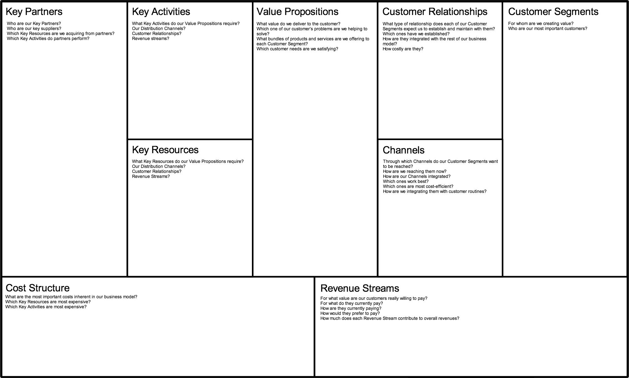

Source: www.businessmodelgeneration.com www.Cacoo.com Entrepreneurship Foundation
Payroll Taxes

Employer and Employee PAYROLL TAXES

Current as of 2019

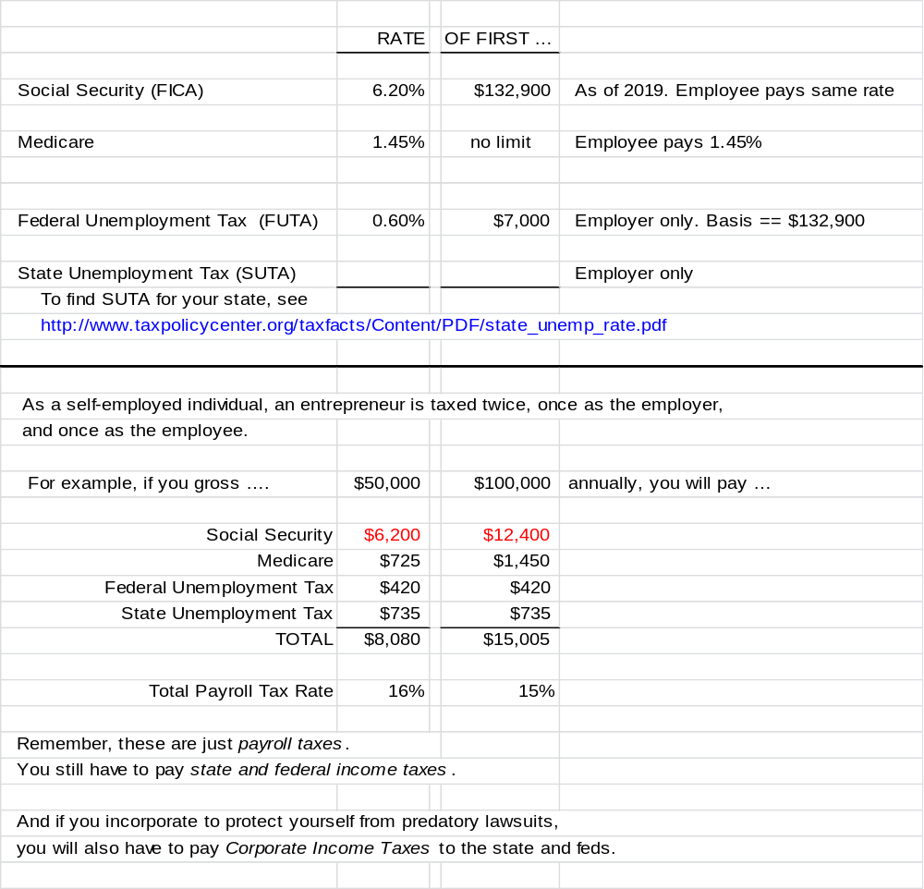
The State Unemployment Tax rate shown in this chart is based on Connecticut, the state with the highest rate in the continental U.S.

NDA

Non-Disclosure Agreement (NDA)

This form was downloaded from http://www.docracy.com/27/generic-shortform-nda.

Non-Disclosure Agreement (NDA)

THIS AGREEMENT is made and entered into as [DATE] (“Effective Date”), by and between [DISCLOSING PARTY NAME], (“the Disclosing Party”) and [RECIPIENT NAME], (“the Recipient”) (collectively, “the Parties”).
Purpose for Disclosure (“Business Purpose”): [GIVE SOME THOUGHT TO DESCRIBING THE BUSINESS PURPOSE SO THAT IT IS NOT OVERLY BROAD OR NEBULOUS]
The Parties hereby agree as follows:
1. For purposes of this Agreement, "Confidential Information" shall mean any and all non-public information, including, without limitation, technical, developmental, marketing, sales, operating, performance, cost, know-how, business plans, business methods, and process information, disclosed to the Recipient. For convenience, the Disclosing Party may, but is not required to, mark written Confidential Information with the legend "Confidential" or an equivalent designation.
2. All Confidential Information disclosed to the Recipient will be used solely for the Business Purpose and for no other purpose whatsoever. The Recipient agrees to keep the Disclosing Party’s Confidential Information confidential and to protect the confidentiality of such Confidential Information with the same degree of care with which it protects the confidentiality of its own confidential information, but in no event with less than a reasonable degree of care. Recipient may disclose Confidential Information only to its employees, agents, consultants and contractors on a need-to-know basis, and only if such employees, agents, consultants and contractors have executed appropriate written agreements with Recipient sufficient to enable Recipient to enforce all the provisions of this Agreement. Recipient shall not make any copies of Disclosing Party’s Confidential Information except as needed for the Business Purpose. At the request of Disclosing Party, Recipient shall return to Disclosing Party all Confidential Information of Disclosing Party (including any copies thereof) or certify the destruction thereof.
3. All right title and interest in and to the Confidential Information shall remain with Disclosing Party or its licensors. Nothing in this Agreement is intended to grant any rights to Recipient under any patents, copyrights, trademarks, or trade secrets of Disclosing Party. ALL CONFIDENTIAL INFORMATION IS PROVIDED "AS IS". THE DISCLOSING PARTY MAKES NO WARRANTIES, EXPRESS, IMPLIED OR OTHERWISE, REGARDING NON-INFRINGEMENT OF THIRD PARTY RIGHTS OR ITS ACCURACY, COMPLETENESS OR PERFORMANCE.
4. The obligations and limitations set forth herein regarding Confidential Information shall not apply to information which is: (a) at any time in the public domain, other than by a breach on the part of the Recipient; or (b) at any time rightfully received from a third party which had the right to and transmits it to the Recipient without any obligation of confidentiality.

NDA
5. In the event that the Recipient shall breach this Agreement, or in the event that a breach appears to be imminent, the Disclosing Party shall be entitled to all legal and equitable remedies afforded it by law, and in addition may recover all reasonable costs and attorneys' fees incurred in seeking such remedies. If the Confidential Information is sought by any third party, including by way of subpoena or other court process, the Recipient shall inform the Disclosing Party of the request in sufficient time to permit the Disclosing Party to object to and, if necessary, seek court intervention to prevent the disclosure.
6. The validity, construction and enforceability of this Agreement shall be governed in all respects by the law of the [STATE]. This Agreement may not be amended except in writing signed by a duly authorized representative of the respective Parties. This Agreement shall control in the event of a conflict with any other agreement between the Parties with respect to the subject matter hereof.
IN WITNESS WHEREOF, the Parties have executed this Agreement as of the date first above written.

Signed:

_____________________________________ Date ________________
[Typed Name]

_____________________________________ ________________
(Date)
[Typed Name]

Self-Assessment

EntrepreneurSHIP aPTITUDE Self-Assessment

By: Ken Kollmeyer, Small Business Development Specialist, CT Small Business Development Center

INTRODUCTION:
It is a common practice for a budding entrepreneur to want to leap into the fray and to ‘get on’ with starting-up their business. They are excited about and anxious to make decisions about products, customers, markets, facility and a plethora of other relevant issues. After all, is this not the appropriate activity for a pre-venture or nascent entrepreneur? Yes, it is; however, perhaps an even more important question is in order and it needs to be answered with complete honesty even before seeking answers to the afore-mentioned decision points. That special question is, "Am I ‘cut out’ to start, own and operate a business?" The pre-venture or nascent entrepreneur needs to come to understand the personal skills, qualifications and motivators that she must have in order to have a fair chance at being successful. It is time to stand before the mirror and take a long look at the whole person you see.

Take Your Time-Think About What Being In Business Will Be Like. Starting up and sustaining a growing and profitable business will be no easy undertaking. Insufficient operating capital will be the primary reason for failure during year one. Beyond year one, numerous factors will come into play to sink businesses and they can all be lumped together under the banner labeled ‘management problem’. Briefly, the entrepreneurs were not ready and able to startup and/or operate a business. Don’t be a casualty asking that infamous question, ‘What could I have been thinking’? As you exit your place of business and lock the door behind you for the final time. So what proactive steps can you take?

Firstly, one needs to understand their reason(s) for taking the big leap. Some of the more common reasons given for starting a business include: having flexible hours; choosing where you will work; choosing what you will wear; being able to run the show; being able to fire a customer if inclined, being the business hero who can meet an unsatisfied market opportunity and making lots of money. While these motivators are all appropriate and real, having a solid chance for business success must go beyond one’s emotions and feelings. A decision to start a business must include a healthy dosage of realism and logical purpose. Have you looked at your business concept from all angles and under a microscope? Have you performed a ‘hands-on’ survey to test the viability of your marketplace potential? Have you articulated your personal rationale for why you are starting a business to your entrusted circle of family members and friends? Did you listen to their responses?

Secondly, the entrepreneur must conduct an introspection of what it is they like to do and what it is they do not like to do. In most situations, an individual will tend to deliver an overall higher quality of work when completing those tasks that are more closely aligned with their ‘likes’. Conversely, an individual will not tend to perform as well when dealing with tasks that are more closely aligned with their ‘dislikes’. It will be beneficial for prospective entrepreneurs to make a listing of their specific likes and dislikes. After creating this list, the individual should create another listing of all business related activities that will need to be completed on a week in week out basis in order to conduct business. Lastly, you should add a column for self-assessing your predisposition for and your proficiency for carrying out these specific tasks. Keep in mind that you may be very capable of performing a certain task but may find it extremely uninteresting, boring or difficult. Examples might include paying the bills, cleaning the shop or firing an employee. Since starting and running a business will necessitate that all business-related tasks be completed, you will need to figure out who will actually do the work. If your business is you and you will be doing everything, you will need to have some knowledge of all business areas and should also have a

Self-Assessment

solid background in most areas of the business‘s operations. When you have reached a point where you enjoy doing the work and are being compensated for it as well, consider yourself fortunate. While it will not be easy, an entrepreneur should always attempt to maximize their likes and minimize their dislikes.

Thirdly, look back in time and come to a realistic appraisal of where you have succeeded in both your personal and professional lives. Think about those projects that required demonstrated planning and management skills; they are key ingredients for business success. Community service projects, parties and events, home improvement projects, coaching little league sports and writing policy and procedure manuals are all fair game for consideration. How did you perform? If you fared well and positive results were achieved, then you most likely have some of the talents and skills required for running a successful business. It is probably very safe to add and that in all likelihood, your planning efforts did not materialize exactly as expected. Such is often the norm. You may have faced unforeseen issues that you had to adapt to modifying your plan along the way. Yes, you were managing. Your planning and managing skills may be very rudimentary indeed, but the good news is that they exist and they can be grown and refined.

Lastly, any pre-venture or nascent entrepreneur should dig down deep and try to determine how they will feel about the loss of 1) a steady income, 2) paid holidays and vacations, 3) regular working hours, 4) reduced family time, 5) peace of mind and 6) financial security. Some not too far-fetched scenarios for consideration might include: 1) it’s 2:00 am; your phone rings and it’s a representative of your alarm company advising you that a door alarm at your building has been activated. They ask you if you will be driving to the facility to meet the police. What will you do? Or, 2) you just opened a small boutique across from the regional mall and you have decided that you will open on the July 4th holiday and take advantage of the traffic that will be created by the colossal sale events being held at the regional mall. Sally, your lone employee has agreed to cover the day but has taken ill and contacts you during the early morning hours on the Holiday. You have committed to spending the day at the beach with your family; all family members have been looking forward to this day. What will you do? Will you open the shop and abandon your family plans or will you keep the shop closed? What if you had already purchased a newspaper ad indicating that you would be open for business?

Small Business-a Roller Coaster Ride: Starting and operating a small business can truly be a ‘double-edged sword’. There can be exhilarating highs and there can be harsh lows. Think about the following possibilities:
- You are the focal point and carry the prestige that owning a business can bring; you are the proverbial point at which the buck stops.
- You have independence and can come and go as you wish; you will need to accept 60-84 hour workweeks as a fact of entrepreneurial life and you cannot quit.
- Running a successful small business can be extremely gratifying and uplifting; if your business is underperforming and you are struggling to pay your bills, your ego may suffer.
- Attaining your dream of financial security can bring a lifestyle filled with many creature comforts; owning a business can result in fluctuating levels of income and the loss of your investment …You may even lose your home.
- Since your business is your dream, it is your ‘labor of love’; in some instances, however, the pressures and stresses of running a business may turn your avocation into drudgery.
- You set out to create a product and/or service that fill a void creating economic value and jobs for the community; however and for example, you must live with the ever-present risk of being responsible for some sort of accident, which can leave a negative impression on the community.
Self-Assessment

Insightful Questions: Therefore, it’s time to come to grips with whether or not you have what it takes to be a successful entrepreneur or business owner. Here are some insightful questions that should be answered before crossing the point of no return. They are:

 | PREPAREDNESS | YES = 5 | 4 | 3 | 2 | NO = 1
1 | Do I have the skills to start and operate a business?
2 | Do I have substantial experience in the type of business I want to start?
3 | What is motivating me to act and can these motivators be sustained?
4 | Do risk taking and I get along?
5 | Can I afford to lose the money I need to invest in the business?
6 | Have I allowed my family or significant others to voice their true feelings about this significant commitment of family time and finances?

Inventory Your Skills: Have you taken an inventory of your skills? Do you possess a reasonable level of proficiency across the various business disciplines (e.g. sales, marketing, finance, operations, etc.)?

- Basic math skills are unavoidable. You will need to be reasonably comfortable working with numbers (e.g. addition, subtraction, multiplication, division, ratios). Can you analyze revenue and expense figures in order to determine what products or services are profitable, and which are unprofitable? Can you determine what level of sales and profit increases might justify a 20% increase in advertising?
- People skills are indispensable. Running a business will require that you interact with other people nearly every hour of the day. If you are not engaged with people, you will probably not be as successful as you would be if you were interacting productively with business stakeholders. After all, your customers, employees, suppliers, lenders and advisors are people.
- Solid written and verbal communication skills are critically important to your success. Observe almost any ‘help wanted’ classified advertisement. How many positions of leadership do not require ‘strong written and verbal’ communication skills? Not many!
- A solid grounding in technology is also a logical prerequisite for a successful small business journey. Technology must be viewed as a tool that can help to market your business, sell your product or service and help your business to operate more efficiently keeping your costs structure as lean as possible. You must embrace technology, become comfortable with it and strive to make it work for your business. Do not fear it; it is your friend. It is a means to an end rather than an end unto itself.
- While not a specific skill set, possessing an ongoing ‘Passion to Learn’ will serve you well. You may ask, what is a ‘Passion to Learn’? Well, it is an incessant drive that causes you to look at all facets of your business searching for an understanding of why it is working or not working. This quality tends to be within the makeup of most successful individuals.

Self-Assessment

- Lastly, are you grounded in reality? Can you be honest and face your strengths and weaknesses? We all have our pluses and our minuses; you are most likely not an exception to the rule. Therefore, understanding what you can do well and what you cannot do so well will serve you well as you move forward and decide upon what tasks you will tackle and what tasks you should not tackle without assistance.
- It is recommended that you compare your skill set proficiency against these requirements and should you arrive at the conclusion that you are indeed deficient in one or more competencies, do not despair. Help is available. Individual and multiple session seminars, workshops, and courses are available through the Small Business Development Centers in partnership with local Community Colleges and Adult Education Programs across the state. While classroom sessions are the norm, online learning opportunities are also becoming more and more commonplace and convenient.

Why Criticism Will Be of Value:
- Most of us will claim that we are open to criticism, but most of us will also develop a knot within our stomach as quickly as the first critical word falls upon our ears. Successful entrepreneurs and business people understand that their primary role is one of meeting a market need more effectively than their competition. Consumers are indeed fickle and their tastes are ever changing; perfection can be a ‘fool’s mission. Therefore, a primary goal for any entrepreneur or businessperson will be to ‘continuously improve’ their product and service. Constructive criticism is a valuable ingredient to the ‘continuous improvement’ process and this practice can help you to reach your goals. How would you respond to the following questions?

 | SELF-CRITIQUING SKILLS | YES = 5 | 4 | 3 | 2 | NO = 1
7 | Do I seek advice and feedback?
8 | Do I listen to my critics?
9 | Do I take the criticism to heart?
10 | Do I apply what I learn?

Having the ability to answer yes to all of the above questions is a state of being we should all aspire to reach.

Being a Student of Your Business:
Within an earlier section of this chapter, I stated that successful entrepreneurs and small business owners will usually exhibit a ‘Passion to Learn’. Directly related to this concept is the need for the entrepreneur and small business owner to know every ‘facet’ of their business and to know it inside and outside, upward and downward. Will an accountant be helpful? Yes, unless you are an educated and experienced accountant, retaining one with experience in your business and industry will be a very important decision for you to make. After all, accounting is the ‘language of business’. You will need to understand where your business has been and you will need to chart a course for where you will take it going forward. The financial and operating numbers will enable you to understand where you have been and to articulate your path into the future.

Self-Assessment

Furthermore, make it your business to learn every ‘nook and cranny’ of your business. For example, do you know the answers to the following business -related questions?
- What are my busiest days, weeks, months?
- What percent of revenues is my cost of goods sold?
- During what months will my cash flow be stressed?
- What are my service challenges?
- What forms of advertising are most effective for my business?
- Etc.?

The Family’s Role:
Now let us bring your family into the mix. Have you shared your dream and your plans with your family members? If you have done so, congratulations are in order. However, did you also talk about the ‘downside risk’ as well as the ‘upside benefits’? If you have not, then you have not communicated the whole story to them. In addition, don’t they deserve to learn everything about your business dream? After all, their lifestyle, as they know it today, might change in the not too distant future. Your family time together will most likely be diminished. Will your children and spouse need to pitch in during the evening or on weekends? Have they bought into this arrangement? The stresses related to starting a business can also take its toll on the family unit. If not all members are on the same page, the family unit can break apart.

Common Characteristics of Successful Entrepreneurs and Owners:
Successful entrepreneurs and small business owners just do not happen. While some luck is always a welcomed ingredient, the primary reasons for success can generally be traced to a series of characteristics that are possessed by or developed by the entrepreneur or small business owner. Here are the important characteristics:

Experience
Do you have general business, specific business and specific industry experience? Are you a seasoned decision-maker? You may be a very bright person; however, common errors of omission and commission can be fatal to a startup business. Learning from mistakes is not necessarily wrong, however, the pre-venture entrepreneur should try to learn on someone else’s wallet if possible.

Therefore, take the necessary time to learn as much as you can about your business. If you have never performed your intended business’s work, take a job(s) that will provide you with the necessary insights and feel for its unique rhythm and challenges. For example, if you have no relative experience, whatsoever, but seek to own and operate a sporting goods store, do yourself a favor and get the necessary experience working for an established company before charging forward. On the other hand, if you have worked in the retail industry but have a shoe store background rather than a sporting goods background, it is plausible to pick up pointers by talking with other sporting goods retailers. Following the principle that people will generally try to help out other people in need, there is a very good chance that you can learn enough from these conversations and may move forward with your endeavor.

Self-Assessment

Personality. Personality is a component of the ‘art form’ of management. In many respects, it is part of your DNA. Please answer these questions honestly:

 | IS THIS REALLY WHAT I WANT | YES = 5 | 4 | 3 | 2 | NO = 1
11 | Do I like to sell?
12 | Can I persevere and stay focused?
13 | Can I interact effectively with others?
14 | Can I inspire and motivate others?
15 | Am I an effective listener?
16 | Am I competitive?
17 | Am I a self-starter?
18 | Am I comfortable with ambiguity?

If you were not able to answer yes to the vast majority of these questions, you probably will find the road to entrepreneurship or small business ownership success to be very bumpy and possibly distressful.

Managerial Ability. In the business world, achieving positive results through other people is an ever-present challenge. You will not be able to do everything that must be done; you will go to your grave trying. Furthermore, you will need to be incessantly planning, organizing, implementing and monitoring your ideas and your business results on a daily basis. Are you skilled and able to do the following?

 | MANAGERIAL ABILITY | YES = 5 | 4 | 3 | 2 | NO = 1
19 | Manage people?
20 | Deliver results?
21 | Maintain a tight control over the money?
22 | Keep accurate records?
23 | Understand the dynamic relationships between resources, assets and financial results?

Wearing Many Hats. You will most likely be doing the vast majority of the jobs when you start up your company. Listed below are many of these functions. Take a ‘self-inventory’. Are you knowledgeable about these business functions and do you have the skills to perform them? Know your strengths; know your weaknesses.

Hats to wear: be prepared to act as general manager; marketing manager; advertising manager; copywriter; graphic artist; production manager; website developer; mailing list manager; bulk mail expert; order fulfillment clerk; shipping clerk; materials manager; administrative assistant; customer relations

Self-Assessment

representative; order taker; file clerk; bookkeeper; accountant; computer expert; personnel specialist; benefits administrator; etc.

While larger companies will typically have at least one person for each of these jobs, it would be virtually unrealistic for you to know the ins and outs of each position. However, recognize that many of them will need to be performed in a proficient manner in order for your company to attain success. How will you ensure that this happens?

For example, let us say that you are going to be opening a restaurant business and have worked in this business for several years but mostly performing and supervising tasks related to the delivering top-flight culinary service in dining room. You understand what happens in the kitchen, but have never had to perform job duties related to inventory control. Short of having a knowledgeable partner or a highly trusted and knowledgeable employee in place to watch over this situation, it will be incumbent upon you to do so. Therefore, if an employee of yours will be handling the inventory control duties and your role will be to supervise the process, how will you be certain that the inventory is indeed being accounted for properly and is not falling into the ‘black hole’ and becoming ‘shrinkage’? Without the proper inventory management practices in place, a significant portion of your startup money can be stolen before you even open the doors. How will your organization ensure that this situation will never arise?

Once again, should you not possess this necessary skill set, do not despair. Bricks and mortar and online seminars, workshops and courses are available through the Small Business Development Centers in partnership with local Chambers of Commerce, libraries, Adult Education Programs and Community Colleges across the state.

Vision. Our world is ever changing and the pace at which change occurs continues to accelerate. Keeping up with customer preferences and the markets is at best a daunting necessity. If your business is not changing, it is probably dying. What new concept has your competition just rolled out? What will be the next market ‘breakthrough’? Will your business be a leader, a follower or a laggard? Therefore, can and will you be able to identify and react to changes in the marketplace in a timely manner?

 | VISION | YES = 5 | 4 | 3 | 2 | NO = 1
24 | Be able to know an opportunity when you see one?
25 | Be able to identify and react to changes in the marketplace in a timely manner?

Courage. Starting and running a business will require that you deal with business issues ‘front and center’. Procrastination will usually translate into costs and will reduce profit. Therefore, can and will you:
 | COURAGE | YES = 5 | 4 | 3 | 2 | NO = 1
26 | Deal with adversity ‘head on’?
27 | Make bold and difficult business decisions in a timely fashion?
28 | Not become easily discouraged or intimidated?

Self-Assessment

IN CONCLUSION: Beginning your own business is indeed a very serious matter. The preceding thoughts and information are meant to provide a ‘reality check’ and ‘food for thought’ for all would be entrepreneurs and business owners. In many instances, deciding not to take this plunge will be the correct decision. Entrepreneurship and business ownership is not for everyone. Eight of ten businesses will fail within the initial five years of operation. Finding out the hard way can lead to the loss of your home, financial security, health and even your family.

However, let us not lose sight of the fact that many storied entrepreneurs have indeed forged ahead starting and owning small businesses that have grown into very significant companies. It can be done. Examples include Intel; Jet Blue, Subway Restaurants, Microsoft, and Walmart to name but a few. All started with an entrepreneur’s dream and that dream was nurtured with hard work, capital and more ideas, dreams, passion and capital. Their evolution continues.

The key is to be informed and to be true to yourself; then, make the big decision.

Index

Index
TERMS IN CAPS INDICATE SECTION TITLES

Advertising and Promotion, 105
ADWORDS, 112
Angel Investor, 168, 194, 214
BANKING, 187
Barriers to Entry, 29
Benefit Corporation, 137
Brochure, 111
Budget, 65
BUSINESS PLAN COMPETITIONS, 160, 215
C Corporation, 137, 141
Calculating Amount to Charge Clients per Hour, 67
CAP TABLE, 172
CAPITAL, 12, 171
Capital Providers in Connecticut, 214
Color Palette, 90
Competitive Positioning, 22
Contract Manufacturers, 121
Copyright, 135
Crowdfunding, 161
Customer Survey, 36
Debt Capital, 166
Department of Community and Economic Development, 215
DOMAIN NAME, 97
E-commerce, 103
Email Account, 94
Email Marketing, 116, 117, 118, 119
Entrepreneur Self-Assessment, 196, 206
Equity Capital, 166
Exit Strategy, 173, 181
Facebook, 114
FAX SERVICE, 93
FEIN Number, 147
FINANCIAL FORECAST, 181
Flyer, 111
Freight and Handling, 62
Fulfillment, 126
Funding Plan, 181
FUNDING PLAN, 171
Glossary, 187, 193
Grants, 160, 215
Graphic Standards, 95
Hosting, 97
Importing, 123
Initial Public Offering, 173
INSURANCE, 52
Intellectual Property, 120, 128
L.L.C., 140
L.L.P., 140
Landing Page, 38
Lease Versus Buy, 159
Leveraged Buy-Out, 173
Limited Liability Company, 140
Limited Liability Partnership, 140
Limited Partnership, 140
Loan Application, 174
LOCATION, 56, 57
Logo, 88
Management Team, 75, 76, 80, 180
Market Niche, 22, 26, 27, 28, 32, 200
Marketing And Sales Strategy, 105
Minimum Viable Product, 42
N.A.I.C.S. CODE, 146, 147
Naming The Company, 84
Net Promoter Score, 50
Non-Disclosure Agreement (NDA), 11, 196, 204
Nonprofit Corporation, 142, 143
Packaging, 63
PATENT, 16, 131
Payment Terms, 106
PAYROLL TAXES, 203
Personal Budget, 70
PHONE, 93
Pitching Investors, 174
PIVOT, 40
Poster, 104, 108
Printing, 110
Private Equity, 173
Rapid Prototyping, 41, 45
Small Business Administration, 166, 215
Small Business Innovation Research (SBIR), 160, 215
Social Media Marketing, 114
Social Security, 66, 137
Sole Proprietorship, 139
Sources of Capital, 158, 159, 160
Space, 56, 57
SPACE, 162
Subchapter “S” Corporation, 142, 143
Supply Chain Management, 120
Tag Line, 89
TEAM FORMATION, 34
Trade Secrets, 135
Trademark Filing Fees, 130
Trademark Protection Overseas, 130
Trademarks, 129
VALUATION, 169
Value Proposition, 32, 200
Web Hosting, 98, 99
Website, 96
WEBSITE EVALUATION, 100
White Labeler, 121

Cantillon, Richard (1755). Essai sur la nature du commerce en général. London: MacMillan. (The first reference to “Entrepreneurship”)
Shane, Scott Andrew (2000). A General Theory of Entrepreneurship: The Individual-opportunity Nexus. Edward Elgar Publishing.
Nathan Furr, Forbes, February 2, 2012, “Practical Insights on the Management Science of Entrepreneurship”
The Startup Checklist, David Rose, p. 33
The Lean Startup, Crown Publishing Group, 2011
http://www.forentrepreneurs.com/lessons-learnt-viral-marketing/
Since this paragraph was written, in 2018, Austin Russell became the youngest new billionaire in 2020 at age 25, His startup,Luminar Technologies is focused on technology for autonomous vehicles. entrepreneur.com/article/361130
Kouzes and Posner, The Leadership Challenge, 5th Ed., p. 172.
The 'Onliness Statement' was originally developed by Marty Neumeier in his brand strategy book, Zag
Michael Porter, Competitive Strategy, 1980, p. 35.
https://unbounce.com/landing-page-articles
https://www.optimizely.com/optimization-glossary/ab-testing/
Joshua Porter, https://blog.hubspot.com/blog/tabid/6307/bid/20566/the-button-color-a-b-test-red-beats-green.aspx July 2017
The Lean Startup, Crown Publishing Group, 2011
https://www.satmetrix.com/wp-content/uploads/2019/04/2019-Benchmarks.pdf
www.washingtonexaminer.com, Joseph Lawler. June 13, 2018
Chart based on analysis of 1000 term sheets and “Four Key Insights From Analyzing 5,000+ Cap Tables” by Jeron Paul, Dec 13, 2016.
Entrepreneur.com/article/21774
https://www.entrepreneur.com/article/21774
Jason Feifer (May 2018). “Did You Pick the Right Name?” Entrepreneur.com (print), p. 28.
Jason Calacanis. http://blog.launch.co/blog/how-to-name-your-startup-and-land-the-perfect-domain.html)
www.quantcast.com/top-sites-1
www.MyAffordableMarketing.com
https://sensortower.com/blog/tiktok-downloads-2-billion 4/29/2020
https://www.statista.com/statistics/274564/monthly-active-twitter-users-in-the-united-states/
http://localvox.com/resources/small-business-marketing-statistics/
http://succeedinginyourbusiness.com/
Source: Google
Source: Google
A full page ad in the Wall Street Journal is $250,000; but a quarter-page ad in the New York edition is only $15,000, and a quarter page in the Bozeman (MT) Daily Chronicle $700.
https://www.cpcstrategy.com/blog/2019/05/how-much-do-influencers-charge/ May 23, 2019
https://ignitevisibility.com/much-social-media-influencer-marketing-cost/
Based on various sources, including https://www.digitalmarketing.org/blog/how-much-does-influencer-marketing-cost and https://www.cpcstrategy.com/blog/2019/05/how-much-do-influencers-charge/
https://www.upcounsel.com/contract-manufacturer
https://www.investopedia.com/terms/i/incoterms.asp Reviewed by Troy Segal Apr 18, 2019
A 3PL (third-party logistics) provider may also offer procurement, shipping, storage and fulfillment services
https://www.entrepreneur.com/article/288063
https://www.justia.com/intellectual-property/trademarks/unregistered-trademarks/
www.USPTO.gov

