Launching a New Venture

Ninth Edition

Module 3
Entrepreneurial Finance
Production and Distribution, HR, Space Requirements, Risk, Budgeting, Accounting, Buying a business, Banking, Raising Growth Capital, Pitching business plans

Entrepreneurship Foundation, Inc.

Launching a New Venture
Edition 9.0

Module 3 – Entrepreneurial Finance

ISBN-13: 979-8-9998903-0-6

ALL MODULES IN THE SERIES

Module 1 - Entrepreneurship
Startup Checklist, Business Modeling, Problem-Solution Fit, MVP, Product-Market Fit, Competition, Lean BMC, Pricing, Landing Page, Company Name, Protecting IP, Legal Structure, Regulatory Matters, Raising Startup Capital

Module 2 – Small Business Marketing
Branding, Website, the Message, Collateral Material, Traditional Mass Media, Digital Mass Media, Targeted Media, Direct sales

Module 3 – Entrepreneurial Finance
Production and Distribution, HR, Space Requirements, Risk Management, Budgeting, Accounting, Buying a business, Banking, Raising Growth Capital, Pitching business plans

Module 4 - Business Planning
Content, Style

Editor@EntrepreneurshipFoundation.org
© Academy Publishing, 2012, 2014, 2016, 2020, 2023, 2024, 2025 All rights reserved.
DISCLAIMER: The contents of this work are for general informational purposes only and do not constitute legal advice. You should not act or refrain from acting on the basis of any content without seeking professional legal advice. This site contains links to other web sites. We are not responsible for the privacy practices or the content of such web sites, and we do not endorse such sites.
Table of Contents

3.1 – Production, Importing and Distribution 5
3.1.1 Production 6
3.1.2 IMPORTING 7
3.1.3 Distribution (Delivering Orders) 9
3.2 – Human Resources 10
3.2.1 BUILDING THE Management Team 11
3.2.2 Assessing skill needs 12
3.2.3 Your Management Team 13
3.2.4 hiring 14
3.2.5 Payroll REPORTING REQUIREMENTS 15
3.2.6 Incentivizing THE MANAGEMENT TEAM 16
3.2.7 Team Collaboration 17
3.2.8 ADVISORY COMMITTEE (Non-paid Members of the Team) 18
3.2.9 Selecting an Attorney 19
3.3 – Space 20
3.3.1 Sourcing Physical Locations 21
3.3.2 Comparing Locations 22
3.4 – Risk Management 23
3.4.1 RISK ANALYSIS 24
3.4.2 RISK MITIGATION 26
3.4.3 Business Insurance 27
3.5 – Budgeting and Accounting 30
3.5.1 Credit and Collections Policies 31
3.5.2 swot analysis 33
3.5.3 Personal INCOME AND Expense Budget 35
3.5.4 PAYROLL TAXES 36
3.5.5 BUSINESS BUDGETING 37
3.5.6 Cash Flow Forecasting 41
3.5.7 Break-Even and PROFIT MARGIN Calculation 42
3.5.8 cAPTIAL REQUIRMENTS FOR LAUNCH 43
3.5.9 Accounting 44
3.6 - Buying a Business or Franchise 45
3.6.1 Buying an Existing Business 46
3.6.2 Buying a FRANCHISE 48
3.7 - Banking 50
3.7.1 Selecting a Bank 51
3.7.2 Opening A Bank Account 53
3.7.3 Ordering Checks and Banking Supplies 54
3.8 – Raising Growth Capital 56
3.8.1 DETERMINING GROWTH CAPITAL REQUIREMENTS 57
3.8.2 Internal Sources of Growth Capital 58
3.8.3 TYPES OF EXTERNAL GROWTH CAPITAL 59
3.8.4 DEBT CAPITAL 60
3.8.5 EQUITY CAPITAL 61
3.8.6 OWNERSHIP RETENTION WHEN RAISING EQUITY CAPITAL 62
3.8.7 VALUATION (ESTIMATING THE FUTURE VALUE OF A VENTURE) 63
3.8.8 VALUATION (ESTIMATING PRESENT VALUE OF A VENTURE) 64
3.8.9 THE TERM SHEET 66
3.8.10 EQUITY CAPITALIZATION SCHEDULE (CAP TABLE) 67
3.8.11 EXIT STRATEGY 68
3.9 – Pitching Business Plans to Competition Judges and Capital Providers 69
3.9.1 Oral Presentations 70
3.9.2 Content of Presentation OR Written EXECUTIVE SUMMARY 72
3.9.3 Questions You Should Be Prepared to Answer 75
3.9.4 Style: DELIVERING Convincing Presentations 77
3.9.5 The Slides 78
3.9.6 HOW CAPITAL PROVIDERS EVALUATE PROPOSALS 79
Module 3 - Finance Checklist

FINANCE CHECKLIST

Click on a topic to go to that secion in the book.

Determine the resources you will need for your business (Production resources, Human resources, and Space requirements); research the costs of those resources; and then prepare budgets for launching and operating the business.

DETERMINE RESOURCES
- □ Production and Distribution Resources
- □ Determine HR Needs
- □ Determine Space Needs
FINANCE
- □ Assess Risks and Draft Mitigation Plan
- □ Determine Insurance Needs and Budget
- □ Conduct SWOT Analysis
- □ Prepare Personal Budget to Determine How Much the Business Needs to Earn
- □ Prepare Business Budget
- □ Prepare Cash Flow Forecast
- □ Calculate Break-Even Point and Profit Margin
- □ Select a Bank

Module 3 - Finance Chapter 1 – Production and Distribution

3.1 – Production, Importing
and Distribution

3.1.1 Production

3.1.2 Importing

3.1.3 Distribution (Delivering Orders)

Module 3 - Finance Chapter 1 – Production and Distribution

Once you have a market-tested business concept you will need a strategy to produce and distribute in quantity. This is relatively easy for a service business (although the management may become quite challenging once you grow to the point where you personally cannot serve every customer). Virtual products, such as mobile apps, music and digital images are also easy to distribute via a website, iTunes and the Google Store. However, a physical product requires a bit more research and planning to manage the Supply Chain: the movement and storage of components and finished goods from points of origin to points of consumption.

The goal of Supply Chain Management is to minimize inventory, while maintaining adequate supplies to keep retailers supplied and online consumers satisfied with delivery speed. A successful strategy will include answers to the following:

- Will the product be sold online and shipped direct to the consumer?
- Will you also distribute through retail establishments?
- Who will produce the product? (Will you do the manufacturing or job it out?)
- Where will you store the finished goods until delivered?
- Who will pick, pack and ship the orders?

3.1.1 Production

If you want to conserve capital and keep your overhead costs at an absolute minimum, you may want to outsource the manufacturing process. Fortunately, there are companies that specialize in manufacturing goods for other businesses. These providers are called Contract Manufacturers, Private Labelers, White Labelers, or Contract Packagers (AKA Copackers). These terms are sometimes used interchangeably, so verify with your supplier in writing exactly what services will be provided.

- CONTRACT MANUFACTURERS produce custom products (e.g., electronic products, auto parts, kitchen aids) according to your specifications. You retain ownership of designs and patents (make sure this is confirmed in your contract), but you are responsible for the cost of all tooling and dies required.
Note, contract manufacturers typically do not want to store your finished goods and will want to send them all to your warehouse or distributor as soon as completed.
- WHITE LABELERS (AKA PRIVATE LABELERS) are makers of generic products like corn flakes, shampoo, and men’s suits. You are usually restricted to their designs and formulations, but do not have to pay for custom dies or raw materials purchased for a specific formulation. Moreover, the turn-around time is much quicker than a fully custom product. The finished goods will still display your label. Store branding is usually referred to as private labeling although the term means the same as white labeling.
- CONTRACT PACKAGERS (COPACKERS) manufacture food, beverages and supplement products. Copackers will generally mix and prepare ingredients to your specifications, plus package and label products. For advice from entrepreneurs using copackers view www.youtube.com/watch?v=erjLVRQiMwI.

Outsourcing Manufacturing
ADVANTAGES | DISADVANTAGES
No need for manufacturing space and equipment | Less control over quality
No need for employees with manufacturing expertise | Lack of legal protections if outsourced overseas
You can focus your attention on marketing | Theft of intellectual property. (The manufacturer will know how much demand there is for your idea.)
Overall costs may be lower due to volume efficiency of the contract manufacturer

How to Find Contract Manufacturers. Contract manufacturers and private label firms abound. Search for your product category in this free database: www.ThomasNet.com

What to Look for in a Contract Manufacturer
- ISO Certification
- Direct delivery to wholesalers and retailers
- Good reputation in market. (Ask the contractor for the names of other companies they produce for and call those CEOs. They will be willing to share their experiences with a fellow entrepreneur.)
- Clean manufacturing and storage facilities (Do not take their word for it. Visit)
Protecting intellectual property. To prevent a manufacturer from selling a similar product, make sure the contract includes provisions for recourse and remedies if this occurs. Ask a lawyer to look over the contract before signing.

For more information on outsourcing see https://www.ecommerceceo.com/private-label-manufacturers/#how-to-find-private-label-manufacturers

Module 3 - Finance Chapter 1 – Production and Distribution

3.1.2 IMPORTING


You may find less expensive goods outside the U.S., but the import duties and freight costs could make it more attractive to buy locally. Delivery time is also longer from overseas. And you may wind up buying more than you need in order to bring down the freight cost per product. When starting out it is wise to order small batches until you have adequate feedback from buyers.

INCOTERMS. To reduce misunderstandings between buyers and sellers, the International Chamber of Commerce has published a set of commercial terms for use in purchase agreements. Importers and exporters worldwide use these definitions to spell out who is responsible for shipping, insurance, and tariffs. Examples include:

- DAP (Delivered-at-place) indicates the seller agrees to pay all costs and suffer any losses of goods in moving them to the agreed-upon place.
- DPU: (Delivered at Place Unloaded) indicates that the seller delivers the goods to a terminal and assumes all the risk and transportation costs until the goods have arrived and been unloaded. After that, the buyer assumes the risk and transportation costs from the terminal to destination.
- FOB (Free on Board). If the goods are sold “FOB factory” or “FOB [shipping point]”, the buyer assumes all freight costs and liability for goods from that point on. If “FOB [destination point]", then the shipper accepts the costs and responsibility until the goods arrive at the stated destination. Note: “destination” does not necessarily mean inside your warehouse. It may mean the port of entry, or the dock. Read the fine print.

For more information and additional terms see https://cyprusgloballogistics.com/incoterms/

FREIGHT FORWARDERS. If you are new to importing, you might want to employ a Freight Forwarder: an experienced professional who knows how to get your products through customs.

A freight forwarder (or forwarding agent) organizes shipments to get goods from the manufacturer or producer to the customer or final point of distribution. A freight forwarder does not actually move the freight but rather acts as an intermediary between the seller and various transportation services such as cargo ships or airfreight.

In selecting a forwarding agent, find one that is familiar with …
- YOUR INDUSTRY (an agent that specializes in importing coffee from Brazil may not be the best person to help you import plastic housings from Canada).
- COUNTRY from which you are importing.
THE RIGHT BANK. Arrange for payment to the exporter though a financial institution that understands Letters of Credit (LOCs), currency exchange rates, and wire transfers. Most major banks have departments that specialize in international transactions. You should be safe with an international bank like Bank of America, CitiGroup, HSBC, J.P. Morgan Chase, or Silicon Valley Bank (SVP). Find the closest branch with an import-export specialist, so you can meet personally with the representative. The banker may recommend a freight forwarder and offer advice on shipment insurance. Having a nearby branch will also speed up paperwork.

CARGO INSURANCE. The point at which you take possession of goods (become responsible for losses) will inform your decision to insure them during passage. The cost of the insurance usually runs about 1 percent of the insured value, although this varies with the type of goods and method of shipping.

Module 3 - Finance Chapter 1 – Production and Distribution

Import Duties. Depending on the context, import duties may be known as customs duties, tariffs, import tariffs, or import taxes. Tariffs differ depending on the exporting countries' trade relations with the U.S. To look up the import tariff rates for components and raw materials, search for the item in the database of the Harmonized Tariff Schedule of the of the U.S. International Trade Commission at https://hts.usitc.gov/. Write down the full 10-digit HTS number, as you will need this for your import documents.
As an example, a student wanted to import “Hair Extensions”. Searching for this term produced no results. However, searching for “Human Hair” returned HTS 6703.00.30.00 “Human hair…for use in making wigs or the like.” Bingo. The rate is “free”, that is, no duty on imports. The lesson is that you may have to start with a general category and then drill down to terms that are more precise.

Here is a second example. Say you are producing a product that includes a small electric motor and want to know what the import duties would be if you purchased this component overseas. Searching under Electric Motors returned all results with the word Electric or Motor (electric fans, motor oil, and a thousand more we did not want.) However, searching for “Electric Motors” in quotes took us right to what we were looking for. (See screen shot below.)

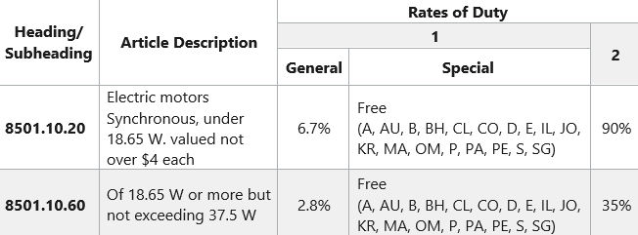

The HTS number for a small motor is 8501.10.20.00. The tarrif will be 6.7% of the purchase price (according to the Column 1-General under “Rates of Duty”; unless you purchase the goods from a country with which the U.S. has a trading agreement, in which case it is “free” (there is no tarrif). To find out which countries are included, scroll over the two-digit codes. Some of the codes refer to specific countries (e.g. - “AU” Australia) but other refer to trade agreements with multiple countries.

However, “A” is the Generalized System of Preferences (GSP) trade agreement with many developing countries. (For a list of the GSP countries, see https://ustr.gov/sites/default/files/gsp/countrieseligiblegsp.pdf) It would be time-consuming to check all the applicable treaties for the country you want to import from; so, for budgeting purposes, just ask the company providing the quote to indicate the import duties to the U.S., and for the name of the applicable trade agreement. But before you actually send the purchase order, check with a freight forwarder to verify the tariff rate. For a search guide see https://www.usitc.gov/documents/hts_external_guide.pdf.

Interestingly, there is a lower general tariff (only 2.8%) for an electric motor with a rating higher that 18.65 watts.

Note also there is a “Column 2” with much higher tariffis. This is the rate for countries with which the U.S. has no Normal Trade Relations. Currently, the countries with Column 2 status are Cuba, North Korea, Russia and Belarus.

Module 3 - Finance Chapter 1 – Production and Distribution

3.1.3 Distribution (Delivering Orders)

FULFILLMENT HOUSES (someone else does the warehousing, packing and shipping).

Fulfillment houses, also known as Drop-Shippers, accept finished goods from manufacturers into their warehouses, and then reship the products, whether in bulk to stores, or individually to consumers. The process is called Fulfillment or Drop Shipping.

If you want to outsource the functions of warehousing and shipping, search online for “fulfillment houses” or see https://fitsmallbusiness.com/best-fulfillment-warehouse
Typical Fulfillment Fees:
- One-time charge to set up account ($0 to $250)
- Account maintenance ($40 per month)
- Storage (about $15 to $40 per pallet per month).
- Order Pick and Pack ($1.80 to 2.85 per order + $.30 to .40 per item.). Some services charge a monthly minimum, which can amount to several hundred dollars per month.
- Acceptance of customer returns
- Gift wrapping for an additional fee
- Kitting (assembling a variety of items into a kit, such as a travel or tool kit)
As an example, FBA (Fulfillment by Amazon) fees are as of 2025 approximately $10 for a one-item order up to 8 ounces or $13 for a 1- or 2-pound item. The charge for each additional unit of the same weight is about half that. In addition, you will need to pay a monthly storage fee of $.78 a cubic foot. A carton of 9 basketballs would cost ~ $7 per month to store, and this rate triples during October-November-December. Takeaway: you will need a lot of monthly inventory turnover to be profitable. For details see https://supplychain.amazon.com/pricing

Most services offer discounts on shipping rates due to their overall large volume; but you will need margins of at least 60%, and perhaps 75-80%, even when selling direct to consumers, to cover the costs of the fulfillment center.
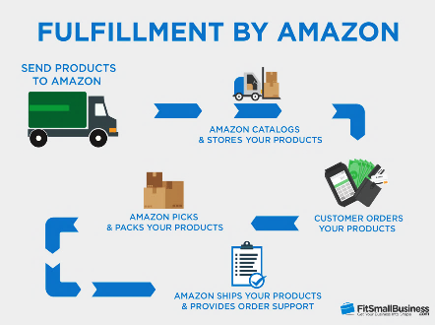

Typical fulfillment process
Module 3 - Finance Chapter 2 – Human Resources

3.2 – Human Resources

3.2.1 Building the Management Team

3.2.2 Assessing Skill Needs

3.2.3 Your Management Team

3.2.4 Hiring

3.2.5 Payroll Reporting Requirements

3.2.6 Incentivizing the Management Team

3.2.7 Team Collaboration

3.2.8 Advisory Committee

3.2.9 Selecting an Attorney

Module 3 - Finance Chapter 2 – Human Resources

3.2.1 BUILDING THE Management Team

When you are ready to build out your launch team, look for people with the same aspirations and ideals. Having to dissolve a business because you find that your styles and priorities are not compatible, can be just as messy—and as expensive—as a divorce. Fortunately, there are matching sites like https://www.cofounderslab.com/ to help you find compatible partners for your venture.

Of course, you can always choose to go it alone and keep all the proceeds and credit. However, the success rates of solopreneurs--who might be really great at one function, like programming or marketing--have not been as high as that of comprehensive management teams. Co-founders also provide motivation (no one wants to be the one to let the team down by not doing their share), reality checks (people to bounce ideas off just to make sure they’re not completely crazy; and moral support (people with whom to discuss concerns and share the agony of defeat and the thrill of doubling the number of monthly hits to your web site). When casting about for co-founders or early hires, try to find others who ..

- Are true entrepreneurs willing to take risks with careers and savings, not pretenders who really want a guaranteed weekly check and benefits. Partners with an “employee” mentality will bolt at the first setback.
- Are team players.
- Self-motivate, self-direct, and do not need to be told what to do every minute.
- Have similar working styles. Do you like to get up at 5:00 am, jog for an hour and then work from 6:00 am to 5:00 pm? You probably will never see your partners if they are ex-rockers accustomed to rising at noon or taking month-long vacations. Sorry, did we fail to mention that entrepreneurs work 70 hours a week and do not get vacations or sick days.
- Share a common vision and commitment. If you want to feed the world’s poor, and they want to make billions selling food to the poor, you will never agree.
- Are honest. If your new partner has ideas on how to hide income from the IRS, he will also steal from you the first chance he gets. Integrity is not a relative term.
- Have complementary skills. If everyone on the team is expert at coding, in a year you will have a warehouse full of great but unsold software. Assemble a well-rounded team that can cover all the bases.
To stay alert for telltale signs of bad partners, read https://www.entrepreneur.com/article/202434

Dynamic Duos  How many can you name? |  | 
Slide this label out of the way to reveal answers  Top left to lower right:  1 Steve Jobs/ Steve Wozniak  2 Orville Wright/ Wilbur Wright  3 Sergay Brin / Larry Page  4 David Packard/ Bill Hewlett |  | 
Module 3 - Finance Chapter 2 – Human Resources

3.2.2 Assessing skill needs

1. Skill categories needed for any business team to be successful
- project management

- industry experience
- technical
- market research
- marketing
- finance and accounting

2. Skills needed for my business

□ writing,

□ fluency in __________,

□ graphic design,

□ web design,

□ software or app development,

□ accounting,

□ marketing,

□ market research

□ other _______________________________________

□ other _______________________________________

□ other _______________________________________

□ other _______________________________________

3. Skills I can contribute

Module 3 - Finance Chapter 2 – Human Resources

3.2.3 Your Management Team

Note: not all functions have to be filled by employees or partners. Consider other resources, such as consultants, outsourcing, contract workers, subcontractors, or advisory committee members.

FUNCTION | PERSON | RELEVANT SKILLS, EXPERIENCE, and/or EDUCATION
General Management
(CEO)
Operations
(COO)
Technology and IT (CTO)
Marketing
(CMO)
Accounting and Finance
(CFO)

Module 3 - Finance Chapter 2 – Human Resources

3.2.4 hiring

When you arrive at the stage when you need to bring on staff to assist you in delivering value to your customers, bear in mind that this will trigger some reporting and payroll tax obligations.

The current (2025) federal minimum wage rate is $7.25 per hour. Check your state as their minimum wage rates will probably be higher

You will also need to purchase Workers Compensation Insurance.

HIRING BEST PRACTICES.

Online hiring platforms can cost as much as $350 for one listing, and with no guarantee you will find anyone that meets your requirements; same for local staffing agencies that charge a fee for their searches.

Fortunately, every state has a Department of Labor that serves as a free employment agency.

For assistance hiring veterans, see https://www.dol.gov/agencies/vets/veterans/veterans-employment-services#CT

Also contact your local schools. The going rate for high school students is the state minimum wage; for skilled college students add $1 per hour, for graduate students add $2 ($5 for in-demand tech skills like computer programming). There is usually no charge for the school to connect you with current students (for part-time or summer employment) and graduating students (for full-tome employment). One company that specializes in placing college interns and graduates is Handshake, and their “Basic” service is free. See https://joinhandshake.com/

Another direct but often overlooked avenue is to post notices on bulletin boards of local grocery stores and churches.

WORKER STATUS: Independent Contractor or Employee. The classification affects tax obligations, legal protections, and benefits.

 | INDEPENDENT CONTRACTOR | EMPLOYEE
AUTONOMY | Has control over how, when and where to work. | Works set hours and is supervised by a manager
FINANCIAL RELATIONSHIP | Responsible for own payroll taxes. Company issues a check for services without any payroll deductions. | Company issues a paycheck, typically weekly or bi-weekly; after payroll deductions (income tax withholdings and employee share of Social Security and Medicare).

For more information on status determination see https://www.irs.gov/businesses/small-businesses-self-employed/independent-contractor-self-employed-or-employee

Module 3 - Finance Chapter 2 – Human Resources

3.2.5 Payroll REPORTING REQUIREMENTS

ANNUAL FEDERAL REPORTING REQUIREMENTS AND FORMS

 | TO INDEPENDENT CONTRACTOR | TO EMPLOYEE
COMPANY REPORTING | For workers paid $600 or more a year, issue a 1099-NEC (Non-Employee Compensation) by end of January of the following year, with a copy to the IRS. The government also is due Form 1096 showing the total of all 1099s. Some states require a copy. Check with your Department of Revenue Services. | Issue a W-2 (Wage and Tax Statement) to each worker, due by January 31 of the following year.  Copies must be filed with the Social Security Administration.
FORMS WORKER PROVIDES TO EMPLOYER BEFORE STARTING WORK | W-9 (Request for Taxpayer ID Number (either an EIN if a business, or a Social Security Number). | W-4 (necessary for calculating the amount of income tax to withhold).  I-9 (to verify eligibility to work in U.S.)

1099 forms may be ordered free from https://apps.irs.gov/app/taxmat/information-employer-returns. If you have 10 or more 1099s, you will need to file electronically. To e-file you will need to apply for a Transmitter Control Code (TCC) – which can take 45 days so plan ahead. See https://www.irs.gov/filing/e-file-information-returns
W-2 Form. If you have fewer than 10 employees, you may file paper forms with the Social Security Administration. See https://www.ssa.gov/employer/paperFormInstr.htm For 10 or more employees, file electronically at www.ssa.gov/employer/bsohbnew.htm Plan ahead, as it takes time to obtain forms or open an e-filing account.
I-9 forms may be downloaded for free from https://www.uscis.gov/i-9

QUARTERLY FEDERAL REPORTING REQUIREMENTS AND FORMS (For Employees Only)
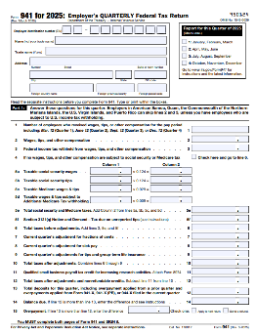
Federal Form 941. This is the first page of a 3-page form that must be submitted quarterly to the IRS by employers along with a check for the amount of payroll taxes you owe as an employer, plus the amount you have withheld from employee paychecks. Another 2-page document (Form 940), is filled annually. Most state Departments of Revenue Services also require a copy.

For a list of companies that process payroll and submit the correct state and federal forms, see “Payroll Processing”. The service will cost about $40 per month base fee plus $6 per employee.

If you have some accounting experience and want to save money, here’s a video that will guide you through the forms: https://www.youtube.com/watch?v=TeuJwEB7mjw&t=2s

Be advised, Uncle Sam will charge you up to 25% of the amount you should have paid, plus interest, if you make a mistake, or submit a form or payment late.

Module 3 - Finance Chapter 2 – Human Resources

3.2.6 Incentivizing THE MANAGEMENT TEAM

By default, original entrepreneurs start out with 100% of the ownership. However, if you have ambitious plans, you will probably need to give up shares to attract investors and key staff with the critical skills you need to compete and grow. (Co-founders and key employees must initially be willing to work long hours for little or no pay.)

Although the shares you offer as incentives to others may leave you with a shrinking percentage of ownership, the total value of your shares should increase as the company grows. So, how many shares should you set aside for members of the management team? For a formula to assign a value to the predicted contribution of each co-founder, see https://cofounders.gust.com. The following chart is an example of division of ownership.
STAGE OF COMPANY DEVELOPMENT | Founder | Co-Founders  Shares granted upon incorporation | Key employees  Shares Allocated for discounted stock-purchase options | Investors
Concept stage | 100%
Development and Testing stage (Proof of Concept Stage) | 80% | 20% *
Startup (Seed stage) | 40%  (=4/7 of non-investor shares) | 20%  (=2/7 of non-investor shares) | 10% **  (=1/7 of non-  investor shares) | 30% *** to friends, family and angels
Series A Financing Round (Early stage) | 29%  (=4/7 of non-investor shares) | 14%  (=2/7 of non-investor shares) | 7%  (=1/7 of non-  investor shares) | 50% after VC investment
Series B Financing Round (Growth stage) | 17%  (=4/7 of non-investor shares) | 9%  (=2/7 of non-investor shares) | 4%  (=1/7 of non-  investor shares) | 70%
* Co-founder shares should be vested (that is, earned gradually over time). For example, a co-founder might be allowed 4% ownership, but the shares would be earned at the rate of 1% per year over the next 4 years (a common length of time for vesting) if the co-founder has worked full time and satisfactorily. This prevents a co-founder—who might be long on promises but short on delivery— from running off with 5% of the company without making any real contribution.
** Assumes you will use a large portion of seed round to hire additional key employees, who will also need shares as
incentives to climb aboard a young company. The investors will no doubt insist that you set aside shares to attract and motivate the additional staff needed to grow the company.
*** Reduce initial share for investors to 20% if a high-tech, high-growth-potential enterprise.

>> Consult a lawyer, as this decision can negatively affect your ability to raise growth capital. <<

ALTERNATIVE INDUCEMENTS. Before offering shares of stock or options to key individuals, give some thought to alternative enticements to keep the ownership structure simple and reserve a greater number of shares to exchange with equity investors for growth capital. This is called “keeping your powder dry.”
  - Contingent Deferred Compensation. This is basically an IOU that is redeemable if and when the deferment the company achieves sales or cash-balance milestones. Future payouts should be greater than the perceived value of their work, in consideration of the fact that they will have to wait to be paid, and if the enterprise fails to thrive, perhaps they will not be paid at all.
  - Royalties. This is a way to pay someone a percentage of profits (as common stock does) without issuing any shares. Royalty obligations usually have a total dollar cap and expiration date. For example, in exchange for developing a mobile app, you contract to pay the developer a modest amount plus 20% of the sales for the first five years, or $50,000, whichever comes first.
Module 3 - Finance Chapter 2 – Human Resources

3.2.7 Team Collaboration

It can be challenging for teams to communicate and work collectively on a Business Model Canvas, product prototype, website, or other activity that requires participation from multiple members. Project Management tools can literally keep everyone on the same page, set priorities and goals, and let everyone know what is expected of them…with due dates. Following are some free online PM platforms:

Canvanizer.com Templates for both the Lean Canvas and the Osterwalder model. To go directly to the Lean Canvas see https://canvanizer.com/new/lean-canvas $25/ year for a team of 5 (as of 2025).

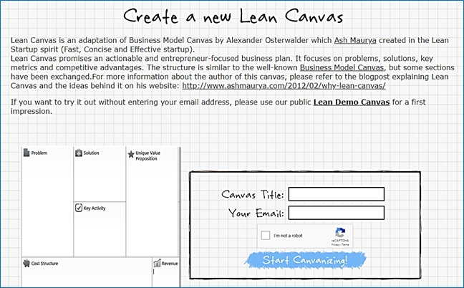

THE FOLLOWING ARE FREE PROJECT MANAGEMENT PLATFORMS, BUT THEY DO NOT OFFER A BUSINESS MODEL CANVAS TEMPLATE.

Zoho.com Free for up to 5 users. Assign tasks and deadlines to team members. This two-minute YouTube video explains how to use https://www.youtube.com/watch?v=NfZ3rwLxzNs.

Asana.com Designed to manage marketing campaigns. Free with up to 10 users..

Trello.com Uses digital 3x5 cards to help you and your team keep track of tasks. Free.

Module 3 - Finance Chapter 2 – Human Resources

3.2.8 ADVISORY COMMITTEE (Non-paid Members of the Team)

A group of volunteer advisors can bring valuable experience and contacts. Although most entrepreneurs like the idea of an advisory committee, few know how to form one (who to ask, what to ask of them, or how to recognize advisors for their services).
The difference between an advisory committee and a board of directors. A board of directors is a legal entity responsible and liable for decisions and actions of the company. If you have investors who own at least 10 per cent of the company, they may expect to be offered a seat on the board.
An advisory committee, on the other hand, is informal. Advisors have no legal authority and assume no liability. There are no set rules, such as how often they must meet.
If you are looking for outside funding, an advisory committee shows potential investors that you have consulted with experts to help you form strategies for the company and that you are taking advantage of free resources. The names of the committee members and their backgrounds should be an integral part of the management section of the business model or plan.
The right number of advisors: two to five. You do not have to ask everybody at once; you can add advisors as you progress, but you should have one or two to start.
How often should you meet? Perhaps never. If the committee is diverse and selected to give guidance in many different areas, one-on-one discussions may yield better results and in less time than meetings of the entire committee. One member might help shape marketing efforts, while others could introduce you to client prospects.
Be careful not to call on them too often. Advisors are not signing up for a job. Nevertheless, keep them informed with copies of e-mail announcements and invitations to company events.
Building a company can be lonely work. An advisory committee can be a great source of help and comfort. They can give you guidance, contacts, friendship as well as credibility with investors.

Module 3 - Finance Chapter 2 – Human Resources

3.2.9 Selecting an Attorney

Your business lawyer will be a critical member of your management team. In fact, be sure to list your attorney and accountant in the “Management Team” section of your pitch deck and eventual business plan. (Investors will expect you to have these key advisers to keep you and the investors out of trouble with the IRS and regulatory agencies.)

HOW TO FIND AN ATTORNEY. www.avvo.com and www.martindale.com provide free databases of user-rated attorneys that are searchable by “practice area” (legal specialty) and location (state, and in some cases, city). Your local (state, county or city) bar association will also host a directory of attorneys by practice area. Search for “bar association near me”. They will not recommend an attorney or provide any ratings.

HOW TO SELECT AN ATTORNEY.

- PROXIMITY. Start with the nearest firms. The closer they are the easier it will be to meet or sign papers.
- SPECIALTY within practice area. Naturally, you want a “corporate” “business” or “Small Business” attorney, but there are categories within these broad terms. What is most important to you? If you are an inventor, you probably want an “Intellectual Property” attorney. If you want to raise money from investors, you will want an attorney who specializes in “Venture Capital.” Common specialties within business law include:
  - General business law
  - Contracts (leases, purchase contracts, employment contracts, NDAs)
  - Intellectual property (patents, trademarks and copyrights)
  - Venture Capital (you are raising equity financing)
  - Mergers and Acquisitions, aka M&A (buying or selling a company)
  - Litigation (you are being sued)
  - Employment law (you have troublesome employees)

Note: you will not find all these skills in one lawyer, so focus on the one most important to your company. A large law firm is more expensive than a solo practitioner but may be able to provide all the services you will need.

Once you have compiled a short list of attorneys, do some due diligence:
- Check the website for “Events.” Is an attorney to speak at an event near you? This is a great way to meet them without any awkwardness. Some other clients will probably be there. Ask about their experience.
- Check the attorney’s bio. Do they have experience in your industry? You do not want an attorney who knows drug patenting if you are opening a restaurant, or vice versa.
- Find someone who can grow with you. Younger attorneys are less experienced, but less costly per hour.
Select the right attorney and schedule a face-to-face meeting to explore whether this will be a good fit. You will not be billed, but do not abuse the courtesy by taking up their time to gain as much free advice as possible. A half-hour introductory meeting is appropriate. Talk about your business and the help you think you will need:
- Lease?
- Employment contracts?
- Non-disclosure agreements?
- LLC formation? Incorporation?
- Patent searches? Provisional patent filings? Full patent filing?
- Trademark registration?
Ask for estimates of costs for each service.

HOLDING LEGAL EXPENSES TO A MINIMUM. Prepare a draft of legal documents for your attorney to review. This will save them time, and their time is your money. A first draft prepared by you will also give your attorney a clearer idea of your intentions and what you need. A variety of legal templates can be downloaded for free at https://law4startups.com.

Module 3 - Finance Chapter 3 – Space

3.3 – Space

3.3.1 Sourcing Physical Locations

3.2.3 Comparing Locations

Module 3 - Finance Chapter 3 – Space

3.3.1 Sourcing Physical Locations

You may have a virtual company, such as a software product, that you can run from your home, in which case skip this section and enter zero for space in your budget. If you have a dedicated room in your home for your business office, you can write off a pro-rata share (square footage of home office / total square footage of home) of the cost as a business expense on your personal taxes, up to the amount of business income. However, if you have a retail or manufacturing business, read on.

The best way to get a feel for a location is to talk to other businesses in the area. Visit the locale at a time your business will be open; notice the amount of parking, traffic congestion, and noise from other businesses.

TRAFFIC FLOW. Most state Departments of Transportation have traffic flow maps on their websites that show the number of cars that pass various points in each town on a daily basis.

INCUBATORS are multi-tenant facilities that offer small spaces, and short term leases of one year or less. Note: a “small” working space at some incubators is 100 s.f., at others 5000 s.f. A dedicated office or starter manufacturing space will run $600 to $1200 per month, gross (including utilities and taxes). Shop around.

Your best deal is a short-term lease of only a few months but with an option to renew for a longer period of time (so you can bail if the business fails, but lock in a favorable rate if it succeeds). You may also want to ask for a month-to-month lease, which means you can leave with only one month notice.

Another negotiating stratagem is to ask for a number of free months rent up front, especially if you will need to expend time and money to make the space suitable for your purpose.


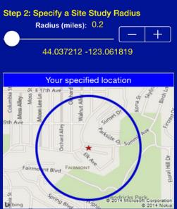
CO-WORKING OFFICE SPACES. These have lately become very popular. The rates are typically low, $100 to $250 per month including access to a conference room, coffee pot, printer and copier. However, the space may be at a table shared by others, or desk space on a first-come, first-served basis. Hence the term co-working.

MAKER SPACES. These are shared spaces for research and development, prototyping, and short production runs for customer (beta) testing. Most maker spaces have vinyl cutters, woodworking and metalworking equipment, soldering irons, and 3-D printers.

RETAIL/ RESTAURANT. Three things matter: traffic flow past the location, neighborhood demographics (income, housing, lifestyle), and parking. Your state department of transportation web site should have some data on traffic flow. For some urban locations and malls, auto traffic may not be as important as foot traffic.

For eateries located in a mall, there are some common lease clauses you may not expect, such as right to approve your menu, no handing out samples in the mall proper, and you can’t open another restaurant nearby (as this may take traffic from the mall).
www.EASIdemographics.com offers a free app [right] called Easi, that will provide demographics of surrounding area of different sites you may be considering.

Module 3 - Finance Chapter 3 – Space

3.3.2 Comparing Locations

A. Address____________________________________________ City ______________________

B. Address____________________________________________ City ______________________

C. Address____________________________________________ City ______________________

This is an interactive spreadsheet. To open, right-click on spreadsheet, click “Worksheet Object” and then "Open.” You need to enter data in shaded fields only; the totals will be computed for you. You can download a copy of this form at http://www.EntrepreneurshipFoundation.org/spreadsheets

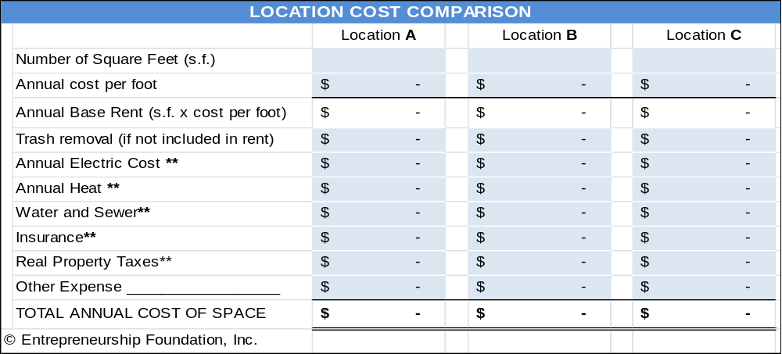

** If rent is advertised as gross, then utilities, real property taxes, and property insurance are covered by the property owner. If the rate is triple net (or nnn), then the tenant is responsible for these costs. The property owner should have prior utility bills. If costs are not available, estimate $2.00 per year per square foot for electric and gas, and $.50 for property taxes. (Note: in any case, you will need to purchase liability insurance to cover “slips and falls” in your space.)

Comparison of Other Factors | Location A | Location B | Location C
CITY OR STREET >>
Zoned to allow your type of business. (Check with town planning office.)
Free parking spaces for employees
Parking spaces for customers
Traffic Flow (Number of cars or foot traffic passing the location daily. Critical for retail.)
Signage (Can you put sign on building?)
Safety. Employees and customers will feel safe in the neighborhood.
Module 3 - Finance Chapter 4 – Risk Management

3.4 – Risk Management

3.4.1 Risk Analysis
3.4.2 Risk Mitigation
3.4.3 Business Insurance

Module 3 - Finance Chapter 4 – Risk Management

3.4.1 RISK ANALYSIS

Whereas a SWOT Analysis examines current situations you can correct or exploit now; a Risk Analysis identifies potential future challenges to your business model, the probability of the risk occurring, and strategies to eliminate or mitigate the risks.
Indeed, investors, lenders, and major customers may ask you “What can go wrong?” If you do not have a reasoned response, based on diligent research and introspection, that will be the end of the discussion. Most entrepreneurs present three forecasts for capital providers: a “Best”, “Worst” and “Expected” scenario for revenue, cost of goods sold, and overhead. (To win over capital providers, even your worst-case scenario should show at least break-even.)


If I always appear prepared, it is because before entering an undertaking, I have meditated long and have foreseen what might occur.” – Napoléon Bonaparte

“Opportunity does not waste time with those
who are unprepared.” – Idowu Koyenikan

Standard practice is to first list all the things that can go wrong. Admittedly, this is difficult since you do not want to believe anything will go wrong, so get help with this. Talk to mentors and interview other entrepreneurs. What did not go entirely according to plan for them.
Then focus on the dangers deserving a strategy to reduce the risk or a quick-response plan if it does occur (like the evacuation plans cities have in case of hurricanes), or perhaps insurance against the risk. For example, if you do a lot of importing, changes in exchange rates can cause your cost for components to spike. This particular risk can by mitigated by purchasing a futures contract to sell a specific amount of a foreign currency at a future date for a pre-set amount in dollars.

New businesses and products face a variety of risks, broadly categorized as market, financial, operational, and strategic. These risks can impact a company's success and profitability.
MARKET RISKS: These arise from external factors impacting demand and competition. Examples include:
- Misjudging market demand: A product might not align with consumer preferences in the future.
- Competitive pressures: Existing businesses or new entrants can threaten market share.
FINANCIAL RISKS: These relate to funding, profitability, and cash flow. Examples include:
- Inadequate funding: A lack of capital can hinder development, marketing, and operations.
- Cash flow problems: Inability to meet short-term financial obligations can lead to instability.
OPERATIONAL RISKS: These relate to internal processes and execution. Examples include:
- Technical difficulties: Problems with manufacturing, software, or technology
- Supply chain disruptions: Delays or shortages in raw materials or components impacting production.
- Operational inefficiencies: Poor processes or inadequate production or human resources.
STRATEGIC RISKS: These arise from flawed strategic decisions. Examples include:
- Poor market entry: Entering a new market without sufficient research or planning can lead to failure.
- Lack of scalability: A business model that is not scalable cannot accommodate growth.

Module 3 - Finance Chapter 4 – Risk Management

Business Risk Matrix: Impact on Business Survivability if Risk Occurs

IMPACT >>  PROBABILITY | 1  Insignificant  1-4% of sales | 2  Minimal  5-14 % | 3  Moderate  15-24% | 5  Severe  25-39 % | 8  Extreme  40% or more
5 - Very Likely  (80% or greater) | 4  MEDIUM | 10  HIGH | 15  VERY HIGH | 25  EXTREME | 40 EXTREME
4 - Likely  (60% chance) | 4  MEDIUM | 8  HIGH | 12  VERY HIGH | 20  EXTREME | 32  EXTREME
3 - Very possible  (40% chance) | 3  LOW | 6  MEDIUM | 9  HIGH | 15  VERY HIGH | 24  EXTREME
2 - Unlikely  (20% chance) | 2  VERY LOW | 4  LOW | 6  MEDIUM | 10  HIGH | 16  VERY HIGH
1 - Very rare  (10% or less) | 1  VERY LOW | 2  VERY LOW | 3  LOW | 5  MEDIUM | 8  HIGH

Place in the matrix below common risks within your industry, surroundings and economic climate.
IMPACT >>  PROBABILITY | 1  Insignificant  1-4% of sales | 2  Minimal  5-14 % | 3  Moderate  15-24% | 5  Severe  25-39 % | 8  Extreme  40% or more
5 - Very Likely  (80% or greater) | 5 | 10 | 15 | 25 | 40
4 - Likely  (60% chance) | 4 | 8 | 12 | 20 | 32
3 - Very possible  (40% chance) | 3 | 6 | 9 | 15 | 24
2 - Unlikely  (20% chance) | 2 | 4 | 6 | 10 | 16
1 - Very rare  (10% or less) | 1 | 2 | 3 | 5 | 8

Module 3 - Finance Chapter 4 – Risk Management

3.4.2 RISK MITIGATION

To optimize the chance for success, formulate tactical plans to eliminate, or reduce to an acceptable level, the significant risks identified in the Business Risk Matrix.

RISK | TACTIC TO AMELIORATE

Module 3 - Finance Chapter 4 – Risk Management

3.4.3 Business Insurance

As soon as you commence operations, you and your company are liable for injuries sustained by employees and customers resulting from business activities. Each of the following types of insurance may or may not be necessary, depending upon your risk exposure and state regulations. Click here to find the link to your state’s insurance department http://www.naic.org/state_web_map.htm.

This can all be a bit overwhelming, so we recommend as a first step that you find a trustworthy local insurance agent to advise you on which policies are mandatory, which are advisable, and which may not be necessary until your sales are more substantial.

GENERAL LIABILITY. Also known simply as liability insurance, this coverage protects the business against most damage claims resulting from injuries or property damage, or even non-physical acts like libel. You should obtain this insurance coincident to starting operations. Any lease for space will certainly contain a clause that you provide the property owner with proof of liability insurance; and in some cases, you will need to have the property owner named as a co-insured in the policy. Claim examples include…
- A cable installer who works for you breaks a piece of furniture while running cable in a home.
- A competitor sues for libel based on the content of your website.

PRODUCT LIABILITY INSURANCE. Companies that manufacture, distribute or retail a product may be liable for its safety. Insurance rates are dependent on the type of product and predicted annual sales. Product coverage is often included in General Liability Insurance. Claim example: A child chokes on a toy that you have manufactured.

WORKERS’ COMPENSATION INSURANCE. Workers’ Comp covers medical treatment, disability and death benefits for an employee injured on the job. Workers Compensation insurance is required in most states as soon as you hire your first employee (not counting yourself). Claim examples…
- An employee slips and falls on a wet office restroom floor.
- An employee contracts carpal tunnel syndrome.

Rates vary by industry and state and range from $.35 to $2.00 per $100 of payroll, for non-hazardous work (2025).
According to Forbes https://www.forbes.com/advisor/business-insurance/workers-compensation-insurance-cost/ the average cost of workers' compensation is around $1 per $100 of payroll.

EMPLOYEE DISABILITY INSURANCE. Some states require employers to provide partial wage replacement insurance coverage to their eligible employees for non-work-related sickness or injury. Currently, if your employees are located in any of the following states, you are required to purchase disability insurance: CA, HI, NJ, NY, RI.

EMPLOYMENT PRACTICES LIABILITY. EPLI covers claims related to hiring, firing, or disciplinary action. Claim examples…
- Lawsuits for violating employment laws regarding race/gender/age discrimination...
- Sexual harassment or hostile work environment lawsuits.
- Wrongful termination lawsuits.

ERRORS AND OMISSIONS. E&O covers claims against you and your company for problems with your product or service that cause a financial loss to the user. The problem can be professional (doctor’s malpractice) or technical (defective software). This is one of the most important policies for tech startups, particularly in the B2B SaaS space. Claim examples…
- A bug in sales platform that causes users to lose money. For example, sales leads entered are not saved.
- A customer claims you have violated the terms of the user agreement. Even if the allegation is frivolous, you will still have to pay a lawyer to deal with it. E&O policies cover those costs.
Module 3 - Finance Chapter 4 – Risk Management

CYBER LIABILITY. Cyber liability insurance reduces the cost of data breach incidents and the loss or theft of third-party data. Expenses covered can include lawsuits, forensic costs, data restoration and breach notification costs. Claim examples…
- Your database is hacked, and your users sue you for leaking information.
- An employee leaves a laptop in a cab that is then picked up by someone who leaks private user data.

VEHICLE INSURANCE (COMMERCIAL AUTO INSURANCE). If employees are using their own cars for business, their personal insurance might cover them in the event of an accident (unless they are delivering goods or services for a fee). You will of course require this insurance if you have company vehicles.

D&O (DIRECTORS AND OFFICERS) LIABILITY COVERAGE. A D&O policy shields the personal assets of officers and directors of the company. Most people who agree to be on your board will not want their personal assets to be at risk if the company is sued. (You might not either.) Claim examples…
- A shareholder sues the board for violating fiduciary duties.
- Alleged misrepresentations in a prospectus.

KEY PERSON INSURANCE. A life insurance policy that pays the company if the insured dies or is incapacitated. This is to compensate for the expense of searching for a replacement and potential losses during the interim. Investors may insist on you having this coverage.

PERSONAL PROPERTY INSURANCE. This covers equipment, signage, inventory and furniture in the event of a fire, storm or theft. If you have a lot of expensive electronic equipment, that if destroyed or stolen would put you out of business, you may want to consider insuring these critical assets. Note: damage from floods and earthquakes is generally not covered.

EMPLOYEE HEALTH INSURANCE. Although you are not required to purchase healthcare for your employees (until you have 50), the Affordable Care Act of 2013 requires all individuals to have health insurance per the “Individual Mandate,” or face fines. Helping your employees obtain health insurance may in turn help you to attract the best and brightest; and small business tax credits are available for healthcare.

-----------------------------------------------------------------------------------------------------------------------------------------

INSURANCE AGENCIES. Solicit quotes and advice from at least two agencies. To find agents, ask other entrepreneurs for recommendations or search online for “insurance agents” and your zip code

INSURANCE AGENCY | Agent name | Email | Phone
A.
B.
C.

Module 3 - Finance Chapter 4 – Risk Management

INSURANCE PLAN AND BUDGET. These are common estimates for $1 million in coverage. Verify actual charges with your insurance representative. Some rates vary widely among industries.
INSURANCE | When needed | Typical Cost | Actual quote
WORKERS’ COMP | Recommended when you hire first employee (other than yourself). Required by law if you have 5 or more employees. | $300-$500 per salaried employee. Hourly-worker rates are ~ 1% of payroll. Check with an insurance broker in your state =
GENERAL LIABILITY | When operational. | $ 500 - $1000 for a startup
PRODUCT LIABILITY | When you start selling products. | About $.26 per $100 of anticipated sales. Can vary widely, depending on danger
EMPLOYMENT PRACTICES LIABILITY | Recommended when you hire employees, essential if you have more than 10 employees. | $2,000 initially (Increases with size of work force)
ERRORS & OMISSIONS | When you launch your service. | $1,500  (with $25k deductible)
CYBER LIABILITY INSURANCE | When you collect user data. Laws requiring insurance vary by state. | Included with most E&O policies
DIRECTORS AND OFFICERS (D&0) | When you have Investors or outside directors (who will usually request the protection). | $1,000 to $3,000 per year for a startup
KEY PERSON | Usually demanded by banks or VCs when they provide capital. | Varies by health and age of key person(s)
PERSONAL PROPERTY | When equipment is so critical to success you cannot afford not to insure. | .2% to 2% of value of equipment covered; actual rate depends on industry, location, and deductible
EMPLOYEE HEALTH CARE | Mandatory when you have 50 or more employees. | Varies by coverage

Module 3 - Finance Chapter 5 – Budgeting and Accounting

3.5 – Budgeting and Accounting

3.5.1 Credit and Collections Policies
3.5.2 SWOT Analysis
3.5.3 Personal Income and Expense Budget
3.5.4 Payroll Taxes
3.5.5 Business Budgeting
3.5.6 Cash Flow Forecasting
3.5.7 Profit Margin and Break-Even Calculation
3.5.8 Accounting

Module 3 - Finance Chapter 5 – Budgeting and Accounting

3.5.1 Credit and Collections Policies

Whether to Extend Credit to Clients: The Problem of Slow-Payment and Non-Payment
Credit terms (not having to pay in advance or upon delivery) should be a privilege that customers earn by establishing a sterling payment history with your company (no bounced checks, declined credit cards, frequent returns, or chronic complaints and attempts to inveigle invoice adjustments). Be especially wary of temporary businesses such as political campaigns—and require full payment in advance from these clients. Credit limits, even when extended to worthy repeat clients, should be meted out gradually.

Moreover, do not assume that a large, well-known company is a safe risk. Large companies can and do fail: Arthur Andersen, Enron, WorldCom, and Lehman Brothers. Large companies can also be the slowest payers, as the president, insulated by layers of financial bodyguards, never has to look you in the eye

The best credit policy for a startup is C.O.D. (Cash on Delivery), for several reasons. The longer it takes to receive payment, the more capital will be tied up in receivables. Extending credit will also introduce uncertainties into your cash flow projections, since it is difficult to predict exactly when customers will pay for your goods and services. Finally, you will probably spend more time, aggravation and money on paperwork and collections than the value of the additional sales that extending credit might bring.

If You Do Offer Credit, Here Are Some Simple Guidelines to Reduce Bad Debts
- Offer only small amounts of credit for short periods.
- Never extend more credit to any one customer than you can afford to shrug off.
- Never extend additional credit to a company in arrears to you. I realize you are hoping to maintain a cordial relationship and help the debtor turnaround; but you are probably only throwing good money after bad. Sometimes it is better to turn down a sale.
- If your service is expensive, you will probably want to do a credit check. Ask for references from other suppliers in your industry and call the bookkeepers of those firms to find out how well the prospective client pays and what credit limits the other firms offer. Bookkeepers, even at competing firms, do not see themselves as competitors. Indeed, they want to help each other. Their job is not sales; it is collecting on sales.
- Do not let companies fall into arrears without regular phone, email and written “overdue” reminders at least every two weeks.
- For custom-made products that you cannot take back to resell (printed stationery, T-shirts) require at least a 50% deposit. The same goes for services like painting.
How to State Your Payment Terms on Invoices and Quotations
Traditionally, payment terms are written in shorthand, such as “Net 30.” This means the bill is due in 30 days. Invoices are generally dated and mailed when the job or product is completed and accepted by the customer.
The terms on the invoice should match the terms on your written quote. (Confirming in writing when you will be paid is one reason to ask customers to sign quotes.)
STAYING COMPETITIVE. Check the terms used by other companies in your field to determine what is customary. In most industries, it is net 30 days. Of course, buyers look at price and terms together, so if your prices are lower, you might be able to get away with requiring quicker payment terms or even COD (cash on delivery).

Module 3 - Finance Chapter 5 – Budgeting and Accounting

According to a study of small business collections by FreshBooks https://www.freshbooks.com/, the terms that generated the fastest payment were net 21. They also suggest stating the terms in polite non-accounting language, such as “Thank you for your business. Please send payment within 21 days.” One explanation by the FreshBooks analysts was that some unsophisticated clients do not know what “Net 21” means.

DISCOUNT FOR PROMPt PAYMENT. If you wish to offer your customers a discount for early payment, you might state your terms as “2% 10 net 30” or “2-10, net 30” indicating that the payer may deduct 2% from the bill if it is paid within 10 days of the invoice date; or pay the full amount in 30 days. Again, you may want to spell this out in plain language.

PENALTY FOR LATE PAYMENT. The FreshBooks researchers also found that a 1.5% monthly interest penalty for late payment also helped to shorten the payment cycle.

TALK TO YOUR CUSTOMERS. Of course, this whole discussion of payment terms is academic. There is no guarantee your customers will adhere to the terms. You may therefore find it productive to involve customers in the planning of your policy on terms and conditions for payment. When do they pay their bills now (weekly, end of month)? How do they like to pay (by check, credit card)? How important is price versus time to pay versus other terms, such as the right to return items?

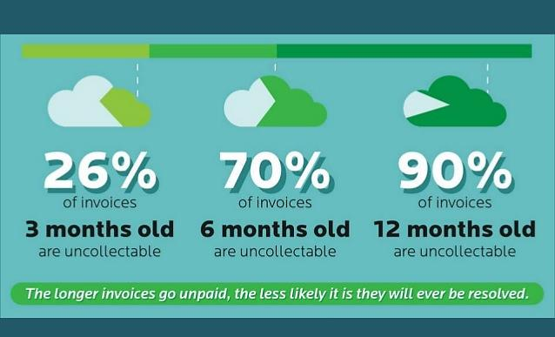
Chart by E2B Teknologies

Module 3 - Finance Chapter 5 – Budgeting and Accounting

3.5.2 swot analysis

To prepare an accurate and convincing projection of income and expenses, conduct a SWOT ANALYSIS of the internal and external factors that will affect revenue and expenses. SWOT stands for Strengths, Weaknesses, Opportunities, and Threats. The term refers to a strategic planning technique that assesses internal strengths and weaknesses, and external opportunities and threats. The purpose of the candid analysis is to avoid pursuing strategies or ventures unlikely to succeed, while leveraging competitive advantages for new growth initiatives.
Use template on the next page to create a SWOT analysis for one or more contemplated new initiatives. Here are some prompts for your assessment:

STRENGTHS
- What assets or resources do we have that other companies generally do not have?
- Do we have a strong brand loyalty and customer base?
- What do potential customers like about our business model?
- What knowledge do we have that gives us an advantage?
- What skills do we possess that give us an advantage in our industry?
- What unique relationships do we possess?
- What patents, trademarks, copyrights or trade secrets do we possess?
- What are our reserves of dry powder (capital on hand or that we can access if needed)?
- ____________________________________________________________________________________
WEAKNESSES
- Do we have gaps on our team?
- What do we not have that we need to be competitive?
- What business processes need improvement?
- What knowledge or assets do our competitors have that we do not?
- What is the competitive landscape? Do competitors enjoy strong brand loyalty, making it hard for us to capture market share? Are there large competitors with the resources to counterattack our entry into the market?
- What technology needs to be updated?
- Does one customer make up more than 10% of our business?
- ____________________________________________________________________________________
OPPORTUNITIES
- Is there a current need in the market that we could be addressing?
- What trends are positively impacting us?
- What are customers asking for that we could provide?
- Can we offer something that our competitors cannot offer?
- Can we increase our profit margins in some way?
- ____________________________________________________________________________________
THREATS
- Are there any upcoming law or regulation changes that may impact us?
- Might competitors offer new products?
- Are we dependent on a single manufacturer or supplier?
- What happens if a natural disaster strikes either where we do business or where we obtain supplies?
- How easy is it for someone to copy what we do?
- ____________________________________________________________________________________

Module 3 - Finance Chapter 5 – Budgeting and Accounting

SWOT Analysis for Your Business

STRENGTHS | WEAKNESSES
OPPORTUNITIES | THREATS
Module 3 - Finance Chapter 5 – Budgeting and Accounting

3.5.3 Personal INCOME AND Expense Budget

Now that you have evaluated the market landscape in which you will operate, you can begin to plug some numbers into a budget to guide you in pricing and purchasing decisions.

The most expensive line item for new businesses is the personal living expenses of the founder.

This is an interactive spreadsheet. To open, right-click then select “Worksheet Object” and “Open.” Enter amounts in the blue fields; the white field will be computed. You can download a copy of the form at EntrepreneurshipFoundation.org/spreadsheets

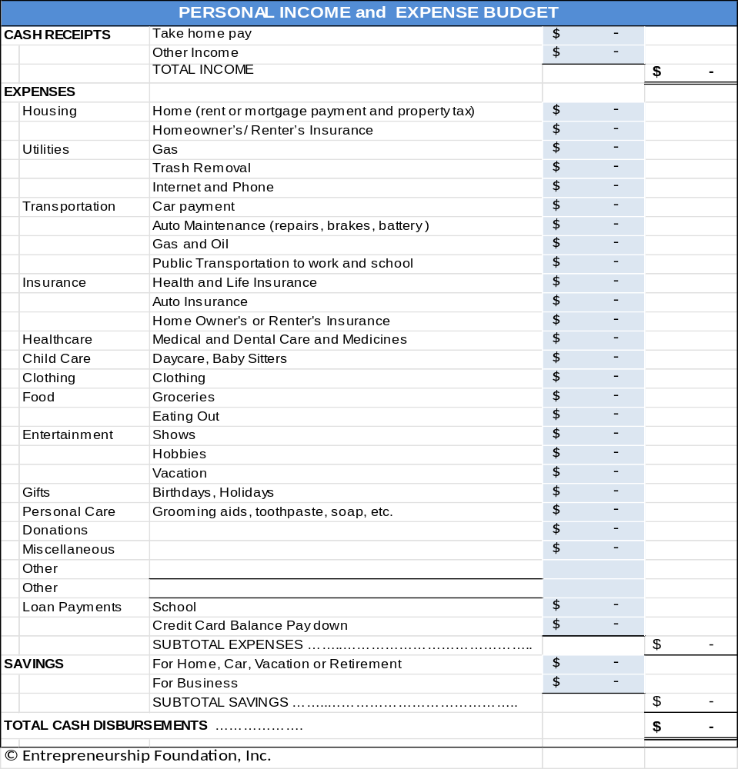

Module 3 - Finance Chapter 5 – Budgeting and Accounting

3.5.4 PAYROLL TAXES

Current as of 2025

Note: A self-employed entrepreneur must pay the Employee and Employer portion of Social Security and Medicare.

For a list of income tax rates and brackets for every state, as well as the federal income tax. See https://www.tax-brackets.org/

To find SUTA (State Unemployment Tax) for your state, see
https://www.paycom.com/resources/blog/suta-taxes-heres-what-you-need-to-know/

PAYROLL TAXES | RATE |  | ON FIRST …
Social Security (FICA) | 6.20% |  | $176,000 | Employee pays same rate
Medicare | 1.45% |  | no limit | Employee pays 1.45% on first $200,000
 |  |  |  | plus .9% on wages exceeding $200,000
Federal Unemployment Tax (FUTA) | 0.60% |  | $7,000 | Employer only
State Unemployment Tax (SUTA) | 2.20% |  | $26,100 | Employer only
This SUTA rate is an example.
SELF-EMPLOYMENT TAX RATES
As a self-employed individual, an entrepreneur is taxed twice, once as the employer,
and once as the employee.
For example, if you gross …. | $50,000 |  | $100,000 | annually, you will pay …
Social Security | $6,200 |  | $12,400
Medicare | $ 725 |  | $ 1,450
Federal Unemployment Tax | $ 420 |  | $ 420
State Unemployment Tax | $ 574 |  | $ 574 | (Example; check with your state for rate)
TOTAL | $7,919 |  | $14,844
Total Payroll Tax Rate | 16% |  | 15%
Remember, these are just payroll taxes. You still have to pay state and federal income taxes.

For a list of companies that provide payroll processing services, see Payroll Processing

Module 3 - Finance Chapter 5 – Budgeting and Accounting

3.5.5 BUSINESS BUDGETING

Now that you have professionally evaluated the economic, market, geographic and competitive landscapes in which you will operate, you can begin to plug some numbers into a budget, to guide you in pricing and purchasing decisions, and to show lenders and investors that your predictions are based on sound intelligence, and to show exactly you will be able to generate sufficient cash flow to pay them back.


Allow for black swans: unpredictable events that could have a negative impact on sales or costs. No business goes according to plan, so build in a contingency for surprise expenses; if you are certain your sales will be $1 million in the first year, budget for $500,000. If you can at least break even at 50% of your sales forecast, then those black swans will not put you out of business.

But beyond just hedging your bet, you will need to prepare a “Risk Analysis”.

BUDGET SAMPLE AND DOWNLOADABLE WORKSHEET. On the following five pages is a sample Excel workbook. You can download a blank form from http://www.EntrepreneurshipFoundation.org/spreadsheets.

The five-year worksheet contains imbedded formulas to compute totals. The tabs are Revenue, Cost of Goods Sold, Salary Schedule, Startup Capital, and Profit and Loss Forecast. Decisions made on one tab (e.g., Salary Schedule) are automatically reflected in the other worksheet tabs.

(The sample below and those on following pages are not interactive within the text.)

REVENUE |  | Year 1 |  | Year 2 |  | Year 3 |  | Year 4 | Year 5
Inflation Price Escalator | 4%
Annual Sales Growth Escalator | 20%
Product Group 1
Unit Sales | # | 5,000 | 6,000 |  | 7,200 |  | 8,640 |  | 10,368
Retail Price per Unit | $ | $ 25.00 | $26.00 |  | $27.04 |  | $28.12 |  | $29.25
TOTAL SALES |  | $125,000 | $ 156,000 |  | $ 194,688 |  | $ 242,971 |  | $ 303,227
Product Group 2
Unit Sales | # | 500 | 600 |  | 720 |  | 864 |  | 1,037
Retail Price per Unit | $ | $ 30.00 | $31.20 |  | $32.45 |  | $33.75 |  | $35.10
TOTAL SALES |  | $ 15,000 | $ 18,720 |  | $ 23,363 |  | $ 29,156 |  | $ 36,387
Grand Total Sales………………… |  | $ 140,000 | $ 174,720 |  | $ 218,051 |  | $ 272,127 |  | $ 339,615

WAGE RATES. As of 2025 the federal minimum hourly wage was $7.25. Most state minimums are higher.
To find the rate for your state see https://www.dol.gov/agencies/whd/minimum-wage/state

Module 3 - Finance Chapter 5 – Budgeting and Accounting

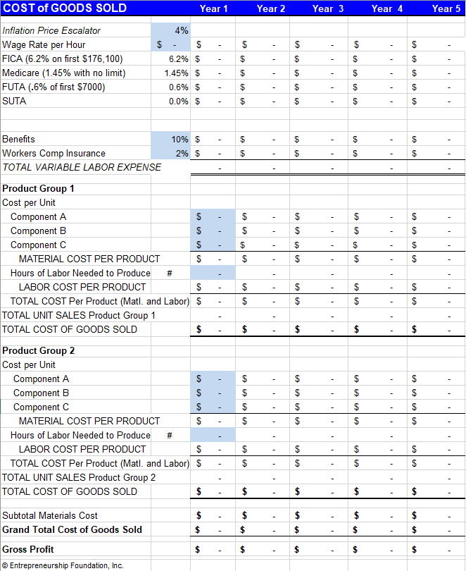This is one Worksheet in the “Budget” Excel file. The worksheet cannot be opened within this text. Download complete file from www.entrepreneurshipfoundation.org/spreadsheets
Module 3 - Finance Chapter 5 – Budgeting and Accounting

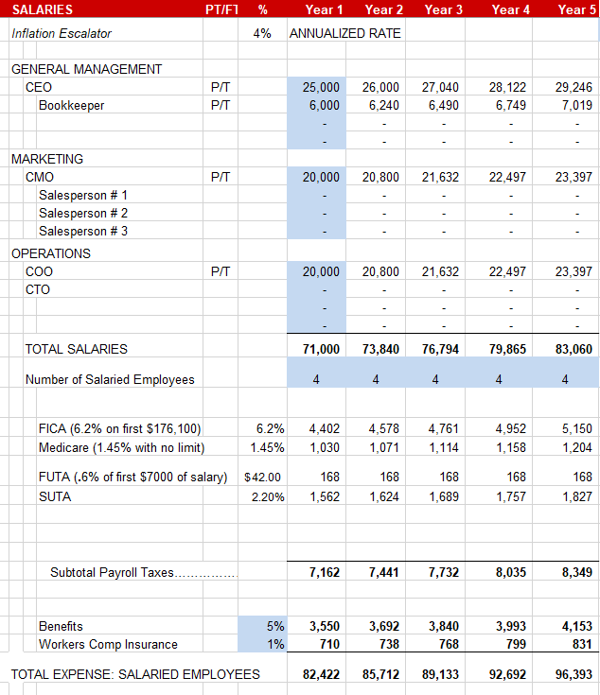

This is one Worksheet in the “Budget” Excel file. The worksheet cannot be opened within this text. Download complete file from www.entrepreneurshipfoundation.org/spreadsheets

Module 3 - Finance Chapter 5 – Budgeting and Accounting

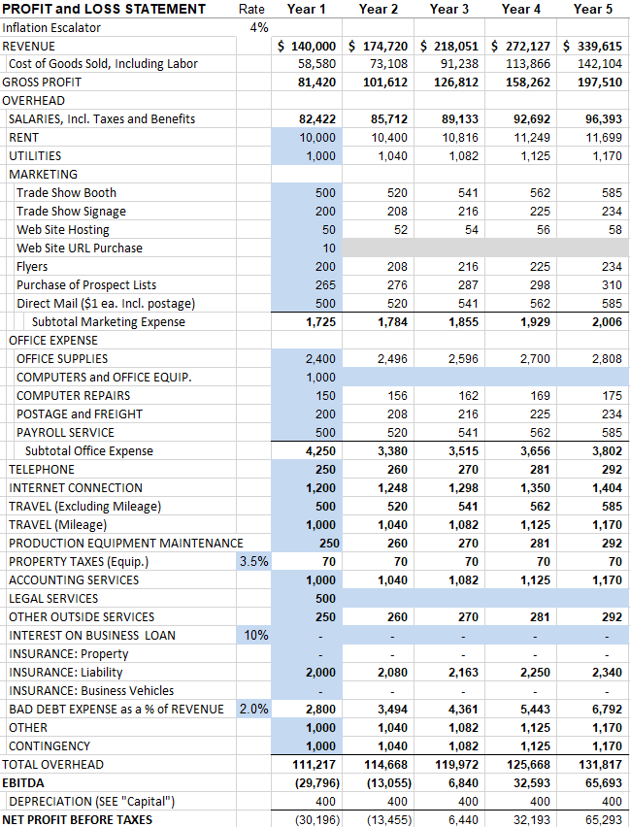
This is one Worksheet in the “Budget” Excel file. The worksheet cannot be opened within this text. Download
complete file from www.entrepreneurshipfoundation.org/spreadsheets
Module 3 - Finance Chapter 5 – Budgeting and Accounting

3.5.6 Cash Flow Forecasting

This worksheet cannot be opened within the text. You can download a copy at www.EntrepreneurshipFoundation.org/spreadsheets

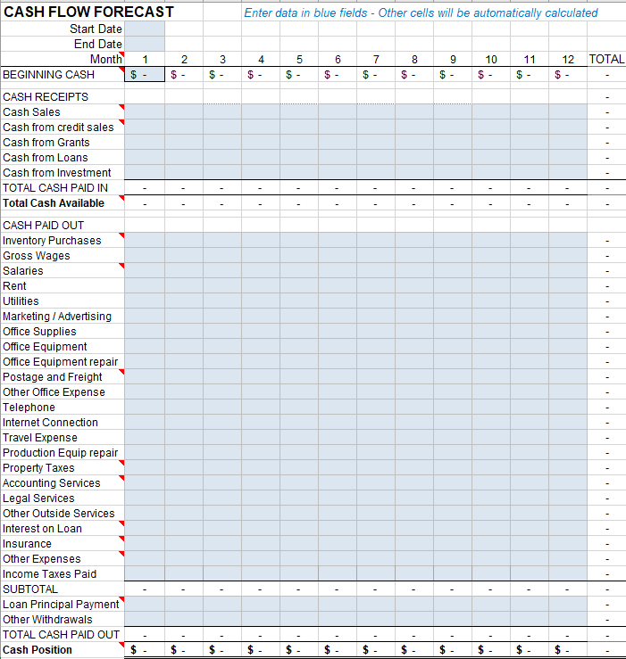
Module 3 - Finance Chapter 5 – Budgeting and Accounting

3.5.7 Break-Even and PROFIT MARGIN Calculation

Break-even occurs at the point where total revenue equals total costs. Use the following spreadsheet to compute your break-even point. Only enter amounts in shaded boxes. The other fields will be computed.

This is an interactive spreadsheet. To open, right-click and select “Worksheet Object” and then "Open.” You can download a copy of this form at http://www.EntrepreneurshipFoundation.org/spreadsheets

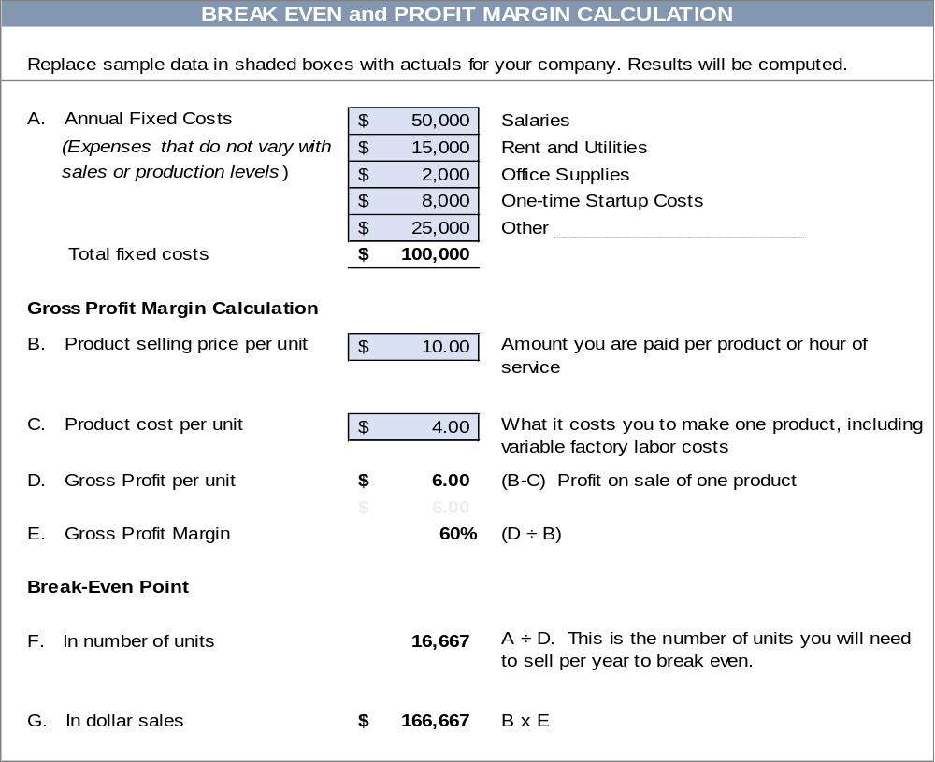

Reality checkS:
- Are the unit and dollar sales realistic?
- Can you make and sell this many products: or if a service business, can you realistically provide the number of hours required?

Module 3 - Finance Chapter 5 – Budgeting and Accounting

3.5.8 cAPTIAL REQUIRMENTS FOR LAUNCH

Startup Capital Requirement. The amount of cash you will need to cover start-up expenses and to cover operating expenses until the company attains break-even. The Cash Flow Forecast should indicate the amount of capital required each year. If you have already launched and need capital to expand a successful model, see the “Growth Capital Requirements” spreadsheet on the following page.

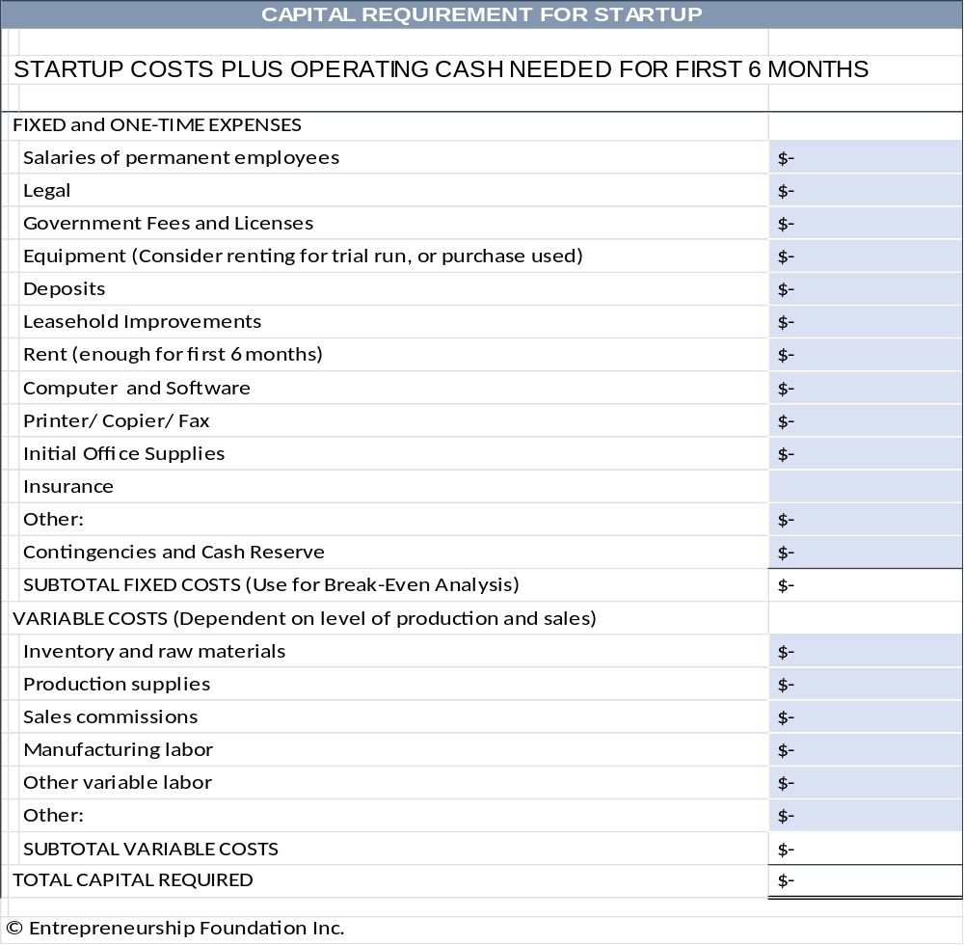

Module 3 - Finance Chapter 5 – Budgeting and Accounting

3.5.9 Accounting

Keeping your own books allows you to monitor cash flow and know how the business is doing in real time. Here are two online bookkeeping platforms that will help keep you organized. Fees are as of 2025.
1. WAVEAPPS offers a free cloud-based accounting package for entrepreneurs. Waveapps.com


- Optional Credit card processing: 2.9% + 60¢ per transaction
- Optional payroll processing starts at $40 per month. Note, you still need to send payroll taxes and 940 and 941 forms to state and IRS, but Wave will help you calculate how much you need to remit.
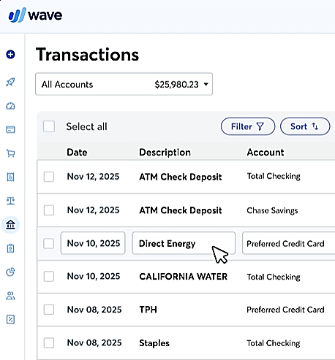
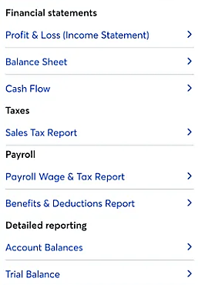


2. QUICKBOOKS by Intuit.
Plans start at $420 per year, but include some additional features, such and receipt scanning to automatically post espenses. The payroll processing option starts at $600 per year. For details see https://quickbooks.intuit.com/pricing.

COMPANIES THAT OFFER PAYROLL PROCESSING SERVICES ONLY INCLUDE:
- ADP https://www.adp.com/
- Paychex https://www.paychex.com/
- Homebase https://www.joinhomebase.com/
- Onpay https://onpay.com/
Payroll processing will run about $40 per month plus $6 per employee.
Module 3 - Finance Chapter 6 – Buying a Business or Franchise

3.6 - Buying a Business or Franchise

3.6.1 Buying an Existing Business
3.6.2 Buying a Franchise
3.6.3 Growing a Business

Now that you have identified a promising concept for a business, gauged market demand, researched the competition, scouted locations, determined costs, and crafted a business model, you are ready to implement your plan.

One shortcut is to buy a going concern or purchase a franchise in a successful chain.
This is largely a personal preference. Do you want to reduce risk, in exchange for a higher startup cost? Do you appreciate the advice from someone who has done this before, or do you like figuring things out yourself by trial and error?

Module 3 - Finance Chapter 6 – Buying a Business or Franchise

3.6.1 Buying an Existing Business

This can take some of the risk out of owning your own business. And you will hit the ground running, with everything in place: space, experienced employees, inventory. However, this comes at a cost.

PURCHASE PRICE. You should expect to pay 1.5x to 3x annual net cash flow (cash receipts less cash paid out). If the business was throwing off $1,000,000 per year in cash, then the asking price will probably be $1,500,000 to $3,000,000. In economic terms you are buying an annuity: an asset that will (presumably) pay you a yearly return on that investment. Of course, in the case of buying a business, you also have to run it, so you have an “opportunity cost” as well: the amount you would have made working for someone else.

In 2025, U.S. Treasury Bills, which are considered the safest investments, were paying around 4% interest annually.
However, no business is as sure an investment as the U.S. government, so the price you pay for a business will reflect the higher risk. If you paid 3x for the business in this example, the expected annual return would be 33.3% ($1,000,000 is 33.3% of $3,000,000). The difference between 33.3% and the safer 4% ROI you could obtain from Treasury Bills is the premium for your greater risk and opportunity costs. See “Valuation” in Module 4 of this series for guidelines on how to determine the value of a company.

FINANCIAL RECORDS. The owner of the company you are contemplating purchasing should provide tax returns for the past five years, current year-to-date P&L (Profit and Loss Statement), and a balance sheet showing liabilities (debts) and assets (patents, trademarks, copyrights, buildings, vehicles, equipment, supplies, furniture, vehicles, and inventory of raw materials, components, and finished goods.) Also ask for a detailed inventory list showing …
- Quantity (Verify by spot checking at least the more valuable items. Check condition as well as the number)
- Purchase price
- Source
- Date purchased. (Those 2023 calendars might not be worth as much as shown in the books.)
The difference between the cash value of the assets and the asking price is the Goodwill (reputation and loyalty of the customer base, which should translate into continuing sales). But do not assume. Look for telltale signs of a decline in sales to new customers or a lessening of repeat sales.

DUE DILIGENCE CHECKLIST.
- Licenses. Make sure the business has all the required permits and meets current zoning requirements.
A current sales tax permit should be prominently displayed.
- Is the business in good standing with the Secretary of State (all taxes current?), the Department of Labor (payroll reports and payroll taxes are current?) The Department of Revenue Services (sales taxes paid and up to date)? Ask for proof, because when you buy a business, you acquire its obligations. If the business owes $10,000 in payroll taxes to the IRS, that becomes your responsibility.
Buying a business is like buying a home, only riskier, so have an experienced accountant review the financials and inventory data; and consult a business attorney to advise on the purchase contract. These professionals have probably advised on a number of deals and can provide suggestions on what to look for during due diligence.

PURCHASE CONTRACT TEMPLATES. Here is a link to a form you can download and paste into Word to create a purchase agreement: https://freelegalforms.uslegal.com/sale-of-business/agreement-for-sale-of-business/. Rocket Lawyer, a monthly subscription service for legal forms, will allow you to create a customized document online. See https://www.rocketlawyer.com/sem/business-sale-agreement. Your attorney may want to make some changes, but you will save her time and your money if you fill in as much as you can in advance.

Module 3 - Finance Chapter 6 – Buying a Business or Franchise

TO FIND A BUSINESS FOR SALE….
- Talk to attorneys and accountants. They may know someone ready to retire.
- Think about a business you have frequented for years, and it always seemed to be busy. Let the owner know you are looking for a business to buy.
- Check your local classifieds for “Business Opportunities”
- Search online for Business Brokers near me. Be aware the broker will collect a fee of 5%-15% from the seller; so, their obligation is not to the buyer.
- Two online business directories are www.bizbuysell.com/ and https://us.businessesforsale.com/
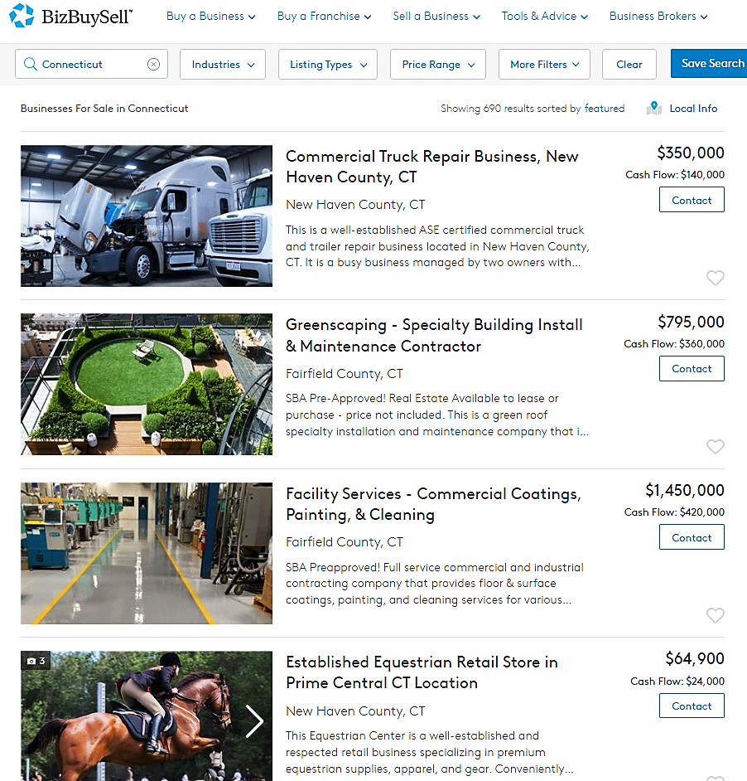
Module 3 - Finance Chapter 6 – Buying a Business or Franchise

3.6.2 Buying a FRANCHISE

Buying a franchise is like buying an independent business, but usually more expensive. The premium price is compensated by some advantages:
- Proven business model and procedures
- Access to training and support
- Assistance finding a location with the right traffic
- Brand recognition
- National advertising campaign by the franchisor (company that sells the franchise)
- Marketing materials and signage
COSTS
- Initial franchise fee. The more popular and profitable the franchise is, the higher the initial fee. Some franchise fees can be raised after the initial 10 or 20 years. (So, check the fine print.)
- Ongoing royalty fee paid on sales
- Other costs might include mandatory training fees or a requirement to purchase signage and equipment
DISADVANTAGES OF FRANCHISING
- Lack of independence and decision-making. You must operate the business by the corporate manual.
- You must buy the franchisor’s product line and cannot add your own products.
- Franchisors receive their royalty payments as a percentage of sales, not of your profits; so, they are incentivized to push high-volume, low-priced (low-profit) products.
- A franchise may require a long-term contract similar to a lease for space. So, even if your business is losing money, you may still be locked into paying an annual minimum royalty.
- Difficulty in selling the business. Some contracts give the franchisor the right to buy back the franchise.
- Some franchisors compete with their franchisees by offering products online.

COMPARING FRANCHISES. Two sites, www.entrepreneur.com/franchises and www.franchise.com list franchises by industry and cost. According to the advice of attorney Clifford Ennico, ask the franchisors on your short list for:
- Franchise Disclosure Document (FDD) a disclosure mandated by the Federal Trade Commission. www.ftc.gov/business-guidance/blog/2023/05/franchise-fundamentals-taking-deep-dive-franchise-disclosure-document
For a glossary of franchising terms see https://www.franchise.com/franchise-glossary
- The average time for franchisees to recoup initial investments.
- Contact information of franchisees who have left the system in the past three years. Call them.
By now your list should be no more than a handful. Go kick the tires:
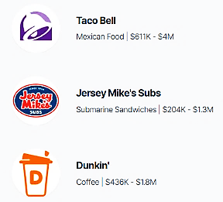
- Visit a franchise. Would you buy the product or service? Would you work there? Talk to the franchise owner. Would he do it again? Is he enthusiastic and planning to open more units?
- Attend a franchise trade show. Compare deals of competing franchisors. Which franchises have been around three years, AND are still growing? To find a franchise expo, see https://www.franchiseexpo.com/

Three of the 500 franchise opportunities listed on
website of Entrepreneur Magazine.
Food is one of 10 industry categories in the database.
www.entrepreneur.com/franchises

Module 3 - Finance Chapter 6 – Buying a Business or Franchise

3.6.3 Growing a Business

Once you have recouped your initial investment and refined the business into a profitable and sustainable model, you may want to invest more time and funds to grow the business to its full potential. But do you really want to? It is OK to say that you like your current work-life balance, that you like to be the one to bake the cookies and hand them to the children, without the headaches a chain of stores would entail. But if you’re the “full speed ahead” type, here are some strategies for multiplying your great idea:
- Additional Brick-and-Mortar Locations. How many outlets can you service?
- What are the location requirements in terms of traffic, access, neighborhood demographics, distance you are willing to travel to check on operations?
- What current available locations meet these criteria?
- Consider moving in with someone with surplus space. (The Post Office has done this. Some sandwich shops have opened branches in local libraries)
- What are the additional incremental costs per location, including additional layers of management?
- New Client Acquisition.
- Where is the low-hanging fruit? Is there a market niche overlooked by the competition?
- If you are a B-C company, can you offer your product/service to businesses?
- If you serve small companies, are you now ready to scale up to service larger corporations?
- New Products. New products are an obvious way to grow sales. These can be variations of your core product or completely new offerings that expand your overall base.
- Franchising. Restaurants often turn to franchising, and it is a feasible option for many other industries as well. Franchising works best when your product is consistent, customers have certain expectations about your brand, you are consistently profitable and growing in your current location.
- Online Expansion. Use your own website, Shopify, Amazon, eBay and/or Etsy,
- New Advertising Channels. Try some A-B testing of new media (Newspaper, radio, TV, influencers, events, direct mail, press releases, blogs, etc.)

- Sell Internationally. The U.S. Post Office will deliver packages anywhere; but best to avoid countries with political or financial instability. First-Class Package International Service is usually the cheapest rate, but it can still get pricey fast. The higher the shipping and handling cost, compared to the value of the product, the more market resistance you will encounter. Even a 4 oz. package (pair of earrings) will cost over $22 to the UK, France, or Brazil; a 12-to-16 oz package will cost over $32.
- Acquisitions. A logical strategy for a mature company that is close to market saturation. (e.g. – Facebook purchase of Instagram).

Frito-Lay started with just corn chips.

Module 3 - Finance Chapter 7 – Banking

3.7 - Banking

7.1 Selecting a Bank

7.2 Opening a Bank Account

7.3 Ordering Checks and Banking Supplies

.
WHY YOU NEED A BUSINESS ACCOUNT. It is generally a good idea to keep business funds separate from family money. In addition, when you pay bills, using checks with a business name it shows this is not just a hobby. Any check made out to the name of a business must be deposited in an account of that name. If you intend to operate as a sole proprietorship, you can open the account as a d/b/a (doing business as): “[Your personal name] d/b/a [your company name]”. Make sure the business name is available and register it with your town clerk before opening the account and purchasing checks.

Module 3 - Finance Chapter 7 – Banking

3.7.1 Selecting a Bank

LOCATION. Your business banking needs will most likely occur during normal business hours, so consider banks near your office instead of where you live. In any case, the bank around the corner from your home that you use for your personal needs may not offer the services your business will need.

TYPE OF INSTITUTION. By law, savings and loan institutions (S&Ls) cannot allocate more than 20% of their assets for commercial loans, and only half of that can be placed with small businesses. Savings institutions are designed to service individuals, not companies. So, pick a full-service commercial bank.

SERVICES AVAILABLE. Will you be making many cash deposits? If so, how late is the bank open? (Some close their windows at 3:00 pm.) If you have a retail store, you will need to obtain rolls of coins and small bills. Will you be doing a lot of importing and exporting? If so, you will want a bank with international experience or with correspondent banks in the countries where you will be doing business

Think ahead about the services you may need in the future, such as payroll processing or a business loan. You will not build a relationship if you change banks every few years to find the next new service the company needs.

SERVICE FEES. Some banks offer free or low-cost checking/savings plans.


These ads describe what you want
in a bank.
Talk to the bankers
to find out if the hype is true.


Module 3 - Finance Chapter 7 – Banking

BANK RESEARCH | Bank A | B | C
NAME OF BANK
Name and email of bank representative
Are deposits FDA insured up to $250,000? | Yes / No | Yes / No | Yes / No
Free business checking? | Yes / No | Yes / No | Yes / No
Minimum balance to maintain free checking | $ | $ | $
Interest on savings account | % | % | %
Overdraft fee | $ | $ | $
Will bank take money out of savings automatically to cover insufficient funds in the checking account (thus avoiding inadvertent overdrafts)? | Yes / No | Yes / No | Yes / No
Printed monthly statement? | Yes / No | Yes / No | Yes / No
Able to check online for balance and see which checks have cleared? | Yes / No | Yes / No | Yes / No
Import/ Export experience? | Yes / No | Yes / No | Yes / No
Experience with Letters of Credit? | Yes / No | Yes / No | Yes / No
Experience with wire transfers? | Yes / No | Yes / No | Yes / No
Cost for 250 checks, binder, and book of carbonized deposit tickets | $ | $ | $
Is the bank an SBA lender? | Yes / No | Yes / No | Yes / No
What is the range of the size of business loans that the bank makes? | $____k to $____M | $____k to $____M | $____k to $____M
How many business loans does the bank make in a typical year? | # | # | #

Module 3 - Finance Chapter 7 – Banking

3.7.2 Opening A Bank Account

DECIDE WHO YOU WANT TO BE AUTHORIZED TO SIGN CHECKS. You might have a bookkeeper who prepares your checks, but to maintain a prudent system of checks and balances, you should be the only one authorized to sign.

WHAT YOU NEED TO OPEN AN ACCOUNT.
- SOLE PROPRIETORSHIP – Social Security number or EIN.

- LLC –
  - Employer Identification Number (EIN), available at no charge from the IRS. You can apply online at https://sa.www4.irs.gov/modiein/individual/legal-structure.jsp
  - Operating Agreement, outlining the internal structure, management, and member relationships. (This is different from Articles of Organization, which are filed with a state to set up an LLC.) A boilerplate LLC Operating Agreement may be downloaded from http://www.EntrepreneurshipFoundation.org/LLC.
- C CORP – Corporate Resolution by your board authorizing you to open a checking and savings account and to sign checks. A boilerplate “Banking Corporate Resolution” can be downloaded free from https://www.northwestregisteredagent.com/legal-forms/corporation/corporate-banking-resolution
Template for Banking Corporate Resolution
I, Enter the name of the secretary of the corporation, Secretary of Enter the name of the corporation, referred to as corporation, certifies that the following is a true copy of resolutions adopted by the Board of Directors of this corporation at a meeting held on proper notice, a quorum being present, on Enter the date of the corporate meeting, and that such resolutions are now in full force and effect.
Resolved that the Enter the name of the bank of Enter city, state of the bank is designated a depository of this corporation; and
Further resolved, that all drafts, checks, and other instruments or orders for the payment of money drawn against the account or accounts of this corporation with such depository shall be signed by any Enter number of signatories on checks of the following:
Enter the names of the authorized signatories
Further resolved, that such depository is authorized to place to the credit of the account, or any of the accounts of this corporation, funds, drafts, checks, bills of exchange, or other property whomever delivered to such depository for deposit for account of this corporation, endorsed with the name of this corporation by rubber stamp, facsimile, mechanical, manual or other signature (and any such endorsement by whomever affixed shall be the endorsement of this corporation), or otherwise endorsed, or un-endorsed, provided that if any such draft, check or other property shall bear, or be accompanied by, directions (by whomever made) for deposit to a specific account then such deposit shall be to the credit of such specific account; and
Further resolved, that such depository is directed to accept, and/or pay and/or apply any draft, check, instrument or order for the payment of money, or any proceeds thereof, drawn on such account or accounts when signed as required by these resolutions without limits as to amount, without inquiry, and without regard to the disposition of any such item or proceeds thereof, and such depository shall not be liable in connect therewith notwithstanding that such item may be payable to the order of a person whose signature appears thereon or of any other officer or officers, agent or agents of this corporation, or such item or any proceeds thereof may be used for the personal credit or account of any such person or person with the depository or used in payment of the individual obligation of any such person or persons to the depository or otherwise.
Further resolved, that such depository is authorized to deduct from the accounts of the corporation the regular promulgated service charges and fees for accounts and other services rendered to the corporation.

Dated: _________________ Signed by its Secretary _________________________________________
Module 3 - Finance Chapter 7 – Banking

3.7.3 Ordering Checks and Banking Supplies

CHECK STYLE. Puppies and balloons are right out, unless of course you are opening party supply business. Order business-like checks with subdued hues and no decoration. Order the large size (3” x 8.25” plus stub) that comes in a ring binder.

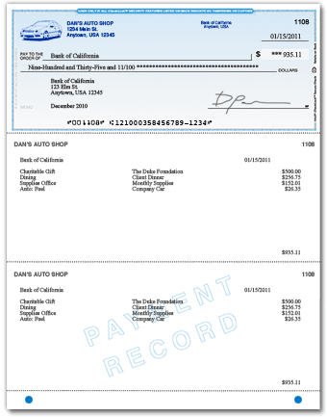
You might feel a wallet-size checkbook is more convenient, but larger checks and stubs allow for more-detailed record keeping and help convince suppliers that you have outgrown the sidewalk lemonade stand.

Checks will come pre-numbered and printed with your business name and address, the routing number that identifies your bank, and your bank account number.

You will have a choice between manual checks [below] or laser checks [right] designed for accounting software—like QuickBooks—and intended to be over-printed with the payee and amount. The imprintable checks save time and help you look more professional. They are a bit more expensive, however.
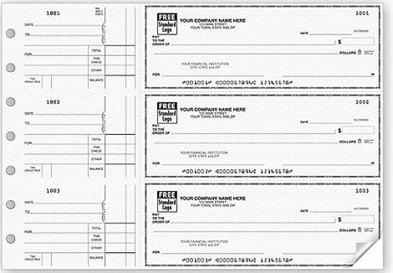

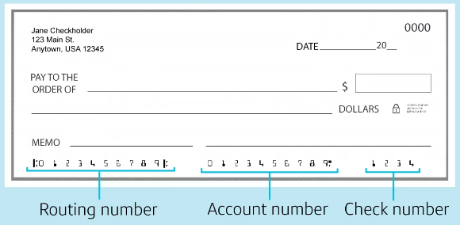
WHAT YOU NEED TO ORDER CHECKS: Your checking account number and the routing number for your bank. This is an identification number that tells the receiving bank how to route the canceled check back to your bank to be reimbursed. The routing number will appear at the bottom of the check, before the account number.

Module 3 - Finance Chapter 7 – Banking

WHERE TO BUY CHECKS. You can purchase your checks from your bank when you open the account but check their prices. It may pay to buy your checks directly from one of the following check printers. Whomever you buy from, resist the offer of a free stock logo. These are not exclusive and typically somewhat dated in style. Go with no logo (you will look very businesslike) or use your own.

Deluxe Check printers and Harland Clark are well-known suppliers of quality printed checks, but they do not disclose pricing until you log in and give them your bank account information.

Intuit (https://intuitmarket.intuit.com/bvc) is the producer of the QuickBooks accounting software, so you know the checks will line up with their software templates. $140 for 250 checks (as of 2025).

Amazon.com Custom Business Checks for laser printing, compatible with QuickBooks accounting software.
250 for $70. Manual checks: 100 for $54 (2025).

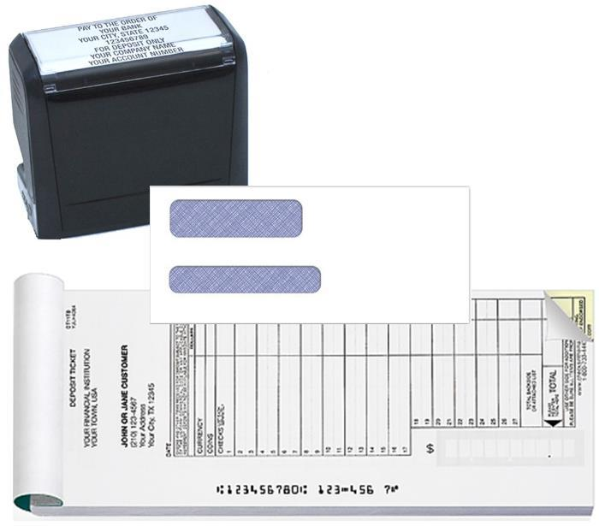
WINDOW ENVELOPES (to save addressing). QuickBooks compatible, self-seal, double window, for laser-printed checks. Size #8 (3 5/8” x 8 11/16”). Amazon 500 for $32 (2025)
Pad of 150 2-part carbonized DEPOSIT TICKETS with company name and account number. Amazon $54 (2025).
STAMP with company name and account number. Amazon $20 (as of 2025). The stamp saves time endorsing checks. The stamp also indicates that the check is being presented “For Deposit Only” to prevent the bank from applying the funds to an outstanding loan.

Module 3 - Finance Chapter 8 – Raising Growth Capital

3.8 – Raising Growth Capital

3.8.1 Determining Growth Capital Requirement

3.8.2 Internal Sources of Growth Capital

3.8.3 Types of External Growth Capital

3.8.4 Debt Capital

3.8.5 Equity Capital

3.8.6 Ownership Retention When Raising Equity Capital

3.8.7 Valuation (Estimating the Future Value of a Venture)

3.8.8 Valuation (Estimating Present Value of a Venture)

3.8.9 The Term Sheet

3.8.10 Equity Capitalization Schedule (Cap Table)

3.8.11 Exit Strategy

RAISING CAPITAL is a complex process. It usually takes 3 to 6 months to get a proposal in front of capital providers and for them to conduct due diligence. The steps in the process are:
- COMPUTE HOW MUCH CAPITAL YOU NEED at each stage of development. (If your launch is successful and you achieve break-even quickly, you may want to accept additional outside capital to grow the company more quickly than would be possible by relying solely on profits to fund growth.) The key is to allow for periodic infusions of equity capital, and the resulting dilution of the founders’ ownership position. The company that captures the market first wins.
- DETERMINE THE RIGHT TYPE OF CAPITAL FOR EACH STAGE: Savings, debt, equity, grants, or combination thereof.

Module 3 - Finance Chapter 8 – Raising Growth Capital

3.8.1 DETERMINING GROWTH CAPITAL REQUIREMENT

First, determine how much capital you will need to achieve the sales and profit goals in your business plan. Then break the total into tranches, or incremental investments spread over time, due when you meet interim milestones. This allows the investors to conserve cash until you need it, and reduces their risk, as they can withdraw from the agreement if you do not achieve a milestone within the agreed time.

This is an interactive spreadsheet. To open, right-click on spreadsheet, click “Worksheet Object” and then "Open.” You need to enter data in shaded fields only; the totals will be computed for you. You can download a copy of this form at
http://www.EntrepreneurshipFoundation.org/spreadsheets

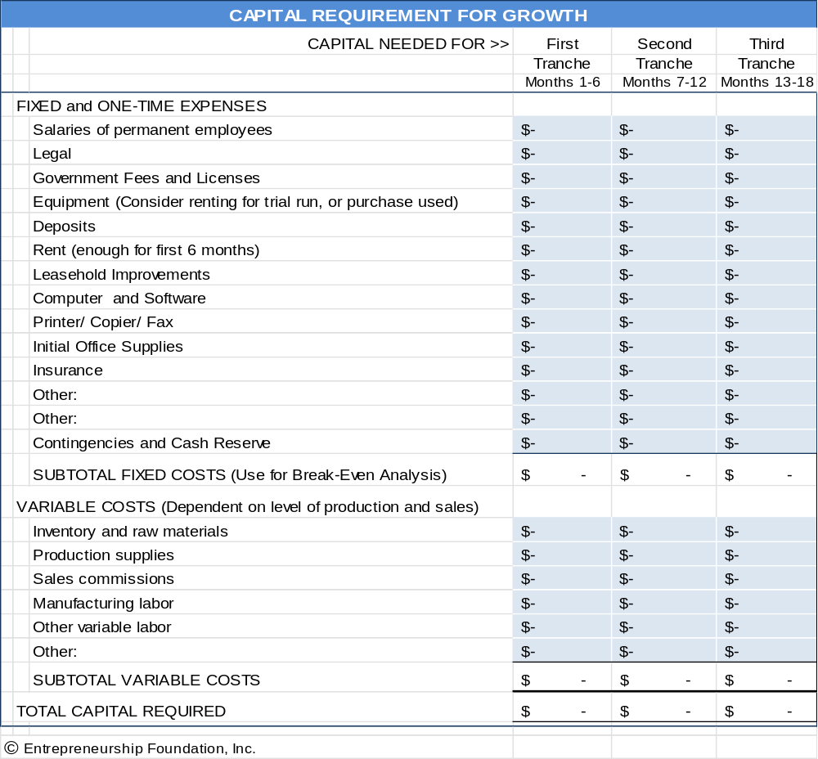

Module 3 - Finance Chapter 8 – Raising Growth Capital

3.8.2 Internal Sources of Growth Capital

For established businesses, expansion capital can often be generated from within the company by managing cash flow better or by converting other assets into cash.

1. Cash Flow Management.
    - Would some customers pay within 10 days for a 2% discount? This common payment option is written as 2/10 net 30; meaning the customer can deduct 2% from the bill if paid within 10 days, otherwise the full payment is due within 20 days.
    - Can you eliminate credit to new customers and require payment at time of order?
    - Are you paying bills sooner than required?
    - Have you tried to renegotiate credit limits or payment terms? If you are required to pay C.O.D., attempt to obtain credit. If you are required to pay bills within 30 days, ask for more liberal net 60 or net 90 terms. If you are a good customer, have been meeting payment obligations on time, and have a rationale (your business is cyclical like the fashion or toy industries, or it takes you 60-90 typically to collect from your customers), then you may have a convincing case.
    - Look at annual payments such as insurance. Do they come at the worst time of the year? If so, talk to the vendor about changing the payment date; or spreading out the payments into quarterly or monthly installments.
    - Paying salespeople a commission, after the customer pays, is one way of keeping down risk and negative cash flow. Some magazines and websites will also accept ads whereby payment is based on inquiries or actual orders received as a result of the ad. (Again, payment is after the sale.)

2. Converting Assets into Cash
- SURPLUS INVENTORY.
      - Do you have excess inventory that should be discounted to free up cash to produce more of the better-selling products?
      - Can any merchandise or supplies on hand be returned for cash or credit?
  - FACTORING. Have you tried to sell purchase orders to a factoring agent? Practitioners of this little-known source of business financing will buy a purchase order from you at a discount, assuming the customer has good credit. There are few companies that offer this service, but you should be able to find one in your region by searching the web.
  - LEASE VERSUS BUY. Everyone understands that leasing a car or truck for a business instead of purchasing it conserves cash. There are also leasing agents and finance companies that will purchase capital assets that you already own and lease them back to you.

Module 3 - Finance Chapter 8 – Raising Growth Capital

3.8.3 TYPES OF EXTERNAL GROWTH CAPITAL

- Debt Capital carries with it a legal obligation to repay the investment within a specified time, along with interest. Commercial lenders will generally require collateral and/or the borrower's personal guarantee in case of default. This protects the lender and ensures that the borrower has sufficient personal interest at stake to work diligently at the business. Lending sources include …

- U.S. Small Business Administration. The SBA’s Basic 7(a) Loan is designed to help small companies obtain financing when they might not be eligible through conventional lending channels. Loans may be used for most business purposes including working capital, machinery and equipment, furniture and fixtures, building renovation or construction, and debt refinancing (under special conditions). Loan maturity is up to ten years for working capital and up to 25 years for fixed assets. Interest rates range from 6% to 10% (as of 2025). See https://www.sba.gov/loans-grants.

- COMMERCIAL BANKS. Once you have achieved profitability and are generating positive cash flow (to repay a loan), you may be able to access growth capital through a commercial bank. You will still need a convincing business plan, a five-year financial forecast, including at least 3 years of month-by-month cash flow projections. Include the payments to the bank in the forecasts. Interest rates for established businesses range from 6% to 13% (as of 2025). Also, a bank will want to lend against collateral (hard assets like vehicles), and/or require a personal guarantee.
- FACTORS. A factor will purchase a receivable at a discount, based on the creditworthiness of the debtor. For a list of factoring agents see www.forbes.com/advisor/business-loans/best-factoring-companies/

2. Equity Capital (investment of cash in exchange for shares of stock in a company). Unlike loans, you are not legally obligated to refund an equity investment if the business fails. However, if the business is successful, you may wind up paying back more than you would have with a loan. A loan calls for a specific interest rate, no more and no less. However, an equity agreement provides the investors with a percentage of ownership (and therefore of the profits).
Preparation to pitch to equity investors involves the following steps:
- COMPUTE “GROWTH CAPITAL REQUIREMENTS” for each stage of your growth plan.
- ESTABLISH A REASONABLE AND DEFENSIBLE VALUATION OF YOUR COMPANY. You are, in fact, selling a portion of your business. So, what is it worth? What price is fair for you and the capital providers? This process is partly math but mostly negotiation—because you are really trying to arrive at a reasonable price today based on how profitable you expect the business will be in the future.
- PREPARE A “CAP TABLE” showing the rounds of new capital you project you will need (including the month and year and amount of each round), type of capital, source, and resulting dilution (amount prior investors will be crammed down, that is, how much their ownership percentages will be reduced).
- DECIDE ON AN “EXIT STRATEGY” to allow equity investors to harvest their original investment and their share of the gains. Exiting applies only to equity investors (banks would be happy if you kept their money and paid them interest forever, although they do like to see the loan paid down to zero once a year so they can sleep better). Equity investors (angels and VCs who provide capital for shares of stock) do not typically receive interest, so they need you to sell the company (exit) so they can have their payday. They will want to see that day arrive ideally 3 to 5 years after investing but realize that it may be 5 to 7 years.

Module 3 - Finance Chapter 8 – Raising Growth Capital

3.8.4 DEBT CAPITAL

A loan proposal is comprised of the following elements:
Summary. This should be clear, concise, accurate and inviting. You want to summarize how the proposed loan will be used, how it will be repaid and how it will benefit your business. Remember that you are competing with many others, so you will also want to point out some of the distinguishing features of your business.
Top management profiles. You will need resumes from all owners and key members of the management team. Resumes should include relevant experience, education and credentials. Be prepared for close scrutiny.
Business description. You do not need to repeat all of the information contained in your business plan, but you do need to present a description of your business. Include a brief overview of the history of your business, plus a summary of current activities. Make sure you clearly demonstrate that you understand your markets and industry, including current trends and risks. Include literature showing your products or services. It is also helpful to include endorsements from suppliers, customers and other business references.
Projections. Include projected income and cash flow for two to three years. Your assumptions should be clearly stated and realistic. Be prepared to answer questions (in quantifiable terms) about what happens if some of your assumptions do not come true. For example, if you anticipate obtaining a major new contract or customer as a result of newly expanded capacity, can you estimate the impact on your income statement if that customer decides to take their business elsewhere?
Financial Statements. The loan package must include both business and personal financial statements. Make sure that you are familiar with the details of your financial statements, especially if they were prepared by someone else. Be assured that your banker will fully analyze your historical financial statements and calculate all the ratios. So, prepare in advance and point out any significant trends in an introductory paragraph.

Amount and Purpose of the loan. Present a detailed statement of how you will use the loan proceeds. Do not forget to include the proceeds of the loan in your cash flow projections (and the interest in your projected expenses).
Repayment plans. You will have to make some assumptions about the terms of the loan in your proposal. (Obviously, this is necessary to prepare the initial financial projections.) In the first package, you will propose the terms that you want, but ultimately this will be a point that will be negotiated with the bank. The bank will consider a number of factors as they assess the overall risk of the loan, and this will impact the repayment terms that they are willing to give you.

If your loan is approved, make sure that you:
- Thoroughly review and make sure you understand all loan documents before signing. Consult with your lawyer or accountant if you have any questions.
- Get documents in on time. Keep up that good impression the bank has of you by promptly responding to requests for additional information, documents, signatures, etc.
- Maintain close contact with your loan officer. It is a good idea to give your banker progress reports -- the bank now has a vested interest in your success and will want to be kept current on your progress.
- Keep lenders apprised of any problems. Bankers do not like surprises.

If your loan is not approved.
- Do not despair, a "no" today does not necessarily mean no forever or from the next bank you approach.
- Do Not get defensive but do seek information so that your next proposal addresses and corrects any deficiencies in the rejected application. Ask the banker to explain "why" your loan was not approved.

Module 3 - Finance Chapter 8 – Raising Growth Capital

3.8.5 EQUITY CAPITAL

Equity investors provide capital to ventures in exchange for shares of stock. Their strategy is to recoup 10- to 20-times their investment within 3 to 5 years by helping you grow and then sell the company or float an initial public stock offering (IPO) and then selling their shares on a stock exchange.

- Private Individual Investors (Angels). Typically, angels are successful former entrepreneurs themselves looking to reinvest some of their winnings helping others and can bring a wealth of free expertise and assistance. But do not get engaged on the first date. It is important for you and the angel investor to get to know each other, test compatibility, and to understand each other’s expectations through preliminary meetings.
STAGE. Angels will expect applicants to have revenue
ANGEL INVESTOR CLUBS. A group of angel investors that invest individually or collectively through a common fund. The advantage of approaching a club versus an individual investor is that the club has greater investment resources. Although it is almost impossible to find one private individual who will commit to providing $500,000 in capital, a group of individuals could.

To find an angel investor club near you see http://www.angelcapitalassociation.org/directory/#1

- Venture Capital (VC) Firms. VCs are equity investment firms, with offices, websites and paid analysts. A VC firm will specialize in a specific range of investment dollar size, industry and geography.

STAGE. VCs invest other people’s money and are therefore very conservative: they do NOT invest in startups. Wait until your business is profitable and the business model sustainable before seeking funding.

INVESTMENT CRITERIA. VCs list their investment preferences on their website. Find a firm that ...
- Invests in your state. VCs want to check up on their investments periodically, so travel time is an issue.
- Invests in your industry. VCs will invest only in an industry they know a lot about. Check the website for the current portfolio companies (businesses they have invested in). Would you be a good fit?
- Invests the amount of money you need. If you need $1 million, do not go to a firm with $1 billion under management. That firm cannot afford to do deals as small as $1 million as that would mean they would wind up with 1000 investments to keep track of. Similarly, do not approach a firm with only $5 million under management, as no firm would invest 20% of its funds into one deal.
If you find a match, check the website to find out what they would like you to send them initially.
WHERE TO FIND THE RIGHT VC FIRM. The National Venture Capital Association (NVCA) lists members on its website, sortable by state and city https://nvca.org/nvca-members/. But be aware that not all listed firms are venture capitalists; some are brokers or firms that serve entrepreneurs and investors. For example, Synchrony Ventures is a credit card company. Inspect the website before sending a plan.

The NVCA website also lists state and regional associations http://nvca.org/ecosystem/regional-groups. These membership associations typically hold monthly events that entrepreneurs may attend to learn more about sources of capital in their region and the process of accessing funding. This is a good place to learn the ropes and meet with other entrepreneurs, venture capital attorneys and investors.
3. Brokers and Finders. A finder works for investors to source deals. A broker works for entrepreneurs to find investors. Some investors may not want to do business with you if you use a broker, as the fees (usually 5% of amount raised) and/or shares you have to pay the broker will dilute the value of their investment.
Module 3 - Finance Chapter 8 – Raising Growth Capital

3.8.6 OWNERSHIP RETENTION WHEN RAISING EQUITY CAPITAL

The following chart illustrates the concept that an equity investor will expect a percentage of ownership in relation to the perceived risk. The more advanced the development of your product and business, the less ownership the investors will require to balance their risk.

MORE RISK FOR INVESTORS LESS RISK FOR INVESTORS

There are additional factors that may affect the percentages in the preceding chart. These variables may exert an upward pull on the percentage of ownership the entrepreneur might retain (dotted line); or they may lower the ownership percentage the entrepreneur should expect to retain.
External factors (variables not within your control):
        - The Economy
        - Investor Confidence
        - Total amount of capital available in the investment market
Internal Factors (variables under your control):
        - Newness or uniqueness of product or service
        - Prior experience (Successful serial entrepreneurs can retain a larger share of ownership)
        - Profit potential

Module 3 - Finance Chapter 8 – Raising Growth Capital

3.8.7 VALUATION (ESTIMATING THE FUTURE VALUE OF A VENTURE)

If you plan to raise equity capital, you will need to establish a specific value for your business. Valuation is the art and science of estimating the present worth of a business based on its potential future earnings. Most investors will want to cash out in 3 to 5 years, so let us assume for this discussion that the agreed goal is to harvest the company in five years, by flipping it to a larger company, a private equity firm, or by floating an initial public offering (IPO) to sell the company to many individual investors.

The first step is to estimate the value of the company five years out. Two popular methods of estimating the future value (FV) of an enterprise are…

- FUTURE EARNINGS METHOD (Based on extrapolating current earnings in the expected harvest year)
- COMPARABLES METHOD (Based on the value of similar companies)

1. FUTURE EARNINGS METHOD. Since an early-stage company has limited sales data, future earnings are difficult to estimate, and here is where it gets tricky. You (the eternal optimist) will project a high growth rate and the assumption that nothing will go wrong. The investors, however, will likely assume a lower growth rate and that everything that can go wrong will.
However, for the sake of argument, let us assume that after much polite negotiation you and your investors arrive at a 5-year projection of $100,000,000 in sales, with a net profit after tax of $10,000,000. So, what is the business worth? Here is how the staff at Fundable.com foresees how the negotiation might play out:

The Valuation depends on the Earnings Multiplier agreed to. Again, you and the investor may begin the negotiations with markedly differing views. You will point to average stock market P/E ratios of say 8 for your industry, giving your business a valuation of $80,000,000. The investor will argue that those are proven businesses with real sales and profit margins. Your profits are hypothetical. The investor will counter with 2x earnings, or $20,000,000.

The investors will also argue that their money will be tied up for years. In addition, investing in established companies is less risky.

The state of the economy at the time you enter the capital markets will also affect the cost of money. It is more difficult to launch and grow a company during a recession when potential customers are cutting back. Investors may therefore discount your valuation even further during a weak economy.

Other factors that will raise or lower the prospects for success, and therefore the value of your business are:
- Extent of prior industry experience of your management team
- Connections you have to buyers (through management team or board of directors)
- Strength and number of competitors
- Expanding or shrinking market
- Past rate of sales growth
In the end, let us assume you agree that the business will be worth $40,000,000 in 5 years.

2. COMPARABLES METHOD. Future value may also be estimated by comparing the entrepreneur’s company to the value of similar companies in the industry. Businesses that are traded on a stock exchange are good comparables since their market value is easy to calculate: number of shares outstanding x price per share. (The entrepreneur still needs to convince the investors that their company will be equally successful.) For the sake of argument, we will assume that the comparable companies also have an average value of $40,000,000.

Module 3 - Finance Chapter 8 – Raising Growth Capital

3.8.8 VALUATION (ESTIMATING PRESENT VALUE OF A VENTURE)

COMPUTING PRESENT VALUE. Once you have arrived at an estimated Future Value of the company ($40,000,000 in 5 years in the example), you will then need to determine the Present Value (PV) of the company, since the investment will be made today—not in 5 years. This computation can be performed using the Discount Method based on the target Internal Rate of Return (IRR).

TARGET INTERNAL RATE OF RETURN (IRR). This is done mathematically using a discount rate agreed to by all parties. There are several methods investors use to determine the necessary IRR for each investment for them to derive an average competitive return on all their investments, considering many will fail to return any profit.

If investors put their funds into a portfolio of Standard and Poor's 500 (S&P 500) stocks in 2000, they would have earned an average IRR of 13.6% during the 5 years ending in 2025. Of course, that does not mean that an investment today would yield the same return, but an investor will contend that instead of investing in your (risky) company they could safely invest the same amount in the S&P and earn a comfortable 13.6%; so that is how much they would at least need to earn on their investment each year while waiting to cashout. But investors will want an even higher IRR to compensate for the greater risk and the illiquidity (not being able to sell their shares in an emergency because there is no exchange where your shares can be sold.) Typically, the target IRR will be 40% or higher.

Investors will often express their target IRR as a multiple of their investment: 5x, 10x, 20x, or even 30x.
5x = ~ 40% IRR
10x = ~ 60% IRR
20x = ~ 80% IRR
30x = ~100% IRR

PRESENT VALUE FORMULA. Present Value (PV) is computed using the formula:
PV = FV / (1 + r)^{n} where r is the discount rate and n the number of years.
Assuming 60% target IRR… PV = 40,000,000/ (1.6)⁵ = 40,000,000/ 10.48576 = $ 3,814,697 PV

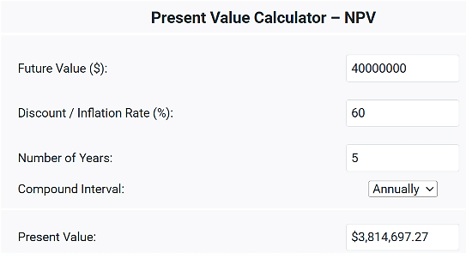
$ 21,143,084

Use this handy online calculator for the math

www.financialmentor.com/calculator/present-value-calculator

Module 3 - Finance Chapter 8 – Raising Growth Capital

PRE-MONEY VERSUS POST-MONEY VALUATION. The Present Value of the company includes the investment since it is assumed that the business will not achieve the $40,000,000 Future Valuation without the capital infusion. The valuation that includes the beginning inherent value of the company + the investment is called the post-money valuation (meaning it is the value after the money has been invested). The value of the company before the investment is called the pre-money valuation. In the example, we know the total post-money valuation is $21,143,084 from our calculation. If we subtract the amount of the investment (we will assume $2,000,000 for the example company) then the company is inherently worth $19,143,084 pre-money ($21,143,084 – 2,000,000).

So, what would be a fair split of the shares? If the company is worth $21,143,084 post-money, and the investor’s contribution toward that valuation is $2,000,000, then the investment is 9.3% of the Post-Money Valuation, entitling the investor to 9.3% of the shares of stock in the company. Easy.

SHORT-HAND METHOD OF DETERMINING OWNERSHIP SPLIT. Some equity investors seek to acquire a certain ownership percentage (often 30%) regardless of the valuation calculations; and others will stipulate an ownership stake on norms for a given industry and stage of investment. These Rules of Thumb are based on an analysis of returns (and losses) on prior investments.

WHAT IF YOU AND THE INVESTORS CANNOT AGREE ON A VALUATION IN ADVANCE? There are tactics to move ahead with the financing by delaying the determination of valuation:

1. Convertible Preferred Shares. This class of stock pays shareholders a fixed dividend and may be converted to common shares at the discretion of the investor. The investor would convert to common stock to participate in the proceeds from a sale of the company, since preferred stock does not represent ownership in the business.

2. The Safe (Simple Agreement for Future Equity). It stipulates that the percentage ownership due the original investors will be based on the valuation at the time of the first formal A round of financing; at which time, the Safes will convert to the appropriate number of shares in the company. See https://www.ycombinator.com/documents

3. The Earn-Out. A financial arrangement where a portion of the investment is contingent on a company's performance. This is a way to bridge the gap between the buyer's and seller's valuation, particularly when the future performance of the business is uncertain. For example, an entrepreneur asserts the business is worth $3 million; the investor $1 million. The investor might offer to pay $1 million immediately, with the balance contingent on the company hitting a milestone of say $10 million in cash sales within 3 years. The milestone should be quantifiable and irrefutable.

QUICK START-UP VALUATION CALCULATORS. These two online apps will allow you to perform a quick estimate of the value of an early-stage business, to serve at least as a starting point for discussion.

1. Cayenne Consulting has a free valuation calculator at www.caycon.com/valuation.php#

2. EquityNet. The results are based on market data gathered from over 3,000 businesses. To access, go to...
https://www.equitynet.com/crowdfunding-tools/startup-valuation-calculator.aspx

NOTE TO ENTREPRENEURS. You ma expect your years of toil, brilliant inspiration, and personal cash invested to count toward the Valuation of your business. Unfortunately, this is a sunk cost to you. To investors, the value of your business idea, invention, or patent is not how much time and expense you put into it, but its potential for earning.

Your business will be valued like a company listed on a stock exchange. The price of the stock is the present value of the firms predicted future earnings.
Module 3 - Finance Chapter 8 – Raising Growth Capital

3.8.9 THE TERM SHEET

Once you have agreement on valuation, you are ready to draft a Term Sheet, a preliminary written agreement between you and the investor(s). Venture capital firms usually prepare the term sheet, but if you are working with an angel investor, feel free to prepare a first draft.

The document will contain clauses to protect the interests of the investors and entrepreneur and stipulate how the proceeds are to be distributed if the company is dissolved or sold.

Both the investors and you should have experienced attorneys guiding you through the process.”

A term sheet is like a letter of intent. It is a nonbinding summary of the key points of the transaction. These terms will be included later in a formal Stock Purchase Agreement.

COMMON TERMS AND THEIR MEANINGS

- Valuation, Investment Amount, and Equity Stake (percentage of shares the investor will receive).
- Lock-Up Rights. Most investors will stipulate that the entrepreneur cannot shop the deal to other investors for a 30-to-60-day period. This Lock-up allows the Investors ample time to conduct due diligence without having to worry that another investor—knowing of their interest—may swoop in and deprive them of the opportunity.

- Timing of Investment. Many investors will prefer to distribute capital in installments, or tranches, as milestones are met.
- Liquidation Preference. If the company shut down and its assets converted to liquid assets (cash), the clause will stipulate who receives priority in the distribution of the proceeds. Investors will often insist that their investment be returned to them before any proceeds are paid out to the founders. In some cases, they will request twice their investment before any other distributions.
- Anti-dilution clause. This provision protects the investor in case the company raises future funding at a lower valuation (a down round). The provision protects investors by adjusting the conversion price of a convertible security (such as preferred stock or convertible debt) when new shares are issued at a price lower than the price they originally paid. This adjustment increases the number of shares the investor can convert their securities into, thereby preserving their ownership percentage.
To look up other financial terms, see https://www.investopedia.com/terms


Attendees at a venture capital event listing to 3-minutes pitches by entrepreneurs seeking capital.

Module 3 - Finance Chapter 8 – Raising Growth Capital

3.8.10 EQUITY CAPITALIZATION SCHEDULE (CAP TABLE)
To conserve cash and minimize risk, Investors prefer to meet out only the amount needed to fund the company during each successive phase of development. Each of these raises is known as a funding round.
At each round, founders will need to trade shares of stock in the company (equity), in exchange for the new capital. Growing companies will generally need multiple rounds to fund the ramping up of facilities, equipment and staff to satisfy ever-increasing demand. Entrepreneurs are advised to prepare a “Cap Table” showing the percentage of the company they plan to exchange for each round of financing.
Pre-Seed. ($5.000 - $50,000). This is the R&D and testing phase. Pre-seed sources include SBIR, government economic development grants, business plan competitions, and angel investors.
Seed Round ($50,000 to $500,000). This is the start-up stage to prove product-market fit. Funding sources include angel investors, accelerators, and incubators.

Series A ($1,000,000 - $5,000,000). This will be a larger round to scale up a proven concept. The company should be showing rapid and steady growth and at or near break-even. Series A investors are usually venture capitalists and corporate venture arms.
A Cap Table is the capitalization plan necessary to fund a venture to its full potential. Note that as new money is invested, the prior investors, including the founders, are crammed down. For the “A” round (first venture capital round) in the example below, both the angel investors and the founders each had to take a 33% haircut to make up the 33% ownership necessary to give the venture capitalists in return for their $1,000,000 cash infusion. What percentage of ownership was retained by the angels? (Answer at bottom of page.)

CAPITALIZATION PLAN (CAP TABLE) - EXAMPLE

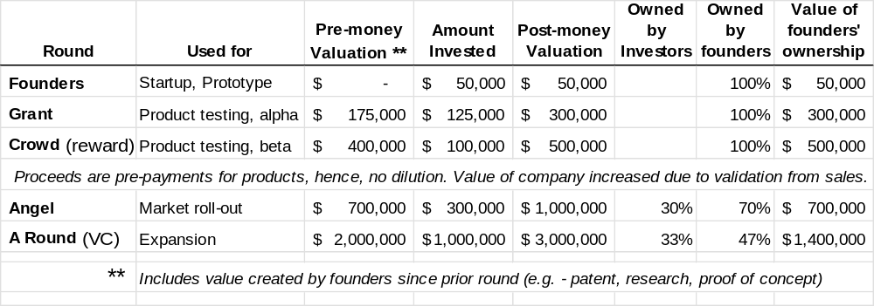

Use the blank spreadsheet below to try different Cap Table scenarios for your company. You can download a copy of this form at http://www.EntrepreneurshipFoundation.org/spreadsheets

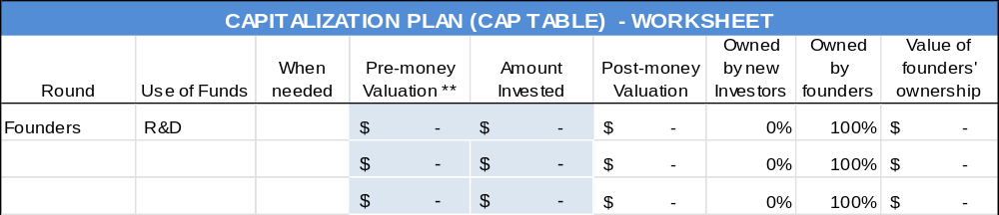
20%
Module 3 - Finance Chapter 8 – Raising Growth Capital

3.8.11 EXIT STRATEGY

If you accept equity capital, the investors will insist that you have a reasonable plan for them to exit the business. They will not have your love for the business. They just want to get their cash out as soon as possible, with a profit. You might still be able to stay on as president or become a serial entrepreneur and start another business. Exit strategies in common use are:
- Buy-back by Founders through an LBO (Leveraged Buy-Out).
- Acquisition. Sell the company to a larger firm that can leverage your technology, patents, or customers. If this is your intended exit strategy, be prepared to name logical buy-out candidates in your pitch to investors.
- Private Equity. Private Equity Firms purchase companies to own outright and manage, typically when the companies reach an annual profit level of $5 to $20 million.
- Initial Public Offering (IPO). Issuing stock to the public creates a market for the stock you and the investors own. It is difficult to sell new stocks in a recessionary economy, so do not suggest this exit strategy in a down market. Also, be advised that neither you nor your investors will be able to sell your shares immediately. (That would drive your stock value down precipitously.) You will have to cash out overtime.
If an IPO is your intended harvesting strategy, be prepared to give examples of similar companies that have launched successful IPOs and the market value of the outstanding stock. (This Market Cap[italization] should be equal to or greater than the Business Valuation as claimed by you in your business plan–or your valuation will not be credible.)

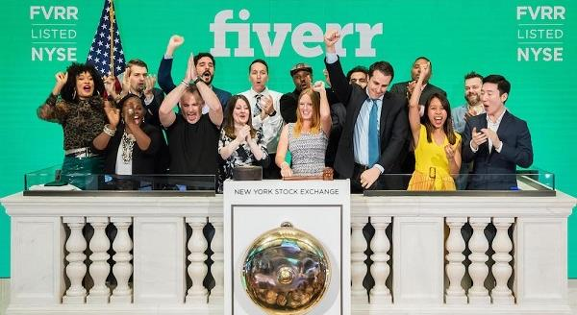
Fiverr celebrating having made it. Companies approved to list their stock on the New York Stock Exchange are traditionally allowed to ring the opening bell, signaling the start of trading for the day.
Module 3 - Finance Chapter 9 – Pitching Capital Providers

3.9 – Pitching Business Plans to Competition Judges and Capital Providers

3.9.1 Oral Presentations
3.9.2 Content of Presentation or Written Executive Summary

3.9.3 Questions You Should Be Prepared to Answer

3.9.4 Style: Delivering Convincing Presentations
3.9.5 The Slides

3.9.6 How Capital Providers Evaluate Proposals

Competition judges and capital providers, by nature, are risk averse and skeptical. Be Clear, Concise and Convincing.

“The value of a killer technology is zero unless you can show how it can be turned into a profitable business.” — W. Daniel Mothersill

Module 3 - Finance Chapter 9 – Pitching Capital Providers

3.9.1 Oral Presentations

There are several levels (in terms of detail and time length) of oral presentations to investors.

1. Elevator Pitch

EIGHT-SECOND SOUND BITE. This is a statement about your investment opportunity that you can get out in one breath. The place to use this is at a business-networking event where someone asks, “What do you do?” You never know who you might meet, so assume everyone you talk to is a potential investor or knows someone who is. A brief but engaging introduction about what you do is also valuable when recruiting employees or clients.
No one writes a check in an elevator. The sole purpose of the elevator pitch is to pique the interest of the investor, so they want more information. Success is these brief encounters is an exchange of business cards and an offer for you to call and set up an appointment for an in-depth interview.

The elevator pitch forces you to achieve clarity. At a minimum, the pitch should include YOUR NAME, COMPANY NAME, PROBLEM, and YOUR SOLUTION.

The elevator pitch should be memorized and rehearsed enough so that you can give it without it sounding rehearsed. You never know where you might meet a potential investor: at a cocktail reception, football game, even in an elevator. An 8-second elevator pitch might sound like this:
“Sugarcoate Systems reduces the time to bring new drugs to market by 20%.”
“We make flameproof fabrics for aircraft interiors.”
“We make cupcake decorating kits for children’s birthday parties.”

You need to convey all the essential information in a clear, concise, credible, and convincing manner that is also natural but passionate.

For more on mastering the elevator pitch see...
http://www.inc.com/guides/2010/05/mastering-business-elevator-pitch.html.

30-to-60-SECOND PITCH (without audiovisuals). You will probably be one of many presenters, so be memorable. State your name and company name slowly and distinctly at the beginning and end of your talk. Consider opening with a dramatic statement to capture the attention of the audience. Address the following points:

        - Big idea (customer problem and your solution) (1 or 2 sentences)
        - Status of the idea or business (1 brief sentence)
        - Revenue model (e-commerce, wholesale, etc.) (1 sentence)
        - Sales potential (justify expectations) (1 sentence)
        - Competition and why do you believe you have an advantage (2 sentences)
        - Rock stars are on the team who will ensure success (2 sentences)
        - Personal goal (1 sentence). To create a …
1) Part-Time Business (side hustle),
2) Full-time Personal Business,
3) Venture Enterprise with a substantial market and requiring venture capital to reach full potential.
        - Total funding required to launch the business full-time, and how much you need initially to develop the Minimum Viable Product and test it in the marketplace (1 brief sentence)

Module 3 - Finance Chapter 9 – Pitching Capital Providers

2. Formal Presentation at a Venture Fair or Business Plan Competition (3-10 minutes). You will probably be expected to have a PowerPoint presentation to support your commentary.
There may be Q&A during or after the presentation. You can cover a lot more in 3 to 10 minutes than in an elevator pitch, but generally, there will not be time to cover financial projections in detail or the resumes of the management team. For finances, discuss sales and profit projections and funding sought. For the management team, mention only one or two relevant experiences or credentials of each team member. For more on formal presentations, see the following sections on “Content” and “Style”.
3. Private Interview (15 minutes) in the office of the equity investor or lender. (This is what you hope an elevator pitch leads to.)
- If meeting with a VC firm, be prepared to present to an investment team of 3 to 5 people. Plan to give a formal presentation. Expect to be interrupted with questions.

- Ask about logistics prior to the meeting, so you know what to expect:
  - How many people will be in the audience?
  - Who are the decision makers? (Look up their bios on investor’s website.)
  - Can you (should you) deliver a PowerPoint presentation?
  - What is the total amount of time allotted for the interview?
  - Anything you should specifically cover? (The answer might reveal their biggest concern.)
- Research the firm. What companies have they invested in?
- Would a relationship with your firm help any of their portfolio companies? Are there potential synergies?
- Call some of the CEOs of the portfolio companies.
    - What advice do they have?
    - What is it like working with the investor or lender?
- What is their sweet spot for investing? $100,000, $1 million, $5 million?
d) Bring to the private meeting:
- Copies of executive summary for all attendees.
- Copies of the full plan to leave behind (if requested). Exclude confidential information, trade secrets, or content that might be useful to competitors until you obtain a signed NDA (non-disclosure agreement).
- Any purchase orders or contracts you have.
- If you are meeting with a lender, bring a list of assets that you can pledge as collateral. Show the date each asset was manufactured, purchase price, and current market value.
- Business cards
e) EXPECT SOME CHIT CHAT AT THE START OF THE MEETING. The investors want to get to know you as a person, are you someone they can get along with? Will they be able to participate in key decisions?
If you make it through this round, you will probably be called back to answer more detailed questions and begin negotiations over the term sheet (a preliminary draft of the investment contract).

Module 3 - Finance Chapter 9 – Pitching Capital Providers

3.9.2 Content of Presentation OR Written EXECUTIVE SUMMARY

The following is a comprehensive outline for a 3-to-15-minute oral presentation or 6-to10-page written executive summary. Adjust the amount of detail to the time or space allotted. Investors are looking for clear, compelling and credible information. Be concise but comprehensive. Remember the six Ps:

1. Product or Service

WHAT THE COMPANY DOES: Perform tax accounting services? Manage trade shows? Bottle and market sugar-free beverages?

PRODUCT/SERVICE
- Brief description and how it is new and different
  - Describe what creates the demand for your solution: Pain? Desire? High cost of alternatives?
- Explain the value proposition
  - How much customers need or want your solution. Give dramatic examples.
  - What it is worth to them, literally. Prove it.
- Eliminate the jargon and tech-speak. Competition judges and investors will not be familiar with shorthand used in your industry. Do not try to impress them with your vocabulary; sell them your concept.

Product/Service Development STAGE
- Current development status
- Patent status, if applicable
- Work, timeline and expense remaining before the product or service is ready to roll out.
- Remaining development risks or challenges (what might still go wrong?)

2. Potential

What is you market niche?
- Define the characteristics of the companies or consumers that need a solution
- How many potential customers are there? Is number growing or declining? Why?
- How many customers do you have now?

What ARE the potential dollar sales annually in your MARKET niche?
According to Blue Chip Ventures, do not use top-down math: “There are 8 billion people in the world and if we only sell one per cent of them …” That is not convincing as anyone could make the same claim. Similarly, the size of an industry is not predictive of sales. To say that Americans spend $349 billion dollars a year on fast food, though accurate, in no way informs the sales potential of a lemonade stand.

Instead, compile market data from the bottom up: “We have compiled a list of 1000 coffee shops within a two-hour drive. In a survey of 200 shops, we found that only 10% do their own roasting; and of the other 90%, half would like to. This gives us a serviceable market for our in-house coffee roasters of 450 shops.”

Marketing and Sales Strategy. How you propose to reach your targeted customers
- Marketing to raise awareness of product and stimulate buying
- Sales to give decision-makers a convenient way to learn details and place an order
- Support to help customers understand your product during installation and use

Module 3 - Finance Chapter 9 – Pitching Capital Providers

If you rely on indirect channels, explain:
- Your approach to reaching distributors
- Who will raise awareness and generate demand
- Who will provide sales and customer support
- Describe special sales incentive programs for distributors (if any)

3. Positioning Versus Competition and Alternative Solutions. What is your “Secret Sauce”?
Technology edge. [Do not delve into too much detail. Not everyone gets excited about dual-phase ether shifts.] Just explain that it will allow aircraft to save 50% on fuel costs. That they will understand.
COMPETITION and how your company excels.
How will large COMPANIES THAT HAVE established relationships with your target customers REACT TO YOUR INITIATIVES?
How will you overcome Market Inertia? (What will it take to get customers to change what they are using today?)
Are there companies that might leapfrog your solution with better technologies?

4. Protection. What Barriers to Entry have you erected to prevent competitors entering your market?
- Patents – Received or pending in US and abroad. Note: a pending patent or provisional patent is not a guarantee of market protection. (In the decade ending in 2020 only 53% of applications were approved https://yjolt.org/what-probability-receiving-us-patent.)
- Black box technologies – Is your technology difficult to reverse engineer?
- Lead time advantage – Would it take competitors years to reproduce your technology?
- Major Customers locked in with exclusive long-term agreements

5. People
MANAGEMENT TEAM. Skills should be varied and include individuals with business as well as technical backgrounds. Has anyone on team led a similar company to a successful IPO or buy-out?
- CEO (Chief Executive Officer) – Prior entrepreneurial experience in similar business. You may know your technology, but how do investors know you can run a business?
- CTO (Technology) – Proven expertise in your core technology
- CMO (Marketing) – Proven knowledge of the target market; strong relationships with buyers
- CFO (Financial) – Prior IPO or acquisition experience

Identify who is full-time and who is part-time or on the sidelines awaiting funding.
board members or advisers who add strategic value.

Module 3 - Finance Chapter 9 – Pitching Capital Providers

6. Profit Potential (This is not the place to go into detail.)

FINANCIAL FORECAST SUMMARY.
FINANCIAL FORECAST | Year 1 | Year 2 | Year 3 | Year 4 | Year 5
Units Shipped
Revenues
Gross Margin %
Gross Profit
EBITDA

BURN RATE. Current monthly costs to run company. When will you run out of cash if you are not funded?

Funding Plan
  - Funding received previously
  - Investment by founders (cash skin in the game)
  - Amount of new funding needed, and type of capital (debt or equity)
  - How long will it last? (To what milestone?)
  - Intended use of funds
Exit Strategy. If seeking equity from angels or VCs, the investors will naturally want to know what’s in it for them. Tell them when and how they will be able to cash out. And how. If you anticipate being acquired…

- Identify the two or three most likely buyers
- Explain why those larger companies would be interested
- Describe recent acquisitions of comparable companies and the deal values

- Describe any relationships you already have with potential acquirers, investment banks, private equity firms or larger VCs that might facilitate your exit plan.

To Conclude, Summarize the Most Compelling Arguments:
- Accomplishments. Milestones already reached. Show momentum.
- Why is this an exciting investment opportunity?
- Assume pitch decay will occur: A week later, your audience will probably remember only about 10% of your presentation. So, make sure they recall your strongest points. Repeat:
  - Reason to invest in us #1 (e.g. - Strategic alliances.)
        - Reason to invest in us #2
Module 3 - Finance Chapter 9 – Pitching Capital Providers

3.9.3 Questions You Should Be Prepared to Answer

You will appear professional and competent if you prepare answers to common questions (enumerated below). Do not try to memorize responses but do commit to memory important statistics.

Finally, be open to advice from your audience. Investors want to collaborate with someone who is easy to get along with and who will consider their ideas.

1. Solution: Product/Service
- What special issues relate to manufacturing the product? Any special materials or processes needed?
- What special equipment is needed to begin manufacturing at break-even capacity? And at what cost?

2. Market Opportunity
- How do you know the market exists? What evidence can you cite, such as independent market research?

- For industrial products…
  - What 2-3 industries comprise the most important prospects?
  - What are the job titles of the buyers (decision-makers) in these prospective companies?
- For consumer products, what are the demographics of the important customer segments?

3. Competitive Positioning
- How else can the customer solve the problem?
- How do you compare to each alternative solution? (Comparative advantages AND disadvantages)

4. Barriers to Entry by Competitors into Your Market
- Why are you confident that no new entrant will come along with a better solution?
- Why do you think you can dominate your market niche?
- Are there patents? If so, what specific features do they protect?

5. Product/Service Development
- What needs to be done to bring your product to where it is market-ready? What is your next step?
- How much of the production process does your company perform?
  - How much do you rely on outside contractors?
  - How much do you license from others?

6. Marketing and Sales
- What channels of distribution will you use to deliver your products to customers?
- How will these channels be established? By whom? When?

7. Management Team
- What gaps are there in the management structure and how you plan to fill critical functions
Module 3 - Finance Chapter 9 – Pitching Capital Providers

8. Financials
- Be prepared to explain dramatic numbers, such as:
  - Hockey stick growth (i.e. – exponential growth)
  - Unprecedented margins for the industry
  - Long periods of negative cash flow. (Goodness is positive cash flow in 6 to 12 months)
- When do you expect the next rounds of financing to take place? Why will you need those follow-on round(s) and how much will you need?

9. Requested Funding and Intended Use of Funds
- How much hard money (cash) have the founders put in?
- How much cash have directors and advisory board members invested?
- What equity is available to recruit key executives?
- How did you arrive at your pre-money valuation for this round?

10. Exit Strategy. What comparables are you using for your proposed IPO or exit round?

11. Summary and general
- When did the company begin operations?
- What is your long-term vision for the company?
- How has it been funded to date?
- Where does company stand today?
- What is the business model? (What will produce the company’s revenue?)
- What kind of gross margins will the company have?
- Do you have any corporate partnerships in place?
- What are the significant risks your business faces?

Module 3 - Finance Chapter 9 – Pitching Capital Providers

3.9.4 Style: DELIVERING Convincing Presentations

- DRINK WATER JUST BEFORE YOU SPEAK. (Fear makes our mouth dry.)
- TAKE BULGING ITEMS OUT OF YOUR POCKETS.
- STAND UP, FACE THE AUDIENCE, not the screen.
- BE PASSIONATE! Show that you believe in your concept and that you are determined for it to succeed.
- EXUDE ENERGY. Demonstrate how you can push through any obstacle to reach the end zone.
- SPEAK CONFIDENTLY IN A STRONG VOICE. Do not be self-deprecating in an attempt to gain the audience’s sympathy. Would you have confidence in someone who prefaced their talk with “I’m so nervous!” or “I’m not used to speaking in front of people”? You probably are nervous; everyone is when giving a talk; but you probably do not look it, so no need to let on. If you want to feel more confident, rehearse the speech until it becomes second nature.
- OPEN WITH A STRONG STATEMENT. Grab attention with a surprising statistic, or a 10-second story that shows how much customers need your product. “Eighty per cent of organ transplants are rejected within three years. Compatico has developed immune therapeutics to reduce rejections to 50%.”
- LEAD THE PRESENTATION PERSONALLY so that investors can judge your knowledge of the industry, and that you know how to present and think on your feet. Investors look at the founders first, then the idea.
- CONTROL THE DISCUSSION. If you get interrupted, go back to your slides. (Exude leadership.)
- PAUSE OCCASIONALLY so your listeners can catch up. When we are nervous, we tend to speed up. A good average pace is 120 words per minute.
- VARY VOICE PITCH AND SPEED, especially to emphasize a point.
- AVOID PUFFERY: “This is going to be the hottest selling product.” Eschew vague generalities: “It’s going to be really, really great.” Stick to specific facts and only what you can prove, to maintain your credibility.
- AVOID TECH TALK. Keep your language simple and accessible. Remember your audience.
- DO NOT DRONE ON ABOUT DETAILS OF YOUR TECHNOLOGY. The investors do not care how the watch works (at least not at this stage); just tell them how they will make money by helping you make watches. If they snooze – you lose.
- PRACTICE – PRACTICE – PRACTICE. Twenty times. It does make a difference. Videotape your rehearsal. Do you make distracting gestures?
- BE FORTHCOMING ABOUT WEAKNESSES AND THREATS. Investors are experts in spotting weaknesses. If you do not reveal them, they will think you are trying to hide the bad news. On the other hand, if you are the one to point out the challenges, they will see you as realistic, insightful, and most importantly, honest.
- TRANSLATE ASSERTIONS INTO ROI FOR INVESTORS. Your mission is not to convince them you will make money; your goal is to sell them that they will make money.
VIDELINKS Examples of 3- to 5-minute presentations by student teams.

Spyce MIT https://youtu.be/EeaGT9lMYUA
SilvaTerra Yale https://youtu.be/Lqp1y0ZMMFA
Checked Twice Yale https://youtu.be/tUt_CQTZlxI
Seratis Harvard https://youtu.be/rrCBsLbt4BY

Module 3 - Finance Chapter 9 – Pitching Capital Providers

3.9.5 The Slides

So that no one forgets who you are, put company name and logo on every slide. This is especially important in a competitive environment with other presenters, as at a venture fair or business competition.
- SLIDES ARE AN OPPORTUNITY TO SHOW AS WELL AS TELL. Audiences will remember much more if they receive information through both their eyes and ears.
- DO NOT waste real estate. Use selling slide titles, like “Why 90% of our customers come back for more” instead of “Customer data.”
- Type. If the audience cannot read your material, you will lose their attention. If you cannot read PowerPoint from 15 feet away, your audience will not be able to see the slides when projected onto a screen.
  - Use large type, 24 points or larger
  - Audience-friendly font like Arial or Helvetica.
  - Limit slides to 7 lines and 7 words per line.
  - Substitute symbols [=, %, >] for words.
  - Use phrases instead of sentences.
- USE A HIGH-CONTRAST COLOR SCHEME.
- Keep The Show Moving. One slide every 15 seconds for a 3-to-5-minute talk; One every 30-to-60-seconds for longer presentations.
- Use text on slides to supplement, reinforce or offer examples of claims. (Do not put your speech on the slides. Nothing is more annoying and boring than having to listen to someone read a speech.)
- SPELLCHECK!
- Clarity. Do not get clever. This is not a design competition. Which of the following charts is easier to read? Make sure labels are large and legible. Viewers should be able to grasp slide messages in two seconds.
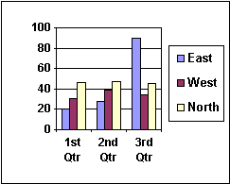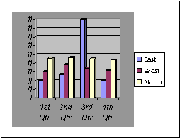

Module 3 - Finance Chapter 9 – Pitching Capital Providers

3.9.6 HOW CAPITAL PROVIDERS EVALUATE PROPOSALS

The following metrics were derived from surveys of lenders and investors. Capital providers may look at thousands of proposals a month and spend at most 5 to15 minutes deciding to place each in the reject or consider pile. They will generally look first at the Problem-Solution and Product-Market Fits. If compelling at face value, they will then turn to the Management Team, and study this like a resume. (Would they hire this team to run the company?) And next, the financials to see if the projections are attractive.

PRODUCT
- □ FOCUSED ON A COMPELLING PROBLEM THAT IS INTENSE AND FREQUENT
- □ ATTRACTIVE SOLUTION
- □ COMPETITIVE ADVANTAGE THAT IS SUSTAINABLE (Difficult to replicate)
- □ IMPROVES RAPIDLY WITH CUSTOMER FEEDBACK
- □ BUSINESS MODEL IS REPEATABLE, SCALABLE AND PROFITABLE
- □ COMPANY HAS TRACTION: BUSINESS CONCEPT HAS BEEN VALIDATED BY REPEAT
SALES AND CONSISTENT GROWTH OVER TIME IN BUSINESS
- □ DEVELOPMENT STAGE. The further advanced the company along the development path,
the lower the risk to capital providers. Idea > Prototype > Lab Testing > Beta (Customer)
Testing > Sales > Repeat Sales > Profit > Break even.
COMPETITION
- □ NUMBER AND STRENGTH OF COMPETITORS. (Goodness is being first to market.)
MANAGEMENT TEAM
- □ BUSINESS PLAN IS CLEAR AND CREDIBLE
- □ OWNER(S) HAVE KNOWLEDGE OF INDUSTRY AND RECORD OF PERSONAL SUCCESS
- □ THE MANAGEMENT TEAM IS COMPREHENSIVE: CEO, CMO CFO. Members have proven
executive skills.
- □ OWNERS WORK AS A TEAM and all are equally committed.
- □ OWNERS ARE “COACHABLE”: OPEN TO ADVICE.
- □ OWNERS HAVE (OR WILL HAVE) ENOUGH PERSONAL FUNDS AT RISK for failure to
be painful. They will not cave when the going gets tough
MARKET
- □ DEFINED MARKET NICHE
- □ PROSPECTS CAN BE EASILY FOUND AND REACHED ECONOMICALLY
- □ MARKET SIZE FOR PRODUCT (Not total industry GDP). Is market size adequate to
meet projections? Angel investors will expect an attainable market potential of at least $50
million, for some VCs use $1 billion is the threshold.
- □ MARKETING DATA IS CONVINCING AND VERIFIABLE. Third-party validation is a plus.
- □ MARKETING MATERIALS ARE PROFESSIONAL.
Module 3 - Finance Chapter 9 – Pitching Capital Providers

FINANCING
- □ FINANCIALS ARE COMPLETE, RELEVANT AND ACCURATE
- □ SALES ARE EASY TO FORECAST ACCURATELY AND ARE BACKED UP BY DATA
- □ IT’S CLEAR HOW THE COMPANY WILL MAKE MONEY
- □ AMOUNT OF CAPITAL REQUIRED TO REACH NEXT PLATEAU. (The greater the capital
requirement, the greater the risk.)
- □ REALISTIC ABOUT AMOUNT OF CAPITAL NEEDED. Asking for too little (and running
out of cash) is as bad as asking for too much (and incurring crippling interest payments if
a loan; or putting more investor funds at risk than necessary if equity capital).
- □ REPAYMENT PLAN -- IF A LENDER. Credibility of plan to repay the investment
and interest in time allotted. EXIT STRATEGY – IF AN EQUITY INVESTOR.
- □ BARRIERS TO ENTRY: THE INVESTMENT IS PROTECTED.
Additional Criteria Used by LENDERS
- □ CREDIT SCORE SHOWS HISTORY OF GOOD FISCAL MANAGEMENT. Lenders will
generally expect you to personally guarantee loans.
Additional Criteria Used by EQUITY INVESTORS
- □ CONCEPT IS DISRUPTIVE, A GAME CHANGER. MOON SHOT!
- □ POTENTIAL ROI AS COMPARED TO OTHER INVESTMENT OPPORTUNITIES. If there are
two competing investments with a $10 million profit potential within 5 years, and one requires
$1 million to launch, and the other $2 million the less risky option will be preferred.
If you have evaded the reject bin, the next step will be a deeper dive into the proposals and if it still ranks in the top 2%, to invite you in for Q&A. Capital providers will then move to Due Diligence to verify information in the proposal.

HOW CAPITAL PROVIDERS EVALUATE PRESENTERS
There is a reason lenders and investors want to see you in person. They have realized that the jockey is more important to success than the horse. Here is what they look for:
- ARE YOU DRESSED LIKE A CEO?
- DO YOU MAKE EYE CONTACT?
- DO YOU SMILE? Sense of humor?
- ENERGY! PASSION! LEADERSHIP!
- RELAXED, CONFIDENT?
- KNOWLEDGEABLE ABOUT INDUSTRY AND YOUR OWN PLAN?
- ABLE TO THINK ON FEET. FLEXIBLE?
- OPEN TO ADVICE?

A 3PL (third-party logistics) provider may also offer procurement, shipping, storage and fulfillment services
https://www.entrepreneur.com/article/288063

