Instructions for Games and Simulations
For use with Launching a Lean Venture notebook/text 7th Edition

August 2020 © Entrepreneurship Foundation
-------------------------------------------------------------------------------------------------------------------------------
These new PowerPoint-based games and simulations are designed to reinforce entrepreneurship concepts. To download additional copies see www.EntrepreneurshipFoundation.org/edu

They may be used in the classroom or online to enhance student engagement. When using Zoom, the “Floating Meeting Controls” banner may obscure the top of the game board when sharing your screen. To move Meeting Controls out of the way, click “More” and then “Hide Floating Meeting Controls”; or press Ctrl+Alt+Shift+H

--------------------------------------------------------------------------------------------------------------------------------------------
Risk and Reward. This fun activity reinforces basic knowledge of entrepreneurship in a familiar Jeopardy format. The first half of the game presents 30 questions that cover the first 29 pages of the text. The second round reviews material from pages 30-50. Instructions are included within the PPT. Two additional slides provide printouts for the instructor that cross-reference each question and answer to a page in the text. Side effects include attentiveness and enthusiasm.
When opening and saving, be sure to “enable macros.”

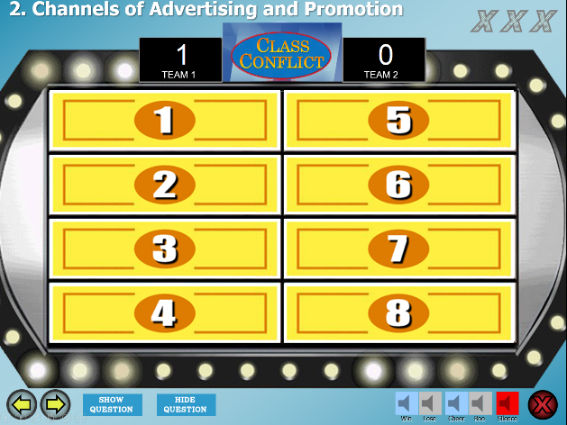
Class Conflict. Based on the popular TV show Family Feud, the PowerPoint includes three different games, covering the following startup topics:
- Porter’s Five Forces of Competitive Analysis (Chapter 3, page 25)
- Channels of Advertising and Promotion
(Chapter 13, page 105)
- Sources of Startup Capital (Chapter 17, page 160)
Instructions included within the PowerPoint.

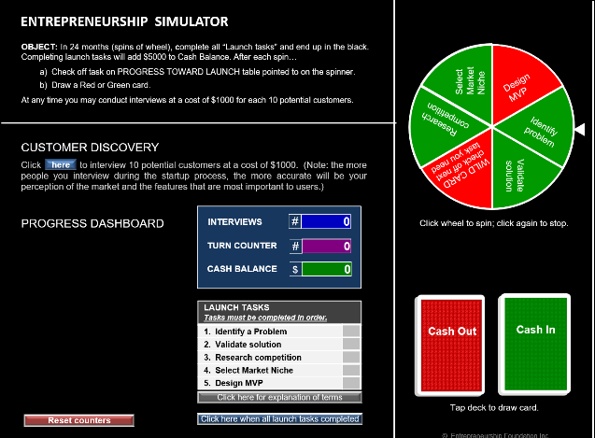
Entrepreneurship Simulation. In this solo exercise, students are immersed in the uncertain life of an entrepreneur. While chance plays a role in the outcome—as it does in real life—students will improve if they learn from the experience the value of “Customer Discovery”.
Student instructions on the home screen. Offered in “Show” (PPTS) format, the sim will open in “kiosk” view instead of edit mode, thus limiting the temptation to hack the game.
Time to play: 10 minutes + debriefing discussion.

