Launching a New Venture

Ninth Edition

Modules 1-2-3-4
Entrepreneurship
Small Business Marketing
Entrepreneurial Finance
Business Planning

Entrepreneurship Foundation, Inc.

Launching a New Venture

Edition 9.0

ISBN: 978-0-9967327-7-2

Module 1 - Entrepreneurship
Startup Checklist, Business Modeling, Problem-Solution Fit, MVP, Product-Market Fit, Competition, Lean BMC, Pricing, Landing Page, Company Name, Protecting IP, Legal Structure, Regulatory Matters, Raising Startup Capital

Module 2 – Small Business Marketing
Branding, Website, Message, Collateral Material, Traditional Mass Media, Digital Mass Media, Targeted Media, Sales

Module 3 – Entrepreneurial Finance
Production and Distribution, HR, Space Requirements, Risk Management, Budgeting, Accounting, Buying a business, Banking, Raising Growth Capital, Pitching business plans

Module 4 - Business Planning
Content, Style

Editor@EntrepreneurshipFoundation.org
© Academy Publishing, 2012, 2014, 2016, 2020, 2023, 2024, 2025 All rights reserved.
DISCLAIMER: The contents of this work are for general informational purposes only and do not constitute legal advice. You should not act or refrain from acting on the basis of any content without seeking professional legal advice. This site contains links to other web sites. We are not responsible for the privacy practices or the content of such web sites, and we do not endorse such sites.
Table of Contents

Module 1 – Entrepreneurship

1.1 – Introduction 8
1.1.1 Checklist 9
1.1.2 Business Modeling 10
1.1.3 INCREMENTAL Launch STRATEGY 11
1.1.4 EntrepreneurSHIP aPTITUDE Self-Assessment 12
1.2 – Problem-Solution Fit: Identifying a Problem and the Best Solution 15
1.2.1 Identify a Real Problem 16
1.2.2 Survey to See if There is a Market for a Solution 17
1.2.3 Ideate: Brainstorm POSSIBLE SOLUTIONS 18
1.2.4 SHORT LIST OF POSSIBLE SOLUTIONs 19
1.2.5 Filter SOLUTIONS BASED oN PATENTABILITY 20
1.2.6 FILTER SOLUTIONS Based on market POTENTIAL 21
1.2.7 FILTER SOLUTIONS Based on Feasibility of Success 22
1.2.8 Validated problem-soLution fit 26
1.3 – Building an MVP for Market Testing 27
1.3.1 Designing a Minimum Viable Product or Service 28
1.3.2 Building a Physical Prototype 29
1.3.3 Software and Mobile App Prototyping 30
1.3.4 Market TESTING THE PRODUCT OR SERVICE 32
1.4 – Product-Market Fit: Perfecting the Solution 33
1.4.1 How to Measure Product–Market Fit 34
1.4.2 FINDING PRODUCT-MARKET FIT 35
1.4.3 Customer Survey to discover buyIng preferences 36
1.5 – Competitive Positioning 37
1.5.1 Researching COMPETITIon 38
1.5.2 Selecting a Target Market Niche 39
1.5.3 dETERMINing Size of Target Market 40
1.5.4 Developing a COMPETITIVE STRATEGY 41
1.5.5 CoMparing Features to Competitor Products 42
1.5.6 Strategizing Barriers to Entry To DETER Competition 43
1.6 – Lean Business Model Canvas 44
1.7 – Pricing the Product or Service 48
1.7.1 PRoduct COMPONENT CostS 49
1.7.2 Shipping AND HANDLING COSTS 50
1.7.3 ESTIMATING TOTAL COST OF PRODUCTION 52
1.7.4 Pricing ProductS 53
1.7.5 Pricing SERVICES 54
1.7.6 TESTING PRICEs WITH A SOFT LAUNCH (The Landing page) 56
1.8 – Naming the Company 58
1.9 – Protecting Intellectual Property 63
1.9.1 Trademarks 64
1.9.2 Patents 66
1.9.3 Trade Secrets 69
1.9.4 CopyrightS 69
1.10 – Structure and Regulatory Matters 70
1.10.1 Finding Your NAICS CODE 71
1.10.2 Federal EIN Number (Employer Identification Number) 71
1.10.3 SETTING UP AN LLC 72
1.10.4 Business Licenses 73
1.11 – Raising Startup Capital 74
1.11.1 Determining Startup capital requirements 75
1.11.2 Sources of Startup Capital 76
1.11.3 Pitching Business Concepts 78

Module 2 – Small Business Marketing

2.1 – Branding 83
2.1.1 Brand Strategy 84
2.1.2 Company NAME 85
2.1.3 design standards 88
2.1.4 Logo 91
2.1.5 Packaging 92
2.1.6 Labeling 93
2.1.7 PHONE Number 94
2.1.8 Business Email Address 95
2.2 – Website 96
2.2.1 Choosing A DOMAIN NAME 97
2.2.2 SELECTING A WEBSITE HOSTING Service 98
2.2.3 WEBSITE EVALUATION 99
2.2.4 SEARCH ENGINE OPTIMIZATION (SEO) 100
2.3 – Marketing (The Message) 101
2.3.1 Marketing Strategy 102
2.3.2 PRESENTING PRICES TO BEST ADVANTAGE 103
2.3.3 Posting Prices in a Compelling Manner 104
2.3.4 Content for Ads 105
2.3.5 USING AI To Draft Ad Copy 106
2.3.6 PHOTOGRAPHS 107
2.3.7 MARKETING Plan and BUDGET 108
2.4 – Marketing (Collateral Material) 109
2.4.1 Business cards 110
2.4.2 POSTERS 111
2.4.3 FLYERS AND BROCHURES 113
2.4.4 Printing Through a Cloud-Based Service 114
2.4.5 Marketing Videos 115
2.5 – Marketing (Traditional Mass Media) 118
2.5.1 Publicity 119
2.5.2 TV ADVERTISING 121
2.5.3 RADIO ADVERTISING 122
2.5.4 BILLBOARDS 123
2.5.5 KIOSKS 124
2.5.6 NEWSPAPERS 125
2.5.7 MAGAZINES 126
2.6 – Marketing (Digital Mass Media) 128
2.6.1 FREE WEB ADVERTISING (local SEARCH DirectorieS) 129
2.6.2 PAID Web Advertising: Search Engine Marketing (SEM) 130
2.6.3 Social Media MARKETING (smm) 131
2.6.4 SOCIAL MEDIA INFLUENCERS 132
2.7 – Marketing (Targeted Media) 133
2.7.1 DIRECT MAIL MARKETING 134
2.7.2 EMAIL MARKETING 135
2.8 – Direct Sales (Online and In Person) 140
2.8.1 Online Sales 141
2.8.2 TRADE SHOWS, FLEA MARKETS AND POP-UPS 142
2.8.3 SELLING FROM BEHIND A TABLE 143
2.8.4 NETWORKING TO GENERATE LEADS (B-B) 144
2.8.5 The Sales Call (B-B) 145
2.8.6 Indirect Selling (To Distributors, Reps, and Retailers) 146
2.8.7 ACCEPTING ELECTRONIC PAYMENTS 147

Module 3 – Entrepreneurial Finance

3.1 – Production, Importing and Distribution 150
3.1.1 Production 151
3.1.2 IMPORTING 152
3.1.3 Distribution (Delivering Orders) 154
3.2 – Human Resources 155
3.2.1 BUILDING THE Management Team 156
3.2.2 Assessing skill needs 157
3.2.3 Your Management Team 158
3.2.4 hiring 159
3.2.5 Payroll REPORTING REQUIREMENTS 160
3.2.6 Incentivizing THE MANAGEMENT TEAM 161
3.2.7 Team Collaboration 162
3.2.8 ADVISORY COMMITTEE (Non-paid Members of the Team) 163
3.2.9 Selecting an Attorney 164
3.3 – Space 165
3.3.1 Sourcing Physical Locations 166
3.3.2 Comparing Locations 167
3.4 – Risk Management 168
3.4.1 RISK ANALYSIS 169
3.4.2 RISK MITIGATION 171
3.4.3 Business Insurance 172
3.5 – Budgeting and Accounting 175
3.5.1 Credit and Collections Policies 176
3.5.2 swot analysis 178
3.5.3 Personal INCOME AND Expense Budget 180
3.5.4 PAYROLL TAXES 181
3.5.5 BUSINESS BUDGETING 182
3.5.6 Cash Flow Forecasting 186
3.5.7 Break-Even and PROFIT MARGIN Calculation 187
3.5.8 cAPTIAL REQUIRMENTS FOR LAUNCH 188
3.5.9 Accounting 189
3.6 - Buying a Business or Franchise 190
3.6.1 Buying an Existing Business 191
3.6.2 Buying a FRANCHISE 193
3.7 - Banking 195
3.7.1 Selecting a Bank 196
3.7.2 Opening A Bank Account 198
3.7.3 Ordering Checks and Banking Supplies 199
3.8 – Raising Growth Capital 201
3.8.1 DETERMINING GROWTH CAPITAL REQUIREMENTS 202
3.8.2 Internal Sources of Growth Capital 203
3.8.3 TYPES OF EXTERNAL GROWTH CAPITAL 204
3.8.4 DEBT CAPITAL 205
3.8.5 EQUITY CAPITAL 206
3.8.6 OWNERSHIP RETENTION WHEN RAISING EQUITY CAPITAL 207
3.8.7 VALUATION (ESTIMATING THE FUTURE VALUE OF A VENTURE) 208
3.8.8 VALUATION (ESTIMATING PRESENT VALUE OF A VENTURE) 209
3.8.9 THE TERM SHEET 211
3.8.10 EQUITY CAPITALIZATION SCHEDULE (CAP TABLE) 212
3.8.11 EXIT STRATEGY 213
3.9 – Pitching Business Plans to Competition Judges and Capital Providers 214
3.9.1 Oral Presentations 215
3.9.2 Content of Presentation OR Written EXECUTIVE SUMMARY 217
3.9.3 Questions You Should Be Prepared to Answer 220
3.9.4 Style: DELIVERING Convincing Presentations 222
3.9.5 The Slides 223
3.9.6 HOW CAPITAL PROVIDERS EVALUATE PROPOSALS 224
Module 4 - Business Planning

4.1 – Business Plan Outline 227
4.1.1 Executive Summary 228
4.1.2 Product or Service 229
4.1.3 Market size (sales Potential) 229
4.1.4 MARKETING AND SALES STRATEGY 231
4.1.5 COMPETITION 235
4.1.6 BARRIERS TO ENTRY (Protecting your market niche) 236
4.1.7 RISK ANALYSIS 237
4.1.8 PRODUCTION (OPERATIONS) 238
4.1.9 MANAGEMENT 239
4.1.10 HUMAN RESOURCES 240
4.1.11 FINANCE 241
4.1.12 RESOURCES NEEDED TO LAUNCH BUSINESS 244
4.1.13 CAPITAL REQUIREMENT 245
4.1.14 APPENDICES 246
4.2 – Bullet-Proofing The Plan 247
4.2.1 Content Mistakes 248
4.2.2 Financial Model Mistakes. 251
4.2.3 Stylistic Mistakes 252
4.2.4 Execution Mistakes 252
4.3 – Professional Writing Style 253

Launching a New Venture

Ninth Edition

Module 1
Entrepreneurship
Problem, Solution, MVP, Competition, BMC, Pricing,
Company name, Website, Protecting IP, Legal Structure, Regulatory matters

Entrepreneurship Foundation, Inc.

Module 1 - Entrepreneurship Chapter 1 - Introduction

1.1 – Introduction

1.1.1 Checklist

1.1.2 Business Modeling

1.1.3 Incremental Launch Strategy

1.1.4 Entrepreneurship Aptitude Self-Assessment

Entrepreneurship is the art of solving a problem with a new product or service, and building a business to produce, market and deliver that solution.

Launching a new venture is rewarding, creative, and allows true freedom. It also involves risk and uncertainty. Those who want a predictable income through traditional employment will still benefit from an understanding of entrepreneurship. The skills you acquire will help you advance in any company. Entrepreneurship inside a firm is called intrapreneurship.

What is the life you want? What are your personal goals? Where do you want to be in five years? Ten Years? Then decide whether starting a new venture as an entrepreneur, or working for someone else as an intrapreneur, is the best way to achieve them. To help you choose the right path, see the Entrepreneurship Aptitude Assessment at the end of this chapter.

IF YOU DO WANT TO START YOUR OWN BUSINESS, do you think you would be happier running a personal business or high-growth enterprise?

ASPECT OF BUSINESS | PERSONAL BUSINESS | HIGH GROWTH ENTERPRISE
Time and Attention Required | You can still have a life | Business will be your life until you can hire others to help
Scalable (average product cost declines as volume increases) | No (e.g. – If it takes 3 people to roof one house, it takes 6 to roof 2 houses) | Yes (e.g.– software or music. The orignal may cost $100,000 to create; but the second is only $.50)
Annual Sales Potential | $100,000 to $500,000 | $50,000,000 (amount necessary to attract investors)
Geographic Range of Market | Neighborhood or Town | State, country or world
Capital needed to launch | $5000 to $500,000 | $50,000 to $250,000
Typical Sources of Startup Capital | Savings, credit cards, family | Savings, credit cards, family

Module 1 - Entrepreneurship Chapter 1 - Introduction

1.1.1 Checklist

Click on a topic to go to that secion in the book.

BUSINESS MODELING - Conceive and validate a winning concept
- □ Indentify a Real Problem to Address
- □ Determine If There Is a Market for a Solution (Interview people with problem)
- □ Brainstorm Possible Solutions
- □ Filter Solutions: Patentability
- □ Filter Solutions: Market Potential
- □ Filter Solutions: Feasibility
- □ Achieve Problem-Solution Fit
- □ Design a Minimum Viable Product or Service (MVP)
- □ Build and Test an MVP Prototype
- □ Achieve Product–Market Fit: Solution is repeatable, profitable, and sustainable
- □ Research Competition
- □ Select A Market Niche
- □ Determine Size of Target Market Niche
- □ Strategize Barriers to Entry – To hold Competitors at Bay
- □ Draft a Business Model Canvas
PRODUCT OR SERVICE
- □ Determine Price for Product or Service
- □ Test Price Acceptability with a Landing Page
MARKETING
- □ Select Best Name for Company
LEGAL
- □ Decide Which Intellectual Property Protections to Pursue
- □ Determine NAICS code
- □ Obtain Federal Employer Identification Number (EIN)
- □ Set up LLC (if appropriate)
- □ Determine Business Licenses and Permits Needed
CAPITAL
- □ Determine Startup Capital Requirements
- □ Write a 60-Second Elevator Pitch

Module 1 - Entrepreneurship Chapter 1 - Introduction

1.1.2 Business Modeling

ITERATIVE BUSINESS MODELING VERSUS TRADITIONAL BUSINESS PLANNING. Business Modeling is based on the premise that a traditional business plan is not suited to a new venture. Formal business plans and proforma financials presume the new venture must immediately support the founder on a full-time permanent basis (a legacy from large-company planning). But for a startup ...

- ​​Long-range forecasts are largely discounted by investors. According to John Seiffer, former president of the Angel Investor Forum, "It is not an efficient use of time and energy to prepare elaborate 20-page pro formas on untested concepts."
- A new business concept is really a set of unproven hypotheses. These include: demand per price point, production costs, feasible distribution channels, cost for post-purchase customer service, production lead times, repeat sales rates, and preferred features.

Champions of business modeling, Eisenmann (Harvard), Bob Dorf (Columbia), and Steve Blank (Stanford) assert that startups need a plan to FIND a sustainable business model. Nathan Furr, a contributing writer to Forbes, differentiates the two approaches this way:

“In a business plan, you are trying to plan, inside the building, the optimal solution that you can execute. In a business model process, you recognize that everything is a guess that has to be tested, outside the building, with the goal of learning” what will work.

“Startups are more likely to succeed when they rapidly and iteratively test assumptions about a new venture’s business model based on customer feedback, then quickly refine promising concepts and ruthlessly cull the flops. New ventures that follow this approach are lean startups.”

Bear in mind that formulating a business model is a non-linear process. As each aspect of the business is refined, an entrepreneur may have to revise budgets, production plans, distribution channels, or even the product itself.

TRADITIONAL BUSINESS PLANNING. But once you do arrive at a sustainable business model, you will need a comprehensive business plan to to secure growth financing. Still, as serial investor David Rose warns: “A real business plan is never done.” Tim Perry refers to the continuing updating process as PRRR: Plan, Run the plan, Review the plan based on results and customer feedback, and Revise.

Module 1 - Entrepreneurship Chapter 1 - Introduction

1.1.3 INCREMENTAL Launch STRATEGY

The strategy recommended in this text is to establish a new business in stages, with each milestone confirming the assumptions necessary to advance to the next.
DISCOVER A VIABLE BUSINESS CONCEPT using the Lean Startup Method: market testing iterative versions of a product or service, with a limited number of customers. A venture starts with a a Minimum Viable Product (MVP), a prototype with the fewest number of features to test customer acceptance, then refines and iterates based on feedback until it discover a profitable and sustainable model.

START SMALL. Bootstrap the business with what you can save or borrow comfortably. If your dream is a restaurant, start with a food cart, second-hand.
VIDE Lean Startup Method. https://www.youtube.com/watch?v=QaoVWtLX038
GROW ORGANICALLY. Use the proceeds from your first sales to buy the materials for your second round of production. You may be able to gradually increase the volume of purchasing and production to grow organically without ever having to raise outside capital.

MINIMIZE RISK. If you do need outside investment, raise only the amount of capital required at each stage, rather than raising in advance the entire amount necessary to take an idea to profitability. Successfully mastering each stage before raising funds for the next will also allow you to negotiate more favorable financing terms.

This incremental approach reduces risk. The process of launching a startup is divided into capitalization tranches, corresponding to the stages of development of the business. The incremental approach allows the entrepreneur or investor the opportunity to withdraw from the venture at an interim stage if expected results are not attained. For example, an investor might agree to provide a total of $250,000 to bring a new idea to the market, provided interim milestones are achieved. Initially, the investor might provide $25,000 to apply for a patent, but if the patent is not received, the investor would then not be obligated to provide the balance of the capital.

TYPICAL LAUNCH STAGES

Stage 1: Advance the idea on paper—without financing—to the furthest extent possible.
Stage 2: Save your own money in a business savings account to build, bench test, and market test a minimum viable product, performing as much of the work yourself to conserve capital.
Stage 3: Raise seed capital from crowd sources to launch business on a part-time basis. (Do not quit the day job just yet.)
Stage 4: Raise growth capital from an angel, VC or bank once the business proves itself as a long-term source of increasing revenue.

“The goal of an entrepreneur is to find a repeatable and scalable business model.”
– Steve Blank
Module 1 - Entrepreneurship Chapter 1 - Introduction

1.1.4 EntrepreneurSHIP aPTITUDE Self-Assessment

By: Ken Kollmeyer, Small Business Development Specialist

IS ENTREPRENEURSHIP RIGHT FOR YOU? An entrepreneur should think about how they will feel about the loss of 1) steady income, 2) paid holidays and vacations, 3) regular working hours, 4) reduced family time, 5) peace of mind and 6) financial security. Some not too far-fetched scenarios for consideration might include:
a) it’s 2:00 am; your phone rings and it’s your alarm company advising you that a door alarm at your building has been activated. They ask you if you will be driving to the facility to meet the police. What do you do?
b) you have a small boutique across from a mall and you have decided that you will open on the July 4th holiday to take advantage of the traffic from a sale at the mall. Sally, your lone employee has agreed to cover the day but has become ill and contacts you during the early morning hours on the Holiday. You have committed to spending the day at the beach with your family; all family members have been looking forward to this day. What will you do? Will you open the shop and abandon your family plans, or will you keep the shop closed? What if you had already bought a newspaper ad saying that you would be open?

Small Business-a Roller Coaster Ride: Starting and running a small business can truly be a ‘double-edged sword’. There can be exhilarating highs and there can be harsh lows. Think about the following possibilities:
- You are the focal point and carry the prestige that owning a business can bring; you are the proverbial point at which the buck stops.
- You have independence and can come and go as you wish; you will need to accept 60- to 84-hour workweeks as a fact of entrepreneurial life, and you cannot quit.
- Running a successful small business can be gratifying and uplifting; But if your business is underperforming and you are struggling to pay your bills, your ego may suffer.
- Attaining your dream of financial security can bring a lifestyle filled with many creature comforts; But owning a business can also result in fluctuating levels of income and the loss of your investment.
- Since your business is your dream, it is your ‘labor of love’; in some instances, however, the pressures and stresses of running a business may turn your vocation into drudgery.

Insightful Questions: To come to grips with whether you have what it takes to be a successful entrepreneur, here are some insightful questions to answer before taking the leap:
 | PREPAREDNESS | YES = 5 | 4 | 3 | 2 | NO = 1
1 | Do I have the skills to start and operate a business?
2 | Do I have substantial experience in the type of business I want to start?
3 | What is motivating me to act, and can these motivators be sustained?
4 | Do risk taking and I get along?
5 | Can I afford to lose the money I need to invest?
6 | Have I allowed my family or significant others to voice their true feelings about this significant commitment of time and finances?

Module 1 - Entrepreneurship Chapter 1 - Introduction

Inventory Your Skills: Have you taken an inventory of your skills? Do you possess a reasonable level of proficiency across the various business disciplines (e.g., sales, marketing, finance, operations, etc.)?
- Basic math skills are unavoidable. You will need to be reasonably comfortable working with numbers (e.g., addition, subtraction, multiplication, division, ratios). Can you analyze revenue and expense figures to determine what products or services are profitable, and which are unprofitable? Can you determine what level of sales and profit increases might justify a 20% increase in advertising?
- People skills are indispensable. Running a business will require you to interact with other people. After all, your customers, employees, suppliers, lenders and advisors are people.
- Solid written and verbal communication skills are critically important to your success. Observe almost any ‘help wanted’ classified advertisement. How many positions of leadership do not require ‘strong written and verbal’ communication skills?
- A solid grounding in technology is also a logical prerequisite for a successful small business.
- Possessing a ‘Passion to Learn’ will serve you well. You will need to look at all facets of your business for an understanding of why it is working or not working.
- Are you grounded in reality? Can you be honest and face your strengths and weaknesses?

Compare your skill set proficiency against these requirements and should you arrive at the conclusion that you are indeed deficient in one or more competencies, do not despair. Help is available. Individual and multiple session seminars, workshops, and courses are available through SCORE and the Small Business Development Centers.
 | SELF-CRITIQUING SKILLS | YES = 5 | 4 | 3 | 2 | NO = 1
7 | Do I seek advice and feedback?
8 | Do I listen to my critics?
9 | Do I take the criticism to heart?
10 | Do I apply what I learn?

Common Characteristics of Successful Entrepreneurs.

Experience. Therefore, take the necessary time to learn as much as you can about your business. If you have never performed your intended business’s work, take a job(s) that will provide you with the necessary insights and feel for its unique rhythm and challenges.

Personality. Personality is a component of the ‘art form’ of management. In many respects, it is part of your DNA. Answer these questions honestly:
 | IS THIS REALLY WHAT I WANT | YES = 5 | 4 | 3 | 2 | NO = 1
11 | Do I like to sell?
12 | Can I persevere and stay focused?
13 | Can I interact effectively with others?
14 | Can I inspire and motivate others?
15 | Am I an effective listener?
16 | Am I competitive?
17 | Am I a self-starter?
18 | Am I comfortable with ambiguity?

Module 1 - Entrepreneurship Chapter 1 - Introduction

If you did not answer yes to most of these questions, you probably will find the road to small business ownership success to be very bumpy and possibly distressful.

Managerial Ability. In the business world, achieving positive results through other people is an ever-present challenge. Are you skilled and able to do the following?
 | MANAGERIAL ABILITY | YES = 5 | 4 | 3 | 2 | NO = 1
19 | Manage people?
20 | Deliver results?
21 | Maintain a tight control over the money?
22 | Keep accurate records?
23 | Understand the relationships between resources, assets and financial results?

Courage. Starting and running a business will require you to deal with various issues. Avoidance will usually translate into costs and will reduce profit. Therefore, can and will you:

 | COURAGE | YES = 5 | 4 | 3 | 2 | NO = 1
24 | Deal with adversity ‘head on’?
25 | Make bold and difficult business decisions in a timely fashion?
26 | Not become easily discouraged or intimidated?

IN CONCLUSION: The preceding thoughts and information are meant to provide a ‘reality check’ and ‘food for thought’ for all would-be entrepreneurs. In many instances, deciding not to take this plunge will be the correct decision. Entrepreneurship and business ownership is not for everyone. Eight of ten businesses will fail within the initial five years of operation. Finding out the hard way can lead to the loss of your home, financial security, health and even your family.

However, let us not lose sight of the fact that many storied entrepreneurs have indeed forged ahead starting and owning small businesses that have grown into significant companies. It can be done. Examples include Intel; Jet Blue, Subway Restaurants, Microsoft, and Walmart to name but a few. All started with an entrepreneur’s dream and that dream was nurtured with hard work, capital and passion.

The key is to be informed and to be true to yourself; then make the big decision.

Module 1 - Entrepreneurship Chapter 2 - Problem-Solution Fit

1.2 – Problem-Solution Fit:
Identifying a Problem and
the Best Solution

Using insights from market research, in-person interviews, and surveys, problem-Solution Fit focuses on on identifying an intense problem, explores whether there is a viable market for a solution, and formulates the ideal solution to the problem. The process also helps define a target market and competitive positioning.

1.2.1 Identify a Real Problem
1.2.2 Survey to See if There is a Market for a Solution
1.2.3 Ideate: Brainstorm Possible Solutions
1.2.4 Short List of Possible Solutions
1.2.5 Filter Solutions Based on Patentability
1.2.6 Filter Solutions Based on Market Potential
1.2.7 Filter Solutions Based on Feasibility of Success
1.2-8 Validated Problem-Solution Fit

Module 1 - Entrepreneurship Chapter 2 - Problem-Solution Fit

1.2.1 Identify a Real Problem

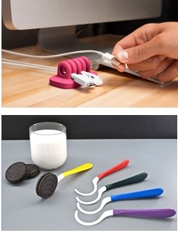
According to Thomas Eisenmann, “Most startups fail—usually due to lack of customer demand—not product development problems. These new ventures burn through their capital, wasting money on engineering and marketing before discovering they have built a product no one wants. These new ventures fail not because the innovation did not work; but because the founders did not guage the market’s ability or willingness to adopt it.”
What problem (customer pain) does each of these products solve?

All successful companies start with identifying a problem, and then brainstorming and testing possible solutions until they discover a sustainable business model

Investigate a market in which you have an interest. What are you passionate about? What would you be happy doing the rest of your life? It might be a hobby, a social need, or a sport you follow. One innovator developed a product to filter out carbon monoxide from the air race drivers breathe. He discovered the problem by talking to drivers.

Jane Porter, writing in Entrepreneur magazine, asks, “What bugs you?” Then suggests, “Do something about it!”


WHERE TO LOOK FOR PROBLEMS
- Amazon.com: what are the top nonfiction books (what problems are people trying to solve?)
- Google trending searches: http://www.google.com/trends/hottrends
- Needs Identifier https://www.kolenda.io/tools/needs-generator employs AI to uncover customer needs by industry. (Confirm results with customer interviews.)

ADDRESS AN OLD PROBLEM NOT ADEQUATELY SOLVED. What problems persist? Ask people who likely deal with the issue.


FIND A MARKET NICHE NOT CURRENTLY SERVED. Is there a need for a left-handed version? Foreign-language version? Organic model? Disposable (e.g. - Pampers)? Major corporations target a new product or service to the largest buying demographic. However, one size does not always fit all consumers.

RESPOND TO AN EMERGING PROBLEM. Covid caused the demand for disposable face masks to spike.
LOOK FOR PROBLEMS CAUSED BY NEW SOLUTIONS. The mobile phone made calling possible anywhere anytime. But it created a new problem: the cost of repairing the phone if dropped. (Users seldom dropped a wall phone or desk set.) What solution did entrepreneurs create? What opportunities are being created by new technologies? Peruse Wired magazine (a publication that monitors the future).

Module 1 - Entrepreneurship Chapter 2 - Problem-Solution Fit

1.2.2 Survey to See if There is a Market for a Solution

Once you identify a problem you would like to address, interview potential customers. Is it a real problem? How strong is the desire to be rid of it? Would anyone pay for any solution? Probe for details by asking follow-up questions: “Why is that important?” Your first objective is to validate the pain, not to validate a solution. Do not discuss solutions yet; keep an open mind.

Prepare an 8-second preview to place your questions in context. Describe the problem you want to solve: “Hi, I’m Tyler Swift, and I’m talking to people about paparazzi.”
Respondent Demographics Estimated age >> | 1  M – F  Age~____ | 2  M – F  Age~____ | 3  M – F  Age~____ | 4  M – F  Age~____ | 5  M – F  Age~____
A. [Qualifying question]  Are you hounded by paparazzi? | Y / N | Y / N | Y / N | Y / N | Y / N
B How often?
5 = Constantly
4 = Once a day
3 = Once a week
2 = Once a month
1 = Once or twice a year
C. How much of an annoyance are they?
5 = Dangerously so, pushing and shoving
4 = They stalk my family
3 = I cannot have a life.
3 = They get in the way
2 = They can be rude
1 = Not really a problem
D. Any suggestions for a solution?
[Do not approach problem investigation with a pre-conceived solution; keep an open mind]
E. How much would it be worth, per month, to solve this problem?
5 = $ 500
4 = $ 200
3 = $ 100
2 = $ 10
1 = $ 0

Module 1 - Entrepreneurship Chapter 2 - Problem-Solution Fit

1.2.3 Ideate: Brainstorm POSSIBLE SOLUTIONS

Now that you have verified that the problem is real and those who experience it will gladly pay for an effective solution, time can now be invested productively conceptualizing products or services to reduce or eliminate the problem.

But keep it real: Place-based businesses (restaurants, retail stores, gyms) may require $150,000 or more to set up; and raising that kind of money from a bank or investors for a startup is not realistic. Pick something that you can fund now or open a bank account in the name of the business and set aside $50 a week, $500 per month, or whatever you can afford. And do not touch this money. It is for your future.

To maximize your chance of success, Sam Altman, of Open AI and Y Combinator, suggests that you Explore opportunities at the intersection of your skills, excitement and needs of the world.
- Greenlighting. Jot down ideas as quickly as they come to you. Then go back over the list and narrow to a manageable number to research. Think about innovation during down time: while driving, in the shower.

- Improve an existing solution by making it...
  - Cheaper (Model T Ford),
  - Faster (McDonalds hamburgers, Amazon delivery),
  - Better (Starbucks coffee, Google search),
  - Customized or personalized (American Girl dolls)
  - Less worrisome, with superior customer service (State Farm Insurance: “"Like a good neighbor…."
What successful businesses can you think of that did not invent a solution, but rather improved upon one?
Talk to consumers about what they feel is missing or needs improvement in current solutions.
- Seek insights from suppliers and service providers in your industry. If you are planning a restaurant, talk to the food and beverage distributors. They know what sells in your area.
- Outsighting. Talk to people outside your industry or area of expertise to gain fresh insight into solutions.
- Peruse Trend-Monitoring Websites
  - https://www.trendhunter.com/
  - https://cassandra.co/ For insights on Millennial, Gen Z, and Gen Alpha
- Surf media. Look for ideas, trends, events, anything that is not in your daily line of sight.
- TechCrunch Media, an online tech news platform https://techcrunch.com.
- Entrepreneur Magazine, information and inspiration for starting or growing a business. https://entrepreneur.com. While you are there, check out the database on franchises.
- Quirky, an online platform that pairs inventors with product designers and companies that can bring ideas to market. https://quirky.com
- Consult an idea generating site: http://www.entrepreneur.com/businessideas
- Check new-product launch sites http://www.Kickstarter.com and http://www.IndieGoGo.com. What is getting attention?
- Consider combining two products to make something new. Steve Wozniak wired a TV screen to a digital computer to invent the PC. Now anyone can run (or even write) software in their home or office.
Module 1 - Entrepreneurship Chapter 2 - Problem-Solution Fit

1.2.4 SHORT LIST OF POSSIBLE SOLUTIONs

But catch the start of the wave. If you wait too long you will have to compete with dozens of others fighting over the scraps left by the first movers. Don’t get wiped out.

There is a tide in the affairs of men
Which taken at the flood, leads on to fortune -- William Shakespeare

A. Product or Service _______________________________________________________________________________________

_______________________________________________________________________________________
Problem it solves:
_______________________________________________________________________________________

_______________________________________________________________________________________

B. Product or Service _________________________________________________________________________

_________________________________________________________________________
Problem it solves:
_________________________________________________________________________

_________________________________________________________________________

C. Product or Service _________________________________________________________________________

_________________________________________________________________________
Problem it solves:
_________________________________________________________________________

_________________________________________________________________________

D. Product or Service _________________________________________________________________________

_________________________________________________________________________
Problem it solves:
_________________________________________________________________________

_________________________________________________________________________
Module 1 - Entrepreneurship Chapter 2 - Problem-Solution Fit

1.2.5 Filter SOLUTIONS BASED oN PATENTABILITY

If your idea is a product or process, make sure it is not already patented, and therefore you have the right to make it. The legal termfor this is Freedom to Operate (FTO). You can conduct a patent search at patents.Google.com or www.USPTO.gov. For guidance see https://ppubs.uspto.gov/pubwebapp/static/pages/quick-reference-guides.html

Whether or not you should seek a patent is a very different question that you can postpone until you have verified that your idea is feasible and that there is adequate demand. For more information see section on “Patenting”.

Give some thought to your search words and phrases. For example, if you have an idea for a better mousetrap, you will want to search for mouse, mousetrap, mouse capture, mouse eradicator, rodent trap, pest control, etc.
Enter below the terms you used to search for patents related to your ideas.
PRODUCT IDEA A __________________________________________________________________________
PRODUCT IDEA B __________________________________________________________________________

If you do not find a patent for your idea, it could be because...
- YOUR IDEA HAS NOT BEEN PATENTED
- THE PRODUCT CANNOT BE PATENTED BECAUSE IT IS “OBVIOUS.” The non-obvious requirement is defined by the Patent Office as an invention or improvement that would not have been obvious "to a person having ordinary skill in the art to which the claimed invention pertains.”
- THE IDEA HAS BEEN PATENTED, BUT YOU DID NOT USE A SEARCH TERM WOULD FIND IT.

HOW TO LOOK FOR SOMETHING YOU HOPE NOT TO FIND. This is probably the hardest thing for an innovator to do. Several ways to reduce the chances of missing something in your patent search are:
- Have a disinterested party do the search. A patent attorney might charge $500 or more for this service.
- Try every conceivable search term for your product or service, and their synonyms. For example, for a tic-tac-toe game for mobile phones, try mobile game, phone game, electronic games, tic-tac-toe, tic tac toe, and “noughts and crosses” (an early name for the game).
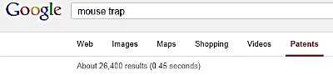
IF YOU DO FIND A PRIOR PATENT, Share the first page of your search results with a patent attorney. Your product may still be—or with some modification, could be—different enough from the original to not violate the existing patent. For example, if you search for “mousetrap”, you will find thousands of patents. So just because a mousetrap has been patented does not mean there isn’t room for one more.

26,400 hits for “Mouse trap”

NUMBER OF HITS FOR YOUR IDEAS: Idea A ( ) Idea A ( )
IF YOU DO NOT FIND A PRIOR PATENT that might prohibit you from producing a product, you can file a patent application. For a list of filing fees see section in this text on “Patenting” The Patent Office will check for any conflicts before issuing you a patent. In some cases, however, a prior patent holder might still sue you, claiming the patent office made a mistake and should not have issued you a patent. So best to work with an experienced patent attorney. Alternatively, you can request a Freedom to Operate opinion from an attorney. This is expensive and could cost $25,000 or more. However, an investor may require you to obtain an FTO opinion.

Module 1 - Entrepreneurship Chapter 2 - Problem-Solution Fit

1.2.6 FILTER SOLUTIONS Based on market POTENTIAL

Now that you have identified a real problem and devised some possible solutions, you’re ready to validate the potential market demand.

AI MARKET RESEARCH: PROMPT: Bill Schloth of www.USBizStrong.org offers this as a quick way to obtain a quick market everview:
“Conduct a comprehensive market analysis for [specific industry/product in geographic area], identifying key trends, customer preferences, and competitive landscape.”

SECONDARY RESEARCH. Visit sites where similar products might be offered for sale such as:
- www.Amazon.com
- www.Etsy.com
- www.Shopify.com
- www.eBay.com (It’s not just collectibles; many companies us eBay to sell new products.)
Even www.Pinterest.com can be a useful market research source as it may indicate how passionate consumers may be about a particular item.

DEMAND VERSUS PRICE RESEARCH (How much will the market bear?) Assume you want to introduce a new board game. A search for “Board Games” on Amazon delivered 80,000 results! Okay, you’re going to have lots of competition, but you knew that. What else can you learn?

Below is a screenshot from 2025 of “board games” for sale on Amazon. Selecting “Board Games Under $30” produced 50,000 results. Only 10,000 games were sold in the $30-$60 range; and an equal number above $60. This reveals that most board game competitors sell their products for under $30.

Note also that Amazon shows how many of each item sold in the past month. Look for products similar to the one you want to launch. How many were sold? At each price point? If only 50 were sold nationally last month, this would suggest a small market; but if 5000 were sold, perhaps the marketplace could tolerate another entry. For even more insight, click on the ratings. What do customers like/not like about the current offerings? This will help you decide which features to offer and how to beat the competition at their own game.

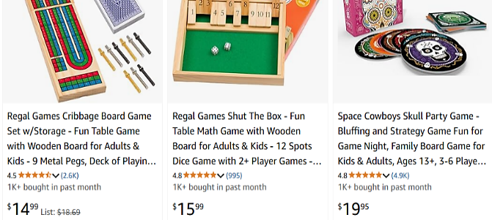
Module 1 - Entrepreneurship Chapter 2 - Problem-Solution Fit

1.2.7 FILTER SOLUTIONS Based on Feasibility of Success

Evaluating your ideas to identify the one most likely to succeed.

Complete a feasibility analysis for each idea. Verify assumptions through interviews, market research and discussion with advisers. Total the scores and enter on the “Summary” page at end of this section.

A. Industry and Competition (Variables affecting potential success of concept)
 |  | +1 | 0 | -1
1 | Growth rate of market:  companies in industry are typically...  The Risk Management Association publishes financial data on over 700 industries.  Ask if your library has the RMA Annual Statement Studies. | ...New and adding employees (check help wanted ads). | Stable or growing slowly. Busy, but no lines at registers. | Mature or declining. Advertising copy reveals desperation.
2 | Dependency on suppliers | Many alternative suppliers | Few suppliers, but prices have been stable for years. | Only a few suppliers. They set prices (e.g.- DeBeers diamonds)
3 | Competition in market niche | No direct competitors. | A few small competitors, and most are new | Market crowded and some competitors have deep pockets
4 | Industry profitability  PERSONAL BUSINESSES  See www.bizbuysell.com for offering prices for businesses like the one you want to start.  The site indicates the annual “cash flow” (amount owner earns before taxes). | Adequate to live on and repay a loan for startup costs. | Profits adequate to live on | Many similar businesses available for purchase.
4 | VENTURE ENTERPRISES | Net profit at least 10% and adequate to repay investors 10 times in 5 years | Industry profit percentages are a few points above prime rate | Industry profit percentages are at or near Consumer Price Index

B. Market Niche
1 | Annual sales potential  PERSONAL BUSINESSES  VENTURE ENTERPRISES | $ 1,000,000  $ 1,000,000,000 | $ 500,000  $ 50,000,000 | $ 250,000  $10,000,000
2 | Market trend (Total industry sales growth, year over year) | A hot new trend | Demand has settled down, but market is still growing by 5% annually | Stagnant. Item is passé; or anyone  who wanted one has one
3 | Purchase frequency. Do customers tend to make repeat purchases (as in banking, gyms, food products)? | You sell blades that fit only your razor. Customers buy monthly. | Customers buy quarterly but not necessarily from you | Your product lasts a year or longer. (When was last time you bought a hammer?).
4 | Customer pain intensity | Solution is a must-have: Eating out occasionally | Customers need your product but are not enthusiast. Groceries | Customers are ambivalent.  Squash
Module 1 - Entrepreneurship Chapter 2 - Problem-Solution Fit

C. Customers (Liklihood they’ll adopt new idea)
 |  | +1 | 0 | -1
1 | Customer Inertia. IF A NEW SOLUTION, to what degree will customers have to change practices or habits to adopt? | Little or no change in habits necessary. | Moderate change necessary for adoption. | Substantial change in habits necessary, plus retraining or one-time cost to switch over.
1 | IF AN IMPROVED VERSION OF EXISTING PRODUCT, how willing are users in target market to  adopt new ideas and solutions? | Customers are early adopters, tech savvy, fearless. eager to try new ideas. | Neither averse to nor eager to try new things. | Customers tend to show brand loyalty, are risk averse, or tied to old ways.
2 | Customer satisfaction with current solutions and alternatives | Desperate for a better solution. | Ambivalent. | Customers like current solutions.
4 | Customer budget for product category | High. | Medium. | Low
4 | Customer bargaining power  relative to yours | Enough potential customers that you will only have to sell less than1% to reach goal. | You will have to sell 1-2% of customer base to reach goal. | You will have to sell  more than 2% of customer base to reach goal.

D. Comparative Advantage of Concept
1 | Degree of improvement of new  idea over existing products or services | Market disruptor; earth shaking improvement. | Somewhat better than alternatives. | Equal to, but different from current solutions.
2 | Your can erect “barriers to entry” to keep other companies from copying your concept | Patentable or you have an exclusive  Contract. | Secret sauce (process difficult to reverse engineer); or you have first-mover advantage. | No way to protect your idea.
3 | Scale advantage. Is each successive product or service cheaper to produce and deliver? | Cost of each additional product is lower than first (e.g.- software). | There is some gain in efficiency from experience and volume production. | No. Each product costs as much as the one before (e.g.-kitchen remodeling).
4 | Complexity | Opportunity is easy to launch and grow. You control all the necessary resources | Will involve other people or companies, but you have proof they are on board. | Requires cooperation from other people or companies. Many moving parts that must come together. Investors will avoid as too risky.
Module 1 - Entrepreneurship Chapter 2 - Problem-Solution Fit

E. Costs
 |  | +1 | 0 | -1
1 | Startup cost: the amount of capital required to launch business  FOR PERSONAL BUSINESS | Well within your personal budget. No need to raise capital. | Significant amount, but loan payments manageable – even  if business fails | You risk losing home if business fails.
1 | FOR VENTURE ENTERPRISE  Initial capital for proof of concept >  Additional to reach break-even > | $ 10,000 or less  $ 250,000 | $ 25,000  $ 500,000 | $ 100,000  $ 1,000,000
2 | Space costs | You can work from home. | Only need small office or shared space. | Would need to sign a  five-year lease for necessary space.
3 | Labor cost | Plentiful low-cost talent available. | Moderate cost (e.g.-salespeople). | High-cost (e.g. – MBAs,  proven marketers, programmers)
4 | Advertising cost  (Customer acquisition cost) | Free. Only need social media | Affordable; only local advertising needed. | Expensive. Slick ads, broadcast media, or national exposure required.

F. Team (Relevant Skills and Experiences of Founders)
1 | Team passion for industry | It’s why you get  up in the morning. Nothing is more important. | This is a deal breaker. If you would not crawl through a desert to make this business a success, pick something else or do not be an entrepreneur.
2 | Skills | Highly skilled in technology or service. | Average skill level. | None or almost none.
3 | Experience | Successful management and marketing experience. | Some management or marketing experience. | Little or no experience.
4 | Industry connections | Well known in industry; strong connections with suppliers and resellers. | Connections with a critical supplier or marketing outlet. | None or minimal.

Module 1 - Entrepreneurship Chapter 2 - Problem-Solution Fit

Summary (Overall Potential of the Idea.) Add up scores from preceding pages. Then brainstorm ways to raise low scores. How might you modify the concept so that it becomes realistically doable? If the idea is just not viable, no problem, look for a more promising problem and solution. You have not spent a lot of time or money on the idea.

 | CATEGORY | SCORE | WAYS SCORE MIGHT BE IMPROVED
A | Industry and Competition | 4 max
B | Market Niche | 4 max
C | Customers | 4 max
D | Comparative Advantage of  Concept | 4 max
E | Costs | 4 max
F | Team | 4 max
 | TOTAL (24 max)

Module 1 - Entrepreneurship Chapter 2 - Problem-Solution Fit

1.2.8 Validated problem-soLution fit

If you have identified a problem, determined that a market exists for a solution, and have devised a solution that you can deliver, congratulations! You have achieved Problem-Solution Fit. Summarize your conclusions here:

PROBLEM (Customer pain or desire)

SOLUTION: product or service (the painkiller)

PRODUCT OR SERVICE FEATURES, especially innovations that make it unique and competitive.
This is usually a zero-sum game; that is, to make a sale, you will have to take a customer away from a competitor. To do this you must offer either: a) lower price, b) better performance, c) greater variety, d) faster delivery,
e) more liberal return privileges, f) better customer service, or g) serve a new market niche.

BENEFITS. What are the benefits your product/service provides to the customers in your target market?
(Benefits are the answer to “So what?” for every feature you listed above.)

Module 1 - Entrepreneurship Chapter 3 - MVP

1.3 – Building an MVP for Market Testing

DESIGN > PROTOTYPE > ALPHA TEST by entrepreneur > BETA TEST by customers

1.3.1 Designing a Minimum Viable Product or Service

1.3.2 Building an MVP Prototype

1.3.3 Software and Mobile App Prototyping

1.3.4 Market Testing the Product or Service

Module 1 - Entrepreneurship Chapter 3 - MVP

1.3.1 Designing a Minimum Viable Product or Service

A MINIMUM VIABLE PRODUCT [or SERVICE] (MVP) is one with the fewest set of features necessary to test basic functionality and measure customer acceptance. MVPs can be counter-intuitive since full-featured products are considered easier to sell as they have something for everyone. However, building more features than necessary risks wasting time and money on functionality no one wants. It can also be difficult to determine why a customer rejected an offering if it incorporated many new features or changes.
Also, the more features you add to a product, the more expensive it will be to build and service, driving up the price. You may wind up with a product that is priced out of the market because it includes extra features no one wants.
In the R&D phase, founders rapidly evolve an MVP based on customer feedback through interviews, focus groups, and user tests.

USING AI TO CREATE A VISUAL MOCKUP. Physical prototypes can be time-consuming and costly. Before investing in actual products samples, consider employing AI to generate one or more virtual concepts. The cost is zero and takes only a minute or two. The digital image can also be used for …
- Trying out different designs or features. For example, what might a backpack look like with a pocket for a phone? (See AI-generated concepts below.)
- Customer validation. An easy way to show potential users alternative designs or colors.
- Providing judges or potential investors with a clear explanation of your vision.
- Clearly communicating to fabricators exactly what you want when you are convinced you have the optimal design and are ready to create physical prototypes for user testing.
The following images were created with Microsoft Copilot. The prompt given was “Create an image of a backpack with a built-in phone charger.” The version with the gray background was the first iteration. The AI program probably “thought” it needed a dark background to show the white power cord for the phone. I, on the other hand, felt it more important that the product pop.

The second gray version was created using a follow-up prompt “Remove the gray background.” The third version with the prompt “Please shows a version of the backpack in medium blue.”
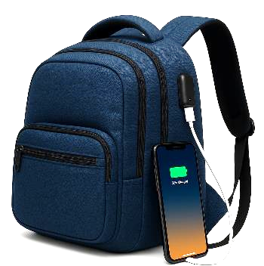



Virtual product prototypes generated by MS Copilot in two minutes at no cost.
Module 1 - Entrepreneurship Chapter 3 - MVP

1.3.2 Building a Physical Prototype

Develop the product in stages to conserve capital and reduce risk.

- First-Stage Prototype. A prototype that demonstrates proof of principle: that your idea will work. It does not have to be pretty, and it may not even be fully functional.
- Second-Stage Prototype. A product iteration that can be produced in small quantities and with a level of quality adequate to assess market reaction. The manufacturing method at this stage does not need to be the optimum method for later volume production.
A common mistake at this stage is to attempt to produce a test supply at the eventual projected cost. It is better to buy 10 samples at $20 each—that you offer for $20 for market testing; than to produce 100 units at $10 each that you wind up scrapping because of a technical flaw or the market rejects the design.

You may lose money on every production run until you derive the perfect design and set of features. Then research methods and quantities of production that will allow the product to be sold at a competitive price and still earn a gross margin of 75% to 80%.

  - DESIGN AND ENGINEERING ASSISTANCE. If, as is usually the case, you need engineering and design help before approaching a manufacturer, you may wish to work with a component maker, industrial design house, or product engineering firm with the ability to design products for efficient fabrication at varying volumes.

  - BUILD OR BUY. If you are willing and able to serve as general contractor and perform the final assembly, you can utilize multiple component manufacturers to reduce costs.
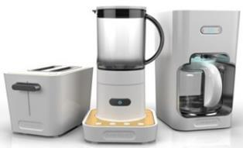
A second-stage prototype will likely require some trial and error before you arrive at a functional, aesthetic and economically viable product.

Products designed by
Big Bang for Cuisinart.

- Third-Stage Prototype. After you have perfected the second-stage prototype in the market, the next step is to prepare the Full-Production Prototype. The production prototype should be designed in such a way as to be able to be manufactured in volume.
Reward-based crowdfunding (e.g., Kickstarter.com or Indiegogo.com) is a great way to underwrite the cost of tools and dies and your initial production run. To arrive at a realistic fundraising goal for this stage, prepare a comprehensive cost accounting of all the component parts and labor.
RESOURCES FOR PROTOTYPING AND MANUFACTURING. Many colleges and universities have 3-D printers that are excellent for prototyping. There are also maker and hacker clubs in most cities that may offer help.

Module 1 - Entrepreneurship Chapter 3 - MVP

1.3.3 Software and Mobile App Prototyping

If you or a co-founder is skilled at coding, great, you will save time and money doing the development yourselves. To ensure that the CEO, CMO and CTO are all on the same page, it will be helpful to create a mock-up showing how the software is to work, especially the user experience (UX), with screen shots and working links to navigate between screens.

If you plan to outsource the development, the demo model will help to explain what you are expecting in the finished product; which will save developer’s time and you money; and prevent rework due to misunderstandings.

A demo version also allows you to show competition judges, investors and potential customers (for market research) exactly how your software or mobile app will function.

There are free and low-cost tools available that anyone can use to create remarkably convincing prototypes: (no coding required):

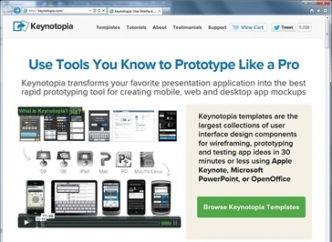
- MICROSOFT PowerPoint and Apple Keynote both support embedded video, slide transitions to simulate animation, and clickable links to jump to other slides (posing as web pages). For Apple Keynote see https://support.apple.com/keynote

- ADOBE XD. For website wireframing and interactive click-through prototypes for mobile apps. For macOS, Windows, iOS, Android. Freemium adobe.com/products/xd.html

3. PROTO. iPhone and Android app development www.Proto.io. Free for 15 days, then $24/mo. (2025). Discounts for schools.

4. FLINTO.COM. Free for 30 days, then $99 per year (2025). For iPhone or Android. http://www.Flinto.com

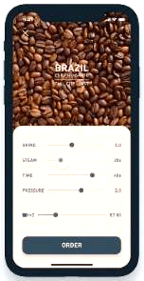
5. Balsamiq. For quick software mockups. Web-based. $144/ year (2025). www.balsamiq.com
6. ForeUI. Mockup and simulate an app in a browser. PC/Mac. $150 for permanent license (2025). http://www.foreui.com

Mockup of Coffee-ordering app developed by Shingo Suzuki on Adobe XD

Module 1 - Entrepreneurship Chapter 3 - MVP

SOFTWARE AND MOBILE APP FINAL DEVELOPMENT

When you have created a prototype and shown it to prospective users to:

a) Verify that it solves a real problem and people are willing to pay for it; and

b) Confirm that users intuitively know how to use the software or app and do not get frustrated because it does not work the way they expect it to…

… then you are ready to develop the final version to sell—although on a limited basis until you are certain you have worked out all the bugs.

WHERE TO FIND DEVELOPERS. If you want to find those near you, just search online for “developers” (or “programmers” or “coders”) near [your city]. The advantage of buying local is you can interview the person face-to-face; or if a company, visit the office to meet the people who will be working on your account.

You can also access developers through freelancing sites like www.freelancer.com and www.upwork.com where you can review samples of work. Many of the freelancers work in countries where wage rates are lower, but communications may not be as good unless you speak the same language and are awake at 5 am when they are. Someone working for $10 per hour, but who takes longer (because of misunderstandings) can be more expensive than someone nearby who charges $30 an hour.

It may be wise to work through a multilingual local company who in turn works with employees in other countries, as they can translate your needs accurately.

The freelance sites usually allow you to set a budget limit, which protects you from cost overruns, but may not be fair to the freelancer if they have to redo work because your instructions were vague, or they just did not understand correctly because of language differences. The best solution is a written set of very detailed specifications from you, so the freelancer can make an informed estimate of the time required and therefore give you a firm quote you can both live with. This is an ETHICAL question for all employers of contract employees

FREE TEMPLATES TO SPEC SOFTWARE AND APP PROJECTS:

Software Requirements Documents (SRD)
https://krazytech.com/projects/sample-software-requirements-specificationsrs-report-airline-database
App Requirements Documents (ARD) http://www.creativesparksolutions.com/blog/how-to-create-a-requirements-document-for-your-mobile-app-steps-and-tips/

WHAT TO BUDGET FOR DEVELOPMENT
- APP -- $5,000 to $50,000 depending on complexity of software and credentials of developer
- SOFTWARE -- $20,000 to $150,000

DIY APP MAKERS. There are programs that allow you to create actual finished products, even if you are not a coder. If you do know how to code, these aids can save you time on simple routines, and you can still add your own HTML.. For example platforms, see
- https://appery.io/pricing $25 per month (2025).
- https://www.appypie.com/ $16 per month (2025).

Module 1 - Entrepreneurship Chapter 3 - MVP

1.3.4 Market TESTING THE PRODUCT OR SERVICE

All new products and services must go through two testing periods before release for sale:
- ALPHA TESTING. This is testing in the lab. Does product work as intended? How well does it hold up with normal handling? What if it gets wet, cold or hot? For software, use it extensively to catch as many bugs as possible before allowing customers to try it. For services, practice on friends and family.



Auto test track

- BETA TESTING. Seek out Early adopters, customers willing to try new things, to perform this testing. Ethically, you should tell customers that the product has not been fully vetted. Typically, beta testers are allowed to use the product free of charge.

HOW TO KNOW WHEN YOUR PRODUCT IS CONSUMER-READY: THE NET PROMOTER SCORE (NPS).
This simple test, developed by Satmetrix, has a lot of research behind it. It consists of asking only one question: “How likely is it that you would recommend our company to a friend or colleague?” Users choose an answer along a scale from zero to ten, with zero meaning “not likely at all”, and ten “Extremely likely”.

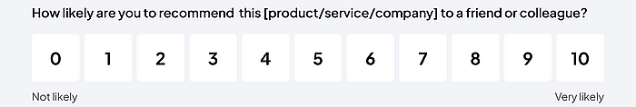

Research shows that responses of
- 9 or 10 are “Promoters”, people who will repurchase and refer others
- 7-8 are “”Passives” who are satisfied but easily drawn away by competitors
- 0-6 are “Detractors” who are unhappy and may damage you brand through negative word-of-mouth
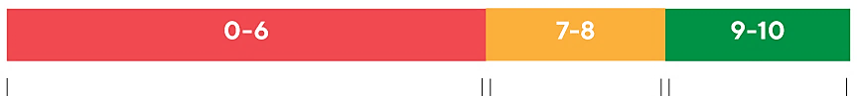
DETRACTORS PASSIVES PROMOTERS

Subtract the percentage of Detractor responses from the percentage of Promoter responses to arrive at your NPS.
NUMBER OF PEOPLE YOU SURVEYED _____
PROMOTORS #_____ (_____%) DETRACTORS #_____ (_____%) YOUR NPS = _________

Highly successful companies operate in the 50-80 NPS range.

Module 1 - Entrepreneurship Chapter 4 – Product-Market Fit

1.4 – Product-Market Fit: Perfecting the Solution

Whereas Product-Solution Fit is critical during the ideation stage to verify that the problem is real and there is a strong desire for a solution; Product-Market fit is a tool for validating a specific solution to determine if is a repeatable, profitable and sustainable.

Attaining Product-Market Fit describes the point where a product meets the needs of a specific group of customers, who actively buy, use, and recommend it.

The process of finding Problem-Market Fit can only commence once Problem-Solution Fit has been confirmed: That is, the company’s solution serves a real problem, an adequate market exists for a solution, and the company has drafted a Minimum Viable Product (MVP) to obtain customer feedback for its solution.

Refining the solution to the point of true Product-Market Fit will reduce the risk for you and your capital providers. Achieving Product-Market Fit is also necessary for the company to reach its full potential: if the company scales up production and marketing prematurely, the company may never grow beyond first-time buyers.

1.4.1 How to Measure Product–Market Fit
1.4.2 Finding Product–Market Fit
1.4.3 Customer Survey to Discover Buying Preferences

Module 1 - Entrepreneurship Chapter 4 – Product-Market Fit

1.4.1 How to Measure Product–Market Fit

1. QUANTITATIVE MEASUREMENTS
- Net Promoter Score (NPS): A measure of customer satisfaction and loyalty, which indicates the likelihood of customers recommending your product to others.
- Conversion Rate: The percentage of users who continue using your product or service after the beta test
- Growth rate. Each month, are you onboarding more customers than in the previous month?
- Churn Rate. The percentage of users who stop using your product or service. If you obtain a new customer every week, but lose 10% of current customers every month you will not achieve traction.
- Engagement Metrics: Time spent using the product, frequency of use, and feature adoption.

2. QUALITATIVE MEASUREMENTS:
- When surveying potential customers or allowing them to test your product, does some segment indicate they will switch to your product?
- Do users demonstrate an understanding of your product’s differentiators?
- Word of mouth. Are customers talking about your product? Postively? Search for your brand on social media for comments, Pinterest, and Yelp. What is the ratio of positive to negative posts?


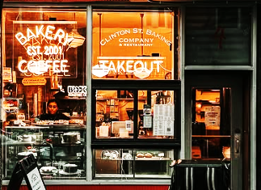

New York Coffee Shops on Instagram. Number of likes range from 200 to 2000.
Module 1 - Entrepreneurship Chapter 4 – Product-Market Fit

1.4.2 FINDING PRODUCT-MARKET FIT

VIDELINK Surveying customers to validate business concept: https://hitenism.com/business-ideas/

The process of refining your solution until you are certain people will buy it at a price that allows an adequate gross profit margin (typically 75-80%), plus a competitive profit is called Product-Market Fit.

Start with face-to-face surveys. People will be more likely to volunteer additional information in person, or ask you questions that may give clues to possible concerns. Bur before jumping into Q&A, give the survey subject your 8-second elevator pitch to put your questions in context. Find strangers; If we only talk to friends, discussions will likely proceed along familiar lines. And friends will tell you what they think you want to hear.

Once you have surveyed at least 30 people live to determine whether the solution will meet with an enthusiastic market, drill down on the issues with a survey of at least 100 people via email or through social media followers that match your customer demographics. (Capital providers will want to know how many people you have surveyed.)

FREE SURVEY SERVICE. www.QuestionPro.com offers free surveying with up to 10 questions to 200 respondents that you supply. (2025). www.SurveyMonkey.com allows up to 10 questions and 25 respondents for free.

FEE-BASED SURVEY SERVICES. Google and Amazon will provide survey-takers for you, for a fee. Both services have a base rate for randomly selected respondents; but you can request specific demographics for additional fees. (This is recommended to give your results credibility. Surveying non-homeowners for roof shingles with solar panels would have zero value.)
Google allows users to specify respondents by the first 3 Zip code digits of (not all 5 digits). But with Zip code targeting, you will not be able to drill down by age or gender as there are not enough registered survey takers for that level of granularity. See https://support.google.com/surveys/answer/2447244. Rates (2025) per respondent:
Random Population Age, gender, or location targeted Postal code targeted
1 Question | 2-10 questions | 1 Question | 2-10 questions | 1 Question | 2-10 questions
$.10 | $1.00 | $.15 | $1.50 | $.60 | $6.00

Amazon’s www.MTurk.com is also fee-based, but you can set the amount you are willing to pay per survey. MTurk then adds 25% for “Masters” (respondents with verified demographics and high ratings from prior surveyors). Choose this option; otherwise, you will wind up paying Nepalese Sherpas for opinions on your new hip-hop release. With MTurk you can specify location of respondents. (Contact MTurk for pricing.)
MAXIMIZING THE LIKELIHOOD PEOPLE WILL TAKE THE TIME TO RESPOND.
- Start with simple, non-threatening questions to qualify the respondent: are they a potential customer?
- Put the demographic identifiers you might need (gender, age, occupation, etc.) at end of survey. Survey takers may be less reluctant to provide personal data if they have already answered other questions
- Keep questions short and to no more than five. If you need more feedback, do a second survey.
INSURING RELIABILITY OF RESULTS.
- Use multiple-choice questions with no more than five options, or yes/no questions. Keep it simple.
- Avoid absolutes like “Always” and “Never” as answer options. If question is how much time a person spends in the car, use specific ranges like “Less than 10 minutes a day, 10-30 minutes, 31-60 minutes, 61-120 minutes, over 120 minutes.” This way, every possible situation is covered, and answers do not overlap. Vague answer choices like “A lot of time” may mean 30 minutes to one person and 2 hours to another.
- Use simple wording, not subject to more than one interpretation. To make sure the questions and answer choices mean to others what they mean to you, ask your friends the questions and answer choices and then ask them to explain to you what they mean. You may be surprised at the answers you receive.
- For additional surveying tips see https://support.google.com/consumersurveys.
Module 1 - Entrepreneurship Chapter 4 – Product-Market Fit

1.4.3 Customer Survey to discover buyIng preferences

Use surveys to answer the following questions to achieve product-market fit:
- Where customers would want to purchase (in stores, online, other)
- How customers expect to find out about new products or services
- Opinion of your offering versus alternatives
- Most valued and least valued of possible features
- Amount customers would be willing to pay
Respondent Demographics Estimated age >> | 1  M – F  Age~____ | 2  M – F  Age~____ | 3  M – F  Age~____ | 4  M – F  Age~____ | 5  M – F  Age~____
A. What would most affect your buying decision?
Price, convenience, fast delivery, choice of styles/colors/sizes, or other: _______________
B. How would you improve
upon the product?
C. How much would you
be willing to pay?

D. Would you use product?
5 = definitely,
4 = probably
3 = maybe
2 = probably not
1 = definitely not
E. If you are not likely to use product, why not?
If potential customers are not as enthusiastic as you hoped, probe to find out why; how would they solve the problem?
Module 1 - Entrepreneurship Chapter 5 – Competitive Positioning

1.5 – Competitive Positioning

1.5.1 Researching Competition

1.5.2 Selecting a Target Market Niche

1.5.3 Determining Size of Target Market

1.5.4 Developing a Competitive Strategy

1.5.5 Comparing Features to Competitor Products

1.5.6 Erecting Barriers to Entry

Module 1 - Entrepreneurship Chapter 5 – Competitive Positioning

1.5.1 Researching COMPETITIon

In the space below, list the companies in your market area with similar products that have features or prices that pose a potential threat to your company. According to Cliff Ennico, “Competitors are all companies going after the same customers, even if the product (solution to the problem) is different. For example, if you are planning to open a pizza parlor, other pizza restaurants in your market radius are clearly competitors, but so are all other restaurants, as they also offer a solution to problem you solve: hunger.

A. ______________________________________________ URL______________________________

City _________________________ Their competitive strategy ______________________________
__________________________________________________________________________________

B. ______________________________________________ URL______________________________

City _________________________ Their competitive strategy ______________________________
__________________________________________________________________________________

C. ______________________________________________ URL______________________________

City _________________________ Their competitive strategy ______________________________
__________________________________________________________________________________

TO IDENTIFY LOCAL COMPETITORS, Google the name of the industry you want to research and add “near me” (e.g. - “pizza parlors near me”.) Here are some other ways to gather intelligence about competition:
- If a store, count the number of cars in the parking lot or count the number of people who walk in during different days of the week and times of the day. (Do they walk out with packages?)
- Talk to suppliers of your industry. They will know who is doing well, and who is not.
- Talk to buyers in your industry. Ask them what criteria they use to make decisions.
- Google the competition. Have they been in the news? What are people saying about them on their website, Yelp and local search directories?
TO SEARCH FOR NATIONAL COMPETITORS …
Hoovers maintains a database of companies that includes industry, location, sales, employees and other variables. You can access Hoovers at most universities and the main branch of city libraries. Search for “Hoovers” under the “research” or “online resources” tab of the library website. Within Hoovers, click on “Company Dossier.” You will see a search form that will allow you to generate a list of potential competitors in your industry and service area.
Bizminer.com. Market and financial research on thousands of small businesses. Reports cost $100 or more, so check to see if your local public library or university has a subscription.
Crunchbase.com is a free site where you can search for companies in hot industries. www.crunchbase.com


If you do not find any competitors in your search, this is not necessarily a good thing. It may mean that there is not adequate demand in the marketplace to support the product or service.

Module 1 - Entrepreneurship Chapter 5 – Competitive Positioning

1.5.2 Selecting a Target Market Niche

Positioning your company within competitive landscape.

Market Niche. Who needs your product, and why? How can you fit into the competitive landscape to carve out a beachhead in the marketplace?

Your Market Niche

Demographics of Target Customers
- Age _________
- Gender _________
- Where they live, work ___________________________________
- Educational level ___________________________________
- Income level $ ___________ to $ ________________
- Any other pertinent descriptors (e.g. -- home ownership) ___________________________________
_________________________________________________________________________________

Target Customer Buying Habits.

Who do they buy from now? ________________________________________________________________

_______________________________________________________________________________________

How often do they buy? ___________________________________________________________________

In what quantities? _______________________________________________________________________

How much are they accustomerd to spending? ___________________________________________________

Module 1 - Entrepreneurship Chapter 5 – Competitive Positioning

1.5.3 dETERMINing Size of Target Market

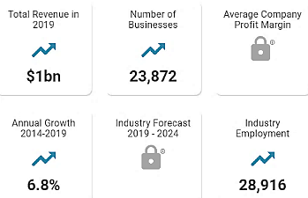
It is important to know the size of the market for your industry (the number of buyers and the amount they spend annually) as this is one indication of the potential success of your business. Investors and lenders will ask for this.
Market size data on every imaginable industry is available at www.IbisWorld.com. Although a full industry report is approximately $1000, enough data is available free to glean some useful information. For example, a search on “Food trucks” provided the following:
From the public data on the IbisWorld site, the average food truck is a one-person business grossing $42,000 per year.

For local demographics, consult www.census.gov/

Calculating TAM SAM SOM. These are short-hand measures of your market size.

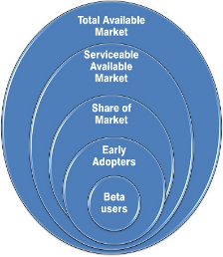
TAM = TOTAL AVAILABLE MARKET. Everyone in the world with the problem. (If product is left-handed scissors, how many left-handed people are in the world?)

SAM = SERVICEABLE AVAILABLE MARKET. The market segment served by
your solution. (If your scissors are designed primarily for cutting cloth, how
many left-handed tailors, clothes designers, crafters, and people who
make their own cloths from patterns are there?)

SOM = SHARE OF MARKET that you can acquire, realistically, based on your:
- Technology
- Geography
- Features
- Price
- Capacity
If your scissors are priced at $100, but have ball bearings to prevent fatigue
by employees in the clothing industry, you will probably have to eliminate
DIYers. Also, as a startup, you may not be able to reach all markets.

Your TAM SAM SOM

TAM Units per year _______________ $_______________

SAM Units per year _______________ $_______________

SOM Units per year _______________ $_______________

Goal for number of beta testers _______

Be prepared to explain to competition judges and capital providers how you arrived at your market size. What are your sources of information?

Module 1 - Entrepreneurship Chapter 5 – Competitive Positioning

1.5.4 Developing a COMPETITIVE STRATEGY

HOW WILL YOU DIFFERENTIATE YOUR PRODUCT OR SERVICE? Your options are:
- Lower price. To maintain this competitive advantage, you will need to purge every excess cost from the supply chain. (Examples: Walmart, Bob’s Discount Furniture.) This is a risky strategy: too many entrepreneurs simply offer their product for less than competitor pricing, usually resulting in an unsustainable business model and insolvency.

- Superior product. Better quality materials, more pleasing design, better performance, or more features. (Apple).

- Superior service. On-site repairs, longer warrantee, 24-hour phone support, returns accepted for full credit with no questions asked. Some online apparel sellers ship in cartons that can be used to return unwanted merchandise.

- Unique Market Niche. A sub-group of customers not adequately served.

YOUR COMPETITIVE STRATEGY:

________________________________________________________________________________________

________________________________________________________________________________________

________________________________________________________________________________________

________________________________________________________________________________________

________________________________________________________________________________________

________________________________________________________________________________________

________________________________________________________________________________________

________________________________________________________________________________________

________________________________________________________________________________________

________________________________________________________________________________________
Before settling on your Competitive Strategy, you might want to read some advice from other entrepreneurs who have been down the same path. Entrepreneur Magazine has published guides (at under $20 each) for starting businesses in more than 60 different industries. For titles, see https://www.entrepreneur.com/bookstore/category/starting-a-business
Module 1 - Entrepreneurship Chapter 5 – Competitive Positioning

1.5.5 CoMparing Features to Competitor Products

Look for an opportunity for an “ONLY STATEMENT: “We are the only company that______________” For example, “We are the only pizza parlor that keeps your pie heated and drinks chilled during delivery.”

 | Point of comparison | Your product ** | Competitor A  ______________ | Competitor B  ______________ | Competitor C  ______________
 | FEATURES
1 | Price | $ | $ | $ | $
2 | Quantity Discount
3 | Shipping and Handling
4 | Delivery Time
5 | Product Options
6
7
 | STRENGTHS
8
9
10
 | WEAKNESSES
11
12
13

** See Pricing the Product or Service. If you have not yet priced your product, researching competitor pricing will help determine where you need to be to capture a share of the market.

Module 1 - Entrepreneurship Chapter 5 – Competitive Positioning

1.5.6 Strategizing Barriers to Entry To DETER Competition

(How you will prevent—or impede--competitors copying your idea)

□ Patents – Received or pending in US and abroad. Note: a pending patent or provisional patent is not a guarantee of market protection. (In the decade ending in 2020 only 53% of applications were approved https://yjolt.org/what-probability-receiving-us-patent.
□ Technology will be difficult to reverse engineer.
□ Lead time advantage. It will take competitors ____ months to reproduce solution.
□ Major Customers locked in with exclusive long-term agreements: _________________________
_____________________________________________________________________________
□ Critical suppliers locked in: _______________________________________________________
□ Other _______________________________________________________________________
_____________________________________________________________________________
_____________________________________________________________________________
_____________________________________________________________________________
_____________________________________________________________________________
_____________________________________________________________________________
_____________________________________________________________________________

Module 1 - Entrepreneurship Chapter 6 – Lean Business Model Canvas

1.6 – Lean Business Model Canvas

A Business Model Canvas (BMC) is a shorthand approach to business planning, whereby the entrepreneur lays out assumptions about the market and tentative plans all on one page; and then validates those assumptions through surveys and prototype testing with potential customers. The premise is that you will find some false hypotheses, some customer reactions you did not expect; and it is a lot better to discover flaws in the business concept before you create detailed plans and invest in the concept.

The original Canvas, developed by Alexander Osterwalder in 2008, was designed to help established businesses bring new products to market quickly and economically. In this text, we use the Lean Canvas, designed for startups. If you prefer the Osterwalder BMC, a copy may be found at https://www.strategyzer.com/library/the-business-model-canvas

Module 1 - Entrepreneurship Chapter 6 – Lean Business Model Canvas

The Lean Business Model Canvas (LBMC) is a process for thinking through the business model for a new enterprise. The LBMC helps you

- Quickly explain your idea to others
- Identify who has the problem that you are trying to solve
- Get to Product Market Fit quickly (the degree to which a product serves a strong market demand) by Asking, Listening and Learning.

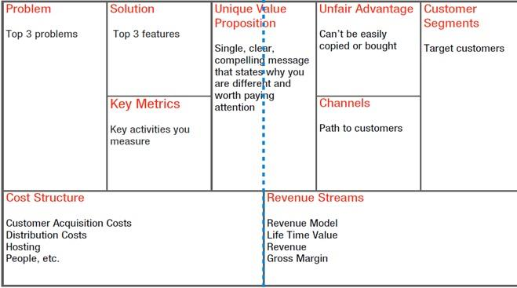
FINANCE
Gross Margin
Existing Alternative Sound bite: Early Adopters
Solutions
PRODUCT
MARKET

Click here to access a fillable Lean BMC on Google Docs:
https://docs.google.com/drawings/d/16uOd158UzJM9oqGWgJOtbppzGNPmZ4fWMSV6_xBz3Z8/edit
As you pivot (modify your plan), go back online and update your BMC, and print out the new iteration.

See https://canvanizer.com/new/lean-canvas for a free fillable online lean canvass. The canvas may be shared with four other team members for collaboration for $25/ year (as of 2025).

VIDELINK Eight-minute overview on how to fill out a Lean BMC, using Uber as an example.
https://www.youtube.com/watch?v=pvIN9STpzCQ

Here is a 16-minute video if you want more details
https://www.youtube.com/watch?v=uE34HsmT6E0

Module 1 - Entrepreneurship Chapter 6 – Lean Business Model Canvas

THE NINE SEGMENTS OF THE LEAN CANVAS

Problem. Most startups fail, not because they fail to build what they set out to build, but because they waste time, money, and effort building the wrong product. I attribute a significant contributor to this failure to a lack of proper “problem understanding” from the start. “A problem well stated is a problem half-solved.” - Charles Kettering

Solution. Once you understand the problem, you are then in the best position to define a possible solution.

Value Proposition. The measurable benefits prospective customers can expect versus how much they pay in return, including any indirect expenses, like having to retrain employees onto a new system, having to pay to park, or other inconvenience. From the customer’s standpoint the perceived value should exceed the costs: Value = Benefits – Cost. The right Value Prop serves as a differentiator to motivate customers to choose your product or service over others in the marketplace. The Value Prop should be reflected in the Branding Strategy, and clearly and continuously communicated. If an investor asks you only one question, it will be “What is your Value Proposition?”

Key Metrics. Startups often drown in a sea of numbers in an attempt to bring order to the chaos of uncertainty. At any given point in time though, there are only a few key actions (or macro metrics) that matter. “A startup can only focus on only one metric. So, decide what that is and ignore everything else.” - Noah Kagan.

Unfair Advantage. What feature, expertise, supply source, or market connection do you have that few competitors have? “A true unfair advantage is something that cannot be easily copied or bought.”- Jason Cohen

Customer Segments. The users of Cocoa Puffs are children, but they are not the Customers, the people who make the buying decision.

a) For your product, who is the ultimate user? Who are the decision makers in the buying process?
b) Demographics of Market Niche (potential customers you will appeal to).
- Age
- Gender
- Where they live, work
- Educational level
- Income level
- Any other pertinent descriptors (e.g. -- home ownership)
What are their Buying Habits?
From whom do they buy now? Why?

EARLY ADOPTERS are a segment of a market niche that is most likely to adopt the product or service in its early stage. They tend not to be risk averse and are willing to try new things. Or they may just be the most desperate sub-set of a market to solve the problem.

Channels.
- How will you deliver the product or service to the customer?
- How will the user become aware of the product?
- How will you support customers after purchasing and delivery?

Cost Structure.
a) How much it will cost you to provide product/ service.
b) Pricing Model (e.g. – low-volume, high margin)

Revenue Streams.
a) Who will pay you (distributor, wholesaler, end user)?
b) How will you collect the money?

Lean Business Model Canvas Product ________________________

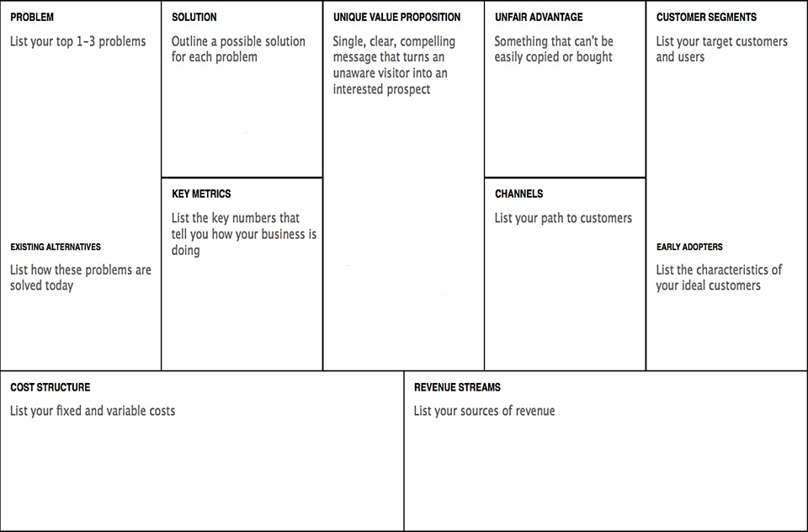

Click on a colored section to add text. Slide color block to side to see explanation for section.

Module 1 - Entrepreneurship Chapter 7 – Pricing

1.7 – Pricing the
Product or Service

1.7.1 Product Component Costs

1.7.2 Shipping and Handling Costs

1.7.3 Estimating Total Cost of Production

1.7.4 Pricing Products

1.7.5 Pricing Services

1.7.6 Testing Price with a Soft Launch (The Landing Page)

Novices price products and services to get the sale.
Pros price to make a profit.

Module 1 - Entrepreneurship Chapter 7 – Pricing

1.7.1 PRoduct COMPONENT CostS

This is an interactive spreadsheet. To open, right-click on spreadsheet, click “Worksheet Object” and then "Open.” You need to enter data in shaded fields only; the totals will be computed for you. You can download a copy of this form at thttp://www.EntrepreneurshipFoundation.org/spreadsheets
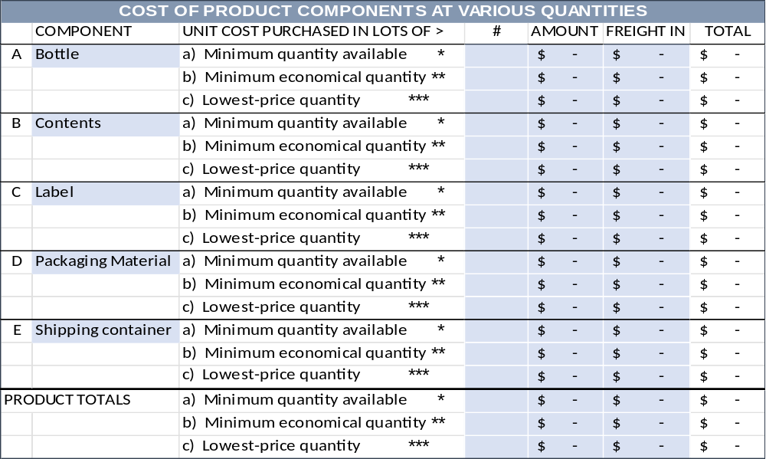
* Minimum Quantity you can purchase, at any price. Typically, manufacturers and wholesalers will not “break carton lots.” However, most suppliers will provide free samples for testing.
** Minimum Economical Quantity. A balance between the minimum quantities you can purchase (to conserve cash), and the lowest-price quantity (requiring the largest commitment). Most suppliers publish a price list showing the price breaks. You will quickly notice that there is a diminishing return. Buying 10 instead of just one might save 50% per unit, 100 versus 10 another 20%; but the next price break at 1000 might only save 2%. The MEQ in this case is 100.
*** Lowest-Price Quantity. The quantity that will allow you to purchase the component at the lowest possible price. Knowing this quantity price break enables you to predict the profit potential of the business if it really takes off. Hint: you may be able to negotiate a commitment to purchase the lowest-price quantity over time. Not having to take delivery of all the material at one time will allow you to recycle your capital and minimize the cost of storing materials.
----------------------------------------------------------------------------------------------------------------------------------------------------------

COMPONENT SOURCES. Consult Thomas Register, a directory of 700,000 manufacturers www.thomasnet.com. Companies that are known to work with small companies include:

METAL COMPONENTS. Metals Depot will ship “any size, any quantity, anywhere”: metalsdepot.com. The company will also fabricate parts.

FASTENERS AND OTHER STOCK PARTS. www.McMaster.com is a source of a wide variety (550,000 items in stock) for prototyping and initial short runs for market testing. Stock parts include nuts and bolts, shims, spacers, threaded inserts, metal stock for machining, tubing, bearings, motors, belts, gears, etc.

PLASTIC COMPONENTS. Modern Plastics sells small quantities and will also fabricate modernplastics.com.

Module 1 - Entrepreneurship Chapter 7 – Pricing

1.7.2 Shipping AND HANDLING COSTS

1. Shipping

FREIGHT OUT AND HANDLING ON SALES TO RESELLERS. Retailers typically pay the actual freight costs on products shipped to their stores. However, be sure to make this clear in your sales literature. The term used is F.O.B. [location], shorthand for free on board, meaning shipping is free to the place designated. F.O.B. Destination means the seller will pay for all freight charges from the factory to the buyer’s location. F.O.B. Factory means that the buyer must pay for all freight charges.
If your terms state “FOB customer’s warehouse,” then you are saying you will pay the freight. If your terms state “FOB factory” or “FOB [city where products are made or warehoused]” then you are advising the customer that they will be billed freight costs from that point to their store or warehouse. It is not customary to charge retailers for handling and packaging. That is on you – so do not forget to include packaging and handling when figuring your product cost.

FREIGHT OUT AND HANDLING ON DIRECT SALES TO CONSUMERS. Decide if you want to absorb the freight costs (for simplicity and to better compete with retail stores) or pass these expenses along to the buyer. In either event, you will want to know what they are, as these expenses can be a large part of the total.

2. Computing Your Handling labor (The “H” in “S&H”)
A. Number of shipments that one person can process per hour # _______
(Assume there will be down time: sick days, holidays, and times
when no work can be done because you are out of boxes or goods.)
b. Wage per hour (including payroll taxes of approximately 10%) $ _______
c. Cost per order (b / a) .......................................................... $ _______

3. Cost of Shipping Materials (See following page for hints on what to order)
OUTER CARTON for bulk shipments
Cost each $_______ in quantities of ______________ Best source: _____________________________
INNER CARTON for bulk shipments
Cost each $_______ in quantities of ______________ Best source: _____________________________
CARTON TO SHIP ONE ITEM (Corrugated mailer or padded bag)
Cost each $_______ in quantities of ______________ Best source: _____________________________
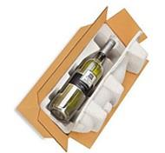

Whatever you are planning to ship directly to customers, rest assured there is a container designed for it.

Module 1 - Entrepreneurship Chapter 7 – Pricing

SHIPPING CARTONS FOR BULK SHIPMENTS TO BRICK AND MORTAR STORES

To save money on freight charges most companies ship products in outer cartons that hold an economical quantity for shipping, but still a reasonable number to expect a store to purchase. However, an outer carton for shampoo (as an example) that could hold 48 bottles would probably result in complaints from stores, as the bottles would jostle about loose in a large carton. The answer is to add smaller inner cartons that hold fewer products each. The two carton sizes also allow you to sell a smaller quantity to a store (or even to an online purchaser who wants to save money by buying in quantity).

An outer carton with eight inner cartons, each containing 6 bottles of shampoo. Allowing sales in quantities of 48, 6, or even 12 (two sub-cartons taped together).

Obviously, you have a better chance of a store carrying your product if the buyer has a range of quantity/price options. By knowing preferred quantities (and designing cartons for them) you will keep your handing costs low. Broken carton shipments require more work to open a carton, take out a non-standard quantity, and then custom package the shipment. Moreover, this leaves you with an odd quantity that will be difficult to sell.

SHIPPING CARTONS FOR SAMPLES AND DIRECT SHIPMENTS TO ONLINE CUSTOMERS.
Regardless of who ships the small individual orders directly to online customers, order a supply of individual mailers that can serve as shipping cartons, so the shipper just has to add a label and mail.
Standard mailers are available in a variety of stock sizes, and as such may be purchased in small quantities as needed. These sturdy shipping boxes will arrive flat and can be easily set up without tape or glue.
When ordering these single-product cartons, do not forget to allow room for instructions or bubble wrap, if needed. Ask for free samples (vendors will be happy to provide them) so you can make sure everything fits.


Sample mailer from Uline uline.com/Cls_04/Boxes-Corrugated
Prices current as of 2025.

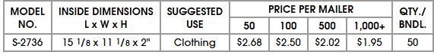

The shipping terms are FOB factory (so you pay the freight), but this supplier has eight warehouses in the U.S. Still, boxes are heavy and bulky, so figure at least 20% additional for delivery.

Another company, Packaging Price also sells fold-up boxes in small quantities https://www.packagingprice.com/mailers-1

Module 1 - Entrepreneurship Chapter 7 – Pricing

1.7.3 ESTIMATING TOTAL COST OF PRODUCTION

ESTIMATING COST OF PRODUCTION. Double click to open spreadsheet. This data is for a sample company. To use form for your company, delete data in shaded fields. (Do not delete data in white boxes as these contain formulas.) You can download a copy of this form at http://www.EntrepreneurshipFoundation.org/spreadsheets

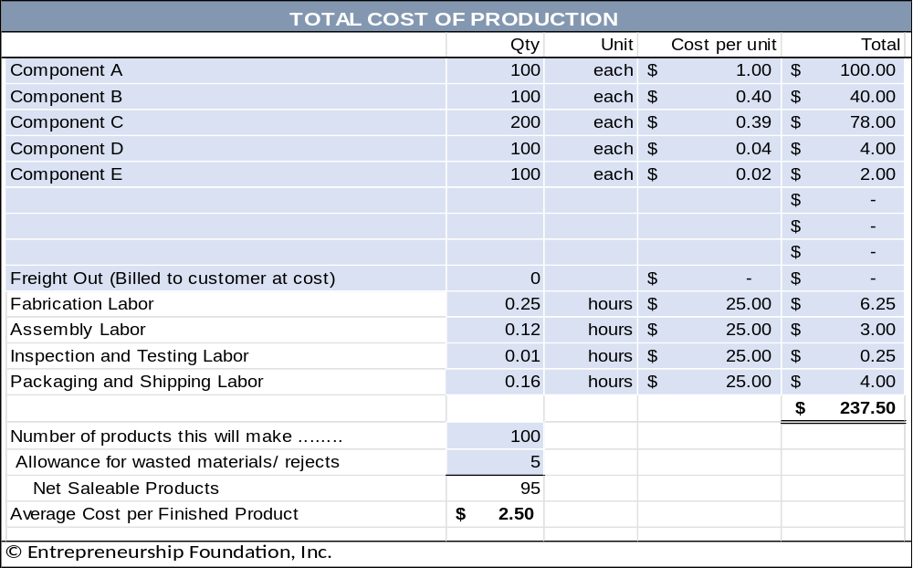

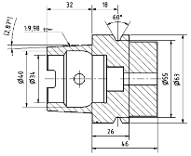
MEETING WITH MANUFACTURERS. Express your expectations clearly. Keep in mind that most manufacturers are wary of startups. They do not want to waste their time working with entrepreneurs that have a poor understanding of their industry. They will expect you to have market research to support your eventual production needs.

You will need to provide a professional drawing or sketch for manufacturers.

Module 1 - Entrepreneurship Chapter 7 – Pricing

1.7.4 Pricing ProductS

MARKUP VERSUS MARGIN. Products sold on TV generally have a 5x markup (retail price divided by the cost of production). A 5 times markup for a product that costs $2 to make = $10. The margin of profit on the $10 sale would be $8 or 80% of retail (Retail-Cost)/Retail). A high margin is necessary to cover the cost of the infomercial. Another rule of thumb in the industry is to price products at “impulse” amounts like $9.99, and with a max of $19.95.

When using traditional distribution channels: MANUFACTURER > DISTRIBUTOR (WHOLESALER) > RETAILER, a safe margin to cover salaries, marketing and other fixed costs is a retail of 4 times the cost to produce.

TRY UP TO FIVE ALTERNATIVE RETAIL PRICES for your product using the spreadsheet below (downloadable from http://www.EntrepreneurshipFoundation.org/spreadsheets. Assume material and production labor is based on your Minimum Economical Quantity ) Enter amounts in shaded boxes; the spreadsheet will calculate the other amounts.

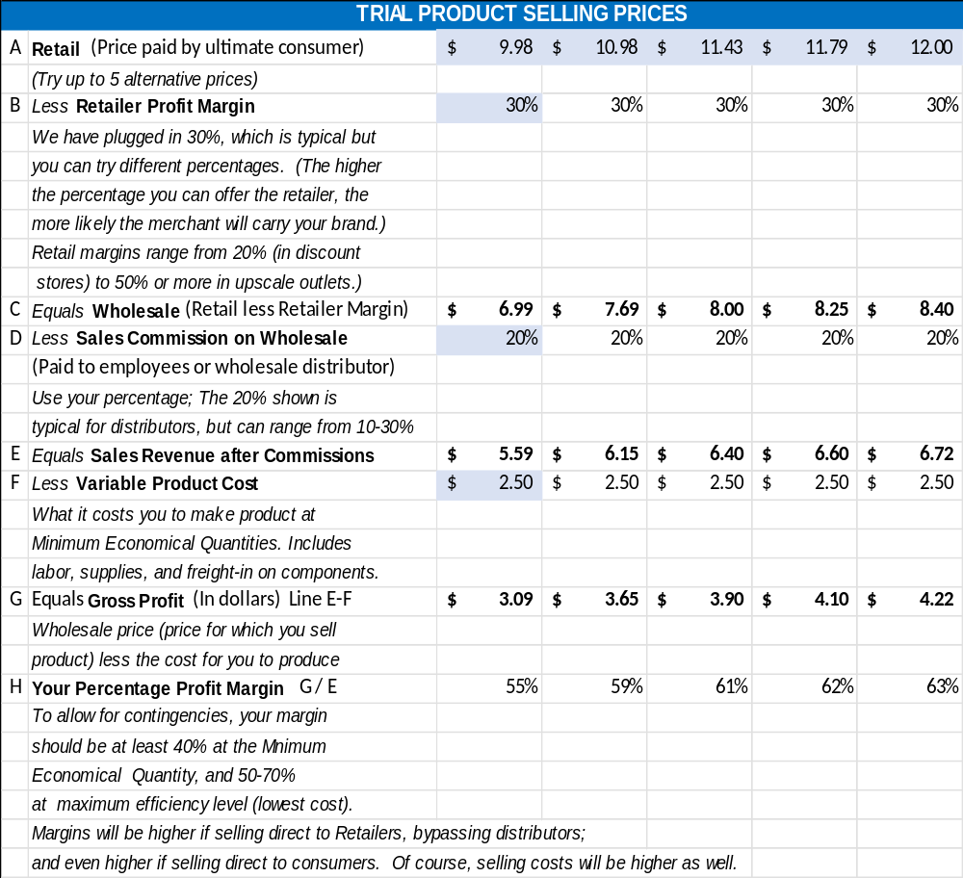

Module 1 - Entrepreneurship Chapter 7 – Pricing

1.7.5 Pricing SERVICES

If you provide a service as an individual, without employees or an office, then the total of the fees you collect will be your personal annual income.

1. Take-Home Income Goals. How much do you need to earn from your business each year? According to the Washington Examiner, it now takes a $32 hourly wage (in 2024) to afford a typical modest two-bedroom rental, assuming you spend 30% of your income on housing. Of course, rates will vary with locale. However, as a rough rule of thumb, this would equate to $40,000 to $50,000 per year.
EXAMPLE YOU
A. Full-time to live solely off the business ….................................... $ 50,000 per year $_________

B. As a part-time endeavor ………………………………………….… $ 10,000 per year $_________
Therefore, how much do you need to earn (gross) to take home these amounts? You will need to earn more than the target numbers above to allow for Payroll and Income Taxes.

2. Allowance for Taxes.

PAYROLL TAXES. As a self-employed individual, you have to pay the employer and employee shares of all payroll taxes. As a rule of thumb, assume you will pay the government approximately 16% of your earnings for Payroll Taxes: Social Security, Medicare, and Federal and State Unemployment Insurance (FUTA and SUTA). Do not forget to report the income and pay the taxes. When you are self-employed, no one will be doing this for you.

PERSONAL INCOME TAXES. H&R Block has a tax calculator at hrblock.com/free-tax-tips-calculators/index.html

- FEDERAL INCOME TAX. For a quick estimate of the FIT, use 10%.

- STATE INCOME TAX. Look up your state’s personal income tax rate at http://www.tax-brackets.org.
For quick budgeting, assume your total personal taxes (payroll taxes and Income taxes) will amount to approximately 30% of your gross earnings.
3. Calculating Your Tax Multiplier. To arrive at the business revenue necessary for you to net your personal income goal, you will need to multiply the goal by (1 minus the tax rate) or
Business Revenue Target = Personal Net Income Goal (1-tax rate)

Therefore, if your goal is $50,000 per year take-home, and the total personal taxes are 30% of your business revenue, the calculation would be …
Revenue = 50,000 (1x –.3x) or .7 Revenue = 50,000 or Revenue = $50,000 / .7 = $71,429

To prove the formula, multiply the Revenue target $71,429 x 30% tax rate = $42,857 in taxes. Subtract the tax bill from the Revenue target ($142,857 - $42,857) = $100,000 which is the take-home goal.

Incidentally, you can use 143% instead of the more cumbersome 142.857% and still be close enough for government work, which this is.

Module 1 - Entrepreneurship Chapter 7 – Pricing

The correct MULTIPLIER for your TAKE-HOME PAY GOAL to arrive at your BUSINESS REVENUE TARGET will not always be 143%. That works for a combined tax rate of 30%. To find your MULTIPLIER, divide 100 by (100% - your combined federal and state tax rate %).

4. Calculating Service-Business Revenue Goals EXAMPLE YOU
A. ULTIMATELY, to live on the business revenue alone ……. $ 71,429 per year $_________

B. INITIALLY, as a part-time endeavor to test the concept …. $ 14,286 per year $_________

5. Calculating Amount to Charge Clients per Hour. First, determine the number of hours you will work in a typical year. Full-time, you may want to assume 40 hours per week x 50 weeks, allowing 2 weeks for vacation (and to make the math easier) = 2000 hours per year. For the initial part-time launch, estimate how many hours you will be able to devote to the business, after allowing for school, work, family, etc. For the example below, we assumed 8 hours each Saturday plus one evening per week for 4 hours, for a total of 12 hours per week. Times 50 weeks = 600 hours part-time.
A. ULTIMATELY, to live on the business revenue alone ……40 hours / week x 50 weeks #______hours
= 2000 hours /year

B. INITIALLY, as a part-time endeavor to test the concept …12 hours / week x 50 weeks #______hours
= 600 hours /year

Divide the Business Revenue Goals (step #4 above) by the number of hours per year to arrive at AVERAGE HOURLY INCOME.
A. ULTIMATELY, to live on the business revenue alone ……. $ 35.71 per hour $_______ hr.

B. INITIALLY, as a part-time endeavor to test the concept .… $ 23.81 per hour $_______ hr.

6. Allowance for Uncollectables. Some unscrupulous buyers, knowing you are a small startup without a battery of lawyers, and knowing you cannot take back the service once you deliver it, will take advantage of that situation and simply not pay unless you take them to court. So, before you know which clients are honorable and which are not, assume that 10% of sales will be uncollectible.

7. Allowance for Non-Billable Hours and Office Supplies. The above hourly customer rates assume a perfect world where you always have work, and the kids do not get sick. You also need to budget non-earning time for bookkeeping, filing tax returns, and marketing. In addition, you will have some modest expense for office supplies.

8. Adjusting Your Hourly Fee to Cover Uncollectables, Non-Billable Hours, and Office Supplies. To arrive at a realistic fee to charge clients per hour, multiply the amount you need to earn per hour (as calculated in step 5 above) by three. The example business then would need to charge $107 per hour to meet the entrepreneur’s personal full-time income goal. You may be able to start out with only a 2x multiplier, but when you begin to grow and hire associates, you will need 3x or 4x to cover office space and other overhead.

Failing to add multipliers to allow for taxes and non-billable hours is the single most common reasons service businesses fail.

Module 1 - Entrepreneurship Chapter 7 – Pricing

1.7.6 TESTING PRICEs WITH A SOFT LAUNCH (The Landing page)

Now that you know how much you need to charge for your product or service (and this is the correct place to start), you need to determine if customers are willing to pay that amount, The VALUE PROPOSITION, what you provide the customer versus how much the customer pays you in return, must be in equilibrium. And the only way to be certain that customers will pay the advertised price is to ask them to take out their credit cards. You may find that even your friends will vanish into a fog of non-commitment.

To obtain honest feedback, set up a Landing Page, a temporary website to accept pre-orders or to obtain emails of potential clients who want to be notified when you launch. According to Unbounce.com a landing page is a one-page website created specifically for the purposes of test marketing. It’s where a visitor lands when they click on a social media ad or a link in an email.

CALL TO ACTION. Landing pages require a Call to Action (CTA) to measure customer receptiveness to your Value Proposition. As such, they do not have additional pages, as do traditional web sites, as these would be a potential distraction from the laser-focus of the CTA. Typical Calls to Action are:
- Pre-order product not yet manufactured. Reward-based crowdfunding sites like Kickstarter and Indiegogo are landing pages. Of course, you have to share the platform with other companies (potential distractions to your customers) and pay about 8% to the platform provider as a commission and to cover payment-processing fees). Pre-selling your product or service may give you—and your investors—the confidence you need to press forward with your plans. Moreover, it helps with the cash flow if you collect all or part of the purchase price in advance. Just make sure you can deliver when you promise.
- Sign up to be notified when a product or service will be available. You might be able to gauge whether there is enough potential demand to invest funds in inventory and marketing; and you can survey prospects as to which features are most important. You can also add this notification form to your main web site to capture contact information of anyone who discovers you from a web search.
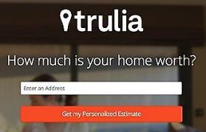
- Provide contact information in exchange for a free report, webinar or free trial. The offer shown here by Trulia, an online real estate agency, is an example of a lead-generation landing page.
Get a free estimate
Enter an address


Flea Markets and local fairs are also an easy and low-cost ($40 to $150) way to test market a product or service, or to obtain feedback on a prototype. People love to give their opinion. Take along some printed surveys and product samples and find out what consumers do and do not like. Think of it as a brick-and-mortar landing page

To find flea markets near you, go to...
http://www.keysfleamarket.com/fleamarket/state/

Module 1 - Entrepreneurship Chapter 7 – Pricing

A/B TESTING. You can create multiple landing pages to try different …
- Marketing copy,
- Product names,
- Package designs
- Alternative Prices. Try different price points to find the sweet spot for maximum GROSS PROFIT. For example, if a $9.95 price generates adequate sales volume and a 70% gross profit margin, what effect would an $8.95 offer have on demand? Might it double the demand, allowing you to reduce production costs and thereby achieve a higher gross profit? For more see chapter on “Pricing the Product”.
- Price discounts (does two for $1.97 outperform $.99 each?)
- Customer preference for feature A versus feature B
- Keywords for ad purchases
The A/B tests will allow you to see which options convert more ad readers to ad clickers, and more website or landing-page visitors to buyers.

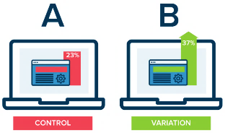
At the right is A hypothetical example by Optimizely.com comparing conversions between landing pages, one with a red color scheme, the other green.

A seemingly trivial change can sometimes produce very different results. In a test of 2000 visitors, a red “get started now” button brought 21% more visitors to a landing page.

LANDING PAGE PLATFORMS. Most provide a free basic service. Analytics are sometimes extra.

LaunchRock.com Helps new companies acquire beta testers and customers. (LaunchRock practices what they preach; the Call-to-Action [right] is from their website.) $249/ year (2025).

Mailchimp.com Free basic landing page, plus free email marketing platform.

Wix.com. They are a traditional web hosting service, inexpensive and easy to use, and you can create a one-page landing page (www.Wix.com/YourCompanyName).

Unbounce.com Expensive but great how-to articles. Perhaps a good fit after you reach your first million in sales.

Module 1 - Entrepreneurship Chapter 8 – Naming the Company

1.8 – Naming the Company

“The action that follows deliberation should be
quick, but deliberation should be slow.”
— Aristotle

Module 1 - Entrepreneurship Chapter 8 – Naming the Company

DO NOT rush this decision.
It has far-reaching effects on the business and is difficult to change after the company launches because of all the places a company name appears:
- Letterhead and business cards
- Signage
- URL and email address
- Legal documents
- Bank accounts and checks
The personality of the words in your company name will color public opinion. Your company or product name will be a potential customer’s first impression. Entrepreneur Magazine suggests, “Your name should convey the expertise, value and uniqueness of the product or service you have developed.” If you were starting a bakery, which of these company names is more likely to arouse positive emotions: “Anderson’s Bread Shop” or “Open Hearth Breads”?

CRITERIA FOR THE PERFECT NAME INCLUDE...
- Short and easy to remember (easy to type into a web browser).
  - Of the 100 most visited websites, 72% have six or fewer letters; only 3% have more than 15.
No one wants to type www.TheWorldsMostWonderfulWidget.com. As evidence that shorter is better, consider that United Parcel Service goes by UPS, International Business Machines as IBM, Hewlett-Packard legally changed its name to HP Inc., and International House of Pancakes changed its name to Ihop.
  - Single words. All things being equal, a one-word name is better than two or three words, so “Panera” for a bakery trumps mouthfuls like “Open Hearth Breads”, which is also a long string to type into a browser. Short, simple words are also easier to remember (Apple, Google, Skype, Madonna).
  - Conjoined words are the next best (Netflix, Microsoft, StubHub, FedEx, Hotmail). They become unique new words and therefore are relatively easy to trademark.
- Describes what service you provide or the type of products you sell. Most people now use search engines to find products or services online or that are available locally. Does the name allow you to be found by search engines? Which is better for a bookstore, “Jane’s Place” or “Academy Books”?

But the name is not too specific. Diversifying might become awkward. Which is better: Acme Garage Doors or Acme Manufacturing? Consider a made-up name like Exxon, Xerox, or Google. An advantage of a word you make up is that it is easy to trademark (it is not likely anyone else will have registered it.)
- Name conveys the sense of a stable, reliable company. Some words suggest quality and inspire confidence. Some do not. Jennifer Fitzgerald, founder of Policygenius (an insurance advisory service) suggests asking yourself if you can imagine saying your company name to a Wall Street Journal reporter.
- Spelling is easy and unambiguous. Do not get clever with words like “Muunglow”. Select a name that people will spell correctly the first time, so they find you in a search, and not your competitor.

Module 1 - Entrepreneurship Chapter 8 – Naming the Company

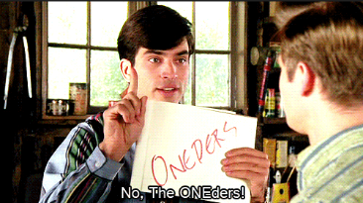
- Pronunciation is obvious. The movie, That Thing You Do, was built around a disastrous homonymous name for a musical group called the Oneders. Band members thought fans would pronounce it as the “Wonders,” but they were always introduced as the “Oh-Needers”.

- It is not geographically limiting. An exception is if you want to evoke a regional culture or food (e.g. - Kentucky Fried Chicken).
- Does not have a negative meaning in another language. Examples of unfortunate translations include:
  - Chevy Nova. “No va” means “No go” in Spanish.
  - Nature’s Gift aromatherapy products. “Gift” means “poison” in German.
- It conforms to legal requirements and restrictions.
  - You cannot use LLC, Corp, Corporation, Ltd, Inc. or Incorporated unless your company is organized under that legal structure.
  - On the other hand, if the business is an LLC, then the company must disclose this fact by placing "LLC" or "Limited Liability Company" at the end of its name. The purpose is to advise the public about the type of business organization. You cannot use Corp, Corporation, Ltd, Inc. or Incorporated in the name of an LLC as those adjectives designate and are restricted to full corporations.
  - The name cannot include words prohibited by state law (e.g., "Bank" or “Insurance” in some states). The prohibited words vary from state to state.

- The Domain name is available. A .com is usually the best choice for a commercial enterprise (com is short for commercial). If buyers know your company name, they will probably assume you are a .com and type that ending. When the top-level domain is not typed in, the default is .com. That is, if someone types in just a company name without a suffix, search engines will deliver the searcher to the .com version. Do not adopt a name if you cannot secure the domain name. If someone else owns it, all your marketing will just benefit them. For more information see Choosing a Domain Name.

- Name is Easy to Trademark: Of the following different types of names, the higher it is on the list, the easier it will be to trademark.
  - Your personal name (This is usually safe unless your name is J. C. Penney, and do not even think about using McDonalds for the name of a restaurant, even if your name really is Ronald McDonald. Examples of companies based on the names of their founders include Ford Motor Company, Smuckers, Firestone, and Ben and Jerry’s.
  - Fanciful (made up) words like “Google” and “eBay” were chosen because no one anywhere in the world was using them.
  - Combinations (Linking two words to make a new word): Kickstarter, LinkedIn.
  - Arbitrary (using a common word out of context): Apple computer, Twitter.
  - Suggestive (These can help establish your brand): Coppertone suntan lotion
  - Descriptive (The name explains what you do): Freightliner, International Business Machines.
Trademark Horror Stories
Two young entrepreneurs were sued for $1 million by a company who claimed their use of the name “HypeWipes” (for their mobile phone cleaning pad) conflicted with its long-standing trademark “Hype-Wipe” for a hospital disinfecting wipe. Lesson: check hyphenated and plural spellings when conducting a trademark search.
Facebook sued a company for using the name DesignBook. Lesson: Do not kick big dogs.

Module 1 - Entrepreneurship Chapter 8 – Naming the Company

BRAINSTORMING NAME IDEAS.

- For insights into the psychology of words see: kolenda.io/guides/brand-names.
- Consider ancient Greek or Latin words (Nike, Volvo). The right word may be evocative of what you do or the customers you want to attract.
- Use a Name-Generator Site. Free name-generator sites, useful for getting the creative process going. Note: you do not have to purchase your URL through these sites. See ”Where to Buy Domain”.
  - www.123Finder.com,
  - http://www.shopify.com/tools/business-name-generator
  - http://www.NameStation.com
CLEARING THE NAME. Make sure the name is not used by a competitor in your current or future market area. (For web-based companies, remember your market is the universe.) Do not worry if another company has a similar name if they are in another industry, as it would be unlikely that your use of the name will create confusion. For example, there are over 30 companies with the word “Sterling” in their name. However, before you buy that $20,000 sign for your building, check with an attorney. Confirm availability of each potential company name against the checklist on the following page.
- □ Google search (may uncover an unregistered trademark or competitor already using the name.)
Search name as two words (Whole Foods) and as one word (Wholefoods). .
- □ Check Secretary of State for your state (Has a company reserved or currently using the name?)
- □ Check social media. Is another company using the name on FB, IG, YouTube, X, TikTok?
- □ Domain name is available
These free AI services can suggest names as well as check for domain and trademark availability
  - www.Namify.tech Checks to see if domain, social media username and trademark are available
  - https://namelix.com/ Checks for domain availability
  - http://www.godaddy.com/offers/airo Checks for domain availability

PROTECTING THE NAME
- Buy the URL. Many registrars charge only $11 or $12 to purchase a domain name (but read the fine print, some services charge $35 or more for renewals). For low-cost sources, see “Selecting a Domain Name”
- Purchase the URL for your product name as well if it is different from the company name.
- Use TM (if a product) or SM if a service when you use your trade name. This puts others on notice that you claim the name as your trademark. For more information, see the “Trademarks” section of this text.

SUMMARY: Picking the perfect name is probably the most important decision you will make. Don’t get clever – pick a straightforward name anyone can understand, pronounce, spell, and find on a search engine.
- Brainstorm Names that evoke the right impression among your target demographic
- Test your short list on potential customers
- Verify that the name is not already being used
- Protect the name

Module 1 - Entrepreneurship Chapter 8 – Naming the Company

CHOOSING A DOMAIN NAME

Of the top 100 most visited sites in the United States, all are dotcoms. Some newer endings are growing in popularity, especially .co, but this should be a distant second choice. If you type in the name of a company in your browser, as the default, you will be taken to the company with the .com suffix.

Protecting Your Brand. Pirates have been known to register a name similar to a popular site and then clone the content. To protect yourself, consider registering...

- Alternative spellings: If you have drjones.com, you might want to buy doctorjones.com, as well.

- Additional extensions: if you own the .net or .co, consider registering the .com as a defensive measure.
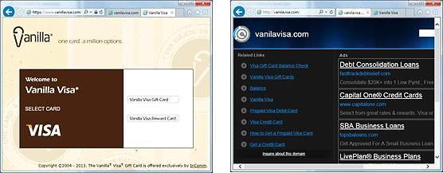

InComm launched a pre-paid Visa card called Vanilla Visa. They registered VanillaVisa.com but did not purchase VanilaVisa.com (a common misspelling), or VisaVanilla. As a result, another company registered those URLs to take advantage of InComm’s advertising and siphon off clients who had not won spelling bees. Wise entrepreneurs register likely mistypings as well as possible misspellings. If you type “Goddady.com” into a browser, you will arrive at “Godaddy.com”. Smart daddy.

Where to Buy Domain. NameCheap.com $11 first year/ $17 on renewal. GoDaddy.com charges $.01 first year/ $22 on renewal. Wix.com Free first year with hosting/ $19.35 on renewal. (All prices are for .COM domains (2025).

Subdomains. Some web hosting services offer free hosting if you use a subdomain of their domain name. A domain would be www.YourCompanyName.com. A subdomain might be www.YourCompanyName.Wix.com.

Module 1 - Entrepreneurship Chapter 9 – Protecting Intellectual Property

1.9 – Protecting Intellectual Property

1.9.1 Trademarks

1.9.2 Patents

1.9.3 Trade Secrets

1.9.4 Copyrights

Module 1 - Entrepreneurship Chapter 9 – Protecting Intellectual Property
The law provides three means for you to protect your intellectual property:

A Trademark protects a brand name, product logo or other feature that distinguishes one company’s products from its competitors. The intent of the law is to protect consumers from buying a look-alike, assuming it to be the real McCoy. A trademark of a service is referred to as a Service mark.

A Patent is an intellectual property right granted by the government to an inventor to exclude others from making, using, selling or importing the invention for a specified time, in exchange for public disclosure of the invention. See www.USPTO.gov.

A Copyright protects original works of authorship including books, scripts, music, art and design, and computer software.

DISCLAIMER. Government regulations and fees subject to change. The information provided is not legal advice. If you are contemplating pursuing protection for intellectual property consult with an attorney who practices trademark and patent law.

. Contact them at iplawclinic@law.uconn.edu.

1.9.1 Trademarks


Product names and logos may be protected with a trademark, and in some cases, you can register a color, or even a sound connected to your product or service.
The Coca-Cola Company has trademarked not only “Coca-Cola” and “Coke”, but also the typestyle, the swash below the name, and the shade of red. Even the distinctive hourglass bottle shape is trademarked.

NBC’s distinctive three-note musical theme G-E-C (for General Electric Corporation) is trademarked.

Where to start. Before adopting a trade name for your product or company, make sure it is not already registered for your class of product or service. If you search “Hilton”, you will of course find that it is registered as the name for a chain of hotels. However, this would not prevent you from using or even registering the name Hilton as a brand name for a hockey stick. The Hilton Company could not claim that you are confusing customers shopping for a hotel.

Steve Jobs named his company Apple because he admired the Beatles. (The Beatles record label was Apple.) The Beatles did not object—until Apple Computers entered the music business with iTunes. The Beatles sued for trademark infringement, which resulted in a $500 million payment to the musicians.
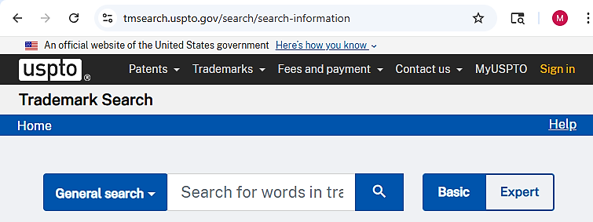

To access the trademark search page at the U.S. Patent and Trademark Office website (shown above) see...
http://www.uspto.gov/trademark
Trade Dress. There are ways to identify your product other than through a name (tradename) or logo (trademark). It could be the general design of a chain of restaurants, like Hard Rock cafes, or the layout of a magazine cover, or the brown trucks used by UPS. The intent of the law is to prevent consumers from being fooled into buying a product thinking it was something else. For example, if you saw a bracelet in a powder blue box, you would probably assume it from Tiffany’s, or a soda in an hourglass bottle was “The Real Thing.” Protection of trade dress may be registered in the same manner as a trademark.

Module 1 - Entrepreneurship Chapter 9 – Protecting Intellectual Property

Do you have to register a mark before using it? No. You can assert your claim to a tradename (the name of your company or product) or trademark (logo) by placing a TM (trademark) or SM (Service mark) designation next to the name or symbol. This is a common-law convention and does not require registration with the U.S. Patent and Trademark Office. However, you need to continually assert that you claim the name as a trademark by using the ^{tm} consistently. Otherwise, someone could say they did not know it was a trademark, adopted it innocently, and argue that you took no steps to protect it. Use the ^{tm} or ^{sm} (for a service) on all sales literature, business card, letterhead, invoices, and where it appears at least once on each page of your website and social media platforms.
Under the law, you even have some protection for an unregistered mark or trade dress, although a registered mark does provide greater protection and clearer title of ownership. Priority ownership goes to the first person to use the mark not the first to file (as with patents). Therefore, you need to be able to prove when you began using the trademark in business. Evidence might include a combination of a dated invoice to a customer, a dated receipt showing your company name for the purchase of products or services, or an ad in a newspaper or magazine (since they are dated). In any case, consult an attorney for professional advice.

While it is not necessary that you register a mark, there are several advantages of doing so:
- Official public notice that your claim of ownership has been registered
- The ability to sue for infringement
- An official registration may be used as the basis to obtain registration in other countries
- The ability to record the registration with the U.S. Customs and Border Protection Service to prevent importation of infringing foreign goods.
- The right to use the federal registration symbol ®; and
- Listing in the United States Patent and Trademark Office’s online database, where other entrepreneurs will see that you have registered the mark.
Trademark Protection Overseas. The Madrid Protocol allows a holder of a U.S. registration to file for protection of a mark in multiple countries with a single application, in English, and for only one set of fees. The World Intellectual Property Organization's International Bureau administers the Madrid System.
For details, see http://www.uspto.gov/trademarks/law/madrid/index.jsp

Trademark Filing Fees. The application filing fee for the TEAS (Trademark/Service mark Electronic Application System) is $350 (as of 2025) per class of goods and/or services. For example, if you intend to use the mark on computer hardware and T-Shirts, then you will have to pay a filing fee for each of the two classes. You will also need to pay $150 when you begin to use the mark in commerce (selling items displaying the mark); and a renewal fee of $525 every 10 years. Budget an additional $700 for attorney fees. For details, see http://www.uspto.gov/trademarks/index.jsp

Trademarks.
Note that the Starbucks mark is not registered.

Module 1 - Entrepreneurship Chapter 9 – Protecting Intellectual Property

1.9.2 Patents

First to File Versus First to Invent. As of March 16, 2013, the law was changed in the U.S. to award patents based on who was the first to file for a patent, as opposed to the previous method of granting a patent to the original inventor. Unfortunately, it is now easier to “steal” an idea. The “poor man’s patent”—mailing plans to yourself to prove when you developed an invention—is now immaterial.

How Can an Inventor Protect an Idea Before It Is Patented?
- DO NOT DIVULGE THE Formula for your SECRET SAUCE when selling your idea to supporters. Just reveal the benefits of the innovation: “Our new beverage beats Coke and Pepsi in taste tests and has zero calories.”
- LIMIT EXPOSURE. Pick out one or two people you feel you can trust: an attorney, potential investor, or beta tester (early customer you allow to use the product for free to determine if the idea needs more development), or a mentor to discuss how best to move the project forward.
- USE A non-disclosure agreement (NDA) when possible. If someone does need to see enough of a product to be convinced, and this would allow the viewer to replicate the product, ask the person to sign an NDA. That said, prospective investors will not sign NDAs just to evaluate an idea. With potential financial backers, you need to trust your instincts as to their character. You can ask for references; that is, names of other innovators or entrepreneurs that the investor has worked with. Then call these individuals and ask about their experiences.
- FILE A Temporary PROVISIONAL PATENT. This requires less paperwork than a full patent and will buy you 12 months to refine the final product and still establishes your precedence as the first to file. You will be able to use the term patent pending in conjunction with the product during the 12-month pending period. You must file for a full (non-provisional) patent within 12 months or risk losing the right to patent.
The cost to file a Provisional Patent is $325 (as of 2025). You will then incur the regular filing expenses when you file for the full patent. (See Patent Office Fees in this text. )

For more on provisional patents, see https://www.uspto.gov/patents/basics/apply/provisional-application

There are two types of full or long-term patents:

DESIGN PATENTS that protect how something looks, not how it works. To obtain patent protection an “Ornamental Design” must be new, original, and non-functional. A design patent is good for 15 years.

Design patent filing fees are about 10% less on average than utility fees. The rounded corners on an iPhone is a design patent. When Samsung introduced its smartphone, with rounded corners, Apple sued for violation of its design patent.

UTILITY PATENTS are full non-provisional protections for inventions, processes, materials, machines and manufactured items that provide utility (they are useful). Good for 20 Years.

For an invention to receive a utility patent it must …
- BE NOVEL. Cannot already be in use in U.S. or patented anywhere in world more than a year before filing.
- HAVE UTILITY. Must have a useful purpose.
- NOT BE OBVIOUS to a person with ordinary skill in the field of the invention

Module 1 - Entrepreneurship Chapter 9 – Protecting Intellectual Property

To Patent or Not to Patent

REASONS TO PATENT:

- To Build Investor Confidence. Investors do not value abstract ideas. They need to see tangible evidence of value: patents, working prototypes, proof of profit potential, satisfied beta testers. A patent also provides some business life insurance for the investors; if the business fails, but the product is still marketable, the investors may be able to salvage some of their investment by selling the patent.

- TO DISCOURAGE KNOCK-OFFS.

- To prevent someone else from PATENTING THE IDEA. It does not matter that you were the inventor. If someone patents the idea before you do, then that person will own it and can prevent you from marketing the product.

REASONS NOT TO PATENT:

- TheRE ARE OTHER FASTER AND LESS EXPENSIVE STRATEGIES TO CREATE A BARRIER TO COMPETITORS. The opposite strategy to patenting and then enforcing your rights in the courts is called the First to Market or First Mover strategy; that is, to establish your platform or methods as the standard. This strategy may be the most feasible even if your intellectual property is not obscured within a secret sauce. Many companies, without patents, have been successful with a first-to-market strategy. Indeed, most new businesses are based on ideas that are not patentable in any event. For example, McDonalds Restaurants (fast, cheap, limited menus, no ambience), Starbucks (good quality coffee), or FedEx shipping services (overnight delivery) are not patentable concepts, but those companies were the first to market nationally and they set new standards.

The Secret Sauce Approach. If you really do have a secret sauce, like Coca-Cola, and it is unlikely anyone will figure it out, then the value of the patent might be more than offset by the fact that to obtain a patent you would have to divulge the formula, thereby aiding the unscrupulous who will not honor your patent rights anyway. Coca-Cola has not been patented for just this reason. Other secret sauces whose very secrecy can sometimes be more valuable than patents (which are online for all to see), include many software products. For example, only Google knows exactly what algorithms it uses to determine which web pages to return during a search.
For more on the just-keep-it-secret strategy versus patenting, see “Trade Secrets” in this text.

The Case Where a PRODUCTS MARKET LIFE IS LESS THAN THE TIME NEEDED TO OBTAIN A Patent. For some software or electronic products, the useful life may be shorter than the time it takes the U.S. patent office to approve it. In this case, you would be better off going to market immediately. Otherwise, the invention may become obsolete or go out of style before a patent is granted.

Time and Expense to File and Defend a Patent. Attorney fees can run to $10,000 or more. A full patent requires typically three or more years to obtain; and applicants are not always successful.

Module 1 - Entrepreneurship Chapter 9 – Protecting Intellectual Property

Patent Office Fees. There are four types of fees, assuming electronic filing versus paper. (Amounts as of 2025.)
- Basic Filing Fee, $ 350 (+$600 for each claim in excess of 3)
- Patent Search Fee, $ 770
- Patent Examination Fee, and $ 880
- Patent Issue Fee (if application is approved) $ 1290
$ 3290
DISCOUNTS FOR SMALL AND MICRO ENTITIES.
Small Business Entity: Independent inventor, a for-profit with fewer than 500 employees, or non-profit organization as long as the filer has not assigned, granted, conveyed, or licensed (and is under no obligation to do so) any rights in the invention to a for-profit company with over 500 employees.
60% Discount on most fees = ……………………... $ 1316 approximate total
Micro Entity: Meets the Small Business Entity requirement and has income below $241,830 (as of June 2025). Note, the threshold amount for a micro entity changes every year during or shortly after September. For more information on micro entity status see https://www.uspto.gov/patents/laws/micro-entity-status
80% Discount on most fees = ……………………..… $ 658 approximate total

Patent Maintenance Fees. However, to maintain the patent, a Small Entity must pay additional fees of $860 after 3.5 years, $1616 after 7.5 years, and $3312 after 11.5 years. (A Micro Entity will pay half of these amounts.)
If the product is not successful, the filer may avoid paying the maintenance fees by abandoning the patent.
For a full schedule of filing fees see https://www.uspto.gov/learning-and-resources/fees-and-payment

Where To Start
- CONDUCT A PATENT SEARCH to confirm that no one else has patented the product, process or design. You can conduct a search at the www.USPTO.gov website. Google also has an easy-to-use patent search function at https://www.google.com/?tbm=pts

If you do not find anything, before committing funds to developing your product idea, you may still want to have a patent attorney conduct a professional search for you. Just to be sure.
- DECIDE WHEN AND IF TO FILE. Seek professional advice, as this is a complex decision.
- DECIDE ON WHICH TYPE OF PATENT TO FILE: Design, Provisional, or Utility.

A Note on Software: Copyright versus Patent. While software may be copyrighted, patenting is becoming a more popular choice of protection. With a copyright, it is difficult to prove plagiarism of specific “expression.” Moreover, the courts may not understand the code. Check with an Intellectual Property attorney.

Module 1 - Entrepreneurship Chapter 9 – Protecting Intellectual Property

1.9.3 Trade Secrets

An alternative to patenting is the Trade Secret. Information about the product or process is not filed with the government, as then it would be available to the public and, well, no longer a secret. The common law behind the concept is that if you literally had a secret sauce, you could take legal action against someone who sells the identical sauce if you can prove they would have had to obtain the information illegally.
To prove the information could have only been obtained surreptitiously, you would have to document that you had a formal procedure to prevent disclosure of the trade secret. The percentage of each ingredient or the process you use to mix and prepare them cannot appear in any sales literature, website or even relayed in a conversation to a customer. It must be kept secret. Proof of your safeguarding procedures might include:
- Security of business office and manufacturing location
- Procedures to keep vital information under lock and key
- Non-disclosure agreements with employees and suppliers

A patent is more expensive, but as a government document it is easier to defend in court than a Trade Secret claim.

1.9.4 CopyrightS
A copyright protects works of authorship, such as writings, music, and works of art.
Before 1989, US copyright law required creators to publish works with a copyright notice, and before 1978, creators had to file for a copyright renewal after the initial 28-year term. However, obtaining and retaining copyright is now an automatic practice. Under the current US statute (US Code Title 17), you own a copyright on your work from the moment you create it, and the copyright lasts for the life of the author plus 70 years.
Although you do not have to register works to protect them, if you wish to bring a lawsuit for infringement of your work, you will have to produce a registration certificate.
Registration Fee. If you choose to register your work, the fee to do so online is $45 (as of 2025). See https://www.copyright.gov/
Protection in Other Countries. The U.S. has reciprocal copyright agreements with most countries. For a list see http://www.copyright.gov/circs/circ38a.pdf, International Copyright Relations of the United States. For More on Copyrights, see www.copyright.gov.


Examples of copyrightable works. The Velvet Underground album embodies three types of copyright examples: 1) the banana cover design by Andy Warhol, 2) the liner notes on the back of the album, and 3) the music itself.
Module 1 - Entrepreneurship Chapter 10 – Structure and Regulatory Matters

1.10 – Structure and Regulatory Matters

1.10.1 Finding Your NAICS Code

1.10.2 Federal EIN Number

1.10.3 Steps to Setting up an LLC

1.10.4 Business Licenses

A wide variety of legal templates can be downloaded for free at

https://law4startups.com

Module 1 - Entrepreneurship Chapter 10 – Structure and Regulatory Matters

1.10.1 Finding Your NAICS CODE

NAICS (North American Industry Classification System). To find the NAICS (rhymes with rakes) code for your business, go to www.naics.com. You will need this code number for many government documents and on trade association membership applications. If you are having difficulty finding your industry, try typing into a Google search “What is the NAICS Code for [describe your business]?”

Terms you used in the search for your NAICS code: ________________________________________
NAICS Code(s) and official definition. Note: a company may have more than one code.

1.10.2 Federal EIN Number (Employer Identification Number)

You will need to complete an EIN Application (federal form SS-4) to establish an LLC or corporation, hire employees, or open a business bank account. You can apply online at sa.www4.irs.gov/modiein/individual/legal-structure.jsp and receive your number within 24 hours.

However, we suggest you first draft a copy of the one-page application to review with an advisor or attorney and to discuss any questions you are not sure how to answer. To access a fillable pdf see www.irs.gov/pub/irs-pdf/fss4.pdf. Here are some explanations of the more ambiguous questions on the Federal EIN application:

No. | QUESTION | BRIEF EXPLANATION
3 | Executor, Administrator, trustee etc. | Leave blank unless you are working through one of these agents
4-5 | Location of business | Use your home address if you do not have a business location, or if it is likely the business will move.
8a | Is this application for an LLC? | If you are intending to organize as an LLC, but have not yet filed the papers, that’s OK, answer YES.
8b | Number of members in the LLC | You may not know how many co-founders you will have. Make as good a guess as you can. If you plan to go it alone, enter “1”.
8c | Was the LLC organized in the U.S.? | If not organized yet, but you do plan to establish in the U.S., answer “Yes.”
9a | Type of Entity | If you will be organizing as an LLC, check the “Other” box and write in “Disregarded entity.”
11 | Date business started. | Businesses are like people. When they are young they want to appear older. So, give your business the earliest possible birthdate. If you have not yet started, enter today’s date.
12 | Closing month of accounting year | Enter “December” so your fiscal year will match the calendar year. This is not like tattoos. You do not want to be different. If you enter a month other than December, you will regret it when you have to issue financial reports to investors or tax returns for Uncle Sam.
14 | Federal Payroll Taxes | Check the box if you do not have employees now and do not expect to hire anyone before the end of the calendar year.
15 | First date wages were paid | If correct, just write “Do not yet have employees”
18 | Third Party Designedd | Leave this section blank unless you want someone else—like your attorney—to receive government notices instead of you.

For detailed instuction for form SS-4 see https://www.irs.gov/pub/irs-pdf/iss4.pdf
Module 1 - Entrepreneurship Chapter 10– Structure and Regulatory Matters

1.10.3 SETTING UP AN LLC

The most common florms are the Sole Proprietorship, LLC (Limited Liability Company), and Corporation (C-Corp). By default, you are a Sole Proprietorship (you and the business are one and the same). Setting up an LLC will provide some protection of your personal assets in case of lawsuits, but requires annual filing fees and in many states a minimum annual tax. If you want to raise outside funding from angel investors or venture capitalists, you will need to organize as a Corporation. However, you can start as an LLC and then convert to a C-Corp when you are ready for equity financing.

LLC State Filing Fees. The one-time fee to register an LLC ranges from $50 to $500 per state, with most in the $100 to $200 range. To find the filing fee for your state see www.upcounsel.com/annual-llc-fees-by-state.

Minimum State Business Income Taxes. Almost all states levy taxes on business income, ranging from 4% to 12%, but what a startup needs to know for budgeting purposes and deciding what legal structure to use, is whether their lurks in the tax code of his or her state a minimum Business Entity Tax, Franchise Tax, Annual Filing Fee, or other term for a minimum tax. Although LLCs allow business income to pass through to the owner(s), so that the owner or owners are not taxed twice, some states still expect the business entity to pay a minimum tax--even if it didn’t have any income. For information on state corporate tax rates, see taxfoundation.org/center/state-tax-policy/

The federal government does not levy a minimum tax on companies that break even or lose money.

STEPS TO SET UP AN LLC

1. Check with your Secretary of State to see if another business has registered the name. Also check the U/S. Patent and Trademark Office https://www.uspto.gov/trademarks/search to see if the tradename is available.

2. Arrive at an agreement among the founders as to what percentage each of you will own. (You can also form an LLC as the sole member.)

3. Prepare an Operating Agreement. This agreement governs the operation of the LLC and defines the rights and obligations of the Members to each other and to the LLC. (The Operating Agreement is not the document you file with the state to set up an LLC. That document is the Articles of Organization.) A boilerplate LLC Operating Agreement may be downloaded from www.LawDepot.com or www.RocketLawyer.com at no charge with a limited=time free trial. We recommend that you review the document with a business attorney.

4. File Articles of Organization with your Secretary of State We recommend you register in the state where your company is located. While some states have very favorable laws for companies, there are additional fees to register in another state. Once you reach $10,000,000 in sales, then consider registering in Delaware.

5. Register your company with the Town Clerk’s office of each municipality in which you will operate. For most companies this will be your headquarters location. However, a consumer service business such as a roofing company will need to register in every town that it has customers. A Google search of “[city] Town Clerk” should connect you to the appropriate web site where you will most likely find a simple one-page form.

6. Obtain a Sales Tax License through your state department of revenue services. (Search “Sales taxes” and the name of your state.) Some municipalities, like New York City, also require you to collect sales taxes on their behalf, so also check with the city administration in the town where your business is headquartered.

Since you will be obligated to submit periodic reports after you register for a sales tax permit, you may want to wait until you have actual sales before doing so.

Module 1 - Entrepreneurship Chapter 10 – Structure and Regulatory Matters

1.10.4 Business Licenses

If you are involved with any of these industries, you may require one or more business licenses from LOCAL, STATE and/or FEDERAL AGENCIES”
- Agriculture
- Alcohol
- Auctions
- Aviation
- Broadcasting (Radio and TV)
- Construction
- Day care
- Dry cleaning
- Energy
- Firearms and ammunition, explosives
- Fish and wildlife
- Food service
- Gambling
- Manufacturing
- Maritime
- Mining and Drilling
- Plumbing
- Recycling
- Restaurants
- Retail
- Spas and beauty parlors
- Tobacco
- Transportation
- Vending machines
LOCAL LICENSES and PERMITS. Check with your town and county clerks to ascertain what may be required. For most businesses, local governments will require only that you register. The cost usually ranges from $25 to $50.
It is also wise to check with the local fire department to make sure your intended business location can be occupied.

ZONING RESTRICTIONS. When you visit your town clerk to register your business, check to see if your business location is zoned to permit your type of business; and what limitations there might be on signage, noise, use of hazardous materials, minimum parking spaces required; and if a food service business, the health department codes.

STATE LICENSING DEPARTMENTS. See https://www.constantcontact.com/blog/state-business-licenses/
If you need help, consult with your nearest Small Business Development Center (SBDC).
https://www.sba.gov/local-assistance/resource-partners/small-business-development-centers-sbdc

FEDERAL LICENSES AND PERMITS.
See www.sba.gov/business-guide/launch-your-business/apply-licenses-permits#federal-licenses-and-permits

Module 1 - Entrepreneurship Chapter 11 – Raising Startup Capital

1.11 – Raising Startup Capital

1.11.1 Determining Startup Capital Requirements

1.11.2 Sources of Startup Capital

1.11.3 Pitching Business Concepts

ANGEL AND BANK FINANCING ARE NOT REALISTIC FOR PURE STARTUPS.
- Investors will not risk money on ventures without a proven revenue and profit model. The time to pitch investors is after a business model has been successfully proven and demonstrated.

- More realistically, the initial capital to test your concept will probably come from personal savings, family, and crowdfunding.
- In any event—with or without startup capital—entrepreneurs should avoid large commitments to marketing and infrastructure until all business model hypotheses are validated.

A WORD ABOUT NDAS (NON-DISCLOSURE AGREEMENTS). An NDA is basically a written promise not to divulge the unique aspects of your business model to potential competitors. If your product is not patented, you may want to ask for an NDA before discussing details with a prospective employee, supplier, or financier. However, it is a rare investor who will sign an NDA. Their concern is that they may already have invested in a similar product that is about to be released.
One work-around is simply not to divulge your secret sauce. For example:
- If you have a new beverage, just say “It outperforms Brand X in blind taste tests” (but do not divulge the formula).
- If you have developed enterprise software for financial institutions, say “It will save banks 20% on their compliance costs” (but do not show the source code).
You can still ask for an NDA when you begin serious investment discussions. A boilerplate

The culture of most collaborative forums (Startup Weekends and entrepreneurship classes, to name two) is to ask everyone to honor each other’s confidential information. As BUSINESS MODEL guru Steve Blank points out, discussing an idea openly in his Stanford University class risks intellectual property theft, but the upside is lots of feedback. He does not use NDAs in his class.

Module 1 - Entrepreneurship Chapter 11 – Raising Startup Capital

1.11.1 Determining Startup capital requirements

THE CAPITAL REQUIREMENT is the amount of cash you will need to cover startup expenses and operating expenses until the company is cash-flow positive. Do not overlook general liability and product insurance. Even if you are selling products made by other companies, you still may be liable if a customer is injured by the product.

MINIMIZING CAPITAL NEEDS. The lower the capital requirement, the easier it will be to attract investment. To reduce investor risk, break down capital requirement into tranches for each plateau of development (e.g. – R&D, prototyping, lab testing, patenting, beta testing with customers, full market launch, and runway to break even). Investors prefer to mete out cash when (and if) interim goals are met. (Investors adhere to Cheops law: Nothing ever gets built on schedule or within budget.)

You may be able to reduce your total capital needs with tight cash-management techniques:
    - REQUIRE PREPAYMENT at time of order, at least enough to cover the cost of the raw materials you will need. This is a customary practice in the home remodeling industry.
    - LEASE VERSUS PURCHASE. Leasing a car or truck for a business instead of purchasing it conserves cash. There are also leasing agents and finance companies that will purchase manufacturing equipment and then lease it back to you.

This is an interactive spreadsheet. To open, right-click on spreadsheet, click “Worksheet Object” and then "Open.”
You need to enter data in shaded fields only; the totals will be computed for you. You can download a copy of this form at http://www.EntrepreneurshipFoundation.org/spreadsheets

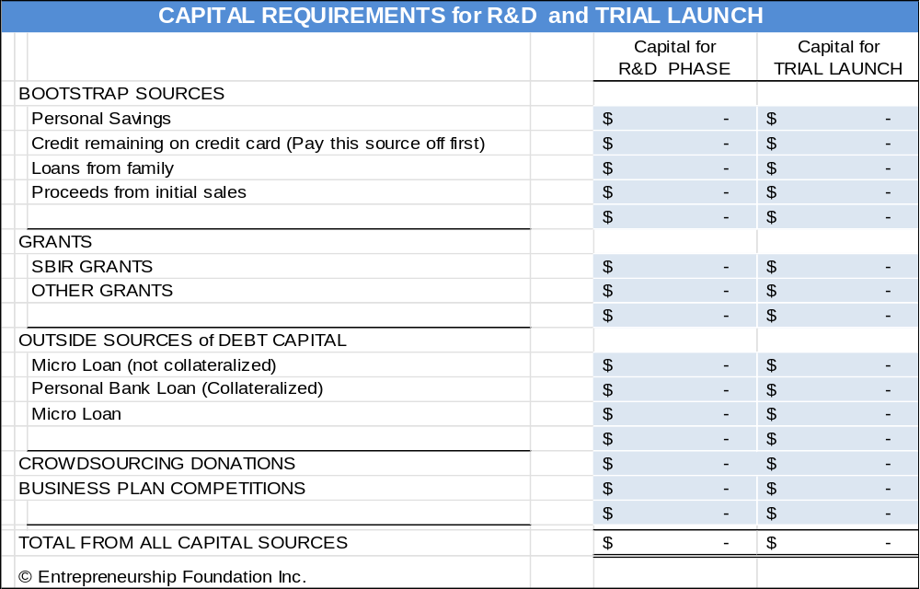

Module 1 - Entrepreneurship Chapter 11 – Raising Startup Capital

1.11.2 Sources of Startup Capital

- Personal Savings. The more money you personally invest in your business, the easier it will be to attract outside financing. Capital providers feel more confident you will stick with the venture if you have “skin in the game.” Investors will only consider cash contributions on your part, not the value of your time. Determine how much capital you need to start the business and set that amount (plus a reserve for contingencies) as your savings goal. If you do not have outside employment, include twelve months of living expenses in your capital needs. You probably will not be able to draw money out of the business for at least that long.
- Family and Friends. Along with personal savings, this is the most common source of capital for new businesses. Family members may not require personal guarantees and therefore will not foreclose on your home but be careful not to risk more family and friends than you can afford to lose. Those Thanksgiving get-togethers can get rather frosty if you lose your sister’s college fund.
- Government Lenders. The SBA offers a Microloan Program (amounts up to $50,000). The average has been around $13.000. See www.sba.gov/loans-grants/see-what-sba-offers/sba-loan-programs/microloan-program
- Small Business Innovation Research (SBIR) Grant Program. SBIR awards grants to small tech businesses. See www.sba.gov/loans-grants/see-what-sba-offers/sba-loan-programs/microloan-program
Phase I awards range up to 314,363 and Phase II awards $2,095,748 (2025). This R&D funding does not have to be repaid.

The Small Business Technology Transfer program (STTR) is a sister program that awards federal funds to small businesses that subcontract R&D to universities or research institutions.


Business Competitions. Search online for “Business plan competitions” and “business model competitions” to find opportunities that you might qualify to enter. If you are a student, search your school’s website to see if it holds an annual competition. Popular competitions include:
Two Yale students accept a check and trophy from angel investor Joseph Demartino at an Entrepreneurship Foundation business plan competition.
  - GLOBAL STUDENT ENTREPRENEUR AWARDS, for students who are already in business, sponsored by the Entrepreneurs Organization https://eonetwork.org/gsea
  - RICE BUSINESS PLAN COMPETITION, with $1 million in awards. https://rbpc.rice.edu/
  - VENTUREWELL. Grants for social, health, or environmental solutions. https://venturewell.org/

- Reward-Based Crowdfunding. RECOMMENDED GOAL: $5000 to $50,000. The funds in this instance come from customers paying for the product in advance of it being manufactured. The buyers need to be told in advance how long it will be (usually months) before the product will be delivered.

The “reward” is typically one or more of the products. However, for amounts less than the value of the product, the reward might be a token of appreciation, such as a mention on the company website.

Module 1 - Entrepreneurship Chapter 11 – Raising Startup Capital

THERE ARE TWO TYPES OF REWARD-BASED CROWDFUNDING:
- All-or-nothing (AON) where the entrepreneur receives nothing unless the goal is met. A study by Inc. Magazine concluded that all-or-nothing fundraising campaigns “were much more likely to be successful at achieving their goals… and potential investors are more inclined to support ‘all-or-nothing’ initiatives.” This is the Kickstarter model. Set your official “goal” as the number you need to produce to meet the Minimum Economical Quantity (MEQ) to produce the products. You can go over the minimum.
- Keep-it-All: the entrepreneur publishes a goal on the crowdfunding website and keeps whatever is raised regardless of whether the goal is met. Indiegogo offers both Keep-it-all and All-or-nothing.

For a free how-to guide see https://entrepreneur.indiegogo.com/how-it-works/

Platform | KIA or aon | COMMISSION FEE | PAYMENT PROCESSING | COMMON  PRODUCTS
Kickstarter.com | AON | 5% | 3.0% + $ .20 | Creative arts
Indiegogo.com | KIA | 5% | 2.9% + $ .30 | Innovation / creative arts

TIPS FOR REWARD-BASED CAMPAIGNS
- Make sure you know the cost and source of every product component and process before launching campaign: (Manufacturing 1000 widgets is a lot more complicated than making one prototype.)
- Factor in the additional cost to ship overseas and price for U.S. and foreign buyers separately. If you have a heavy or bulky product, you may want to limit buyers to the U.S. For international postage rates (and weight and size limits) see https://www.usps.com/international/. Note, for Kickstarter, you must set one price for all foreign buyers, including freight, so estimate high.
- Keep accurate cost-accounting records to make sure you will make money at each level after factoring in the cost of the reward. The following is a link to a free Google Awards Pricing Template: https://docs.google.com/spreadsheets/d/1_nNBz-TheExh8rxeQCffu3U2fJJBkRDBdnUgpKDrmk0/edit#gid=0.
Include a 20% cushion for unforeseen expenses and contingencies: e.g., Tariff hikes between date of sale and when order is shipped. Preferably, look for a domestic supplier. Cost may be a little higher, but you should be able to lock it in.
- Offer donor levels at $5 and $10. (with a thank-you only). Some people may give you money because they like the idea, especially if it is a social enterprise. Check similar products to see which prices and prizes were most popular.
- Start promoting via email and social media starting a month before launch. Maintain momentum with weekly updates on the platform, social media, and emails to backers and media.
- The reward-based-campaign can also serve as a Trial Launch to test pricing and quantity discounts.

FULFILLMENT: Some fulfillment houses specialize in distributing rewards to backers. Contact the services for pricing, which depends on the difficulty of storing and shipping your physical rewards

SHIPBOB https://www.shipbob.com/crowdfunding-fulfillment-services/
SHIPMONK https://www.shipmonk.com/fulfillment-services/crowdfunding-fulfillment
FULFILLRITE https://fulfillrite.com/crowdfunding

Module 1 - Entrepreneurship Chapter 11 – Raising Startup Capital

1.11.3 Pitching Business Concepts

Competition judges and capital providers, by nature, are risk averse and skeptical. Be Clear, Concise and Convincing.

EIGHT-SECOND SOUND BITE. This is a statement about your investment opportunity that you can get out in one breath. The place to use this is at a business-networking event where someone asks, “What do you do?” You never know who you might meet, so assume everyone you talk to is a potential investor or knows someone who is. A brief but engaging introduction about what you do is also valuable when recruiting employees or clients.
No one writes a check in an elevator. The sole purpose of the elevator pitch is to pique the interest of the investor, so they want more information. Success is these brief encounters is an exchange of business cards and an offer for you to call and set up an appointment for an in-depth interview.

The elevator pitch forces you to achieve clarity. At a minimum, the pitch should include YOUR NAME, COMPANY NAME, PROBLEM, and YOUR SOLUTION.

The elevator pitch should be memorized and rehearsed enough so that you can give it without it sounding rehearsed. You never know where you might meet a potential investor: at a cocktail reception, football game, even in an elevator. An 8-second elevator pitch might sound like this:
“Sugarcoate Systems reduces the time to bring new drugs to market by 20%.”
“We make flameproof fabrics for aircraft interiors.”
“We make cupcake decorating kits for children’s birthday parties.”

You need to convey all the essential information in a clear, concise, credible, and convincing manner that is also natural but passionate.

For more on mastering the elevator pitch see...
http://www.inc.com/guides/2010/05/mastering-business-elevator-pitch.html.

30-to-60-SECOND ELEVATOR PITCH (without audiovisuals). You will probably be one of many presenters, so be memorable. State your name and company name slowly and distinctly at the beginning and end of your talk. Consider opening with a dramatic statement to capture the attention of the audience. Address the following points:

        - Big idea (customer problem and your solution) (1 or 2 sentences)
        - Status of the idea or business (1 brief sentence)
        - Revenue model (e-commerce, wholesale, etc.) (1 sentence)
        - Sales potential (justify expectations) (1 sentence)
        - Competition and why do you believe you have an advantage (2 sentences)
        - Rock stars are on the team who will ensure success (2 sentences)
        - Personal goal (1 sentence). To create a …
1) Part-Time Business (side hustle),
2) Full-time Personal Business,
3) Venture Enterprise with a substantial market and requiring venture capital to reach full potential.
        - Total funding required to launch the business full-time, and how much you need initially to develop the Minimum Viable Product and test it in the marketplace? (1 brief sentence)

Module 1 - Entrepreneurship Chapter 11 – Raising Startup Capital

SAMPLE ELEVATOR SCRIPT. "Our company, WorkBoots.com, is an e-commerce website that sells brand-name construction boots. There are currently no companies serving this niche exclusively. We will drive traffic to our site by linking to other websites catering to the construction industry as well as through word-of-mouth. In industry surveys, over 90% of construction workers have three traits: 1) they have a favorite brand of boots, 2) they know their size, and 3) they hate shopping at stores. In our own polling of 30 construction workers, over 70% indicated that they would prefer to buy their boots online and have them delivered. We need $500,000 in funding to reach break-even, which we can reach in 18 months. I am the CEO. I have operational experience and contacts with boot manufacturers. Our Marketing Director was instrumental in the growth and recent sale of a successful e-commerce clothing company. Our goal is to sell WorkBoots.com to a 'brick and mortar' retailer in 3 years."
VIDELINKS Sample elevator pitches: MIT Pitch competition https://youtu.be/n0BKBcSZaA0

YOUR 8-SECOND PITCH:

YOUR 60-SECOND PITCH:

Module 1 - Entrepreneurship Chapter 11 – Raising Startup Capital

 |  | ELEVATOR PITCH RATING SHEET FOR COMPETITIONS
 |  |  | S c o r e
 |  |  | NO | < -- > |  |  | YES
 | 1. PRODUCT or SERVICE: Do you know what it is and what it will do? |  | 1 | 2 | 3 | 4 | 5
 | Compelling value proposition or solution to customer problem?
 | 2. COMPETITION: Is product unique, or superior to alternatives? |  | 1 | 2 | 3 | 4 | 5
 | 3. TARGET MARKET: Clearly defined? Adequate to support business? |  | 1 | 2 | 3 | 4 | 5
 | 4. MANAGEMENT: Was presenter knowledgeable, polished, confident? |  | 1 | 2 | 3 | 4 | 5
 | 5. FINANCE: Do you know how the company will make money? |  | 1 | 2 | 3 | 4 | 5
 | 6. FUNDING: Do you know how much company needs to launch? |  | 1 | 2 | 3 | 4 | 5
 | TOTAL (Maximum 30) ………………………………………………………..
FEEDBACK _____________________________________________________________________________

_____________________________________________________________________________

_____________________________________________________________________________

_____________________________________________________________________________

 | Presentation Style: Speak louder Speak slower

Launching a New Venture

Ninth Edition

Module 2
Small Business Marketing
Branding, Website, Message, Collateral material, Traditional mass media, Digital mass media, Targeted Media, Sales

Entrepreneurship Foundation, Inc.

Module 2 - Marketing Checklist

MARKETING CHECKLIST

Click on a topic to go to that secion in the book.

- □ Formulate Brand Strategy
- □ Resolve Best Name for Company
- □ Establish Corporate Design Standards
- □ Create Logo
- □ Choose a Domain Name
- □ Select a Hosting Service
- □ Build a Website
- □ Create an Ad for a Social Media Banner, Billboard, or Magazine
- □ Prepare Marketing Plan and Budget

Module 2 - Marketing Chapter 1 – Branding

2.1 – Branding

2.1.1 Brand Strategy

2.1.2 Company Name

2.1.3 Design Standards

2.1.4 Logo

2.1.5 Packaging

2.1.6 Labeling

2.1.7 Phone Number

2.1.8 Business Email Address

“The action that follows deliberation should be
quick, but deliberation should be slow.”
— Aristotle

Module 2 - Marketing Chapter 1 – Branding

2.1.1 Brand Strategy

Your brand is your style, attitude and promise to your customers. Also known as your “Brand Image” or “Brand Promise,” it is the sum of what customers can rely upon. Think of companies you trust. Why? How have they convinced you that their brand promise is the real deal?

Your branding extends beyond the look and feel of your company name, logo, website, and advertisements. It is also how you behave toward customers and what they care about. For customers to believe in your brand promise, you have to live it.

Your decisions about every customer touchpoint: logo, typestyle in ads, website, even the way you and your employees dress will affect how people think about your company.

TO BUILD A BRAND IMAGE, START BY DECIDING THE KIND OF COMPANY YOU WANT TO BE. Lowest price? highest quality? best personal service? most durable products? fastest delivery? most liberal trial basis? greenest?
OUR BRAND STRATEGY:
When reviewing our company online, we want customers to say …

We sincerely want customers to rely on that we will ….

BRAINSTORM WORDS AND IMAGES TO REPRESENT YOUR BRAND PROMISE in tag lines and ad copy.

Branding interpretations by the Logo Company, custom logo designers https://thelogocompany.net/
Module 2 - Marketing Chapter 1 – Branding

2.1.2 Company NAME
This segment also appears in Module #1 (Business Modeling) in an abbreviated form.

DO NOT rush this decision. It has far-reaching effects on the business and is difficult to change after the company launches because of all the places a company name appears:
- Letterhead and business cards
- Signage
- URL and email address
- Legal documents
- Bank accounts and checks
Your company or product name will be a potential customer’s first impression. Entrepreneur Magazine suggests, “Your name should convey the expertise, value and uniqueness of the product or service you have developed.” If you were starting a bakery, which of these company names is more likely to arouse positive emotions: “Anderson’s Bread Shop” or “Open Hearth Breads”?
CRITERIA FOR THE PERFECT NAME INCLUDE...
- Short and easy to remember (easy to type into a web browser).
  - Of the 100 most visited websites, 72% have six or fewer letters; only 3% have more than 15.
No one wants to type www.TheWorldsMostWonderfulWidget.com. As evidence that shorter is better, consider that United Parcel Service goes by UPS, International Business Machines as IBM, Hewlett-Packard legally changed its name to HP Inc., and International House of Pancakes changed its name to Ihop.
  - Single words. All things being equal, a one-word name is better than two or three words, so “Panera” for a bakery trumps mouthfuls like “Open Hearth Breads”, which is also a long string to type into a browser. Short, simple words are also easier to remember (Apple, Google, Skype, Madonna).
  - Conjoined words are the next best (Netflix, Microsoft, StubHub, FedEx, Hotmail). They become unique new words and therefore are relatively easy to trademark.
- Describes what service you provide or the type of products you sell. Most people now use search engines to find products or services online or that are available locally. Does the name allow you to be found by search engines? Which is better for a bookstore, “Jane’s Place” or “Academy Books”?

But the name is not too specific. Diversifying might become awkward. Which is better: Acme Garage Doors or Acme Manufacturing? Consider a made-up name like Exxon, Xerox, or Google. An advantage of a word you make up is that it is easy to trademark (it is not likely anyone else will have registered it.)
- Name conveys the sense of a stable, reliable company. Some words suggest quality and inspire confidence. Some do not. Jennifer Fitzgerald, founder of Policygenius (an insurance advisory service) suggests asking yourself if you can imagine saying your company name to a Wall Street Journal reporter.
- Spelling is easy and unambiguous. Do not get clever with words like “Muunglow”. Select a name that people will spell correctly the first time, so they find you in a search, and not your competitor.

Module 2 - Marketing Chapter 1 – Branding

- Pronunciation is obvious. The movie, That Thing You Do, was built around a disastrous homonymous name for a musical group called the Oneders. Band members thought fans would pronounce it as the “Wonders,” but they were always introduced as the “Oh-Needers”.

- It is not geographically limiting. An exception is if you want to evoke a regional culture or food (e.g. - Kentucky Fried Chicken).
- Does not have a negative meaning in another language. Examples of unfortunate translations include:
  - Chevy Nova. “No va” means “No go” in Spanish.
  - Nature’s Gift aromatherapy products. “Gift” means “poison” in German.
- It conforms to legal requirements and restrictions.
  - You cannot use LLC, Corp, Corporation, Ltd, Inc. or Incorporated unless your company is organized under that legal structure.
  - On the other hand, if the business is an LLC, then the company must disclose this fact by placing "LLC" or "Limited Liability Company" at the end of its name. The purpose is to advise the public about the type of business organization. You cannot use Corp, Corporation, Ltd, Inc. or Incorporated in the name of an LLC as those adjectives designate and are restricted to full corporations.
  - The name cannot include words prohibited by state law (e.g., "Bank" or “Insurance” in some states). The prohibited words vary from state to state.

- The Domain name is available. A .com is usually the best choice for a commercial enterprise (com is short for commercial). If buyers know your company name, they will probably assume you are a .com and type that ending. When the top-level domain is not typed in, the default is .com. That is, if someone types in just a company name without a suffix, search engines will deliver the searcher to the .com version. Do not adopt a name if you cannot secure the domain name. If someone else owns it, all your marketing will just benefit them. For more, see “Choosing a Domain Name”

- Name is Easy to Trademark: Of the following different types of names, the higher it is on the list, the easier it will be to trademark.
  - Your personal name (This is usually safe unless your name is J. C. Penney, and do not even think about using McDonalds for the name of a restaurant, even if your name really is Ronald McDonald. Examples of companies based on the names of their founders include Ford Motor Company, Smuckers, Firestone, and Ben and Jerry’s.
  - Fanciful (made up) words like “Google” and “eBay” were chosen because no one anywhere in the world was using them.
  - Combinations (Linking two words to make a new word): Kickstarter, LinkedIn.
  - Arbitrary (using a common word out of context): Apple computer, Twitter.
  - Suggestive (These can help establish your brand): Coppertone suntan lotion
  - Descriptive (The name explains what you do): Freightliner, International Business Machines.
Trademark Horror Stories
Two young entrepreneurs were sued for $1 million by a company who claimed their use of the name “HypeWipes” (for their mobile phone cleaning pad) conflicted with its long-standing trademark “Hype-Wipe” for a hospital disinfecting wipe. Lesson: check hyphenated and plural spellings when conducting a trademark search.
Facebook sued a company for using the name DesignBook. Lesson: Do not kick big dogs.

Module 2 - Marketing Chapter 1 – Branding

BRAINSTORMING NAME IDEAS.

- For insights into the psychology of words see: kolenda.io/guides/brand-names.
- Consider ancient Greek or Latin words (Nike, Volvo). The right word may be evocative of what you do or the customers you want to attract.
- Use a Name-Generator Site. Free name-generator sites, useful for getting the creative process going. Note: you do not have to purchase your URL through these sites. See ”Where to Buy Domain”.
  - www.123Finder.com,
  - http://www.shopify.com/tools/business-name-generator
  - http://www.NameStation.com
CLEARING THE NAME. Make sure the name is not used by a competitor in your current or future market area. (For web-based companies, remember your market is the universe.) Do not worry if another company has a similar name if they are in another industry, as it would be unlikely that your use of the name will create confusion. For example, there are over 30 companies with the word “Sterling” in their name. However, before you buy that $20,000 sign for your building, check with an attorney. Confirm availability of each potential company name against the checklist on the following page.
- □ Google search (may uncover an unregistered trademark or competitor already using the name.)
Search name as two words (Whole Foods) and as one word (Wholefoods). .
- □ Check Secretary of State for your state (Has a company reserved or currently using the name?)
- □ Check social media. Is another company using the name on FB, IG, YouTube, X, TikTok?
- □ Domain name is available
These free AI services can suggest names as well as check for domain and trademark availability
  - www.Namify.tech Checks to see if domain, social media username and trademark are available
  - https://namelix.com/ Checks for domain availability
  - http://www.godaddy.com/offers/airo Checks for domain availability

PROTECTING THE NAME
- Buy the URL. Many registrars charge only $11 or $12 to purchase a domain name (but read the fine print, some services charge $35 or more for renewals). For low-cost sources, see “Selecting a Domain Name”
- Purchase the URL for your product name as well if it is different from the company name.
- Use TM (if a product) or SM if a service when you use your trade name. This puts others on notice that you claim the name as your trademark. For more information, see the “Trademarks” section of this text.

SUMMARY: Picking the perfect name is probably the most important decision you will make. Don’t get clever – pick a straightforward name anyone can understand, pronounce, spell, and find on a search engine.
- Brainstorm Names that evoke the right impression among your target demographic
- Test your short list on potential customers
- Verify that the name is not already being used
- Protect the name

Module 2 - Marketing Chapter 1 – Branding

2.1.3 design standards

Now that you have settled on a name and know how you want to be perceived in the marketplace, you can set design and branding rules so that you present a consistent look and feel to everything: logo, website, packaging, ads, flyers, even the product or service itself (sleek, rugged, colorful?).

The visible elements that are part of your branding include IMAGES and GRAPHICAL ELEMENTS, TYPE FONT, and COLOR SCHEME.

Images and Graphics.

PRINCIPLES OF DESIGN EXCELLENCE
- Contrast. Make sure it is legible.
- Clarity and Simplicity. Avoid cluttering. Leave ample white space as a margin so message stands out.
- Consistency. All elements of the message are in harmony.


BACKGROUND REMOVAL. If you have the perfect photo but need to remove distracting background from an image, https://www.remove.bg/ has a free online service that takes less than 5 seconds.

FIXING FLAWS. See https://www.gimp.org/ for a free downloadable program to manipulate photos at the pixel level or create completely new graphic elements.

USING AI TO CREATE ORIGINAL IMAGES. Caution: AI might copy an image from someone else’s website. If you do not use AI to build up an image from scratch, one element at a time, making changes along the way; direct the AI image generator to make a series of changes, in style color pattern, focus, arrangement, characters, etc., so the final result is indistinguishable from the first iteration, in case it was based on a copyrighted work.
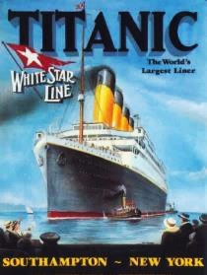
Free AI images generators include:
- https://openai.com/index/dall-e-3/
- https://leonardo.ai/
- https://www.canva.com/ai

This message has it all: contrast, clarity, clean design, consistency.
Everything works together to project an aura of confidence and safety:
- The bold stand-up type font,
- The massive ship contrasted with the tiny tug boat;
- The tag line “World’s Largest Liner”.
All elements reinforce the brand promise: “We’ll get you there.”
Incidentally, this image is in the public domain,
as it was produced more than 95 years ago.

Module 2 - Marketing Chapter 1 – Branding

Font. The typestyle you select for your company name will be part of your business personality. It should reflect the style and customs of your target demographic. Are your potential clients more likely to be retired librarians or bikers? Do you want it to be …
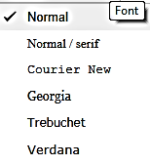
- Modern,
- Playful,
- Theatrical,
- Business-like
Google uses the font menu at the right
in its website building app

COMPATIBILITY. Pick a common font so that it will print on most desktop printers. Not all printers recognize every font. You are probably safe picking one of the stock fonts that comes with Word.

To see how the name looks in various styles, type it in Microsoft Word, then highlight the name and scroll through the drop-down list of fonts. Your company name will appear in each font as you scroll over the font name.

SIZE How does the typestyle look when small, as on a business card; or enlarged, as on a sign or billboard?

KERNING. You can also change the appearance of your company name by kerning the type, which is changing the spacing between letters. In Microsoft Word, click on “Font”, then “Advanced/ Character Spacing”.
Narrow (condensed) Spacing
Normal Spacing
Wide(expanded) Spacing

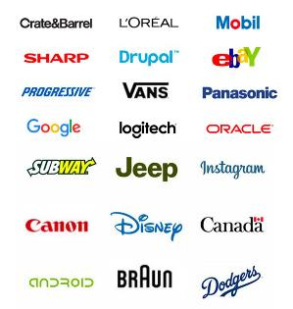

Some brands exude their brand image
with type alone.
Module 2 - Marketing Chapter 1 – Branding

Color Palette. Select colors that are widely available in the programs you will use in your business, such as Word, Publisher, and Illustrator.

Keep it simple: a maximum of two colors. Your logo should also be able to stand alone in one color (for outputting to a black-and-white printer or a newspaper). Note that all the logos in the chart below can be printed in one color.

Colors convey image and emotion. What company attributes do you want your color scheme to exude?
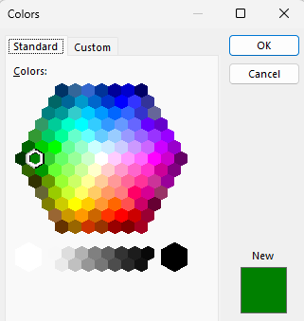
Microsoft Color Pallet. Some applications may require you to provide the formula for a color in an RGB or HEX format which indicate the amount of Red, Blue and Green in the selected color. To find these formulas click on the “Custom” tab. See sample below for a specific shade of green.
 | BURGUNDY - Vigor, elegance, richness, | 
 | RED - Energy, urgency
 | PINK - Romance, femininity
 | ORANGE - Fun, energy, warmth
 | YELLOW - Optimism. Grab attention
 | GREEN - Wealth, nature,
 | TEAL - Luxury, uniqueness
 | PALE BLUE - Tranquility, coolness, purity
 | ROYAL BLUE - Trust, loyalty, confidence,
 | NAVY BLUE - Dignity, credibility, tradition
 | PURPLE – Calming. Women like
 | WHITE - Fresh, light, pure, clean, cool
 | GRAY - Classic, quality, corporate | 
 | BLACK - Powerful, sleek

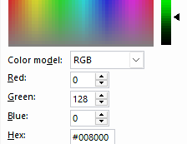
To try different color schemes, go to www.colorexplorer.com/.
Before committing to a color scheme, check to see how it looks printed on a color printer and in black and white. Many colors with complex formulas look dirty or dull when printed.

And of course, know your customers: red is not a good color for marketing in China, or for medical products

Printers may ask you for the CMYK color code so they can mix the inks to the exact shade. CMYK stands for Cyan, Magenta, Yellow, and Black To find the CMYK values, go to https://convertacolor.com
Module 2 - Marketing Chapter 1 – Branding

2.1.4 Logo

Often, the consistent use of a font and color scheme is sufficient to establish a memorable identity. The following logos are just words, but they are recognizable because they always appear in the same font and colors.

SYMBOL. If you will have clientele that do not all speak the same language, you may wish to add a unifying and recognizable symbol to help identity your brand.

Also, look in popular symbol fonts. If you pick one of these special characters, it will always be at your fingertips. Font symbols are also very crisp and blow up well. Here are some examples:
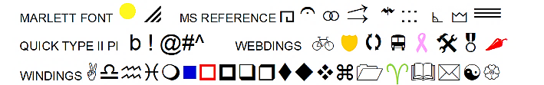
Arrow
You can also create a logo with graphic “Shapes” or “Word Art” available in Word. The “Arrow” logo at right was created in 5 minutes with a Shape and text.

DIY LOGO CREATION SITE. https://looka.com/logo-maker/

IF YOU WANT SOME HELP, there are sites where you can post a project, set a budget range, and review portfolios and proposals from a variety of freelancers. You will often receive several designs to choose from, and costs are surprisingly low, sometimes only $5 to $25 for a logo; and turnaround is usually in a few days, if not hours. Check out the following online services:
www.freelancer.com
www.designcrowd.com Design Crowd has a 2-minute video explaining the process.

Logo Tag Line: a memorable one-liner that summaries the brand image you want to project:
- Fifteen minutes could save you 15% or more on car insurance.
- Just Do It!
- When it absolutely, positively, has to be there overnight.
- When you care enough to send the very best.
Based on their tag lines, how do you think these companies want customers to feel about them?

Module 2 - Marketing Chapter 1 – Branding

2.1.5 Packaging

The inner packaging is a box, bottle or blister pack suitable for a shelf. Retail packaging is typically not durable enough for shipping. Its purpose is to catch the eye of the shopper and sell the product.

Talk to the managers of the type of stores you hope will buy your goods. How do they want products packaged?
- In boxes to display on shelves?
- In packaging to hang from slat-wall panels?
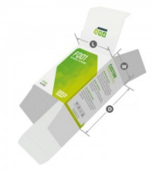
- In bulk bins?
RETAIL PAPERBOARD PACKAGING. There are specialty-printing houses that just make fold-up
boxes. See https://pakfactory.com/ or https://boxprinting4less.com for ideas and price quotations.
Printed boxes can be expensive in “small” quantities, but prices decline as volume increases.
- BoxPrinting4Less.com quoted $629 delivered (2025) for 1000 of the 6x3x3 printed
carton shown at right.

Initially, you could order a small quantity of a stock blank box and apply a label to it.
Uline.com offers a variety of standard sizes of blank boxes in white. An unprinted
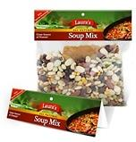
box is $39 for 100 plus approximately $21 for freight or about $.60 delivered (2025).

BAG HEADERS. www.uprinting.com will print 100 five-inch-wide header cards for $62 including shipping (2025). www.printrunner.com charges $40 including shipping (as of 2025) for 25 headers, but only $80 for 1000.
The bags you can buy at a grocery store for a few pennies each.



BOTTLES and JARS. This 10 oz. glass bottle is $.62 (in 2025) with white screw-on cap, in cartons of 12, plus freight, from www.bottlestore.com. Plastic containers cost about the same as glass.

The container is part of the product and will help attract or deter buyers. Research shows that a tall thin container seems larger than a short squat one. A tall bottle also appears rational and purposeful, a fat bottle friendlier. Taller appears lighter, healthier, luxurious (low-cal beverages); a squat jar heavy (ice cream). A tall bottle is harder to ship than a more compact short container. A small package can seem intense: Red Bull.

Since bottles do not fold flat for shipping, like paperboard boxes, find a bottle supplier near you to save on freight, which will probably be more than the cost of the item for small orders. Look for a nearby source so that you can pick them up yourself. This also allows for just-in-time inventory.



Whatever your product, there is a container designed for it.
Module 2 - Marketing Chapter 1 – Branding

2.1.6 Labeling

Whether the inner (retail) packaging is a bottle, jar or box, you can save a great deal on test runs by using a label that you print yourself.
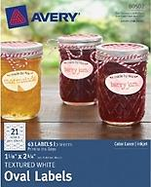
DO-IT-YOURSELF ADHESIVE LABELS.
Both www.Avery.com and www.onlinelabels.com offer 8.5” x 11” sheets of blank
die-cut labels in various shapes and sizes, in matte white, glossy, and clear.
OnlineLabels. 100 sheets (10 white labels 2”x4” per sheet) $18 delivered (2025).
Avery.com is more expensive, at $32 for the same 100 sheets. Avery labels are usually stocked at office supply stores, so you can pick them up quickly.

Both stock label makers offer free design templates.

CUSTOM PRINTED LABELS. If you search for “printed labels”, you will get 100 million hits, so you will not have difficulty finding a source. The key is to find a supplier with stock shapes and sizes, so you do not have to pay for dies.

One source is https://www.printrunner.com/stickers-and-labels where 1000 rectangular labels 2” x 4” printed in four colors will run $120 or $.12 each (2025).


Avery offers a starter supply of 48 pre-printed labels, 2” x 4”, is $.77 each ($37 total) delivered (2025). The price drops to $.25 each ($248) at 1000 labels. See https://www.avery.com/custom-printing

Labels are available in different shapes, sizes, and materials: including clear vinyl—so your product shows through—and silver and gold foil. The paper labels are available in matte and glossy finish. If using paper, go for glossy, as it is easier to keep clean.

[below] Some of the stock shapes available from Avery.

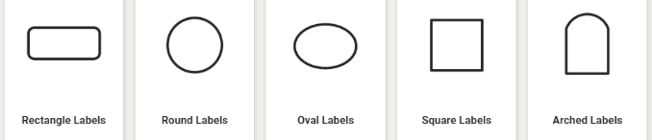


FOOD LABELS. Food product labels must display:
- a statement of identity,
- the product’s net weight,
- manufacturer’s address,
- nutrition facts, and
- ingredients list
An easy-to-follow resource for food labeling may be found at www.foodpackaginglabels.net

Module 2 - Marketing Chapter 1 – Branding

2.1.7 PHONE Number

After spending your hard-earned money and time to create a slick logo and dazzling website, you can still pop the image bubble of your company if your prospective customers are greeted with “Hey Homie, wazzup?” when calling to place an order. One option is to record a message that tells callers they have reached the XYZ company. (Your family and friends will know about your business and will still leave personal messages.) Alternatively, you can install a separate phone number for your business.

VIRTUAL CLOUD-BASED PHONE SYSTEMS. Several companies offer virtual phone numbers for your business that will take messages or forward calls to your phone. You will not know if the caller rang your virtual business phone number or if they called your direct number. That is, you still will not know if it is a business or personal call. However, with caller ID, you should have a good idea. You can also move all your friends to a group in your contacts to receive your personal greeting, and all others the business greeting.

For laid-back businesses, some entrepreneurs just answer their mobile phone with their name, regardless of the caller; and a generic recording: “You’ve reached the phone of (name), please leave a message.”

Ring Central. www.RingCentral.com. $20 per month per user (as of 2025) for an office system with multiple users. With the full-service package, calls can be answered with something like “You have reached the offices of [Ourco], your source for [our products]. For sales, press 1; for customer service press 2; to leave a message, press 3.” Ring Central will forward the call to the cell phone of the appropriate member of the management team. You can of course keep the same roaming system when you set up a permanent office but continue to use this cloud-based phone system rather than an expensive network in the office. Includes conference calling and a toll-free number.

Google Voice. www.Google.com/voice offers a “one-number” service for $10 per user per month (2025). Anyone calling the number will be forwarded to the phone you specify: a mobile phone, your home phone, or all three. You can also search the Google number database for a number that spells your business name. The number will follow you wherever you are. If you cannot take the call, you will receive a voice message (or if you prefer, a text transcription of the message).

Nextiva. www.Nextiva.com with rates starting at $30 a month (2025).

Virtual phone number acquired ____________________________

Module 2 - Marketing Chapter 1 – Branding

2.1.8 Business Email Address

YourName@YourCompany.com is the most professional email an entrepreneur can have; and most hosting services provide free email accounts as part of the hosting package.

Do not make customers type in a long, difficult-to-spell name. Use your first and last name, but remember, customers have to remember how to spell your name then type it to reach you. If your first name is Alexander, consider using Alex in your email handle. If your last name is Solthzenitzhenson, maybe just go with Alex.

For trial launches, a free Gmail account will suffice for many companies; but switch to a custom-domain email address when you launch your business full time.

See “Website” section of this text for suppliers of domains, email services, and website hosting.

Business email address acquired: ____________________@_____________________________.________

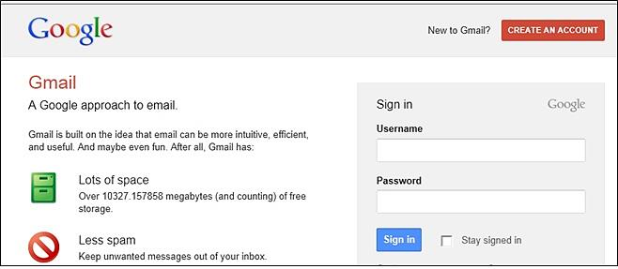
Module 2 - Marketing Chapter 2 – Website

2.2 – Website
This chapter also appears in Module #1 (Business Modeling) in an abbreviated form.

2.2.1 Choosing a Domain Name and Hosting Service

2.2.2 Selecting a Website Hosting Service

2.2.3 Website Evaluation

2.2.4 Search Engine Optimization (SEO)

Yes, you need a website. This is where people assume they can go to find pricing and see your full range of products or services. You will also need the all-important “buy”
button or shopping cart and a contact page so potential customers can ask questions.

Module 2 - Marketing Chapter 2 – Website

2.2.1 Choosing A DOMAIN NAME

Of the top 100 most visited sites in the United States, all are dotcoms. Some newer endings are growing in popularity, especially .co, but this should be a distant second choice. If you type in the name of a company in your browser, as the default, you will be taken to the company with the .com suffix.

Protecting Your Brand. Pirates have been known to register a name similar to a popular site and then clone the content. To protect yourself, consider registering...

- Alternative spellings: If you have drjones.com, you might want to buy doctorjones.com, as well.

- Additional extensions: if you own the .net or .co, consider registering the .com as a defensive measure.

InComm launched a pre-paid Visa card called Vanilla Visa. They registered VanillaVisa.com but did not purchase VanilaVisa.com (a common misspelling), or VisaVanilla. As a result, another company registered those URLs to take advantage of InComm’s advertising and siphon off clients who had not won spelling bees. Wise entrepreneurs register likely mistypings as well as possible misspellings. If you type “Goddady.com” into a browser, you will arrive at “Godaddy.com”. Smart daddy.

Where to Buy Domain. NameCheap.com $11 first year/ $17 on renewal. GoDaddy.com charges $.01 first year/ $22 on renewal. Wix.com Free first year with hosting/ $19.35 on renewal. (All prices are for .COM domains (2025).

Subdomains. Some web hosting services offer free hosting if you use a subdomain of their domain name. A domain would be www.YourCompanyName.com. A subdomain might be www.YourCompanyName.Wix.com.

Module 2 - Marketing Chapter 2 – Website

2.2.2 SELECTING A WEBSITE HOSTING Service

The following hosting services provide a wide range of options and have been in business for at least a decade. All hosting services offer DIY website Content Management Systems (CMS), design templates, and blogging software as part of their hosting packages.
Prices subject to change. Check the fine print. “Free” usually is not forever. Also, most plans automatically renew, so record the date and cancel ahead of time if you do not want to renew.

(Rates as of 2025) |   Weebly.com | Wix.com |   GoDaddy.com | Hostinger.com
Domain (.com) registration | Free for 1 year with paid hosting | Free for 1 year with paid hosting | $.01 for 1 year with paid hosting | Free for 1 year with paid hosting
CMS site builder with templates | Free with hosting | Free with hosting | Included. With GoDaddy, you pay for the CMS, and the hosting is free. | Free with hosting
Web Hosting only + email addresses | Free as subdomain, with ads.  Own domain  $144 yr. No ads.  Unlimited storage.  Online store. | Free as a Wix subdomain.  (OK for student projects, demos  or temporary sites)  $17/mo. with own domain. No Wix branding. 2 GB storage.  $29/mo. ($348/ yr.) for store + 50GB | “Website Builder” “Commerce” plan $21/mo. ($252/yr.) renews $420 yr. | 25 GB storage.  2 email boxes free for one year.  $2.99/mo. 4-year contract ($144); then $576 for next 4 years)
Email service | Not available | Not available | Free with paid hosting | Free with paid hosting
Database | No | Yes. with forms | Yes, with forms | Yes, with forms
Free Ad Words | No | No | No | No
Security Certificate | SSL security included | SSL security included | SSL security included | SSL security included
Single Item Credit Card Sales | Incl. with $144/yr. version | Incl. with $348/ yr. version | Yes | No
PayPal Integration | Incl. with $144/yr. version | Incl. with $348/ yr. version | Yes | No
Shopping Cart (multiple item sales) | Incl. with $348/ yr. version | Incl. with $348/ yr. version | Yes | No
Mobile friendly | No | Yes | Yes | Yes
Other |  |  | 100,000 email sends per month
Favicon | Yes | Yes | Yes | Yes
Module 2 - Marketing Chapter 2 – Website

2.2.3 WEBSITE EVALUATION

Feature | Pts |  | Comments
DOMAIN NAME IS EASY TO REMEMBER AND SPELL | 5
SITE STABILITY. It does not crash. | 5
MOBILE FRIENDLY. Easy to navigate on a phone | 5
STYLE. Appropriate to target audience | 5
DESIGN THEME CONSISTENT THROUGHOUT SITE | 5
COLOR SCHEME appropriate | 5
FONT. Appropriate selection and consistent usage | 5
SPELLING. | 5
GRAMMAR. | 5
WHITE SPACE. Pages are open and pleasing to the eye (not busy and cramped) | 5
BRANDING. You know whose site this is, or at least the product—no matter what page you are on. | 5
SEO is effective. Site shows up near top of search results | 5
PAGE LAYOUT. Placement of graphic elements and text guide the user’s eyes to important information and links. (You do not have to hunt to find what you want.) | 5
SITE ARCHITECTURE. The material is organized into pages and sections in a logical and easy to follow topology. Sequential content flows logically and smoothly. | 5
NAVIGATION. It is easy to find your way around within the site. You do not get lost. | 5
MENUS. Well-organized and easy to figure out. | 5
LINKS. No missing or broken links (No 404s) | 5
IT WORKS. Can you tell what the site was built to do (promote a candidate, sell widgets?) and does it do that | 5
PURCHASING IS EASY, with multiple payment options | 5
STICKINESS. Site encourages visitors to linger and return | 5
TOTAL | 100
Module 2 - Marketing Chapter 2 – Website

2.2.4 SEARCH ENGINE OPTIMIZATION (SEO)

So, your website shows up in search results when consumers look for your solution.
See also SEM (Search Engine Marketing): paying for higher placement on results page, or an ad.

When a web surfer enters a search term in a browser such as Google, Bing, or Firefox, the search engine looks for those terms in website meta tags and page descriptions.

META TAGS are key words and phrases that you include on your website. All hosting services allow for metatags and have clear instructions on how to add them.

The important thing is to guess accurately what words a customer might use to find products like yours. If you were selling cooking utensils, what words might someone enter in Google to find them? Certainly, “Cooking utensils,” but someone might enter “cooking aids”, or “kitchen aids”, “Gourmet”, “Crock pot”. These are all good metatags.

Be creative. Add some recipes to your site; then add “recipe” as a metatag (and perhaps sell that deep fryer mentioned in one of the recipes.)

The list of websites using the same metatags (which probably includes your competitors) are ranked by criteria called algorithms. Your site will place higher in search results if it is...

- Referenced on Other Sites with links back to your site.
- Mobile-friendly. (You can check to see if Google considers it so by entering your site’s URL here: http://www.google.com/webmasters/tools/mobile-friendly.)
- Secure (HTTPS prefix). For this, you will need to obtain a Secure Certificate from your web host.
- Not Top-heavy; that is, it does not contain too many ads at the top of the screen.
- Contains High Quality Content. It does not contain copies of articles from other sites. The content on your site is fresh and unique and adds to the body of knowledge on the web. Proper spelling, grammar, and readability also help. Short, simple sentences with common words beat out sesquipedalian pedantry.
- The URL and Page Names Describe the Content. For example, if you are selling baseball cards, “JacksBaseballCards.com” will place higher than “JacksShack.com.” If you have a page that lists 2010 Dodger cards, a web crawling robot or human searcher will understand this clearly if you name the page “JacksBaseballCards.com/2010/Dodgers.” Remember, the actual page URL appears in search listings. A search for “Dodgers baseball cards” returned the following on the first page of Google results:

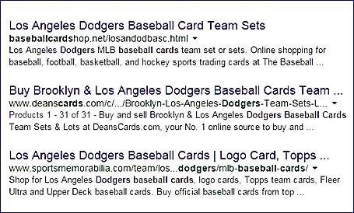
The top return included a large portion of the search string “baseballcards” in the domain.
The second-place domain name (deanscards.com) was less clear about what the shop sold, but the page name included the work “Dodgers” which was part of the search string.

Module 2 - Marketing Chapter 3 – The Message

2.3 – Marketing
(The Message)

2.3.1 Marketing Strategy
2.3.2 Presenting Prices to Best Advantage
2.3.3 Posting Prices in a Compelling Manner
2.3.4 Content for Ads
2.3.5 Using AI to Draft Ad Copy
2.3.8 Photographs
2.3.7 Marketing Plan and Budget

Module 2 - Marketing Chapter 3 – The Message

2.3.1 Marketing Strategy

Advertising Channels. How will customers find out about your product, its features and benefits? This is especially critical if you are relying on intermediaries (retail stores, distributors, contractors, app stores, etc.) as delivery channels. Ask for advice from salespeople at media you are considering. (Do they have any current deals? Best time to advertise? etc.) They are experts so can also suggest other cost-effective media to add to your mix.
- Paid print media advertising (magazines and newspapers)
- Free public relations. Local papers are eager to publish stories about new companies in their area. Contact your local city or business editor.
- TV advertising
- Radio ads
- Direct mail. For mailing list, contact a magazine serving your market, as subscription lists are usually current.
- Trade shows. Search for “Trade shows for [your industry]”
- Email marketing
- Web advertising (purchasing keywords)
- Social Media Influencers (bloggers, instagrammers, tweeters, and podcasters).

Whatever media you select, run a test. To confirm impact, add an identifier like “ Use promo code “TV.”
Sales Channels. (How will you sell your products or services?)
- Directly to consumers
- Through retail stores? (You will need to sell the storeowners as well as the ultimate consumer.)
- Through distributors or manufacturers’ reps? They will sell to retail stores for you, for a commission—but beware; they only want to rep proven winners.
- By bidding on contracts?

Delivery Channels. (How will you deliver your products or services?)
- Via mail?
- Through Fulfillment by Amazon (FBA)? See http://services.amazon.com
- The App Store?

Who will use the product? (The USER) _________________________________________________________

Who will pay you for it? (The CUSTOMER) _____________________________________________________
(e.g. -- if you sell cereal, the users may be children, but the customers will be the parents.)

Whom do you want to reach and what is the Call to Action? (Visit website, download coupon, complete survey?)

What Advertising Channels will you use to reach out to potential customers?

How will you incentivize prospects to respond to the Call to Action?

Module 2 - Marketing Chapter 3 – The Message

2.3.2 PRESENTING PRICES TO BEST ADVANTAGE

Subscription Pricing.

SERVICES. Subscription payment is the norm among a number of service industries, including Software as a Service (SaaS), magazines, cable TV, phone service, education (most schools charge by the semester instead of per class), business services, house cleaning, lawn care. Even some services traditionally acquired when needed, such as haircuts and car washes are now being offered on a subscription basis. Almost any service can be sold as a subscription.

PRODUCTS. We are also seeing more products offered on a subscription basis. Order anything from Amazon and you will be offered a discount (typically 5%) to set up a subscription to receive a quantity each month. This works well with consumable like laundry soap, paper towels, pet food. But even farmers are offering subscriptions to fresh vegetables.

WHY OFFER A SUBSCRIPTION RATHER THAN BILL ON AN AS-NEEDED BASIS? Granted, you may wind up providing more value to some customers than you receive in return. This certainly happens with car insurers when someone does have an accident. But this is an attraction to customers for subscription pricing: they know, no matter how much of the service they will need, their cost is fixed and predictable. Plus, there are upsides to the business to selling products and services on subscription:

- It creates brand loyalty. If customers order goods or services regularly, they may research alternatives.
- Subscriptions provide more predictable cash flow forecasting.

Knowing how much product or service you need to deliver helps in planning your own inventory purchases and production. Although monthly subscriptions can usually be cancelled, it is unlikely that all customers will cancel at the same time.

ANNUAL VERSUS MONTHLY PRICING. Most companies offer both options, with the annual plan typically 20% lower than the monthly plan over the course of a year (https://guybarner.medium.com/) Another obvious advantage to the company of the annual plan also relates to cash flow since the annual plan is paid up front.

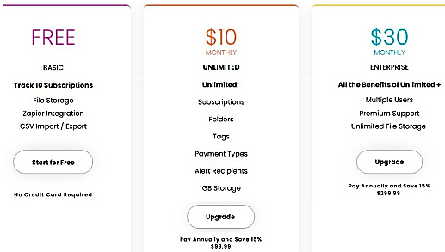
Pricing plan from TrackMySubs.com, a company that helps users track their subscriptions.

This example is uncluttered and easy to understand. If you have a lot of features, list them and then indicate with checkmarks which plans offer each. Or just list only the major features and a link to “See all features.”

Could you offer your product or service as a subscription? Try some options with potential customers.

Module 2 - Marketing Chapter 3 – The Message

2.3.3 Posting Prices in a Compelling Manner

This advice is from Nick Kolenda whose blog condenses academic studies into key takeaways for entrepreneurs. For more suggestions see https://www.kolenda.io/

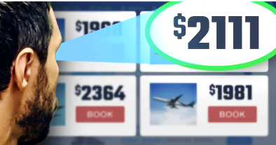
Reduce the Size of Currency Symbols.
Also reduce the Left Digit by One ...

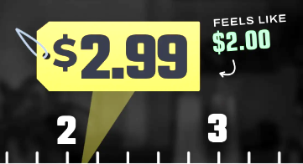

Except for high prices. The left-digit effect would backfire for a $2000 item (reduced to $1999) because customers will focus on the later digits. Instead use $2111. This reduces the digit averages, and the repeated numbers grab attention.



Remove commas from prices

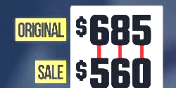

Reduce every digit in a discounted price

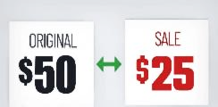

Distinguish a sale price by font color (red attracts
attention), size (a small font suggests small price), and style
Also add gap between original and discount price.
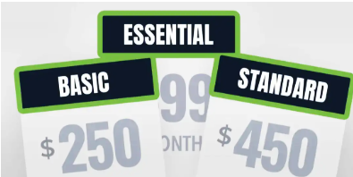

For Pricing Plans use simple names like Starter, Basic, Essential to imply a social norm. Customers avoid prestige names (e.g. Gold ot Platinum.)

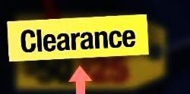

Provide a reason for the discount

Module 2 - Marketing Chapter 3 – The Message

2.3.4 Content for Ads

To attract and engage customers, include information that clearly communicates your value proposition and resonates with your target audience. Winning copy includes:

1. Attention-Grabbing Headline that is …
- Clear, compelling, strong and crisp.
- Communicates the key message.
- Relevant to the target market.
2. Clear Value Proposition: how your product or service provides value by solving a problem or fulfilling a need.

3. Clearly communicate what differentiates your product or service from competitors. "They'll fight over it when you're dead" tagline for Saddleback Leather highlights its durability.
I
love
saving
people
money
4. Active verbs (Acme products catch roadrunners).
5. A human touch. Show how much you enjoy helping people, like the Gecko.
4. Compelling Call to Action (CTA): "Save Now," "Learn More".
4. Trust and Credibility Elements: testimonials, customer reviews, or case studies .
5. Supporting Visual to capture attention, demonstrate benefits, and reinforce branding.
7. Business Information:
- Business name or logo. (And clarify what you do, if necessary.)
- Contact information like your phone number, website, or physical address.

Summary example: Instead of "Marketing Services," try "Unlock 50% More Leads with These Proven Marketing Tactics—Get Started Now!"

HOW TO BE MEMORABLE. Use humor as in the 1966 VW ad below. The company understands exactly who their buyers were. Can you reverse engineer buyer attitudes from this ad?

Or get clever. What is the message of the Lego ad (which incidentally translates into every language)? What is the brand promise of the BMW ad? When BMW talks about the power within, they’re not taling about the car are they?



Module 2 - Marketing Chapter 3 – The Message

2.3.5 USING AI To Draft Ad Copy

Typing a prompt into ChatGbt or other AI copy generator will provide some suggestions for ad content. However, there are some downsides. You need to stay in control and make sure the final product is accurate and appropriate. Some deficiencies in AI-generated copy include:

- All the Warmth of a Robot. AI cannot empathize well with your customers desperate desire to solve a problem. Text can come across as wooden, so add a human touch or rewrite using your voice. You can improve the AI output somewhat by telling it to “build rapport with the viewer” or “show empathy”.
- Lack of Originality. AI only knows what has already been published, so it can sound derivative. And after a while all your ads will sound alike, as AI is not very creative.
- Just Plain Wrong. AI can make mistakes. It does not know if the data it is learning from is correct. So, fact check any data or claims. We cannot blame incorrect information in an ad or website on the robot any more than we can get away with blaming it on the computer. Buck stops with us humans.
- Copyright Violation. AI has the ethics of an office copier. A lot of what it will deliver will be copyrighted by someone else. To screen copy, type into a free plagiarism checker like:
- https://www.grammarly.com/plagiarism-checker
- https://justdone.com/plagiarism-checker
- https://www.duplichecker.com/

AI PLATFORMS THAT CAN GENERATE CONTENT FOR ADS, WEBSITES OR BLOGS.

- ChatGBT https://chatgpt.com/
- Claude https://claude.ai/
- Copy.ai https://www.copy.ai/
- ClickUp https://clickup.com/
-----------------------------------------------------------------------------------------------------------------------------------------
Below is an ad generated in seconds with free version of ChatGbt.com. The PROMPT was
“Write an ad for a food-ordering app. Use persuavive tone, encourage trust, and close with call to action.”

🍽️ CraveEase — Delicious Food, Delivered with Care
Hungry? CraveEase brings your favorite meals from trusted local restaurants straight to your door — in minutes. Whether you're craving comfort food or gourmet dishes, enjoy a seamless experience every time.
Why you’ll love CraveEase:
- Unmatched convenience — Tap, order, and track your delivery in real time.
- Trusted Quality — Partnered with top-rated restaurants you know and love.
- Secure Payments — Safe and reliable checkout — no surprises.
- 24⁄7 Support — Friendly help available anytime, every step of the way.
- Loyalty Rewards & Exclusive Offers — Earn discounts and unlock perks just for ordering.
Join thousands of happy customers who rely on CraveEase for consistent freshness, speedy service, and total reliability.
Try CraveEase today — download the app, place your first order, and get 20% off with code FIRSTBITE.
Satisfy your appetite now. Trust CraveEase to bring food you love — when and where you want.
Module 2 - Marketing Chapter 3 – The Message

2.3.6 PHOTOGRAPHS

A photo—whether one you take yourself or download from a photo library—can convey a great deal of information quickly to busy customers surfing social, driving past a billboard, or thumbing through a newspaper. A great photo can stop them in their tracks.

TAKING PICS. It’s all about the lighting. Natural sunlight is the best as it has the right “color” as well as being bright. (Fluorescent lamps give a greenish tint to photos.) If you do shoot indoors do so near a window during the day. If you are getting distracting shadows, add a light to fill in the dark areas. A light on each side of the subject should suffice.

WHICH CAMERA. If you own a $5000 Hasselblad, great. If not, any smart phone camera will be quite adequate and allow editing of the shots.

Shot with an iPhone
COMPOSITION.

- Keep it simple.
- Consider the angle. Shooting upward makes the product look powerful. A viewpoint from above makes the product appear easy to manage, non-threatening.
- Remove humans from shots with products. Allow prospects to take ownership of the product. They do not want to see someone else using their bath towel. An exception to this rule is for a supporting shot showing people enjoying a product, like a grill at a backyard party.
- Non-distracting background. Better yet, no background. See https://www.remove.bg/
STOCK PHOTOS. If you don’t have the budget or time for a photo shoot, you can download a free stock photo from: www.Pixabay.com, www.flickr.com/creativecommons, or https://commons.wikimedia.org. But check the fine print. There may be some restrictions or attribution requirement.

You might also try searching the web for “images” of the key words you selected to define your brand. Anything you find that is at least 95 years old is in the public domain and you are free to use it. However, you cannot use an image of the American Flag—owned by the U.S. government—for commercial purposes. Nor will Disney look kindly on you appropriating Mickey Mouse.

USE AI TO CREATE IMAGES BASED ON YOUR DESCRIPTION. These services are free:
https://openart.ai/, https://www.midjourney.com/home, https://www.midjourney.com/home
Module 2 - Marketing Chapter 3 – The Message

2.3.7 MARKETING Plan and BUDGET

This worksheet will inform your budget, capital needs and cash flow forecast. The following chapters provide details on each heading in the budget:

- Marketing (Collateral Material)
- Marketing (Traditional Mass Media)
- Marketing (Digital Mass Media)
- Marketing (Targeted Media)
- Sales (Online and In Person)
Backdate from when you want to launch your product or service. Is seasonality a factor?

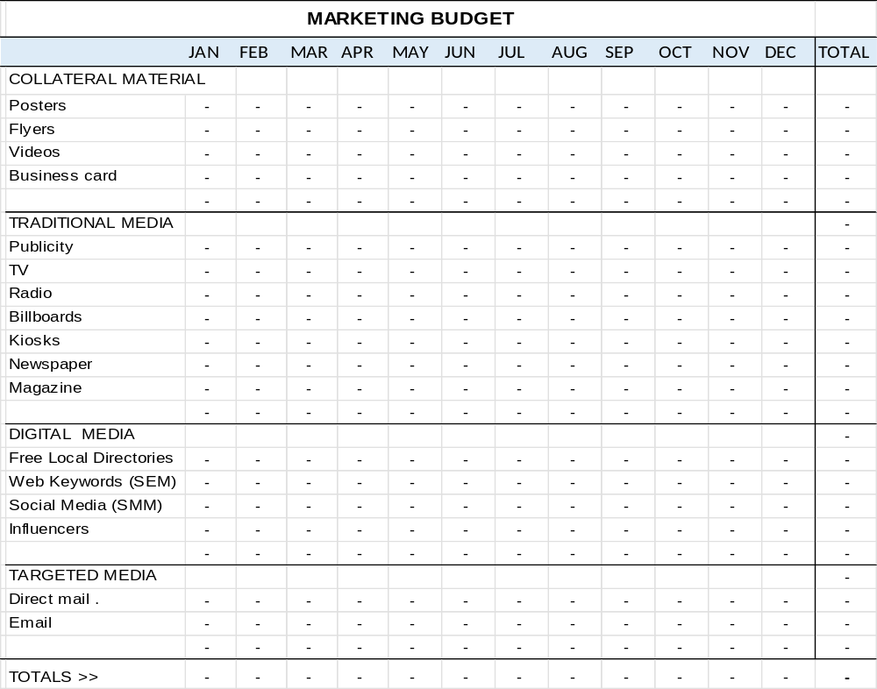
Module 2 - Marketing Chapter 4 – Collateral Material

2.4 – Marketing
(Collateral Material)

2.4.1 Business Cards
2.4.2 Posters
2.4.3 Flyers and Brochures
2.4.4 Printing Through a Cloud-Based Service
2.4.5 Marketing Videos

Module 2 - Marketing Chapter 4 – Collateral Material

2.4.1 Business cards

A business card gives suppliers, investors, customers, and co-founders an easy way to remember you, what you do, your website, and how to reach you. It is also a lasting impression of your brand.
ELEMENTS OF EFFECTIVE BUSINESS CARDS...
- TITLE (give yourself a title). It looks more professional. If a one-person startup, you are the CEO.
- EMAIL. Short and professional. See previous section in this text on “Business Email Address.”
- ADDRESS. This can get tricky. Some people do not want to advertise where they live; and Steve Jobs probably did not want it widely known that Apple was initially headquartered in his parents’ garage. If that is the case, rent a P.O. Box or list your city without a street address. Prospective investors, employees and online customers just need a general idea of where you are located.
- DESIGN. Use matte (not shiny) card stock and a light-colored background and plenty of white space so the recipient can make notes. Keep it simple. Nothing says amateur like a busy card or a photo background.
- PHONE NUMBER. (See previous section in this text dealing with the “Phone number.”)
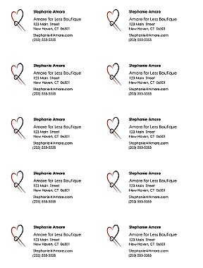
PRINTING BUSINESS CARDS YOURSELF

- Use Avery® “Clean-edge” punch-out card stock. A pack of 200 white cards (20 sheets, 10-up) sells at most office-supply stores for $25 (2025) or online for the same price: https://www.avery.com/products/cards/8871
- For business card templates in Microsoft Word, see File >New>Business Cards. Consider only designs that are in a “10-up” format as these match the layout of the Avery pre-perforated sheets. Here is a link to additional 10-up business card templates online:
https://create.microsoft.com/en-us
- Your 10-up artwork should look like the sample at right.

USING A QUICK-PRINT OUTLET such as Staples, Office Depot, or Kinkos-FedEx.

- Save artwork as a PDF to avoid conversion charges and to ensure your artwork is not corrupted when transferring to the printer’s computer.

- The chart below shows typical prices for business card printing. Note: for 2-color printing, black counts as an ink color. Kinkos does not divulge prices unless you first login and create a design.

ITEM | SPECS | QTY | STOCK | Staples | Kinkos/FedEx | UPrinting.com
Business Cards | Full color  Full color | 250  500 | 14 pt.(100 lb.)  14 pt.(100 lb.)  . | $ 30 del.  $ 34 del. | $38 del.  $50 del. | $ 31 del.  $ 35 del.

Module 2 - Marketing Chapter 4 – Collateral Material

2.4.2 POSTERS


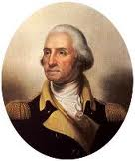
Use a design program like Microsoft Publisher, Adobe Illustrator, or Quark to create documents larger than 8.5x11. Microsoft Word does not allow for a layout larger than 22” in either direction. Theoretically, for an 18 x 24 poster, you could create the design in Word using dimensions of 9 x 12 and instruct the printer to blow it up 100% (print at 200% of the original size) to create an 18 x 24 poster. However, photos may appear fuzzy, graphics and fonts may break up and appear pixilated, and round and diagonal lines may show stair-stepping.

The photo of Washington on the left is the original. The version on the right is a smaller version blown up to twice the original size.

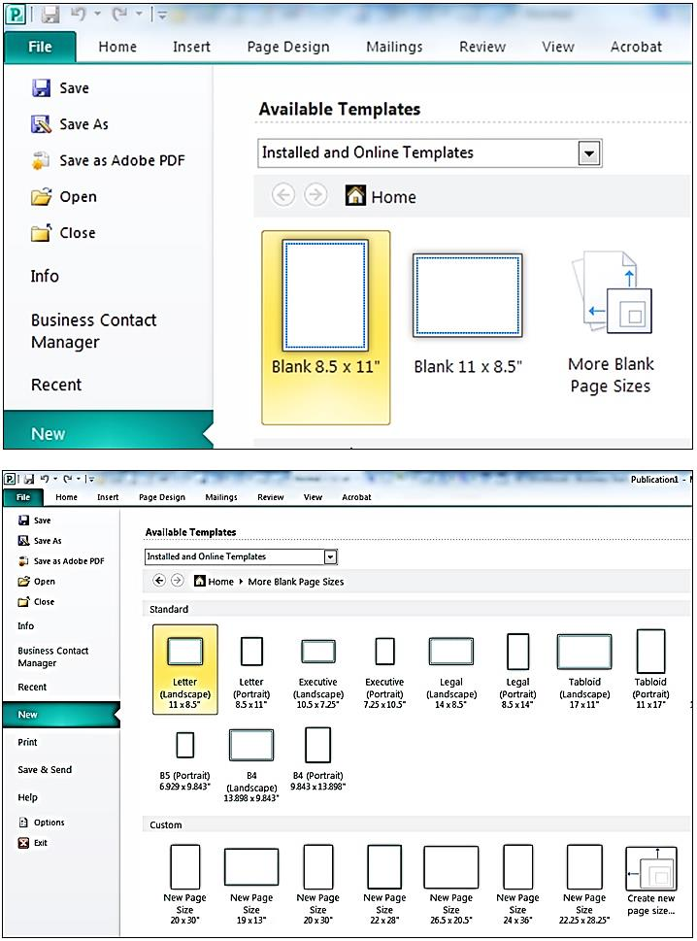

Designing a poster in Microsoft Publisher

On the first screen, click on “More Blank Page Sizes.”

On the next screen, create a template for the desired size by clicking on “Create new page size” (shown in lower right of the partial screen shot at left). A good compromise between size and cost is 18” x 24”. This is a stock printing size at Staples and Office Depot.

Module 2 - Marketing Chapter 4 – Collateral Material

On the next screen, give your new template a name and specify the width and height. Note that we’ve set the margin guides at ¼” all around. This is about as close to the edge of the paper that you can print. The guides will help you stay within these borders. If you want your design to run to the very edge of the paper, just ask the printer to trim off these margins. After trimming the poster will be 17.5” x 23.5”.

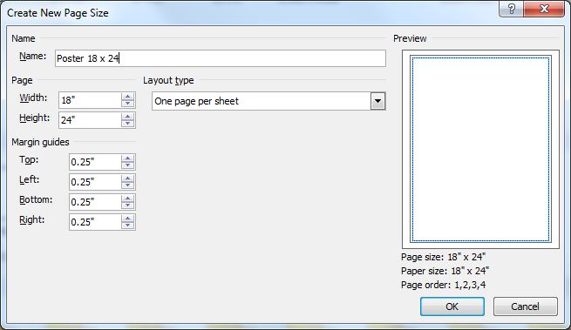


After clicking “OK”, click on the small “Create” button on the extreme right of the screen.

Content. Less is more in poster design. People will be walking by your exhibit table or store window, thinking about something else, so you will only have a half second to gain their attention, pique their interest, and effectively convey your message. Most billboards and print ads do this well. Try to mimic their simplicity in design and text.

Also, to give your posters a long useful life, do not include information that may change, like pricing. Do include:

- Name of company and product
- How it will improve the life of the customer (key benefit)
- How to buy it (website url, phone number, and/or store address). Posters and billboards are another reason to use a short, easy to remember, easy to spell domain name.
- Call to action

Module 2 - Marketing Chapter 4 – Collateral Material

2.4.3 FLYERS AND BROCHURES

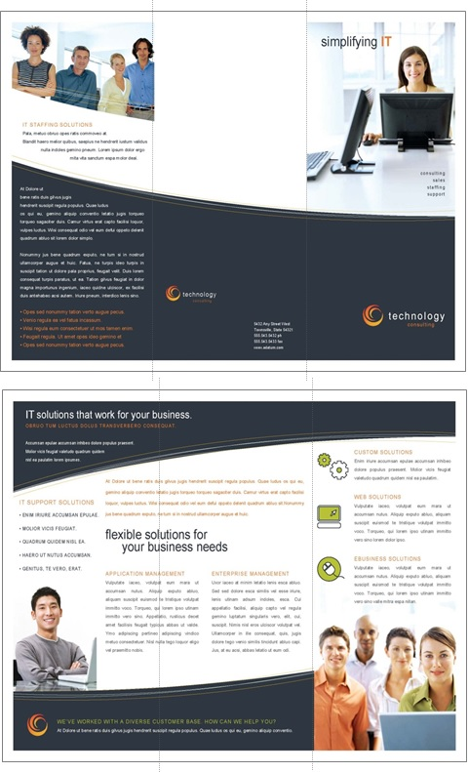
Microsoft Word offers a variety of templates for flyers and brochures. You may find that a simple one-sided flat 8.5 x11 flyer is just as effective as a complex
tri-fold brochure.

The sample on the right shows the outside (top) and inside spread (bottom) of a tri-fold (6-panel) brochure. The designs are printed on the front and back of a standard 8.5 x 11 sheet, which is then folded in thirds, to fit into a stock brochure rack or #10 business envelopes.

If you do want a tri-fold brochure, we suggest you start with a stock Word or Publisher template. (A brochure layout is more complicated than it looks.) First, there are six pages, each with four margins. Second, the right panel on the top section (the cover) must be slightly wider than the middle panel, which in turn must be wider than the panel on the left. Otherwise, the brochure will not fold neatly and lie flat.
Do not worry if the layout or color scheme of the template is not to your taste.
Everything is editable.
PS - Design the brochure to make it easy to fold accurately (NOT like this one. Note how the fold in the lower right is along the seam of two design elements. Good luck folding that neatly every time.

Fold lines >

Module 2 - Marketing Chapter 4 – Collateral Material

2.4.4 Printing Through a Cloud-Based Service

UPLOADING ELECTRONIC FILES. In all cases, you will need to create an online account with login and password. This will allow you to upload files from your computer or to design materials on the printer’s website.

FORMAT. Each printer lists on its website the formats it will accept. The safest is PDF, as what you see is what you will get. Otherwise, if you use a font that is not on the printer's computer, a different font will be substituted. In addition, positioning of graphic elements can shift if you do not use a PDF format.

DELIVERY. In some cases, you can pick up the printed materials at a store near you, thus saving the freight charges. However, sometimes the in-store price is different from the online price, so you may want to confirm the charges before ordering.

PRICING. Use the chart below for budgeting purposes only. Check websites for current pricing. Printing is full color, except as noted (Prices below are current as of 2025)

ITEM | SPECS | QTY | STOCK | Staples | FedEx/ Kinkos | Office Depot
Poster | 18 x 24 | 1 | Matte finish | $ 16.50  on paper  $ 25.50 on foam board | $17.25  on paper  $32.25  on foam board | $ 15  not mounted
Flyer (full color)  1-side printing | 8.5 x 11 | 50  100 | 32 lb.  32 lb. | na | $ 40.00  $ 65.00 | $ 17  $ 32
  Brochure  (Tri-fold) | 8.5 x 3.67 | 25  50  100 | 32 lb.  32 lb.  32 lb.. | na | $ 32.50  $ 60.00  $ 95.00 | na

STAPLES www.Staples.com/copyandprint
- Free delivery on orders of $60 or more
- No access to pricing on flyers or brochures until you have opened an account and uploaded artwork. .
KINKOS/FEDEX https://www.office.fedex.com/default/all-print-products.html

OFFICE DEPOT/ OFFICE MAX www.officedepot.com/a/design-print-and-ship
- Free delivery on all orders of $45 or more.
- No access to pricing on brochures until after you have opened an account and uploaded artwork.
Note: average rating by 73 customers was 2.2 on a scale of 5.

Module 2 - Marketing Chapter 4 – Collateral Material

2.4.5 Marketing Videos

Marketing videos are now a staple in the sales tool kit. One well-done production can serve multiple roles:
- Launching a product on Kickstarter or Indiegogo
- Building buzz on YouTube, Facebook and Instagram.
- Selling on Shopify or Etsy
- Posting on your website to explain how your product or service works
- Used as TV commercial
For marketing videos, keep it to 30 seconds or less. Same for TV. (Would you watch a two-minute infomercial?) Tutorial videos can be 1 or 2 minutes.

BEST PRACTICES WHEN DESIGNING A VIDEO
- Use a strong voiceover.
- Grab interest in the first three seconds
- Tell a compelling story: Show what you are saying. Include examples and testimonials.
- Constantly reinforce these marketing components on the screen to double your conversion rate:
  - Your CTA (call to action),
  - Who you are so viewers remember you (logo, company name, and/or product name), and
  - URL so customers know how to find you


PROFESSIONAL VIDEO PRODUCERS
There are probably several production houses close to you. Search “Video production near me.” An online source that uses animation is www.Promoshin.com. The process is cheaper than live action, and it is easy to make edits after the vid is in the can since you do not have to get the crew back together if you need to reshoot a scene. Control-click on image at right to see a sample animated video

For budgeting purposes, expect a pro to charge $1000 to $3500 for a marketing vid or TV ad. If this is beyond your means, and you do not feel comfortable doing it yourself, the going rate for video by a film or communications student is $300 to 500 for 30 seconds, including music and voice over.

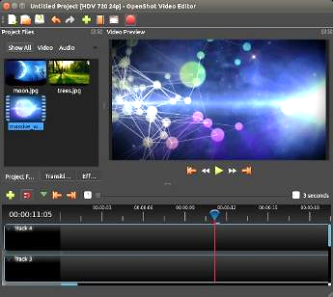
FREE VIDEO EDITORS FOR COMPUTERS
All are Windows and Mac compatible; and you do not need four years of film school.

Shotcut https://shotcut.org/

Avidemux http://fixounet.free.fr/avidemux

Openshot https://www.openshot.org/

Dashboard of Openshot
video editing platform

Module 2 - Marketing Chapter 4 – Collateral Material


VIDEO EDITORS FOR MOBILE PHONES. The iPhone 11 has an excellent video editor built in. There are also free off-the-shelf editors available for iOS and Android that are easy to use and Instagram friendly:
Trim shots, add text and sync music

Vimeo https://vimeo.com/upgrade-plan Scroll down for free plan

GoPro Quik https://gopro.com/en/us/shop/quik-app-video-photo-editor

GoPro Quik for iPhone or Android

PREPARING THE SHOOT.
- Shoot in a quiet place. Turn off HVAC blowers.
- Use a tripod for a steady shot.
- For light, use LED panels that are 5000 Kelvin (natural light) and have adjustable brightness. Place them on both sides of the subject. (A pair of 45-watt LED lights are available on Amazon for $175 (as of 2025).
- Include the product in the background or company logo, or both. Make every second count.
ADDING A MUSIC TRACK. Download a free music track from https://pixabay.com/music/, https://freemusicarchive.org/, https://www.jamendo.com/, or https://archive.org/details/audio

MEDIA PRODUCTION SPEC REQUIREMENTS
The following technical specifications are accepted by broadcast and cable TV, YouTube, and most streaming services (including Hulu, Roku, Tubi, Peacock, and Sling).

Aspect Ratio 16:9
Screen width versus height

Display Resolution 1920x1080 pixels or Full HD (High Definition).
Ultra-high Definition (UHD) is 3840 x 2160 pixels becoming more popular and can
now be reproduced on the TV sets in most U.S. household. However, most media
outlets are still using 1920x1080.

Length in Seconds 30 seconds is optimal and offers the best return on advertising dollar.
Some media accept ads from 6 to 60 seconds, but ALL accept 30 seconds, and a 60-second ad will cost approximately twice as much to produce and air as a 60-second spot but will not generate twice the number of sales.

15 seconds is the maximum length for a non-skippable ad on YouTube.

Max File Size for Ad 10 GB (Roku file limit is 200 MB, Sling is 300 MB), but almost all others are 10GB.

Bitrate 15-30 Mbps (Megabits per second download speed)

Frames per Second 29.97 per second. This is the screen refresh rate, and while some media offer a
variety of options from 23.98 per sec. to 30.00, almost all accept 29.97 per sec.

File Format .mov or .mp4 (Tubi accepts only .mp4)

Technology evolves constantly and every media platform has unique requirements or restrictions, so it is advisable to check with the media outlet you are thinking about using. Ask for a Media Kit.

Module 2 - Marketing Chapter 4 – Collateral Material

USING AI TO PRODUCE VIDEOS

AI is still learning how to generate convincing videos, but if you are willing to put in the time to learn how to use it as a creative tool, you can produce competitive marketing videos and ads at no cost.

The downside is that AI videos still need a lot of editing by a human—like any AI creation—and computer-generated images of humans can seem a little stiff (even creepy according to some viewers.) One workaround is to use animation, animals (e.g. - Geico gecko), or just the product with voice over.

Still from an award-winning beverage ad made with AI,
that only showed the product.

FREE AI VIDEO PLATFORMS. For additional platforms see https://zapier.com/blog/best-ai-video-generator

Runway Advanced, with longer learning curve that most. https://runwayml.com/
Canva's video editor has generative AI powered by Runway.

Descript Intuitive. Video can be edited by editing the script https://www.descript.com/

Synthesia Uses avatars. Multilingual. Intended for employee training. https://www.synthesia.io/home

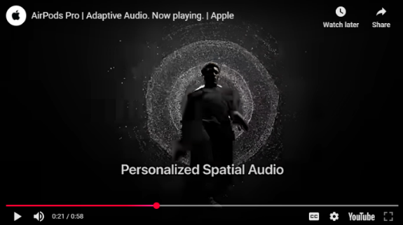
AirPods YouTube commercial created with Descript

Module 2 - Marketing Chapter 5 – Traditional Mass Media

2.5 – Marketing
(Traditional Mass Media)
2.5.1 Publicity
2.5.2 TV Advertising
2.5.3 Radio Advertising
2.5.4 Billboards
2.5.5 Kiosks
2.5.6 Newspapers
2.5.7 Magazines

Module 2 - Marketing Chapter 5 – Traditional Mass Media

2.5.1 Publicity

Public relations is free exposure that appears in the editorial sections of print, blogs and broadcast media. The objective of editorial departments is to provide value to viewers–as opposed to advertisers. Here are a few tips that will increase your free media coverage.

DIRECT PROMOTION: SEND A PRESS RELEASE ABOUT A NEW PRODUCT OR SERVICE

- Do some research. Find the outlets that cover your industry. If you have a restaurant, which media have a section on food? Search the websites for the names and contact information of the department heads or staff writers that cover your beat. Read some of their articles to identify common themes.
- Get Personal. Journalists get pitched constantly, so do not expect a cold email to get their attention. Be personal in your overture: comment on a recent article or invite the journalist to attend your grand opening.
- Talk about yourself, local connections, and why you opened the business, passion for your solution.
- Lead Time. A 10-day lead time is considered good practice for events like product launches.
AI AIDE: https://newswriter.ai/ will draft a press release for free, based on your description.

INDIRECT PROMOTION: Guest blog post, letter to editor, or article that demonstrates your expertise.

- Offer fresh relevant content. If you are a food wholesaler, explain why the price of a particular commodity is going up. You are the expert. If you have an accounting service, write an article in March about overlooked tax deductions. (It is OK to insert at the end of the article “[Your name] is president of Jane’s Tax Services. She can be reached at Jane@Doe.com.”
- Be the Journalists Assistant. Get to know the editors, writers, podcasters. In what form do they want content? How many words? Be aware that some journalists prefer to write the stories themselves, in their voice. In which case, just provide some bullet points.
- Be prepared for special editions. Check the website for upcoming special features like “Back-to-School”, for which your new backpack with a built-in phone tracker would be perfect.
- Be preemptive. By the time an event breaks, it may be too late to write something for the six o’clock news. Prepare some articles in advance: “How to secure your home against a hurricane,” so it is ready to run at the same time as the storm alert. This is creepy, but news media prepare obits for people who are still (barely) alive. Guess who’s going to be first with the half-hour retrospective of what’s-his-name who we all loved as a kid?
- Be on call. When a story breaks, media do not have time to find out who might be an expert. They have a rolodex for that. Write to the appropriate media and give them a list of the topics for which you have expertise, plus your credentials (why they should take your word for it). And—most importantly—let them know you are available 23/7/365 and give them your cell and email.

Module 2 - Marketing Chapter 5 – Traditional Mass Media

Press Release Format. For templates see https://www.ereleases.com/press-release-template/ Check for grammar and spelling and ask someone outside your company to read it to make sure it’s clear.

There are services that distribute press releases to over 100,000 digital and print outlets nationally.
Fees range from $150 to $400. See https://www.einpresswire.com/, https://www.newswire.com/, and https://www.ereleases.com

FOR IMMEDIATE RELEASE
[If you don’t won’t to appear immediately, say “Embargoed until [date]”

Compelling Headline
[Titles like “10 Ways to …” or “How to…” are popular with media as they suggest useful
information for their followers. For search engines, include keywords in first 60 characters.]

Subhead in sentence format
[Get to the point. Pique interest with a crisp summary]

[Dateline] Dateline: CITY, State, Month Day, Year

[Content] Keep to one page. Insert two blank lines between paragraphs to allow for editing. Focus on how you are different and what will be useful to readers. Avoid jargon (industry terms the average person will not know) and hype: “We’re proud to announce…” Omit self-promoting adjectives: “greatest, cheapest.” That is only permitted in paid ads.” Stick to the facts

Provide the who, what, when, where, why and how. Use active voice and focus on how this news impacts the lives of the medium’s followers. Include a story that reveals the need for your solution.
[Quotes] Include quote by CEO, an expert or customer to support solution and humanize the release..

[Photograph] Add image of product, person or business to convey information efficiently, as well as emotion. A photo also shows you are real and adds interest.

[Call to Action] Close with a summary and call-to-action to direct the reader to more information, such as a link to website for a study about the problem addressed by the company.
[Boilerplate] A short paragraph that explains the identity of the company, what it does exactly, mission, website, year founded, and noteworthy achievements.

###
[This is the customary way to indicate the end of the release.]

[Contact information] Who the media should call with questions
Name
Title
Company
Phone, Email

Module 2 - Marketing Chapter 5 – Traditional Mass Media

2.5.2 TV ADVERTISING

Despite the rise of digital media, television advertising – on local network stations, cable channels and streaming media – remains one of the most effective ways to engage buyers. The following are typical costs for a 30-second commercial. For more information see https://www.simulmedia.com/blog/how-much-do-tv-ads-cost

Broadcast Networks (ABC, NBC, CBS, FOX)
Prime time (8-11 PM): $200,000 - $1 million (2025)
Popular shows ~$882,000 (e.g. - NFL Sunday Night Football)
Daytime: $40,000 - $200,000
Late night: $50,000 - $250,000

Cable Networks
National cable average: $1,000 - $50,000 (2025)
Premium networks (ESPN, TNT): $20,000 - $150,000
Niche channels: $1,000 - $20,000

Local TV Rates vary by market size: Small, mid-sized, and large Designated Market Areas (DMAs)
Small Markets (DMAs 151-210): $200 - $1,500 e.g. - Bangor, Billings, Laredo. Meridian, Helena
Mid-Size (DMAs 51-150): $500 - $3,000 Spokane, Omaha, Syracuse, Reno, Lansing, Topeka
Large Markets (DMAs 1-50): $2,000 - $10,000 Charlotte, Baltimore, Memphis, Las Vegas
Top 10 Markets $5,000 - $50,000+ NYC, LA, Chicago

Time Slot also Impacts Costs. Drive times and prime time (7-11 pm) are at a premium, daytime (9 am to 4 pm) and late night (11 pm to 2 am) are less expensive.

Streaming TV (CTV) rates are higher than linear TV (Broadcast and cable) due to high completion rates, audience targeting capabilities, measurable results, and higher engagement. Typical rates are:
Netflix and Amazon Prime: $30-40 CPM (2025)
Hulu: $10-30 CPM
YouTube TV: $20-25 CPM

Seasonal Cost Variations. Ad costs can be 20%-50% higher during the winter holidays, sports playoffs, award shows, and political debates. On the other hand, there are also bargain seasons:
January-February: 20-30% off
Summer months: 10-20% off
Post-election periods: 15-25% off

Media Kit. Since technical requirements for ads can vary among stations, check the website of any medium you are considering for their most current Media Kit or Advertising Specifications. This will also include …
- Viewership: The number of viewers at each time of the day, and the metrics used to support the data.
- Demographics of Viewers: Age, gender, income, education, and lifestyle.
- Programming: Show listings, with air dates and times, summaries and target audiences.
- Ad Rates in terms of CPM (cost per thousand people your ad will reach) If the CPM is $10 for a 30-sec spot at a time when there are typically 100,000 viewers, your spot will cost $1000
________________________________________________________________________________________________________________________________________________________

Recommended Approach for a Small Business with a TV budget of $3000 to $15,000 is to …
- Focus on local TV in smaller markets
- Use off-peak time slots
- Consider remnant inventory
- Leverage AI tools for production
- Test with limited cable TV campaigns

Module 2 - Marketing Chapter 5 – Traditional Mass Media

2.5.3 RADIO ADVERTISING

Local radio advertising remains a powerful and cost-effective way to reach targeted audiences. Sub-media include:
- AM/FM stations
- Satellite radio
- Digital streaming platforms
- Podcasts
Ads categories:
- Traditional Spots – Standard 15, 30, or 60-second commercials played during breaks.
- Live Reads – DJ personally endorse your product or service on air.
- Sponsorships – Your brand sponsors a segment, such as traffic updates or weather reports.
Advantages:
- Highly Targeted Ads can be tailored to specific regions and demographics.
- Cost-Effective Generally more affordable than TV or digital advertising.
- Flexible & Timely Ads can be adjusted quickly for promotions and urgent updates.
Radio Ad Rates depend on station popularity, time slot, and ad length. Here are general estimates:
- 15-second ad: $100 – $500 per spot on local stations.
- 30-second ad: $200 – $1,000, with drive-time slots costing more.
Podcast Ad Rates (According to https://adopter.media/podcast-advertising-rates-explained/)
- Pre-roll ad: $15 - $30 CPM (2025)
- Mid-roll ad: $25 - $40 CPM

For more on podcast advertising see https://adopter.media/podcast-advertising-guide/.
To find podcasters whose followers match your target market, browse Spotify categories at https://open.spotify.com/genre/podcasts-web or Google “Podcasters near me”.

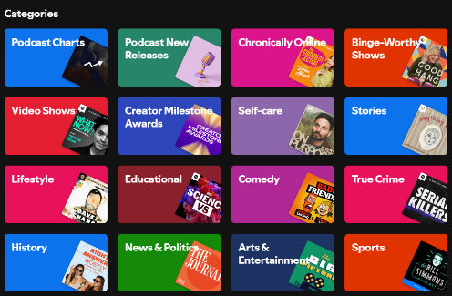
Spotify Podcast Categories

Each category has sub-categories. For example, “Lifestyle” includes podcasts on Food, Beauty, Fashion, Fitness, Health, Hobbies and more.

An advantage of podcast ads is you can fine-tune your targeting.

For more information on podcast advertising see https://ads.spotify.com/en-US/ad-formats/

Module 2 - Marketing Chapter 5 – Traditional Mass Media

2.5.4 BILLBOARDS

Billboards are the most common form of outdoor advertising (termed out-of-home or simply OOH in the ad industry). Other forms of OOH ads include kiosks in public places and transit ads in buses and trains.

The advantage of OOH ads for “”people on the go” is that they are non-skippable, you cannot avoid noticing them; and they are in a fixed location, so ideal for place-based businesses like restaurants or entertainment venues who need hyper-local targeting.

Types of Billboards.

- STATIC, or traditional paper or vinyl billboards are less expensive to rent, but have higher one-time costs for printing and mounting.

- DIGITAL Billboards are becoming more common, but still represent only about 20% of the billboard inventory. They are more expensive to rent due to their higher cost to manufacture and maintain. However, the additional cost may be worth it for businesses who want to change their message frequently, like music venues.

Costs. Rental prices for ad space can vary depending on demand. Billboard bargains can be found after election day, when lots of ads become obsolete. Empty billboards are embarrassing to the owner because they are concerned that a blank or expired billboard means they are no longer in demand. After school starts is another good time to bargain, as all the back-to-school ads need to come down.

- STATIC Billboards: Printing a standard 14’ x 48’ highway billboard in vinyl will run about $1680 or $2.50 a square foot. Add $200 to $1000 for installation. Rental fees average:
  - Small to mid-size cities: $1,000 to $5,000 per month (2025)
  - Large cities and premium locations: $14,000+ per month
- DIGITAL Billboards:
  - General range: $1,200 to $15,000+ per month (2025)
  - Premium locations and spectacular formats: $10,000 to $50,000+ per month

For relative costs by metro area see https://www.adquick.com/billboard-cost

Design. Keep it simple. A billboard message should be grasped in 3 seconds. Make it eye-catching ad.
Keep the message simple, bold, and visually striking. Use large fonts and high-contrast colors.

For more information see https://fitsmallbusiness.com/how-much-does-billboard-advertising-cost/



Need one say more?
Module 2 - Marketing Chapter 5 – Traditional Mass Media

2.5.5 KIOSKS

Kiosks are another form of out-of-home ads. They appear in public spaces: on busy sidewalks, in malls, airports, or stadiums to reach specific audiences. Think of them as billboards for pedestrians.

They have the same advantages of billboards, as you know where the viewers are when they see your ad. With digital kiosks, knowing the location also enables programmed advertising: tailoring the ad to the day of week (churches), time of day (restaurant dinner specials), and even the weather (McDonald’s promotes iced coffee on hot days).

Dwell time. Unlike billboards, kiosks can be read at a somewhat more leisurely pace. An add could take up to 10 seconds to read and still be effective. However, you’ll still need to catch the attention of frenetic urban walkers at first glance if you want them to continue reading. Use eye-popping graphics or clever copy.

Costs. The monthly cost of kiosk advertising can vary widely, ranging from $750 to $2500, depending on amount of traffic at location.

Shopping Mall Kiosks: $750 to $2500 per month. (2025)

Newsstand kiosks: $2,000 to $15,000 per month.

Urban sidewalk panels or bike stations: $750 to $3,000 per month.

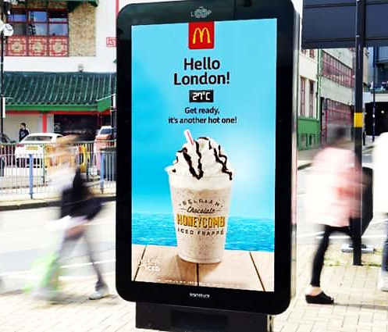
Urban kiosk with built-in thermometer that displays ads based on the weather.
Module 2 - Marketing Chapter 5 – Traditional Mass Media

2.5.6 NEWSPAPERS

Measurable Performance Metrics. Print advertising can deliver highly measurable results by using unique phone numbers, custom landing pages, and various special offer codes to conduct A-B testing to determine the most effective ad size, placement, day of week, or headline text.

Niche Marketing. Newspapers also provide excellent targeting opportunities. Since they are generally purchased through subscriptions, publishers know who their subscribers are and where they live. To find the demographics of a particular publication, check their Media Kit, which you can generally find on their website. They may request your contact information before providing access to the data so they can follow up with you. The Media Kit will include not only number of subscribers (to both print and digital formats), but also household incomes, education levels, home ownership, and other useful data to determine if the paper is a good fit for your product or service.

Newspapers also allow you to drill down to your demographic. You can request that the ad appear in a specific section, say “Food” if you are selling hot sauce, or “Sports” to promote a sporting event.

Formats. Newspaper ads come in two formats: Display ads (that you design and may contain graphics and images) and Classified ads (small, text-only).

Newspaper Ad Rates. Costs typically range from a few hundred dollars in local newspapers to many thousands of dollars for full-page advertisements in national publications. The day of the week also impacts pricing, with Sunday editions generally commanding premium rates due to higher readership.

Newspapers charge by the column inch, which is one column wide (note: not all newspaper columns are the same width) x one inch deep (meaning high). Typical costs are:

CLASSIFIED ADS: $50 – $500 per listing, depending on word count and duration. (2025)

DISPLAY ADS:
Quarter-page $ 200 – $ 1,500 (2025)
Half-page $ 500 – $ 3,000
Full-page $1,000 – $10,000

Media Kit. Search the websites of media you are considering for Media Kit or Advertising. This will include …
- Circulation. Number of subscribers (with demographics) and newsstand sales.
- Sections. Some features may appear only one day a week, like New York Times “Book Review”.
- Page size and ad sizes and rates
- Production specs (how the ad is to be prepared and transmitted to the paper). Below are the production specs for one newspaper, with explanations in blue:
- Offset printing (as opposed to letterpress that uses “hot” lead type)
  - Halftones - 85-line screen (photographs will appear as black dots, 85 per inch).
  - Full page image area: 10.25" x 20.25" (area of the page that is printed: the size of a full-page ad)
  - Color - CYMK (Cyan, Magenta, Yellow, and Black, the four ink colors used in color printing. Word uses RGB (Red, Blue, Green), the color scheme used for computer screens. If you design your ad in Word, you will need Photoshop or Illustrator to convert the colors to CMYK.)
  - Submission Format: PDF (This prevents anything from getting changed accidentally).
  - Fonts. Embed all fonts in artwork. (If your ad looks correct after you convert it to a pdf, then your fonts are embedded.)
To view a full sample guide for newspaper advertisers, with rates, see https://www.nashuatelegraph.com/advertise

Module 2 - Marketing Chapter 5 – Traditional Mass Media

2.5.7 MAGAZINES

For a small business with a small or local market, two categories of magazines provide an attractive ROI on advertising: local lifestyle publications and niche magazines for B-C; and industry trade journals for B-C.

a) Local Lifestyle Magazines offer an opportunity to connect with affluent consumers. Since they are locally focused, they are an ideal medium to promote an apparel boutique, restaurant, wellness service, lawn care, kitchen remodeling, furniture stores, private schools, and personal services. These slick publications provide high-quality brand exposure. Additional Benefits include:
- High-Quality Presentation – Glossy, well-designed layouts enhance brand perception.
- Long Shelf Life – Magazines are often kept and revisited, extending ad exposure.
- Multi-Platform Reach – Many magazines offer digital versions, increasing visibility.

ADVERTISING COSTS. Ad rates reflect the buying power of the target demographic: typically, homeowners in upscale neighborhoods. Depending on circulation, ads will typically run:
- Quarter-page ad: $500 – $2,500 per issue. (2025)
- Half-page ad: $1,000 – $5,000
- Full-page ad: $2,500 – $15,000
- Two-page spread: $5,000 – $25,000
- Cover sponsorship: $10,000 – $50,000 depending on prominence.

b) National Niche Consumer Publications. Like local lifestyle pubs, these magazines focus on a narrow interest group, like organic foods, music, education, almost any topic two or more people have an interest in. Check out your local library and flip through some mags that appear to cater to your market. Who’s advertising? If it seems like a fit, look them up online to find ad rates, publication dates and any special issues coming up that may be a perfect fit for your custom-brewed organic beers.


For every interest there is a magazine. Treasure hunting? Model railroading? Emu farming? Elevator tech? Miniature donkeys? Yep, all those and more.

Module 2 - Marketing Chapter 5 – Traditional Mass Media

c) Trade Journals

Trade journals are specialized publications that cater to professionals within specific industries, making them an effective tool for B2B marketing.

ADVERTISING COSTS
- Quarter-page ad: $ 500 – $ 2,500 per issue. (2025)
- Half-page ad: $1,000 – $ 5,000 per issue.
- Full-page ad: $2,500 – $10,000 per issue.
- Two-page spread: $5,000 – $20,000 per issue.
- Cover sponsorships: $5,000 – $25,000, depending on prominence.

As an example, here are excerpts from the Media Kit of the Rhode Island Beverage Journal.

Size/Glossy | 1X | 6X | 12X
4/C Full Page | $ 1,352 | 1,144 | 1,105
1/2 Page 4/C | 811 | 686 | 663
1/3 Page 4/C | 541 | 458 | 442
MECHANICAL SPECIFICATIONS. Advertisements are accepted in hi-res PDF format. Space reservations are due the 5th of month prior to the publication date. Specs are:
- Full Page Image Area: 7.25” x 9.875; Trim Size: 8.25 x 10.875; Bleed Size: 8.75 x 11.375
- Other Advertisement Dimensions: 1/2 page: 7.25w x 4.9375h; 1/3 page: 7.25” x 3.25″ horizonal
- Preferred Materials: High-Resolution PDF

REGULAR COLUMNS OFFER ALIGNMENT OPPORTUNITIES:
- Around Town: Local launches, events, products and faces
- New Products & Promotions
- Association News: Topics from local trade associations
- Retail Review: A look at off-premise sellers
- The Find: A compendium of trends and products
___________________________________________________________________________

Examples of trade journals across various industries:

- Marketing Advertising Age
- Education Education Week
- Law Enforcement Police Chief
- Technology Engineering News Record
- Healthcare Medical Laboratory Observer
- Business Harvard Business Review
- Public Relations PR News
- Fashion WWD
- Music Billboard
- Automotive Automotive News

Module 2 - Marketing Chapter 6 – Digital Mass Media

2.6 – Marketing
(Digital Mass Media)

2.6.1 Free Web Advertising (Local Search Directories)
2.6.2 Paid Web Advertising: Search Engine Marketing (SEM)
2.6.3 Social Media Marketing (SMM)
2.6.4 Social Media Influencers

Module 2 - Marketing Chapter 6 – Digital Mass Media

2.6.1 FREE WEB ADVERTISING (local SEARCH DirectorieS)

The following Local Search Directories are free. Note: the more search directories you are listed in, the higher you will rank on Google search results.

Apple Maps
Bing.com
Brownbook.net
Elocal.com Pay per call
EZlocal.com
Google My Business
InsiderPages.com
LinkedIn Company Directory
Local.com
LocalStack.com
Manta .com
MapQuest.com
Merchant Circle.com
Mylocalservices.com (for service providers)
Super Pages.com
Thumbtack (For home improvement providers. Pay per lead)
Tupalo.com
Yelp.com

This website will do a quick search of 35 Local Directories to see which ones you are listed on and to make sure your information is current: https://uberall.com
Module 2 - Marketing Chapter 6 – Digital Mass Media

2.6.2 PAID Web Advertising: Search Engine Marketing (SEM)

Google, Yahoo, and other search engines allow companies to buy keywords. If you decorate blue jeans, and you buy hits for the search term “blue jeans”, when someone searches for the term, a brief sales message for your product and a link to your site will appear in the margin of the page displaying the search results.

Ads might run from $.50 to $2.50 per appearance, but you can set a limit on the monthly spend.

Try different keywords and install Google Analytics to see which lead the most searchers to your site. https://analytics.google.com/analytics/web

The screenshot below shows the results of a search for “Football tickets”. The left column contains the normal returns. The right column contains the results for companies that paid for the keywords “Football tickets”.
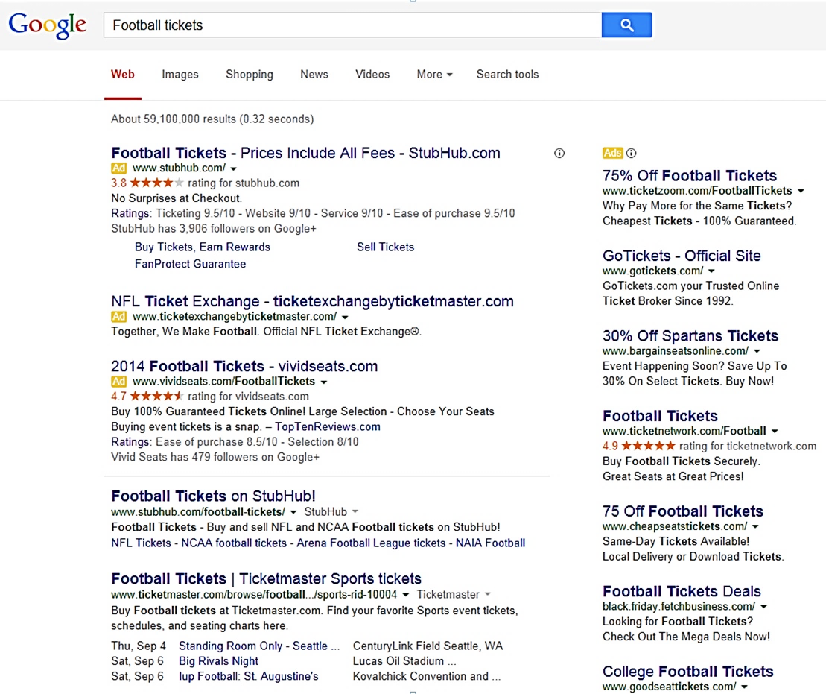

Module 2 - Marketing Chapter 6 – Digital Mass Media

2.6.3 Social Media MARKETING (smm)

Check with your local SCORE or SBDC office for free seminars on Social Media Marketing.
Choose the right Social Media Platforms for your Business. Birth years are for the largest user groups.
- B2C (born 1990-2000) Facebook (3 bb monthly users)
2. B2C (born 1990-2007) Instagram (2 bb monthly users), TikTok (1.6 bb), X (586 mm)
3. B2C (born 1990-2007) YouTube (2.5 bb). Also useful to demo products and services
4. B2C (born 2000-2012) Snapchat (850 mm monthly users)
5. B2C Millennials /Gen Z (born 1981-2012) What’sApp (3 bb monthly users)
6. B2C Impulse buyers Pinterest (537 mm monthly users)
7. Business clients LinkedIn (1.2 bb members)
8. Entertainment Media Myspace

The best social media advertising is the kind you don’t pay for. Consider the following tactics:

- COORDINATE SMM CAMPAINGS with free tools at www.Hootsuite.com or www.Buffer.com.
- SET UP FACEBOOK, INSTAGRAM and MYSPACE pages for your company or product. Link to your website so people can obtain more information about your product, and place orders.
- ENGAGE VISITORS. Invite customers to post their own pics and experiences. This is especially valuable to restaurants, bed and breakfasts, entertainment venues and experience services.
- PROVIDE HELPFUL CONTENT: Tweet tips. Upload how-to videos to YouTube. Join a facebook group.

- JOIN A LINKEDIN GROUP (if B-B) and share leading-edge information and answer questions of members to establish your credentials as an expert in the field.
- ADD FACEBOOK “LIKE” BUTTON to your website and blog.

- WRITE A BLOG for people with the problem you solve. Note: articles with images receive almost twice as many views as text-only posts. Engage followers: ask them for their opinions and experiences. Content must be informative, unique and entertaining—and not all self-serving. The purpose of the content is to project your company as a knowledgeable expert concerned for the well-being of the customer. Share content on the web during high traffic hours in the U.S. (Times are EST.)
  - Facebook 1 pm to 4 pm
  - Twitter 1 pm to 3 pm
  - LinkedIn 7 am to 9 am, and 5 pm to 6 pm (business execs use LinkedIn)
  - Google+ 9 am to 11 am
  - Pinterest 2 pm to 4 pm, and 8 pm to 1 am
- POST COMMENTS TO SITES VISITED BY YOUR CUSTOMERS.
- COUNTER NEGATIVE ONLINE PUBLICITY. To find out when someone says something about you or your company online (positive or negative), sign up for Google Alerts: www.google.com/alerts.

Module 2 - Marketing Chapter 6 – Digital Mass Media

2.6.4 SOCIAL MEDIA INFLUENCERS

Ever since Honus Wagner allowed Hillerich and Bradly to use his name on one of their Louisville Slugger bats in 1905, companies have been using celebrities to endorse their products. Today, a pacesetter is just as likely to be a middle-schooler with a loyal following for her fashion advice. Influence does not come in just celebrity size anymore.

Bloggers have discovered they have power to influence buying decisions; and consumers seem to trust their favorite trendsetters—even if they know the plug is a paid ad.

A startup can tap into the influencer phenomenon to create awareness. Factors that drive influencer costs are …
- Industry
- Platform
- Celebrity
- Number of followers of the influencer
But bigger is not always better. According to Tara Johnson of CPC Strategy, the influencers with the smaller audiences offer the most authority in a specific niche and can deliver high levels of engagement among their dedicated following. Ignite Visibility, a digital marketing agency, adds “If the audience is not in line with your brand, the message will not resonate, no matter how many people hear or see it.

Cost Per Influencer Post (2025) for popular influencer media.
Tier Followers | INSTAGRAM | YOUTUBE | SNAPCHAT | TIKTOK
FORMAT >> | PHOTO or VIDEO | VIDEO | PHOTO or VIDEO | VIDEO
PAY PER >> | Post | Post | View | Post
Nano 500-10,000 | $10 to $100 | $20 to $200 | $200 to $1000 | $5 to $25
Micro 10,000-50,000 | $100 to $500 | $200 to $2500 | $1000 to $5000 | $25 to $125
Mid-tier 50,000-100,000 | $500 to $5000 | $2500 to $10000 | $5000 to $20000 | $125 to $1250
Macro 100,000-500,000 | $5000 to $10000 | $10000 to $20000 | $20000 to $35000 | $1250 to $2500
Mega 500,000 and up | $10000+ per post | $20000+ | $35000+ | $2500+

Module 2 - Marketing Chapter 7 – Targeted Media

2.7 – Marketing
(Targeted Media)

2.7.1 Direct Mail Marketing
2.7.2 Email Marketing

Module 2 - Marketing Chapter 7 – Targeted Media

2.7.1 DIRECT MAIL MARKETING

POSTCARD CAMPAIGN. A postcard campaign can be used to build up an email prospect list for follow-up. You can buy a mailing list of potential customers (by zip code and demographics) and include a call-to-action on the card to visit your website for a free report, sample, or discount coupon. And postcards, unlike emails are always “opened” and at least glanced at. (So, make the headline a grabber.)

STANDARD POSTCARD SIZE is 4” x 6” (or 4.25” x 6”) and typically 14 pt (111 lb.) card stock or heavier.

MAILING SERVICES (Companies that print, address and mail postcards can guarantee the Post Office will not reject your entire mailing because you used the wrong postage, the date is incorrect, or you violated the margin requirement for the address. (Yes, that is a thing.) Plus, these firms receive quantity discounts on postage, so the cost may not be much more than buying stamps from the post office (and you probably do not want to lick all those stamps anyway). Another savings is you will not need to buy a bulk permit from the Post Office ($245 in 2025); you can use the permit of the mailing service.

COMPANIES that will print, address, and mail postcards:
https://www.postcardmania.com/
https://www.gotprint.com/products/postcards
https://www.modernpostcard.com/

COSTS FOR A POSTCARD CAMPAIGN. Most companies will require a minimum of 500 to 1000 postcards to make it worth their while to process an order. Typical costs per card for 1000 postcards will run …

Design $ 0 each Assuming you design yourself. Most services have templates
Mailing List $ .25 each Assuming a $250 minimum
Printing $ .10 each Assuming 4 colors on the front and black only on the address side
Processing fee $ .15 each This is usually a flat fee to upload and sort a mailing list
Addressing $ .07 each To run cards through an addressing machine
Postage $ .40 each Pre-sorted bulk
TOTAL $ .97 each = $970 for 1000 postcards
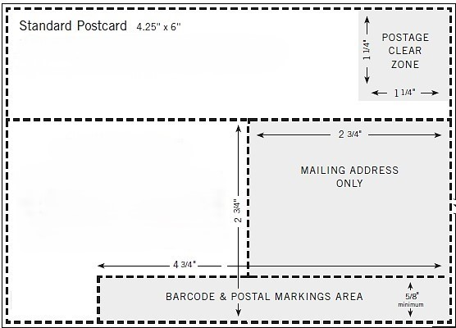

Template from Modern Postcard company.
Do not place any ad copy in a shaded area or Post Office will reject.
Module 2 - Marketing Chapter 7 – Targeted Media

2.7.2 EMAIL MARKETING

Collecting Names to Build an Email Prospect List.

- AT FACE-TO-FACE MARKETING FORUMS (Trade shows, exhibits, sampling tables in retail outlets). Take a clipboard and invite people to join your emailing list. You will collect more emails if you offer to send a sample, free-trial access code, or discount coupon.
- ON YOUR WEBSITE. Add a “sign-up for announcements of sales” button in a prominent location on your site. As an incentive, offer something immediately to anyone who opts in, like a discount off the first purchase.

Sending Emails to Customers. You can send emails from Outlook yourself for free, but DO NOT send more than 39 at one time or you will be blocked as a spammer. For a $79 one-time payment (as of 2025) you can download EmailMerge for Outlook (available from www.standss.com/emailmerge), that allows you to send individual personalized emails from an Outlook address book or Excel database. So, if you have 40 recipients on your customer list, and you use EmailMerge, the receiving servers will see the campaign as 40 individual emails, rather than a 40-email blast.

Alternatively, you can use a paid email service that sends emails out one at a time.
A free email marketing service is available at http://mailchimp.com/, with a limit of 500 names and 1000 emails per month (and no more than 500 per day). Alternative platforms include ...
- https://kit.com/ Designed for creators. Free for basic service up to 10,000 subscribers.
- Brevo.com. There is no fixed monthly fee. You only pay per email sent. 300 emails may be sent per month for free. 500 contacts and 5000 emails per month is $9 a month.
- Woodpecker.co Allows up to 6000 emails per month to 600 different contacts for $20 per month. Woodpecker also checks for invalid addresses prior to sending.
- ConstantContact.com, a competing service, charges $12 per month, which allows for 500 contacts and 5000 emails per month (as of 2025). Pricing is not clear and site not very user friendly, but inexpensive.
- Campaigner.com. Prices range from $59 per month for up to 5000 contacts (as of 2025).

Module 2 - Marketing Chapter 7 – Targeted Media

Increasing Open Rates of Email Marketing Campaigns

- RESTRICT NUMBER OF CAMPAIGNS to three or four a year—certainly no more than once a month—or you will receive as many unsubscribes as opt-ins. Moreover, do not send every email to every person in your database. If you are holding a sale for homeowners in Chicago, filter your list for Chicago zip codes.

- PROVIDE REAL VALUE TO CUSTOMERS IN MESSAGES. Make them want to open your emails because they know you have sent them another great idea. If it is just another sales pitch every month, they will soon opt out.
- WRITE AN ENGAGING SUBJECT LINE. The more people who open your email, the better your sender reputation and future deliverability. Forster Perelsztejn of Prospect.io offers some approaches to crafting a subject line that beckons to be opened:
- Pose a question: “Do you need help with (your message topic).” A question prompts a moment’s thought about the topic.
- Simply use the name of your product or service. This engenders for him a 75% open rate. Perelsztejn says, “If you research your audience and their pain points well enough and are able to determine what kind of solution they might need, presenting it bluntly can be a good way to grab your prospect's attention.”
If you need help creating subject lines, check out ActiveCampaign’s subject-line generator at
https://www.activecampaign.com/free-marketing-tools/subject-line-generator#generator.

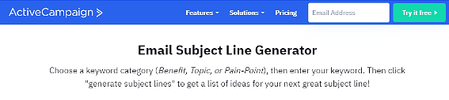

- BUT KEEP THE HEADLINE SHORT. Open rates drop from 24% to 17% on average when subject lines exceed 35 characters.
- SEGMENT LIST BY PRODUCT AND DEMOGRAPHICS and tailor the message to each group. Even better, craft each email to the situation and need of each person: “Kate, I see that you haven’t purchased toner in 6 months for your H-P 4800…”, using dynamic content to pull up customer information from a database. Personalized emails always produce a higher open rate.
- CHECK YOUR SPELLING AND GRAMMAR. Poor English is a clue for scam-checkers that an email may not really be from a princess who desperately wants you to hold her family fortune in your personal bank account. A Radicati Group study found that 80% of people surveyed feel grammar and spelling errors make a sender seem unreliable and untrustworthy; with 70% stating that even one error was “unacceptable”.¹
- BEST DAY AND TIME TO SEND EMAIL. Monday or Friday at 10:00 am.
For more email marketing tips see https://financesonline.com/email-marketing-software-statistics/
Module 2 - Marketing Chapter 7 – Targeted Media

Improving Delivery Rates

Even a well-crafted email with valuable content will not be read if caught in the inbound mail server’s spam filter. According to Statistica.com (2025), 46% of email traffic in 2023 was spam. Email service providers know that their customers do not want to waste time on inbox clutter, so they continually refine their algorithms to screen out probable spam. Unfortunately, the filters can also block your email if it looks like spam. So, what can you do to avoid ending up in the spam net?

- KEEP YOUR LIST UP TO DATE. If your addressees have been unresponsive, the wasted emails are not just costing you 1 or 2 cents; they are affecting your reputation with email service providers. Mail servers notice when recipients consistently ignore overtures from your IP address and learn to categorize your emails as spam.
To keep your list current and populated by engaged recipients, send a message that asks for a response. Rachel Burns of ActiveCampaign suggests…
When a contact has not engaged for 60 days (or the period of time that makes sense for you), trigger a “last chance” engagement email. Then remove contacts who do not interact.
Learn more about re-engagement emails in this post: www.activecampaign.com/blog/re-engagement-email .

Also remove hard bounces from your list. Bounce rates are a factor service providers use to determine your sender reputation. When you receive an “Undeliverable” notification delete the problem email from your list.

- VALIDATE EMAILS YOU HAVE NOT COMMUNICATED WITH IN A WHILE to make sure they are still valid. There are services that will screen your list for a fee. https://emaillistverify.com/pricing charges $5 per thousand. Hunter https://hunter.io/bulks/email-verifier allows validating up to 50 emails per day for free. (2025)
- USE DOUBLE OPT-IN. Ask newsletter subscribers to double opt-in by sending them an email to verify their email address (erroneous or fake email addresses will drive up your score as a likely spammer because they will not get delivered and thus increase your bounce rate).
- MAKE IT EASY TO UNSUBSCRIBE, and honor all opt-out requests immediately. (It’s the law.)
- ASK RECIPIENTS TO ADD YOU TO THEIR ADDRESS BOOKS. This process, called whitelisting, indicates to spam filters that you are a trusted sender.
- INDICATE WHERE YOU ARE LOCATED. Spam filters figure (rightly) that a shady character is not going to reveal how they can be found.
- DO NOT EMBED FORMS. Forms represent a security risk and are not usually supported across common email clients. Just include a link to the form on your website, Dropbox or Google Drive.
- DON’T ATTACH FILES. They are a red flag for spam filters. Reputable email services will not allow you to attach files. Instead, include a link to the file on your website.
- DON'T CLAIM YOUR EMAIL ISN'T SPAM. Spam filters will think you “doth protest too much.”
- KEEP TEXT SIMPLE AND STRAIGHTFORWARD, as if you were writing a business letter. Do not use "cute" spellings, S P A C E out words, or insert character$ in words.
- MAKE SURE YOUR LINKS WORK. Clickable images and redirection to a landing page have become standard practice.
- AVOID URL SHORTENERS. Their use by spammers (to hide their true domain names) got bit.ly and other URL converters branded as risky, so could cause your e-mails to be trapped by spam filters.

Module 2 - Marketing Chapter 7 – Targeted Media

- COMPOSE THE EMAIL IN TEXT. But do not copy and paste formatted text from Word. Select “Paste without formatting” or Ctrl + SHIFT + V (Shift + Option + Command + V on Macs) when pasting text into your email marketing software. And do not use email templates. These use HTML and thereby soak up a lot of kilobytes. If you use an email distribution service, start with a blank page. If you insist you need HTML at least do the following to reduce email size and increase open rates.
- Under no circumstances paste from Microsoft Word. Code generated by MS Word and similar composing tools may appear unorthodox to spam filters. (SpamAssassin calls Word “Horrendous” for emails.)
- Make sure that your code is correct. If your email includes broken or incomplete tags, spam filters may prevent it from reaching the desired inbox. (Sloppy coding is an indicator of spam.)
- Make it look like text (and therefore not look like junk to the spam filter or to the recipient). And do not send in HTML without a text-delivery option. (If your email newsletter is in HTML and it does not automatically switch to text for readers who cannot receive HTML, it will be filtered out.)
- Reduce the size (in pixels) of images and logos before inserting into an email.
- Minimize your code with tools like HTML Minifier and HTML compressor. Do this last because code is hard to read and work with once it is minimized.

- KEEP EMAILS LEAN. No one reads a long email. Link to your website for details. Another reason to keep emails short and sweet is that Gmail clips messages longer than 102kb, to save screen space and the time needed by their customers to preview (and quickly dismiss) incoming messages. Clipping creates multiple problems for email marketing:
- Gmail users will not see your whole email, unless they click “View entire message”.
- You might not be able to track open rates because the tracking code is usually at the bottom of an email.
- The Unsubscribe link is also located at the bottom of emails. If recipients want to opt out of your emails and do not see the (clipped off) Unsubscribe link, they may take the easy route of just marking the email as spam; which will have a negative impact on future deliverability. If a certain number of Gmail users mark your emails as spam, future emails will be filtered out automatically and not just to the recipients who labeled you as a spammer, but to ALL Gmail accounts.
- DIAL BACK ON THE VISUAL HYPE.

Avoid all caps. Subject lines written in uppercase attract spam filters. And in the etiquette of email communication using upper case is usually seen as shouting.

A jumble of font colors and sizes also raises the antennae of spam filters.

Do not use exclamation points!!!! Unless you want to look like a loud-mouthed huckster.

Avoid rich media content. Most email clients do not allow the ability to view rich media content such as video embeds and Flash. If the media content is essential to your campaign, put it on your website and insert a link. Also, avoid using JavaScript and other dynamic scripts, as they attract the attention of spam filters.

Limit the number of images. Lots of images, or large images increase load time and can affect deliverability rates. Also, images will not show correctly to users who block them, which may make your email look spammy.

- AIM FOR AN OPEN RATE OF 20%. Below that and you are leaving sales on the table; and falling below this may be a red flag to Internet Service Providers.
Module 2 - Marketing Chapter 7 – Targeted Media

- USE A RECOGNIZABLE SENDER NAME. It is good practice to always strive to send emails from an email address that contains your personal name with your brand name so that recipients recognize you. A study by Finances Online shows that 45% of email recipients decide whether an email is spam based solely on the information in the “From” field (name and email address).
- BEST Firstname.Lastname@YourCompany.com
- BETTER YourCompanyName@Gmail.com
- AMATEURISH Fred2700@Gmail.com
- DUMB Sales@YourCompany.com
- DO NOT BUY BULK EMAILS. Lists degrade quickly. Purchased lists usually have a high percentage of bad addresses, which leads to high bounce rates and banning. If the addresses have been harvested, they may even contain spam traps, fictitious emails planted in websites to catch spammers. If your email hits such an address, your IP address will be blocked by Internet service providers.
- BE VISIBLE AND “PUBLIC” IN YOUR DOMAIN AND HOSTING REGISTRATIONS. If your registration is "private", some may assume you are a spammer hiding from an outraged public.
Make sure you have an active and monitored abuse@email and register it with http://www.abuse.net.
Make sure your privacy policy and contact information are easily found and clearly stated on your website. It is a good idea to show in your email where to find this information.

- AVOID SPAM TRIGGER WORDS. Stay clear of dubious enticements and questionable claims:
- “Don’t delete this email!”
- “Have you been turned down?”
- “No experience necessary”
- “Absolutely free”
- “No obligation”
There are hundreds of words and phrases that will make spam filters suspicious of your intentions, but the algorithms will not kick you out for using one or two promotional phrases. Spam filters weigh several of the indicators discussed in this section to assign an email spam-probability score. Rachel Burns of ActiveCampaign says …
If you stuff a ton of spam keywords into your email; Use all caps, bright red font, and lots of exclamation points; and you already have a low delivery rate…you are going to be in trouble. But if you use one or two of the words and phrases in context, code your emails well, and have a low bounce rate…you will be fine.

But rather than agonize about whether an email will be filtered out, send one to yourself to see how it looks in an inbox; and run it though a free email Spam Testing Tool: https://www.mail-tester.com.

If your spam score is low, but your open rates are also low, you or your sending URL may have been blocked due to complaints. To check your status, go to https://mxtoolbox.com/blacklists.aspx and enter the IP address or domain name of the sender. If you don’t know the IP address you can look it up at https://mxtoolbox.com/.

Module 2 - Marketing Chapter 8 – Direct Sales

2.8 – Direct Sales
(Online and In Person)

8.1 Online Sales
8.2 Trade Shows, Flea Markets and Pop-Ups
8.3 Selling from Behind a Table
8.4 Networking to Generate Leads (B-B)
8.5 The Sales Call (B-B)
8.6 Indirect Selling (to Distributors, Reps, and Retailers)
8.7 Accepting Electronic Payments

Module 2 - Marketing Chapter 7 – Targeted Media

2.8.1 Online Sales

SELLING FROM YOUR WEBSITE. The major payment services will provide online checkout. For a comparison of rates and the types of payments accepted see “Accepting Electronic Payments.”

To add a PayPal buton to your website, visit PayPal.com and click “Sign-up”. Select the “Business” option and click “Get Started.” After opening a “Business Account” look for the “Pay Links and Buttons” icon. Follow the prompts to create your payment button. In the final step, PayPal will provide HTML code for you to paste into your website. Almost all Content Management Systems (CMS) include an option to insert payment buttons. You do not need to know how to code to do this yourself. For step-by-step instructions see
https://www.fulfillrite.com/blog/how-to-add-a-paypal-button-to-your-website/

SELLING THROUGH THIRD-PARTY ONLINE PLATFORMS. Shopify, eBay, Etsy and Amazon will handle the payment collection and processing. See chart below for rates. You will still need to pick, pack and ship the order; or use a Third-Party Logistics (3PL) company to warehouse, fulfill and ship orders.
.
Online Marketing Platforms (Fees as of 2025)
 | Fees | Permitted Items | Notes
EBAY.com | 250 free listings per month  (This includes items that did not sell in the previous month and were automatically relisted). Then $.35 per item over 250.  + commission of 13.6% of amount collected (including sales tax and shipping) + $.30 to $.40 per order.  + PayPal transaction fee of 2.9% + $.30 | Anything legal | 134 million active buyers.
ETSY.com | $.20 listing fee per item plus 6.5% commission on sales, plus payment processing of 3% + $.25 per transaction. | Goods made by you, vintage items, craft supplies | 96 million buyers in 2025. Discounts on postage.
SHOPIFY.com | $29 per month, plus 2.9% + $.30 per transaction. | Anything legal | 875 million buyers in 2024.  Discounts on shipping. Supports sales on Instagram and Face book with a “Buy” button.

Module 2 - Marketing Chapter 7 – Targeted Media

2.8.2 TRADE SHOWS, FLEA MARKETS AND POP-UPS

Trade Shows (B-B) focus on specific industries (trades) and therefore ensure exhibitors that they will be able to demo their products to the right buyers, as well as research competitors and network with industry leaders. When planning your exhibit and literature, keep in mind that the purpose of a trade show is to generate leads (so make sure you capture contact info of booth visitors), and not to sell products. (No one is going to take your back-yard grill back with them on the plane.)
Trade shows attract buyers from across the country, if not the world, but also involve a range of expenses (2025):
- Booth Space Rental $ 1,000 – 10,000 for a standard 10’ x 10’ pipe-and-drape booth, and table.
- Extras $ 100 for electricity in booth (bring an extension cord); $200 for Internet
- Signage: $250 for roll-up and easel-backed signs.
- Promotional Materials $200 – $2,000
- Bling $ 250 e.g. – thumb drives or stress balls with your logo.
- Drawing $ 300 for prize. Set out a clear bowl with a sign that reads: “Drop your card for a
drawing for a free __. You do not have to be present to win”
- Travel $ 50 per person or more, depending on distance
- Pre-event Advertising $ 500 – $5,000

For more on trade show budgeting, and tips to reduce costs, see
https://www.moddisplays.com/post/unveiling-the-hidden-trade-show-costs-you-need-to-consider

To find a trade shows for your industry see https://tradefest.io/en/home


Trade Show
with 10x10
pipe-and-drape booths.

Do not forget to bring a tablecloth. (These are not supplied.) And a water bottle (unless you want to pay five dollars for one
at the show.)

Flea Markets (B-C) are generally local or regional, and therefore considerably less expensive (2025):
- Space Rental $100 – $300 for space for one table (check to see if you have to supply the table.)
- Signage $200 (for roll-up and easel-backed signs)
- Promotional Materials $200
For a directory of Flea Markets see http://www.keysfleamarket.com/fleamarket/state/
Pop-up Shops (B-C) are typically smaller and irregular (hence the term pop-up) and last only a few hours.
Costs range from zero to $100 at most for a table. To find pop-ups search online for “Pop-up shops near me.”

Module 2 - Marketing Chapter 7 – Targeted Media

2.8.3 SELLING FROM BEHIND A TABLE

ASK QUESTIONS OF THE ORGANIZER SO THERE ARE NO SURPRISES:
- Will a table be supplied? How big?
- Is it indoors? If not, will a tent be suppled?
- Is Internet available (Is there an extra charge?)
- Electricity? (Is there an extra charge?)
- What are the set-up and tear-down times?

- Where will your table be located? Not next to the guy with the megaphone, I hope. If so, ask to be moved. It will be too late when you get there.
WHAT TO BRING
- Tablecloth
- Extension cord if you need electricity
(it may be supplied, but not right to your table)
- Easel-backed Counter Card (at least 17” tall, to be seen easily)
and/or pull-up signs
- Business cards
- Literature
- Email sign-up sheet (for digital coupon)
TIPS FROM THE PROS
- Do not sit. This says, “Don’t bother me.”
- Stay off the phone. (See #1 above.)
- Smile. Look like you want to be there.
- Put out some bling. This does not have to be pricey. Candy, mints, cookies, mini packs of pretzels are fine.
THE PITCH. Don’t be aggressive. Just explain what your product does and how it will benefit the customer. Do not drone on. Keep your opening to what you can comfortably say in one breath. Practice this, until it becomes natural. “Hi, we offer fresh-baked brownies, pre-wrapped for school lunches.” Then follow up with a question to engage the prospect—and probe for possible objections. “Do you have kids in school?” Or “Would you like to try a sample?” Then “What do you think?” Let the customer get a word in edgewise, because their response will contain clues to reasons they may not purchase.

THE CLOSE. Ask a whether question “Would you like to take it with you OR would you prefer we ship it?” – not an if question “Would you like to buy one today?” The later allows an easy “No” reply.

Use this box to draft a brief sales pitch

Module 2 - Marketing Chapter 7 – Targeted Media

2.8.4 NETWORKING TO GENERATE LEADS (B-B)

You never know where your first employee or next sale will come from, but you greatly increase your chances of success by getting out and pressing the flesh. The more people you meet the greater your odds.

Take business cards that tell what you do and include your tag line (how you do it better), and if someone hands you a card make a note on it to remind you what the person looks like and how you might help each other.

Join the local trade association for your industry. Find the nearest one at https://www.directoryofassociations.com. Attend meetings to get to know the members and then start a Mutual Referral Campaign with the professionals who have a solid reputation for reliability and integrity.

It may sound counterintuitive to attend a meeting of, say; fellow contractors or lawyers, but they all will not share your specialty. For example, a builder who does garages may not build fireplaces. If you build fireplaces and a client mentions they need a garage, refer them to the other builder, who might reciprocate if a homeowner mentions they want to add a fireplace. Same with lawyers: a divorce attorney will not do real estate closings.

To find business networking events in your area, check out www.Meetup.com.

For more advice on networking, see https://www.themuse.com/advice/an-introverts-guide-to-networking



Module 2 - Marketing Chapter 7 – Targeted Media

2.8.5 The Sales Call (B-B)

For high-priced products services, advertising and trade shows will typically just provide leads: an expression of interest or request for details. Someone still has to close the sale.

GETTING TO YES. SELLING TIPS FROM THE PROS. First, sell yourself. Prospects must believe in you before they will believe in your product or service. Be open and honest about your product limitations.

Second, you need to be your company’s lead salesperson, to set the example, and more importantly to stay in touch with your customers and their needs. It’s not difficult. Just follow these tried-and-true steps:
1. Prepare. Learn about the prospect's company, industry, and potential needs or pain points.
- Define Your Objective for the call. Is it to set up a meeting, gather more information, or close a deal?
- Outline Talking Points for the call: benefits and how they address prospect's likely challenges.
2. Make the call.
- Identify Yourself Clearly: State your name and company name. State the Reason for Your Call.
- Start with a friendly greeting and ensure you have not caught the prospect at a bad time. A little chit-chat to build report is OK but remember they are busy. Get to the point quickly.
3. Engage and Qualify.
- Ask open-ended questions to gather information about challenges; and follow up with clarifying questions to fully understand their situation. Let the customer talk. Sales result from sympathetic listening.
- Salesforce suggests asking “Has anything changed since the last time we talked?” This allows you to adjust your talking points to meet their current needs.
4. Present Your Solution. Explain how your product or service solves their specific problem and brings value.
5. Handle Objections.
- Be prepared for common objections about price or timing. Know your competition and your advantages.
- Try to discern any underlying—but perhaps unspoken—reason for the objection. Ask a clarifying question to show concern and interest in their issue. Do not be defensive. You have probably heard the adage: “Win the argument but lose the sale.”
- Respond Empathically: Show that you understand their perspective.
- Offer a solution that may satisfy their concern or overcome an obstacle. Use positive language.
For a free guide to handling objections see https://offers.hubspot.com/prospecting-objection-handling
6. Close the Sale.
- Ask for the order.
- If the answer is YES, confirm the details and discuss how payment will be made. Do they require an invoice, or will they send a purchase order? How and when will you deliver the product or service?
- If the answer is NO, thank the prospect for their time and let them know if you can meet their specific needs in the future, you will let them know.
- If the reply is MAYBE, ask for a time to give a demo, or offer to send additional information and then follow up in a few days. To be productive, you can only spend so much time with one prospect. (Some people will never say “no”; but they will never say “yes” either.) Proceed to the next prospect. Selling is a numbers game: it is not how much time you can spend per prospect; success is about talking with as many prospects as possible in the time you have.
7. Follow Up with an email. Summarize the conversation and reiterate the next steps.

For more insights into successful selling see www.salesforce.com/ca/blog/sales-language-affects-bottom-line/

Module 2 - Marketing Chapter 7 – Targeted Media

2.8.6 Indirect Selling (To Distributors, Reps, and Retailers)

For a product to earn you a living you will need help selling. Considers reaching out to intermediaries:
- RETAILERS. Companies that sell products through brick-and-mortar or online stores. They will expect a 30% to 50% margin of profit on the retail price.
- CATALOGUERS. Similar to retailers, and great way to get national exposures.
- DISTRIBUTORS. Intermediaries that buy from you, warehouse products and resell to retailers. They will want at least a 20% margin of the wholesale price (price paid by retailers). If you are just starting out, few distributors will want to handle just one product from a supplier. (Too much paperwork for too little volume.)
- MANUFACTURERS’ REPS (SALES AGENCIES). These are independent agents that act as salespeople for you, but you still need to do all the warehousing, shipping, and invoicing of retailers. Their commission is usually 7-15% of wholesale.
But to be taken seriously by any of these sales channels, you will first need to generate sales on your own and demonstrate that customers will repeat. Distributors need to see that it is worth the time to set up an account and take up space in their warehouse. Retailers need to know you have a winner that will not just collect dust on their shelves. To win over intermediaries …

1. OFFER COMPETITIVE RETAIL PRICING WITH COMFORTABLE MARGINS FOR EACH LEVEL.
Note that some traditionally seasonal or fashion-fickle industries have higher retail margins to absorb losses on products that never sell, or must be deeply discounted to move off the shelves:
- Fashion: Retail is typically 2.2 to 3 times the wholesale price. (If a store pays $10 wholesale for a summer dress that retails for $30; they can still make money when they clear out their summer stock at “half price”.)

- Cosmetics: Retail is generally 1.6 to 1.8 times wholesale.
- Gifts: Retail is generally 2 times wholesale.
- Jewelry: 3 times wholesale.

2. PROVIDE MERCHANDISING SUPPORT MATERIALS:
Offer attractive displays and promotional brochures.
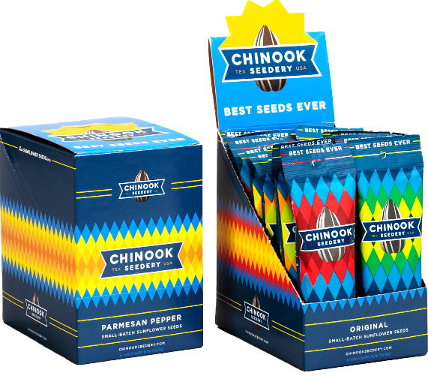
The display at left fits in
a shipping carton and provides in-store signage to help maximize sales.

At right is a customizable display available from www.Displays2go.com.
This display has the added attraction to retailers of not taking valuable shelf space
since it is free-standing.
Module 2 - Marketing Chapter 7 – Targeted Media

2.8.7 ACCEPTING ELECTRONIC PAYMENTS

All services allow ONLINE as well as IN-PERSON payments. All services offer a card reader to collect payments in person by swiping a card or accessing a digital wallet on a phone. (Note: the cost of the readers varies widely.)

Most providers also offer a free Tap-to-Pay app that allows businesses to capture payments phone-to-phone without the need for a physical card reader. But some only offer Tap-to-Pay for iPhones. The more digital wallets you can accept, the broader your market appeal.

Data below is from 2025 but subject to change; click column headers to check for current fees and features.

 | PayPal | Intuit | Square | Stripe
Credit Card Reader to plug into phone. Also accepts contactless digital wallets. Internet connection required.   | Yes  $29  Accepts  cards that  require pin | Yes  $49 | Yes  $399 | Yes  $59
Tap-to-Pay. Contactless payment  by credit/debit card or digital wallets  Without the need for a card reader.   | Yes  iPhone  OR Android. | iPhone only.  Requires QuickBooks  at $420/yr.  + Internet  connection | Yes | Only through card reader or terminal; not through phone.  See also “Fees” below.
Allows multi-users so others  can accept payments for you | Yes | Yes | Yes | Yes
Links to QuickBooks | Yes | Yes | Yes | No, but data downloadable to QuickBooks
Digital Wallets Accepted  - Apple Pay  - Google Pay  - Cash App  - PayPal  - Venmo  - Samsung Wallet | x | x | x  x
Transaction Fees  For in-person transactions.  Keyed-in payments  Online store checkout  Invoices paid online | 2.3% + 9¢  3.5% + 9¢  3.5% +49¢  3.5% +49¢ | 2.5% *  3.5% *  3.0% *  3.0% * | 2.6% +15¢  3.5% +15¢  2.9% +30¢  3.3% +30¢ | 2.7% + 5¢  2.7% + 5¢**  2.9% +30¢***  2.9% +30¢
* Intuit also charges a monthly fee if total amount processed is less than $2500. Contact Intuit for details.
** 10¢ addl. transaction fee for Tap to Pay. *** $10 per month in addition to transaction fees

Launching a New Venture

Ninth Edition

Module 3
Entrepreneurial Finance
Production and Distribution, HR, Space Requirements, Risk Management, Budgeting, Accounting, Buying a business, Banking, Raising Growth Capital, Pitching business plans

Entrepreneurship Foundation, Inc.

Module 3 - Finance Checklist

FINANCE CHECKLIST

Click on a topic to go to that secion in the book.

Determine the resources you will need for your business (Production resources, Human resources, and Space requirements); research the costs of those resources; and then prepare budgets for launching and operating the business.

DETERMINE RESOURCES
- □ Production and Distribution Resources
- □ Determine HR Needs
- □ Determine Space Needs
FINANCE
- □ Assess Risks and Draft Mitigation Plan
- □ Determine Insurance Needs and Budget
- □ Conduct SWOT Analysis
- □ Prepare Personal Budget to Determine How Much the Business Needs to Earn
- □ Prepare Business Budget
- □ Prepare Cash Flow Forecast
- □ Calculate Break-Even Point and Profit Margin
- □ Select a Bank

Module 3 - Finance Chapter 1 – Production and Distribution

3.1 – Production, Importing
and Distribution

3.1.1 Production

3.1.2 Importing

3.1.3 Distribution (Delivering Orders)

Module 3 - Finance Chapter 1 – Production and Distribution

Once you have a market-tested business concept you will need a strategy to produce and distribute in quantity. This is relatively easy for a service business (although the management may become quite challenging once you grow to the point where you personally cannot serve every customer). Virtual products, such as mobile apps, music and digital images are also easy to distribute via a website, iTunes and the Google Store. However, a physical product requires a bit more research and planning to manage the Supply Chain: the movement and storage of components and finished goods from points of origin to points of consumption.

The goal of Supply Chain Management is to minimize inventory, while maintaining adequate supplies to keep retailers supplied and online consumers satisfied with delivery speed. A successful strategy will include answers to the following:

- Will the product be sold online and shipped direct to the consumer?
- Will you also distribute through retail establishments?
- Who will produce the product? (Will you do the manufacturing or job it out?)
- Where will you store the finished goods until delivered?
- Who will pick, pack and ship the orders?

3.1.1 Production

If you want to conserve capital and keep your overhead costs at an absolute minimum, you may want to outsource the manufacturing process. Fortunately, there are companies that specialize in manufacturing goods for other businesses. These providers are called Contract Manufacturers, Private Labelers, White Labelers, or Contract Packagers (AKA Copackers). These terms are sometimes used interchangeably, so verify with your supplier in writing exactly what services will be provided.

- CONTRACT MANUFACTURERS produce custom products (e.g., electronic products, auto parts, kitchen aids) according to your specifications. You retain ownership of designs and patents (make sure this is confirmed in your contract), but you are responsible for the cost of all tooling and dies required.
Note, contract manufacturers typically do not want to store your finished goods and will want to send them all to your warehouse or distributor as soon as completed.
- WHITE LABELERS (AKA PRIVATE LABELERS) are makers of generic products like corn flakes, shampoo, and men’s suits. You are usually restricted to their designs and formulations, but do not have to pay for custom dies or raw materials purchased for a specific formulation. Moreover, the turn-around time is much quicker than a fully custom product. The finished goods will still display your label. Store branding is usually referred to as private labeling although the term means the same as white labeling.
- CONTRACT PACKAGERS (COPACKERS) manufacture food, beverages and supplement products. Copackers will generally mix and prepare ingredients to your specifications, plus package and label products. For advice from entrepreneurs using copackers view www.youtube.com/watch?v=erjLVRQiMwI.

Outsourcing Manufacturing
ADVANTAGES | DISADVANTAGES
No need for manufacturing space and equipment | Less control over quality
No need for employees with manufacturing expertise | Lack of legal protections if outsourced overseas
You can focus your attention on marketing | Theft of intellectual property. (The manufacturer will know how much demand there is for your idea.)
Overall costs may be lower due to volume efficiency of the contract manufacturer

How to Find Contract Manufacturers. Contract manufacturers and private label firms abound. Search for your product category in this free database: www.ThomasNet.com

What to Look for in a Contract Manufacturer
- ISO Certification
- Direct delivery to wholesalers and retailers
- Good reputation in market. (Ask the contractor for the names of other companies they produce for and call those CEOs. They will be willing to share their experiences with a fellow entrepreneur.)
- Clean manufacturing and storage facilities (Do not take their word for it. Visit)
Protecting intellectual property. To prevent a manufacturer from selling a similar product, make sure the contract includes provisions for recourse and remedies if this occurs. Ask a lawyer to look over the contract before signing.

For more information on outsourcing see
https://www.ecommerceceo.com/private-label-manufacturers/#how-to-find-private-label-manufacturers

Module 3 - Finance Chapter 1 – Production and Distribution

3.1.2 IMPORTING


You may find less expensive goods outside the U.S., but the import duties and freight costs could make it more attractive to buy locally. Delivery time is also longer from overseas. And you may wind up buying more than you need in order to bring down the freight cost per product. When starting out it is wise to order small batches until you have adequate feedback from buyers.

INCOTERMS. To reduce misunderstandings between buyers and sellers, the International Chamber of Commerce has published a set of commercial terms for use in purchase agreements. Importers and exporters worldwide use these definitions to spell out who is responsible for shipping, insurance, and tariffs. Examples include:

- DAP (Delivered-at-place) indicates the seller agrees to pay all costs and suffer any losses of goods in moving them to the agreed-upon place.
- DPU: (Delivered at Place Unloaded) indicates that the seller delivers the goods to a terminal and assumes all the risk and transportation costs until the goods have arrived and been unloaded. After that, the buyer assumes the risk and transportation costs from the terminal to destination.
- FOB (Free on Board). If the goods are sold “FOB factory” or “FOB [shipping point]”, the buyer assumes all freight costs and liability for goods from that point on. If “FOB [destination point]", then the shipper accepts the costs and responsibility until the goods arrive at the stated destination. Note: “destination” does not necessarily mean inside your warehouse. It may mean the port of entry, or the dock. Read the fine print.

For more information and additional terms see https://cyprusgloballogistics.com/incoterms/

FREIGHT FORWARDERS. If you are new to importing, you might want to employ a Freight Forwarder: an experienced professional who knows how to get your products through customs.

A freight forwarder (or forwarding agent) organizes shipments to get goods from the manufacturer or producer to the customer or final point of distribution. A freight forwarder does not actually move the freight but rather acts as an intermediary between the seller and various transportation services such as cargo ships or airfreight.

In selecting a forwarding agent, find one that is familiar with …
- YOUR INDUSTRY (an agent that specializes in importing coffee from Brazil may not be the best person to help you import plastic housings from Canada).
- COUNTRY from which you are importing.
THE RIGHT BANK. Arrange for payment to the exporter though a financial institution that understands Letters of Credit (LOCs), currency exchange rates, and wire transfers. Most major banks have departments that specialize in international transactions. You should be safe with an international bank like Bank of America, CitiGroup, HSBC, J.P. Morgan Chase, or Silicon Valley Bank (SVP). Find the closest branch with an import-export specialist, so you can meet personally with the representative. The banker may recommend a freight forwarder and offer advice on shipment insurance. Having a nearby branch will also speed up paperwork.

CARGO INSURANCE. The point at which you take possession of goods (become responsible for losses) will inform your decision to insure them during passage. The cost of the insurance usually runs about 1 percent of the insured value, although this varies with the type of goods and method of shipping.

Module 3 - Finance Chapter 1 – Production and Distribution

Import Duties. Depending on the context, import duties may be known as customs duties, tariffs, import tariffs, or import taxes. Tariffs differ depending on the exporting countries' trade relations with the U.S. To look up the import tariff rates for components and raw materials, search for the item in the database of the Harmonized Tariff Schedule of the of the U.S. International Trade Commission at https://hts.usitc.gov/. Write down the full 10-digit HTS number, as you will need this for your import documents.
As an example, a student wanted to import “Hair Extensions”. Searching for this term produced no results. However, searching for “Human Hair” returned HTS 6703.00.30.00 “Human hair…for use in making wigs or the like.” Bingo. The rate is “free”, that is, no duty on imports. The lesson is that you may have to start with a general category and then drill down to terms that are more precise.

Here is a second example. Say you are producing a product that includes a small electric motor and want to know what the import duties would be if you purchased this component overseas. Searching under Electric Motors returned all results with the word Electric or Motor (electric fans, motor oil, and a thousand more we did not want.) However, searching for “Electric Motors” in quotes took us right to what we were looking for. (See screen shot below.)

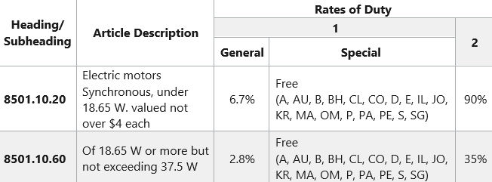

The HTS number for a small motor is 8501.10.20.00. The tarrif will be 6.7% of the purchase price (according to the Column 1-General under “Rates of Duty”; unless you purchase the goods from a country with which the U.S. has a trading agreement, in which case it is “free” (there is no tarrif). To find out which countries are included, scroll over the two-digit codes. Some of the codes refer to specific countries (e.g. - “AU” Australia) but other refer to trade agreements with multiple countries.

However, “A” is the Generalized System of Preferences (GSP) trade agreement with many developing countries. (For a list of the GSP countries, see https://ustr.gov/sites/default/files/gsp/countrieseligiblegsp.pdf) It would be time-consuming to check all the applicable treaties for the country you want to import from; so, for budgeting purposes, just ask the company providing the quote to indicate the import duties to the U.S., and for the name of the applicable trade agreement. But before you actually send the purchase order, check with a freight forwarder to verify the tariff rate. For a search guide see https://www.usitc.gov/documents/hts_external_guide.pdf.

Interestingly, there is a lower general tariff (only 2.8%) for an electric motor with a rating higher that 18.65 watts.

Note also there is a “Column 2” with much higher tariffis. This is the rate for countries with which the U.S. has no Normal Trade Relations. Currently, the countries with Column 2 status are Cuba, North Korea, Russia and Belarus.

Module 3 - Finance Chapter 1 – Production and Distribution

3.1.3 Distribution (Delivering Orders)

FULFILLMENT HOUSES (someone else does the warehousing, packing and shipping).

Fulfillment houses, also known as Drop-Shippers, accept finished goods from manufacturers into their warehouses, and then reship the products, whether in bulk to stores, or individually to consumers. The process is called Fulfillment or Drop Shipping.

If you want to outsource the functions of warehousing and shipping, search online for “fulfillment houses” or see https://fitsmallbusiness.com/best-fulfillment-warehouse
Typical Fulfillment Fees:
- One-time charge to set up account ($0 to $250)
- Account maintenance ($40 per month)
- Storage (about $15 to $40 per pallet per month).
- Order Pick and Pack ($1.80 to 2.85 per order + $.30 to .40 per item.). Some services charge a monthly minimum, which can amount to several hundred dollars per month.
- Acceptance of customer returns
- Gift wrapping for an additional fee
- Kitting (assembling a variety of items into a kit, such as a travel or tool kit)
As an example, FBA (Fulfillment by Amazon) fees are as of 2025 approximately $10 for a one-item order up to 8 ounces or $13 for a 1- or 2-pound item. The charge for each additional unit of the same weight is about half that. In addition, you will need to pay a monthly storage fee of $.78 a cubic foot. A carton of 9 basketballs would cost ~ $7 per month to store, and this rate triples during October-November-December. Takeaway: you will need a lot of monthly inventory turnover to be profitable. For details see https://supplychain.amazon.com/pricing

Most services offer discounts on shipping rates due to their overall large volume; but you will need margins of at least 60%, and perhaps 75-80%, even when selling direct to consumers, to cover the costs of the fulfillment center.
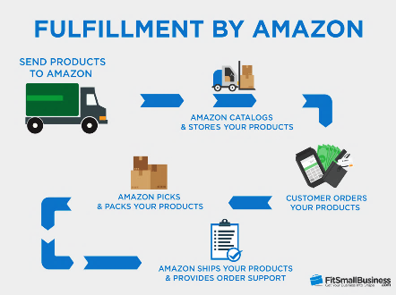

Typical fulfillment process
Module 3 - Finance Chapter 2 – Human Resources

3.2 – Human Resources

3.2.1 Building the Management Team

3.2.2 Assessing Skill Needs

3.2.3 Your Management Team

3.2.4 Hiring

3.2.5 Payroll Reporting Requirements

3.2.6 Incentivizing the Management Team

3.2.7 Team Collaboration

3.2.8 Advisory Committee

3.2.9 Selecting an Attorney

Module 3 - Finance Chapter 2 – Human Resources

3.2.1 BUILDING THE Management Team

When you are ready to build out your launch team, look for people with the same aspirations and ideals. Having to dissolve a business because you find that your styles and priorities are not compatible, can be just as messy—and as expensive—as a divorce. Fortunately, there are matching sites like https://www.cofounderslab.com/ to help you find compatible partners for your venture.

Of course, you can always choose to go it alone and keep all the proceeds and credit. However, the success rates of solopreneurs--who might be really great at one function, like programming or marketing--have not been as high as that of comprehensive management teams. Co-founders also provide motivation (no one wants to be the one to let the team down by not doing their share), reality checks (people to bounce ideas off just to make sure they’re not completely crazy; and moral support (people with whom to discuss concerns and share the agony of defeat and the thrill of doubling the number of monthly hits to your web site). When casting about for co-founders or early hires, try to find others who ..

- Are true entrepreneurs willing to take risks with careers and savings, not pretenders who really want a guaranteed weekly check and benefits. Partners with an “employee” mentality will bolt at the first setback.
- Are team players.
- Self-motivate, self-direct, and do not need to be told what to do every minute.
- Have similar working styles. Do you like to get up at 5:00 am, jog for an hour and then work from 6:00 am to 5:00 pm? You probably will never see your partners if they are ex-rockers accustomed to rising at noon or taking month-long vacations. Sorry, did we fail to mention that entrepreneurs work 70 hours a week and do not get vacations or sick days.
- Share a common vision and commitment. If you want to feed the world’s poor, and they want to make billions selling food to the poor, you will never agree.
- Are honest. If your new partner has ideas on how to hide income from the IRS, he will also steal from you the first chance he gets. Integrity is not a relative term.
- Have complementary skills. If everyone on the team is expert at coding, in a year you will have a warehouse full of great but unsold software. Assemble a well-rounded team that can cover all the bases.
To stay alert for telltale signs of bad partners, read https://www.entrepreneur.com/article/202434

Dynamic Duos  How many can you name? |  | 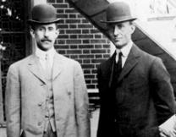
Slide this label out of the way to reveal answers  Top left to lower right:  1 Steve Jobs/ Steve Wozniak  2 Orville Wright/ Wilbur Wright  3 Sergay Brin / Larry Page  4 David Packard/ Bill Hewlett |  | 
Module 3 - Finance Chapter 2 – Human Resources

3.2.2 Assessing skill needs

1. Skill categories needed for any business team to be successful
- project management
- industry experience
- technical
- market research
- marketing
- finance and accounting

2. Skills needed for my business

□ writing,

□ fluency in __________,

□ graphic design,

□ web design,

□ software or app development,

□ accounting,

□ marketing,

□ market research

□ other _______________________________________

□ other _______________________________________

□ other _______________________________________

□ other _______________________________________

3. Skills I can contribute

Module 3 - Finance Chapter 2 – Human Resources

3.2.3 Your Management Team

Note: not all functions have to be filled by employees or partners. Consider other resources, such as consultants, outsourcing, contract workers, subcontractors, or advisory committee members.

FUNCTION | PERSON | RELEVANT SKILLS, EXPERIENCE, and/or EDUCATION
General Management
(CEO)
Operations
(COO)
Technology and IT (CTO)
Marketing
(CMO)
Accounting and Finance
(CFO)

Module 3 - Finance Chapter 2 – Human Resources

3.2.4 hiring

When you arrive at the stage when you need to bring on staff to assist you in delivering value to your customers, bear in mind that this will trigger some reporting and payroll tax obligations.

The current (2025) federal minimum wage rate is $7.25 per hour. Check your state as their minimum wage rates will probably be higher

You will also need to purchase Workers Compensation Insurance. See “Workers Comp” for details.

HIRING BEST PRACTICES.

Online hiring platforms can cost as much as $350 for one listing, and with no guarantee you will find anyone that meets your requirements; same for local staffing agencies that charge a fee for their searches.

Fortunately, every state has a Department of Labor that serves as a free employment agency.

For assistance hiring veterans, see https://www.dol.gov/agencies/vets/veterans/veterans-employment-services#CT

Also contact your local schools. The going rate for high school students is the state minimum wage; for skilled college students add $1 per hour, for graduate students add $2 ($5 for in-demand tech skills like computer programming). There is usually no charge for the school to connect you with current students (for part-time or summer employment) and graduating students (for full-tome employment). One company that specializes in placing college interns and graduates is Handshake, and their “Basic” service is free. See https://joinhandshake.com/

Another direct but often overlooked avenue is to post notices on bulletin boards of local grocery stores and churches.

WORKER STATUS: Independent Contractor or Employee. The classification affects tax obligations, legal protections, and benefits.

 | INDEPENDENT CONTRACTOR | EMPLOYEE
AUTONOMY | Has control over how, when and where to work. | Works set hours and is supervised by a manager
FINANCIAL RELATIONSHIP | Responsible for own payroll taxes. Company issues a check for services without any payroll deductions. | Company issues a paycheck, typically weekly or bi-weekly; after payroll deductions (income tax withholdings and employee share of Social Security and Medicare).

For more information on status determination see
www.irs.gov/businesses/small-businesses-self-employed/independent-contractor-self-employed-or-employee

Module 3 - Finance Chapter 2 – Human Resources

3.2.5 Payroll REPORTING REQUIREMENTS

ANNUAL FEDERAL REPORTING REQUIREMENTS AND FORMS

 | TO INDEPENDENT CONTRACTOR | TO EMPLOYEE
COMPANY REPORTING | For workers paid $600 or more a year, issue a 1099-NEC (Non-Employee Compensation) by end of January of the following year, with a copy to the IRS. The government also is due Form 1096 showing the total of all 1099s. Some states require a copy. Check with your Department of Revenue Services. | Issue a W-2 (Wage and Tax Statement) to each worker, due by January 31 of the following year.  Copies must be filed with the Social Security Administration.
FORMS WORKER PROVIDES TO EMPLOYER BEFORE STARTING WORK | W-9 (Request for Taxpayer ID Number (either an EIN if a business, or a Social Security Number). | W-4 (necessary for calculating the amount of income tax to withhold).  I-9 (to verify eligibility to work in U.S.)

1099 forms may be ordered free from https://apps.irs.gov/app/taxmat/information-employer-returns. If you have 10 or more 1099s, you will need to file electronically. To e-file you will need to apply for a Transmitter Control Code (TCC) – which can take 45 days so plan ahead. See https://www.irs.gov/filing/e-file-information-returns
W-2 Form. If you have fewer than 10 employees, you may file paper forms with the Social Security Administration. See https://www.ssa.gov/employer/paperFormInstr.htm For 10 or more employees, file electronically at www.ssa.gov/employer/bsohbnew.htm Plan ahead, as it takes time to obtain forms or open an e-filing account.
I-9 forms may be downloaded for free from https://www.uscis.gov/i-9

QUARTERLY FEDERAL REPORTING REQUIREMENTS AND FORMS (For Employees Only)
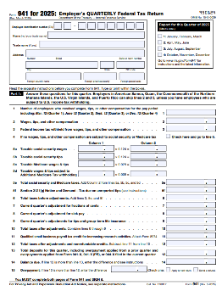
Federal Form 941. This is the first page of a 3-page form that must be submitted quarterly to the IRS by employers along with a check for the amount of payroll taxes you owe as an employer, plus the amount you have withheld from employee paychecks. Another 2-page document (Form 940), is filled annually. Most state Departments of Revenue Services also require a copy.

For a list of companies that process payroll and submit the correct state and federal forms, see “Payroll Processing”. The service will cost about $40 per month base fee plus $6 per employee.

If you have some accounting experience and want to save money, here’s a video that will guide you through the forms: https://www.youtube.com/watch?v=TeuJwEB7mjw&t=2s

Be advised, Uncle Sam will charge you up to 25% of the amount you should have paid, plus interest, if you make a mistake, or submit a form or payment late.

Module 3 - Finance Chapter 2 – Human Resources

3.2.6 Incentivizing THE MANAGEMENT TEAM

By default, original entrepreneurs start out with 100% of the ownership. However, if you have ambitious plans, you will probably need to give up shares to attract investors and key staff with the critical skills you need to compete and grow. (Co-founders and key employees must initially be willing to work long hours for little or no pay.)

Although the shares you offer as incentives to others may leave you with a shrinking percentage of ownership, the total value of your shares should increase as the company grows. So, how many shares should you set aside for members of the management team? For a formula to assign a value to the predicted contribution of each co-founder, see https://cofounders.gust.com. The following chart is an example of division of ownership.
STAGE OF COMPANY DEVELOPMENT | Founder | Co-Founders  Shares granted upon incorporation | Key employees  Shares Allocated for discounted stock-purchase options | Investors
Concept stage | 100%
Development and Testing stage (Proof of Concept Stage) | 80% | 20% *
Startup (Seed stage) | 40%  (=4/7 of non-investor shares) | 20%  (=2/7 of non-investor shares) | 10% **  (=1/7 of non-  investor shares) | 30% *** to friends, family and angels
Series A Financing Round (Early stage) | 29%  (=4/7 of non-investor shares) | 14%  (=2/7 of non-investor shares) | 7%  (=1/7 of non-  investor shares) | 50% after VC investment
Series B Financing Round (Growth stage) | 17%  (=4/7 of non-investor shares) | 9%  (=2/7 of non-investor shares) | 4%  (=1/7 of non-  investor shares) | 70%
* Co-founder shares should be vested (that is, earned gradually over time). For example, a co-founder might be allowed 4% ownership, but the shares would be earned at the rate of 1% per year over the next 4 years (a common length of time for vesting) if the co-founder has worked full time and satisfactorily. This prevents a co-founder—who might be long on promises but short on delivery— from running off with 5% of the company without making any real contribution.
** Assumes you will use a large portion of seed round to hire additional key employees, who will also need shares as
incentives to climb aboard a young company. The investors will no doubt insist that you set aside shares to attract and motivate the additional staff needed to grow the company.
*** Reduce initial share for investors to 20% if a high-tech, high-growth-potential enterprise.

>> Consult a lawyer, as this decision can negatively affect your ability to raise growth capital. <<

ALTERNATIVE INDUCEMENTS. Before offering shares of stock or options to key individuals, give some thought to alternative enticements to keep the ownership structure simple and reserve a greater number of shares to exchange with equity investors for growth capital. This is called “keeping your powder dry.”
  - Contingent Deferred Compensation. This is basically an IOU that is redeemable if and when the deferment the company achieves sales or cash-balance milestones. Future payouts should be greater than the perceived value of their work, in consideration of the fact that they will have to wait to be paid, and if the enterprise fails to thrive, perhaps they will not be paid at all.
  - Royalties. This is a way to pay someone a percentage of profits (as common stock does) without issuing any shares. Royalty obligations usually have a total dollar cap and expiration date. For example, in exchange for developing a mobile app, you contract to pay the developer a modest amount plus 20% of the sales for the first five years, or $50,000, whichever comes first.
Module 3 - Finance Chapter 2 – Human Resources

3.2.7 Team Collaboration

It can be challenging for teams to communicate and work collectively on a Business Model Canvas, product prototype, website, or other activity that requires participation from multiple members. Project Management tools can literally keep everyone on the same page, set priorities and goals, and let everyone know what is expected of them…with due dates. Following are some free online PM platforms:

Canvanizer.com Templates for both the Lean Canvas and the Osterwalder model. To go directly to the Lean Canvas see https://canvanizer.com/new/lean-canvas $25/ year for a team of 5 (as of 2025).

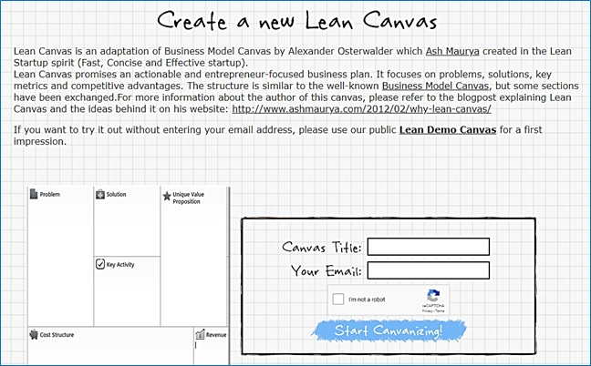

THE FOLLOWING ARE FREE PROJECT MANAGEMENT PLATFORMS, BUT THEY DO NOT OFFER A BUSINESS MODEL CANVAS TEMPLATE.

Zoho.com Free for up to 5 users. Assign tasks and deadlines to team members. This two-minute YouTube video explains how to use https://www.youtube.com/watch?v=NfZ3rwLxzNs.

Asana.com Designed to manage marketing campaigns. Free with up to 10 users..

Trello.com Uses digital 3x5 cards to help you and your team keep track of tasks. Free.

Module 3 - Finance Chapter 2 – Human Resources

3.2.8 ADVISORY COMMITTEE (Non-paid Members of the Team)

A group of volunteer advisors can bring valuable experience and contacts. Although most entrepreneurs like the idea of an advisory committee, few know how to form one (who to ask, what to ask of them, or how to recognize advisors for their services).
The difference between an advisory committee and a board of directors. A board of directors is a legal entity responsible and liable for decisions and actions of the company. If you have investors who own at least 10 per cent of the company, they may expect to be offered a seat on the board.
An advisory committee, on the other hand, is informal. Advisors have no legal authority and assume no liability. There are no set rules, such as how often they must meet.
If you are looking for outside funding, an advisory committee shows potential investors that you have consulted with experts to help you form strategies for the company and that you are taking advantage of free resources. The names of the committee members and their backgrounds should be an integral part of the management section of the business model or plan.
The right number of advisors: two to five. You do not have to ask everybody at once; you can add advisors as you progress, but you should have one or two to start.
How often should you meet? Perhaps never. If the committee is diverse and selected to give guidance in many different areas, one-on-one discussions may yield better results and in less time than meetings of the entire committee. One member might help shape marketing efforts, while others could introduce you to client prospects.
Be careful not to call on them too often. Advisors are not signing up for a job. Nevertheless, keep them informed with copies of e-mail announcements and invitations to company events.
Building a company can be lonely work. An advisory committee can be a great source of help and comfort. They can give you guidance, contacts, friendship as well as credibility with investors.

Module 3 - Finance Chapter 2 – Human Resources

3.2.9 Selecting an Attorney

Your business lawyer will be a critical member of your management team. In fact, be sure to list your attorney and accountant in the “Management Team” section of your pitch deck and eventual business plan. (Investors will expect you to have these key advisers to keep you and the investors out of trouble with the IRS and regulatory agencies.)

HOW TO FIND AN ATTORNEY. www.avvo.com and www.martindale.com provide free databases of user-rated attorneys that are searchable by “practice area” (legal specialty) and location (state, and in some cases, city). Your local (state, county or city) bar association will also host a directory of attorneys by practice area. Search for “bar association near me”. They will not recommend an attorney or provide any ratings.

HOW TO SELECT AN ATTORNEY.

- PROXIMITY. Start with the nearest firms. The closer they are the easier it will be to meet or sign papers.
- SPECIALTY within practice area. Naturally, you want a “corporate” “business” or “Small Business” attorney, but there are categories within these broad terms. What is most important to you? If you are an inventor, you probably want an “Intellectual Property” attorney. If you want to raise money from investors, you will want an attorney who specializes in “Venture Capital.” Common specialties within business law include:
  - General business law
  - Contracts (leases, purchase contracts, employment contracts, NDAs)
  - Intellectual property (patents, trademarks and copyrights)
  - Venture Capital (you are raising equity financing)
  - Mergers and Acquisitions, aka M&A (buying or selling a company)
  - Litigation (you are being sued)
  - Employment law (you have troublesome employees)

Note: you will not find all these skills in one lawyer, so focus on the one most important to your company. A large law firm is more expensive than a solo practitioner but may be able to provide all the services you will need.

Once you have compiled a short list of attorneys, do some due diligence:
- Check the website for “Events.” Is an attorney to speak at an event near you? This is a great way to meet them without any awkwardness. Some other clients will probably be there. Ask about their experience.
- Check the attorney’s bio. Do they have experience in your industry? You do not want an attorney who knows drug patenting if you are opening a restaurant, or vice versa.
- Find someone who can grow with you. Younger attorneys are less experienced, but less costly per hour.
Select the right attorney and schedule a face-to-face meeting to explore whether this will be a good fit. You will not be billed, but do not abuse the courtesy by taking up their time to gain as much free advice as possible. A half-hour introductory meeting is appropriate. Talk about your business and the help you think you will need:
- Lease?
- Employment contracts?
- Non-disclosure agreements?
- LLC formation? Incorporation?
- Patent searches? Provisional patent filings? Full patent filing?
- Trademark registration?
Ask for estimates of costs for each service.

HOLDING LEGAL EXPENSES TO A MINIMUM. Prepare a draft of legal documents for your attorney to review. This will save them time, and their time is your money. A first draft prepared by you will also give your attorney a clearer idea of your intentions and what you need. A variety of legal templates can be downloaded for free at https://law4startups.com.

Module 3 - Finance Chapter 3 – Space

3.3 – Space

3.3.1 Sourcing Physical Locations

3.2.3 Comparing Locations

Module 3 - Finance Chapter 3 – Space

3.3.1 Sourcing Physical Locations

You may have a virtual company, such as a software product, that you can run from your home, in which case skip this section and enter zero for space in your budget. If you have a dedicated room in your home for your business office, you can write off a pro-rata share (square footage of home office / total square footage of home) of the cost as a business expense on your personal taxes, up to the amount of business income. However, if you have a retail or manufacturing business, read on.

The best way to get a feel for a location is to talk to other businesses in the area. Visit the locale at a time your business will be open; notice the amount of parking, traffic congestion, and noise from other businesses.

TRAFFIC FLOW. Most state Departments of Transportation have traffic flow maps on their websites that show the number of cars that pass various points in each town on a daily basis.

INCUBATORS are multi-tenant facilities that offer small spaces, and short term leases of one year or less. Note: a “small” working space at some incubators is 100 s.f., at others 5000 s.f. A dedicated office or starter manufacturing space will run $600 to $1200 per month, gross (including utilities and taxes). Shop around.

Your best deal is a short-term lease of only a few months but with an option to renew for a longer period of time (so you can bail if the business fails, but lock in a favorable rate if it succeeds). You may also want to ask for a month-to-month lease, which means you can leave with only one month notice.

Another negotiating stratagem is to ask for a number of free months rent up front, especially if you will need to expend time and money to make the space suitable for your purpose.


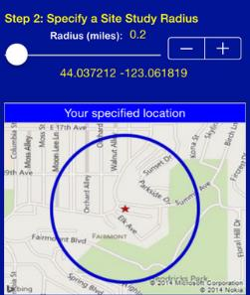
CO-WORKING OFFICE SPACES. These have lately become very popular. The rates are typically low, $100 to $250 per month including access to a conference room, coffee pot, printer and copier. However, the space may be at a table shared by others, or desk space on a first-come, first-served basis. Hence the term co-working.

MAKER SPACES. These are shared spaces for research and development, prototyping, and short production runs for customer (beta) testing. Most maker spaces have vinyl cutters, woodworking and metalworking equipment, soldering irons, and 3-D printers.

RETAIL/ RESTAURANT. Three things matter: traffic flow past the location, neighborhood demographics (income, housing, lifestyle), and parking. Your state department of transportation web site should have some data on traffic flow. For some urban locations and malls, auto traffic may not be as important as foot traffic.

For eateries located in a mall, there are some common lease clauses you may not expect, such as right to approve your menu, no handing out samples in the mall proper, and you can’t open another restaurant nearby (as this may take traffic from the mall).
www.EASIdemographics.com offers a free app [right] called Easi, that will provide demographics of surrounding area of different sites you may be considering.

Module 3 - Finance Chapter 3 – Space

3.3.2 Comparing Locations

A. Address____________________________________________ City ______________________

B. Address____________________________________________ City ______________________

C. Address____________________________________________ City ______________________

This is an interactive spreadsheet. To open, right-click on spreadsheet, click “Worksheet Object” and then "Open.” You need to enter data in shaded fields only; the totals will be computed for you. You can download a copy of this form at http://www.EntrepreneurshipFoundation.org/spreadsheets

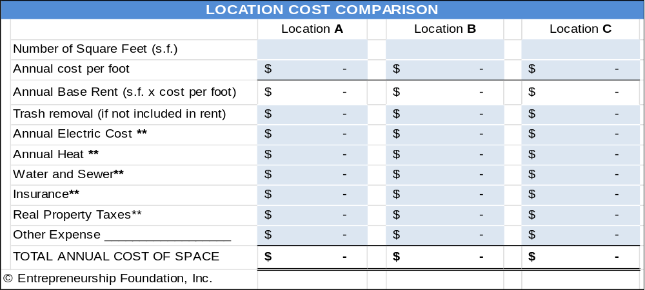

** If rent is advertised as gross, then utilities, real property taxes, and property insurance are covered by the property owner. If the rate is triple net (or nnn), then the tenant is responsible for these costs. The property owner should have prior utility bills. If costs are not available, estimate $2.00 per year per square foot for electric and gas, and $.50 for property taxes. (Note: in any case, you will need to purchase liability insurance to cover “slips and falls” in your space.)

Comparison of Other Factors | Location A | Location B | Location C
CITY OR STREET >>
Zoned to allow your type of business. (Check with town planning office.)
Free parking spaces for employees
Parking spaces for customers
Traffic Flow (Number of cars or foot traffic passing the location daily. Critical for retail.)
Signage (Can you put sign on building?)
Safety. Employees and customers will feel safe in the neighborhood.
Module 3 - Finance Chapter 4 – Risk Management

3.4 – Risk Management

3.4.1 Risk Analysis
3.4.2 Risk Mitigation
3.4.3 Business Insurance

Module 3 - Finance Chapter 4 – Risk Management

3.4.1 RISK ANALYSIS

Whereas a SWOT Analysis examines current situations you can correct or exploit now; a Risk Analysis identifies potential future challenges to your business model, the probability of the risk occurring, and strategies to eliminate or mitigate the risks.
Indeed, investors, lenders, and major customers may ask you “What can go wrong?” If you do not have a reasoned response, based on diligent research and introspection, that will be the end of the discussion. Most entrepreneurs present three forecasts for capital providers: a “Best”, “Worst” and “Expected” scenario for revenue, cost of goods sold, and overhead. (To win over capital providers, even your worst-case scenario should show at least break-even.)


If I always appear prepared, it is because before entering an undertaking, I have meditated long and have foreseen what might occur.” – Napoléon Bonaparte

“Opportunity does not waste time with those
who are unprepared.” – Idowu Koyenikan

Standard practice is to first list all the things that can go wrong. Admittedly, this is difficult since you do not want to believe anything will go wrong, so get help with this. Talk to mentors and interview other entrepreneurs. What did not go entirely according to plan for them.
Then focus on the dangers deserving a strategy to reduce the risk or a quick-response plan if it does occur (like the evacuation plans cities have in case of hurricanes), or perhaps insurance against the risk. For example, if you do a lot of importing, changes in exchange rates can cause your cost for components to spike. This particular risk can by mitigated by purchasing a futures contract to sell a specific amount of a foreign currency at a future date for a pre-set amount in dollars.

New businesses and products face a variety of risks, broadly categorized as market, financial, operational, and strategic. These risks can impact a company's success and profitability.
MARKET RISKS: These arise from external factors impacting demand and competition. Examples include:
- Misjudging market demand: A product might not align with consumer preferences in the future.
- Competitive pressures: Existing businesses or new entrants can threaten market share.
FINANCIAL RISKS: These relate to funding, profitability, and cash flow. Examples include:
- Inadequate funding: A lack of capital can hinder development, marketing, and operations.
- Cash flow problems: Inability to meet short-term financial obligations can lead to instability.
OPERATIONAL RISKS: These relate to internal processes and execution. Examples include:
- Technical difficulties: Problems with manufacturing, software, or technology
- Supply chain disruptions: Delays or shortages in raw materials or components impacting production.
- Operational inefficiencies: Poor processes or inadequate production or human resources.
STRATEGIC RISKS: These arise from flawed strategic decisions. Examples include:
- Poor market entry: Entering a new market without sufficient research or planning can lead to failure.
- Lack of scalability: A business model that is not scalable cannot accommodate growth.

Module 3 - Finance Chapter 4 – Risk Management

Business Risk Matrix: Impact on Business Survivability if Risk Occurs

IMPACT >>  PROBABILITY | 1  Insignificant  1-4% of sales | 2  Minimal  5-14 % | 3  Moderate  15-24% | 5  Severe  25-39 % | 8  Extreme  40% or more
5 - Very Likely  (80% or greater) | 4  MEDIUM | 10  HIGH | 15  VERY HIGH | 25  EXTREME | 40 EXTREME
4 - Likely  (60% chance) | 4  MEDIUM | 8  HIGH | 12  VERY HIGH | 20  EXTREME | 32  EXTREME
3 - Very possible  (40% chance) | 3  LOW | 6  MEDIUM | 9  HIGH | 15  VERY HIGH | 24  EXTREME
2 - Unlikely  (20% chance) | 2  VERY LOW | 4  LOW | 6  MEDIUM | 10  HIGH | 16  VERY HIGH
1 - Very rare  (10% or less) | 1  VERY LOW | 2  VERY LOW | 3  LOW | 5  MEDIUM | 8  HIGH

Place in the matrix below common risks within your industry, surroundings and economic climate.
IMPACT >>  PROBABILITY | 1  Insignificant  1-4% of sales | 2  Minimal  5-14 % | 3  Moderate  15-24% | 5  Severe  25-39 % | 8  Extreme  40% or more
5 - Very Likely  (80% or greater) | 5 | 10 | 15 | 25 | 40
4 - Likely  (60% chance) | 4 | 8 | 12 | 20 | 32
3 - Very possible  (40% chance) | 3 | 6 | 9 | 15 | 24
2 - Unlikely  (20% chance) | 2 | 4 | 6 | 10 | 16
1 - Very rare  (10% or less) | 1 | 2 | 3 | 5 | 8

Module 3 - Finance Chapter 4 – Risk Management

3.4.2 RISK MITIGATION

To optimize the chance for success, formulate tactical plans to eliminate, or reduce to an acceptable level, the significant risks identified in the Business Risk Matrix.

RISK | TACTIC TO AMELIORATE

Module 3 - Finance Chapter 4 – Risk Management

3.4.3 Business Insurance

As soon as you commence operations, you and your company are liable for injuries sustained by employees and customers resulting from business activities. Each of the following types of insurance may or may not be necessary, depending upon your risk exposure and state regulations. Click here to find the link to your state’s insurance department http://www.naic.org/state_web_map.htm.

This can all be a bit overwhelming, so we recommend as a first step that you find a trustworthy local insurance agent to advise you on which policies are mandatory, which are advisable, and which may not be necessary until your sales are more substantial.

GENERAL LIABILITY. Also known simply as liability insurance, this coverage protects the business against most damage claims resulting from injuries or property damage, or even non-physical acts like libel. You should obtain this insurance coincident to starting operations. Any lease for space will certainly contain a clause that you provide the property owner with proof of liability insurance; and in some cases, you will need to have the property owner named as a co-insured in the policy. Claim examples include…
- A cable installer who works for you breaks a piece of furniture while running cable in a home.
- A competitor sues for libel based on the content of your website.

PRODUCT LIABILITY INSURANCE. Companies that manufacture, distribute or retail a product may be liable for its safety. Insurance rates are dependent on the type of product and predicted annual sales. Product coverage is often included in General Liability Insurance. Claim example: A child chokes on a toy that you have manufactured.

WORKERS’ COMPENSATION INSURANCE. Workers’ Comp covers medical treatment, disability and death benefits for an employee injured on the job. Workers Compensation insurance is required in most states as soon as you hire your first employee (not counting yourself). Claim examples…
- An employee slips and falls on a wet office restroom floor.
- An employee contracts carpal tunnel syndrome.

Rates vary by industry and state and range from $.35 to $2.00 per $100 of payroll, for non-hazardous work (2025).
According to Forbes https://www.forbes.com/advisor/business-insurance/workers-compensation-insurance-cost/ the average cost of workers' compensation is around $1 per $100 of payroll.

EMPLOYEE DISABILITY INSURANCE. Some states require employers to provide partial wage replacement insurance coverage to their eligible employees for non-work-related sickness or injury. Currently, if your employees are located in any of the following states, you are required to purchase disability insurance: CA, HI, NJ, NY, RI.

EMPLOYMENT PRACTICES LIABILITY. EPLI covers claims related to hiring, firing, or disciplinary action. Claim examples…
- Lawsuits for violating employment laws regarding race/gender/age discrimination...
- Sexual harassment or hostile work environment lawsuits.
- Wrongful termination lawsuits.

ERRORS AND OMISSIONS. E&O covers claims against you and your company for problems with your product or service that cause a financial loss to the user. The problem can be professional (doctor’s malpractice) or technical (defective software). This is one of the most important policies for tech startups, particularly in the B2B SaaS space. Claim examples…
- A bug in sales platform that causes users to lose money. For example, sales leads entered are not saved.
- A customer claims you have violated the terms of the user agreement. Even if the allegation is frivolous, you will still have to pay a lawyer to deal with it. E&O policies cover those costs.
Module 3 - Finance Chapter 4 – Risk Management

CYBER LIABILITY. Cyber liability insurance reduces the cost of data breach incidents and the loss or theft of third-party data. Expenses covered can include lawsuits, forensic costs, data restoration and breach notification costs. Claim examples…
- Your database is hacked, and your users sue you for leaking information.
- An employee leaves a laptop in a cab that is then picked up by someone who leaks private user data.

VEHICLE INSURANCE (COMMERCIAL AUTO INSURANCE). If employees are using their own cars for business, their personal insurance might cover them in the event of an accident (unless they are delivering goods or services for a fee). You will of course require this insurance if you have company vehicles.

D&O (DIRECTORS AND OFFICERS) LIABILITY COVERAGE. A D&O policy shields the personal assets of officers and directors of the company. Most people who agree to be on your board will not want their personal assets to be at risk if the company is sued. (You might not either.) Claim examples…
- A shareholder sues the board for violating fiduciary duties.
- Alleged misrepresentations in a prospectus.

KEY PERSON INSURANCE. A life insurance policy that pays the company if the insured dies or is incapacitated. This is to compensate for the expense of searching for a replacement and potential losses during the interim. Investors may insist on you having this coverage.

PERSONAL PROPERTY INSURANCE. This covers equipment, signage, inventory and furniture in the event of a fire, storm or theft. If you have a lot of expensive electronic equipment, that if destroyed or stolen would put you out of business, you may want to consider insuring these critical assets. Note: damage from floods and earthquakes is generally not covered.

EMPLOYEE HEALTH INSURANCE. Although you are not required to purchase healthcare for your employees (until you have 50), the Affordable Care Act of 2013 requires all individuals to have health insurance per the “Individual Mandate,” or face fines. Helping your employees obtain health insurance may in turn help you to attract the best and brightest; and small business tax credits are available for healthcare.

-----------------------------------------------------------------------------------------------------------------------------------------

INSURANCE AGENCIES. Solicit quotes and advice from at least two agencies. To find agents, ask other entrepreneurs for recommendations or search online for “insurance agents” and your zip code

INSURANCE AGENCY | Agent name | Email | Phone
A.
B.
C.

Module 3 - Finance Chapter 4 – Risk Management

INSURANCE PLAN AND BUDGET. These are common estimates for $1 million in coverage. Verify actual charges with your insurance representative. Some rates vary widely among industries.
INSURANCE | When needed | Typical Cost | Actual quote
WORKERS’ COMP | Recommended when you hire first employee (other than yourself). Required by law if you have 5 or more employees. | $300-$500 per salaried employee. Hourly-worker rates are ~ 1% of payroll. Check with an insurance broker in your state =
GENERAL LIABILITY | When operational. | $ 500 - $1000 for a startup
PRODUCT LIABILITY | When you start selling products. | About $.26 per $100 of anticipated sales. Can vary widely, depending on danger
EMPLOYMENT PRACTICES LIABILITY | Recommended when you hire employees, essential if you have more than 10 employees. | $2,000 initially (Increases with size of work force)
ERRORS & OMISSIONS | When you launch your service. | $1,500  (with $25k deductible)
CYBER LIABILITY INSURANCE | When you collect user data. Laws requiring insurance vary by state. | Included with most E&O policies
DIRECTORS AND OFFICERS (D&0) | When you have Investors or outside directors (who will usually request the protection). | $1,000 to $3,000 per year for a startup
KEY PERSON | Usually demanded by banks or VCs when they provide capital. | Varies by health and age of key person(s)
PERSONAL PROPERTY | When equipment is so critical to success you cannot afford not to insure. | .2% to 2% of value of equipment covered; actual rate depends on industry, location, and deductible
EMPLOYEE HEALTH CARE | Mandatory when you have 50 or more employees. | Varies by coverage

Module 3 - Finance Chapter 5 – Budgeting and Accounting

3.5 – Budgeting and Accounting

3.5.1 Credit and Collections Policies
3.5.2 SWOT Analysis
3.5.3 Personal Income and Expense Budget
3.5.4 Payroll Taxes
3.5.5 Business Budgeting
3.5.6 Cash Flow Forecasting
3.5.7 Profit Margin and Break-Even Calculation
3.5.8 Accounting

Module 3 - Finance Chapter 5 – Budgeting and Accounting

3.5.1 Credit and Collections Policies

Whether to Extend Credit to Clients: The Problem of Slow-Payment and Non-Payment
Credit terms (not having to pay in advance or upon delivery) should be a privilege that customers earn by establishing a sterling payment history with your company (no bounced checks, declined credit cards, frequent returns, or chronic complaints and attempts to inveigle invoice adjustments). Be especially wary of temporary businesses such as political campaigns—and require full payment in advance from these clients. Credit limits, even when extended to worthy repeat clients, should be meted out gradually.

Moreover, do not assume that a large, well-known company is a safe risk. Large companies can and do fail: Arthur Andersen, Enron, WorldCom, and Lehman Brothers. Large companies can also be the slowest payers, as the president, insulated by layers of financial bodyguards, never has to look you in the eye

The best credit policy for a startup is C.O.D. (Cash on Delivery), for several reasons. The longer it takes to receive payment, the more capital will be tied up in receivables. Extending credit will also introduce uncertainties into your cash flow projections, since it is difficult to predict exactly when customers will pay for your goods and services. Finally, you will probably spend more time, aggravation and money on paperwork and collections than the value of the additional sales that extending credit might bring.

If You Do Offer Credit, Here Are Some Simple Guidelines to Reduce Bad Debts
- Offer only small amounts of credit for short periods.
- Never extend more credit to any one customer than you can afford to shrug off.
- Never extend additional credit to a company in arrears to you. I realize you are hoping to maintain a cordial relationship and help the debtor turnaround; but you are probably only throwing good money after bad. Sometimes it is better to turn down a sale.
- If your service is expensive, you will probably want to do a credit check. Ask for references from other suppliers in your industry and call the bookkeepers of those firms to find out how well the prospective client pays and what credit limits the other firms offer. Bookkeepers, even at competing firms, do not see themselves as competitors. Indeed, they want to help each other. Their job is not sales; it is collecting on sales.
- Do not let companies fall into arrears without regular phone, email and written “overdue” reminders at least every two weeks.
- For custom-made products that you cannot take back to resell (printed stationery, T-shirts) require at least a 50% deposit. The same goes for services like painting.
How to State Your Payment Terms on Invoices and Quotations
Traditionally, payment terms are written in shorthand, such as “Net 30.” This means the bill is due in 30 days. Invoices are generally dated and mailed when the job or product is completed and accepted by the customer.
The terms on the invoice should match the terms on your written quote. (Confirming in writing when you will be paid is one reason to ask customers to sign quotes.)
STAYING COMPETITIVE. Check the terms used by other companies in your field to determine what is customary. In most industries, it is net 30 days. Of course, buyers look at price and terms together, so if your prices are lower, you might be able to get away with requiring quicker payment terms or even COD (cash on delivery).

Module 3 - Finance Chapter 5 – Budgeting and Accounting

According to a study of small business collections by FreshBooks https://www.freshbooks.com/, the terms that generated the fastest payment were net 21. They also suggest stating the terms in polite non-accounting language, such as “Thank you for your business. Please send payment within 21 days.” One explanation by the FreshBooks analysts was that some unsophisticated clients do not know what “Net 21” means.

DISCOUNT FOR PROMPt PAYMENT. If you wish to offer your customers a discount for early payment, you might state your terms as “2% 10 net 30” or “2-10, net 30” indicating that the payer may deduct 2% from the bill if it is paid within 10 days of the invoice date; or pay the full amount in 30 days. Again, you may want to spell this out in plain language.

PENALTY FOR LATE PAYMENT. The FreshBooks researchers also found that a 1.5% monthly interest penalty for late payment also helped to shorten the payment cycle.

TALK TO YOUR CUSTOMERS. Of course, this whole discussion of payment terms is academic. There is no guarantee your customers will adhere to the terms. You may therefore find it productive to involve customers in the planning of your policy on terms and conditions for payment. When do they pay their bills now (weekly, end of month)? How do they like to pay (by check, credit card)? How important is price versus time to pay versus other terms, such as the right to return items?

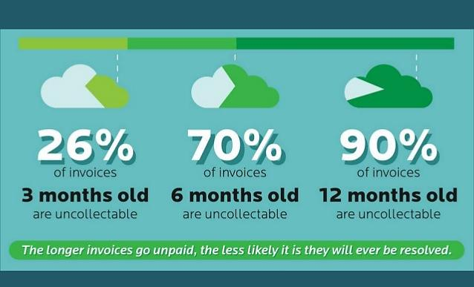
Chart by E2B Teknologies

Module 3 - Finance Chapter 5 – Budgeting and Accounting

3.5.2 swot analysis

To prepare an accurate and convincing projection of income and expenses, conduct a SWOT ANALYSIS of the internal and external factors that will affect revenue and expenses. SWOT stands for Strengths, Weaknesses, Opportunities, and Threats. The term refers to a strategic planning technique that assesses internal strengths and weaknesses, and external opportunities and threats. The purpose of the candid analysis is to avoid pursuing strategies or ventures unlikely to succeed, while leveraging competitive advantages for new growth initiatives.
Use template on the next page to create a SWOT analysis for one or more contemplated new initiatives. Here are some prompts for your assessment:

STRENGTHS
- What assets or resources do we have that other companies generally do not have?
- Do we have a strong brand loyalty and customer base?
- What do potential customers like about our business model?
- What knowledge do we have that gives us an advantage?
- What skills do we possess that give us an advantage in our industry?
- What unique relationships do we possess?
- What patents, trademarks, copyrights or trade secrets do we possess?
- What are our reserves of dry powder (capital on hand or that we can access if needed)?
- ____________________________________________________________________________________
WEAKNESSES
- Do we have gaps on our team?
- What do we not have that we need to be competitive?
- What business processes need improvement?
- What knowledge or assets do our competitors have that we do not?
- What is the competitive landscape? Do competitors enjoy strong brand loyalty, making it hard for us to capture market share? Are there large competitors with the resources to counterattack our entry into the market?
- What technology needs to be updated?
- Does one customer make up more than 10% of our business?
- ____________________________________________________________________________________
OPPORTUNITIES
- Is there a current need in the market that we could be addressing?
- What trends are positively impacting us?
- What are customers asking for that we could provide?
- Can we offer something that our competitors cannot offer?
- Can we increase our profit margins in some way?
- ____________________________________________________________________________________
THREATS
- Are there any upcoming law or regulation changes that may impact us?
- Might competitors offer new products?
- Are we dependent on a single manufacturer or supplier?
- What happens if a natural disaster strikes either where we do business or where we obtain supplies?
- How easy is it for someone to copy what we do?
- ____________________________________________________________________________________

Module 3 - Finance Chapter 5 – Budgeting and Accounting

SWOT Analysis for Your Business

STRENGTHS | WEAKNESSES
OPPORTUNITIES | THREATS
Module 3 - Finance Chapter 5 – Budgeting and Accounting

3.5.3 Personal INCOME AND Expense Budget

Now that you have evaluated the market landscape in which you will operate, you can begin to plug some numbers into a budget to guide you in pricing and purchasing decisions.

The most expensive line item for new businesses is the personal living expenses of the founder.

This is an interactive spreadsheet. To open, right-click then select “Worksheet Object” and “Open.” Enter amounts in the blue fields; the white field will be computed. You can download a copy of the form at EntrepreneurshipFoundation.org/spreadsheets

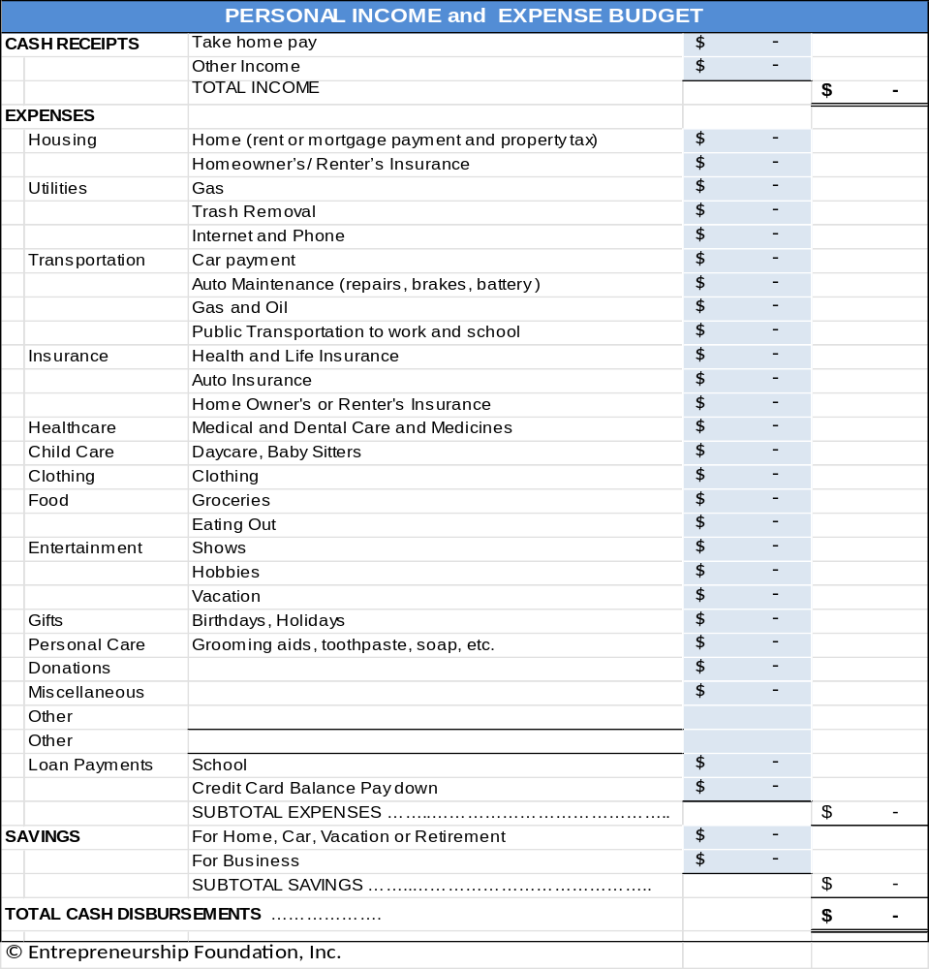

Module 3 - Finance Chapter 5 – Budgeting and Accounting

3.5.4 PAYROLL TAXES

Current as of 2025

Note: A self-employed entrepreneur must pay the Employee and Employer portion of Social Security and Medicare.

For a list of income tax rates and brackets for every state, as well as the federal income tax. See https://www.tax-brackets.org/

To find SUTA (State Unemployment Tax) for your state, see
https://www.paycom.com/resources/blog/suta-taxes-heres-what-you-need-to-know/

PAYROLL TAXES | RATE |  | ON FIRST …
Social Security (FICA) | 6.20% |  | $176,000 | Employee pays same rate
Medicare | 1.45% |  | no limit | Employee pays 1.45% on first $200,000
 |  |  |  | plus .9% on wages exceeding $200,000
Federal Unemployment Tax (FUTA) | 0.60% |  | $7,000 | Employer only
State Unemployment Tax (SUTA) | 2.20% |  | $26,100 | Employer only
This SUTA rate is an example.
SELF-EMPLOYMENT TAX RATES
As a self-employed individual, an entrepreneur is taxed twice, once as the employer,
and once as the employee.
For example, if you gross …. | $50,000 |  | $100,000 | annually, you will pay …
Social Security | $6,200 |  | $12,400
Medicare | $ 725 |  | $ 1,450
Federal Unemployment Tax | $ 420 |  | $ 420
State Unemployment Tax | $ 574 |  | $ 574 | (Example; check with your state for rate)
TOTAL | $7,919 |  | $14,844
Total Payroll Tax Rate | 16% |  | 15%
Remember, these are just payroll taxes. You still have to pay state and federal income taxes.

For a list of companies that provide payroll processing services, see Payroll Processing

Module 3 - Finance Chapter 5 – Budgeting and Accounting

3.5.5 BUSINESS BUDGETING

Now that you have professionally evaluated the economic, market, geographic and competitive landscapes in which you will operate, you can begin to plug some numbers into a budget, to guide you in pricing and purchasing decisions, and to show lenders and investors that your predictions are based on sound intelligence, and to show exactly you will be able to generate sufficient cash flow to pay them back.


Allow for black swans: unpredictable events that could have a negative impact on sales or costs. No business goes according to plan, so build in a contingency for surprise expenses; if you are certain your sales will be $1 million in the first year, budget for $500,000. If you can at least break even at 50% of your sales forecast, then those black swans will not put you out of business.

But beyond just hedging your bet, you will need to prepare a “Risk Analysis”.

BUDGET SAMPLE AND DOWNLOADABLE WORKSHEET. On the following five pages is a sample Excel workbook. You can download a blank form from http://www.EntrepreneurshipFoundation.org/spreadsheets.

The five-year worksheet contains imbedded formulas to compute totals. The tabs are Revenue, Cost of Goods Sold, Salary Schedule, Startup Capital, and Profit and Loss Forecast. Decisions made on one tab (e.g., Salary Schedule) are automatically reflected in the other worksheet tabs.

(The sample below and those on following pages are not interactive within the text.)

REVENUE |  | Year 1 |  | Year 2 |  | Year 3 |  | Year 4 | Year 5
Inflation Price Escalator | 4%
Annual Sales Growth Escalator | 20%
Product Group 1
Unit Sales | # | 5,000 | 6,000 |  | 7,200 |  | 8,640 |  | 10,368
Retail Price per Unit | $ | $ 25.00 | $26.00 |  | $27.04 |  | $28.12 |  | $29.25
TOTAL SALES |  | $125,000 | $ 156,000 |  | $ 194,688 |  | $ 242,971 |  | $ 303,227
Product Group 2
Unit Sales | # | 500 | 600 |  | 720 |  | 864 |  | 1,037
Retail Price per Unit | $ | $ 30.00 | $31.20 |  | $32.45 |  | $33.75 |  | $35.10
TOTAL SALES |  | $ 15,000 | $ 18,720 |  | $ 23,363 |  | $ 29,156 |  | $ 36,387
Grand Total Sales………………… |  | $ 140,000 | $ 174,720 |  | $ 218,051 |  | $ 272,127 |  | $ 339,615

WAGE RATES. As of 2025 the federal minimum hourly wage was $7.25. Most state minimums are higher.
To find the rate for your state see https://www.dol.gov/agencies/whd/minimum-wage/state

Module 3 - Finance Chapter 5 – Budgeting and Accounting

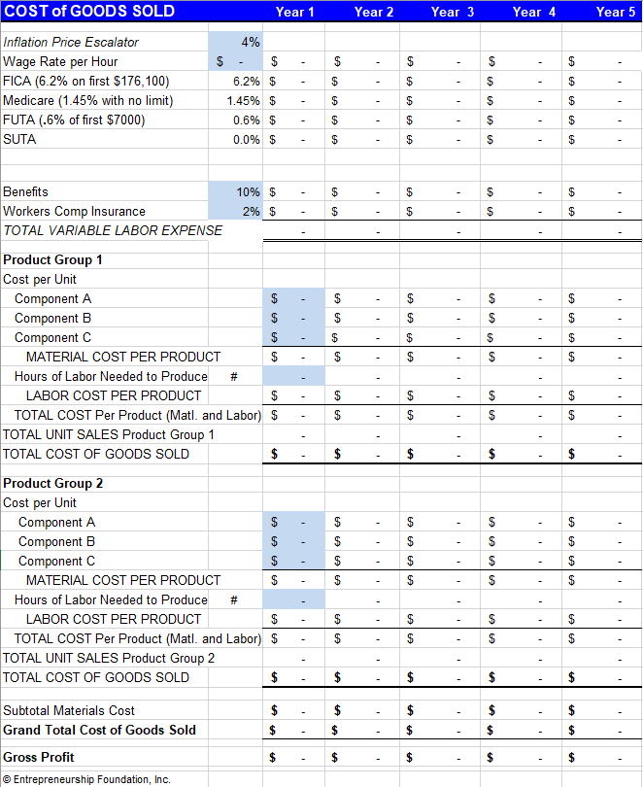This is one Worksheet in the “Budget” Excel file. The worksheet cannot be opened within this text. Download complete file from www.entrepreneurshipfoundation.org/spreadsheets
Module 3 - Finance Chapter 5 – Budgeting and Accounting

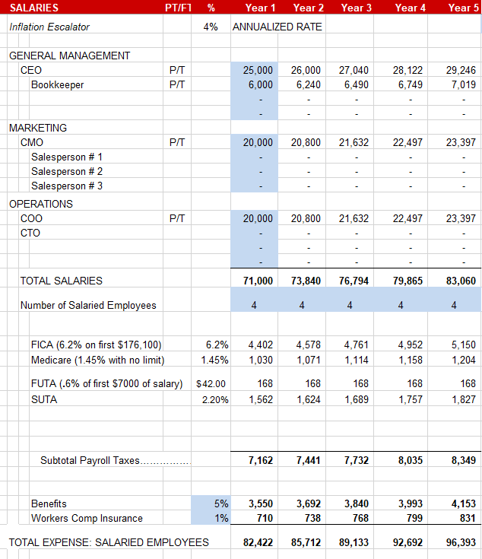

This is one Worksheet in the “Budget” Excel file. The worksheet cannot be opened within this text. Download complete file from www.entrepreneurshipfoundation.org/spreadsheets

Module 3 - Finance Chapter 5 – Budgeting and Accounting

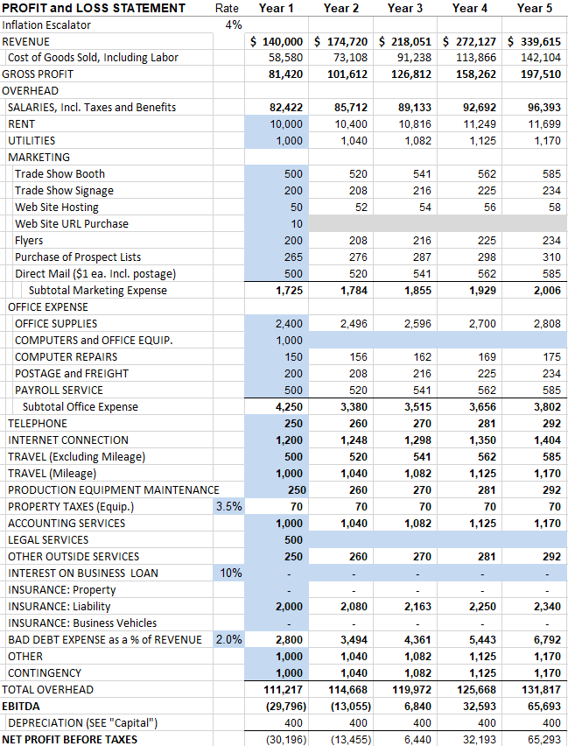
This is one Worksheet in the “Budget” Excel file. The worksheet cannot be opened within this text. Download
complete file from www.entrepreneurshipfoundation.org/spreadsheets
Module 3 - Finance Chapter 5 – Budgeting and Accounting

3.5.6 Cash Flow Forecasting

This worksheet cannot be opened within the text. You can download a copy at www.EntrepreneurshipFoundation.org/spreadsheets

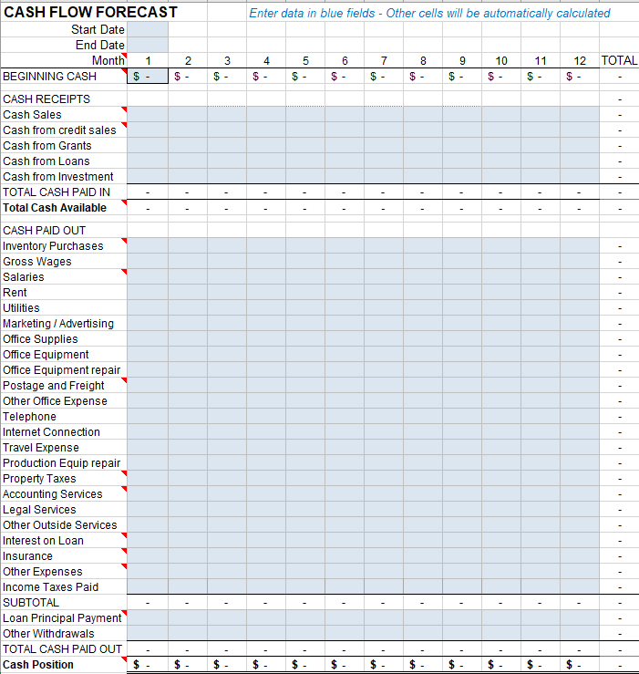
Module 3 - Finance Chapter 5 – Budgeting and Accounting

3.5.7 Break-Even and PROFIT MARGIN Calculation

Break-even occurs at the point where total revenue equals total costs. Use the following spreadsheet to compute your break-even point. Only enter amounts in shaded boxes. The other fields will be computed.

This is an interactive spreadsheet. To open, right-click and select “Worksheet Object” and then "Open.” You can download a copy of this form at http://www.EntrepreneurshipFoundation.org/spreadsheets

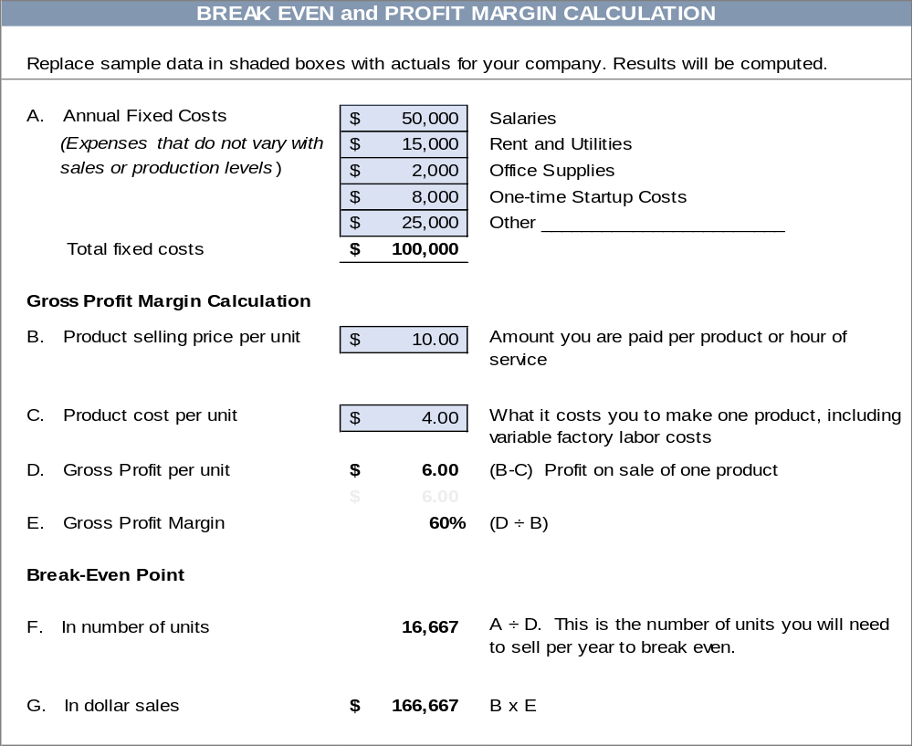

Reality checkS:
- Are the unit and dollar sales realistic?
- Can you make and sell this many products: or if a service business, can you realistically provide the number of hours required?

Module 3 - Finance Chapter 5 – Budgeting and Accounting

3.5.8 cAPTIAL REQUIRMENTS FOR LAUNCH

Startup Capital Requirement. The amount of cash you will need to cover start-up expenses and to cover operating expenses until the company attains break-even. The Cash Flow Forecast should indicate the amount of capital required each year. If you have already launched and need capital to expand a successful model, see the “Growth Capital Requirements” spreadsheet on the following page.

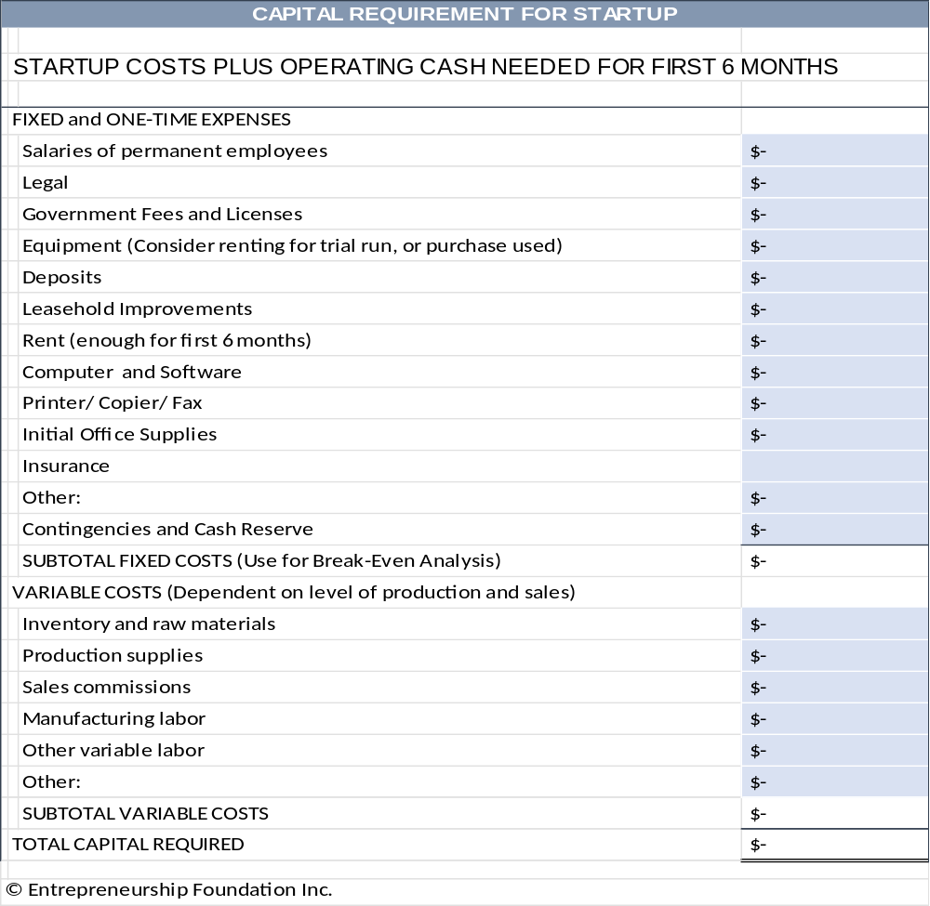

Module 3 - Finance Chapter 5 – Budgeting and Accounting

3.5.9 Accounting

Keeping your own books allows you to monitor cash flow and know how the business is doing in real time. Here are two online bookkeeping platforms that will help keep you organized. Fees are as of 2025.
1. WAVEAPPS offers a free cloud-based accounting package for entrepreneurs. Waveapps.com


- Optional Credit card processing: 2.9% + 60¢ per transaction
- Optional payroll processing starts at $40 per month. Note, you still need to send payroll taxes and 940 and 941 forms to state and IRS, but Wave will help you calculate how much you need to remit.
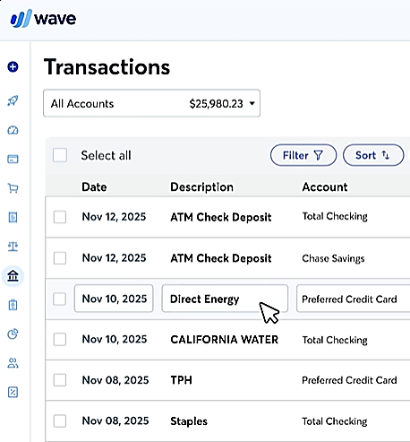
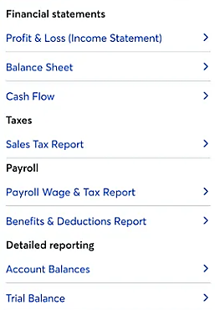


2. QUICKBOOKS by Intuit.
Plans start at $420 per year, but include some additional features, such and receipt scanning to automatically post espenses. The payroll processing option starts at $600 per year. For details see https://quickbooks.intuit.com/pricing.

COMPANIES THAT OFFER PAYROLL PROCESSING SERVICES ONLY INCLUDE:
- ADP https://www.adp.com/
- Paychex https://www.paychex.com/
- Homebase https://www.joinhomebase.com/
- Onpay https://onpay.com/
Payroll processing will run about $40 per month plus $6 per employee.
Module 3 - Finance Chapter 6 – Buying a Business or Franchise

3.6 - Buying a Business or Franchise

3.6.1 Buying an Existing Business
3.6.2 Buying a Franchise
3.6.3 Growing a Business

Now that you have identified a promising concept for a business, gauged market demand, researched the competition, scouted locations, determined costs, and crafted a business model, you are ready to implement your plan.

One shortcut is to buy a going concern or purchase a franchise in a successful chain.
This is largely a personal preference. Do you want to reduce risk, in exchange for a higher startup cost? Do you appreciate the advice from someone who has done this before, or do you like figuring things out yourself by trial and error?

Module 3 - Finance Chapter 6 – Buying a Business or Franchise

3.6.1 Buying an Existing Business

This can take some of the risk out of owning your own business. And you will hit the ground running, with everything in place: space, experienced employees, inventory. However, this comes at a cost.

PURCHASE PRICE. You should expect to pay 1.5x to 3x annual net cash flow (cash receipts less cash paid out). If the business was throwing off $1,000,000 per year in cash, then the asking price will probably be $1,500,000 to $3,000,000. In economic terms you are buying an annuity: an asset that will (presumably) pay you a yearly return on that investment. Of course, in the case of buying a business, you also have to run it, so you have an “opportunity cost” as well: the amount you would have made working for someone else.

In 2025, U.S. Treasury Bills, which are considered the safest investments, were paying around 4% interest annually.
However, no business is as sure an investment as the U.S. government, so the price you pay for a business will reflect the higher risk. If you paid 3x for the business in this example, the expected annual return would be 33.3% ($1,000,000 is 33.3% of $3,000,000). The difference between 33.3% and the safer 4% ROI you could obtain from Treasury Bills is the premium for your greater risk and opportunity costs. See “Valuation” in Module 4 of this series for guidelines on how to determine the value of a company.

FINANCIAL RECORDS. The owner of the company you are contemplating purchasing should provide tax returns for the past five years, current year-to-date P&L (Profit and Loss Statement), and a balance sheet showing liabilities (debts) and assets (patents, trademarks, copyrights, buildings, vehicles, equipment, supplies, furniture, vehicles, and inventory of raw materials, components, and finished goods.) Also ask for a detailed inventory list showing …
- Quantity (Verify by spot checking at least the more valuable items. Check condition as well as the number)
- Purchase price
- Source
- Date purchased. (Those 2023 calendars might not be worth as much as shown in the books.)
The difference between the cash value of the assets and the asking price is the Goodwill (reputation and loyalty of the customer base, which should translate into continuing sales). But do not assume. Look for telltale signs of a decline in sales to new customers or a lessening of repeat sales.

DUE DILIGENCE CHECKLIST.
- Licenses. Make sure the business has all the required permits and meets current zoning requirements.
A current sales tax permit should be prominently displayed.
- Is the business in good standing with the Secretary of State (all taxes current?), the Department of Labor (payroll reports and payroll taxes are current?) The Department of Revenue Services (sales taxes paid and up to date)? Ask for proof, because when you buy a business, you acquire its obligations. If the business owes $10,000 in payroll taxes to the IRS, that becomes your responsibility.
Buying a business is like buying a home, only riskier, so have an experienced accountant review the financials and inventory data; and consult a business attorney to advise on the purchase contract. These professionals have probably advised on a number of deals and can provide suggestions on what to look for during due diligence.

PURCHASE CONTRACT TEMPLATES. Here is a link to a form you can download and paste into Word to create a purchase agreement: https://freelegalforms.uslegal.com/sale-of-business/agreement-for-sale-of-business/. Rocket Lawyer, a monthly subscription service for legal forms, will allow you to create a customized document online. See https://www.rocketlawyer.com/sem/business-sale-agreement. Your attorney may want to make some changes, but you will save her time and your money if you fill in as much as you can in advance.

Module 3 - Finance Chapter 6 – Buying a Business or Franchise

TO FIND A BUSINESS FOR SALE….
- Talk to attorneys and accountants. They may know someone ready to retire.
- Think about a business you have frequented for years, and it always seemed to be busy. Let the owner know you are looking for a business to buy.
- Check your local classifieds for “Business Opportunities”
- Search online for Business Brokers near me. Be aware the broker will collect a fee of 5%-15% from the seller; so, their obligation is not to the buyer.
- Two online business directories are www.bizbuysell.com/ and https://us.businessesforsale.com/
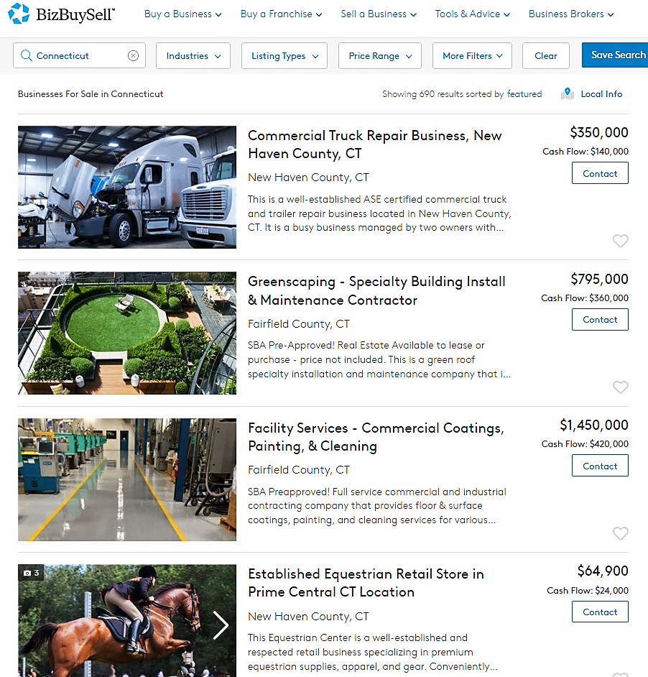
Module 3 - Finance Chapter 6 – Buying a Business or Franchise

3.6.2 Buying a FRANCHISE

Buying a franchise is like buying an independent business, but usually more expensive. The premium price is compensated by some advantages:
- Proven business model and procedures
- Access to training and support
- Assistance finding a location with the right traffic
- Brand recognition
- National advertising campaign by the franchisor (company that sells the franchise)
- Marketing materials and signage
COSTS
- Initial franchise fee. The more popular and profitable the franchise is, the higher the initial fee. Some franchise fees can be raised after the initial 10 or 20 years. (So, check the fine print.)
- Ongoing royalty fee paid on sales
- Other costs might include mandatory training fees or a requirement to purchase signage and equipment
DISADVANTAGES OF FRANCHISING
- Lack of independence and decision-making. You must operate the business by the corporate manual.
- You must buy the franchisor’s product line and cannot add your own products.
- Franchisors receive their royalty payments as a percentage of sales, not of your profits; so, they are incentivized to push high-volume, low-priced (low-profit) products.
- A franchise may require a long-term contract similar to a lease for space. So, even if your business is losing money, you may still be locked into paying an annual minimum royalty.
- Difficulty in selling the business. Some contracts give the franchisor the right to buy back the franchise.
- Some franchisors compete with their franchisees by offering products online.

COMPARING FRANCHISES. Two sites, www.entrepreneur.com/franchises and www.franchise.com list franchises by industry and cost. According to the advice of attorney Clifford Ennico, ask the franchisors on your short list for:
- Franchise Disclosure Document (FDD) a disclosure mandated by the Federal Trade Commission. www.ftc.gov/business-guidance/blog/2023/05/franchise-fundamentals-taking-deep-dive-franchise-disclosure-document
For a glossary of franchising terms see https://www.franchise.com/franchise-glossary
- The average time for franchisees to recoup initial investments.
- Contact information of franchisees who have left the system in the past three years. Call them.
By now your list should be no more than a handful. Go kick the tires:
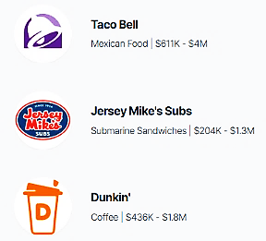
- Visit a franchise. Would you buy the product or service? Would you work there? Talk to the franchise owner. Would he do it again? Is he enthusiastic and planning to open more units?
- Attend a franchise trade show. Compare deals of competing franchisors. Which franchises have been around three years, AND are still growing? To find a franchise expo, see https://www.franchiseexpo.com/

Three of the 500 franchise opportunities listed on
website of Entrepreneur Magazine.
Food is one of 10 industry categories in the database.
www.entrepreneur.com/franchises

Module 3 - Finance Chapter 6 – Buying a Business or Franchise

3.6.3 Growing a Business

Once you have recouped your initial investment and refined the business into a profitable and sustainable model, you may want to invest more time and funds to grow the business to its full potential. But do you really want to? It is OK to say that you like your current work-life balance, that you like to be the one to bake the cookies and hand them to the children, without the headaches a chain of stores would entail. But if you’re the “full speed ahead” type, here are some strategies for multiplying your great idea:
- Additional Brick-and-Mortar Locations. How many outlets can you service?
- What are the location requirements in terms of traffic, access, neighborhood demographics, distance you are willing to travel to check on operations?
- What current available locations meet these criteria?
- Consider moving in with someone with surplus space. (The Post Office has done this. Some sandwich shops have opened branches in local libraries)
- What are the additional incremental costs per location, including additional layers of management?
- New Client Acquisition.
- Where is the low-hanging fruit? Is there a market niche overlooked by the competition?
- If you are a B-C company, can you offer your product/service to businesses?
- If you serve small companies, are you now ready to scale up to service larger corporations?
- New Products. New products are an obvious way to grow sales. These can be variations of your core product or completely new offerings that expand your overall base.
- Franchising. Restaurants often turn to franchising, and it is a feasible option for many other industries as well. Franchising works best when your product is consistent, customers have certain expectations about your brand, you are consistently profitable and growing in your current location.
- Online Expansion. Use your own website, Shopify, Amazon, eBay and/or Etsy,
- New Advertising Channels. Try some A-B testing of new media (Newspaper, radio, TV, influencers, events, direct mail, press releases, blogs, etc.)

- Sell Internationally. The U.S. Post Office will deliver packages anywhere; but best to avoid countries with political or financial instability. First-Class Package International Service is usually the cheapest rate, but it can still get pricey fast. The higher the shipping and handling cost, compared to the value of the product, the more market resistance you will encounter. Even a 4 oz. package (pair of earrings) will cost over $22 to the UK, France, or Brazil; a 12-to-16 oz package will cost over $32.
- Acquisitions. A logical strategy for a mature company that is close to market saturation. (e.g. – Facebook purchase of Instagram).

Frito-Lay started with just corn chips.

Module 3 - Finance Chapter 7 – Banking

3.7 - Banking

7.1 Selecting a Bank

7.2 Opening a Bank Account

7.3 Ordering Checks and Banking Supplies

.
WHY YOU NEED A BUSINESS ACCOUNT. It is generally a good idea to keep business funds separate from family money. In addition, when you pay bills, using checks with a business name it shows this is not just a hobby. Any check made out to the name of a business must be deposited in an account of that name. If you intend to operate as a sole proprietorship, you can open the account as a d/b/a (doing business as): “[Your personal name] d/b/a [your company name]”. Make sure the business name is available and register it with your town clerk before opening the account and purchasing checks.

Module 3 - Finance Chapter 7 – Banking

3.7.1 Selecting a Bank

LOCATION. Your business banking needs will most likely occur during normal business hours, so consider banks near your office instead of where you live. In any case, the bank around the corner from your home that you use for your personal needs may not offer the services your business will need.

TYPE OF INSTITUTION. By law, savings and loan institutions (S&Ls) cannot allocate more than 20% of their assets for commercial loans, and only half of that can be placed with small businesses. Savings institutions are designed to service individuals, not companies. So, pick a full-service commercial bank.

SERVICES AVAILABLE. Will you be making many cash deposits? If so, how late is the bank open? (Some close their windows at 3:00 pm.) If you have a retail store, you will need to obtain rolls of coins and small bills. Will you be doing a lot of importing and exporting? If so, you will want a bank with international experience or with correspondent banks in the countries where you will be doing business

Think ahead about the services you may need in the future, such as payroll processing or a business loan. You will not build a relationship if you change banks every few years to find the next new service the company needs.

SERVICE FEES. Some banks offer free or low-cost checking/savings plans.


These ads describe what you want
in a bank.
Talk to the bankers
to find out if the hype is true.
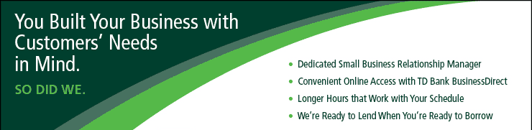

Module 3 - Finance Chapter 7 – Banking

BANK RESEARCH | Bank A | B | C
NAME OF BANK
Name and email of bank representative
Are deposits FDA insured up to $250,000? | Yes / No | Yes / No | Yes / No
Free business checking? | Yes / No | Yes / No | Yes / No
Minimum balance to maintain free checking | $ | $ | $
Interest on savings account | % | % | %
Overdraft fee | $ | $ | $
Will bank take money out of savings automatically to cover insufficient funds in the checking account (thus avoiding inadvertent overdrafts)? | Yes / No | Yes / No | Yes / No
Printed monthly statement? | Yes / No | Yes / No | Yes / No
Able to check online for balance and see which checks have cleared? | Yes / No | Yes / No | Yes / No
Import/ Export experience? | Yes / No | Yes / No | Yes / No
Experience with Letters of Credit? | Yes / No | Yes / No | Yes / No
Experience with wire transfers? | Yes / No | Yes / No | Yes / No
Cost for 250 checks, binder, and book of carbonized deposit tickets | $ | $ | $
Is the bank an SBA lender? | Yes / No | Yes / No | Yes / No
What is the range of the size of business loans that the bank makes? | $____k to $____M | $____k to $____M | $____k to $____M
How many business loans does the bank make in a typical year? | # | # | #

Module 3 - Finance Chapter 7 – Banking

3.7.2 Opening A Bank Account

DECIDE WHO YOU WANT TO BE AUTHORIZED TO SIGN CHECKS. You might have a bookkeeper who prepares your checks, but to maintain a prudent system of checks and balances, you should be the only one authorized to sign.

WHAT YOU NEED TO OPEN AN ACCOUNT.
- SOLE PROPRIETORSHIP – Social Security number or EIN.

- LLC –
  - Employer Identification Number (EIN), available at no charge from the IRS. You can apply online at https://sa.www4.irs.gov/modiein/individual/legal-structure.jsp
  - Operating Agreement, outlining the internal structure, management, and member relationships. (This is different from Articles of Organization, which are filed with a state to set up an LLC.) A boilerplate LLC Operating Agreement may be downloaded from www.LawDepot.com or www.RocketLawyer.com
- C CORP – Corporate Resolution by your board authorizing you to open a checking and savings account and to sign checks. A boilerplate “Banking Corporate Resolution” can be downloaded free from https://www.northwestregisteredagent.com/legal-forms/corporation/corporate-banking-resolution
Template for Banking Corporate Resolution
I, Enter the name of the secretary of the corporation, Secretary of Enter the name of the corporation, referred to as corporation, certifies that the following is a true copy of resolutions adopted by the Board of Directors of this corporation at a meeting held on proper notice, a quorum being present, on Enter the date of the corporate meeting, and that such resolutions are now in full force and effect.
Resolved that the Enter the name of the bank of Enter city, state of the bank is designated a depository of this corporation; and
Further resolved, that all drafts, checks, and other instruments or orders for the payment of money drawn against the account or accounts of this corporation with such depository shall be signed by any Enter number of signatories on checks of the following:
Enter the names of the authorized signatories
Further resolved, that such depository is authorized to place to the credit of the account, or any of the accounts of this corporation, funds, drafts, checks, bills of exchange, or other property whomever delivered to such depository for deposit for account of this corporation, endorsed with the name of this corporation by rubber stamp, facsimile, mechanical, manual or other signature (and any such endorsement by whomever affixed shall be the endorsement of this corporation), or otherwise endorsed, or un-endorsed, provided that if any such draft, check or other property shall bear, or be accompanied by, directions (by whomever made) for deposit to a specific account then such deposit shall be to the credit of such specific account; and
Further resolved, that such depository is directed to accept, and/or pay and/or apply any draft, check, instrument or order for the payment of money, or any proceeds thereof, drawn on such account or accounts when signed as required by these resolutions without limits as to amount, without inquiry, and without regard to the disposition of any such item or proceeds thereof, and such depository shall not be liable in connect therewith notwithstanding that such item may be payable to the order of a person whose signature appears thereon or of any other officer or officers, agent or agents of this corporation, or such item or any proceeds thereof may be used for the personal credit or account of any such person or person with the depository or used in payment of the individual obligation of any such person or persons to the depository or otherwise.
Further resolved, that such depository is authorized to deduct from the accounts of the corporation the regular promulgated service charges and fees for accounts and other services rendered to the corporation.

Dated: _________________ Signed by its Secretary _________________________________________
Module 3 - Finance Chapter 7 – Banking

3.7.3 Ordering Checks and Banking Supplies

CHECK STYLE. Puppies and balloons are right out, unless of course you are opening party supply business. Order business-like checks with subdued hues and no decoration. Order the large size (3” x 8.25” plus stub) that comes in a ring binder.

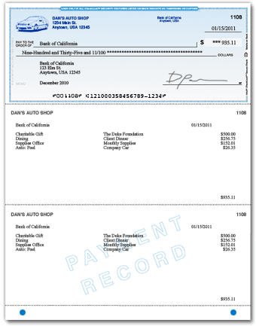
You might feel a wallet-size checkbook is more convenient, but larger checks and stubs allow for more-detailed record keeping and help convince suppliers that you have outgrown the sidewalk lemonade stand.

Checks will come pre-numbered and printed with your business name and address, the routing number that identifies your bank, and your bank account number.

You will have a choice between manual checks [below] or laser checks [right] designed for accounting software—like QuickBooks—and intended to be over-printed with the payee and amount. The imprintable checks save time and help you look more professional. They are a bit more expensive, however.
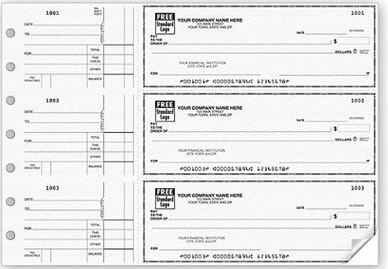

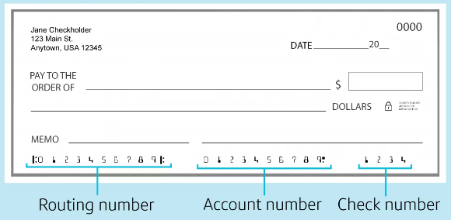
WHAT YOU NEED TO ORDER CHECKS: Your checking account number and the routing number for your bank. This is an identification number that tells the receiving bank how to route the canceled check back to your bank to be reimbursed. The routing number will appear at the bottom of the check, before the account number.

Module 3 - Finance Chapter 7 – Banking

WHERE TO BUY CHECKS. You can purchase your checks from your bank when you open the account but check their prices. It may pay to buy your checks directly from one of the following check printers. Whomever you buy from, resist the offer of a free stock logo. These are not exclusive and typically somewhat dated in style. Go with no logo (you will look very businesslike) or use your own.

Deluxe Check printers and Harland Clark are well-known suppliers of quality printed checks, but they do not disclose pricing until you log in and give them your bank account information.

Intuit (https://intuitmarket.intuit.com/bvc) is the producer of the QuickBooks accounting software, so you know the checks will line up with their software templates. $140 for 250 checks (as of 2025).

Amazon.com Custom Business Checks for laser printing, compatible with QuickBooks accounting software.
250 for $70. Manual checks: 100 for $54 (2025).

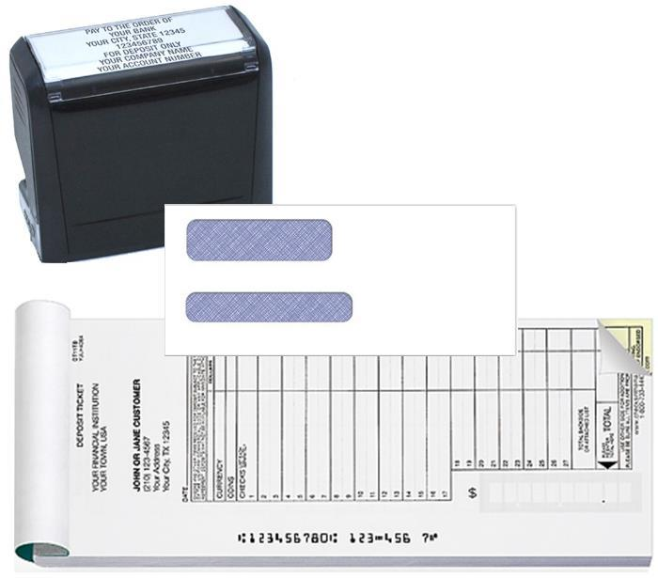
WINDOW ENVELOPES (to save addressing). QuickBooks compatible, self-seal, double window, for laser-printed checks. Size #8 (3 5/8” x 8 11/16”). Amazon 500 for $32 (2025)
Pad of 150 2-part carbonized DEPOSIT TICKETS with company name and account number. Amazon $54 (2025).
STAMP with company name and account number. Amazon $20 (as of 2025). The stamp saves time endorsing checks. The stamp also indicates that the check is being presented “For Deposit Only” to prevent the bank from applying the funds to an outstanding loan.

Module 3 - Finance Chapter 8 – Raising Growth Capital

3.8 – Raising Growth Capital

3.8.1 Determining Growth Capital Requirement

3.8.2 Internal Sources of Growth Capital

3.8.3 Types of External Growth Capital

3.8.4 Debt Capital

3.8.5 Equity Capital

3.8.6 Ownership Retention When Raising Equity Capital

3.8.7 Valuation (Estimating the Future Value of a Venture)

3.8.8 Valuation (Estimating Present Value of a Venture)

3.8.9 The Term Sheet

3.8.10 Equity Capitalization Schedule (Cap Table)

3.8.11 Exit Strategy

RAISING CAPITAL is a complex process. It usually takes 3 to 6 months to get a proposal in front of capital providers and for them to conduct due diligence. The steps in the process are:
- COMPUTE HOW MUCH CAPITAL YOU NEED at each stage of development. (If your launch is successful and you achieve break-even quickly, you may want to accept additional outside capital to grow the company more quickly than would be possible by relying solely on profits to fund growth.) The key is to allow for periodic infusions of equity capital, and the resulting dilution of the founders’ ownership position. The company that captures the market first wins.
- DETERMINE THE RIGHT TYPE OF CAPITAL FOR EACH STAGE: Savings, debt, equity, grants, or combination thereof.

Module 3 - Finance Chapter 8 – Raising Growth Capital

3.8.1 DETERMINING GROWTH CAPITAL REQUIREMENT

First, determine how much capital you will need to achieve the sales and profit goals in your business plan. Then break the total into tranches, or incremental investments spread over time, due when you meet interim milestones. This allows the investors to conserve cash until you need it, and reduces their risk, as they can withdraw from the agreement if you do not achieve a milestone within the agreed time.

This is an interactive spreadsheet. To open, right-click on spreadsheet, click “Worksheet Object” and then "Open.” You need to enter data in shaded fields only; the totals will be computed for you. You can download a copy of this form at
http://www.EntrepreneurshipFoundation.org/spreadsheets

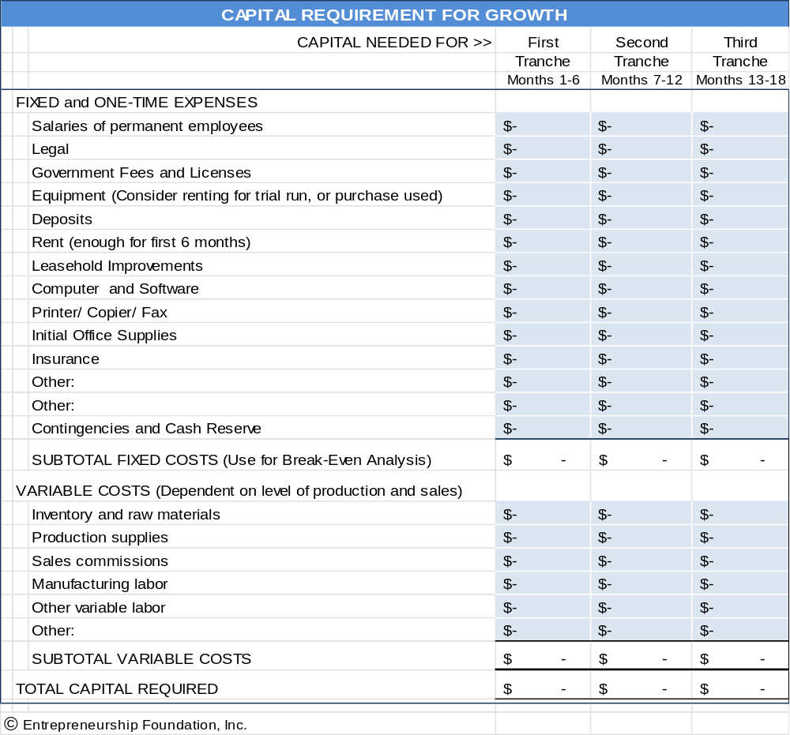

Module 3 - Finance Chapter 8 – Raising Growth Capital

3.8.2 Internal Sources of Growth Capital

For established businesses, expansion capital can often be generated from within the company by managing cash flow better or by converting other assets into cash.

1. Cash Flow Management.
    - Would some customers pay within 10 days for a 2% discount? This common payment option is written as 2/10 net 30; meaning the customer can deduct 2% from the bill if paid within 10 days, otherwise the full payment is due within 20 days.
    - Can you eliminate credit to new customers and require payment at time of order?
    - Are you paying bills sooner than required?
    - Have you tried to renegotiate credit limits or payment terms? If you are required to pay C.O.D., attempt to obtain credit. If you are required to pay bills within 30 days, ask for more liberal net 60 or net 90 terms. If you are a good customer, have been meeting payment obligations on time, and have a rationale (your business is cyclical like the fashion or toy industries, or it takes you 60-90 typically to collect from your customers), then you may have a convincing case.
    - Look at annual payments such as insurance. Do they come at the worst time of the year? If so, talk to the vendor about changing the payment date; or spreading out the payments into quarterly or monthly installments.
    - Paying salespeople a commission, after the customer pays, is one way of keeping down risk and negative cash flow. Some magazines and websites will also accept ads whereby payment is based on inquiries or actual orders received as a result of the ad. (Again, payment is after the sale.)

2. Converting Assets into Cash
- SURPLUS INVENTORY.
      - Do you have excess inventory that should be discounted to free up cash to produce more of the better-selling products?
      - Can any merchandise or supplies on hand be returned for cash or credit?
  - FACTORING. Have you tried to sell purchase orders to a factoring agent? Practitioners of this little-known source of business financing will buy a purchase order from you at a discount, assuming the customer has good credit. There are few companies that offer this service, but you should be able to find one in your region by searching the web.
  - LEASE VERSUS BUY. Everyone understands that leasing a car or truck for a business instead of purchasing it conserves cash. There are also leasing agents and finance companies that will purchase capital assets that you already own and lease them back to you.

Module 3 - Finance Chapter 8 – Raising Growth Capital

3.8.3 TYPES OF EXTERNAL GROWTH CAPITAL

- Debt Capital carries with it a legal obligation to repay the investment within a specified time, along with interest. Commercial lenders will generally require collateral and/or the borrower's personal guarantee in case of default. This protects the lender and ensures that the borrower has sufficient personal interest at stake to work diligently at the business. Lending sources include …

- U.S. Small Business Administration. The SBA’s Basic 7(a) Loan is designed to help small companies obtain financing when they might not be eligible through conventional lending channels. Loans may be used for most business purposes including working capital, machinery and equipment, furniture and fixtures, building renovation or construction, and debt refinancing (under special conditions). Loan maturity is up to ten years for working capital and up to 25 years for fixed assets. Interest rates range from 6% to 10% (as of 2025). See https://www.sba.gov/loans-grants.

- COMMERCIAL BANKS. Once you have achieved profitability and are generating positive cash flow (to repay a loan), you may be able to access growth capital through a commercial bank. You will still need a convincing business plan, a five-year financial forecast, including at least 3 years of month-by-month cash flow projections. Include the payments to the bank in the forecasts. Interest rates for established businesses range from 6% to 13% (as of 2025). Also, a bank will want to lend against collateral (hard assets like vehicles), and/or require a personal guarantee.
- FACTORS. A factor will purchase a receivable at a discount, based on the creditworthiness of the debtor. For a list of factoring agents see www.forbes.com/advisor/business-loans/best-factoring-companies/

2. Equity Capital (investment of cash in exchange for shares of stock in a company). Unlike loans, you are not legally obligated to refund an equity investment if the business fails. However, if the business is successful, you may wind up paying back more than you would have with a loan. A loan calls for a specific interest rate, no more and no less. However, an equity agreement provides the investors with a percentage of ownership (and therefore of the profits).
Preparation to pitch to equity investors involves the following steps:
- COMPUTE “GROWTH CAPITAL REQUIREMENTS” for each stage of your growth plan.
- ESTABLISH A REASONABLE AND DEFENSIBLE VALUATION OF YOUR COMPANY. You are, in fact, selling a portion of your business. So, what is it worth? What price is fair for you and the capital providers? This process is partly math but mostly negotiation—because you are really trying to arrive at a reasonable price today based on how profitable you expect the business will be in the future.
- PREPARE A “CAP TABLE” showing the rounds of new capital you project you will need (including the month and year and amount of each round), type of capital, source, and resulting dilution (amount prior investors will be crammed down, that is, how much their ownership percentages will be reduced).
- DECIDE ON AN “EXIT STRATEGY” to allow equity investors to harvest their original investment and their share of the gains. Exiting applies only to equity investors (banks would be happy if you kept their money and paid them interest forever, although they do like to see the loan paid down to zero once a year so they can sleep better). Equity investors (angels and VCs who provide capital for shares of stock) do not typically receive interest, so they need you to sell the company (exit) so they can have their payday. They will want to see that day arrive ideally 3 to 5 years after investing but realize that it may be 5 to 7 years.

Module 3 - Finance Chapter 8 – Raising Growth Capital

3.8.4 DEBT CAPITAL

A loan proposal is comprised of the following elements:
Summary. This should be clear, concise, accurate and inviting. You want to summarize how the proposed loan will be used, how it will be repaid and how it will benefit your business. Remember that you are competing with many others, so you will also want to point out some of the distinguishing features of your business.
Top management profiles. You will need resumes from all owners and key members of the management team. Resumes should include relevant experience, education and credentials. Be prepared for close scrutiny.
Business description. You do not need to repeat all of the information contained in your business plan, but you do need to present a description of your business. Include a brief overview of the history of your business, plus a summary of current activities. Make sure you clearly demonstrate that you understand your markets and industry, including current trends and risks. Include literature showing your products or services. It is also helpful to include endorsements from suppliers, customers and other business references.
Projections. Include projected income and cash flow for two to three years. Your assumptions should be clearly stated and realistic. Be prepared to answer questions (in quantifiable terms) about what happens if some of your assumptions do not come true. For example, if you anticipate obtaining a major new contract or customer as a result of newly expanded capacity, can you estimate the impact on your income statement if that customer decides to take their business elsewhere?
Financial Statements. The loan package must include both business and personal financial statements. Make sure that you are familiar with the details of your financial statements, especially if they were prepared by someone else. Be assured that your banker will fully analyze your historical financial statements and calculate all the ratios. So, prepare in advance and point out any significant trends in an introductory paragraph.

Amount and Purpose of the loan. Present a detailed statement of how you will use the loan proceeds. Do not forget to include the proceeds of the loan in your cash flow projections (and the interest in your projected expenses).
Repayment plans. You will have to make some assumptions about the terms of the loan in your proposal. (Obviously, this is necessary to prepare the initial financial projections.) In the first package, you will propose the terms that you want, but ultimately this will be a point that will be negotiated with the bank. The bank will consider a number of factors as they assess the overall risk of the loan, and this will impact the repayment terms that they are willing to give you.

If your loan is approved, make sure that you:
- Thoroughly review and make sure you understand all loan documents before signing. Consult with your lawyer or accountant if you have any questions.
- Get documents in on time. Keep up that good impression the bank has of you by promptly responding to requests for additional information, documents, signatures, etc.
- Maintain close contact with your loan officer. It is a good idea to give your banker progress reports -- the bank now has a vested interest in your success and will want to be kept current on your progress.
- Keep lenders apprised of any problems. Bankers do not like surprises.

If your loan is not approved.
- Do not despair, a "no" today does not necessarily mean no forever or from the next bank you approach.
- Do Not get defensive but do seek information so that your next proposal addresses and corrects any deficiencies in the rejected application. Ask the banker to explain "why" your loan was not approved.

Module 3 - Finance Chapter 8 – Raising Growth Capital

3.8.5 EQUITY CAPITAL

Equity investors provide capital to ventures in exchange for shares of stock. Their strategy is to recoup 10- to 20-times their investment within 3 to 5 years by helping you grow and then sell the company or float an initial public stock offering (IPO) and then selling their shares on a stock exchange.

- Private Individual Investors (Angels). Typically, angels are successful former entrepreneurs themselves looking to reinvest some of their winnings helping others and can bring a wealth of free expertise and assistance. But do not get engaged on the first date. It is important for you and the angel investor to get to know each other, test compatibility, and to understand each other’s expectations through preliminary meetings.
STAGE. Angels will expect applicants to have revenue
ANGEL INVESTOR CLUBS. A group of angel investors that invest individually or collectively through a common fund. The advantage of approaching a club versus an individual investor is that the club has greater investment resources. Although it is almost impossible to find one private individual who will commit to providing $500,000 in capital, a group of individuals could.

To find an angel investor club near you see http://www.angelcapitalassociation.org/directory/#1

- Venture Capital (VC) Firms. VCs are equity investment firms, with offices, websites and paid analysts. A VC firm will specialize in a specific range of investment dollar size, industry and geography.

STAGE. VCs invest other people’s money and are therefore very conservative: they do NOT invest in startups. Wait until your business is profitable and the business model sustainable before seeking funding.

INVESTMENT CRITERIA. VCs list their investment preferences on their website. Find a firm that ...
- Invests in your state. VCs want to check up on their investments periodically, so travel time is an issue.
- Invests in your industry. VCs will invest only in an industry they know a lot about. Check the website for the current portfolio companies (businesses they have invested in). Would you be a good fit?
- Invests the amount of money you need. If you need $1 million, do not go to a firm with $1 billion under management. That firm cannot afford to do deals as small as $1 million as that would mean they would wind up with 1000 investments to keep track of. Similarly, do not approach a firm with only $5 million under management, as no firm would invest 20% of its funds into one deal.
If you find a match, check the website to find out what they would like you to send them initially.
WHERE TO FIND THE RIGHT VC FIRM. The National Venture Capital Association (NVCA) lists members on its website, sortable by state and city https://nvca.org/nvca-members/. But be aware that not all listed firms are venture capitalists; some are brokers or firms that serve entrepreneurs and investors. For example, Synchrony Ventures is a credit card company. Inspect the website before sending a plan.

The NVCA website also lists state and regional associations http://nvca.org/ecosystem/regional-groups. These membership associations typically hold monthly events that entrepreneurs may attend to learn more about sources of capital in their region and the process of accessing funding. This is a good place to learn the ropes and meet with other entrepreneurs, venture capital attorneys and investors.
3. Brokers and Finders. A finder works for investors to source deals. A broker works for entrepreneurs to find investors. Some investors may not want to do business with you if you use a broker, as the fees (usually 5% of amount raised) and/or shares you have to pay the broker will dilute the value of their investment.
Module 3 - Finance Chapter 8 – Raising Growth Capital

3.8.6 OWNERSHIP RETENTION WHEN RAISING EQUITY CAPITAL

The following chart illustrates the concept that an equity investor will expect a percentage of ownership in relation to the perceived risk. The more advanced the development of your product and business, the less ownership the investors will require to balance their risk.

MORE RISK FOR INVESTORS LESS RISK FOR INVESTORS

There are additional factors that may affect the percentages in the preceding chart. These variables may exert an upward pull on the percentage of ownership the entrepreneur might retain (dotted line); or they may lower the ownership percentage the entrepreneur should expect to retain.
External factors (variables not within your control):
        - The Economy
        - Investor Confidence
        - Total amount of capital available in the investment market
Internal Factors (variables under your control):
        - Newness or uniqueness of product or service
        - Prior experience (Successful serial entrepreneurs can retain a larger share of ownership)
        - Profit potential

Module 3 - Finance Chapter 8 – Raising Growth Capital

3.8.7 VALUATION (ESTIMATING THE FUTURE VALUE OF A VENTURE)

If you plan to raise equity capital, you will need to establish a specific value for your business. Valuation is the art and science of estimating the present worth of a business based on its potential future earnings. Most investors will want to cash out in 3 to 5 years, so let us assume for this discussion that the agreed goal is to harvest the company in five years, by flipping it to a larger company, a private equity firm, or by floating an initial public offering (IPO) to sell the company to many individual investors.

The first step is to estimate the value of the company five years out. Two popular methods of estimating the future value (FV) of an enterprise are…

- FUTURE EARNINGS METHOD (Based on extrapolating current earnings in the expected harvest year)
- COMPARABLES METHOD (Based on the value of similar companies)

1. FUTURE EARNINGS METHOD. Since an early-stage company has limited sales data, future earnings are difficult to estimate, and here is where it gets tricky. You (the eternal optimist) will project a high growth rate and the assumption that nothing will go wrong. The investors, however, will likely assume a lower growth rate and that everything that can go wrong will.
However, for the sake of argument, let us assume that after much polite negotiation you and your investors arrive at a 5-year projection of $100,000,000 in sales, with a net profit after tax of $10,000,000. So, what is the business worth? Here is how the staff at Fundable.com foresees how the negotiation might play out:

The Valuation depends on the Earnings Multiplier agreed to. Again, you and the investor may begin the negotiations with markedly differing views. You will point to average stock market P/E ratios of say 8 for your industry, giving your business a valuation of $80,000,000. The investor will argue that those are proven businesses with real sales and profit margins. Your profits are hypothetical. The investor will counter with 2x earnings, or $20,000,000.

The investors will also argue that their money will be tied up for years. In addition, investing in established companies is less risky.

The state of the economy at the time you enter the capital markets will also affect the cost of money. It is more difficult to launch and grow a company during a recession when potential customers are cutting back. Investors may therefore discount your valuation even further during a weak economy.

Other factors that will raise or lower the prospects for success, and therefore the value of your business are:
- Extent of prior industry experience of your management team
- Connections you have to buyers (through management team or board of directors)
- Strength and number of competitors
- Expanding or shrinking market
- Past rate of sales growth
In the end, let us assume you agree that the business will be worth $40,000,000 in 5 years.

2. COMPARABLES METHOD. Future value may also be estimated by comparing the entrepreneur’s company to the value of similar companies in the industry. Businesses that are traded on a stock exchange are good comparables since their market value is easy to calculate: number of shares outstanding x price per share. (The entrepreneur still needs to convince the investors that their company will be equally successful.) For the sake of argument, we will assume that the comparable companies also have an average value of $40,000,000.

Module 3 - Finance Chapter 8 – Raising Growth Capital

3.8.8 VALUATION (ESTIMATING PRESENT VALUE OF A VENTURE)

COMPUTING PRESENT VALUE. Once you have arrived at an estimated Future Value of the company ($40,000,000 in 5 years in the example), you will then need to determine the Present Value (PV) of the company, since the investment will be made today—not in 5 years. This computation can be performed using the Discount Method based on the target Internal Rate of Return (IRR).

TARGET INTERNAL RATE OF RETURN (IRR). This is done mathematically using a discount rate agreed to by all parties. There are several methods investors use to determine the necessary IRR for each investment for them to derive an average competitive return on all their investments, considering many will fail to return any profit.

If investors put their funds into a portfolio of Standard and Poor's 500 (S&P 500) stocks in 2000, they would have earned an average IRR of 13.6% during the 5 years ending in 2025. Of course, that does not mean that an investment today would yield the same return, but an investor will contend that instead of investing in your (risky) company they could safely invest the same amount in the S&P and earn a comfortable 13.6%; so that is how much they would at least need to earn on their investment each year while waiting to cashout. But investors will want an even higher IRR to compensate for the greater risk and the illiquidity (not being able to sell their shares in an emergency because there is no exchange where your shares can be sold.) Typically, the target IRR will be 40% or higher.

Investors will often express their target IRR as a multiple of their investment: 5x, 10x, 20x, or even 30x.
5x = ~ 40% IRR
10x = ~ 60% IRR
20x = ~ 80% IRR
30x = ~100% IRR

PRESENT VALUE FORMULA. Present Value (PV) is computed using the formula:
PV = FV / (1 + r)^{n} where r is the discount rate and n the number of years.
Assuming 60% target IRR… PV = 40,000,000/ (1.6)⁵ = 40,000,000/ 10.48576 = $ 3,814,697 PV

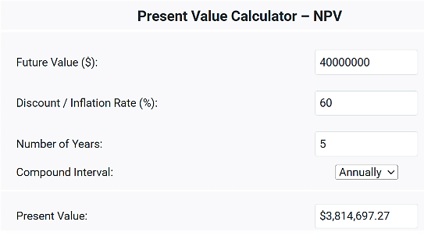
$ 21,143,084

Use this handy online calculator for the math

www.financialmentor.com/calculator/present-value-calculator

Module 3 - Finance Chapter 8 – Raising Growth Capital

PRE-MONEY VERSUS POST-MONEY VALUATION. The Present Value of the company includes the investment since it is assumed that the business will not achieve the $40,000,000 Future Valuation without the capital infusion. The valuation that includes the beginning inherent value of the company + the investment is called the post-money valuation (meaning it is the value after the money has been invested). The value of the company before the investment is called the pre-money valuation. In the example, we know the total post-money valuation is $21,143,084 from our calculation. If we subtract the amount of the investment (we will assume $2,000,000 for the example company) then the company is inherently worth $19,143,084 pre-money ($21,143,084 – 2,000,000).

So, what would be a fair split of the shares? If the company is worth $21,143,084 post-money, and the investor’s contribution toward that valuation is $2,000,000, then the investment is 9.3% of the Post-Money Valuation, entitling the investor to 9.3% of the shares of stock in the company. Easy.

SHORT-HAND METHOD OF DETERMINING OWNERSHIP SPLIT. Some equity investors seek to acquire a certain ownership percentage (often 30%) regardless of the valuation calculations; and others will stipulate an ownership stake on norms for a given industry and stage of investment. These Rules of Thumb are based on an analysis of returns (and losses) on prior investments.

WHAT IF YOU AND THE INVESTORS CANNOT AGREE ON A VALUATION IN ADVANCE? There are tactics to move ahead with the financing by delaying the determination of valuation:

1. Convertible Preferred Shares. This class of stock pays shareholders a fixed dividend and may be converted to common shares at the discretion of the investor. The investor would convert to common stock to participate in the proceeds from a sale of the company, since preferred stock does not represent ownership in the business.

2. The Safe (Simple Agreement for Future Equity). It stipulates that the percentage ownership due the original investors will be based on the valuation at the time of the first formal A round of financing; at which time, the Safes will convert to the appropriate number of shares in the company. See https://www.ycombinator.com/documents

3. The Earn-Out. A financial arrangement where a portion of the investment is contingent on a company's performance. This is a way to bridge the gap between the buyer's and seller's valuation, particularly when the future performance of the business is uncertain. For example, an entrepreneur asserts the business is worth $3 million; the investor $1 million. The investor might offer to pay $1 million immediately, with the balance contingent on the company hitting a milestone of say $10 million in cash sales within 3 years. The milestone should be quantifiable and irrefutable.

QUICK START-UP VALUATION CALCULATORS. These two online apps will allow you to perform a quick estimate of the value of an early-stage business, to serve at least as a starting point for discussion.

1. Cayenne Consulting has a free valuation calculator at www.caycon.com/valuation.php#

2. EquityNet. The results are based on market data gathered from over 3,000 businesses. To access, go to...
https://www.equitynet.com/crowdfunding-tools/startup-valuation-calculator.aspx

NOTE TO ENTREPRENEURS. You ma expect your years of toil, brilliant inspiration, and personal cash invested to count toward the Valuation of your business. Unfortunately, this is a sunk cost to you. To investors, the value of your business idea, invention, or patent is not how much time and expense you put into it, but its potential for earning.

Your business will be valued like a company listed on a stock exchange. The price of the stock is the present value of the firms predicted future earnings.
Module 3 - Finance Chapter 8 – Raising Growth Capital

3.8.9 THE TERM SHEET

Once you have agreement on valuation, you are ready to draft a Term Sheet, a preliminary written agreement between you and the investor(s). Venture capital firms usually prepare the term sheet, but if you are working with an angel investor, feel free to prepare a first draft.

The document will contain clauses to protect the interests of the investors and entrepreneur and stipulate how the proceeds are to be distributed if the company is dissolved or sold.

Both the investors and you should have experienced attorneys guiding you through the process.”

A term sheet is like a letter of intent. It is a nonbinding summary of the key points of the transaction. These terms will be included later in a formal Stock Purchase Agreement.

COMMON TERMS AND THEIR MEANINGS

- Valuation, Investment Amount, and Equity Stake (percentage of shares the investor will receive).
- Lock-Up Rights. Most investors will stipulate that the entrepreneur cannot shop the deal to other investors for a 30-to-60-day period. This Lock-up allows the Investors ample time to conduct due diligence without having to worry that another investor—knowing of their interest—may swoop in and deprive them of the opportunity.

- Timing of Investment. Many investors will prefer to distribute capital in installments, or tranches, as milestones are met.
- Liquidation Preference. If the company shut down and its assets converted to liquid assets (cash), the clause will stipulate who receives priority in the distribution of the proceeds. Investors will often insist that their investment be returned to them before any proceeds are paid out to the founders. In some cases, they will request twice their investment before any other distributions.
- Anti-dilution clause. This provision protects the investor in case the company raises future funding at a lower valuation (a down round). The provision protects investors by adjusting the conversion price of a convertible security (such as preferred stock or convertible debt) when new shares are issued at a price lower than the price they originally paid. This adjustment increases the number of shares the investor can convert their securities into, thereby preserving their ownership percentage.
To look up other financial terms, see https://www.investopedia.com/terms


Attendees at a venture capital event listing to 3-minutes pitches by entrepreneurs seeking capital.

Module 3 - Finance Chapter 8 – Raising Growth Capital

3.8.10 EQUITY CAPITALIZATION SCHEDULE (CAP TABLE)
To conserve cash and minimize risk, Investors prefer to meet out only the amount needed to fund the company during each successive phase of development. Each of these raises is known as a funding round.
At each round, founders will need to trade shares of stock in the company (equity), in exchange for the new capital. Growing companies will generally need multiple rounds to fund the ramping up of facilities, equipment and staff to satisfy ever-increasing demand. Entrepreneurs are advised to prepare a “Cap Table” showing the percentage of the company they plan to exchange for each round of financing.
Pre-Seed. ($5.000 - $50,000). This is the R&D and testing phase. Pre-seed sources include SBIR, government economic development grants, business plan competitions, and angel investors.
Seed Round ($50,000 to $500,000). This is the start-up stage to prove product-market fit. Funding sources include angel investors, accelerators, and incubators.

Series A ($1,000,000 - $5,000,000). This will be a larger round to scale up a proven concept. The company should be showing rapid and steady growth and at or near break-even. Series A investors are usually venture capitalists and corporate venture arms.
A Cap Table is the capitalization plan necessary to fund a venture to its full potential. Note that as new money is invested, the prior investors, including the founders, are crammed down. For the “A” round (first venture capital round) in the example below, both the angel investors and the founders each had to take a 33% haircut to make up the 33% ownership necessary to give the venture capitalists in return for their $1,000,000 cash infusion. What percentage of ownership was retained by the angels? (Answer at bottom of page.)

CAPITALIZATION PLAN (CAP TABLE) - EXAMPLE

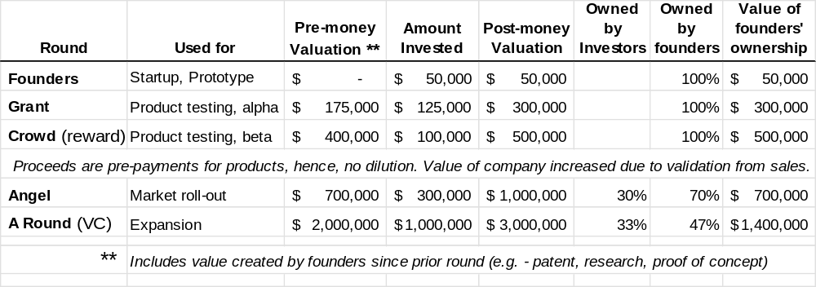

Use the blank spreadsheet below to try different Cap Table scenarios for your company. You can download a copy of this form at http://www.EntrepreneurshipFoundation.org/spreadsheets

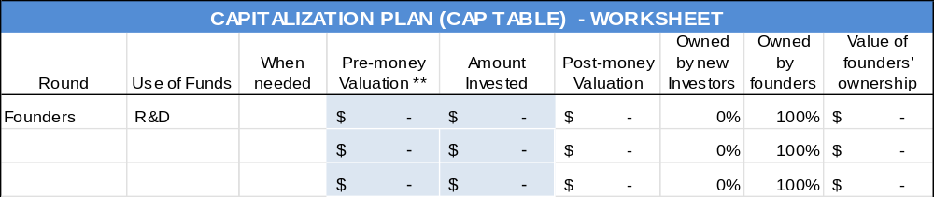
20%
Module 3 - Finance Chapter 8 – Raising Growth Capital

3.8.11 EXIT STRATEGY

If you accept equity capital, the investors will insist that you have a reasonable plan for them to exit the business. They will not have your love for the business. They just want to get their cash out as soon as possible, with a profit. You might still be able to stay on as president or become a serial entrepreneur and start another business. Exit strategies in common use are:
- Buy-back by Founders through an LBO (Leveraged Buy-Out).
- Acquisition. Sell the company to a larger firm that can leverage your technology, patents, or customers. If this is your intended exit strategy, be prepared to name logical buy-out candidates in your pitch to investors.
- Private Equity. Private Equity Firms purchase companies to own outright and manage, typically when the companies reach an annual profit level of $5 to $20 million.
- Initial Public Offering (IPO). Issuing stock to the public creates a market for the stock you and the investors own. It is difficult to sell new stocks in a recessionary economy, so do not suggest this exit strategy in a down market. Also, be advised that neither you nor your investors will be able to sell your shares immediately. (That would drive your stock value down precipitously.) You will have to cash out overtime.
If an IPO is your intended harvesting strategy, be prepared to give examples of similar companies that have launched successful IPOs and the market value of the outstanding stock. (This Market Cap[italization] should be equal to or greater than the Business Valuation as claimed by you in your business plan–or your valuation will not be credible.)

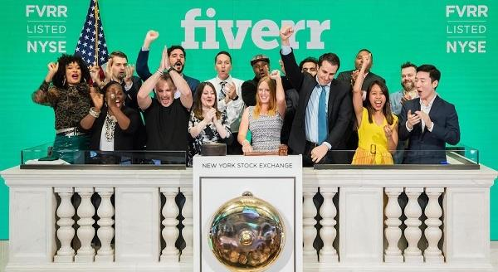
Fiverr celebrating having made it. Companies approved to list their stock on the New York Stock Exchange are traditionally allowed to ring the opening bell, signaling the start of trading for the day.
Module 3 - Finance Chapter 9 – Pitching Capital Providers

3.9 – Pitching Business Plans to Competition Judges and Capital Providers

3.9.1 Oral Presentations
3.9.2 Content of Presentation or Written Executive Summary

3.9.3 Questions You Should Be Prepared to Answer

3.9.4 Style: Delivering Convincing Presentations
3.9.5 The Slides

3.9.6 How Capital Providers Evaluate Proposals

Competition judges and capital providers, by nature, are risk averse and skeptical. Be Clear, Concise and Convincing.

“The value of a killer technology is zero unless you can show how it can be turned into a profitable business.” — W. Daniel Mothersill

Module 3 - Finance Chapter 9 – Pitching Capital Providers

3.9.1 Oral Presentations

There are several levels (in terms of detail and time length) of oral presentations to investors.

1. Elevator Pitch

EIGHT-SECOND SOUND BITE. This is a statement about your investment opportunity that you can get out in one breath. The place to use this is at a business-networking event where someone asks, “What do you do?” You never know who you might meet, so assume everyone you talk to is a potential investor or knows someone who is. A brief but engaging introduction about what you do is also valuable when recruiting employees or clients.
No one writes a check in an elevator. The sole purpose of the elevator pitch is to pique the interest of the investor, so they want more information. Success is these brief encounters is an exchange of business cards and an offer for you to call and set up an appointment for an in-depth interview.

The elevator pitch forces you to achieve clarity. At a minimum, the pitch should include YOUR NAME, COMPANY NAME, PROBLEM, and YOUR SOLUTION.

The elevator pitch should be memorized and rehearsed enough so that you can give it without it sounding rehearsed. You never know where you might meet a potential investor: at a cocktail reception, football game, even in an elevator. An 8-second elevator pitch might sound like this:
“Sugarcoate Systems reduces the time to bring new drugs to market by 20%.”
“We make flameproof fabrics for aircraft interiors.”
“We make cupcake decorating kits for children’s birthday parties.”

You need to convey all the essential information in a clear, concise, credible, and convincing manner that is also natural but passionate.

For more on mastering the elevator pitch see...
http://www.inc.com/guides/2010/05/mastering-business-elevator-pitch.html.

30-to-60-SECOND PITCH (without audiovisuals). You will probably be one of many presenters, so be memorable. State your name and company name slowly and distinctly at the beginning and end of your talk. Consider opening with a dramatic statement to capture the attention of the audience. Address the following points:

        - Big idea (customer problem and your solution) (1 or 2 sentences)
        - Status of the idea or business (1 brief sentence)
        - Revenue model (e-commerce, wholesale, etc.) (1 sentence)
        - Sales potential (justify expectations) (1 sentence)
        - Competition and why do you believe you have an advantage (2 sentences)
        - Rock stars are on the team who will ensure success (2 sentences)
        - Personal goal (1 sentence). To create a …
1) Part-Time Business (side hustle),
2) Full-time Personal Business,
3) Venture Enterprise with a substantial market and requiring venture capital to reach full potential.
        - Total funding required to launch the business full-time, and how much you need initially to develop the Minimum Viable Product and test it in the marketplace (1 brief sentence)

Module 3 - Finance Chapter 9 – Pitching Capital Providers

2. Formal Presentation at a Venture Fair or Business Plan Competition (3-10 minutes). You will probably be expected to have a PowerPoint presentation to support your commentary.
There may be Q&A during or after the presentation. You can cover a lot more in 3 to 10 minutes than in an elevator pitch, but generally, there will not be time to cover financial projections in detail or the resumes of the management team. For finances, discuss sales and profit projections and funding sought. For the management team, mention only one or two relevant experiences or credentials of each team member. For more on formal presentations, see the following sections on “Content” and “Style”.
3. Private Interview (15 minutes) in the office of the equity investor or lender. (This is what you hope an elevator pitch leads to.)
- If meeting with a VC firm, be prepared to present to an investment team of 3 to 5 people. Plan to give a formal presentation. Expect to be interrupted with questions.

- Ask about logistics prior to the meeting, so you know what to expect:
  - How many people will be in the audience?
  - Who are the decision makers? (Look up their bios on investor’s website.)
  - Can you (should you) deliver a PowerPoint presentation?
  - What is the total amount of time allotted for the interview?
  - Anything you should specifically cover? (The answer might reveal their biggest concern.)
- Research the firm. What companies have they invested in?
- Would a relationship with your firm help any of their portfolio companies? Are there potential synergies?
- Call some of the CEOs of the portfolio companies.
    - What advice do they have?
    - What is it like working with the investor or lender?
- What is their sweet spot for investing? $100,000, $1 million, $5 million?
d) Bring to the private meeting:
- Copies of executive summary for all attendees.
- Copies of the full plan to leave behind (if requested). Exclude confidential information, trade secrets, or content that might be useful to competitors until you obtain a signed NDA (non-disclosure agreement).
- Any purchase orders or contracts you have.
- If you are meeting with a lender, bring a list of assets that you can pledge as collateral. Show the date each asset was manufactured, purchase price, and current market value.
- Business cards
e) EXPECT SOME CHIT CHAT AT THE START OF THE MEETING. The investors want to get to know you as a person, are you someone they can get along with? Will they be able to participate in key decisions?
If you make it through this round, you will probably be called back to answer more detailed questions and begin negotiations over the term sheet (a preliminary draft of the investment contract).

Module 3 - Finance Chapter 9 – Pitching Capital Providers

3.9.2 Content of Presentation OR Written EXECUTIVE SUMMARY

The following is a comprehensive outline for a 3-to-15-minute oral presentation or 6-to10-page written executive summary. Adjust the amount of detail to the time or space allotted. Investors are looking for clear, compelling and credible information. Be concise but comprehensive. Remember the six Ps:

1. Product or Service

WHAT THE COMPANY DOES: Perform tax accounting services? Manage trade shows? Bottle and market sugar-free beverages?

PRODUCT/SERVICE
- Brief description and how it is new and different
  - Describe what creates the demand for your solution: Pain? Desire? High cost of alternatives?
- Explain the value proposition
  - How much customers need or want your solution. Give dramatic examples.
  - What it is worth to them, literally. Prove it.
- Eliminate the jargon and tech-speak. Competition judges and investors will not be familiar with shorthand used in your industry. Do not try to impress them with your vocabulary; sell them your concept.

Product/Service Development STAGE
- Current development status
- Patent status, if applicable
- Work, timeline and expense remaining before the product or service is ready to roll out.
- Remaining development risks or challenges (what might still go wrong?)

2. Potential

What is you market niche?
- Define the characteristics of the companies or consumers that need a solution
- How many potential customers are there? Is number growing or declining? Why?
- How many customers do you have now?

What ARE the potential dollar sales annually in your MARKET niche?
According to Blue Chip Ventures, do not use top-down math: “There are 8 billion people in the world and if we only sell one per cent of them …” That is not convincing as anyone could make the same claim. Similarly, the size of an industry is not predictive of sales. To say that Americans spend $349 billion dollars a year on fast food, though accurate, in no way informs the sales potential of a lemonade stand.

Instead, compile market data from the bottom up: “We have compiled a list of 1000 coffee shops within a two-hour drive. In a survey of 200 shops, we found that only 10% do their own roasting; and of the other 90%, half would like to. This gives us a serviceable market for our in-house coffee roasters of 450 shops.”

Marketing and Sales Strategy. How you propose to reach your targeted customers
- Marketing to raise awareness of product and stimulate buying
- Sales to give decision-makers a convenient way to learn details and place an order
- Support to help customers understand your product during installation and use

Module 3 - Finance Chapter 9 – Pitching Capital Providers

If you rely on indirect channels, explain:
- Your approach to reaching distributors
- Who will raise awareness and generate demand
- Who will provide sales and customer support
- Describe special sales incentive programs for distributors (if any)

3. Positioning Versus Competition and Alternative Solutions. What is your “Secret Sauce”?
Technology edge. [Do not delve into too much detail. Not everyone gets excited about dual-phase ether shifts.] Just explain that it will allow aircraft to save 50% on fuel costs. That they will understand.
COMPETITION and how your company excels.
How will large COMPANIES THAT HAVE established relationships with your target customers REACT TO YOUR INITIATIVES?
How will you overcome Market Inertia? (What will it take to get customers to change what they are using today?)
Are there companies that might leapfrog your solution with better technologies?

4. Protection. What Barriers to Entry have you erected to prevent competitors entering your market?
- Patents – Received or pending in US and abroad. Note: a pending patent or provisional patent is not a guarantee of market protection. (In the decade ending in 2020 only 53% of applications were approved https://yjolt.org/what-probability-receiving-us-patent.)
- Black box technologies – Is your technology difficult to reverse engineer?
- Lead time advantage – Would it take competitors years to reproduce your technology?
- Major Customers locked in with exclusive long-term agreements

5. People
MANAGEMENT TEAM. Skills should be varied and include individuals with business as well as technical backgrounds. Has anyone on team led a similar company to a successful IPO or buy-out?
- CEO (Chief Executive Officer) – Prior entrepreneurial experience in similar business. You may know your technology, but how do investors know you can run a business?
- CTO (Technology) – Proven expertise in your core technology
- CMO (Marketing) – Proven knowledge of the target market; strong relationships with buyers
- CFO (Financial) – Prior IPO or acquisition experience

Identify who is full-time and who is part-time or on the sidelines awaiting funding.
board members or advisers who add strategic value.

Module 3 - Finance Chapter 9 – Pitching Capital Providers

6. Profit Potential (This is not the place to go into detail.)

FINANCIAL FORECAST SUMMARY.
FINANCIAL FORECAST | Year 1 | Year 2 | Year 3 | Year 4 | Year 5
Units Shipped
Revenues
Gross Margin %
Gross Profit
EBITDA

BURN RATE. Current monthly costs to run company. When will you run out of cash if you are not funded?

Funding Plan
  - Funding received previously
  - Investment by founders (cash skin in the game)
  - Amount of new funding needed, and type of capital (debt or equity)
  - How long will it last? (To what milestone?)
  - Intended use of funds
Exit Strategy. If seeking equity from angels or VCs, the investors will naturally want to know what’s in it for them. Tell them when and how they will be able to cash out. And how. If you anticipate being acquired…

- Identify the two or three most likely buyers
- Explain why those larger companies would be interested
- Describe recent acquisitions of comparable companies and the deal values

- Describe any relationships you already have with potential acquirers, investment banks, private equity firms or larger VCs that might facilitate your exit plan.

To Conclude, Summarize the Most Compelling Arguments:
- Accomplishments. Milestones already reached. Show momentum.
- Why is this an exciting investment opportunity?
- Assume pitch decay will occur: A week later, your audience will probably remember only about 10% of your presentation. So, make sure they recall your strongest points. Repeat:
  - Reason to invest in us #1 (e.g. - Strategic alliances.)
        - Reason to invest in us #2
Module 3 - Finance Chapter 9 – Pitching Capital Providers

3.9.3 Questions You Should Be Prepared to Answer

You will appear professional and competent if you prepare answers to common questions (enumerated below). Do not try to memorize responses but do commit to memory important statistics.

Finally, be open to advice from your audience. Investors want to collaborate with someone who is easy to get along with and who will consider their ideas.

1. Solution: Product/Service
- What special issues relate to manufacturing the product? Any special materials or processes needed?
- What special equipment is needed to begin manufacturing at break-even capacity? And at what cost?

2. Market Opportunity
- How do you know the market exists? What evidence can you cite, such as independent market research?

- For industrial products…
  - What 2-3 industries comprise the most important prospects?
  - What are the job titles of the buyers (decision-makers) in these prospective companies?
- For consumer products, what are the demographics of the important customer segments?

3. Competitive Positioning
- How else can the customer solve the problem?
- How do you compare to each alternative solution? (Comparative advantages AND disadvantages)

4. Barriers to Entry by Competitors into Your Market
- Why are you confident that no new entrant will come along with a better solution?
- Why do you think you can dominate your market niche?
- Are there patents? If so, what specific features do they protect?

5. Product/Service Development
- What needs to be done to bring your product to where it is market-ready? What is your next step?
- How much of the production process does your company perform?
  - How much do you rely on outside contractors?
  - How much do you license from others?

6. Marketing and Sales
- What channels of distribution will you use to deliver your products to customers?
- How will these channels be established? By whom? When?

7. Management Team
- What gaps are there in the management structure and how you plan to fill critical functions
Module 3 - Finance Chapter 9 – Pitching Capital Providers

8. Financials
- Be prepared to explain dramatic numbers, such as:
  - Hockey stick growth (i.e. – exponential growth)
  - Unprecedented margins for the industry
  - Long periods of negative cash flow. (Goodness is positive cash flow in 6 to 12 months)
- When do you expect the next rounds of financing to take place? Why will you need those follow-on round(s) and how much will you need?

9. Requested Funding and Intended Use of Funds
- How much hard money (cash) have the founders put in?
- How much cash have directors and advisory board members invested?
- What equity is available to recruit key executives?
- How did you arrive at your pre-money valuation for this round?

10. Exit Strategy. What comparables are you using for your proposed IPO or exit round?

11. Summary and general
- When did the company begin operations?
- What is your long-term vision for the company?
- How has it been funded to date?
- Where does company stand today?
- What is the business model? (What will produce the company’s revenue?)
- What kind of gross margins will the company have?
- Do you have any corporate partnerships in place?
- What are the significant risks your business faces?

Module 3 - Finance Chapter 9 – Pitching Capital Providers

3.9.4 Style: DELIVERING Convincing Presentations

- DRINK WATER JUST BEFORE YOU SPEAK. (Fear makes our mouth dry.)
- TAKE BULGING ITEMS OUT OF YOUR POCKETS.
- STAND UP, FACE THE AUDIENCE, not the screen.
- BE PASSIONATE! Show that you believe in your concept and that you are determined for it to succeed.
- EXUDE ENERGY. Demonstrate how you can push through any obstacle to reach the end zone.
- SPEAK CONFIDENTLY IN A STRONG VOICE. Do not be self-deprecating in an attempt to gain the audience’s sympathy. Would you have confidence in someone who prefaced their talk with “I’m so nervous!” or “I’m not used to speaking in front of people”? You probably are nervous; everyone is when giving a talk; but you probably do not look it, so no need to let on. If you want to feel more confident, rehearse the speech until it becomes second nature.
- OPEN WITH A STRONG STATEMENT. Grab attention with a surprising statistic, or a 10-second story that shows how much customers need your product. “Eighty per cent of organ transplants are rejected within three years. Compatico has developed immune therapeutics to reduce rejections to 50%.”
- LEAD THE PRESENTATION PERSONALLY so that investors can judge your knowledge of the industry, and that you know how to present and think on your feet. Investors look at the founders first, then the idea.
- CONTROL THE DISCUSSION. If you get interrupted, go back to your slides. (Exude leadership.)
- PAUSE OCCASIONALLY so your listeners can catch up. When we are nervous, we tend to speed up. A good average pace is 120 words per minute.
- VARY VOICE PITCH AND SPEED, especially to emphasize a point.
- AVOID PUFFERY: “This is going to be the hottest selling product.” Eschew vague generalities: “It’s going to be really, really great.” Stick to specific facts and only what you can prove, to maintain your credibility.
- AVOID TECH TALK. Keep your language simple and accessible. Remember your audience.
- DO NOT DRONE ON ABOUT DETAILS OF YOUR TECHNOLOGY. The investors do not care how the watch works (at least not at this stage); just tell them how they will make money by helping you make watches. If they snooze – you lose.
- PRACTICE – PRACTICE – PRACTICE. Twenty times. It does make a difference. Videotape your rehearsal. Do you make distracting gestures?
- BE FORTHCOMING ABOUT WEAKNESSES AND THREATS. Investors are experts in spotting weaknesses. If you do not reveal them, they will think you are trying to hide the bad news. On the other hand, if you are the one to point out the challenges, they will see you as realistic, insightful, and most importantly, honest.
- TRANSLATE ASSERTIONS INTO ROI FOR INVESTORS. Your mission is not to convince them you will make money; your goal is to sell them that they will make money.
VIDELINKS Examples of 3- to 5-minute presentations by student teams.

Spyce MIT https://youtu.be/EeaGT9lMYUA
SilvaTerra Yale https://youtu.be/Lqp1y0ZMMFA
Checked Twice Yale https://youtu.be/tUt_CQTZlxI
Seratis Harvard https://youtu.be/rrCBsLbt4BY

Module 3 - Finance Chapter 9 – Pitching Capital Providers

3.9.5 The Slides

So that no one forgets who you are, put company name and logo on every slide. This is especially important in a competitive environment with other presenters, as at a venture fair or business competition.
- SLIDES ARE AN OPPORTUNITY TO SHOW AS WELL AS TELL. Audiences will remember much more if they receive information through both their eyes and ears.
- DO NOT waste real estate. Use selling slide titles, like “Why 90% of our customers come back for more” instead of “Customer data.”
- Type. If the audience cannot read your material, you will lose their attention. If you cannot read PowerPoint from 15 feet away, your audience will not be able to see the slides when projected onto a screen.
  - Use large type, 24 points or larger
  - Audience-friendly font like Arial or Helvetica.
  - Limit slides to 7 lines and 7 words per line.
  - Substitute symbols [=, %, >] for words.
  - Use phrases instead of sentences.
- USE A HIGH-CONTRAST COLOR SCHEME.
- Keep The Show Moving. One slide every 15 seconds for a 3-to-5-minute talk; One every 30-to-60-seconds for longer presentations.
- Use text on slides to supplement, reinforce or offer examples of claims. (Do not put your speech on the slides. Nothing is more annoying and boring than having to listen to someone read a speech.)
- SPELLCHECK!
- Clarity. Do not get clever. This is not a design competition. Which of the following charts is easier to read? Make sure labels are large and legible. Viewers should be able to grasp slide messages in two seconds.
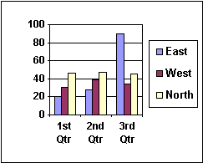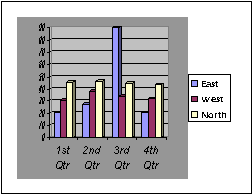

Module 3 - Finance Chapter 9 – Pitching Capital Providers

3.9.6 HOW CAPITAL PROVIDERS EVALUATE PROPOSALS

The following metrics were derived from surveys of lenders and investors. Capital providers may look at thousands of proposals a month and spend at most 5 to15 minutes deciding to place each in the reject or consider pile. They will generally look first at the Problem-Solution and Product-Market Fits. If compelling at face value, they will then turn to the Management Team, and study this like a resume. (Would they hire this team to run the company?) And next, the financials to see if the projections are attractive.

PRODUCT
- □ FOCUSED ON A COMPELLING PROBLEM THAT IS INTENSE AND FREQUENT
- □ ATTRACTIVE SOLUTION
- □ COMPETITIVE ADVANTAGE THAT IS SUSTAINABLE (Difficult to replicate)
- □ IMPROVES RAPIDLY WITH CUSTOMER FEEDBACK
- □ BUSINESS MODEL IS REPEATABLE, SCALABLE AND PROFITABLE
- □ COMPANY HAS TRACTION: BUSINESS CONCEPT HAS BEEN VALIDATED BY REPEAT
SALES AND CONSISTENT GROWTH OVER TIME IN BUSINESS
- □ DEVELOPMENT STAGE. The further advanced the company along the development path,
the lower the risk to capital providers. Idea > Prototype > Lab Testing > Beta (Customer)
Testing > Sales > Repeat Sales > Profit > Break even.
COMPETITION
- □ NUMBER AND STRENGTH OF COMPETITORS. (Goodness is being first to market.)
MANAGEMENT TEAM
- □ BUSINESS PLAN IS CLEAR AND CREDIBLE
- □ OWNER(S) HAVE KNOWLEDGE OF INDUSTRY AND RECORD OF PERSONAL SUCCESS
- □ THE MANAGEMENT TEAM IS COMPREHENSIVE: CEO, CMO CFO. Members have proven
executive skills.
- □ OWNERS WORK AS A TEAM and all are equally committed.
- □ OWNERS ARE “COACHABLE”: OPEN TO ADVICE.
- □ OWNERS HAVE (OR WILL HAVE) ENOUGH PERSONAL FUNDS AT RISK for failure to
be painful. They will not cave when the going gets tough
MARKET
- □ DEFINED MARKET NICHE
- □ PROSPECTS CAN BE EASILY FOUND AND REACHED ECONOMICALLY
- □ MARKET SIZE FOR PRODUCT (Not total industry GDP). Is market size adequate to
meet projections? Angel investors will expect an attainable market potential of at least $50
million, for some VCs use $1 billion is the threshold.
- □ MARKETING DATA IS CONVINCING AND VERIFIABLE. Third-party validation is a plus.
- □ MARKETING MATERIALS ARE PROFESSIONAL.
Module 3 - Finance Chapter 9 – Pitching Capital Providers

FINANCING
- □ FINANCIALS ARE COMPLETE, RELEVANT AND ACCURATE
- □ SALES ARE EASY TO FORECAST ACCURATELY AND ARE BACKED UP BY DATA
- □ IT’S CLEAR HOW THE COMPANY WILL MAKE MONEY
- □ AMOUNT OF CAPITAL REQUIRED TO REACH NEXT PLATEAU. (The greater the capital
requirement, the greater the risk.)
- □ REALISTIC ABOUT AMOUNT OF CAPITAL NEEDED. Asking for too little (and running
out of cash) is as bad as asking for too much (and incurring crippling interest payments if
a loan; or putting more investor funds at risk than necessary if equity capital).
- □ REPAYMENT PLAN -- IF A LENDER. Credibility of plan to repay the investment
and interest in time allotted. EXIT STRATEGY – IF AN EQUITY INVESTOR.
- □ BARRIERS TO ENTRY: THE INVESTMENT IS PROTECTED.
Additional Criteria Used by LENDERS
- □ CREDIT SCORE SHOWS HISTORY OF GOOD FISCAL MANAGEMENT. Lenders will
generally expect you to personally guarantee loans.
Additional Criteria Used by EQUITY INVESTORS
- □ CONCEPT IS DISRUPTIVE, A GAME CHANGER. MOON SHOT!
- □ POTENTIAL ROI AS COMPARED TO OTHER INVESTMENT OPPORTUNITIES. If there are
two competing investments with a $10 million profit potential within 5 years, and one requires
$1 million to launch, and the other $2 million the less risky option will be preferred.
If you have evaded the reject bin, the next step will be a deeper dive into the proposals and if it still ranks in the top 2%, to invite you in for Q&A. Capital providers will then move to Due Diligence to verify information in the proposal.

HOW CAPITAL PROVIDERS EVALUATE PRESENTERS
There is a reason lenders and investors want to see you in person. They have realized that the jockey is more important to success than the horse. Here is what they look for:
- ARE YOU DRESSED LIKE A CEO?
- DO YOU MAKE EYE CONTACT?
- DO YOU SMILE? Sense of humor?
- ENERGY! PASSION! LEADERSHIP!
- RELAXED, CONFIDENT?
- KNOWLEDGEABLE ABOUT INDUSTRY AND YOUR OWN PLAN?
- ABLE TO THINK ON FEET. FLEXIBLE?
- OPEN TO ADVICE?

Launching a New Venture

Ninth Edition

Module 4
Business Planning

Content and Style

Entrepreneurship Foundation, Inc.

Module 4 - Business Planning Chapter 1 – Business Plan Outline

4.1 – Business Plan Outline

After you have discovered a sustainable business model and battle-tested it with the lean launch of a Minimum Viable Product (MVP), you will need to prepare a thorough Business Plan to convince lenders and investors that their funds will be returned, and with the expected ROI.

4.1.1 Executive Summary

4.1.2 Product or Service

4.1.3 Market Size (Sales Potential)

4.1.4 Marketing and Sales Strategy

4.1.5 Competition

4.1.6 Barriers to Entry (Protecting Your Market Niche)

4.1.7 Risk Analysis

4.1.8 Production (Operations)

4.1.9 Management

4.1.10 Human Resources

4.1.11 Finance

4.1.12 Resources Needed to Launch Business

4.1.13 Capital Requirement

4.1.14 Appendices

Module 4 - Business Planning Chapter 1 – Business Plan Outline

4.1.1 Executive Summary

TABLE OF CONTENTS (1 page). Number pages to make it easy to find information.

EXECUTIVE SUMMARY (2-5 pages). Investors are looking for clear, compelling and credible information to have confidence in you and your idea. Write this section last. Be concise but cover all the bases. (Lengthy explanations and examples should be left to the body of the full plan or the appendices.) Cover the same information as you would in a three-to-eight-minute oral presentation.

- Business Description.
- Indicate whether the plan is for a start-up, purchase of an existing business, or expansion of a business you own. If the business is a franchise, so indicate and include a copy of the Franchise Agreement in the appendices to your business plan.
- Legal form of ownership: sole proprietor, LLC, partnership, corporation, etc.
- Brief description of product or service.
- Development stage of the product or service
- How you will make money (The business model)
- If expanding an established business, also include the following:
  - years in business,
  - number of employees,
  - growth rate, and
  - current sales volume
- Market opportunity. Define the potential customers in your market niche and the pain they are experiencing without your product.
  - Your solution to this customer problem; and the amount of money, aggravation, and time your product will save the customer.
  - Market growth trend
  - Sales potential within five years (number of customers and annual dollar volume)
  - Competitive advantage
  - Marketing and sales strategy
- Management team credentials (relevant training and successful experience)
- Amount of funding requested and intended use of the capital
Module 4 - Business Planning Chapter 1 – Business Plan Outline

4.1.2 Product or Service
(2-4 pages)

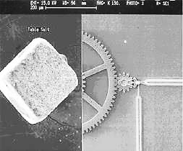
Describe your product or service and its important features. Include a photo or drawing if helpful to understand product and its unique characteristics.

What are the benefits your product provides to the customers in your target market? And more to the point, what urgent need or desire does your product fulfill?
Microelectromechanical Biopump.
Grain of table salt shown for size comparison.

4.1.3 Market size (sales Potential)
(1-2 pages)

Market Niche. It is difficult to take on the whole world. When planning your company, look for a market niche to target, a portion of the market in which you have a unique advantage; or a small corner of the market largely overlooked or underexploited by the competition. Some submarkets are just too small for a Microsoft or General Electric to bother with; but might provide adequate income for a young lean enterprise.

The book publishing industry, for example, has many niches. There is a worldwide market for books; but sports books would be a niche, albeit a large niche, and still tough to break into. Books on fishing would be a narrower niche and one in which it would be easier to establish a beachhead, fly fishing narrower still.
Describe your market niche, your target customers, their characteristics and geography (i.e. - their demographics).

FOR CONSUMER PRODUCTS OR SERVICES, demographics often include:
- Age
- Gender
- Location
- Income level
- Occupation
- Education
- Other (specific to your industry)

FOR BUSINESS CUSTOMERS, demographic factors include:
- Industry
- Location
- Size of firm
- Other (specific to your industry)

Module 4 - Business Planning Chapter 1 – Business Plan Outline

Size of Market Niche (Initial Sales Potential). Define the size of your target market and provide evidence that the market is as large as you claim. Your market research data will be the basis of the sales projection and therefore the income projection of the company. Be specific: give numbers and sources. (Potential investors will want to double-check your information. This is called Due Diligence, the process of making sure everything in your plan is accurate.)
- Number of customers and the amount they spend annually.
- Percentage of the market you have now and that you realistically expect to capture within 3-5 years.
- Obstacles you must surmount to achieve a) break even, and b) full potential. Examples might include:
        - Consumer acceptance and brand recognition. (There are hundreds of superior mousetraps in the annals of the patent office, but no one is beating a path to the doorways of the inventors. Humans are creatures of habit. They buy the familiar, not the new and untested, in spite of marketing claims.)
        - Unique technologies and patents of competitors
        - Union restrictions
        - Shipping costs (The Internet pet supply company, Pets.com, failed because the cost of shipping dog food made them more expensive than the local pet store. Glib sock puppets will not compensate for a defective strategy.)
        - Tariffs and quotas
- How you will overcome the barriers

Sources For Substantiating Data
- Amazon Sales of Similar Products. Amazon typically lists the number of products sold in the prior month. Ideally, track the sales over time. Is it seasonal?
- Trade journals. Every industry has one or more periodicals. Check the business reference department of your local library or the web. The trade publications will often include information about market conditions in the industry. How many subscribers does the magazine have?
- Professional Societies. Research the associations your customers might join. How many members do they have? How many in your area? Is the organization growing?
- Trade shows. Attending a trade show for your industry will provide useful information and insights into trends. How many people were at the event? Were the aisles packed with buyers? Which booths were attracting the most attention? Why do you think that was and what does this suggest for the potential for your chosen market niche?
- Census data will provide demographic profiles in your area. See https://www.census.gov/data.html.
- Mail List Companies know the number of people by title within any geographic area or group of zip codes. (There will not be a charge for the list providers to tell you how many companies or consumers are in a particular demographic.)
- Traffic Monitoring. Who will be your main competitors and how many cars/pedestrians flow past their establishments in an average day?
Module 4 - Business Planning Chapter 1 – Business Plan Outline

4.1.4 MARKETING AND SALES STRATEGY

How will you capture the market share necessary to meet sales projections?

Advertising and Promotion. How will customers find out about your product, its features and benefits? This is especially critical if you are relying on intermediaries (e.g. - retail stores, wholesale distributors, or contractors) to sell your product. Advertising channels might include some or all of the following:
- Print advertising (magazines and newspapers)
- Radio and TV advertising
- Web advertising
- Guerrilla marketing (spreading the word through word-of-mouth). This works in a tight-knit community of buyers
- Direct mail (Indicate where you will obtain lists of prospects)
- Trade shows

Indicate how much you plan to spend on each marketing channel …
- At startup to establish the brand
- Annually thereafter
Corporate Identity Program. Do you have graphic design standards to project the necessary image consistently? Components of a design program that impact a company’s image include:
- Logo,
- Website,
- Print material (business cards, brochures, etc.)
- Signage,

Distribution Channels. (How will you sell your products or services?)
- Directly to consumers (mail order, Web, catalog)?
- Through retail stores?
- Through wholesalers?
- Through your own sales force?
- Through manufacturers’ reps?
- By bidding on contracts?

Credit Policies.
- Will you need to extend credit to customers?
- If so, what policies will you have about how much credit to extend and for how long?
- How will you check the creditworthiness of new applicants?
- How will you collect from slow-paying customers?

Module 4 - Business Planning Chapter 1 – Business Plan Outline

Sales Forecast

Now that you have described your products, services, customers, markets, and marketing plans in detail, you’re ready to attach some numbers to your plan. Entrepreneurs Magazine has extensive information on annual sales as well as startup costs for various franchises at www.Entrepreneur.com.

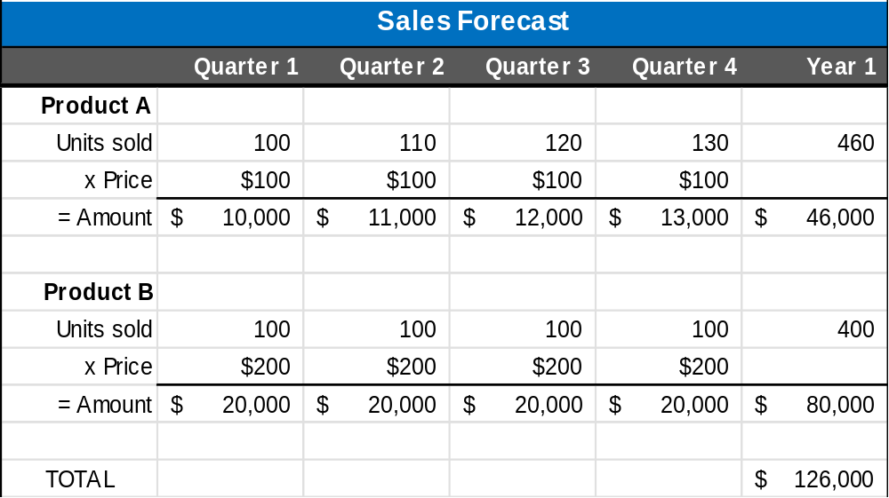

You may want to prepare two forecasts:
- Best guess – what you really expect, and
- Worst case – low estimate that you are confident you can reach no matter what happens.
Keep notes on your research and your assumptions as you build this sales forecast. Investors will grill you on your assumptions.

Obviously, it helps to have some hard data based on market testing, an analysis of the sales of similar companies. The comparative sales should be based on other startups or early-stage companies. Basing your sales forecast on the sales experience of Microsoft or GE is not realistic.

Here are two empirical methods of forecasting sales that are based on more than wishing and hoping, and therefore more believable to investors or lenders:

- RELATIONSHIP BETWEEN SALES AND ADVERTISING DOLLARS. If, for example, you can show that an $8000 two-week radio campaign in one market resulted in sales of $100,000, it is reasonable to presume equal results from the same advertising budget in a city of similar size. However, check to make sure the station listener demographics (especially family income) are the same as for the test campaign, and that the ads will run at the same time on the same days of the week.
- Similarly, if you show $100,000 in sales worldwide from a purchase of $10,000 of Google ad words, you may correctly project sales of $1 million dollars with an investment of $100,000 for an identical marketing effort, assuming no seasonal variation in the marketplace. Be aware that investors will want proof that you have the resources to produce, deliver, and service 10x the number of goods or services as in the trial, while maintaining the same level of quality, service and customer satisfaction.

Module 4 - Business Planning Chapter 1 – Business Plan Outline

Excel Sales Trend Function. Excel can project future sales based on a mathematical analysis of prior sales, using the “least squares” method.

a) START BY PREPARING A SIMPLE TWO-COLUMN FILE OF PAST SALES. You can record unit or dollar sales. In this example, we have used unit sales. In the left column, indicate the time interval you wish to use: (week, month, quarter, or year). An established company might use yearly sales, whereas a recent startup might only have weeks or months of actual data.

b) HIGHLIGHT THE CHART DATA,
INCLUDING HEADINGS.

c) CLICK ON THE “INSERT” TAB,

RIGHT CLICK ON THE “SCATTER CHART.”

SELECT THE PLOT POINTS ONLY VERSION


Excel will create the chart at left.

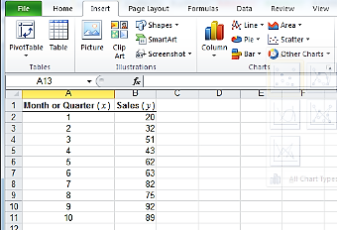

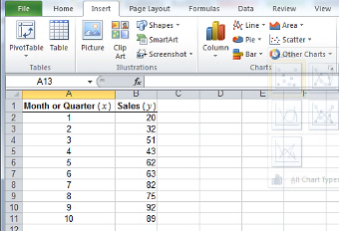
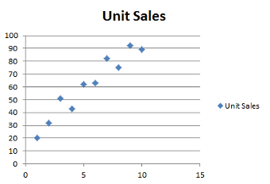

Module 4 - Business Planning Chapter 1 – Business Plan Outline

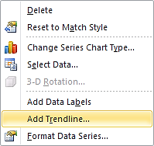
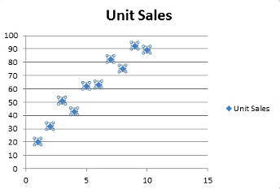
d) RIGHT-CLICK ON ONE OF THE DATA POINTS in your chart.

SCROLL DOWN ON POP-UP WINDOW AND CLICK ON “ADD TRENDLINE.”

e) A “Trendline Options” window will appear.

SELECT THE “LINEAR” LINE OPTION

NAME THE CHART

SELECT THE NUMBER OF TIME PERIODS YOU WOULD LIKE TO FORECAST. In the example we selected 6 [months].

We also suggest you check the “Display Equation on chart” option so that you can estimate unit sales based on the derived formula; and check the “Display R-squared value on chart” as this will indicate to your readers the validity of the forecast.

An R-value near .99 is considered reliable.
Of course that is in the predictable world of mathematicians. You’re an entrepreneur embarking on the seas of uncertainty, so do not assume the fates will cooperate.

Your final chart should look something like the one at left. Using the displayed formula, the unit sales (y) for the example company can be computed for a future month by multiplying the month number (x) by 7.7515 and adding 18.267 (which is called the “y-intercept,” the value where the line intercepts the y or vertical axis).
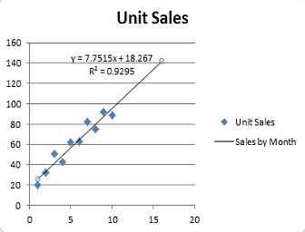
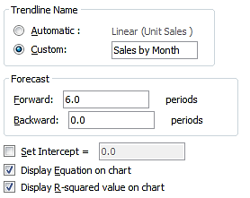
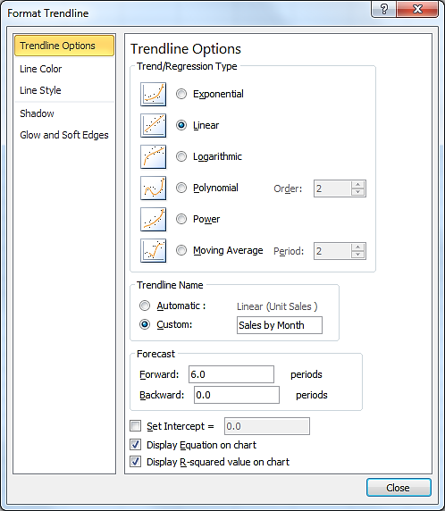
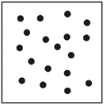
To verify the validity of your forecast, check the R value. The lower the number (.99 is high), the less reliable the results. You can also tell pretty quickly just by reviewing your scatter chart. If it looks like the one at right, the R value will be close to zero, and the data meaningless for
predicting future sales.
Module 4 - Business Planning Chapter 1 – Business Plan Outline

4.1.5 COMPETITION

(2 pages)

List the significant competitors in your niche, with their locations.

Also show alternatives to your product. If there is a way customers can solve their problem or satisfy their need without your type of product, this should be noted. For example, if you run a live music venue, you would probably compare your operation to other clubs. However, movie theaters that show movies of live shows and streaming services are also competition. Even other non-music entertainment venues will impact your sales.

What are the Market Drivers? Determine what product differentiators drive customer decisions. Criteria might include some of the following variables.
- Price
- Quality
- Range of choices
- Service and Support
- Reliability
- Expertise and Reputation
- Location
- Credit Policies
- Advertising budget

Analyze each competitor, summarizing its strengths and weaknesses, especially as regards the above critical customer decision-making factors.

Competitor | Strengths | Weaknesses
A

B

C

D

Module 4 - Business Planning Chapter 1 – Business Plan Outline

4.1.6 BARRIERS TO ENTRY (Protecting your market niche)

(1 page)

How will you keep competitors from entering your market with similar products? Barriers can include:

- Patents
- Exclusive contracts with sole suppliers of critical components
- Long-term contracts with customers
- A long product development cycle. For example, a complicated software program that would take someone else at least two years to reverse-engineer, test and deploy. This would provide two years for you to build brand loyalty.
- Significant first-mover advantage. For example, anyone can offer to sell books online, but Amazon has had such a long head start that it would be difficult to entice many of its customers to switch to a new online supplier.

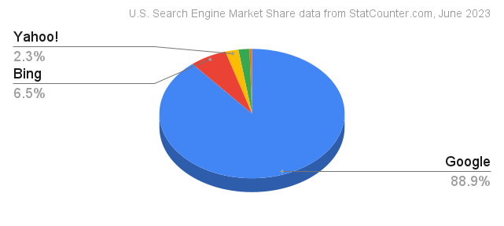
You may have invented a search engine that is preferred 2-to-1 over Google in focus-group testing, you’ll still have a daunting battle to attract users now using Google. Humans are creatures of habit. Even Microsoft, with its huge war chest and marketing resources, has barely chipped away at Google’s lead. In fact, Bing has even slipped since this 2023 study. According to gs.statcounter.com, as of April 2025, Bing has slipped to under 4% of search-engine market share and Google had climbed above 90%. All other search engines worldwide made up the remaining 6% of usage. Moral: pick a competition battle you have a chance of winning.

Module 4 - Business Planning Chapter 1 – Business Plan Outline

4.1.7 RISK ANALYSIS

(2-4 pages)

Potential Risks (“Anything that can go wrong will” – Murphy).
- Human resources risks. Is there an adequate supply of labor available with the skills you require at a wage you can afford to pay?
- Will new employees require training? How long will the training take and what will it cost?
- Technology risks. What theoretical technologies could overtake you if they become practical realities?
- Economic risks. What happens to your company in a recession or inflationary cycle? Do you need to borrow money regularly because your business is cyclical, like the fashion industry or toy sales? If so, what would happen to your bottom line if interest rates doubled in a year?
- Society risks. Do you have a strategy to mask your forecasts from effects of the next pandemic?
- Political risks. What happens to your power plant in Bali if there is a coup?
- Competitive risks. What happens if you really are wildly successful and Bigco decides your niche is valuable after all.

Adversity Preparedness
Just as the weather bureau needs to monitor new developments that might turn into natural disasters, you need to keep an eye out for the winds of change in your key technologies, consumer behavior, and the economic climate in general. An effective early warning system can help you minimize any negative impact.
Imagine the worst thing that could happen to your company or your customers or the country, then figure out what you could do to survive that catastrophe. Is there a prudent change you might make to your business plan to reduce your susceptibility to this contingency? Perhaps plan to raise more equity capital so that you are not overly dependent upon the debt market to perpetuate your company. The lack of emergency preparedness has sunk many a venture.
Include in your plan the steps you would take to respond to changes in ...
- Consumer preferences
- Technology. Can AI perform the same function as your service business cheaper and faster?
- Government regulations
- The economy (How would you retrench if you only achieve half the sales you forecast for year one?)
Module 4 - Business Planning Chapter 1 – Business Plan Outline

4.1.8 PRODUCTION (OPERATIONS)
(2-4 pages)

- How and by whom is your product or service to be produced? What portions of the product or service will you produce “in house”; what components will be produced by subcontractors?
- How reliable is the supply chain?
  - What is the source of each critical component and raw material?
  - How reliable are the subcontractors?
  - Are they in economically and politically stable countries?
- Are supply costs steady or fluctuating? If fluctuating, how would you deal with changing costs?
- Production capacity of your space and equipment
  - Planned production level
  - Break-even production level
- Quality control
  - What procedures will you use to establish and monitor quality standards?
  - Who will provide customer service? (Not every customer will understand your written instructions for how to assemble their mini home nuclear reactor. Expect calls.)
- What R&D processes will need to be continued and for how long?
- What type and level of inventory will you need to maintain? (raw materials, supplies, finished goods).
  - Average monthly value (your inventory investment)?
  - Annual turnover rate and how it compares to the industry averages?
  - Seasonal buildups?
  - Lead-time for ordering?

Module 4 - Business Planning Chapter 1 – Business Plan Outline

4.1.9 MANAGEMENT

(1-2- pages)

Management Team
New businesses are usually dependent upon the enthusiasm, dedication, special expertise and contacts of their founders. List the key management positions and the qualifications and relevant education and experiences of the individuals that are filling these critical roles (or who will fill the positions once the company is funded.) Bases that need to be covered, at a minimum, are:
- CEO (Chief Executive Officer). As the top manager, the CEO is typically responsible for the entire operations. Indicate prior successful management experience in growing a similar company.
- CMO (Chief Marketing Officer). Indicate prior sales experience with similar products and key contacts the CMO has with buyers in the industry.
- CTO (Chief Technology Officer). What evidence is there that this individual has the expert knowledge of how to produce the product or deliver the service.
- CFO (Chief Financial Officer). the CFO is responsible for analyzing and reviewing financial data, reporting financial performance, preparing budgets and monitoring costs. Business failure is often related to mismanaging cash flow, failing to monitor accounts receivable adequately, inaccurate budgeting, poor purchasing practices, or failure to meet government reporting and compliance regulations. Indicate education and relevant experience of the CFO.
What measures will be taken to ensure the survival of the business if it loses one of the key managers? For example, will you have key person insurance to at least refund investor money if you lose someone critical to the success of the venture. You have a restaurant named for your celebrity chef and he dies from food poisoning …

Professional and Advisory Support.
List any of the following that you have or plan to retain:

- Corporate Attorney (who advises you on contracts, investor deals, and legal structure)
- Intellectual Property Attorney (who makes sure your important patents and trademarks are bullet proof)
- Accountant
- Insurance agent
- Banker
- Board of directors (Indicate members with relevant experience, expertise or valuable contacts)
- Advisory board (Indicate members with relevant experience, expertise or valuable contacts)
- Mentor
- Consultants
Module 4 - Business Planning Chapter 1 – Business Plan Outline

4.1.10 HUMAN RESOURCES
(1-2 pages)

At least half the operating cost of most businesses is personnel.

- Ultimately, how many people will you need and what skills must they have for you to…
  - Get started?
  - Reach break-even?
  - Meet your five-year projection?
  - Meet ultimate sales potential?
- How do you know these human resources are available?
- Where/how will you recruit the workers you will need?
- What is the cost per hour and per year for each type of worker?
- Will you have to provide benefits in order to compete for these workers?
  - What benefits will you provide?
    - Health Insurance?
    - Dental?
    - Paid vacations?
    - Retirement plan?
  - What will this cost?
- Will they need training?
  - Who will provide necessary training?
  - What will this cost?
Determine how much you will need to live on. Your living expenses will need to be included in your start-up capital (unless you plan to keep your day job). We recommend that you do obtain alternate means of paid employment until your business is self-sustaining. Not only is it unlikely that you will be able to withdraw money in salary or dividends for some time, but you will probably need to periodically pump new funds into the business until it can sustain itself. See https://entrepreneurshipfoundation.org/spreadsheets for a downloadable personal budget worksheet
Note that investors and lenders will scrutinize your salary budget and may turn you down if they feel you are expecting a lifestyle too luxurious at their expense. They expect you to tighten your belt.

Human Resources Requirements Worksheet
EMPLOYEE CATEGORY | Number Needed | Annual Wage  per Employee | Taxes and benefits ** | Total Annual Cost  per Employee
** As a rough rule of thumb, add 10% for payroll taxes; 30% if you also provide health insurance.
Module 4 - Business Planning Chapter 1 – Business Plan Outline

4.1.11 FINANCE
(5 pages)

The finance section consists of a 5-year Profit and Loss Projection, Cash Flow Forecast, and Capitalization Table. These documents are necessary for investors to evaluate the reasonableness of your plan.
A Profit and Loss projection should be accompanied by a narrative explaining the major assumptions used to estimate company income and expenses. Keep careful notes on your research and assumptions, so that you can explain them during interviews with skeptical investors. A free Budget Worksheet in the form of an Excel document is downloadable from https://entrepreneurshipfoundation.org/spreadsheets

EMPLOYER TAX RATES (as of 2025). You’ll need to factor these taxes into your management and labor costs.

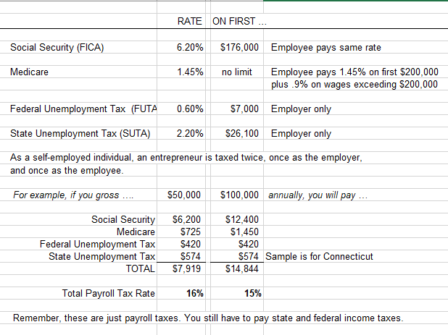

The above SUTA rate is an example. To find SUTA for your state, see
https://www.paycom.com/resources/blog/suta-taxes-heres-what-you-need-to-know/

Module 4 - Business Planning Chapter 1 – Business Plan Outline

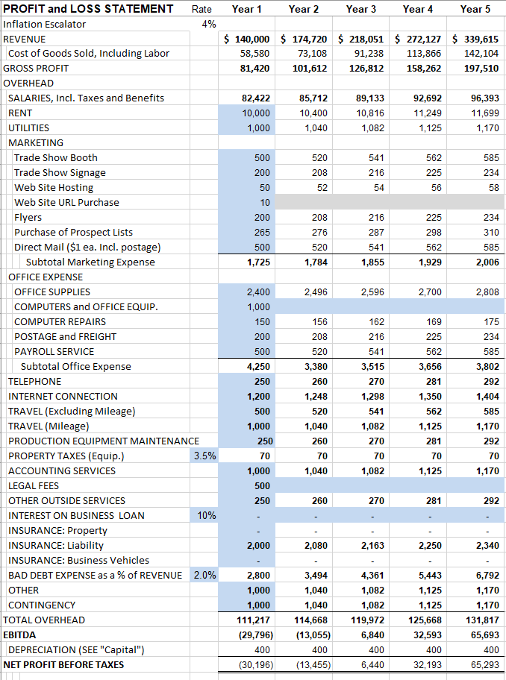
Sample of P&L spreadsheet available at https://entrepreneurshipfoundation.org/spreadsheets
Module 4 - Business Planning Chapter 1 – Business Plan Outline

A Cash Flow FORECAST will tell you how much capital you will need to start the business. Explain your major assumptions, especially where the cash flow differs from the Profit and Loss Projection. For example, if you make a sale in month one, when do you collect the cash? Probably the same month if a retail store; but perhaps month two or three if a service business. Depreciation should not appear on a Cash Flow Forecast. (You will not write a check for depreciation.) However, the full purchase price of capital equipment should appear in the Forecast. A Cash Flow spreadsheet may be downloaded from https://entrepreneurshipfoundation.org/spreadsheets

CAPITALIZATION TABLE (Cap Table). The amount of new capital you expect you will need at each stage of development, and the share of ownership of the founders and outside investors upon founding and after each round of financing. As new capital is invested the percentage ownership of prior investors is reduced, or “diluted” by the new investment. A Cap Table may be downloaded from https://entrepreneurshipfoundation.org/spreadsheets
THE BREAK-EVEN ANALYSIS shows the sales volume, at a given price, required to cover total costs. In other words, it is the sales level that is the dividing line between operating at a loss and at a profit:
Unit Sales to Break Even = Fixed Overhead Costs / (Selling price - Cost per unit)

For example, if your product sells for $100, and the variable cost to produce each unit is $40, and your overhead costs are $100,000, the BREAK-EVENT POINT is …

Unit Sales to Break Even = $100,000 / ($100-$40) or 100,000 / $60 = 1667 Units

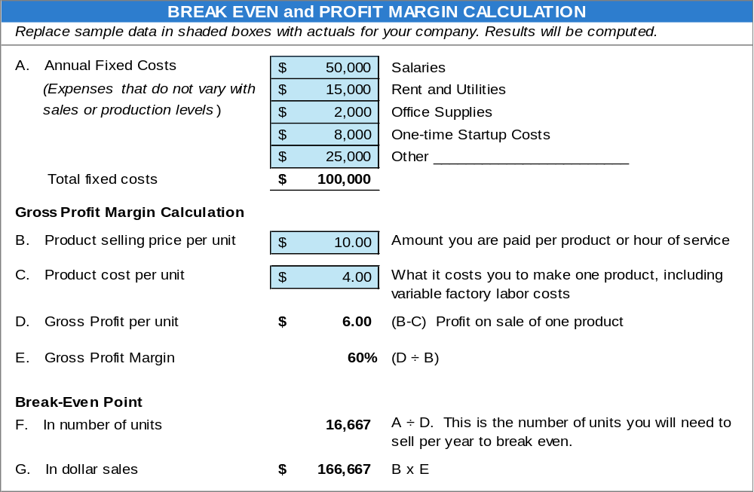

This Break-Even Calculator may be downloaded from https://entrepreneurshipfoundation.org/spreadsheets

Module 4 - Business Planning Chapter 1 – Business Plan Outline

4.1.12 RESOURCES NEEDED TO LAUNCH BUSINESS
(1-2 pages)

Space

BUSINESS-TO-Consumer (B-C) VENTURES. Location is particularly important for retail, restaurant or consumer services since customers must come to you. The location must obviously be convenient and project the proper image for your target clientele. Indicate your intended place of business:
- Physical address. Include a map with the location marked.
- Access (Is it convenient to transportation arteries?)
- Number of parking spaces
- Size (square footage)
- Amenities
- Type of heat and air conditioning
- Does it conform to government requirements for your industry?
  - Zoning laws
  - Building codes
  - Health department regulations
  - Handicap access
  - Fire codes
- Interior design. (Does space need extensive remodeling?)
Business-to-Business (B-B) Enterprises. A factory or warehouse might not need to meet high standards for ambience, but there are efficiency and cost considerations. Is it all on one floor, or will you have to move goods up and down elevators? Is it accessible to tractor-trailers? How close is the turnpike entrance? Indicate the physical characteristics of the intended space:
- Amount of space (square footage)
- Type of construction and age
- Zoning restrictions
- Power supply
- Heating system

Equipment
- What equipment will you need?
- Will you lease or buy? Why?
- What will the equipment cost?

Intangibles
- Licenses
- Bonding, if required
- Insurance
- Trademarks and copyrights
- Patents

Personnel (See “Human Resources” section.)

Module 4 - Business Planning Chapter 1 – Business Plan Outline

4.1.13 CAPITAL REQUIREMENT

(1 page)
Divide the capital requirement into periodic tranches. Investors prefer to mete out cash when (and if) interim goals are met. The tranches may be annual, semi-annual, or based on important milestones, such as receiving a patent, demonstrating a working prototype, or concluding the first sale.

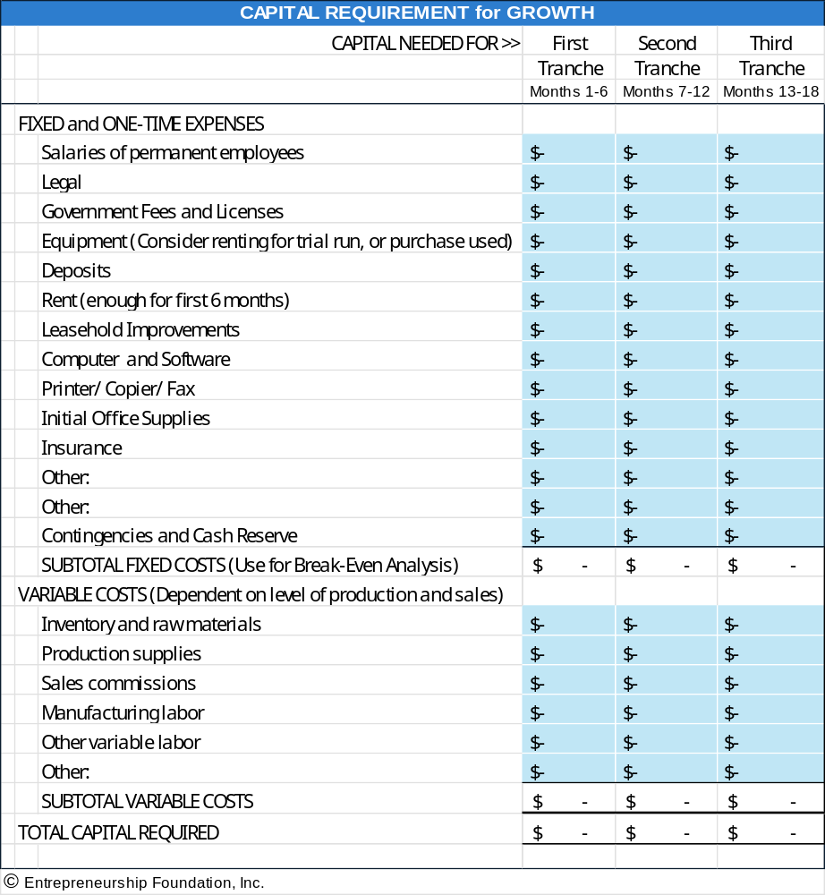
Module 4 - Business Planning Chapter 1 – Business Plan Outline

4.1.14 APPENDICES

- Brochures and advertising materials
- Industry studies or articles that support growth predictions
- Letters of endorsement from potential customers
- Any other materials needed to support assertions in the plan

Modify the business plan outline as needed to include the unique factors determining success or failure in your industry. For example, if you are planning a brick-and-mortar retail establishment, a discussion of the planned location and traffic flow would be appropriate to include.

Module 4 - Business Planning Chapter 2 – Bullet-Proofing the Plan

4.2 – Bullet-Proofing The Plan

INVESTORS see thousands of business plans each year. With so many opportunities, most investors focus on finding reasons to say no. Following are the most common errors found in business plans. (© copyright, Cayenne Consulting. www.caycon.com.)

4.2.1 Content Mistakes

4.2.2 Financial Model Mistakes.

4.2.3 Stylistic Mistakes

4.2.4 Execution Mistakes

Module 4 - Business Planning Chapter 2 – Bullet-Proofing the Plan

4.2.1 Content Mistakes

Failing to relate to a true pain. Pain comes in many flavors: my computer network keeps crashing; my accounts receivable cycle is too long; existing treatments for a medical condition are ineffective; my tax returns are too hard to prepare. Businesses and consumers pay good money to make pain go away.
You are in business to get paid for making pain go away.
Pain, in this setting, is synonymous with market opportunity. The greater the pain, the more widespread the pain, and the better your product is at alleviating the pain, the greater your market potential.
A well-written business plan places the solution firmly in the context of the problem being solved.

Value inflation. Phrases like "unparalleled in the industry;" "unique and limited opportunity;" or "superb returns with limited capital investment" - taken from actual documents - are nothing but assertions and hype.
Investors will judge these factors for themselves. Lay out the facts - the problem, your solution, the market size, how you will sell it, and how you will stay ahead of competitors - and tone down the hype.

Trying to be all things to all people. Many early-stage companies believe that more is better. They explain how their product can be applied to multiple, very different markets, or they devise a complex suite of products to bring to market.
Most investors prefer to see a more focused strategy, especially for very early-stage companies: a single, superior product that solves a troublesome problem in a single, large market that will be sold through a single, proven distribution strategy.
That is not to say that additional products, applications, markets, and distribution channels should be discarded - instead, they should be used to enrich and support the highly focused core strategy.
You need to hold the story together with a strong, compelling core thread. Identify that and let the rest be supporting characters.

No go-to-market strategy. Business plans that fail to explain the sales, marketing, and distribution strategy are doomed. The key questions that must be answered are: who will buy it, why, and most importantly, how will you get it to them?
You must explain how you have already generated customer interest, obtained pre-orders, or better yet, made actual sales - and describe how you will leverage this experience through a cost-effective go-to-market strategy.

"We have no competition". No matter what you may think, you have competitors. Maybe not a direct competitor - in the sense of a company offering an identical solution - but at least a substitute. Fingers are a substitute for a spoon. First class mail is a substitute for e-mail. A coronary bypass is a substitute for an angioplasty. Competitors, simply stated, consist of everybody pursuing the same customer dollars.

To say that you have no competition is one of the fastest ways you can get your plan tossed - investors will conclude that you do not have a full understanding of your market.
The "Competition" section of your business plan is your opportunity to showcase your relative strengths against direct competitors, indirect competitors, and substitutes. Besides, having competitors is a good thing. It shows investors that a real market exists.

Module 4 - Business Planning Chapter 2 – Bullet-Proofing the Plan

Too LONG. Investors are very busy, and do not have the time to read long business plans. They also favor entrepreneurs who demonstrate the ability to convey the most important elements of a complex idea with an economy of words.
An ideal executive summary is no more than 1-3 pages. An ideal business plan is 20-30 pages (and most investors prefer the lower end of this range).
Remember, the primary purpose of a fund-raising business plan is to motivate the investor to pick up the phone and invite you to an in-person meeting. It is not intended to describe every detail.
Document the details elsewhere: in your operating plan, R&D plan, marketing plan, white papers, etc.

Too technical. Business plans - especially those authored by people with scientific backgrounds - are often packed with too many technical details and scientific jargon.
Initially, investors are interested in your technology only in terms of how it:
- solves a big problem that people will pay for.
- is significantly better than competing solutions.
- can be protected through patents or other means; and
- can be implemented on a reasonable budget.
All these questions can be answered without a highly technical discussion of how your product works. The details will be reviewed by experts during the due diligence process. Keep the business plan simple. Document the technical details in separate white papers.

No risk analysis. Investors are in the business of balancing risks versus rewards. Some of the first things they want to know are what are the risks inherent in your business, and what has been done to mitigate risk. Key risks of entrepreneurial ventures include:

- Market risks: Will people buy what you have to sell? Will you need to create a major change in consumer behavior?
- Technology risks: Can you deliver what you say you can? On budget and on time?
- Operational risks: What can go wrong with the day-to-day operations of the company? What can go wrong with manufacturing and customer support?
- Management risks: Can you attract and retain the right team? Can your team pull this off? Are you prepared to step aside and let somebody else take over if necessary?
- Legal risks: Is your intellectual property truly protected? Are you infringing on another company's patents? If your solution does not work, can you limit your liability?
This is, of course, just a partial list of risks.
Even if you feel that the risks are negligible, potential investors may feel otherwise, unless you demonstrate that you have given a lot of thought to what can go wrong and have taken steps to mitigate the risks.

Module 4 - Business Planning Chapter 2 – Bullet-Proofing the Plan

Poorly organized. Your idea should flow in a nice, organized fashion. Each section should build logically on the previous section, without requiring the reader to know something that is presented later in the plan.
Although there is no single "correct" business plan structure, one successful structure is as follows:

- Executive Summary: This is a brief, 1-to-3-page summary of everything that follows in the plan. It should be a stand-alone document, as many readers will make their initial decision based on the executive summary alone. This should usually be written last; otherwise, you have nothing to summarize!
- Background: If you are in a highly specialized field, you should provide some background in lay terms since most investors will not have advanced degrees in your field.
- Market Opportunity: Describe how businesses and consumers are suffering, and how much they are willing to pay for a solution.
- Products or Services: Describe what you do, and how your solution fits into the market opportunity.
- Market Traction: Describe how you have succeeded in attracting customers, marketing and distribution partnerships, and other alliances that demonstrate that experts in your market are betting on your solution.
- Competitive Analysis: Identify your direct and indirect competitors and describe how your solution is better.
- Distribution and Marketing Strategy: how you will go to market, how you will price your products, etc.
- Risk Analysis: Identify major sources of risks and describe how you are mitigating them.
- Milestones: Showcase a strong past track record and describe key checkpoints for the future.
- Company and Management: Provide the basic facts about your company - where and when you incorporated, where you are located, and brief biographies of your core team.
- Financials: Provide summaries of your P&L and cash flows, and the assumptions used to come up with these. Also describe your funding needs, how you will use the proceeds, and possible exit strategies for investors.

Module 4 - Business Planning Chapter 2 – Bullet-Proofing the Plan

4.2.2 Financial Model Mistakes.
Forgetting TO PROVIDE A CASHFLOW FORECAST. (Revenues are not cash. Gross margins are not cash. Profits are not cash.) Only cash is cash.

For example, suppose you sell something this month for $100, and it cost you $60 to make it. But you have to pay your suppliers within 30 days, while the buyer probably won't pay you for at least 60 days.
In this case, your revenue for the month was $100, your profit for the month was $40, and your cash flow for the month was zero. Your cash flow for the transaction will be negative $60 next month when you pay your suppliers.
Although this example may seem trivial, very slight changes in the timing difference between cash receipt and disbursement - just a couple of weeks - can bankrupt your business.
Make sure that your assumptions are realistic so that you raise sufficient capital.

Lack of Detail. Your financials should be constructed from the bottom-up and then validated top-down.
A bottom-up model starts with details such as when you expect to make certain sales, or when you expect to hire specific employees.
Top-down validation means that you examine your overall market potential and compare that to the bottom-up revenue projections.
Round numbers - like one million in R&D expenses in Year 2, and two million in Year 3 - are a sure sign that you do not have a bottom-up model.

Unrealistic financials. Only a very small handful of companies achieve $100 million or more in sales only five years after founding.
Projecting much more than that will not be credible and will get your business plan canned faster than almost anything else.
On the other hand, a business with only $25 million in revenues after five years will be too small to interest serious investors.
Financial forecasts are a litmus test of your understanding of how venture capitalists think.
If you have a realistic basis for projecting $50-100 million in Year 5, you are probably a good candidate for venture financing. Otherwise, you should probably look elsewhere.

Insufficient financial projections. Basic financial projections consist of three fundamental elements: Income Statements, Balance Sheets, and Cash Flow Statements. All of these must conform to Generally Accepted Accounting Principles, or GAAP.
Investors generally expect to see five years of projections. Of course, nobody can see five years into the future. Investors primarily want to see the thought process you employ to create long-term projections.
A good financial model will also include sensitivity analyses, showing how your projected results will change if your assumptions turn out to be incorrect. This allows both you and the investor to identify the assumptions that can have a material effect on your future performance, so that you can focus your energies on validating those assumptions.
They should also include benchmark comparisons to other companies in your industry - things like revenues per employee, gross margin per employee, gross margin as a percentage of revenues, and various expense ratios (general and administrative, sales and marketing, research and development, and operations as a percentage of total operating expenses).

Module 4 - Business Planning Chapter 2 – Bullet-Proofing the Plan

Conservative assumptions. Nobody ever believes that assumptions are conservative, even if true.
Develop realistic assumptions that you can support, refrain from using the words "conservative" or "aggressive" in your plan and leave it at that.
Offering a valuation. Many business plans err by stating that their company is worth a certain amount.
If you name a price, one of two things can happen: (a) your price is too high, and investors will toss your plan; or (b) your price is too low, and investors will take advantage of you. Both are bad.
The purpose of the business plan is to tell your story in the most compelling manner possible so that investors will want to go to the next step. You can always negotiate the price later.

4.2.3 Stylistic Mistakes
Poor spelling and grammar. If you make silly mistakes in your business plan, what does that say about how you run your business? Use your spelling and grammar checkers, get other people to edit the plan, do whatever it takes to purge embarrassing errors.

Too repetitive. All too often, a plan covers the same points repeatedly. A well-written plan should cover key points only twice: once, briefly, in the executive summary, and again, in greater detail, in the body of the plan.

Appearance matters. At any point in time, an investor has dozens if not hundreds of plans waiting to be read. Get to the top of the pile by making sure that the cover is attractive, the binding is professional, the pages are well laid out, and the fonts are large enough to be easily read. On the other hand, do not go too far - you do not want to give the impression that you are all style and no substance.

4.2.4 Execution Mistakes
Waiting until too late. The capital formation process takes a long time. In general, count on 6 months to a year from the time you start writing the plan until the time the money is in the bank.

Failing to seek outside review. Make sure that you have a few people review your plan before you send it out - preferably people who understand your market, sales and distribution strategies, the VC market, etc.
Your plan may look perfect to you and your team, but that's probably because you have been staring at it for months. Good, objective reviews from outsiders with a fresh perspective can save you from myopia.

Over-tweaking. You could spend countless hours tweaking your plan in the pursuit of perfection. A lot of this time would be better spent working on your product, company, and customers. At some point, you need to pull the trigger and get the plan out in front of a few investors. If the reaction is positive, and they want to move forward, great. If the reaction is negative (assuming that the investor was a good fit to begin with), then you may have been heading down the wrong path. Get feedback from a couple of investors, and if a general consensus emerges, go back and refine your plan.

Conclusion. It's a tough investment climate, but good ideas backed by good teams and good business plans are still getting funded. Give yourself the best possible chance by avoiding these simple mistakes.
Module 4 - Business Planning Chapter 3 – Professional Writing Style

4.3 – Professional Writing Style

Packaging sells. Writing an easy-to-read proposal is almost as important as the substance of your plan.

Headings -- use headings and subheadings to separate and identify sections. Headings show the organization of the content.

Vocabulary. Do not be sesquipedalian. Use short paragraphs, simple sentences, and short words for readability.

Use active verbs. “Jane saw the disaster,” and not “The disaster was seen by Jane

Use the Grammar Checker in Word.”

Break up monotonous text blocks with simple charts, graphs, tables and photographs to break up the text.

Use Consistent Page Layout

Absolutely, positively no typos.

Avoid orphans: a single word left over at the end of a paragraph. Rewrite the sentence or, if it’s a short word, try kerning.

The previous sentence had one word left over “kerning.”

Here is the sentence again but foreshortened by .01 point of letterspacing (the spacing between letters).
Avoid orphans. A single word at the end of a paragraph. Rewrite the sentence or if it’s a short word, try kerning.

To kern, highlight the line you want to shorten, go to the “Font” menu, select “spacing” and then hit the down arrow once in the “By” window. You can kern the letter spacing by up to .03 points without it being noticeable.

Start each new page with a new section or at least a new paragraph. A paragraph that slops over from one page to the next is a “widow”.

Do not mix fonts. Stick with one type font, Times Roman, Arial, or another business-like typestyle. You can use different sizes of the same font, but do not use less than a 12-point font size for Times Roman, or less than 10 points for Arial. You are reading Arial 10-point text.

Justification. You can align your text with left justification. This will leave a ragged edge on the right side (like the preceding paragraph). Or you can fully justify the text. Full justification (like this paragraph) looks more professional to most people. But full justification is a bit harder to read than left justification.

Alternatively, use Semi-Justification to combine a professional look with easy-to-read text, rewrite your text so it is almost at full justification.

Avoid breaking words (hyphenating) at the end of lines. Rewrite the line or use kerning to remove the hyphen.

Highlighting. Use CAPS, color, font size, Italics and boldfacing. Avoid underlining except to point out negatives. (Sarah is not familiar with models, except for Simplex.)

Use bullet points to present ideas in a list.

Module 4 - Business Planning Final Thoughts

Final Thoughts
Lessons from Successful Investors and Serial Entrepreneurs

1. THREE HEADS ARE BETTER THAN ONE. Based on the experience of business accelerators, teams with diverse skills are more successful than solopreneurs. Empower your staff. Require action but provide coaching. Give your team members ownership of their ideas, and diplomatic immunity from failure.

2. MANAGE YOUR TIME LIKE MONEY. Your business will make demands, but you can still do other things: school, day job, family, and just unwinding.
The trick is budgeting your time. When you were a student you probably did this for homework. Decide how many hours per day or week you want to devote to the needs of the business. Get into a routhine by setting aside a consistent time of day, and place, to work on the business. This makes it easier for others who have a claim to your time and attention. “Kids, when mom is sitting at her desk, she is at work.”

Harvard Professor Kyle Westway advises:
- Prioritize your to-do list. What is really important?
- Put goals and their deadlines on your calendar.
- Then backdate from those deadlines: what has to be done, by what date, to meet ultimate goals?
Check the calendar every night and morning, and adjust as necessary—but meet the deadlines.
- Avoid distractions. Stay focused.
- Work on the most important goal or problem until you cannot progress further until something else happens. Then make that happen.
3. MONITOR THE COMPETITION within your product and service area. Be prepared to zig if they zag.
4. GET HELP. Find a mentor or form an advisory board. Attract and keep the best and the brightest employees. Teams are much more successful than solopreneurs.

"If you want to go fast, go alone. If you want to go far, go together"
- African proverb
“I'm convinced that about half of what separates successful entrepreneurs from the non-successful ones is pure perseverance”

- Steve Jobs

5. LEARN FROM FAILURE through honest introspection. Create an imaginary out of body experience to observe the company and your decisions. Pretend you are a customer or investor.

“The only real mistake is the one from which we learn nothing.”
-- Henry Ford
“Fail fast; Succeed sooner” – Peter Drucker
“Success is survival.” -- Leonard Cohen
6. LEAD BY EXAMPLE: be the top salesperson. Employees, investors and customers will see your confidence and passion; and follow.
7. BELIEVE IN YOURSELF. Nurture the passion that led you to launch the venture.
8. STAY FOCUSED ON THE MOST IMPORTANT GOALS.
9. REMEMBER: HONESTY IS THE BEST POLICY. Your most valuable asset is your reputation.

Nathan Furr, Forbes, February 2, 2012, “Practical Insights on the Management Science of Entrepreneurship”
The Startup Checklist, David Rose, p. 33
Kouzes and Posner, The Leadership Challenge, 5th Ed., p. 172.
The Lean Startup, Crown Publishing Group, 2011
Michael Porter, Competitive Strategy, 1980, p. 35.
https://nlihc.org/oor/about
https://unbounce.com/landing-page-articles
https://www.optimizely.com/optimization-glossary/ab-testing/
Joshua Porter, https://blog.hubspot.com/blog/tabid/6307/bid/20566/the-button-color-a-b-test-red-beats-green.aspx 2017
Entrepreneur.com/article/21774
https://www.entrepreneur.com/article/21774
Jason Calacanis. http://blog.launch.co/blog/how-to-name-your-startup-and-land-the-perfect-domain.html)
Jason Feifer (May 2018). “Did You Pick the Right Name?” Entrepreneur.com (print), p. 28.
www.quantcast.com/top-sites-1
https://www.justia.com/intellectual-property/trademarks/unregistered-trademarks/
Entrepreneur.com/article/21774
https://www.entrepreneur.com/article/21774
Jason Calacanis. http://blog.launch.co/blog/how-to-name-your-startup-and-land-the-perfect-domain.html)
Jason Feifer (May 2018). “Did You Pick the Right Name?” Entrepreneur.com (print), p. 28.
www.quantcast.com/top-sites-1
https://www.statista.com/statistics/272014/global-social-networks-ranked-by-number-of-users/ data as of 2025
https://ignitevisibility.com/much-social-media-influencer-marketing-cost/
Rates gleaned from several sources, including https://influencermarketinghub.com/influencer-rates/ https://www.shopify.com/blog/influencer-pricing#8 https://impact.com/influencer/how-much-do-influencers-charge-per-post/
https://blog.hubspot.com/marketing/email-writing-mistakes-data
https://mailchimp.com/ (2025)
According to digital marketing platform GetGist https://getgist.com/how-to-avoid-spam-filters/
https://fulcrumtech.net/resources/preventing-gmail-from-clipping-your-emails/
https://www.inman.com/next/gmails-spam-filter-is-killing-your-drip-campaign-top-tips-to-get-personal/
https://financesonline.com/email-marketing-statistics/
https://cwiki.apache.org/confluence/display/SPAMASSASSIN/AvoidingFpsForSenders
A 3PL (third-party logistics) provider may also offer procurement, shipping, storage and fulfillment services
https://www.entrepreneur.com/article/288063

