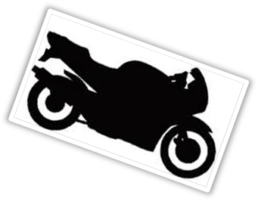

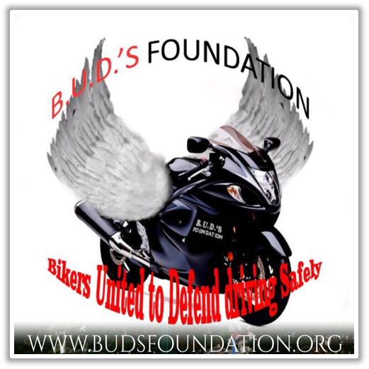
What is B.U.D.’S Foundation?

B.U.D.’S Foundation or Bikers United to Defend Driving Safely is a non-profit tax-exempt organization described in section 501(C)3 of the IRS code (FEIN-ID: 90-0760013) founded September 2011. As a company, B.U.D.’S Foundation is committed to urging the message of safety and responsibility on the roads and in the communities, alike. B.U.D.’S Foundation, founded in 2011, in memory of former Marine Private 1st Class Marcellus Farmer IV also known as Bud. BUD was a Motorcyclist, brother of Mount Hebron Masonic Lodge #42 Wilson NC, and Bridgestone Employee who knew what it meant to be of service to others and often gave of his time, his belongings, and offered his home for those who needed a place of refuge.
  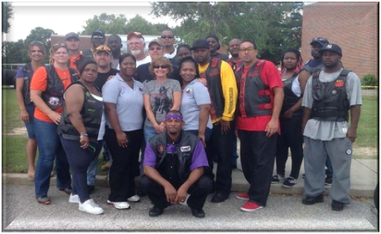
  ENCSD Project Renovation 2013
  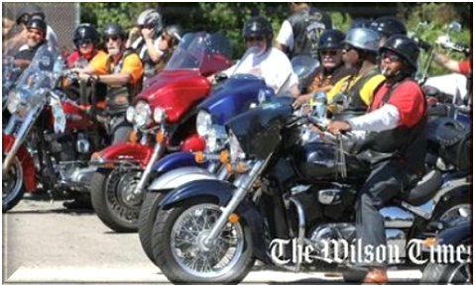
  Fallen Riders Charity Ride Fundraiser 2014
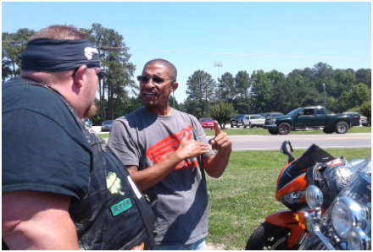  B.U.D.’S Safety Check at Brewer Cycles, Inc. Henderson NC |  |  |  | Our Mission is:  To bring awareness to motorcyclists' safety and educate auto drivers and motorcyclists to be more aware of each other.
To assist motorcyclist victims and their families, whenever financially possible, through donations or gifts when they have expenses due to a fatality or injury from a motorcycle related accident through no fault of their own |  |  |  | 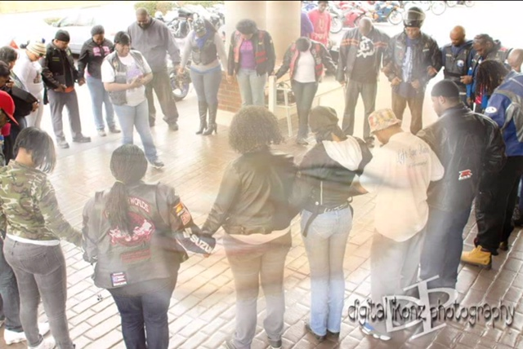  A B.U.D.’S Ambassador offering prayer before charity ride
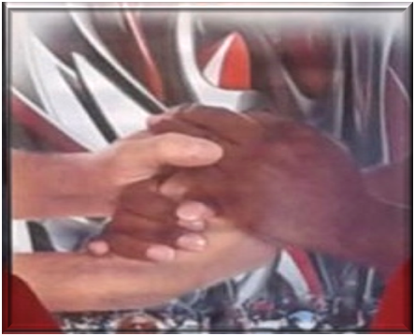 |  |  |  | To assist with locating a supportive counseling for those who are dealing with grief that may not have supportive structure in place; and To issue a one-time donation to the college age child of a fatality victim, whenever possible, when the victim has died in an accident and left behind children who currently are in college. The scholarship is also available to other youth as well.
To administrate seminars to educate the importance of the motorcyclists and vehicle safety. To Secure and distribute contributions from individuals, estates, government, corporations, foundations, and any other source for the educational benefit of the motorcyclists and drivers, more specifically. |  |  |  | 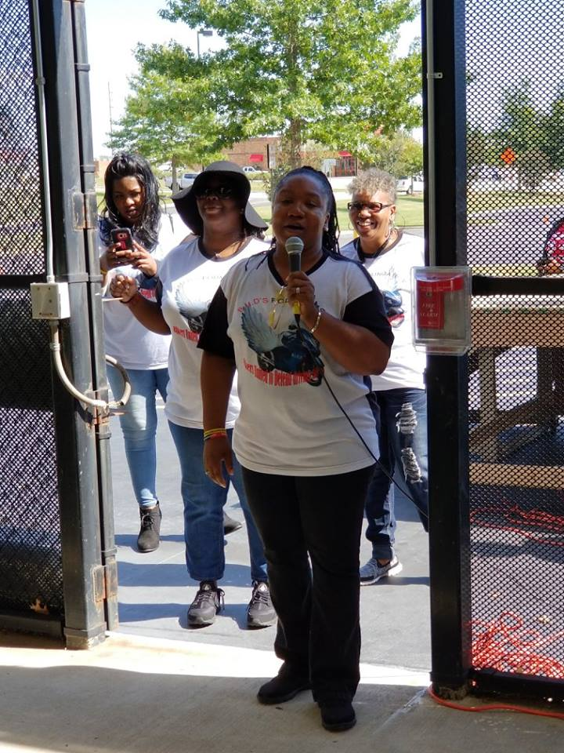  B.U.D.’S Officers conducting Awareness and Safety Seminar

Our Foundation is firmly committed to assisting the riders and their families. Since December 2011, one of our annual projects, B.U.D.’S Foundation’s “Santa on the Bike Toy Run”, is a holiday toy drive to provide Christmas gifts to children in order to assist those parents who were injured (thru no fault of their own), children of fallen fatality rider(s) and those critically ill riders who passed within that calendar year and those community low income youth. The Foundation provides Christmas wish list boxes to each of these children in order to help them have gifts during the holiday season that the injured parent could not afford or in memory of those parents who are no longer here. This past 2018, over 40 children in the communities of Edgecombe County, Wilson County, Wake County, Wayne County, and Myrtle Beach SC each received a box of their Wish List items or a monetary donation in memory of their fallen parent or on behalf of a parent recovering from serious injuries related to a non-fault accident.
In giving back to the community, our foundation also links positive mentoring to these children through other community events. B.U.D.’S has aided in providing afterschool mentoring to feeding low-income, disadvantaged children in many NC and surrounding communities. The foundation also strives to provide a positive environment for school age children. Since our inception, B.U.D.’S Foundation has also partnered with motorcyclists from all over to assist in various projects such as the Eastern North Carolina School for the Deaf “Adopt -A-Room” Renovation project, Wilson NC Lane Street Park Community Yearly Easter Extravaganzas, and community Back to School supply giveaways in addition to the Foundation’s busy schedule to carry out its mission. B.U.D.’S Foundation also urges rider to sign up for motorcycle safety courses with NC Bike Safe and utilizes NC Bike Safe in our annual Safety Awareness Kick Off Events such as the annual B.U.D.’S Foundation Fallen Riders Fundraiser Weekend to be held in September this year. This event recognizes the benevolence of motorcyclists from state to state but mainly to provide financial assistance to those on the road to recovery be it financial, physical, or mentally in locating supportive structure or counseling whenever possible.
This year, your help is needed. The Foundation is asking for your support and sponsorship in the cause of Awareness and Safety while supporting the injured and families of fatality victims. We are asking for your support at this time as we continue to speak on awareness and safety while supporting those in emotional and financial need whenever possible.
This includes those now in need of assistance with medical bills or financial assistance or support structure while out of work as well as this year’s annual fundraiser entitled the B.U.D.’S Foundation Annual Fallen Riders Fundraiser Weekend held in September. Our weekend event includes a Friday Night Meet n Greet where we welcome special guests, introduce ourselves and fellowship with the local riders, families of injured and fallen riders and the community. On that Saturday, we host our Legacy of Giving Day Celebration to include a 200 Plus Biker Charity Ride, a Family Friendly Stunt Show, Food, Fun, Face Painting for children, Vendors, door prizes, B.U.D.’S Clues and DJ just to name a few. We will also be doing educational sessions featuring guest speakers on Saturday.
The B.U.D.’S Annual Legacy of Giving: Fallen Riders Fundraiser Weekend donations are equally divided between the B.U.D.’S Injured Riders Fund, B.U.D.’S Children of Fallen Riders Scholarship Fund and the B.U.D.’S Fallen Riders Fund which assists non-fault seriously injured riders and families of fallen riders post recovery and other expenses such as utilities, mortgage, rent, medical bills, funeral or other expenses as always whenever financially possible. We are humbled to bring this event where we conclude on Sunday with a Breakfast and Fellowship at a local church.
Your company is vital to the motorcycle community and we invite your corporate involvement with B.U.D.’S Foundation. There are many to assist along the way. So your help is needed Right Now! We seek your support towards our vision of motorcycle safety education, family support for injured or killed bikers, and community outreach initiatives. Thank you in advance for your donation and support! YOU DON’T WANT TO MISS BEING A PART OF B.U.D.’S FOUNDATION!
We look forward to hearing from you,
Tracey M. Burnett, President India M. Hussey, Vice President
Email: buds.foundation@yahoo.com Email: bfvp.ops@gmail.com

Benefits of Sponsorship
- Supporting B.U.D.’S Foundation and its events is a cost-effective way for companies, firms, and individuals to gain exposure for their products and services as they support those programs that educate safe driving and awareness for each other on the road.
- Supporting B.U.D.’S Foundation events and publication enhances a company’s recognition within the educational arena for motorcycle and vehicle safety within the vast multicultural communities, strengthens their relations with existing clients, and helps to generate new business.
- Supporting B.U.D.’S Foundation gives businesses and individuals the opportunity to provide support towards the education of a college student who has lost a parent/guardian from a motorcycle related fatality.

As a continuing Sponsor, you are a part of a nationwide initiative by:

- Educating and empowering new and experienced drivers, bike riders, survivors, and community.
- Setting an example of integrity and leadership in advocating safe driving.
- Bringing awareness to relevant issues and effecting an environment for change in the way motorcyclists are viewed.
- Supporting B.U.D.’S Foundation in working to emphasize safety.
- Encouraging community and foundation advocacy through your sponsorship.
- Providing an intellectual platform to educate, nurture, and support other groups or individuals with sponsors who care.

Knowing This, Which Package Below Will You Choose?

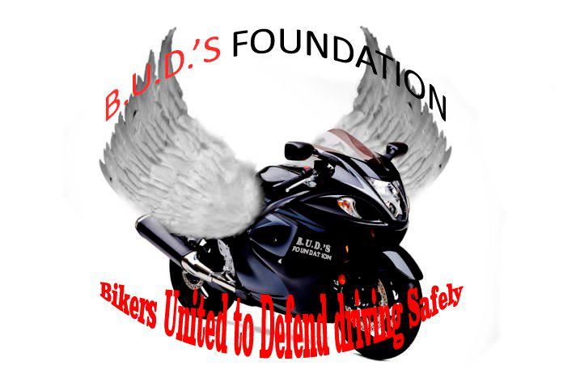  2019 Sponsorship  Package levels:    The Survivor ($1501– $2499)  - Gold-level Sponsorship listing in Newspaper Advertising.  - Sponsorship announcement on Radio & TV Ads/Interviews.  - Promotional items handed out to guests or in giveaway bags at events.  - Business Logo placed on all promotional materials in bags.  - Business listed on B.U.D.’S Foundation website as a sponsor  - Business recognition on B.U.D.’S Foundation Facebook, Twitter, Instagram pages  - Dedicated section about the sponsor’s information on our “Sponsors” page.  - Vendor Table at Annual Event  - Banner Advertisement for Your Business  - Guest Speaker Spot at Annual FRFW |  | The Life Package ($2500 Up)  - Platinum-level Sponsorship listing in event area Newspaper Advertising.  - Sponsorship announcement on Radio & TV Ads/interviews.  - Promotional items placed in giveaway bags and handed out to guests at annual and local events. Business Logo or card included.  - Company banner listing business as sponsor for Safety Demo/Stunt Show  - Guest Speaker Spot at Annual FRFW  - Business listed on B.U.D.’S Foundation website as a sponsor  - Business recognition on B.U.D.’S Foundation Facebook, Twitter, Instagram pages  - Dedicated section about the sponsor’s information on our “Sponsors” page.  - Email Blasts on Community Events and Sponsorship Updates  - Weekly publicity of your business on social media.  
The Safety Package ($500 - $1500)  - Silver-level Sponsorship listing in Newspaper Advertising.  - Email Blasts on Community Events and Sponsorship Updates  - Business recognition on B.U.D.’S Foundation Facebook page  - Promotional items placed in giveaway bags & given to event guests  - Business listed on B.U.D.’S Foundation website as a participating sponsor  - Vendor Table at Annual Event  - Banner Advertisement for Your Business |  | 


The Awareness (up to $500)
- Bronze-level Sponsorship listing in Newspaper Advertising.
- Email Blasts on Community Events and Sponsorship Updates
- Promotional items placed in giveaway bags & given to event guests

.

Sponsorship Application

Print the name of the individual or corporation exactly as you wish for it to appear. Please complete the form below and return by mail or contact us to discuss your contribution. You may also give directly online by credit card or PayPal at www.budsfoundation.org or call toll free 1-800-439-5280.

Contact Name____________________________________________________

Title____________________________________________________________

Organization Name________________________________________________

Address_________________________________________________________
City____________________________State______________Zip____________
Contact Phone ______________________________________________
Email (Required for Email Blasts) ___________________________________
Facebook / Website_______________________________________________
My Sponsorship Package level is: (please put amount)
- The Life Package $__________________
- The Survivor Package $_________________
- The Safety Package $__________________
- The Awareness Package $___________________
IF YOUR SPONSORSHIP IS FOR A Particular Fund, Please indicate
- My sponsorship/donation is for The Scholarship Fund $___________________
- My sponsorship/donation is for The Injured Riders Fund $___________________
- My sponsorship/donation is for The Families of Fallen Riders Fund $___________
If a particular scholarship, rider or child, please indicate___________________________
__________________________________________________________________

Please make checks payable to:
B.U.D.’S Foundation
P.O. Box 1743
Wilson, NC 27894

Thank You for Your Generous Support!

