Below you will find the following reports through 12/31/2024

* 2024 Cash flow report separate upload
* 2024 Expense report
* 2024 Ending account balance
* 2025 Budget

**2024 Expense report by category**

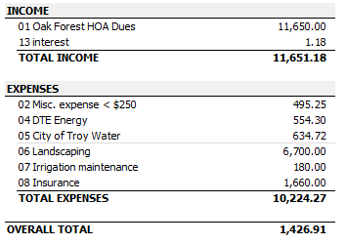

**2024 Account Balances As of 12/31/2024**

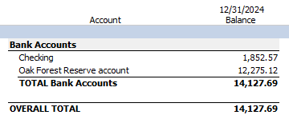

**2024 expenses vs our annual budget**- This will show the annual expenses that are balanced, and will show the remaining funds for each category. Keep in mind this is based on our annual income and expenses; the total budget does not include funds carried over from the previous year.

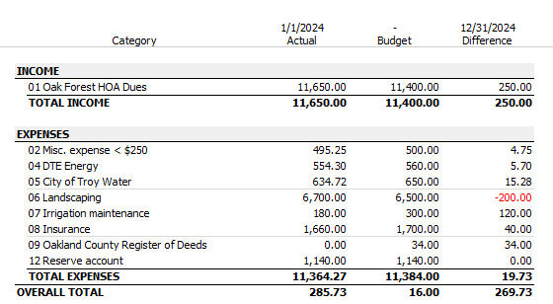

**2025 Budget**

