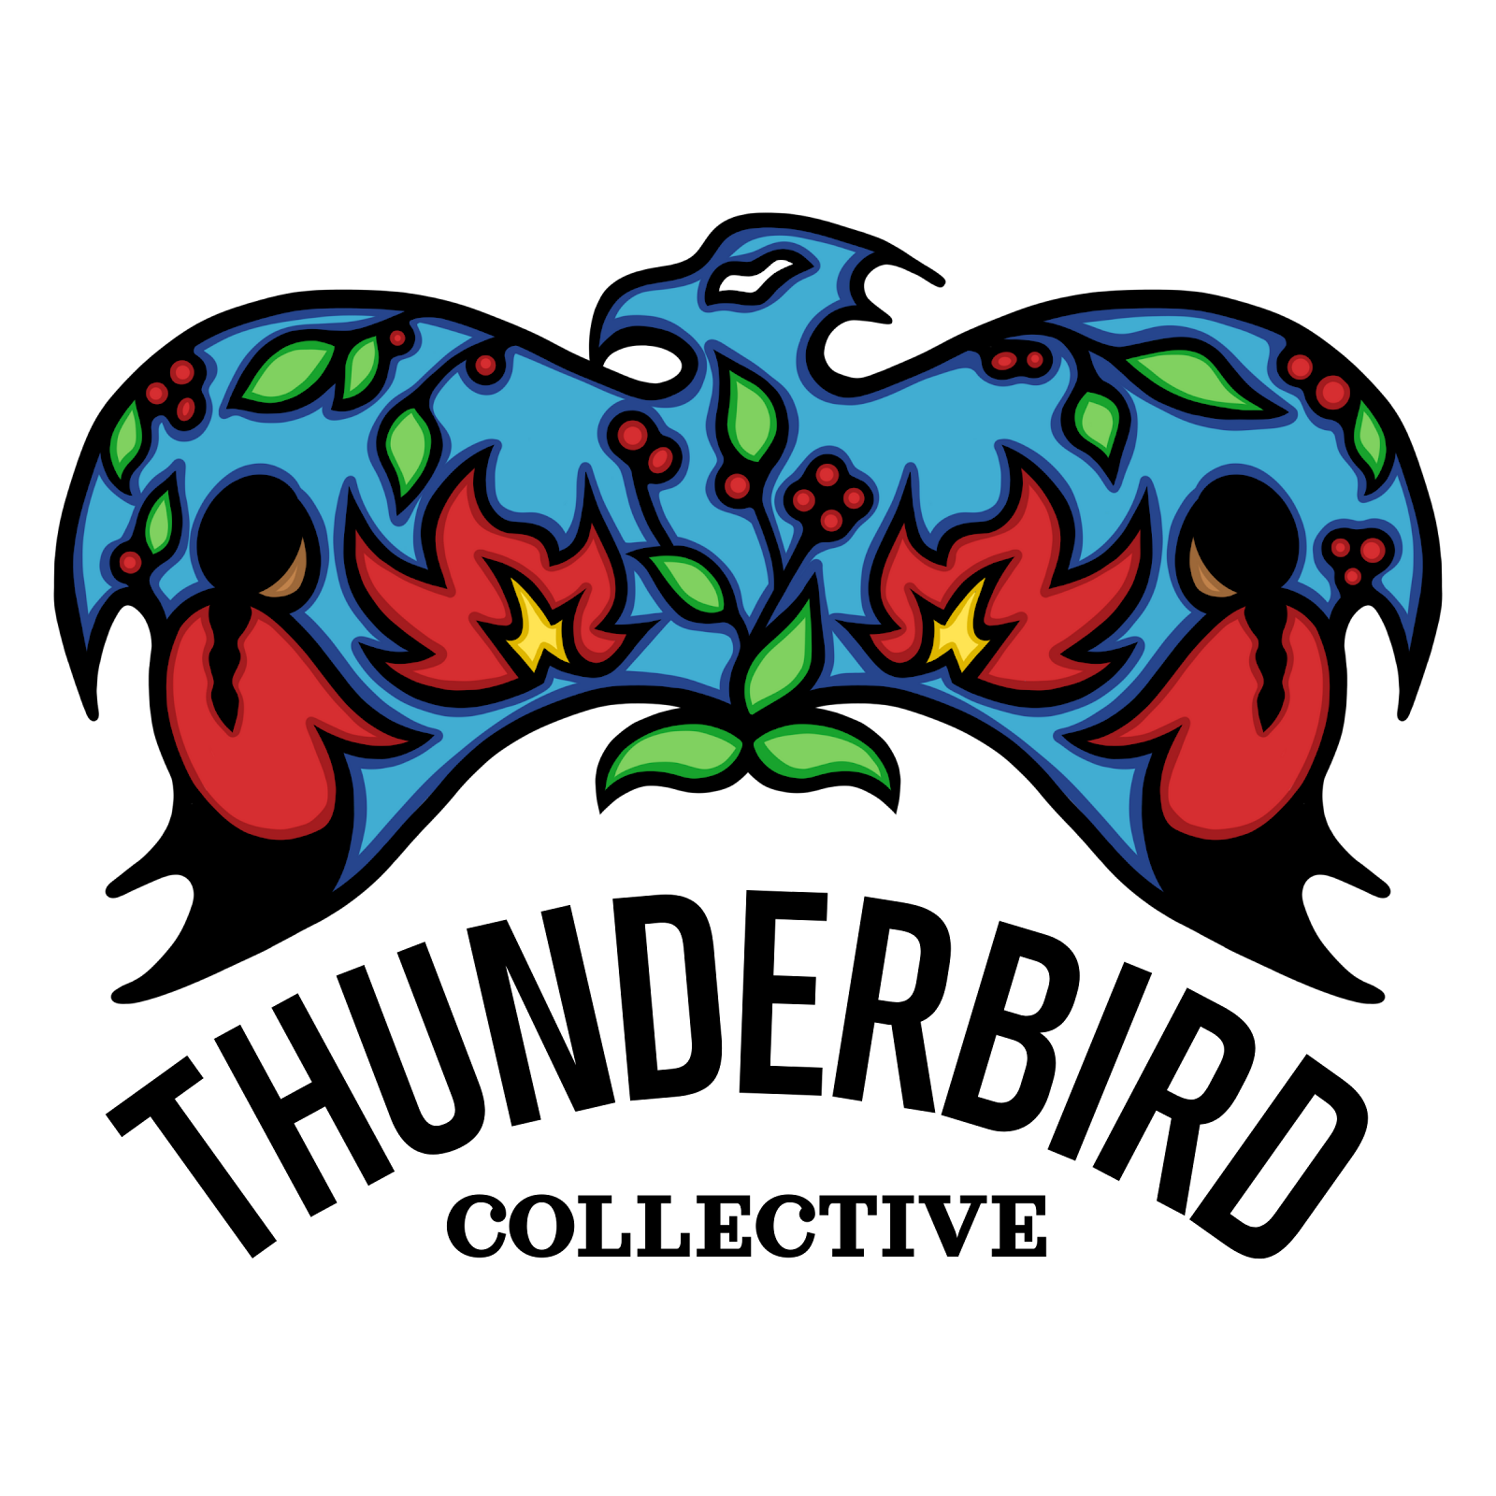
Indigenous Fire Stewardship Grant Application 2026/27

1. Applicant Information
Name of individual, Nation, or organization:
Type of Applicant:  Note: Non-Indigenous and for-profit organizations are not eligible to apply. | ☐ Indigenous Nation or community (First Nation, Inuit, Metis government, council and tribal organization).  ☐ Indigenous organization (non-profit, collective, cultural and land-based groups)  ☐ Collaborative Group led by Indigenous Peoples (e.g. partnerships with schools, local fire departments)
Primary contact: (name, title)
Address
Phone:
Email address:
Secondary contact: (name, title)
Address: (if different than primary)
Phone:
Email address
Finance contact: (name, title)
Address: (if different than primary)
Phone:
Email address:
For organizations: Please describe your organization, who you represent, location, how you meet eligibility and governance structure (for signing authority).
Have you previously received funding from Thunderbird Collective?
☐Yes
☐No

2. Project Pillar (select one only)
Which of the four pillars of Fire Stewardship does your project align with?
☐ Knowledge Sharing – preserving, sharing, and growing cultural or traditional knowledge
☐ Land-Based Learning – connecting people to land and traditional practices
☐ Sovereignty – strengthening governance, leadership, and self-determination
☐ Advocacy – raising awareness, mobilizing, and influencing change

3. Project Plan

Overview
Title of Project:
Community (ies), Nation or Region:
Project location, access, permission (map attached)
Land status: | ☐ Reserve  ☐ Crown land  ☐ Private land
Proposed Project Timeline: | Start date: | End date:
Please provide a brief summary of your project (one paragraph).

Individual/Community Need and Impact
Please describe the need or challenge the funding for the project will address, including baseline information or data if possible. (e.g. number of community members lacking access to land-based learning programs)

Please describe and explain the expected impacts/benefits for people, community (ies), land and future generations

Objectives with KPIs
For each objective, list who, what, when, where and how, followed by KPIs to measure success.

Project Description  - Where did the project take place?  - When will the project happen?  - Who was involved?  - What was done?  - How was the work carried out?  - What changed or improved?  - Key results | Details
 | - Community, territory, specific site
 | - Timeline, season
 | - Elders, Fire Guardians, youth, partners, Nations
 | - Key activities
 | - Methods, approach, protocols
 | - Benefits for people, community, land
 | - Number of participants, events, burns, hectares, resources created

Project Description: (Who/What/When/Where/How) | Key results/outcomes: Number of participants / Nation (anticipated), events, burns, hectares, resources and knowledge products created. Changes or benefits for the people, community and land.
Sample
Project Description:  (Who/What/When/Where/How) | Key results / outcomes
Engage community in land, cultural workshop  Who is involved, what activity is being delivered, when and where it occurs, and how it will be facilitated | e.g. 20-30 participants
Increase knowledge of traditional fire stewardship  Who is involved, what learning takes place, when/where it occurs, and how knowledge is shared. | e.g. 80% of participants reporting improved knowledge
Conducting cultural burning  Who is involved, what is being done, when/where it occurs, and how it is carried out safely and appropriately. | e.g. 4 burns per year
Strengthen intergenerational knowledge transfer  Who is involved, what activities support learning, when/where they occur, and how knowledge is shared between generations. | e.g. 10 elder-youth pairs involved
Landscape-level fire stewardship  Area of land managed under community-led practices | e.g. 5 hectares of territory under stewardship plan

Reporting and Evaluation
Please describe how you will track and share the results of your project.

Describe:
- How success will be measured (qualitative and/or quantitative).
- Indicators, outcomes or stories that will demonstrate impact.
- Who will be responsible for reporting and documentation?

4. Budget
Please use the template below to provide a simple budget showing:
- Funding requested (from this program).
- Other confirmed or potential funding sources
- Breakdown of expenditures (e.g. wages, training, equipment, travel, supplies, honoraria, etc.)
*In-kind contribution includes use of community donated space, volunteer time, materials, equipment, and partners’ contributions that support a project’s activities. Including in-kind in the budget shows community support and leverages resources to the funder.

Justification is the explanation and breakdown of each major line item. Why is this expense needed? Clarify the amount in the calculation. (e.g. $250 honorarium x 10 Elders = $2,500)
Budget Template
Category | Description | Amount Funding Requested | Other Sources / In-Kind | Total amount of Project | Justification / Details about funding request:
Wages / Salaries | Staff, crew, trainees, project coordinator | $ | $ | $
Professional Fees | Services for data collection, evaluation, technical expects (e.g., Indigenous facilitators or fire specialists) | $ | $ | $
Honoraria | Elders, Knowledge Keepers, cultural advisors | $ | $ | $
Training and Capacity Building | Workshops, certification, safety training | $ | $ | $
Equipment and Supplies | PPE, tools, radios, monitoring gear | $ | $ | $
Travel & Meals | Transportation, fuel, accommodation, food | $ | $ | $
Community Engagement and Meeting Expenses | Gatherings, knowledge-sharing, events, communication | $ | $ | $
Monitoring and Reporting | Data collection, documentation, evaluation | $ | $ | $
SUB TOTAL |  | $ | $ | $
Administrative Support | Clerical and financial support, up to a maximum of 10% of subtotal. | $ | $ | $
TOTAL |  | $ | $ | $

5. Letter of support

If you are including a letter of support with your grant application, please clearly indicate below who the letter of support is from:

If a letter of support is not attached, please indicate below the date you expect to submit it. Please note that the letter of support must be received no later than June 19, 2026 (noon Pacific Time).

***Applicants must use the provided application templates. Submissions that do not follow the required templates may not be reviewed or considered.

