MISSOURI ELITE SPORTS CLUB

Waiver. Release & Hold Harmless Agreement
The undersigned Parent/Guardian, in consideration Of the time and effort expended by the Missouri Elite Sports Club, (hereinafter MO Elite), on behalf Of my/our child/children participating with MO Elite, I do hereby waive and agree to release all claims for damages for death. personal injury, or property damage that may occur as a result of engaging in this activity. This discharges in advance MO Elite and the owner/operator of any facility where MO Elite meets, practices or competes,
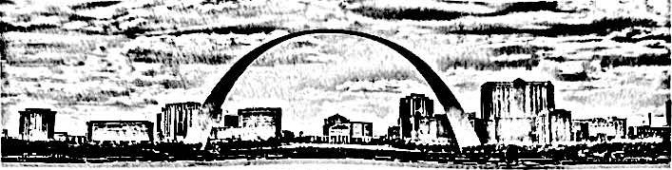
and their coaches, officers, volunteers, employees, agents, invitees and/or representatives from any and all obligations, liabilities, claims, demands, causes of action regarding any injury to and/or loss by my/our child/children, including, without limitation, wrongful death, arising out of or incident to any acts, omissions, negligence. This indemnification applies to and includes, without limitation, the payment of all penalties. fines, judgments, awards, decrees, as well as attomey's fees and related costs or expenses incurred by MO Elite and the owner/operator of any facility where MO Elite meets, practices or competes, and their coaches, officers, volunteers, employees, agents, invitees and/or representatives regarding any such obligation, liability, claim, demand and/or cause of action. I give permission for any medical care that the leaders of the above deem necessary. I also agree to accept full responsibility, financial and otherwise, for the conduct of my child/children. I understand that there are no refunds should my child/children be removed from this program for improper conduct I hereby consent to the photographing, recording or reproduction on any other manner (including use of videotapes and audiotapes) if the likeness, of activities of my child/children and further authorize MO Elite, its agents or assigns, to make unlimited use of reproductions. including but not limited to advertising to the public.
l/we have acknowledged that they have read and understood the foregoing.

Parent/Guardian Signature Date Signed
Member Ozark District • Amateur Athletic union • USA Track Field
Missouri Elite Sports Club Is an IRS 501 c (3) non-pront all volunteer organization

