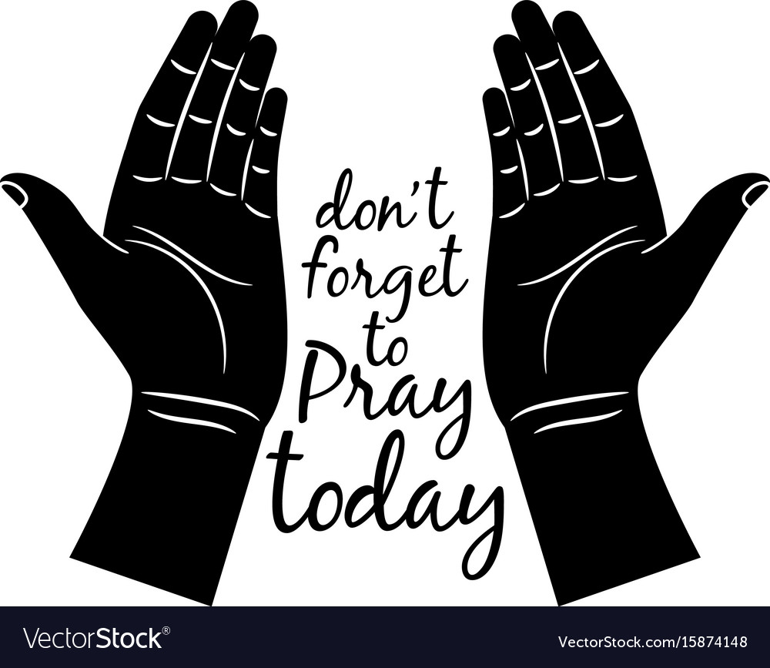
“We ask…He hears” 1 John 5:15
Newcastle Christian Church Prayer Requests
As of January 11, 2019
(Requests remain on the list four weeks unless they are resubmitted.)

Members:
- Vanis Hightower had surgery on 1/10 to remove tonsils and adenoids. PTL surgery went well, prayers for quick recovery for Vanis.
- David & Tami Rodgers are traveling next week; prayers for their safety.
- Prayers asked for Tommie & Cathy White, under stress due to physical, financial, emotional issues.
- Joe Miller is still in rehab, prayers for his recovery and for his wife, Darlene.
- The Yanceys lost their son Robert, please pray for the family, for God’s peace and comfort. A memorial service will be held on Thursday, January 17, at noon, at Council Road Baptist Church (NW 30th & Council Rd.) in the chapel.
- Sarah Wint requests prayers for Debbie Simpson, for good results from tests on 12/31 to find out what’s wrong and decide effective treatment.
- Debbie DeWeese praises God for quick recovery for her mom, Etha Ray, from a stroke and a viral infection, and for Rick after a heart cath and stent placement. God is good…all the time!
- Trevor & Michaela Todd ask prayers for a continued healthy pregnancy. 17-week report, their baby boy looks great!
- Casina Ray requests prayers for her 11-year-old granddaughter, Abby Lee, had surgery on 12/19 to remove a benign bone tumor on her knee. Surgery went very well. Prayers that Abby heals quickly.
- Casina also asks prayers for her granddaughter, Emma Lee, diagnosed with impetigo on her face.
- Jody Olsen has been released from the hospital after undergoing stem cell therapy. He is recuperating from some infections and the chemo and stem cell procedures; prayers for healing and strength.
- Donna Males started infusion procedures again on December 20.
- Lisa Cullen asks prayers for her and the boys as they finish up moving, for healing of her ankle which she injured during the move, and for Austin as he heals from a sinus infection.
- Prayers for Brien Sims; having issues with migraines and intestinal problems.

Loved Ones & Friends:
- Curtis requests prayers for the Brown family, the wife of his friend passed away on 1/9.
- Curtis also asks prayers for a friend of his from Army Guard who was severely injured in a head-on collision. Now in rehab, healing, but progress is slow.
- Neil Newcomb requests prayers for his friend, Joe Parsons, just diagnosed with prostate cancer.
- Casina Ray asks prayers for a friend, Gary Seagrove, in the hospital suffering from pneumonia and sepsis.
- Retha Jantz will be traveling to Chicago with her daughter, Denise, for medical care. Prayers for travel safety and good news.
- Loretta Lee requests prayers for the family of Don’s cousin, a bad accident claimed the lives of several family members just after Christmas.
- Terri Wint asks prayers for her friend Denee whose mother has Alzheimers, issues with her care.
- Becki Nail requests prayers for her neighbors, the Lewis family, having a tough time.
- Dianna McEvoy’s daughter, Hope, battling thyroid cancer. She’s 30 with 5 kids, needs to have half of her thyroid removed.
- Prayers asked for Clay Cheaky, for a sore wrist.
- The Littlejohns ask prayers for Randy Break, having 3rd surgery to remove the remainder of his colon. Prayers for successful surgery and good recovery.
- Lisa Cullen asks prayers for her friend Karen Allen’s family; her 19-year-old son committed suicide recently. They don’t have a church home, Lisa prays for the right words to say to help the family.
- Mike Aston requests prayers of healing for his son-in-law, Chris Roth, injured in a fall.
- Leveda Wood asks prayers for her great-grandson, Sam, in Integris PICU, with RSV.
- Sarah Wint asks prayers for Rick Austin, for pain from a biopsy on 12/23.
- Emily Littlejohn asks prayers for the family of her friend’s mother, Marci Kelly, who passed away on 12/29.
- Wilma Hammonds asks prayers for her daughter, Misty’s, living situation.
- Jacob Cullen requests prayers for his dad, for severe back pain and some not-so-good news from his doctor.
- The Hadleys ask prayers for granddaughter, Erin Mills, who had a miscarriage and lost her baby at 16 weeks, and is taking it pretty hard.
- Cheryl Millican asks for prayers for her daughter’s mother-in-law, Peggy Mauldin, battling cancer and needing medical miracles. She is beginning clinical trials for cancer treatment.
- Cheryl Faires asks prayers for Whitney Faires, for quick healing from recent surgery, and God’s divine comfort in the sudden loss of her sister.
- Donna Burkhart asks prayers for Michaela Bishop, for God’s healing touch. She had a heart procedure and is having swelling issues.
- Rick Austin asks prayers for his nephew, Allen, who had part of his heart removed.
- Saundra Newcomb asks prayers for her nephew having surgery.
- Saundra also asks prayers for her niece, Susan Stone, having high blood sugar issues.
- Stephanie Garrett requests prayers for Grady’s teacher, Kasey Geary, her child was admitted to the hospital with RSV.
- Debbie Simpson requests prayers for her sister and family.
- Debbie’s brother-in-law, Billy Pegram, passed away. Prayers for the family.
- Ann Mills requests prayers for her nephew, Mark Mills, in the hospital with gall bladder issues.
- Marie Cantrell asks prayers for God’s watch care over her son, John (off his meds).
- Justin Hightower’s cousin, Andrea, questioning about Christianity, almost got baptized but backed out.
- Kathy Clark had back surgery on 12/17. She was released to go home 12/19. Surgery went well, prayers for quick recovery for Kathy.

General Prayers:
- Pray for the leadership of our country, and for good Christian leadership.
- Pray for those who have fallen away, for their eyes and hearts to be opened and for them to return to their faith in the Lord.
- For our missions at Camp Sooner, Cookson Hills, Ozark Christian College, and Operation Care.
- Lord, we are thankful for your grace, mercy, and blessings.
- For God’s guidance for our church leadership & for our church family to attend church and increase our relationships with God.
- End to terrorism; pray for the turmoil that is increasing in our world, for Jesus’ presence to give peace.
- Please pray for our military men and women serving our country and their families and our veterans. If you would like prayer for someone in the military, call the office. Their names will be added here: Grady Wint, Sasha Kirkpatrick, Ben Ryan, Paul Jones, Kurt Fuller, Logan Wint, Derek Park, Bo Nixon, Morgan Loveless, Emily Carroll, Jeremiah Thacker, Marcus McCawley, Caleb Cotten, Jeryt Hansen.

“If my people, who are called by my name, will humble themselves and pray, and seek my face, and turn from their wicked ways, then will I hear from Heaven, and I will forgive their sin and heal their land.” (II Chron. 7:14)

