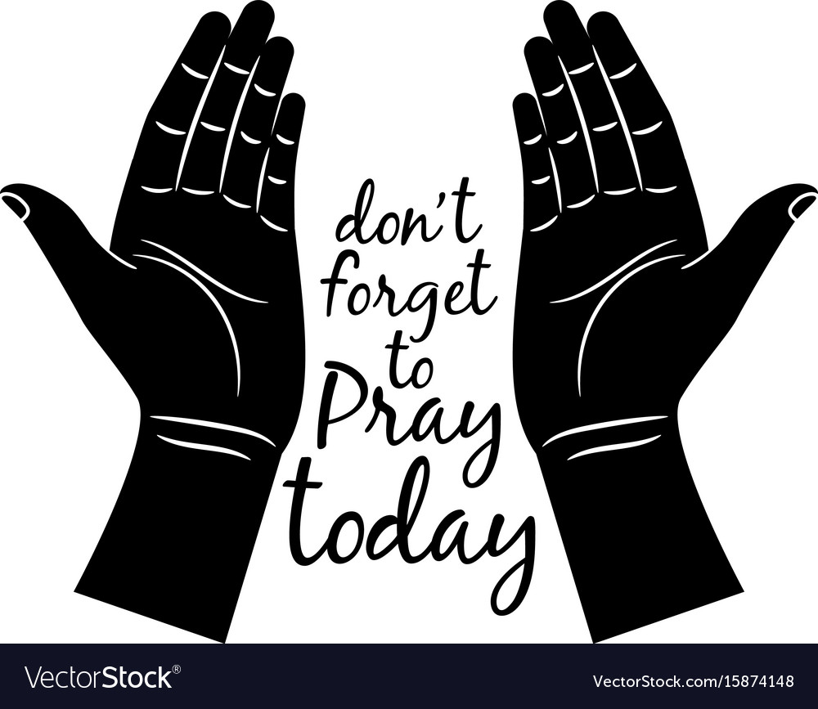
“We ask…He hears” 1 John 5:15
Newcastle Christian Church Prayer Requests
As of February 15, 2019
(Requests remain on the list four weeks unless they are resubmitted.)

Members:
- Ed Harris requests prayers for Joe Miller who just got out of the hospital; he’s home now with pneumonia. Prayers for healing.
- Rick DeWeese asks prayers for Debbie, she has re-injured her back. Pray for good treatment and relief from pain.
- Lisa Cullen’s car was totaled after being hit while it was parked in a parking lot. PTL she was not in the car at the time. Prayers for the man who hit her car as well as the others, and for all who are affected by this as they deal with getting replacement vehicles and insurance, etc.
- Vicki Bertsch has pneumonia, prayers for return to health.
- Sharron Allison is ill at home.
- Haden Stovall is doing well, recovering from having wisdom teeth removed. Prayers for less pain and good healing.
- Prayers for Austin Cullen to have complete restoration of his knee so that he can play basketball again. His season is done for this year, but he would like to play in the future. Going through tests to determine the extent of damage and how to proceed.
- Austin Cullen asks prayers for his mom, Lisa, to get better from a bad headache.
- Linda Cotten got some very good news from her doctor this week. PTL! God is so good! Please continue to pray for a clear CT scan in 3 months. Linda says thanks for all the prayers and cards!
- Pray for the Rouse’s health issues to be lessened.
- For all our shut ins.
- Prayers for Dalton Grooms, to hold tight to his faith and get through the next months of incarceration, and God’s presence with him and his family throughout the ordeal. Also, prayers for Dalton’s son, Waylon, and for his mother to make good choices.

Loved Ones & Friends:
- Ann Mills asks prayers for the family of Vicki White, Ann’s daughter’s mother-in-law, who passed away suddenly.
- Prayers for Courtney Loveless & family, her grandmother Marcella passed away on 2/12.
- Mike Aston asks prayers for his niece, Joellen Shol, in Pawhuska, OK. She is suffering from sudden weakness and difficulty in walking. She’s going through tests to determine the cause, one thing they’re looking at is MS. Prayers for her as she goes through this process.
- Michelle Collier’s brother, Mike Haden, had surgery on Friday, 2/15. Went well, will go home on Sat.
- Ellen Storey asks prayers for Megan’s fiance’s new baby niece, Liyah Abigail Renee, born 4 weeks premature on Wednesday, 2/13, a little under 4 pounds. She’ll have to be in NICU for a time, but doing well in spite of her early entry into the world. She joins her mom Stephanie, dad Cortez, and older sister, Destinee.
- Emily Littlejohn asks prayers of comfort and guidance for friends going through difficult times and decisions to be made.
- AJ Motes requests prayers for his dad, Chris, who just had hip replacement surgery. Surgery went well, Chris is recuperating at home.
- Andy & Robin Dennington’s little boy Elijah is hospitalized with RSV and an infection. Prayers that he will heal quickly.
- Mike Littlejohn asks prayers for Mark Denny to heal quickly from a second colon surgery.
- Lyn Manuel requests prayers for Connie, the sister of a friend, who had open heart surgery.
- Whorton Collier asks prayers for his daughter, Amy, having back problems and will have back surgery in March.
- Kristi Harris requests prayers for the family of her uncle, Bud Boyd, who passed away.
- Diana McEvoy asks prayers for her back problems.
- Barbara Autery, former NCC member, has pneumonia again; has had it several times. Please pray for complete healing for her.
- Curtis Lee asks prayers for the family of his cousin, Mary Allen, who passed away.
- Jackie Doyle requests prayers for her neighbor, Jessica, has a newborn baby boy who has a rare congenital disease.
- Cheryl Millican asks for prayer for Ruth Bunch, hospitalized with heart failure, for good treatment.
- Mike Aston asks prayers for the family of his friend, Melvin Morrow, who passed away.
- Rhonda Hamilton requests prayers for her friend, Shannon Luney, she had surgery for a broken hip on 1/31.
- Pat Ray asks prayers for Mary Crosby, continuing to battle pancreatic cancer.
- Linda Frank asks prayers for her daughter and son-in-law, Lora and Albert Hanson, for the sale of their home and the purchase of another home in Yukon.
- Lyn Manuel asks for prayer for Yevonna Cook and their family issues.
- Theresa Wadlow requests prayer for Tammy Clark to have tachycardia issues resolved.
- An unspoken prayer submitted. God knows the situation.
- Rhonda Hamilton prays for Jackie Doyle to have good test results.
- Mike Littlejohn requests prayers for his cousin, Brad Goleman, who crashed while hang-gliding, not doing well.
- Mike also asks prayers for a friend, Tim Holmberg, as he is dealing with divorce, custody issues, and job problems.
- Curtis Lee asks prayers for his neighbor, Theresa January, her husband committed suicide.
- Prayers for strength and comfort for the family of Chris Clyma’s uncle, Kenneth Clyma, from his passing.
- Request from Cristal Thacker for prayers of strength and comfort for the Henry and Thacker families in the passing of their wife/mom/grandma who is now in Heaven with our Lord.
- The Cottens ask prayers for Ronnie Cotten and his family as they are separated while Ronnie is here overseeing the sale of their house in Moore and his family is getting settled in Vermont.
- Courtney Loveless has an unspoken prayer request for her brother, Jacob Violette.
- Cotten’s niece, Nichole’s, new baby boy, having breathing problems. Prayers for this little guy’s healing and for peace for Nichole and family.
- The Littlejohns ask prayers for Randy Break, Mike’s brother-in-law, recovering from colon surgery.

General Prayers:
- Pray for the leadership of our country, and for good Christian leadership.
- Pray for those who have fallen away, for their eyes and hearts to be opened and for them to return to their faith in the Lord.
- For our missions at Camp Sooner, Cookson Hills, Ozark Christian College, and Operation Care.
- Lord, we are thankful for your grace, mercy, and blessings.
- For God’s guidance for our church leadership & for our church family to attend church and increase our relationships with God.
- End to terrorism; pray for the turmoil that is increasing in our world, for Jesus’ presence to give peace.
- Please pray for our military men and women serving our country and their families and our veterans. If you would like prayer for someone in the military, call the office. Their names will be added here: Grady Wint, Sasha Kirkpatrick, Ben Ryan, Paul Jones, Kurt Fuller, Logan Wint, Derek Park, Bo Nixon, Morgan Loveless, Emily Carroll, Jeremiah Thacker, Marcus McCawley, Caleb Cotten, Jeryt Hansen.

“If my people, who are called by my name, will humble themselves and pray, and seek my face, and turn from their wicked ways, then will I hear from Heaven, and I will forgive their sin and heal their land.” (II Chron. 7:14)

