Affidavit Address:
School Boards:
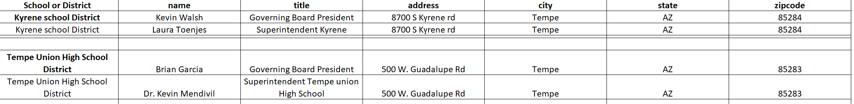
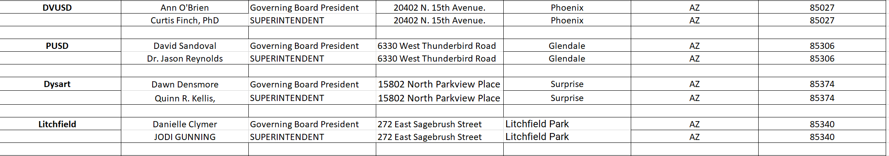
Elected Officials:
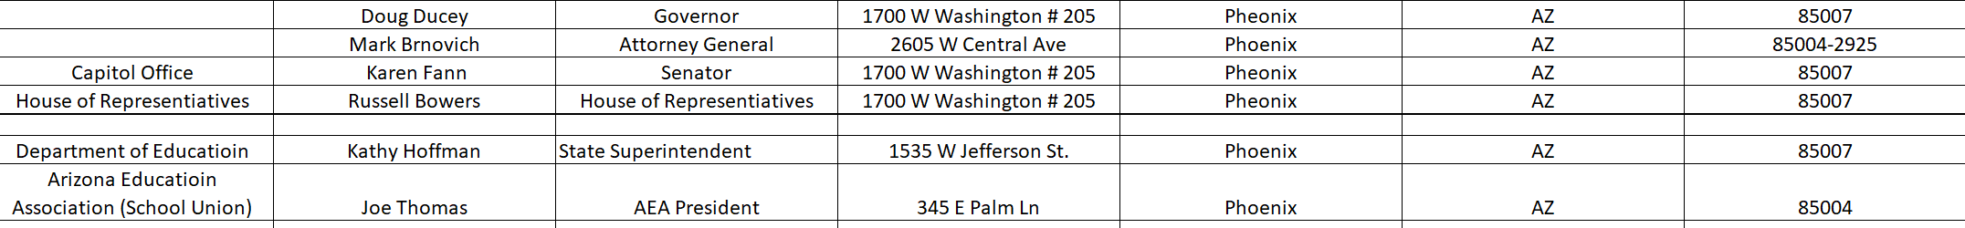
Law Enforcement:

