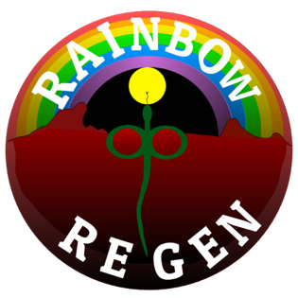
Culture bank:

Mycelium species | Decay Type | Tree Species
 |  | Cinnamomum Camphora- Camphor Laural | Ligustrum sp. (privet family) | Murraya paniculata - mock orange | Hardwood sp.
Ganoderma applanatum | White- -Semi Parasitic | x
Ganoderma chalceum | White- Semi Parasitic | x
Lentinula laterita | White- saprophytic |  |  |  | x
Lentinus sajor -caju | White- saprophytic | x | x
Laetiporus sulphureus | Brown- Parasitic |  |  |  | x
Pleurotus ostreatus | White- saprophytic | x | x
Pleurotus tuber regime | White- saprophytic
Stropharia rugosoannulata*- | White - Saprophytic | Woodchips best
Trametes versicolour | White-Saprophytic- | x | x | x
(*Not endemic)

To Order please contact Pierre via:
Rainbowbushregen@gmail.com
0456145261

