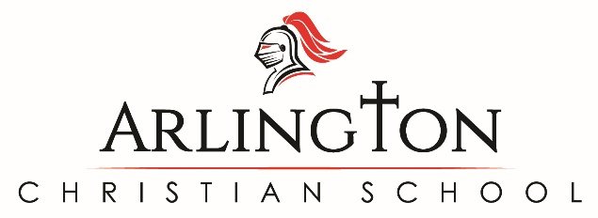

Re-enrollment Application 2021-2022
Return this form to:
P.O. Box 3337
Arlington, WA 98223

Parent’s Name: ____________________________________________________ Date Rcvd:____________________

_____YES We are planning to enroll the following student(s) in Arlington Christian School for the 2021-2022
school year.

Student’s Name Grade Entering
Please list oldest student first. Include new Kindergarteners
(Kindergarteners must be age 5 by August 1, 2021)

________________________________________________ _______________
________________________________________________ _______________
________________________________________________ _______________
________________________________________________ _______________

With this early re-enrollment form completed (due by April 15, 2021), we will receive a $300 re-enrollment fee waiver for the 2021-2022 academic year. To secure my child’s spot for the next school year, we understand that this form must be submitted to the office by May 3, 2021. After May 3rd, ACS will be opening enrollment to the waitlist families and new families.

The Financial Administrator will arrange tuition agreement appointments upon receipt of this re-enrollment form.
Tuition payments can be set up on a 10 or 12 month payment basis. Refer a family to ACS and receive a $500 per family tuition credit upon new student’s full-time enrollment.

Please complete the information below:

Attending church at: _______________________________________________________

Pastor’s name: ___________________________________________________________

_____ NO We will not be enrolling our student(s) in Arlington Christian School for the 2021-2022 school year.*

*If you are not re-enrolling your children in Arlington Christian School, it would be helpful for us to know the reason:
________________________________________________________________________________________________________________________________________________

