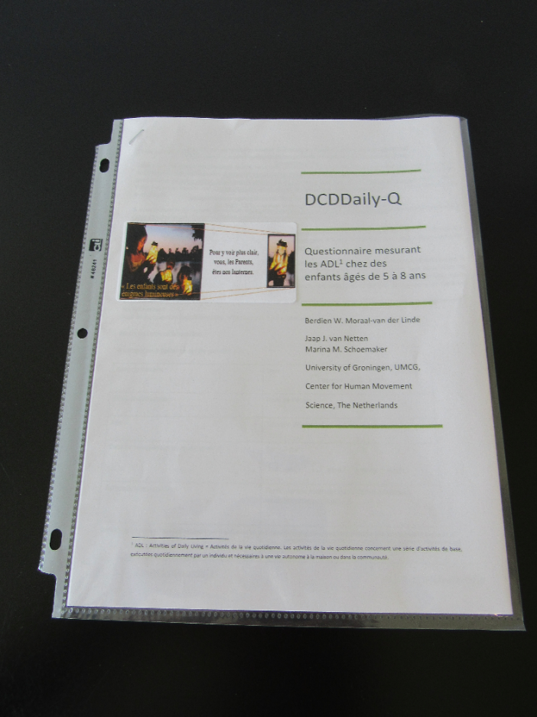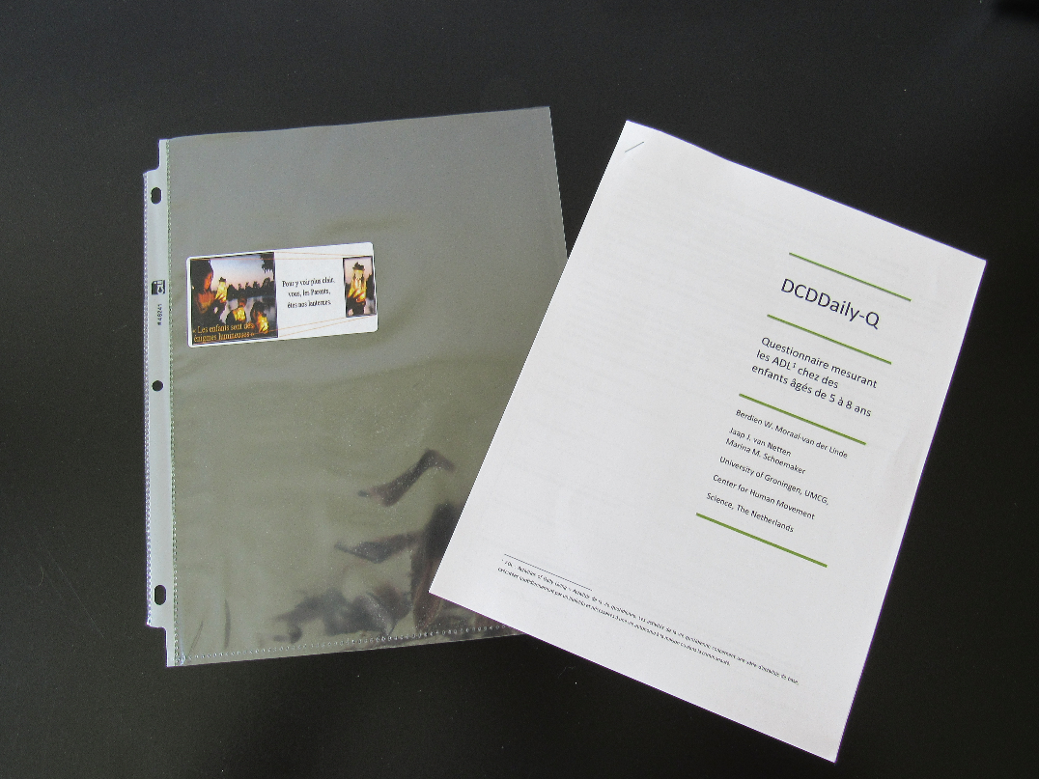

**Quality of presentation: an asset!**  
  
One of the main strategies for boosting the rate and quality of responses is to produce more personalised and attractive material.  
*(Réf. Improving Survey Response Rates form Parent in School-Based Research Using a Multi-Level Approach, Elizabeth J. Schilpzand & al. PLOS ONE 2015)*

Here's a proposal that was accepted by the authors.  
**Because a picture is worth a thousand words!**

Print the next page

on a label sheet

|  |  |  |
| --- | --- | --- |
|  |  |  |
|  |  |  |
|  |  |  |
|  |  |  |
|  |  |  |