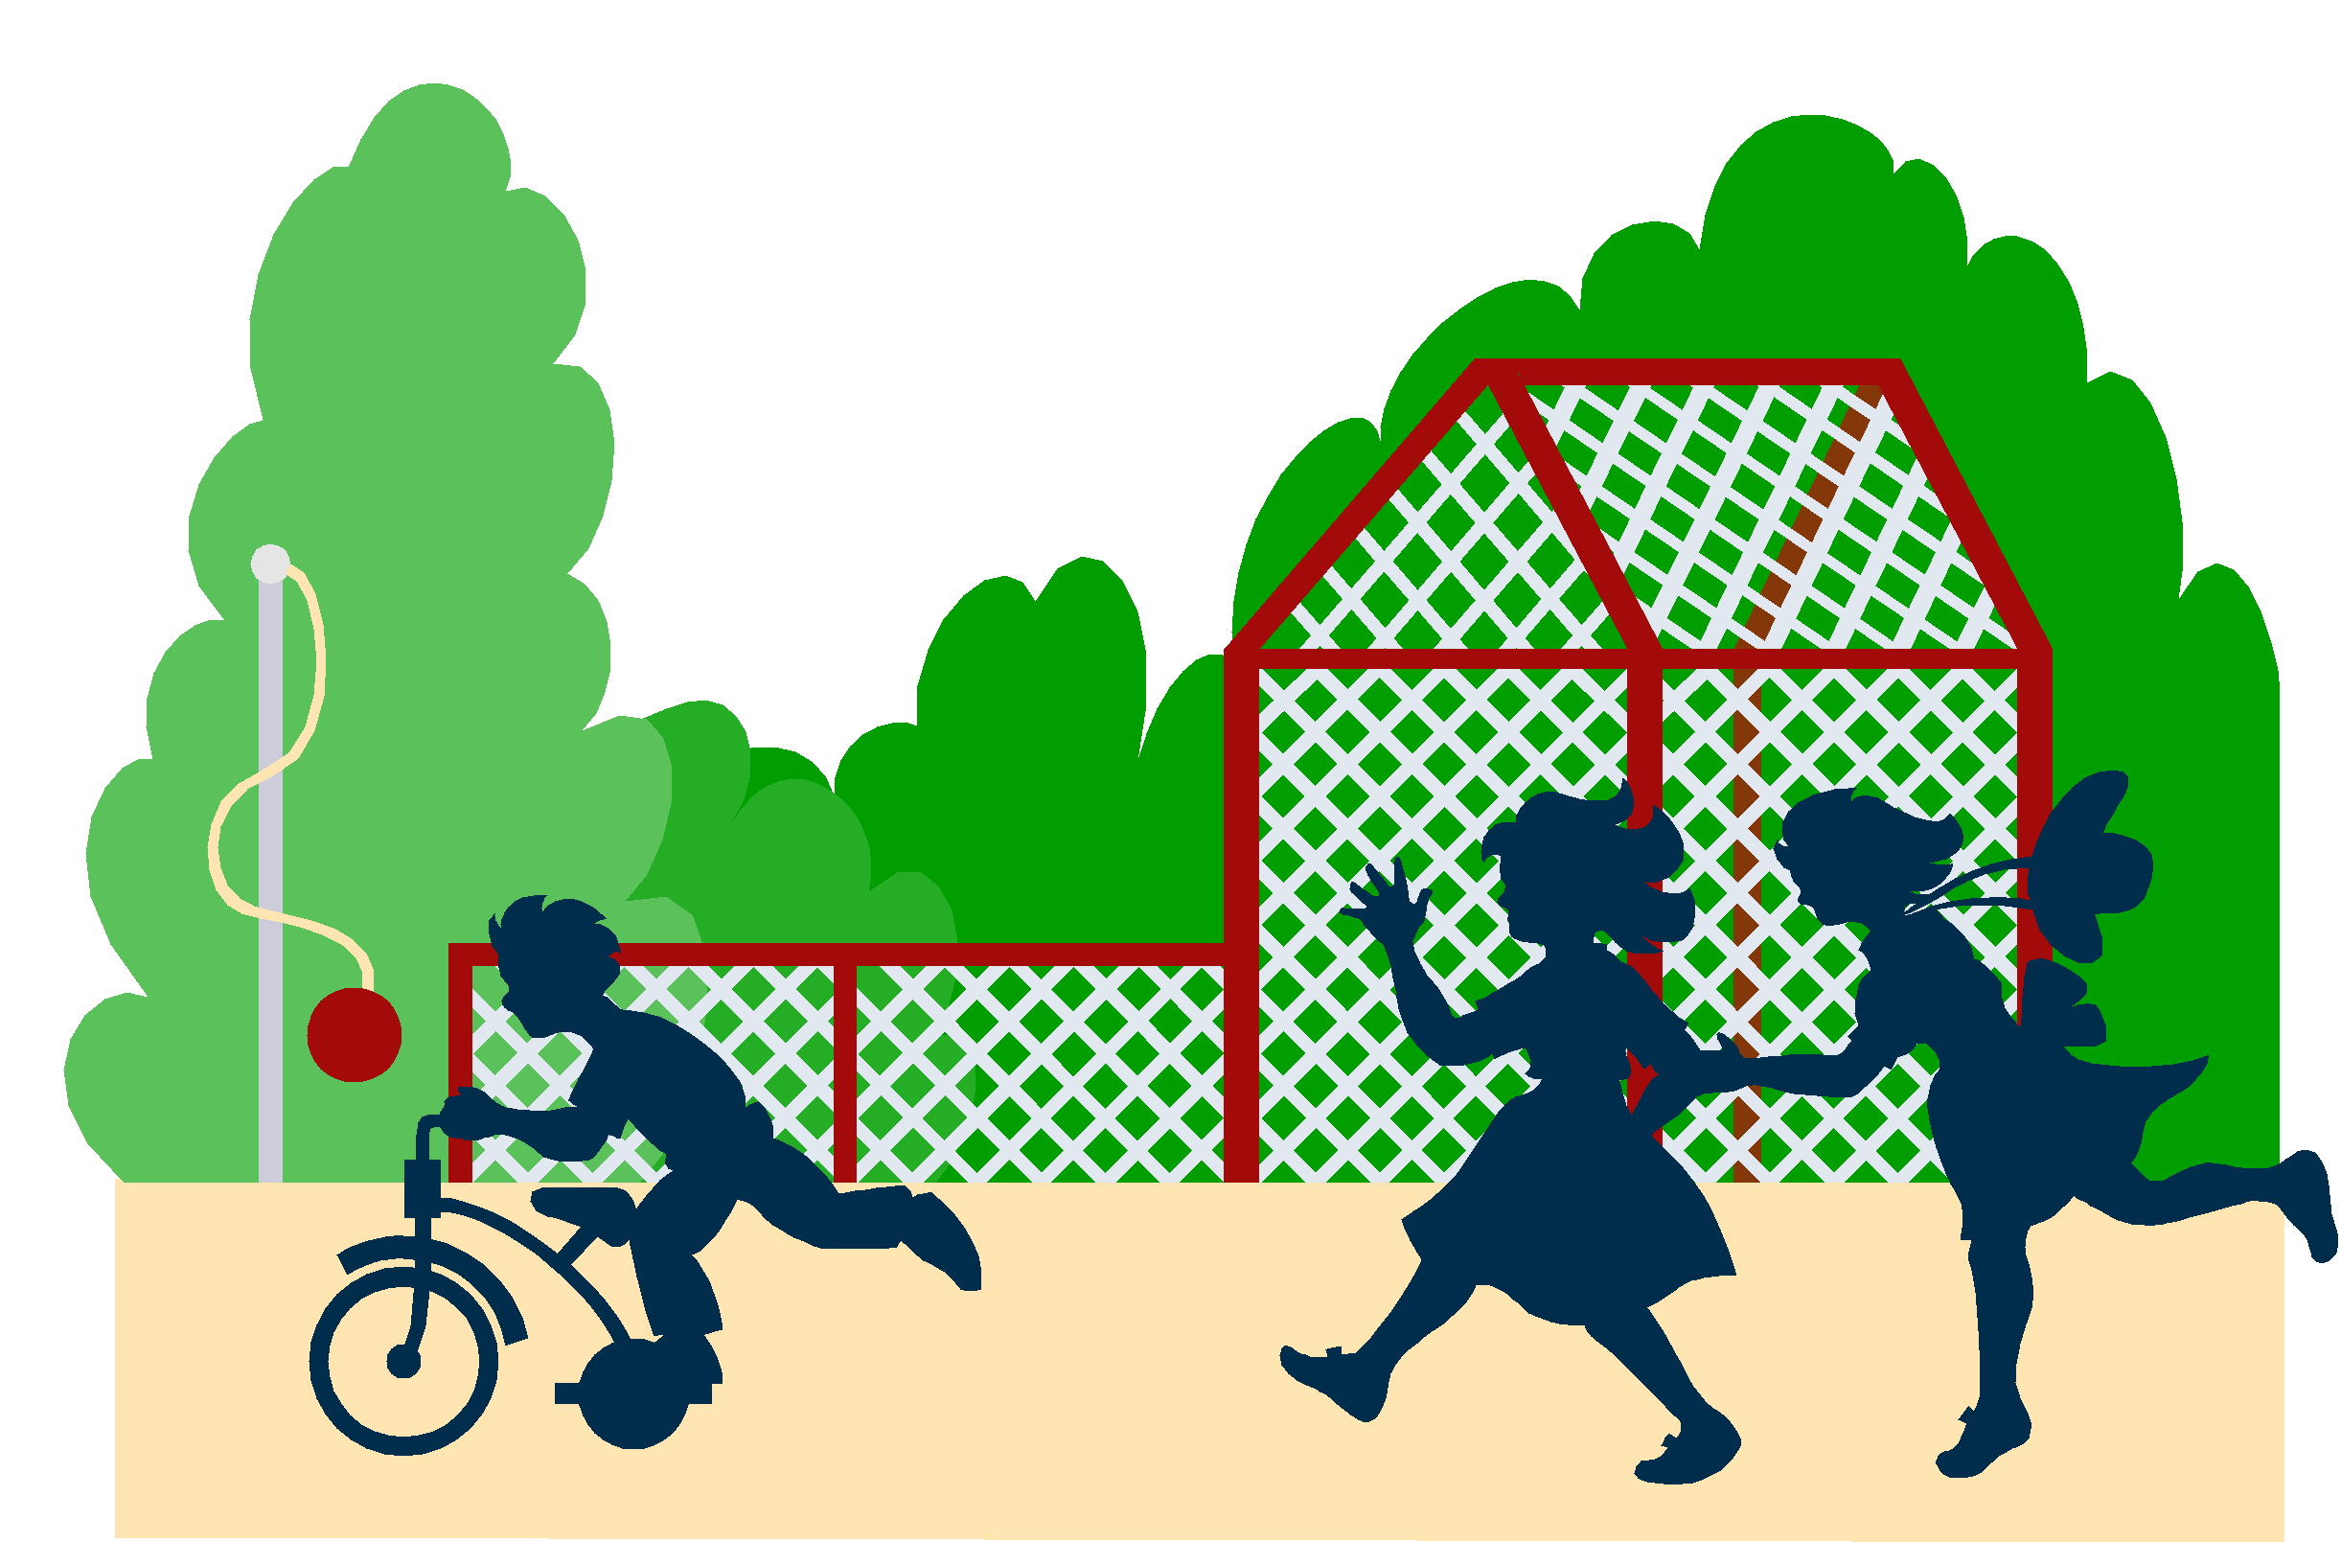
AFTERSCHOOL CARE
Tuition and Fees
Registration Fee: | $TBA enroll
 | $TBA registration fee for two children

Monthly rates
wE ARE HOPEING TO REOPEN IN SEPTEMBER 2021
$TBA per- month
(approximately $8 dollars a day!)
Full USda Meal Provided

Tuition is due by the 10th of the month; a late payment fee of $10.00 will be added after that time.

Great Days does not provide all day care for school age children.

Great days is an equal opportunity employer
Tuition payments should be made out to:
GREAT DAYS, E.E.C.

All payments can be paid on site at the After School Program or paid at :
Great Days Early Education Center
P.O. Box 1215
Cottage Grove, OR 97424

Important Phone Numbers

Great Days | 942-7460
After School Care Activity
Schedule
Monday, Tuesday, Thursday, and Friday
2:30 to 6:00 p.m.

2:30 to 2:45 | Gathering
2:45 to 3:00 | Full Meal
3:00 to 3:30 | Recess
3:30 to 4:00 | Homework
4:00 to 4:30 | Special Activity
4:30 to 6:00 | Free Choice/Recess

Wednesdays
1:30 to 6:00 p.m.

1:30 to 1:45 | Gathering
1:45 to 2:30 | Recess
2:30 to 2:45 | Snack
2:45 to 3:15 | Homework
3:15 to 4:00 | Special Activity
4:00 to 4:30 | Recess
4:30 to 6:00 | Free Choice

