***Great Days***

***Early Education Center Inc.***

***Educational Program:***

***A preschool that combines basic academic skills with socialization.***

***At the Great Days children learn through a combination of structured activities and exploratory play. Staff set learning goals for each student in reading, math, and writing. Some of each day’s activities help children achieve these goals. Students are informally assessed several times a year and the results reported to parents. What follows is a sample of the school’s goals. For additional details, please refer to the parent handbook for a complete document.***

***Sample Goals for ages 2 ½ to 4 years***

1. ***Climb ladder of low play equipment***
2. ***Walks on balance board using hands for assistance***
3. ***Catches bounced playground ball***
4. ***Moves hands and feet to music***
5. ***Completes 3-5 piece puzzle***
6. ***Cuts a 6” line within 1”***
7. ***Makes balls, ropes and flat cakes with play dough***
8. ***Follows simple directions***
9. ***Names major body parts (head, legs, ears, arms, fingers, etc.)***
10. ***Names 4 colors when requested (red, blue, yellow, green)***
11. ***Matches 4 shapes: circle, square, triangle, rectangle***
12. ***Sorts by color and by shape***
13. ***Counts out objects to 3***
14. ***Tries to read books from memory***

***Sample of Goals for ages 4 to 5 ½***

1. ***Skips alternating feet***
2. ***Takes two of more steps and kicks a ball***
3. ***Completes 10-12 piece puzzles***
4. ***Cuts circle within 1” of line***
5. ***Prints first name***
6. ***Participates in a conversation without monopolizing it***
7. ***Names major &minor body parts***
8. ***Names 8 colors***
9. ***Names 4 shapes***
10. ***Understands basic time concepts***
11. ***Sort by size***
12. ***Reads a story by looking at pictures, reads some sight words***
13. ***Recites alphabet***
14. ***Counts out objects to 10***
15. ***Recognizes numerals to 5***
16. ***Adds using objects to 6***

**This institution is an equal opportunity provider.**

***Great Days***

***Early Education Center Inc.***

***2022-2023Rates***

***A preschool that combines basic academic skills with socialization***

***Sponsored by***

***Great Days Early Education Center Inc.***

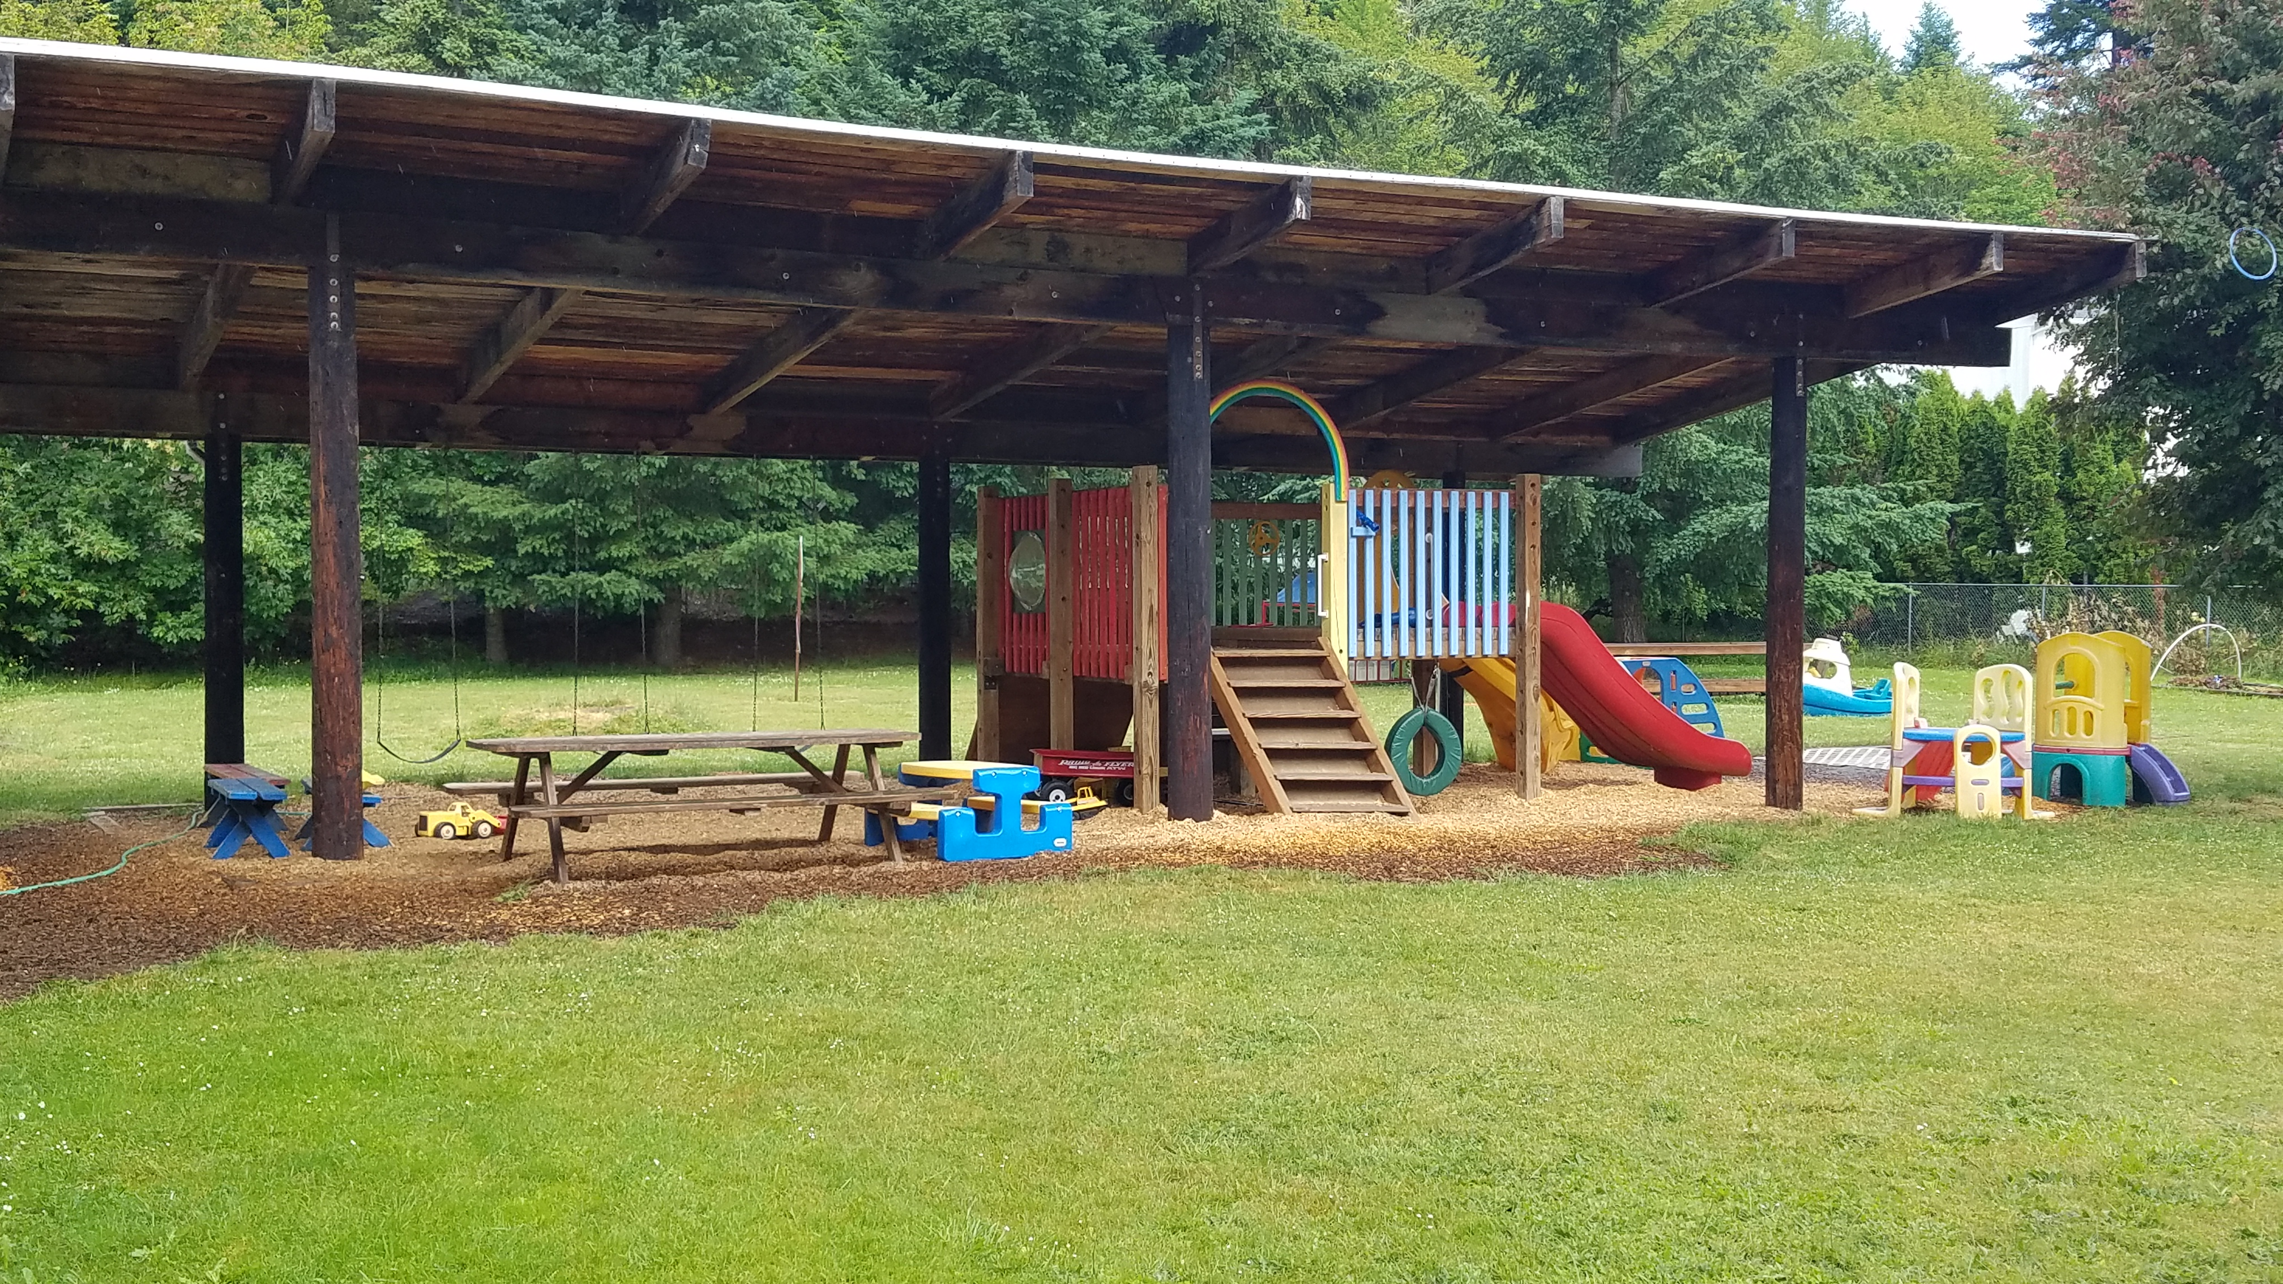

***Tuition & Program Information***

*Great Days Early Education provides progressive quality education and child care for children ages 2 ½ to 5. The class is taught by experienced, certified, caring adults.*

*Our educational program provides appropriate activities that develop school readiness.*

*Great Days is certified by the State Health Department and the Child Care Division of the Oregon Employment Division*

*Located at*

***Great Days Early Ed Center***

***P. O. Box 1215***

***403 North River Road***

***Cottage Grove Oregon 97424***

***MONTHLY CHILD CARE RATES***

2021-2022

***Full-Day/Per Month***

5-Days--------------$900.

3-Days--------------$700.

2-Days--------------$550.

***Half- Day/Per Month***

***UP TO 5 HOURS/ Per Day***

5 Days--------------$600.

3 Days--------------$475.

2 Days--------------$375.

Preschool 9:00-12:00

5 Days----$375

3 Days----$310

2 Days----$275

Yearly processing fee: $150.00-due each September

Or upon enrollment

***ADDITIONAL INFORMATION***

*Great Days is an equal opportunity employer*

*Healthy snacks are provided by Great Days*

*9:30 Morning snack*

*11:30 Hot Lunch*

*Tuition due by the 5thof each month*

*Hours*

*7:00 am until 6pm*

*For additional information please contact*

*GREAT DAYS EARLY EDUCATION CENTER INC.*

***541-942-7460***

***Greatdaysed.org***