FIELD REPORT
WHAREHOUSE ESSENTIALS
S/N | ITEMS | PRICE ($) | AVAILABLE AT | NOTES
1 | Copying machine printer and scanner - https://www.wbmason.com/ 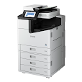 | 800 | Bambu Lab P2S Combo Micro center | OOS-  Can handle multiple processing
2 | Fork Lifts - 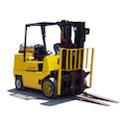 https://www.elitemetaltools.com/ | 20000+ | Superior industrial products | Selling.  For lifting, loading and off-loading
3 | Rolling Ladders – Northern tool- https://materialhandlingsolutions.theonlinecatalog.com/ 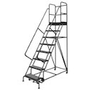 | 649.99 | Ballymore Steel Rolling Ladder | Selling.  For reaching overhead items.
5 | Hand Trucks - https://www.google.com/ 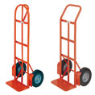 | 169.99 | 3-in-1 at Harbor Freight | Selling good quality
5 | Flow Racks - https://www.google.com/ 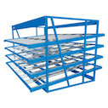 | 382 Not exact as this one | Dewalt | Selling
6 | Strapping & Banding Equipment - https://www.google.com/ 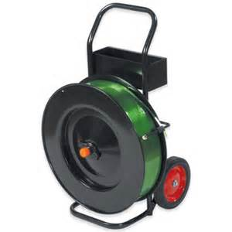 | ~ 150 | eBay | Selling- for strapping and banding items.
7 | Plastic Dumpster - https://www.google.com/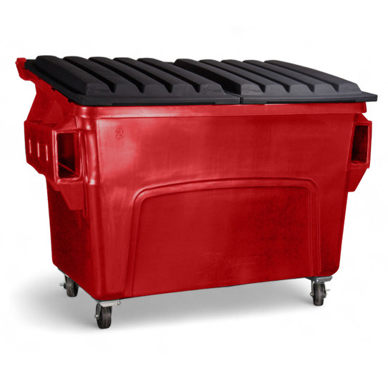 | 1099 | Baricuda Bins | Selling- for disposing garbage
8 | Stretch Wrap Machines - https://www.uline.com/ 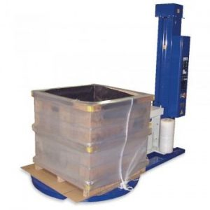 | ~12,000 | ULINE | Increase productivity and eliminate worker strain
9 | Parking Tables - https://www.uline.com/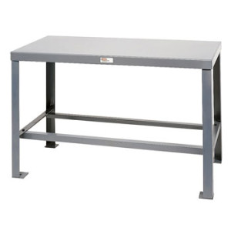 | ~760 – not exactly the type | Motor freight: Call: 1-800-295-5510 | Can get tables from people relocating
10 | First Aid Kit - https://www.redcross.org/  | ~30 | American Red Cross | Industrial/OSHA for emergency use
11 | Bins & Containers e.g. Bulk Boxes - https://www.globalindustrial.com/ 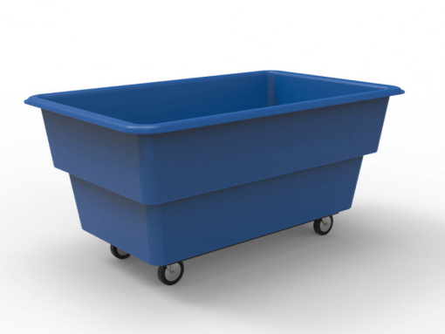 | 762 | Selling Solutions | Heavy duty reinforced bulk delivery truck for smooth material handling.
12 | Trash bags - https://www.google.com/ 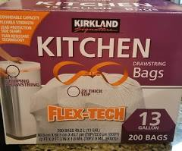 | ~17 | COSTCO | Useful for taking out trash.
13 | Pallet Racks - https://www.google.com/ 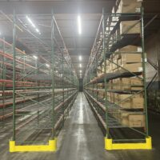 | 410 | Pallet Rack World | Used pallet in stock and ready for delivery and installation. Call : 800-974-9086
14 | Service Carts and Dollies - https://www.google.com/ 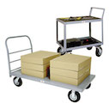 | ~100 | Harbor Freights | Selling
15 | Wire Mesh Baskets - https://materialhandling.com/ 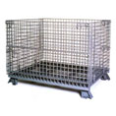 | ~105 Not the exact one | Alibaba.com | Useful for handling wet items.
16 | Deep Freezer - https://www.walmart.com/ 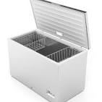 | ~200 | Home Depot | For storing perishable goods
17 | Shredder - https://www.ebay.com/ 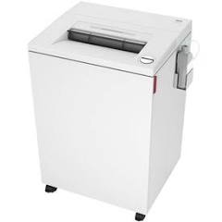 | ~100 | Best Buy | T o shred sensitive information.
18 | Paper Towers for Dispensers - https://www.google.com/ 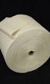 | 28,98 | Home Depot | For bathroom dispensers
19 | Bathroom Tissues - https://www.google.com/  | 19.99 | BJ’s wholesale club | Selling
20 | Security cameras - SimplySafe.org 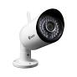 |  | SimplySafe.org | For safety monitoring. Call: 877-621-6572
21 | Trash cans - https://www.google.com/ 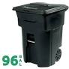 | 96 | Home Depot | For collecting trash and keeping the environment clean.
22 | Brooms with Dust Pans - https://www.google.com/ 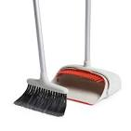 | 19.99 | Home Depot | For sweeping off dirts.
Total | Estimate without security cameras | 37730.95

