Update on the current situation on Africa ministry
Dear Dr. Don Walker
Receive greetings from Africa, from the time of our last conference up to now the number of the people that are coming to Christ is bigger. The message about relational evangelism was powerful and every body that attended caught fire.
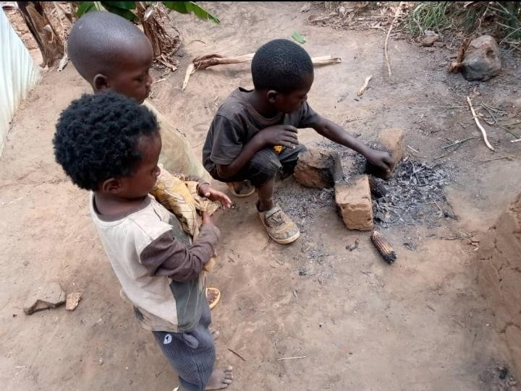

Rwanda
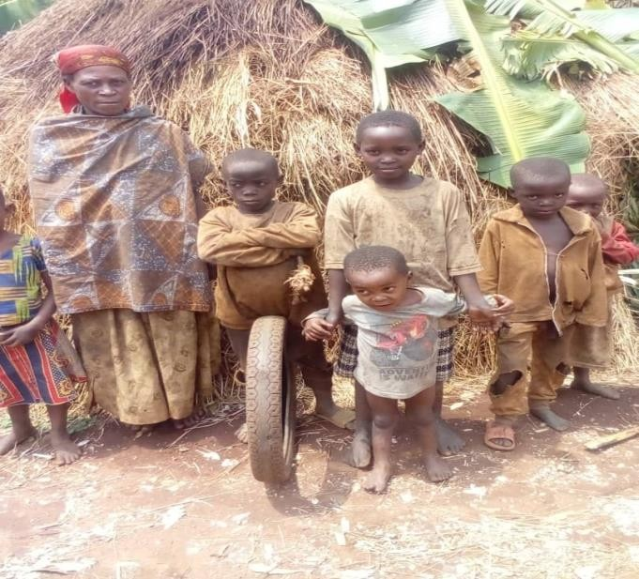
As we shared with you, we are still facing such a huge challenge in Rwanda from the time churches were closed. 8,000 churches were closed, 100 churches had orphanage projects and widows project, due to the church closer our pastors have been reaching out to us because of the suffering of the children who have gone back to the streets, widows are in their death beds in hospitals because the churches that supported them are closed and government is not standing in a challenge to help the widows who are suffering and the children that have gone back to the streets, we are seeking much of your prayers that the Lord will make a way for these children.

DRC Congo
Again, we appreciate you for your prayers for many years Congo has had internal conflicts and civil wars which have claimed many lives in the past two years there has been an on-going war which has destabilized Kive region, all churches have been abandoned many people lost their lives but we want to thank God that president Trump has intervened and peace has been restored in the region.
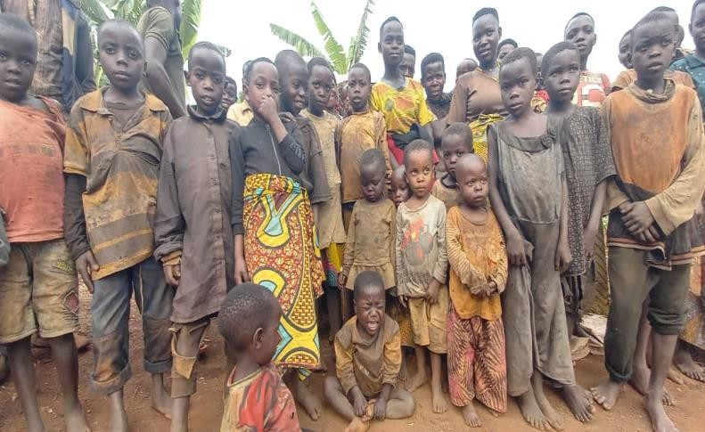
We have been taking care of a lot of Congolese most especially 800 children who are unaccompanied minors, we want to thank God that since peace has been restored these kids will be going back home, our organization is overseeing 6 refugee camps where we have planted 150 churches of all these 150 churches are exited and looking forward to go back, Pr. Masimasiya, Bp. Olivie and
BP. John were running widow and
orphan projects in their communities and when they run away they left the widows and children in the hands of no one. It has been their prayer that they go back and look for these children and see if there are still surviving.
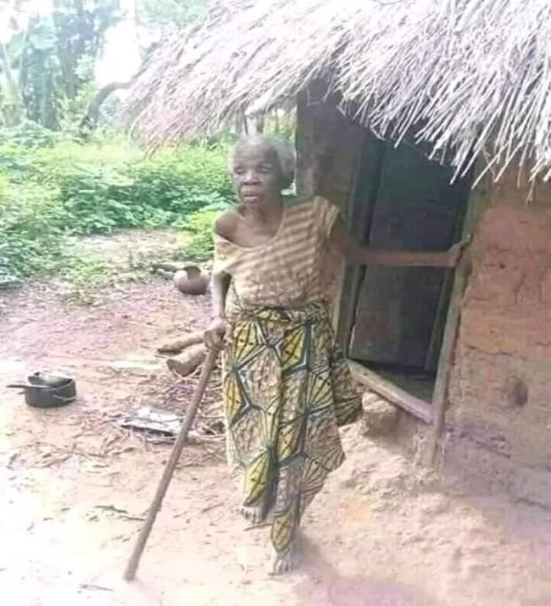
According to the report a greater number of street kids have increased because of loos of lives that happened in a war that has taken 3 years and 3 months.
There are 5 Christian schools and orphanages that were burnt during the war, and 2 hospitals that need to be rebuilt again after facing a huge destruction during the war.
In a month of August, we are taking the first group of people to be restored back in their communities. Our greatest prayer is that we many get people to partner with us in us in rebuilding the church that were burnt during the war, provide daily necessities, and house hold equipment, sanitary items and meals to start with as they settle back home. We also trust the Lord for provision to have the schools and hospitals rebuilt again to be able to provide medical services and education the people that will settle back to their communities.

- Bukave care center headed by Pr. Masimasiya has 230 orphans and unaccompanied minors.
- Goma care center headed by Bp. Olivie has 124 orphans and unaccompanied minors.
- North Kive care center headed by Bp. John Kishibisha has 90 orphans and unaccompanied minors
- South Kive care center headed by Pr. Celestine has 83 orphans and unaccompanied minors
- Butembo care center headed by Pr. Safari has 114 orphans and unaccompanied minors
- Beni Rescue center headed by Pr. Benjamin it reaches out to 152 kids on the street and looks forward to rescuing them.
- Rutshuru widows and single mothers headed by Pr. Geraldine and this center handles and takes care of 289 widows and single mothers.

Government requirement from Pastors
- On an endeavor for the government to protect its people from being manipulated, they require that every church should have a sound proof, fire extinguisher, enough space, clean toilets.
- A pastor to be qualified with at least a certificate in ministry.
- Registered church with government authorization.
National Fellowship of Born Again Church in Uganda is a fraternity of Churches that brings together 30,000. Of these 12,000 are overseen by pastors that lack a certificate in ministry/ bible training. Uganda will soon be closing churches in Uganda like it was done in Rwanda for the churches that lack qualified pastors thus a huge need for many pastors in Uganda to have a bible study training program that will equip them to Pastor Churches with the required qualifications by the government of Uganda.
Our desire is to train them so that they can not fall in the same challenge with Rwanda.
We are so grateful and pleased to share with you and look forward to hear from you and have you partner with us to raise the sleeping giants.
Thank you and God Bless you.
Pastor Noah

