


Solicitation Number: ABCD12345
Prepared for: U.S. Citizenship and Immigration Service
Submitted to: Contract.Officer@uscis.gov
Due Date: June 9, 2026
Tagline
Practices 4-7
Customer Success Vision Practice 15
Customer-Centric ELIS Modernization Through Agile Leadership
Flexible Agile Development Services
Volume 1 – Technical Approach
Tagline
Practices 4-7

Executive Summary
“We hear you” - Contract
Practice 18
USCIS has assumed a position of Agile leadership within the Department of Homeland Security (DHS) and Federal government. The Flexible Agile Development Services (FADS) procurement enables USCIS to substantiate its Agile leadership with an Electronic Immigration System (ELIS) modernization success story of accelerated cloud- readiness and immigration fraud reduction.
Win Themes
Practices 8-11



FADS development teams will be part of an ecosystem, participating with federal employees and other contractors in a team-based Scaled Agile approach to deliver mission value. The Government will oversee product planning, requirements, architecture, design, Agile methodologies, code integration and deployment. FADS contractors will be responsible for developing high-quality IT systems to work within those architectures and processes to meet the business requirements. Challenges include:
- Mission continuity through contract transition
- Cloud-ready in 2016
- 50% immigration fraud reduction by 2017

“We hear you” - Drivers
Practice 18
- Challenge 1. Lorem ipsum dolor sit amet, consectetuer adipiscing elit. Maecenas porttitor congue massa.
“We hear you” – Challenges
Practice 18
- Challenge 2. Fusce posuere, magna sed pulvinar ultricies, purus lectus malesuada libero, sit amet commodo magna eros quis urna.
- Challenge 3. Nunc viverra imperdiet enim. Fusce est. Vivamus a tellus.
Big Dog Systems’ [solution, proprietary framework], detailed throughout this technical approach, addresses each challenge. Primary solution components include:
- Solution Component 1. Discriminating phrase with benefit. Lorem ipsum dolor sit amet, consectetuer adipiscing elit. Maecenas porttitor congue massa.
Solution Components
Practice 13
- Solution Component 2. Discriminating phrase with benefit. Fusce posuere, magna sed pulvinar ultricies, purus lectus malesuada libero, sit amet commod.
- Solution Component 3. Discriminating phrase with benefit. Nunc viverra imperdiet enim. Fusce est. Vivamus a tellus.

Exhibit 1 depicts the USCIS ecosystem supporting the applicant journey. USCIS goals include improving petition security and reducing the average petition decision wait time. FADS services modernize ELIS and adjacent ecosystem elements, as illustrated by the gold rubber band. Impacts to each element are detailed in Section x.y.
“We hear you”
Practice 18
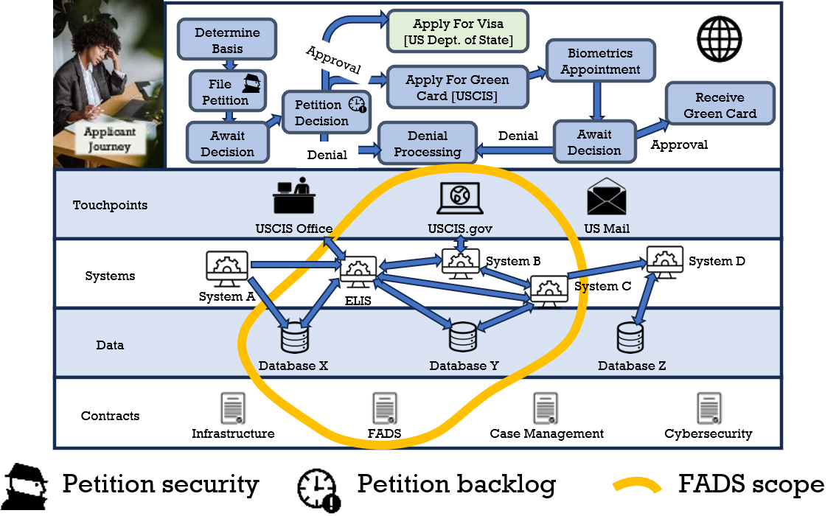
Playing Field
Practice 12
Exhibit 1. Petition Filing Ecosystem. FADS modernizes ELIS and adjacent systems, streamlining the applicant journey.
Exhibit 2 depicts a FADS solution that delivers meaningful ELIS outcomes, including mission continuity, cloud readiness and immigration fraud reduction.
Anchor Graphic
Practice 15
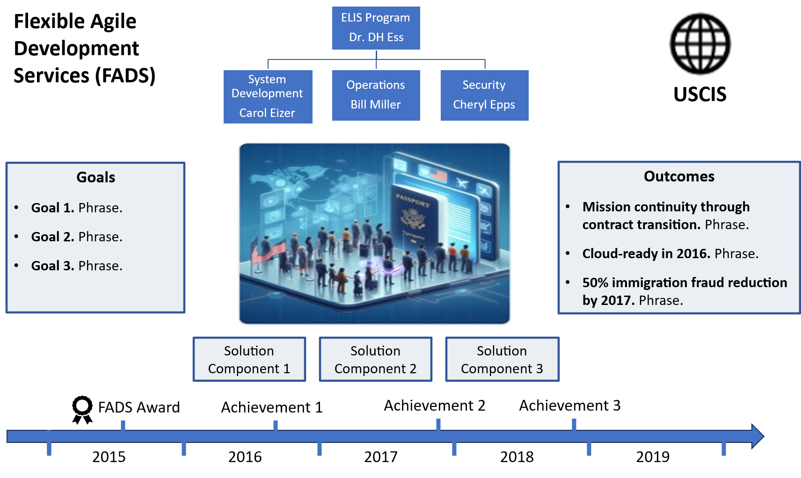
Win Themes
Practices 8-11
“We hear you”
Practice 18
Solution Components
Practice 13
Exhibit 2. FADS Success. FADS achieves the USCIS vision for ELIS.

Big Dog’s low risk FADS solution addresses USCIS priorities with a four-phased solution. The FADS roadmap depicted in Exhibit 3 depicts ecosystem evolution through solution phases.
Solution Roadmap
Practice 14
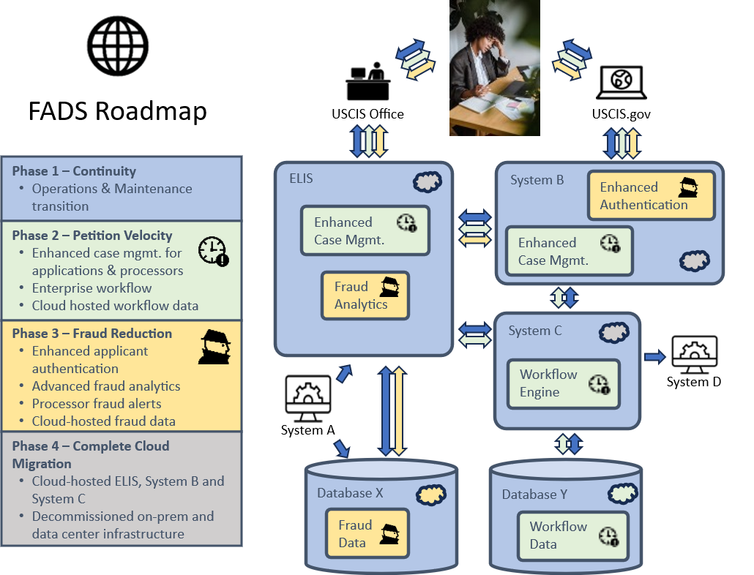
Exhibit 3. Solution Roadmap. Iterative solution delivery accelerates value delivery and reduces risk.

Solution Features
Features of Big Dog’s FADS solution deliver meaningful benefits to USCIS, as detailed in Exhibit 4. Alternative solutions raise mission risk.
Solution Justification Table Practice 16
Solution Component | Feature | Benefits | Risk of Alternatives
Solution Component 1 | Feature 1 | - Benefit 1  - Benefit 2 | - Risk 1  - Risk 2
Solution Component 1 | Feature 2 | - Benefit 1  - Benefit 2 | - Risk 1  - Risk 2
Solution Component 2 | Feature 1 | - Benefit 1  - Benefit 2 | - Risk 1  - Risk 2
Solution Component 2 | Feature 2  Solution Components  Practice 13 | - Benefit 1  - Benefit 2 | - Risk 1  - Risk 2
Solution Component 3 | Feature 1 | - Benefit 1  - Benefit 2 | - Risk 1  - Risk 2
Solution Component 3 | Feature 2 | - Benefit 1  - Benefit 2 | - Risk 1  - Risk 2
Exhibit 4. Solution Justification. Solution component features deliver benefits (strengths) and mitigate risk.

Stakeholder Value
FADS impacts many USCIS constituencies. As detailed in Exhibit 4, each receives near- and long-term benefits from Big Dog’s solution.
FADS Stakeholder | Year 1 Benefits | Years 2-5 Benefits
Immigration Applicants | - Benefit 1  - Benefit 2 | - Benefit 1  - Benefit 2
USCIS Leadership | - Benefit 1  - Benefit 2 | - Benefit 1  Stakeholder Value Table Practice 22  - Benefit 2
ELIS Org | - Benefit 1  - Benefit 2 | - Benefit 1  - Benefit 2
[Stakeholder 4] | - Benefit 1  - Benefit 2 | - Benefit 1  - Benefit 2
[Stakeholder 5] | - Benefit 1  - Benefit 2 | - Benefit 1  - Benefit 2
Exhibit 4. Stakeholder Value. Big Dog’s FADS solution accounts for all impacted USCIS stakeholders.

Delivery Team
Big Dog FADS delivery leadership team, depicted in Exhibit 5, has [quantified delivery experience].
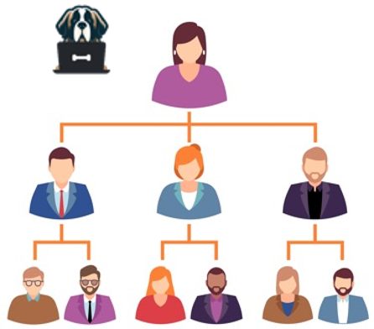
Exhibit 5. Big Dog FADS Leadership. [Name], with [x] years of USCIS project delivery experience, has Big Dog’s full authority to make decisions enabling successful FADS delivery.
Each member of the Big Dog leadership team is responsible for the satisfaction of one or more USCIS leaders, as specified in Exhibit 6.
USCIS Leadership | Big Dog Leadership | Customer Satisfaction Responsibilities
[Person 1] | [Person 1] | - [Weekly meeting]  - [Monthly report]
[Person 2] | [Person 2] | - [Weekly meeting]  Man-to-Man Defense Practice 21  - [Monthly report]
[Person 3] | [Person 3] | - [Weekly meeting]  - [Monthly report]
[Person 4] | [Person 4] | - [Weekly meeting]  - [Monthly report]
[Person 5] | [Person 5] | - [Weekly meeting]  - [Monthly report]
Exhibit 6. USCIS Customer Satisfaction. Big Dog align FADS leaders with USCIS leaders to simplify communication, tailor reporting, and promptly address issues.

Big Dog Systems [is established, wonderful, best deliverer of solutions in this category].
We have applied this approach [similar agencies, similar programs, quantified proof points].
Close With “We’re #1!” Practice 20

Document Organization.
In compliance with instructions, Big Dog’s aligns Section X of this technical approach with the Statement of Work. Section Y addresses additional information requested in the instructions.
Spoonfed Compliance Practice 23
Per evaluation criteria, we structure detailed approach sections as follows:
Paragraph | Description  Spoonfed Scoreability Practice 24
  Clear Understanding | [insight into task requirement]
  Effective, Efficient, Achievable Approach | [straightforward steps to achieving task]
  Strengths, Benefits | [benefits of Big Dog approach per stakeholder]
  Demonstrated Experience | [demonstrated Big Dog experience reduces risk of unsuccessful performance]

