

**Win Themes**

Practices 8-11

Customer-Centric ELIS Modernization Through Agile Leadership

**Tagline**

Practices 4-7

**Customer Success Vision** Practice 15

U.S. Citizenship and Immigration Services (USCIS)

* Mission continuity through contract transition
* Cloud-ready in 2016
* 50% immigration fraud reduction by 2017

Flexible Agile Development Services (FADS)

Solicitation Number 509871

Volume I – Technical Approach

# Executive Summary

**Tagline**

Practices 4-7

*USCIS has assumed a position of Agile leadership within the Department of Homeland Security (DHS) and Federal government. The Flexible Agile Development Services (FADS) procurement enables USCIS to substantiate its Agile leadership with an Electronic Immigration System (ELIS) modernization success story of accelerated cloud- readiness and immigration fraud reduction.*

**Win Themes**

Practices 8-11

**“We hear you” - Contract**

Practice 18

FADS development teams will be part of an ecosystem, participating with federal employees and other contractors in a team-based Scaled Agile approach to deliver mission value. The Government will oversee product planning, requirements, architecture, design, Agile methodologies, code integration and deployment. FADS contractors will be responsible for developing high-quality IT systems to work within those architectures and processes to meet the business requirements. Challenges include:

**“We hear you” - Drivers**

Practice 18

* Mission continuity through contract transition
* Cloud-ready in 2016
* 50% immigration fraud reduction by 2017
* **Challenge 1.** Lorem ipsum dolor sit amet, consectetuer adipiscing elit. Maecenas porttitor congue massa.

**“We hear you” – Challenges**

Practice 18

* **Challenge 2.** Fusce posuere, magna sed pulvinar ultricies, purus lectus malesuada libero, sit amet commodo magna eros quis urna.
* **Challenge 3.** Nunc viverra imperdiet enim. Fusce est. Vivamus a tellus.

Big Dog Systems’ [solution, proprietary framework], detailed throughout this technical approach, addresses each challenge. Primary solution components include:

* **Solution Component 1.** Discriminating phrase with benefit. Lorem ipsum dolor sit amet, consectetuer adipiscing elit. Maecenas porttitor congue massa.

**Solution Components**

Practice 13

* **Solution Component 2.** Discriminating phrase with benefit. Fusce posuere, magna sed pulvinar ultricies, purus lectus malesuada libero, sit amet commod.
* **Solution Component 3.** Discriminating phrase with benefit. Nunc viverra imperdiet enim. Fusce est. Vivamus a tellus.

Exhibit 1 depicts the USCIS ecosystem supporting the applicant journey. USCIS goals include improving petition security and reducing the average petition decision wait time. FADS services modernize ELIS and adjacent ecosystem elements, as illustrated by the gold rubber band. Impacts to each element are detailed in Section x.y.

**“We hear you”**

Practice 18

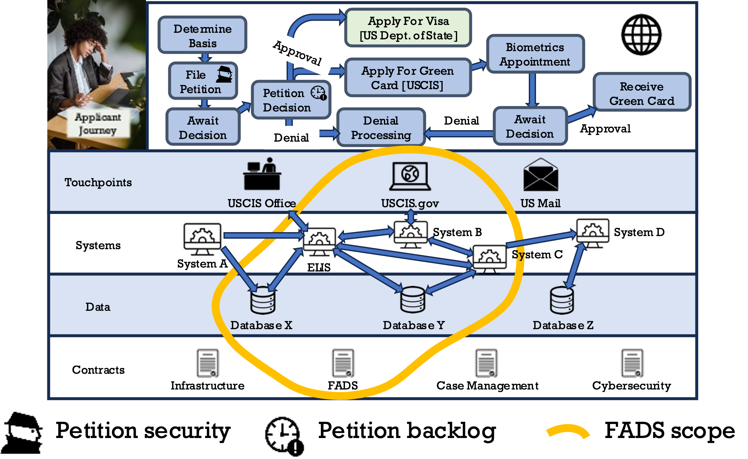

**Playing Field**

Practice 12

Exhibit 1. Petition Filing Ecosystem. FADS modernizes ELIS and adjacent systems, streamlining the applicant journey.

Exhibit 2 depicts a FADS solution that delivers meaningful ELIS outcomes, including mission continuity, cloud readiness and immigration fraud reduction.

**Anchor Graphic**

Practice 15

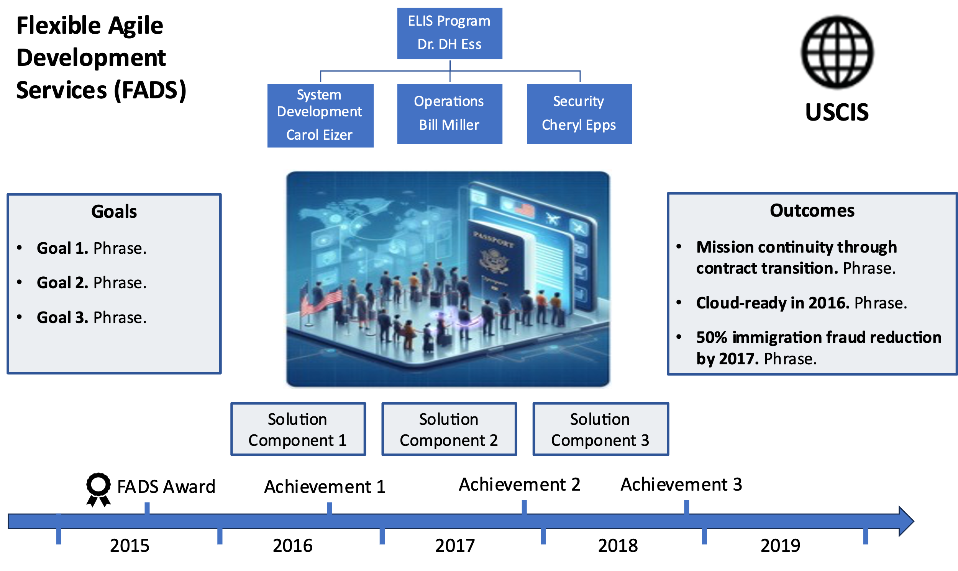

**Win Themes**

Practices 8-11

**“We hear you”**

Practice 18

**Solution Components**

Practice 13

Exhibit 2. FADS Success. FADS achieves the USCIS vision for ELIS.

Big Dog’s low risk FADS solution addresses USCIS priorities with a four-phased solution. The FADS roadmap depicted in Exhibit 3 depicts ecosystem evolution through solution phases.

**Solution Roadmap**

Practice 14

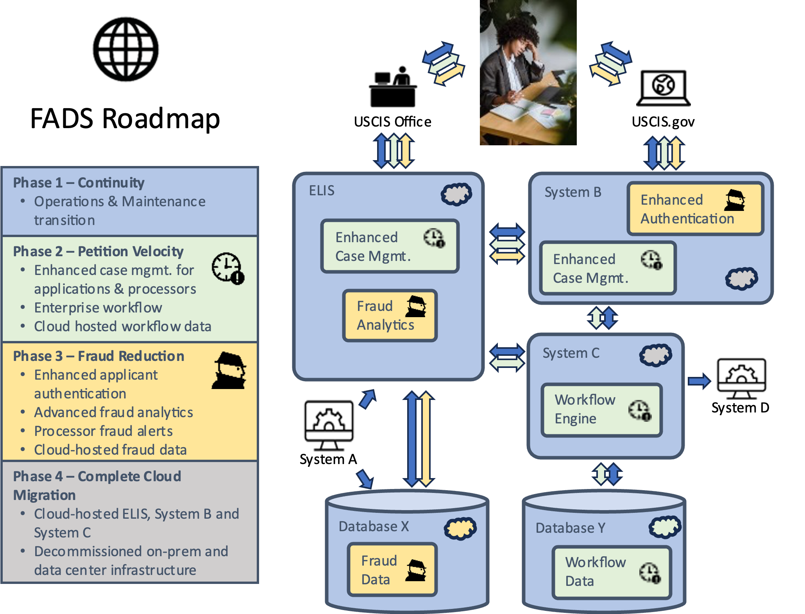

Exhibit 3. Solution Roadmap. Iterative solution delivery accelerates value delivery and reduces risk.

**Solution Features**

Features of Big Dog’s FADS solution deliver meaningful benefits to USCIS, as detailed in Exhibit 4. Alternative solutions raise mission risk.

**Solution Justification Table** Practice 16

|  |  |  |  |
| --- | --- | --- | --- |
| Solution Component | Feature | Benefits | Risk of Alternatives |
| Solution Component 1 | Feature 1 | * Benefit 1 * Benefit 2 | * Risk 1 * Risk 2 |
| Feature 2 | * Benefit 1 * Benefit 2 | * Risk 1 * Risk 2 |
| Solution Component 2 | Feature 1 | * Benefit 1 * Benefit 2 | * Risk 1 * Risk 2 |
| Feature 2  **Solution Components**  Practice 13 | * Benefit 1 * Benefit 2 | * Risk 1 * Risk 2 |
| Solution Component 3 | Feature 1 | * Benefit 1 * Benefit 2 | * Risk 1 * Risk 2 |
| Feature 2 | * Benefit 1 * Benefit 2 | * Risk 1 * Risk 2 |

Exhibit 4. Solution Justification. Solution component features deliver benefits (strengths) and mitigate risk.

**Stakeholder Value**

FADS impacts many USCIS constituencies. As detailed in Exhibit 4, each receives near- and long-term benefits from Big Dog’s solution.

|  |  |  |
| --- | --- | --- |
| FADS Stakeholder | Year 1 Benefits | Years 2-5 Benefits |
| Immigration Applicants | * Benefit 1 * Benefit 2 | * Benefit 1 * Benefit 2 |
| USCIS Leadership | * Benefit 1 * Benefit 2 | * Benefit 1   **Stakeholder Value Table** Practice 22   * Benefit 2 |
| ELIS Org | * Benefit 1 * Benefit 2 | * Benefit 1 * Benefit 2 |
| [Stakeholder 4] | * Benefit 1 * Benefit 2 | * Benefit 1 * Benefit 2 |
| [Stakeholder 5] | * Benefit 1 * Benefit 2 | * Benefit 1 * Benefit 2 |

**Exhibit 4. Stakeholder Value.** Big Dog’s FADS solution accounts for all impacted USCIS stakeholders.

**Delivery Team**

Big Dog FADS delivery leadership team, depicted in Exhibit 5, has [quantified delivery experience].

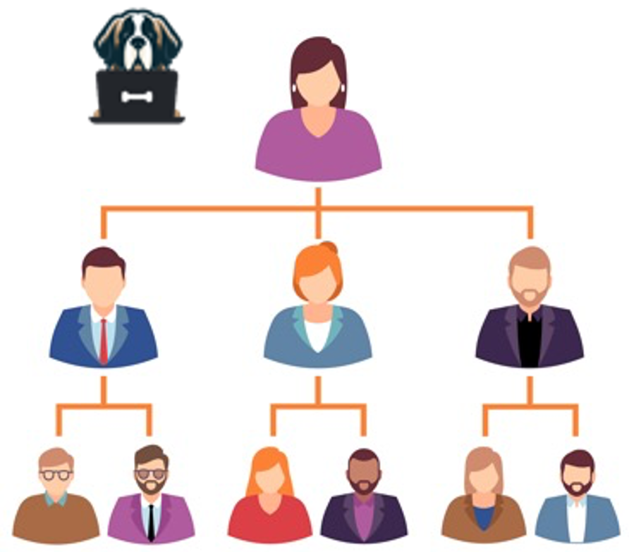

**Exhibit 5. Big Dog FADS Leadership.** [Name], with [x] years of USCIS project delivery experience, has Big Dog’s full authority to make decisions enabling successful FADS delivery.

Each member of the Big Dog leadership team is responsible for the satisfaction of one or more USCIS leaders, as specified in Exhibit 6.

|  |  |  |
| --- | --- | --- |
| USCIS Leadership | Big Dog Leadership | Customer Satisfaction Responsibilities |
| [Person 1] | [Person 1] | * [Weekly meeting] * [Monthly report] |
| [Person 2] | [Person 2] | * [Weekly meeting]   **Man-to-Man Defense** Practice 21   * [Monthly report] |
| [Person 3] | [Person 3] | * [Weekly meeting] * [Monthly report] |
| [Person 4] | [Person 4] | * [Weekly meeting] * [Monthly report] |
| [Person 5] | [Person 5] | * [Weekly meeting] * [Monthly report] |

**Exhibit 6. USCIS Customer Satisfaction.** Big Dog align FADS leaders with USCIS leaders to simplify communication, tailor reporting, and promptly address issues.

**Big Dog Systems** [is established, wonderful, best deliverer of solutions in this category].

We have applied this approach [similar agencies, similar programs, quantified proof points].

**Close With “We’re #1!”** Practice 20

**Document Organization.**

In compliance with instructions, Big Dog’s aligns Section X of this technical approach with the Statement of Work. Section Y addresses additional information requested in the instructions.

**Spoonfed Compliance** Practice 23

Per evaluation criteria, we structure detailed approach sections as follows:

|  |  |
| --- | --- |
| Paragraph | Description  **Spoonfed Scoreability** Practice 24 |
| Understand Icons - Free SVG & PNG Understand Images - Noun ...Clear Understanding | [insight into task requirement] |
| Workflow Icons - Free SVG & PNG Workflow Images - Noun ProjectEffective, Efficient, Achievable Approach | [straightforward steps to achieving task] |
| Benefit Icons - Free SVG & PNG Benefit Images - Noun ProjectStrengths, Benefits | [benefits of Big Dog approach per stakeholder] |
| Low Risk Icons - Free SVG & PNG Low Risk Images - Noun ProjectDemonstrated Experience | [demonstrated Big Dog experience reduces risk of unsuccessful performance] |