Click on the little man to create an account or sign in.
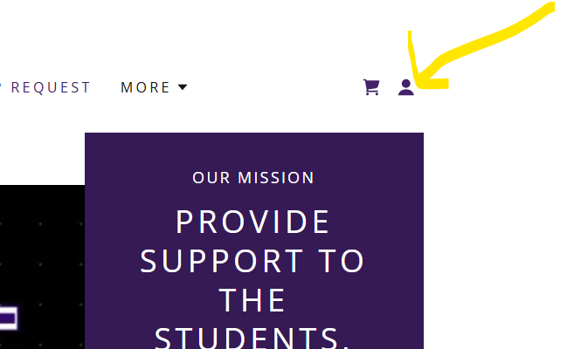

Once you are signed in, you can make new appointments or reschedule existing. There are currently 5 slots available for each hour. If you don’t see the time you are looking for on a specific day, try another slot. Don’t pay attention to the “trainer” assigned to each slot. If you want to book more than one slot at a time, choose “book more services” at the checkout.
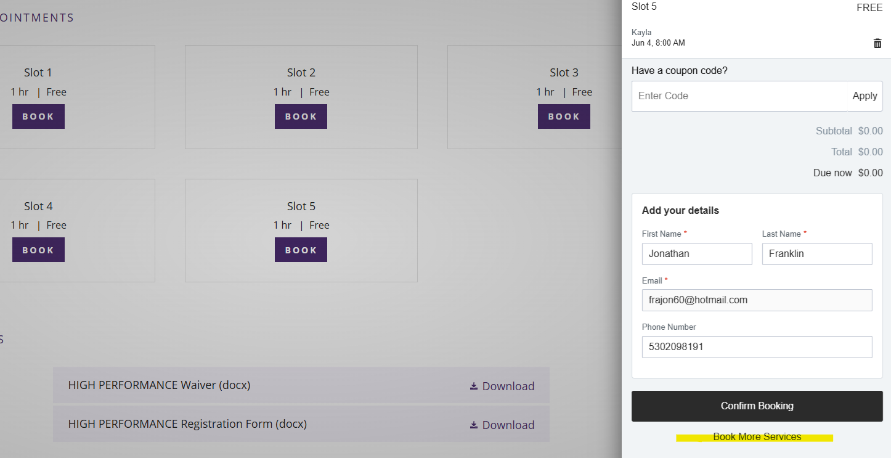

To reschedule, click on bookings on the little man:
Click on the slot you want to reschedule, and click on “reschedule”
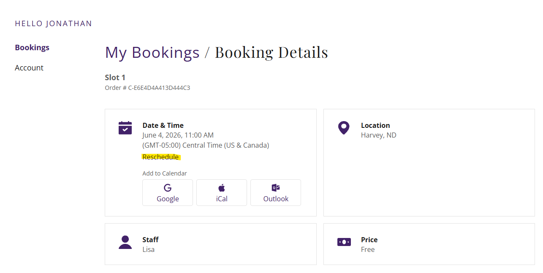
If you need to cancel, you will need to email us at info@hwcbooster.org

