BD10307_

**Irish Soda Bread**

4 cups all-purpose flour

¼ cup sugar

1. teaspoon baking soda
2. teaspoons baking powder
3. teaspoon salt
4. large eggs
5. ¼ cups buttermilk

¼ Cup light tasting vegetable oil (or substitute butter cut into small pieces and mixed into dry ingredients)

1. tablespoon caraway seeds or more if preferred
2. cup dark raisins
3. tablespoon buttermilk to brush top

sprinkle of sugar

Preheat oven to 375 F. Lightly grease a 2-quart glass or stoneware dish with butter. Soak the raisins in the buttermilk while mixing.

In a large bowl stir the flour, sugar, baking soda, baking powder and salt to combine. Add the caraway seeds.

In a separate bowl beat the eggs and oil together. Add the buttermilk with the raisins.

Make a well in the center of the dry ingredients and pour in the buttermilk mixture. Stir from the liquid center out, slowly incorporating the flour, until a soft dough is formed.

Spread some flour on the counter and flour your hands. Gently shape the dough into a ball, slightly flatten, careful not to over handle.

Place in buttered dish. Brush the top with the tablespoon of buttermilk and sprinkle with sugar.

Make a deep cross in the top of the bread before placing in oven. (This was an old Irish tradition to bless the bread so it would rise and the deep cut allows the wet dough to bake better)

Bake 40 minutes until golden brown and tester comes out clean. Allow to cool before cutting. Great toasted the next few days and with butter or marmalade.

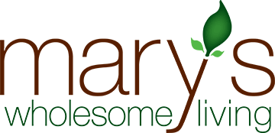BD10307_

Mary Krystinak

Mary’s Wholesome Living

mary@maryswholesomeliving.com

www.maryswholesomeliving.com

630-776-4604