[](http://mageenews.wpengine.com/)

Now

# **The Willie Spears Experience**

*State Farm*

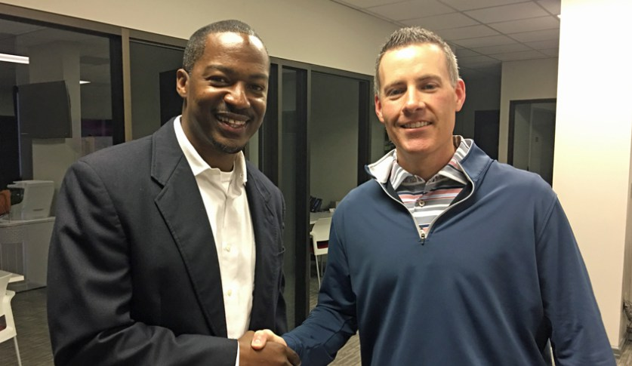

*by* [*Sue Honea*](http://mageenews.wpengine.com/author/suehonea/)*April 8, 2018*

While visiting Breck, Carolyn and girls in Montgomery for Larkin’s birthday party, I got an extra treat! Breck and another State Farm agent, Clay Carroll, sponsored a motivational team meeting for their offices.I, of course, I had to tag along!

Willie Spears spoke to the group. I had never seen or heard of Willie Spears…but “Willie Spears” is not a name I will soon forget.

Head Coach at Carver High School in Montgomery, Al, Willie speaks to thousands each year. His goal is to add value to the life of the listener.

One of the many things that impressed me about Willie was his speech spoke to his audience (State Farm team members). I talked with Willie following the talk and he explained that he always researches the audience. In other words, he comes prepared!

He is the author of several motivational books.

Willie Spears is a professional speaker, teacher, author, head football coach, and motivator. A licensed minister, he has motivated churches, youth groups, prison inmates, schools, teachers, teams, companies, and individuals through his business.

Ok, I’m just saying, if any group is looking for a speaker…check out Willie Spears. “Work it”…I’m saying…hire him for several motivational talks in one day! (I think he is paid by the day!)

For more information on The Willie Spears Experience [click here](https://williespears.com/).

## http://0.gravatar.com/avatar/c79638945d462d186ab0b915d52195cd?s=288&d=mm&r=g [SUE HONEA](http://mageenews.wpengine.com/author/suehonea/)

Sue Honea, affectionately known as "The Prez," began writing a newsletter to members of the First Baptist Church BYW nearly 40 years ago. The newsletter turned into an email which turned into a website. Today, MageeNews.com has more than 200,000 page views per month, and it all began with a simple "Message from the Prez."