****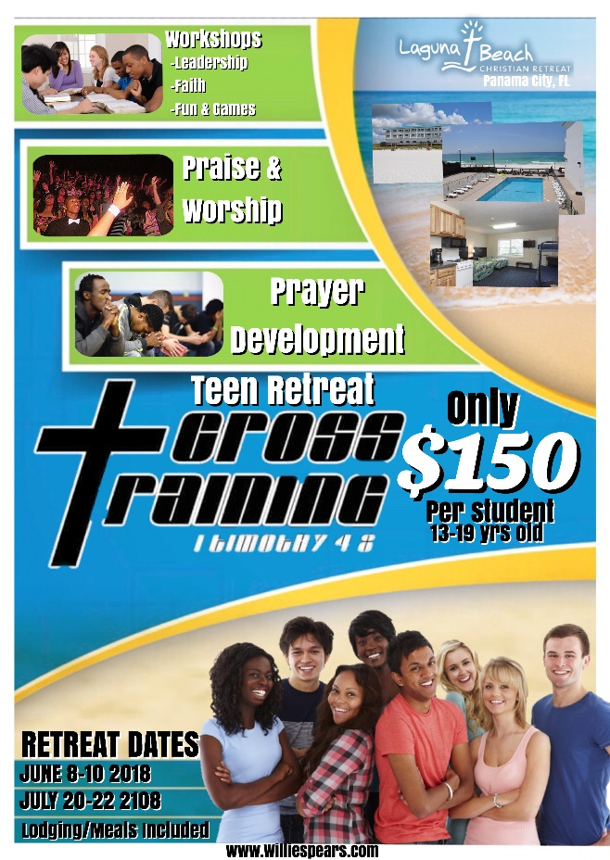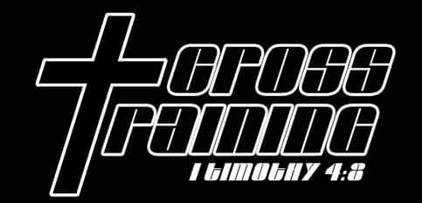



@TWSE



@TWSE

Willie Spears

**Willie Spears is a professional speaker, teacher, author, head football coach, and motivator. A licensed minister, he has motivated churches, youth groups, prison inmates, schools, teachers, teams, companies, and individuals through his business, The Willie Spears Experience.**

Donte Sheppard

**Donte is a sought after motivational speaker. Speaking is a natural gift. He has the ability to captivate any audience, and his passion and enthusiasm are evident within each keynote. He is a phenomenal storyteller who delivers messages that provide hope and inspiration.**

**Check out our website and follow us on social media!**

***Office Use only***

Processed by:______________________________________________________________

Date: ____________________________________________________________________



The Willie Spears Experience

**www.williespears.com**

**Cross Training Summer Camp is a church camp for teenagers. The camp director is ordained Minister Willie Spears. Co-director is former youth pastor Donte Sheppard. The purpose of the camp is to show young people you can be bold about your faith and still have a good time. We want to give young people resources, contacts, and biblical references to help them cultivate a stronger relationship with Jesus Christ.**

**PANAMA CITY BEACH, FL**



APPLICATION FORM

NAME:_______________________________________

AGE:___________PHONE:______________________

ADDRESS:____________________________________

ADDRESS 2:___________________________________

CITY:_________________________________________

STATE:________________ ZIP CODE:______________

Payment Method:

CASH CHECK DEBIT PAYPAL

**If mailing payment, please send check and application to:**

**Cross Training**

**c/o Donte Sheppard**

**7147 Santa Barbara Street**

**Pensacola, FL 32526**

**This application can also be submitted online at** [**williespears.com**](http://www.williespears.com) **or emailed to** [**twse.bland@gmail.com**](mailto:twse.bland@gmail.com)