‘You have the choice to change’
By TYRA JACKSON
http://www.newsherald.com/news/20180126/you-have-choice-to-change
Posted Jan 26, 2018 at 5:18 PM Updated Jan 26, 2018 at 5:19 PM

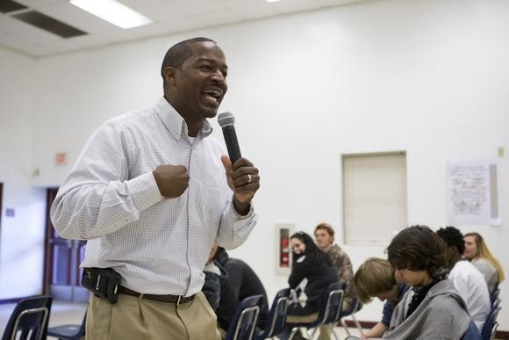 “He is back by popular demand,” the principal said. “He is the only visitor that students requested a return visit.”
Editor’s note: This story is part of a series that will feature mentors from various organizations working in the school district. January is National Mentor Month.
PANAMA CITY — Willie Spears walked — and got into trouble for excessive talking — in some of the same hallways as Rosenwald High School students. Now, he gets paid to talk.
The Panama City native, now a motivational speaker, dropped a bit of knowledge and a few beats on those students at an assembly Friday for Mentors Matter Month and Celebrate Literacy Week. That’s right — he opened the assembly by beat boxing.
“In middle school, I stayed in in-school suspension. I thought it was a part of my schedule,” he jokingly told the students. “You have the choice to change.”
He challenged them to imagine themselves in the next 10 years, and to work toward becoming that person.
“All you have to do is begin with the end in mind,” he told them.
Spears is a familiar face to those at the high school.
“He’s come maybe the last five or six years,” Rosenwald Principal Chandra Tyson said. “He is back by popular demand. He is the only visitor that students requested a return visit. They really identify with him. He connects well with the students.”
He also knows what topics to discuss. Tyson said before Spears arrived to the school, students filled out surveys with requests for topics like bullying, overcoming obstacles, maintaining a positive attitude and more.
He reminded students one bad decision they made does not define them.
“Smart people think about the future,” Spears said. “The decisions you make today will determine your tomorrow. You get to decide.”
Senior Larry Lewis said a lot of Spears’ encouraging words stuck with him, and he did take away something: “Always listen to your elders, and listen if people are trying to tell you right,” Lewis said.
“We’re delighted he took the time out of his schedule to speak with our kids,” Tyson said. “We consider him to be a mentor. He keeps it 100. We are just thrilled. He has a heart for the kids.”

