Town of Kiawah Island Comprehensive Marsh Management Plan

Charette Outcomes, July 21, 2022

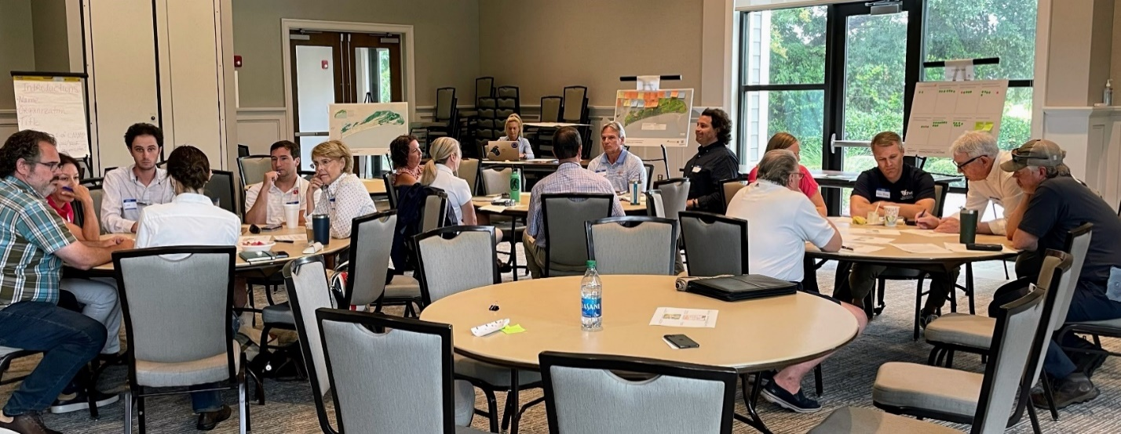Community members, outside experts, and Kiawah staff and officials joined the Planning Charette on Thursday, July 21 at Town Hall Council Chambers. It was a lively day of unencumbered idea sharing and innovative options for the Comprehensive Marsh Management Plan (CMMP). Together, we began the co-development of preliminary actions and recommendations that will ultimately be incorporated into the CMMP.

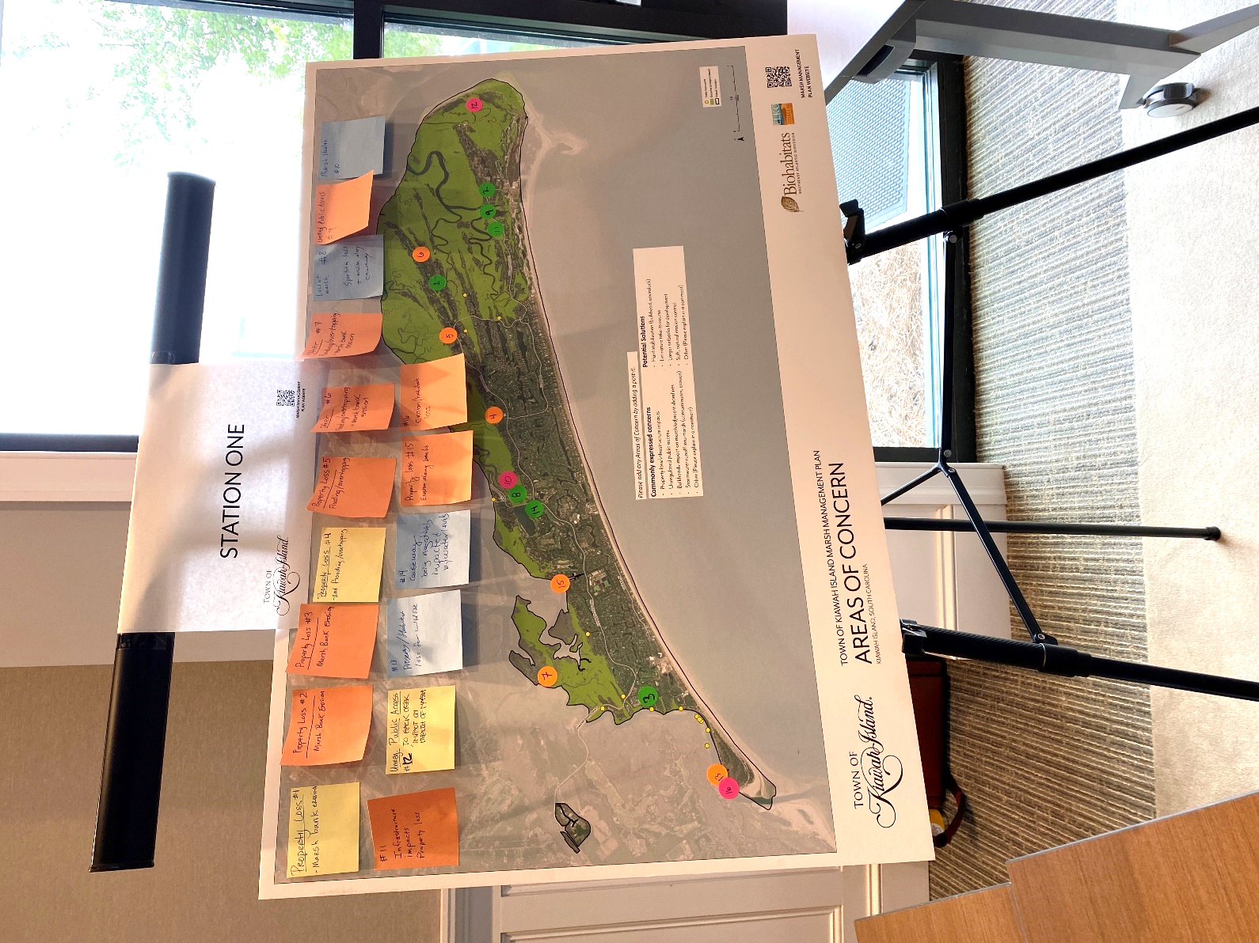Before the Charette, stakeholders were engaged about their marsh management concerns through an online survey and an interactive mapping tool. Results from these engagements have been combined with input from the Charette in the following.

Figure 1. Survey responses to the question, “How concerned are you about threats to Kiawah's marsh?”

During the Charette, mapping activities helped the team identify “low hanging” ideas and immediate areas of concern.

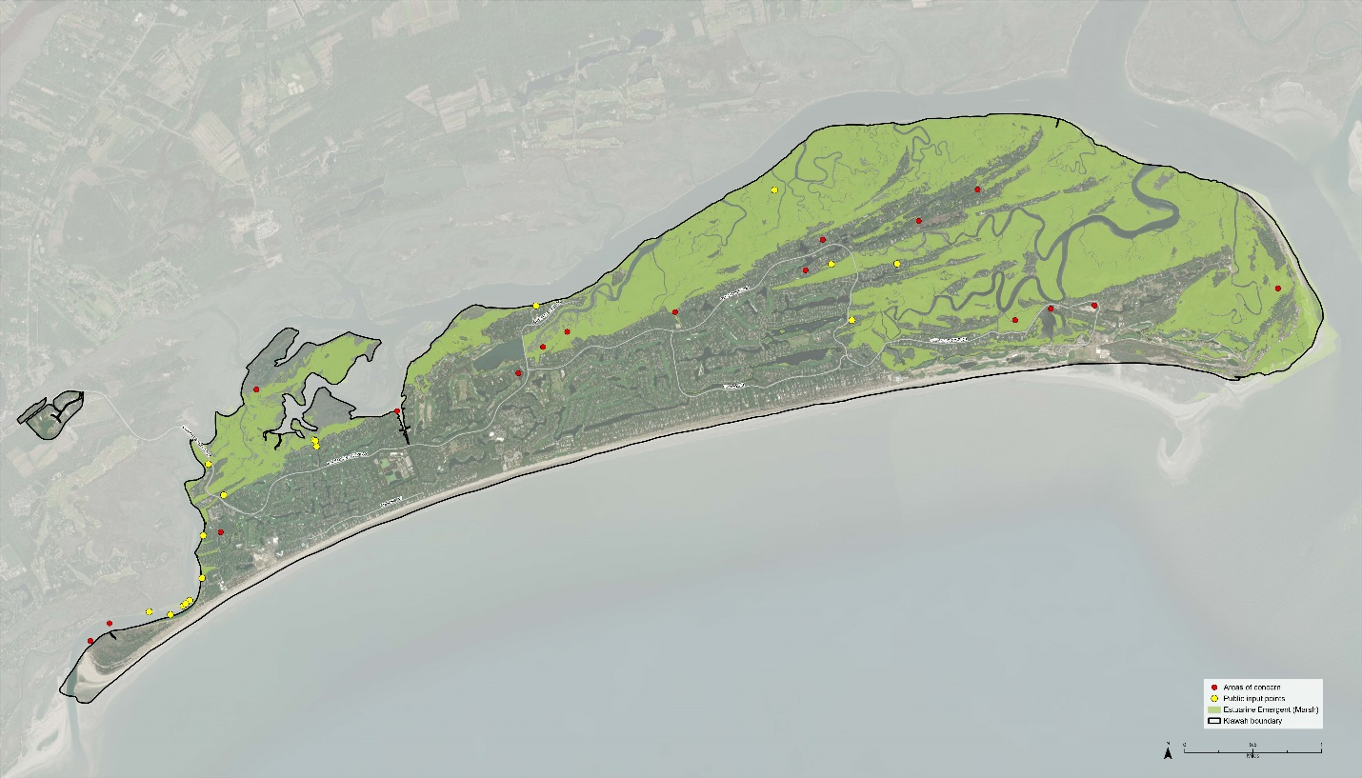

Figure 2. Map of combined input on areas of marsh management concern on Kiawah from the survey, interactive map, and Charette boards.

Feedback allowed for the following prioritization of marsh management concerns.

Figure 3. Prioritized marsh management concerns from survey and Charette.

During the Charette, the team solicited ideas and feedback on conceptual actions and recommendations from decision makers, owners and stakeholders. The following draft list summarizes those items and broadly categorized as **monitor, regulate/protect, educate, or restore.** Please help prioritize this list by letting us know if you agree with our assessment that some are **easy wins/no brainers** and others *will require additional coordination and discussion*.

1. **Mapping/monitoring marsh health**
   1. **Establish annual program with triggers**
   2. **Use data to inform items below**

**Regulate/Protect**

1. **Clarify town code by consolidating marsh-related elements,**
2. **Streamline natural solutions permitting at local, state, federal levels to maintain balance between development and a healthy marsh,**
3. **Determine marsh management and education responsibilities of each entity (Marsh of Ks),**
4. *Incentivize permeable surfaces, formalize storm water BMPs for private properties,*
5. *Regulate marsh front berms upland of critical line,*
6. *Standardize setbacks:*
   1. *Determine setback + native buffer sizes, distance from critical line/property line,*
   2. *Vegetation: Limit lawns, manage dying trees/vegetation as sea level rises,*
   3. **Consultant to:**
      1. **Analyze different parts of island (based on timeframe of initial development), including buffers, determine criteria for each typical case/prototype,**
      2. **Develop time series of illustrations of setback/buffer proposal today and how marshfront property and the setbacks may evolve over time (distance specifics, measured from where)**
7. *Development guidelines for marsh protection:*
   1. *Undeveloped lots and new developments,*
   2. *Redevelopment,*
      1. *Cautious to avoid moving majority of existing development into non-compliance*
   3. *Disaster rebuilds,*
      1. *Clarify 50% rebuild policy re: new development guidelines*

**Educate**

1. **What** –
   1. Marsh health indicators, science of marsh management, outcomes of monitoring
   2. Conservancy’s catalog of:
      1. Shoreline management practices: Options such as nature/vegetation based, living shorelines (LSL), marshfront berms, bulkheads, hybrid projects with LSL as long-term role model/preference, and
      2. Green infrastructure practices: On-site stormwater mgmt, permeable surfaces, and vegetative buffers for marsh health
2. **Why** – Explain why new policies/ordinances being considered and their role in marsh management
3. *Who, entities that “touch” marsh management* –
   1. Town council, commissions,
   2. KICA, Developer?
   3. Conservancy, education is mission
   4. Realtors, convey information to new buyers,
   5. Rental management companies and property owners of STRs,
   6. ARB and BZA
4. **How/When** –
   1. Slowly! Focus first year on education, ease into issuing warnings and violations,
   2. Utilize town and other entities’ websites, social media,
   3. Develop an education campaign/initiative, similar to the one for Kiawah bobcats,
   4. Host a quarterly series at council meetings and/or One World presentations,
   5. Create an annual marsh management month and/or periodic happy hour updates

**Restore**

1. **Provide a list of funding opportunities, NFWF, SCOR, etc. for marsh restoration, in CMMP,**
2. Prioritize voluntary, multi-property-scale, comprehensive **demonstration/pilot living shoreline project** (near-term),
3. Begin planning for a TOKI **marsh mitigation bank fund** (near-term),
4. Assess feasibility and conceptual design of a **large-scale community-administered marsh restoration project** (2-3 years), and
5. Leverage partnerships for *marshfront property acquisition*.