Homework #1: Windows Server 2019 & SQL 2019 VM Creation
- This is an individual assignment, and is worth 20 points.
- The due date is Saturday, Jan 23rd Midnight.
- You should use the “CIS 483 HW#1-Tasks.docx” file to provide your outcomes.
- Use the following naming convention: homework, underscore, last name, first initial, and extension (e.g., Homework #1_ImG.docx). If you do not follow the convention, I will deduct 1.0.
- Do not use any of the sample screenshots provided as illustrations for your submission.
- Do not make screenshots too small. If too small, I will deduct points.
- You are not allowed to do assignment during the class.

(TASK #1: 5 points) Login to the Windows Server, and take a screenshot of the first screen.
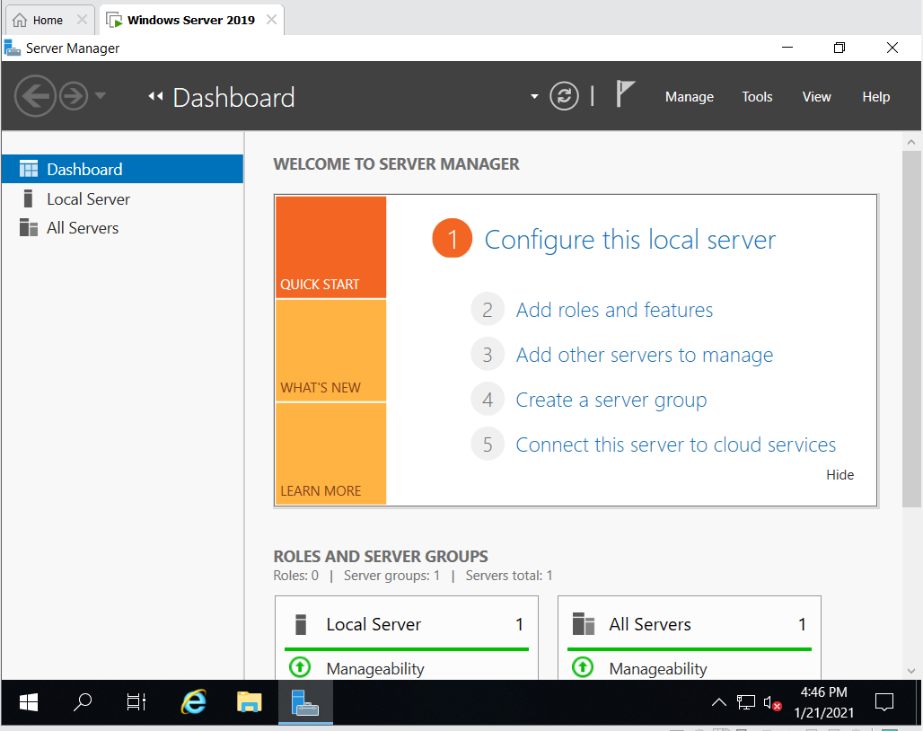

(TASK #2: 5 points) Run the following queries. Show the results in a screenshot. You must show that the installation is SQL Server 2019.
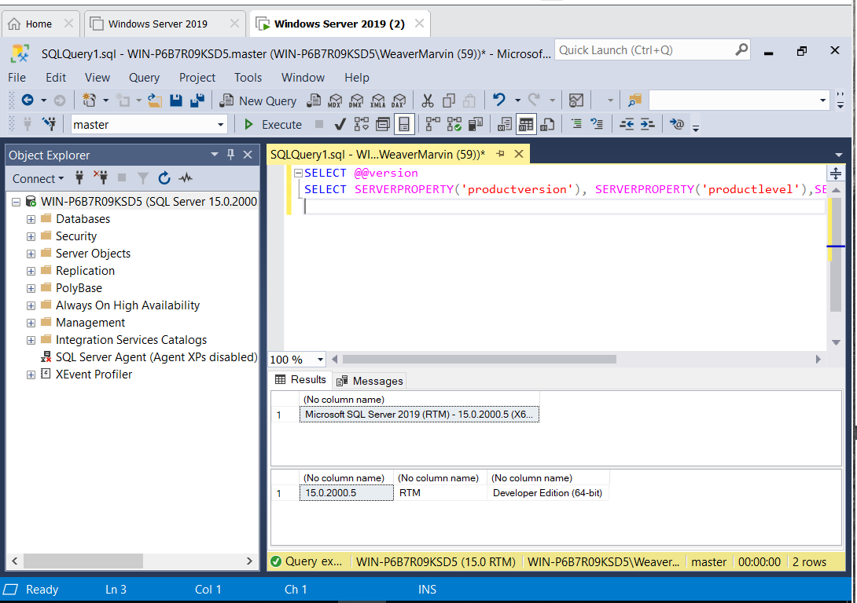

(TASK #3: 5 points) Show in a screenshot that the services you have installed are running.
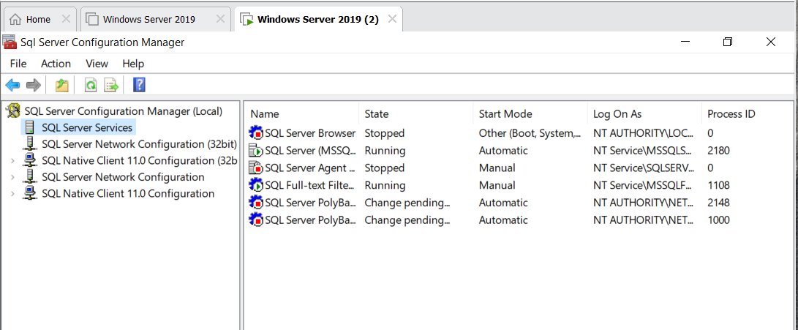

(TASK #4: 5 points) Execute the following query. Show the result in a screenshot. How many departments did you get with the query?
