 | Initial Podiatry Progress Note  Vanessa Nieves, DPM
Date of Service:__________________ Facility:________________________ Room #:_____________
Patient:_______________________________ SEX:___ Attending:________________ DLV:________

Date of Birth:_______________ Allergies:_________________________________________________________________
Responsive Capacity:  Good  Fair  Poor  Combative Place of service:  Bedside Wheelchair Patient is  ambulatory  Bedridden

Clinical Findings

Vascular Exam R L  Dorsalis Pedis /4 /4  Posterior Tibialis /4 /4  Popliteal Pulse /4 /4  Capillary Filling Time _____sec ____sec  Varicosities  Foot Foot   Ankle Ankle   Leg Leg  Temp. Gradient  WNL  WNL  INC/DEC INC/DEC  Skin Temperature  WNL  WNL  Cool/Hot Cool/Hot  Edema  Yes  NO  Yes  No  (Location) ______________ _____________  Hair growth  Yes  NO Yes  No   Diminished  Diminished  Dependant Rubor/Pallor/Cyanosis?   Yes  No Yes  NO  Neurological Exam  DTR’s  Deferred  Deferred  (patellar/ankle) /5 /5 /5 /5  Sharp/Dull  WNL  WNL  DEC./ INC. DEC. / INC.  Hemipariesis Yes  No  Yes  No  Foot brace worn? Yes  No  Yes  No  Ambulatory? Yes  No  Yes  No  Babinsky Sign (+) (-) (+) (-)  PODIATRIC DIAGNOSIS (ES)  1)________________ 2) _________________  3)________________ 4) _________________ | Orthopedic Exam R L  Hammer Toes? 1 2 3 4 5 1 2 3 4 5  Clavi/Callous 1 2 3 4 5 1 2 3 4 5  Bunion?  Yes  No  Yes  No  Overall ROM:  WNL  WNL   Decreased  Decreased  Crepitus/effusion?  Yes  No  Yes  No  Amputation? TOE___ BKA___ TOE___ BKA___  TMA___ AKA___ TMA___ AKA___  Muscle pw /15 Muscle pw /15  Foot Type Cavus/Planus/ Cavus/Planus/  average average  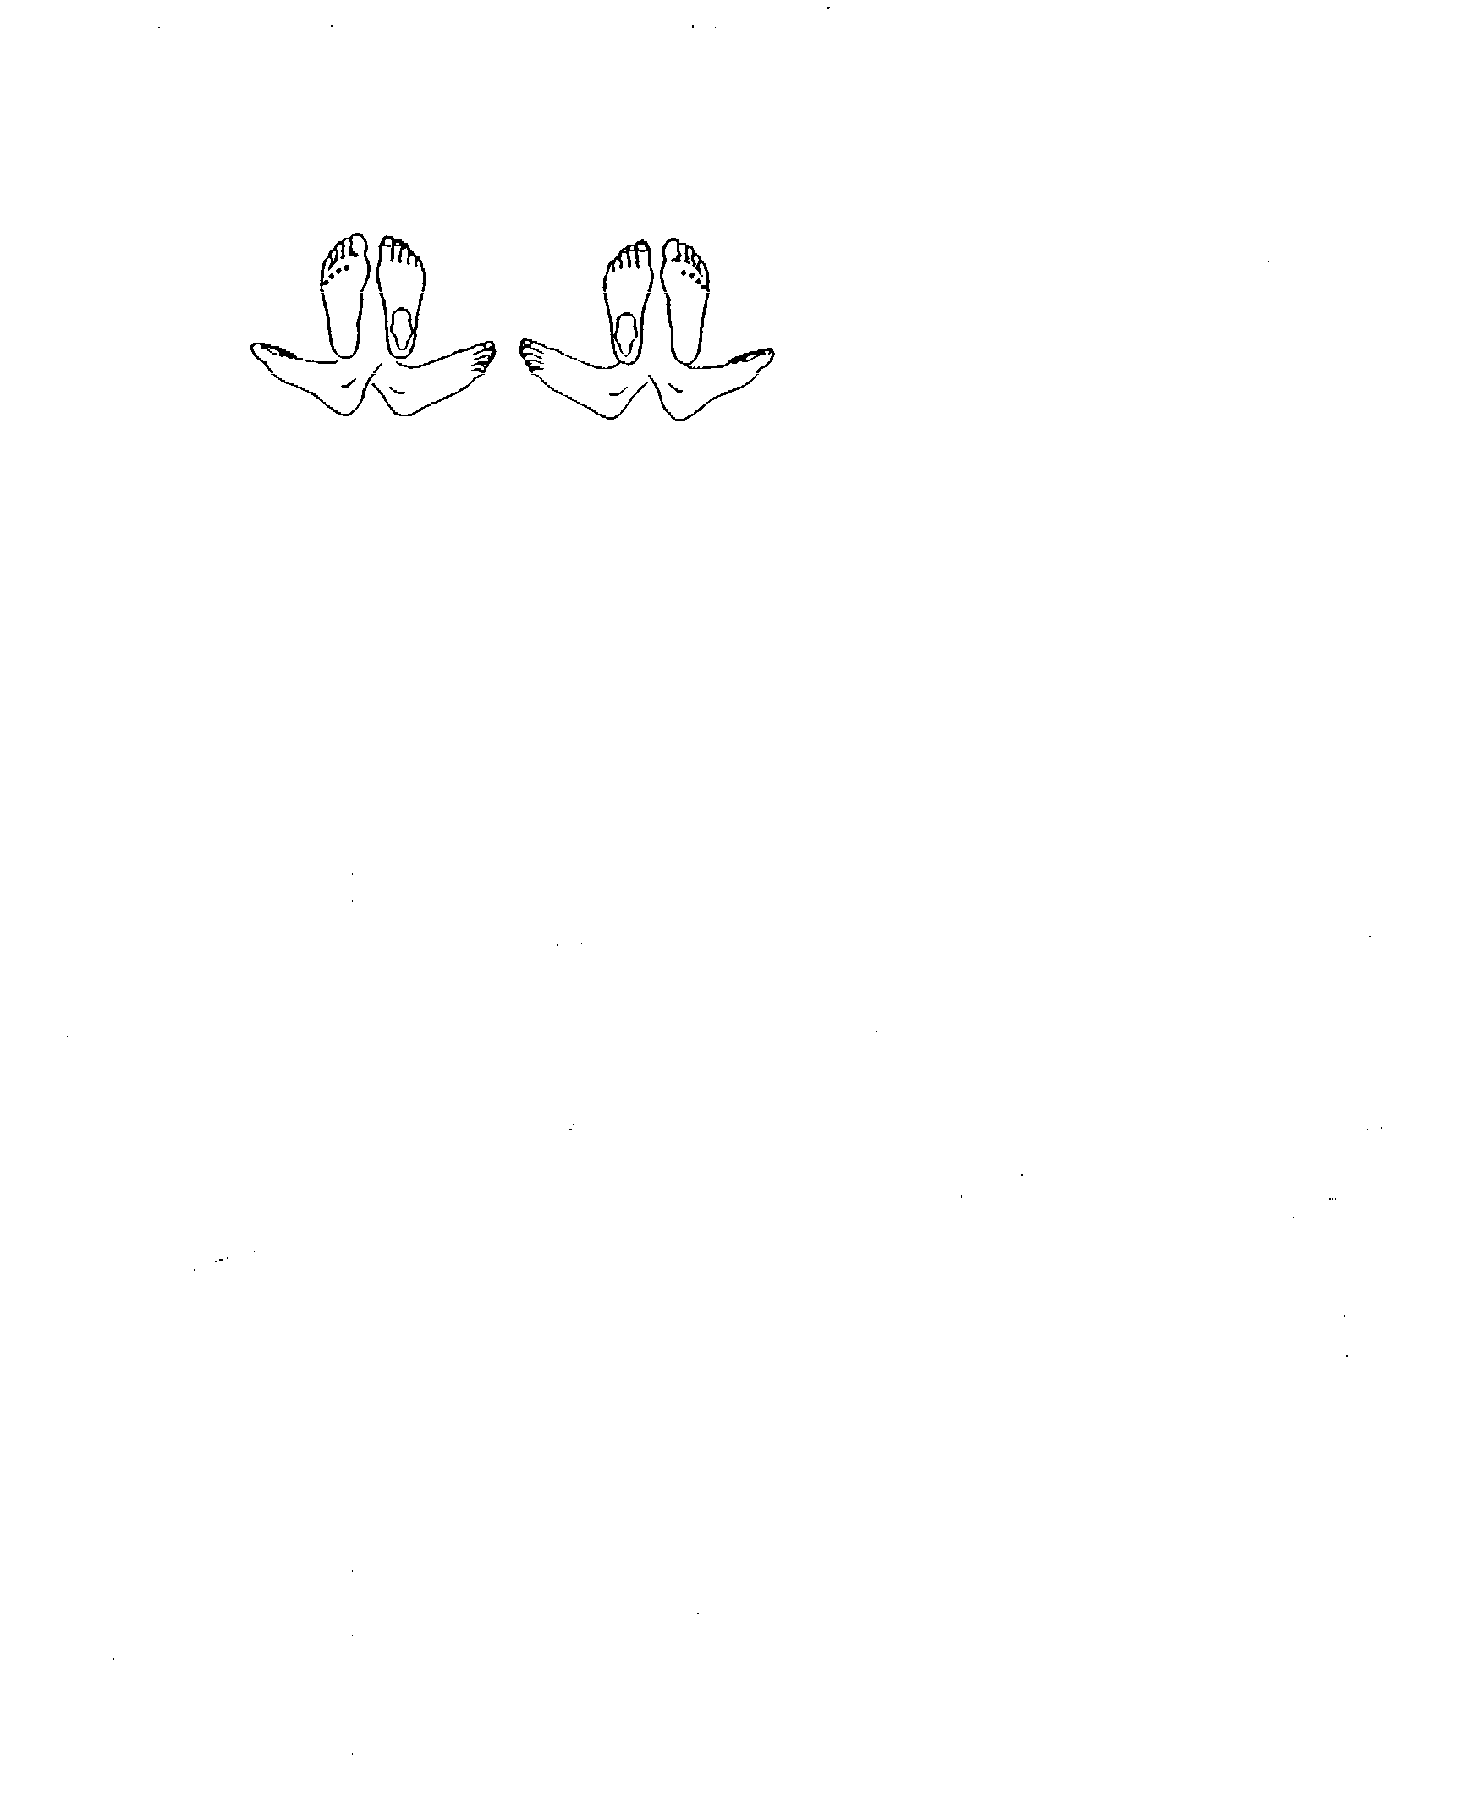  Dermatological Exam  Skin Color  Normal  Cyanotic R L B   Ruborous  Pallor  Texture  Normal  Thin R L B  Atrophic  Skin Lesions   Hyperkeratoses _________________________________   Preulcerative Area_______________________________   Ulcerations_____________________________________   Other_________________________________________  Interspaces R L   Clear 1 2 3 4 5 1 2 3 4 5   Macerated 1 2 3 4 5 1 2 3 4 5  Nails
 |  | 1 | 2 | 3 | 4 | 5 |  | 1 | 2 | 3 | 4 | 5
5)_______________________________ | ❒ Normal
Treatment Plan: | ❒ Hypertrophic Dystrophic
 | ❒ Discoloration
 | ❒ Thickening
 | ❒ Thick,Yellow, Mycotic
 | ❒ Onochocryptosis
 | ❒ Lateral nail border
 | ❒ Medial Nail Border
 | ❒ Both Borders
 | ❒ Drainage
 | ❒ Evidence of clubbing
 | ❒ Evidence of pitting

_______________________________________ _____________ Recall Visit:  30 days  60 days  Next Visit
Podiatrist’s Signature Date
C/O “_______________________________________________________”

/podiatry/Podiatry Progress Note Oct.98

