July 1, 2021
To whom this may be presented:

The American Legion Paul E Bolding Post 7, Gainesville, GA is sponsoring the Gainesville American Legion Post 7 Baseball program. The baseball team(s) will be participating in travel baseball tournaments throughout the region and will be based in Gainesville, GA.
We invite you to become one of our partners/sponsors by contributing to the program’s success and continued growth. The most important part of the program is the growth and development of the youth involved and their opportunity to represent the local area and the American Legion.
The American Legion Paul E. Bolding Post 7 is a 501C19 charitable organization and donations are tax deductible. Our Federal Tax ID# is 58 0537644 is provided for your reference.
If you have any questions or need any further verification, please contact us.

Very Respectfully,
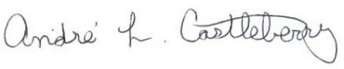
Andre’ L. Castleberry
Sr. Vice Commander
American Legion Paul E. Bolding Post 7
2343 Riverside Dr.
Gainesville, GA 30503
Office: 770-534-7091
Cell: 678-200-4137

