18th Annual Memorial Day Parade
sponsored by
Paul E. Bolding American Legion Post 7

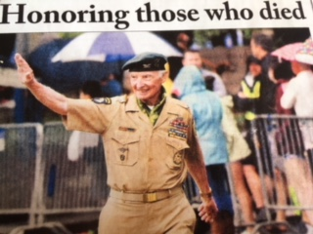

Monday, May 25, 2020

Parade starts at 10:00 am

Come join us in honoring our Veterans, all service Men and Women

- Lineup will begin at 7:00am
- All groups must assemble offsite then travel to staging area together
- Entries must recognize a veteran or say thank-you with signage on your vehicle
- For safety - No candy thrown from vehicles – candy can be thrown by walkers

All entries must be received by Monday, May 11, 2020 (NO EXCEPTIONS)

Organization/Group Name __________________________________________________

Contact person name -printed __________________________________________________________________________________

I have read and will abide by the parade Guidelines – signature _________________________________

Address __________________________________________________________________

Phone_______________ E-mail ______________________________________________

Number of persons walking _______________________________

If a car club, number of vehicles ___________________________

If Shriners, number of motorized vehicles ___________________

Info about entry _____________________________________________________________________

______________________________________________________________________________________

Veteran information: _________________________________________________________________

______________________________________________________________________________________
Please return to: Dave Dellinger Andre’ Castleberry
2374 Sportsman Club Rd 5615 High Harbor Pt
Gainesville, GA 30501 Gainesville, GA 30504
davedellinger57@gmail.com acastle@gainesvilleamericanlegion.org

