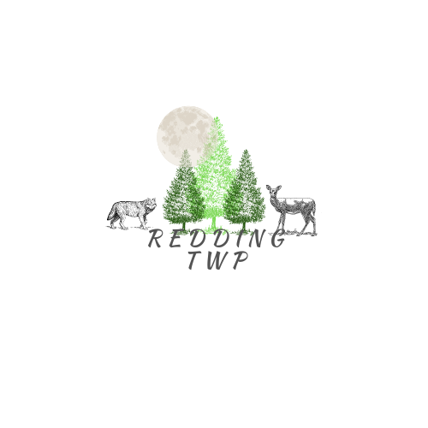

REDDING TOWNSHIP RENTAL AGREEMENT
8391 W. Temple Dr.
Harrison, MI 48625
Ph: 231-743-9525

Name:______________________________________________ Today’s Date:______________

Drivers License #: ______________________________________________________________

Addresss:______________________________________________________________________

City, State, Zip: ______________________________________Phone Number :(___)_________

Type of Event: _________________________________________________________________

Date of Event: _______________________ Number of People:______________

Time of Event: __________am/pm until _________am/pm (includes set up and clean up time)

Please check one: _______ Township Resident ________ Non-Resident

Additional Items for Rental:
______ Sign ________Hot Bar _________Cold Bar

Terms and Conditions of Rental

- Intent. The intent of this Agreement is to ensure that Redding Township (the “Township”) facilities are maintained and kept available for, and used by, Redding Township residents and members of the public at large, without undue restriction. In renting its facilities, the Township shall not illegally discriminate against any person, entity, or organization seeking access to or use of the facilities offered by the Township.
- Categories of Users. In determining the applicable fee for rental of Township facilities, the following definitions shall be controlling:
  - A Resident is hereby defined as a person(s) or business which resides in, or pays property taxes in, the Township.
  - A Nonresident is hereby defined as a person(s) or business that is neither located in, nor pays taxes in, the Township.
- Rental Fees and Security Deposit. The rental fee and security deposit requirements for use and rental of Township facilities is set by the Township Board.
  - The Security Deposit is to be paid when the Rental Agreement is signed. The rental amount(s) are due thirty (30) days prior to the event.
  - The security deposit fee will be returned in the form of a check mailed to the address provided on the agreement. All refunds shall be processed within thirty (30) days of an inspection verifying that all rented equipment and facilities have been left in satisfactory condition.
  - Any damages occurring during or as a result of a reservation will be assessed against Lessee’s Security Deposit. The Lessee will receive an invoice from Redding Township for any costs, expenses or damages that have been deducted. Any damages that exceed the Security Deposit will be billed to the Lessee. All damages shall be calculated according to the following method: the Township’s cost of any repairs to the rented facility, plus the cost of any materials, equipment, or other items that were improperly used, damaged, or destroyed.
- Cancellation Policy. To obtain a full refund of the Security Deposit, notice of cancellation must be provided no less than forty-five (45) days prior to the event. Reservations cancelled within thirty (30) days shall receive a partial refund of 50%. Reservations cancelled within fourteen (14) days shall receive a refund of only 25%.
- Right to Refuse Service. The Township retains the absolute right to cancel a rental agreement and revoke permission to use the Township’s facilities in the event that, in its sole discretion, the Township determines that Lessee has failed to fully satisfy the rules set forth in the rental agreement.
- Facility Use Rules: The following Facility Use Rules (“Rules”) shall govern all rentals of Township facilities and equipment. The Township reserves the right to modify these Rules and to develop and enforce such additional rules and regulations as may be required for the protection of the individual facilities of the Township and the Lessees of those facilities.
  - Only persons ages 21 and over are eligible to contract for the use of Township facilities and equipment.
  - The reservation is for the designated reserved area of the facility only.
  - All posted room capacities must be adhered to. Rental groups shall not overflow into the hallways.
  - Exits, corridors, and hallways must remain free of obstruction at all times.
  - Any decorations used shall not alter or damage any surfaces. Nails, pushpins, glue, or tape cannot be used on any Township facilities.
  - No flame candles, fireworks, torches, or other exposed source of flame is permitted.
  - Inappropriate behavior by any Lessee or their guest(s) will not be tolerated. Inappropriate behavior includes, but is not limited to:
    - Verbal abuse of staff or participants,
    - Profane language,
    - Vandalism of Township property,
    - Drunkenness
    - Fighting,
    - Serving of intoxicants to minors,
    - Gambling,
    - Disorderly conduct,
    - Any other behavior the Township deems to be improper. The ultimate determination of what constitutes inappropriate behavior shall be made by the Township, in its sole discretion. Staff has the authority to remove any person or persons or close any function that demonstrates inappropriate behavior.
  - Redding Township facilities are a smoke-free environment. Smoking or tobacco use of any kind, including the use of E-Cigarette devices, is prohibited in Township facilities.
  - No entryway designated with an exit sign shall be obstructed in any manner.
  - Vehicles are not permitted on grass. This rule shall not apply to for motorized wheelchairs and/or similar devices for the disabled.
  - Any accidents occurring on the property must be reported to the building staff. The party responsible for the rental must also complete an incident report explaining the circumstances of the accident.
  - The sale, use, and possession of any controlled or illegal substance is expressly prohibited in all Township facilities.
  - Prior to any event, the Responsible Party will be required to participate in a walk-through of the facility with Township Personnel for the purposes of obtaining knowledge of emergency procedures.
  - No animals are permitted in Township facilities unless said animal is classified as a service animal by state or federal law.
  - Any noise shall be kept at an appropriate level, not to be audible from more than fifty (50) feet from the relevant Township facility. All broadcasting equipment, including stereo or speaker systems, shall be turned off no later than 12:30 am on Friday and Saturday, and no later than 11:30 pm on all other nights.
  - Tables shall only be moved by two individuals, one on each end of the table. Tables are not to be dragged, as this causes significant damage to the floors. As with all damages to the facility, the Renter shall be responsible for any damages to the floor.
  - Neither tables nor chairs may be removed from the facility. Tables and chairs are not to be taken outdoors.
  - Upon exiting the facility, all doors and windows must be closed and locked. Renter shall be responsible for any and all lost or stolen items resulting from Renter’s failure to secure a Township facility under this Rule.
  - The Township is in no way responsible for any damages or losses to the renters’ equipment.
- Rules for Alcohol.
  - Alcohol is prohibited within or on Township property.
- Ordinance Compliance. In executing this Agreement, Renter agrees to abide by all applicable Township Ordinances

- Limitation of Liability. Renter agrees to hold harmless the Township and its elected officials, employees, agents, and volunteers from any expense or cost (including attorney’s fees and costs) in connection with the use of Township facilities and further agrees to assume all responsibility for liability of any kind.

- Modification. No change, modification, or waiver of any term of this Agreement shall be valid unless it is in writing and signed by both parties. This provision does not apply to the Township’s ability to modify or add Facility Use Rules.

- Choice of Law. This Agreement is to be governed by the law of the State of Michigan. Any dispute arising out of, relating to, or in connection with this Agreement shall be litigated, if at all, solely in the Courts of Clare County, Michigan.

- Severability. Any provision or part of this Agreement held to be void or unenforceable under any laws or regulations shall be deemed ineffective only to the extent of such prohibition and the validity and enforceability of all remaining provisions shall not be affected thereby.

- Waiver. Non-enforcement of any provision of this Agreement by either party shall not constitute a waiver of that provision, nor shall it affect the enforceability of that provision or the remainder of this Agreement.

- Headings. The headings are inserted for convenience only and shall not be considered when interpreting any of the provisions or terms hereof.

_____________________________________________ _____________________
Responsible Party Date

____________________________________________ ______________________
Redding Township Official Date

