April’18- March’19
Report Complied by
Ms. Wilma DCunha
Environment Officer

Dr.V.Shubhalaxmi
CEO and Founder
Ladybird Environmental Consulting LLP
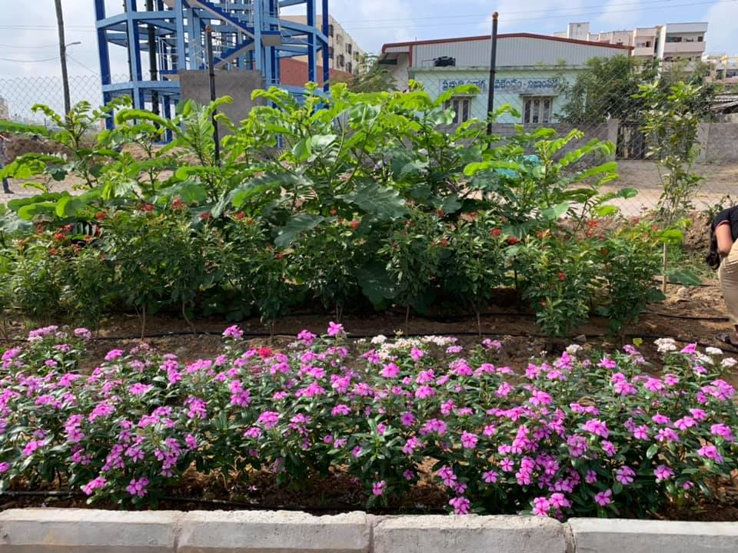
ANNUAL REPORT
Sr. No. | Topic | Page no.
1. | Summary | 3
2. | Introduction | 3
3. | Project Activities | 3
3.1 | CSR Projects | 4
3.2 | Consultancy Projects | 9
3.3 | Employee Volunteering Programmes | 9
4 | Birdwing Publishers | 10
5 | Eco-Desk Calendar | 11
6 | Awards And Honours | 11
7 | Clients And Partners | 11
9 | Aichi Targets | 11
10 | Financial Status | 12
12 | ANNEXTURES | 13
INDEX

Annual Report
(April 2018- March 2019)

- SUMMARY
Ladybird Environmental Consulting is a social enterprise that provides expertise in nature conservation including construction of butterfly habitats and gardens, rehabilitation of lake, conducting volunteering programmes and workshops in order to create environmental awareness. We identify environmental problems and resolve it with the support of corporate and government agencies. So far, we have developed 15 butterfly habitats and gardens. We are also working on the rehabilitation of the lake in Hyderabad by enhancing lake ecology through plantation and community engagement. Lately, we have also indulged ourselves in the infamous Chimbai beach rejuvenation project in Mumbai.

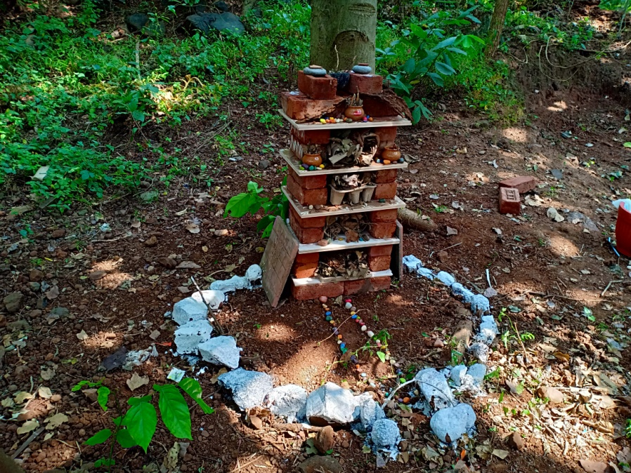
- INTRODUCTION
Ladybird Environmental Consulting was established in 2014 as Limited Liability Company. We came into business to help people in helping environment. We are specialists in environmental CSR (corporate social responsibility) and nature conservation. We have highly trained and dedicated team.
We offer biodiversity services for companies, organizations and govt. agencies. So, we offer corporate with Employee Volunteering programmes. We also undertake Tree Plantation CSR projects where we develop butterfly habitats. Besides, we also conduct biodiversity surveys, conduct wildlife training programmes and develop wildlife books and guides
- PROJECT ACTIVITIES
The company’s activities are broadly categorized into following four categories:
- CSR PROJECTS
- CONSULTANCY PROJECTS
- EMPLOYEE VOLUNTEERING PROGRAMMES
- PRODUCTS

  - CSR PROJECTS
Corporate have tree plantation drives as part of their CSR projects. These projects vary from 1 to 3 years which includes monitoring and reporting. Most of the tree plantation projects involve planting of commercial fruit or timber trees or avenue trees. Commercial crops were used as means of providing livelihood to marginal farmers and avenue trees were used largely for greening highways or for afforestation purpose.
We have adopted Miyawaki model for tree plantation projects to create butterfly habitats. Miyawaki method plantation is creating a mini-forest ecosystem using an accelerated method. It is based on the practices of Japanese forester Akira Miyawaki. A forest planted by humans, once established then left to nature’s own devices within a year.
- Completed Projects
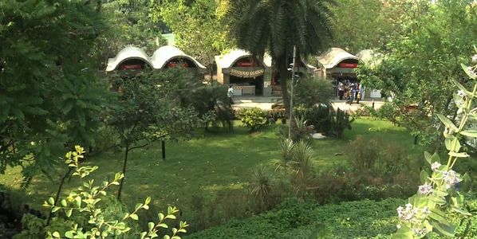
Butterfly Garden at Urban Haat,CIDCO,CBD Belapur

Funding agency: Videojet Technologies India Pvt. Ltd
Site Partner: CIDCO Ltd
Project duration: October 2015- September 2018
No. of plants: 100 saplings of host plants and nectar plants.
Three years since the establishment of the butterfly garden, now the garden has been well established with the plants re-generating on their own. All the plants have adapted to the habitat and have also grown in height of 6-12ft and are healthy. The nectar plants are flowering too. The objective of the project to plant and maintain 100 plants is fulfilled with 100 plants surviving at the site. The local butterfly diversity of the place has also increased. One can now spot around 28 species of butterflies at the site. The favourable time to spot butterflies is during early mornings or in the evenings. As per the feedback of Mr. Nair, Manager Urban Haat the number of butterflies in the area has increased. The visitors are happy to see the butterflies fluttering around.
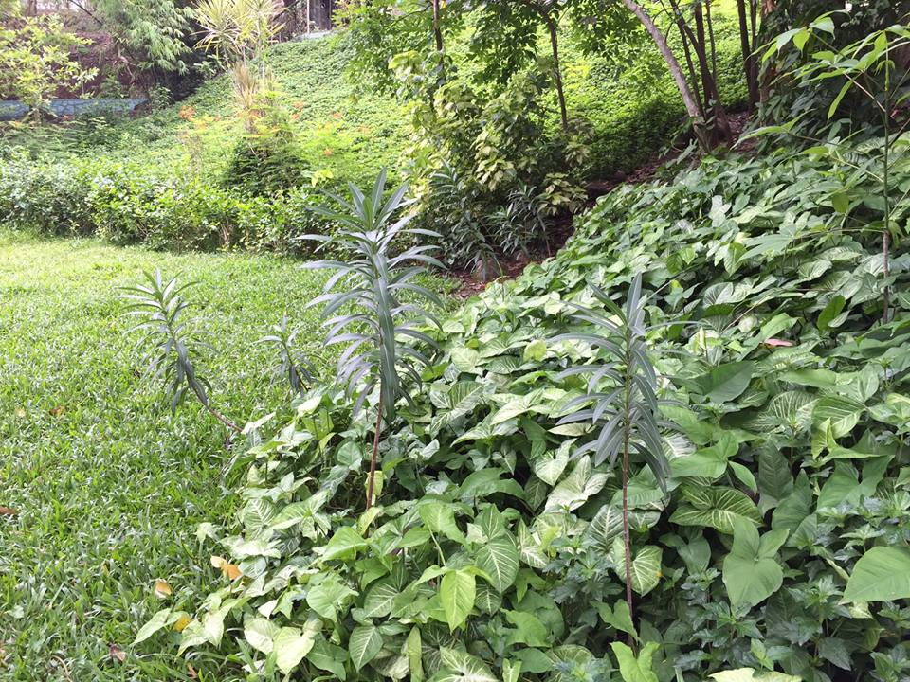
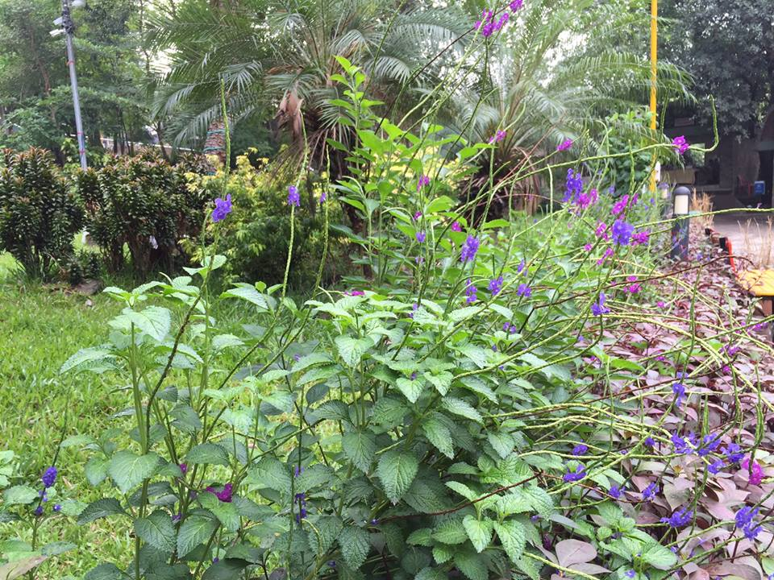
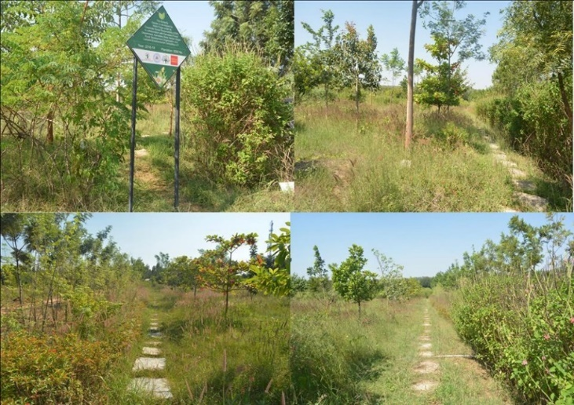
Butterfly Habitat Jarakbande Kaval Tree Park, Bangalore, Karnataka 560064
Project Duration: Mar 2016- Mar 2019
Project Partners: Wells Fargo India Solutions (P) Ltd. and the Karnataka State Forest Department
Project Activities: Plantation of 5000 saplings, development of butterfly educational materials, Development of plant signages, conducting butterfly awareness programmes, painting of pergola.

In this three year of the project we now see that the green cover of the park has increased making it much greener than what it was before plantation in Mar 2016 (64% survival rate) out of 5000 planted. Butterfly diversity increased from 22 species to 46 species in third year. 61 signages were developed, pergola was painted with butterflies. 291 of corporate employees and 991 visitors engaged through volunteering and butterfly awareness programmes. Increased numbers of termite mounds in the park which indicates the secondary succession of a habitat i.e. maturity of a habitat into self-sustaining ecosystem, and improvement in the ground water table leading to better transfer of soil nutrients. This park is now being visited by many educational institutions to know more about the nature through the butterfly awareness programmes conducted in the park. Also there is a noticeable increase in public events held by the Forest Department. All these positive changes indicate the increasing popularity of the tree park.
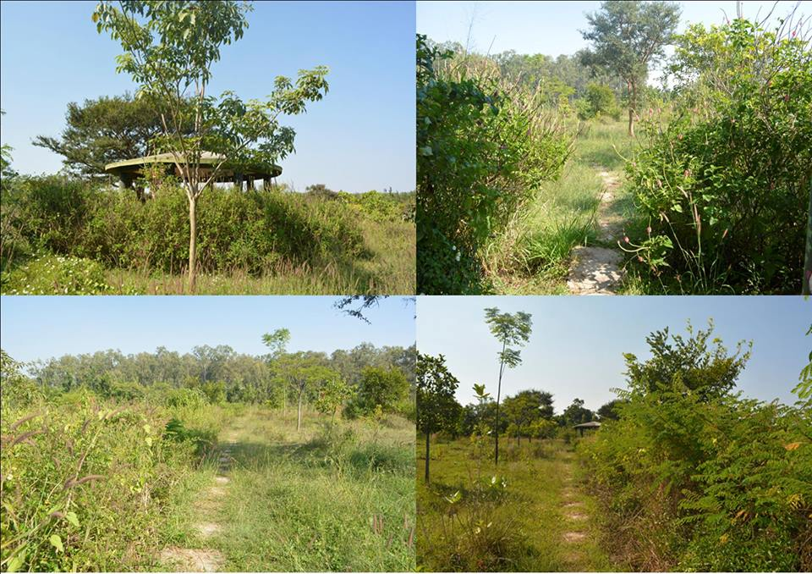
- ONGOING PROJECT
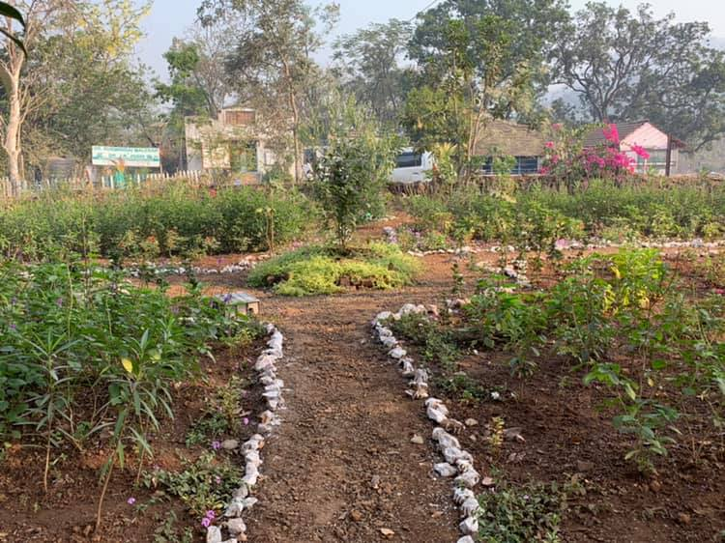
- Butterfly Garden at Yusuf Meherally Centre (YMC), Tara, Panvel.
Funding agency: DCB Bank
NGO Partner: iNaturewatch Foundation
Project duration: September 2018 - August 2019
No. of plants: 1043 saplings of host plants and nectar plants

After the three months of the plantation, it was noted that the habitat is thriving well with the ecosystem well established. Not only the plantation helped in increasing the floral diversity of the Yusuf Meharally Centre, but this also resulted in the increase in the faunal diversity such as birds, bees, other insects in the habitat. Good survival rate of the plants has enriched the habitat.
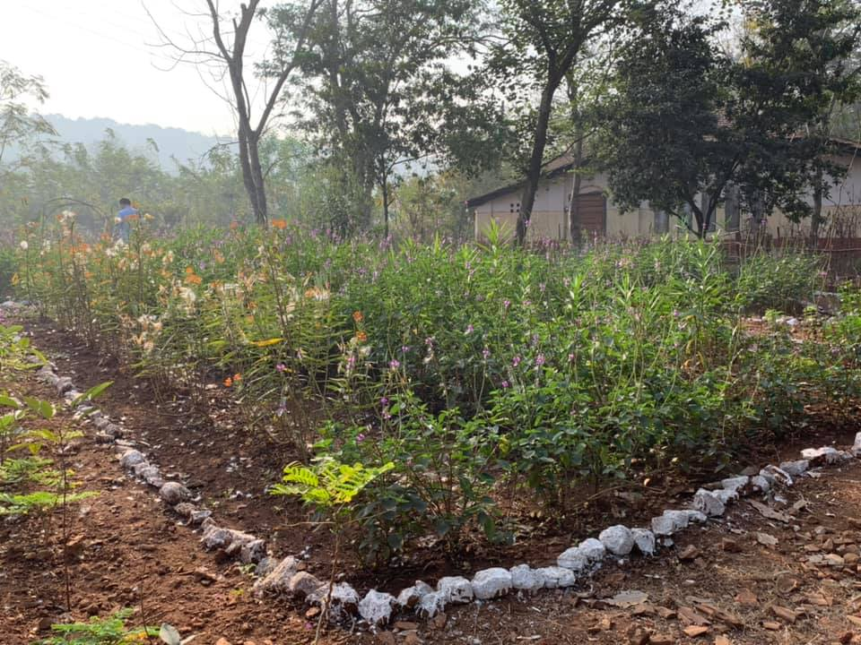
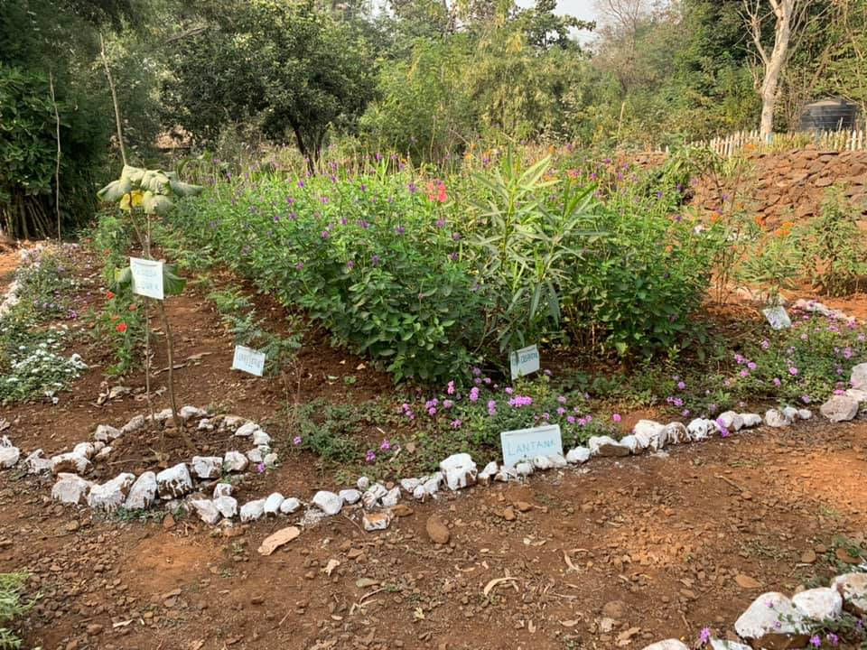
The overall number of saplings has increased from 1043 to 1060 plants. Before the plantation, we recorded 32 different species of butterflies and some caterpillars of Blue tiger butterfly on the site. During our visit in January 2019 we found three new additions to the checklist of butterflies of this site; Ape fly, Great Orange Tip, Tailless Line Blue.

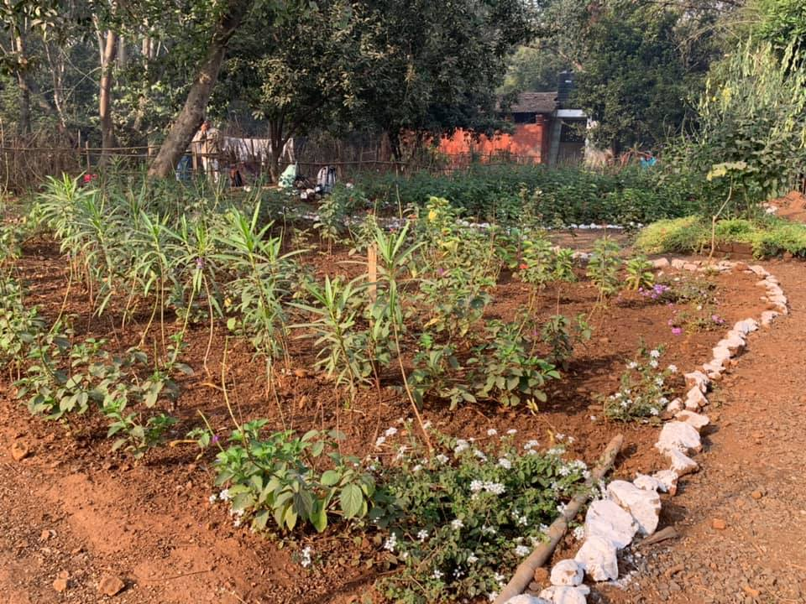
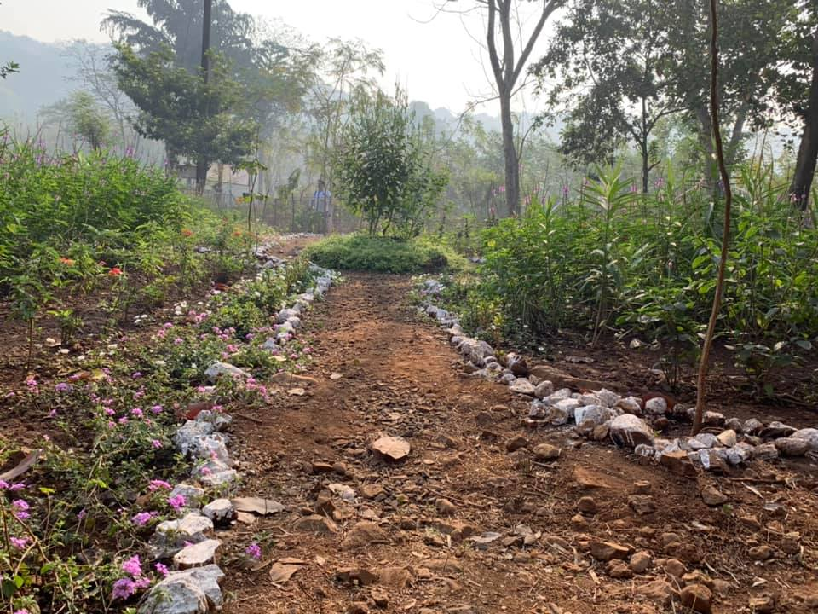

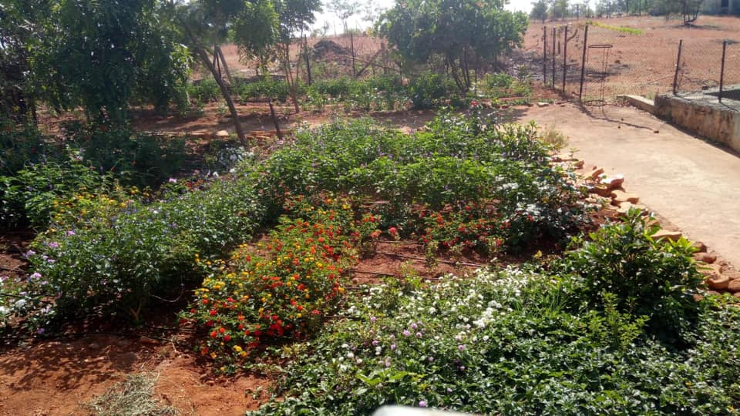
- Butterfly Garden at DivyaVidyalay, Jawhar.
Funding agency: DCB Bank
NGO Partner:iNaturewatch Foundation
Project duration: Sep 2018 - Aug 2021
No. of plants: 3000 saplings of host plants and nectar plants

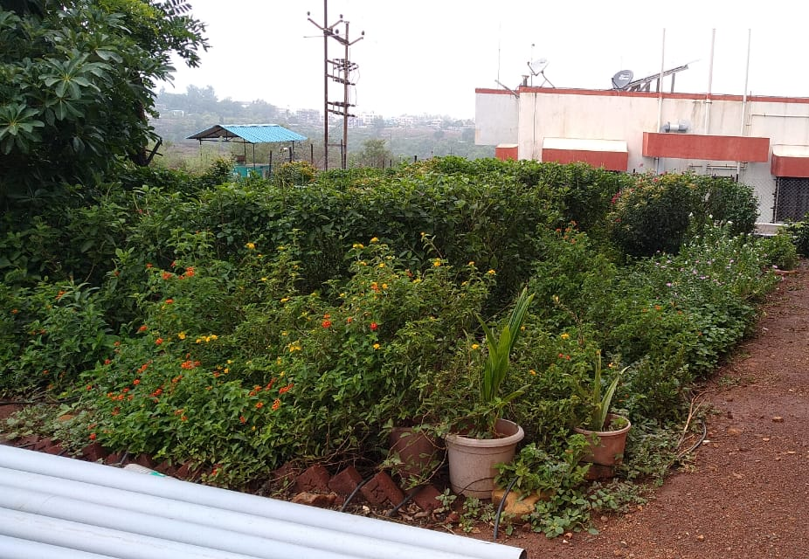
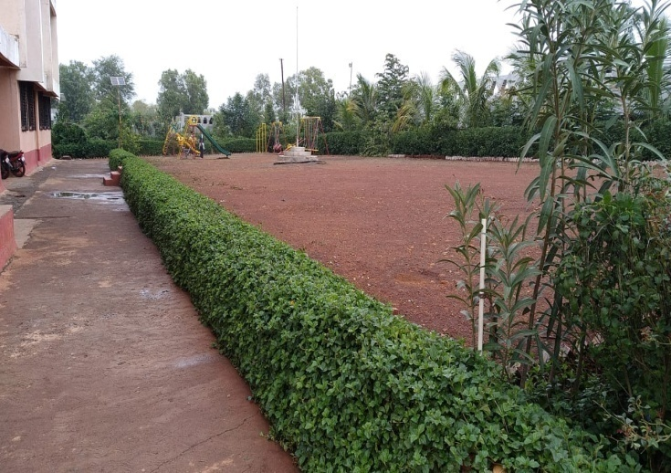
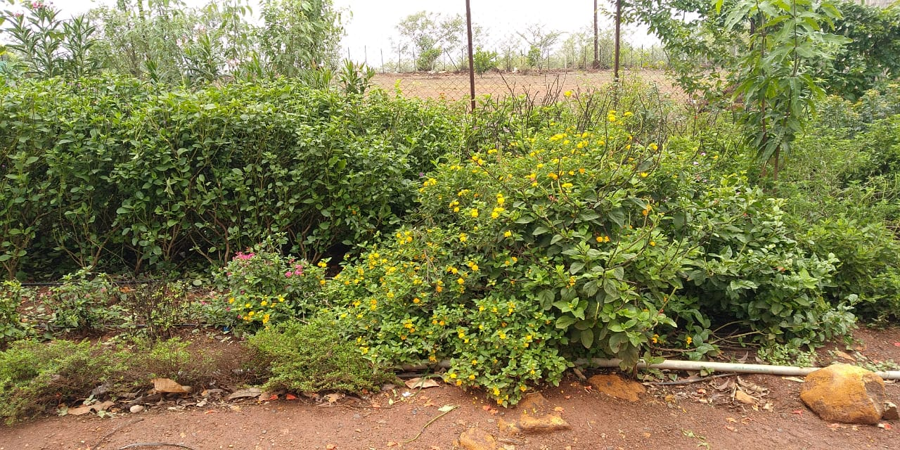
After the six months of the plantation, it was noted that thehabitat is thriving well with the ecosystem well established. Not only the plantation helped in increasingthe floral diversity of the DivyaVidyalaya, but this also resulted in the increase in the green cover and faunal diversity such as birds, bees, other insects in the habitat. The number of plants surviving is 2776 out of 3000 plants. The total plant survival rate is 93.43%. Being a hot summer season when the butterfly diversity is low, yet we recorded 14 species.
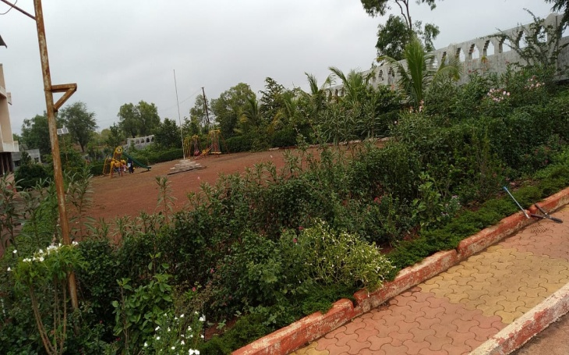
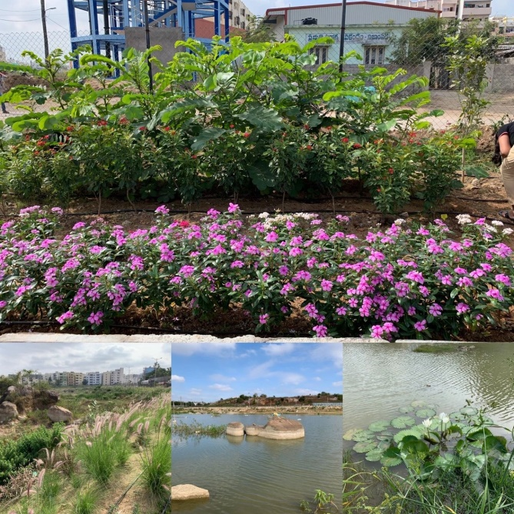
- Nizampet LakeRejuvenation Project, Hyderabad
Funding agency: Wells Fargo India
NGO Partner: Youth for Seva
Project duration: Aug 2018- Jan 2020
No. of plants: 5000 saplings of host plants and nectar plants
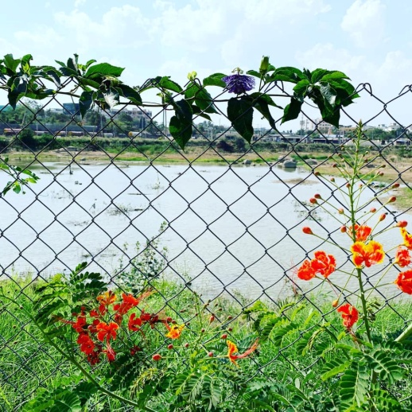
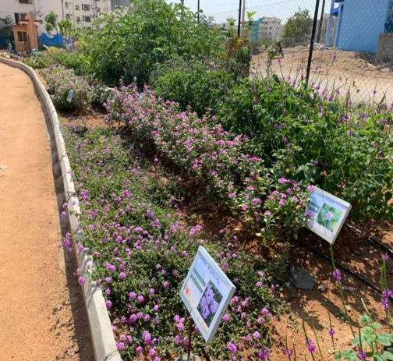
The 5000 plants that we planted during the first quarter of our project have grown well and have well established. However, due to water scarcity recently, we recorded a loss of 235 plants. Construction work at the lake, defect in the functioning of the motor pump are some other reasons behind the loss. 4.56% plant mortality rate was calculated latest.There are three beds whose plants such as Lantana, Oleander, Pentas were not growing well earlier, but in the third quarter these plants have shown remarkable growth. The butterfly and bird diversity have also decreased in last three months. Butterfly diversity decreased from 11 to 23 species,however bird diversity has decreased to 13 species due to change of season. In order to create awareness about the lake conservation we also have also conducted several outreach programmes for the local people. The programmes were a great success.
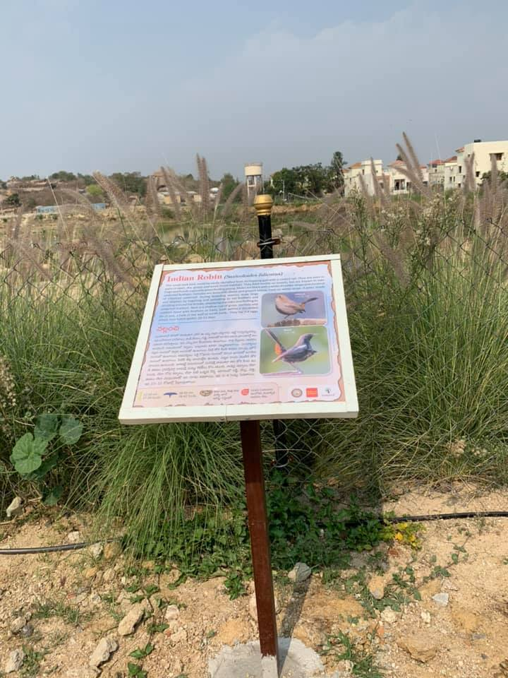

  - CONSULTANCY PROJECTS
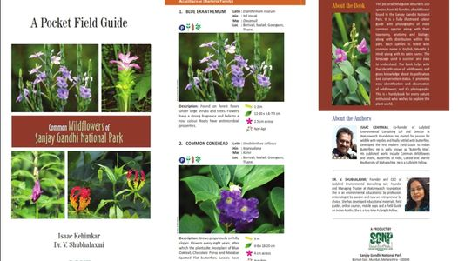
- Common Wildflowers of Sanjay Gandhi National Park

We have completed the making of this pocket field Guide. This is a 100-page pocket field guide which illustrates 100 species of wildflowers includes trees, shrubs, herbs and climbers. Each species information pertaining to the common name, Latin and local name, size, season, plant animal association and uses. Besides the book will have general sections about photography, conservation and pollination biology. The aim of the book is to create awareness about plants and make people appreciate them

  - EMPLOYEE VOLUNTEERING PROGRAMME

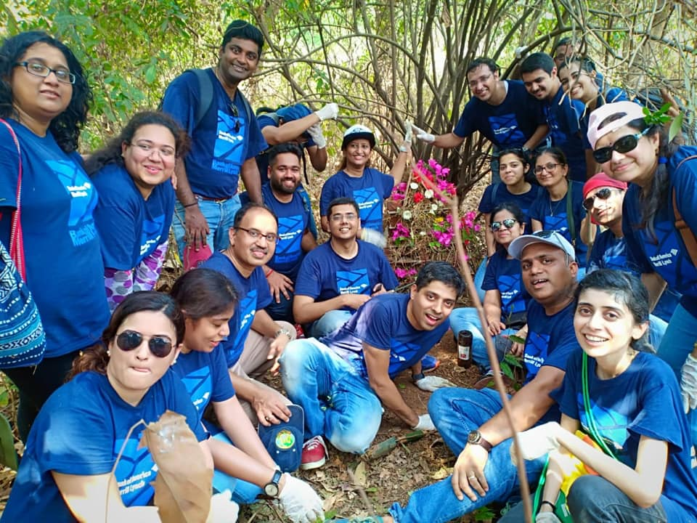
This year all together we conducted 33 different employee volunteering programmes. Employees of various companies helpedin the conservation of nature by carrying out various different activities like habitat restoration that includes de-weeding, removing of the invasive species, mulching, plantation of sapling cuttings, seed plantation, sapling bag making, seed bag making, developing nature trail, cleaning up the trail, preparing tree tags, nature trail, workshop on kitchen gardening, bird architecture workshop, continuous contour trench, bund building and seed dibbling.
This year we also came up with two different activities like Animal Home making – Bug Hotel, Insect Hotel, Frog Home, Bee Home and Floating Wetland. We reached to 1127 employees from 9 different companies, who participated in these programme. This year we not only conducted half day programmes but we also conducted full day programmes. In total 588 hours were spent on environmental works. The details of each programme are given below in Annexure 1.
- PRODUCTS BIRDWING PUBLISHERS

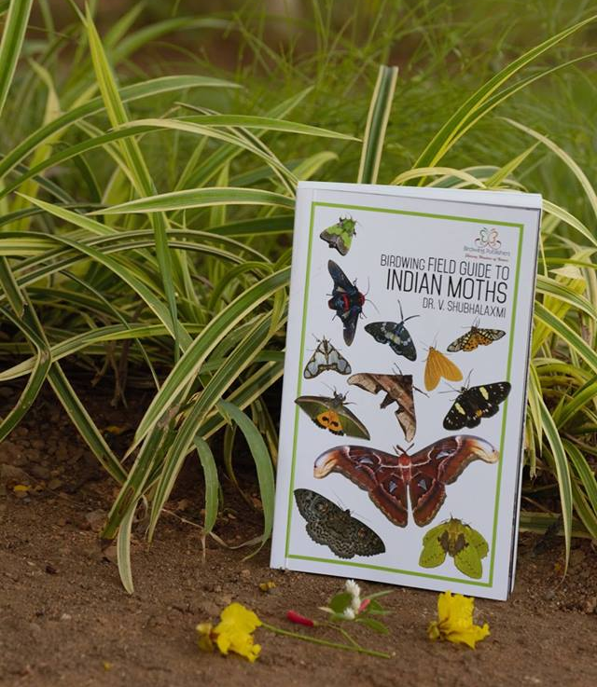
  - Field Guide to Indian Moths: The Field Guide to Indian Moths by Dr. V.Shubhalaxmi was finally released by Dr. AsadRahmani. An august gathering of 50 nature enthusiasts attended this event. The event began with felicitation of Chief Guest Dr. AsadRahmani and Guest of Honour Mrs. Kalpana Reddy (sister-in-law of author). This was followed by welcome address by Mr. Isaac Kehimkar, who emphasized the importance of the book. This was then followed by presentation of Dr.Shubha regarding the making of the book. She shared anecdotes and her journey of book making. Two beautiful video clips charged up the atmosphere. Ms. Kalpana and two of Dr. Shubha's students; Dr. Usha Desai and Ms. Alka Vaidya spoke about their personal experiences related to moths. The book was then released by the Chief Guest who highlighted the importance of such books to spread the much needed awareness on nature conservation.

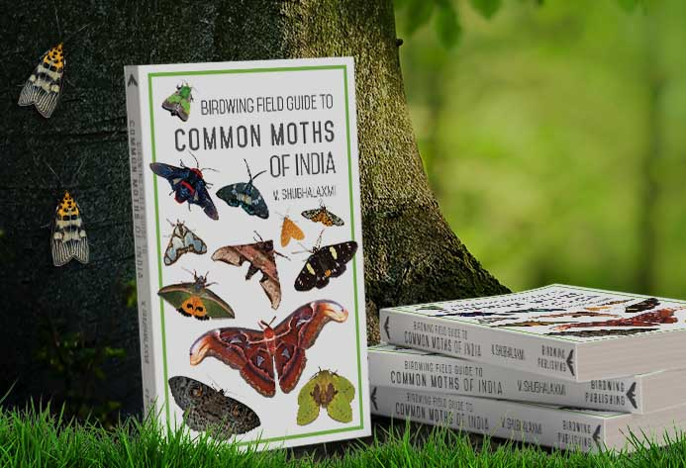
The field guide is meant for beginners therefore the language used is non-technical. It features descriptions of 773 species from 37 micro and macro moth families depicted in 156 colour plates. More than 1000 colour photographs of moths have been used.

By now we have sold more than 300 copies worldwide. We are getting orders not only from all the states of India, but from different countries of the world and our publication has reached toAustralia, London, United Kingdom, China, Japan, United States of America and Nepal.

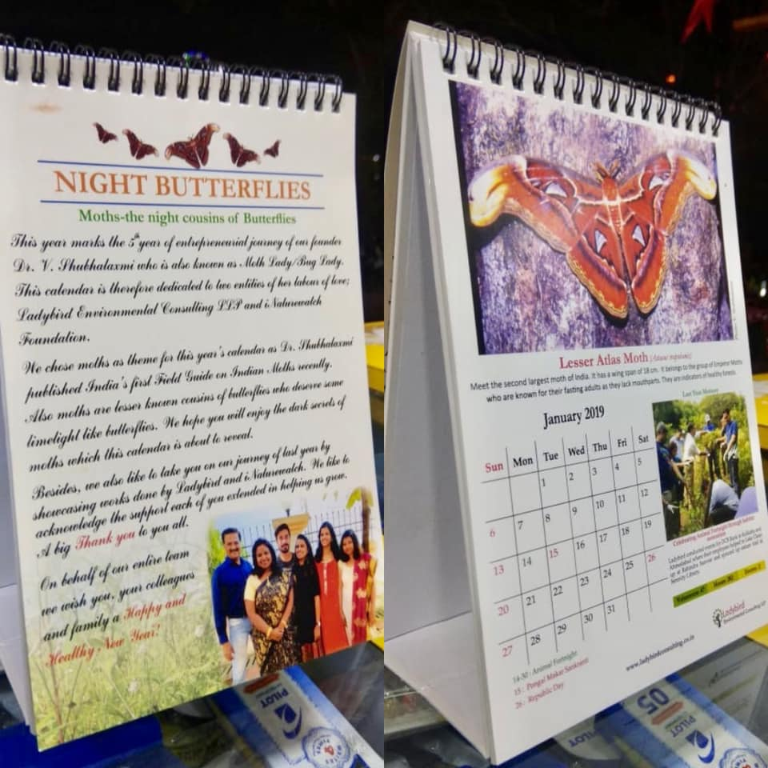
- ECO-Desk Calendar:
This is India's first calendar based on moths. This is a company calendar of Ladybird Environmental Consulting LLP. The calendar covers 12 striking moth images along with interesting facts about each. The calendar also has eco-days marked for each month. This being a company calendar, there is small write-up about the past events on each month.

- AWARDS AND HONOURS

- Dr. Shubhalaxmi was awarded with Think Wildlife TEFLA Awards for Excellence in Entomology and Isaac Kehimkar for Excellence in Lepidoptera Research in the year 2018.

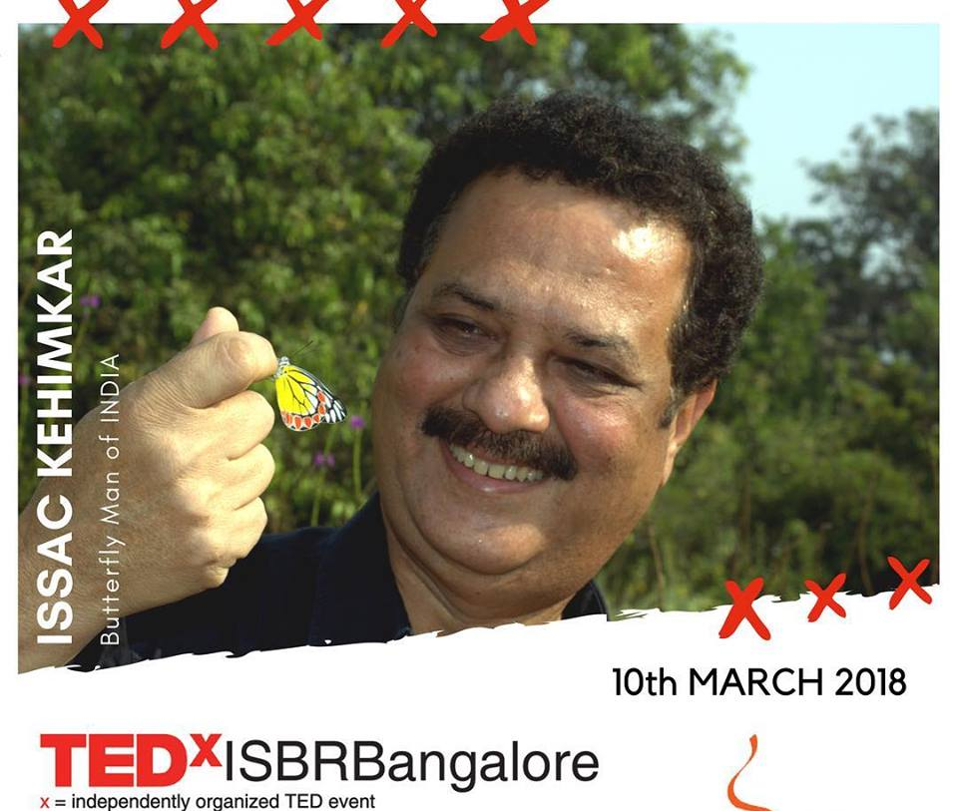
- Mr. Isaac Kehimkar was invited to speak on his passion for butterflies at TEDx Bangalore

- CLIENTS AND PARTNERS

This year we had worked with 7 clients (7 corporates, 1 Govt., 2 NGOs) and 3 partners. Here is the list of some of our potential clients:

- CRISIL Foundation
- DCB Bank
- Galaxy Surfactants
- Mahindra Susten Pvt. Ltd.
- Morgan Stanley
- Tata Communication Engineers Ltd.
- Wells Fargo India Solutions Ltd
- Youth For Seva
- United Way Mumbai
- Urban Haat, CIDCO

- AICHI TARGETS

Aichi Targets= 20 targets, divided into 5 sections (A to E).
- Strategic Goal A: Address the causes of biodiversity loss
- Strategic Goal B: Reduce the direct pressure on biodiversity and promote sustainable use
- Strategic Goal C: To improve the status of biodiversity by safeguarding ecosystems, species and genetic diversity
- Strategic Goal D: Enhance the benefits to all from biodiversity and ecosystem services
- Strategic Goal E: Enhance implementation through participatory planning, knowledge management and capacity building

- FINANCIAL STATUS
In the financial year of 2018-2019 we had made a profit of Rs. 5, 40,790/- only.
- OUR FOOTPRINT
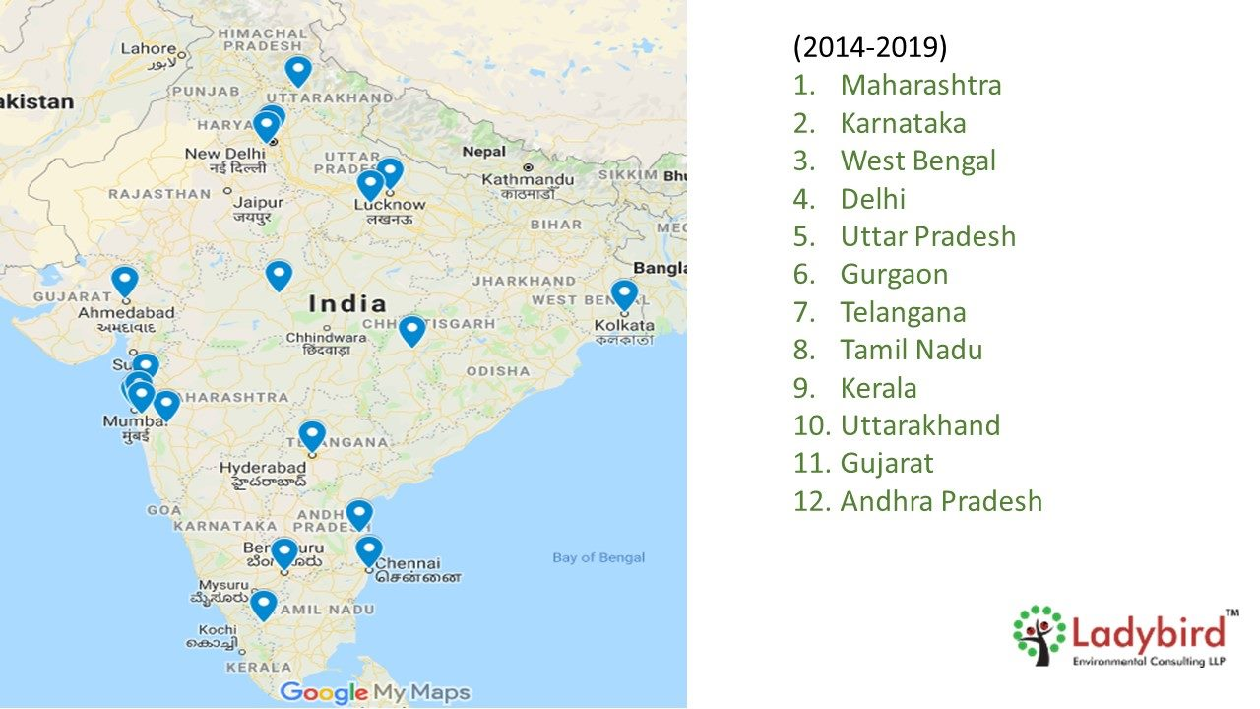
We will be completing our five years soon and in a span of such a short time we have reached accrossed12 different states.
ANNEXURE 1
The details of Employee Volunteering Programmes conducted in the April 2018-March 2019
SR.NO. | DATE | PROGRAMME | CORPORATE | LOCATION | NO OF PARTICIPATION | TIME IN HOURS | TOTAL TIME VOLUNTEERED
1 | 19-Apr-18 | Kitchen Gardening Workshop | CRISIL Foundation | Chennai | 45 | 4 | 180
2 | 19-Apr-18 | Bird Architecture Workshop | CRISIL Foundation | Gurgaon | 25 | 4 | 100
3 | 19-Apr-18 | River Clean-up Drive | DCB Bank | Ahmedabad | 25 | 6 | 150
4 | 20-Apr-18 | Bird Architecture Workshop | CRISIL Foundation | Mumbai | 55 | 4 | 220
5 | 20-Apr-18 | Bird Architecture Workshop | CRISIL Foundation | Pune | 25 | 4 | 100
6 | 21-Apr-18 | Clean-up Drive | CRISIL Foundation | Mumbai | 20 | 6 | 120
7 | 17-May-18 | Kitchen Gardening Workshop | CRISIL Foundation | Mumbai | 35 | 4 | 140
8 | 18-May-18 | Kitchen Gardening Workshop | CRISIL Foundation | Ahmedabad | 15 | 4 | 60
9 | 19-May-18 | Kitchen Gardening Workshop | CRISIL Foundation | Pune | 16 | 4 | 64
10 | 25-May-18 | Bird Architecture Workshop | CRISIL Foundation | Chennai | 21 | 4 | 84
11 | 01-Jun-18 | Bird Architecture Workshop | Mahindra SustenPvt.Ltd. | Mumbai | 27 | 4 | 108
12 | 05-Jun-18 | Workshop on Terrarium | Galaxy Surfactants | Mumbai | 21 | 4 | 84
13 | 13-15- Jun-18 | Habitat Restoration | Wells Fargo India Solutions Pvt. Ltd | Bangalore | 62 | 4 | 248
14 | 19-Jun-18 | Lake Restoration | DCB Bank | Gurgoan | 30 | 6 | 180
15 | 23-Jun-18 | Contour Trench Digging | CRISIL Foundation | Pune | 28 | 4 | 112
16 | 28-Jun-18 | Recycling Plastic Bottles | CRISIL Foundation | Gurgoan | 30 | 4 | 120
17 | 07-Jun-18 | Tree Plantation | DCB Bank | Bangalore | 37 | 6 | 222
18 | 14-Sep-18 | Butterfly Garden Development - YMC | DCB Bank | Panvel | 30 | 6 | 180
19 | 15-Sep-18 | Forest Clean -up Drive | CRISIL Foundation | Delhi | 17 | 4 | 68
20 | 25-Sep-18 | Floating Wetland | Tata Consulting Engineers Limited | Navi-Mumbai | 15 | 4 | 60
21 | 26-Sep-18 | Lake Restoration | Wells Fargo India Solutions Pvt. Ltd | Hyderabad | 155 | 4 | 620
22 | 12-Oct-18 | Butterfly Garden Development - Jawhar | DCB Bank | Palghar | 56 | 6 | 336
23 | 26-Oct-18 | Kitchen Gardening Workshop | Wells Fargo India Solutions Pvt. Ltd | Bangalore | 30 | 4 | 120
24 | 02-Dec-18 | Workshop on How to Seek CSR Funds? |  | Mumbai | 9 | 4 | 36
25 | 14-Nov-18 | Clean-up Drive | Wells Fargo India Solutions Pvt. Ltd | Hyderabad | 25 | 4 | 100
26 | 14-Nov-18 | Tree Plantation | Wells Fargo India Solutions Pvt. Ltd | Hyderabad | 25 | 4 | 100
27 | 21-Dec-18 | Habitat Restoration | Wells Fargo India Solutions Pvt. Ltd | Bangalore | 24 | 4 | 96
28 | 11-Jan-19 | Habitat Restoration | DCB Bank | Navi-Mumbai | 86 | 6 | 516
29 | 19-Jan-19 | Creating Pollinators Garden | DCB Bank | Mumbai | 27 | 6 | 162
30 | 22-Jan-19 | Tree Plantation | DCB Bank | Hyderabad | 39 | 6 | 234
31 | 25-Jan-19 | Mangrove Clean-up | DCB Bank | Mumbai | 14 | 6 | 84
32 | 25-Jan-19 | Habitat Maintenance | Wells Fargo India Solutions Pvt. Ltd | Hyderabad | 32 | 4 | 128
33 | 14-Feb-19 | Lake Clean-up Drive | DCB Bank | Hyderabad | 26 | 6 | 156
 |  |  |  |  | 1127 | 154 | 5288

