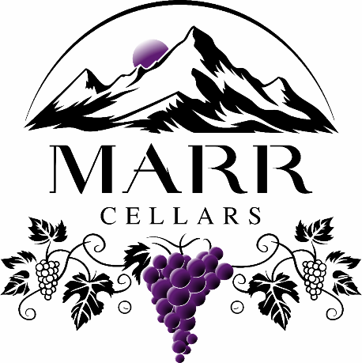

  February Newsletter
  Award Winning Wines
  We are excited to announce that all of the wines we have entered into wine competitions have won medals. This is very humbling for our first year. We are so proud of our Wine!
  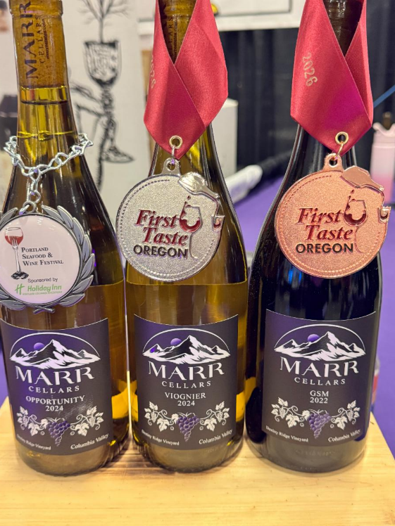



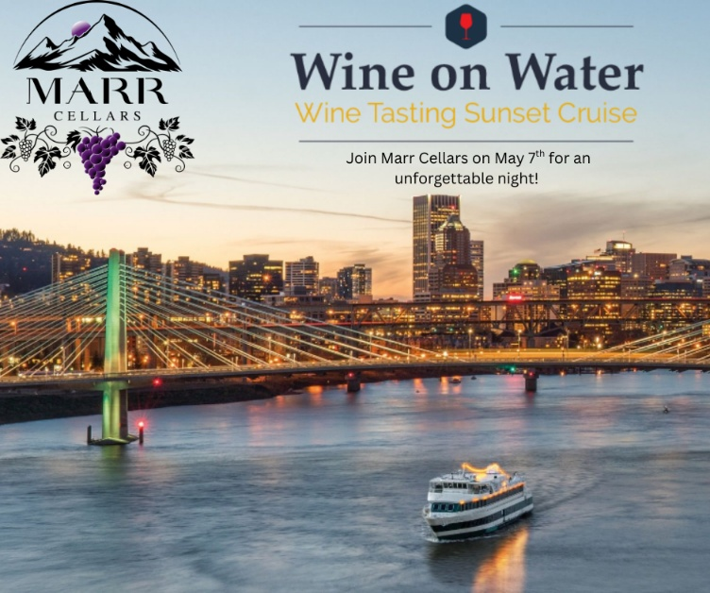

Wine on the Water
Join us on Thursday, May 7th at 5:30 pm for Wine on the Water, a sunset wine tasting cruise aboard the Portland Spirit where you can taste your way through Oregon! We'll be joined by more than a dozen local wineries showcasing their latest vintages while we cruise the Willamette River.
Save $5 per ticket with coupon code "Marr" at portlandspirit.com/wine or call 503-224-3900. Tickets include a two-hour sunset cruise, 14 wine tasting tickets and a souvenir wine tasting glass. Food will be available for purchase.

Get Tickets


  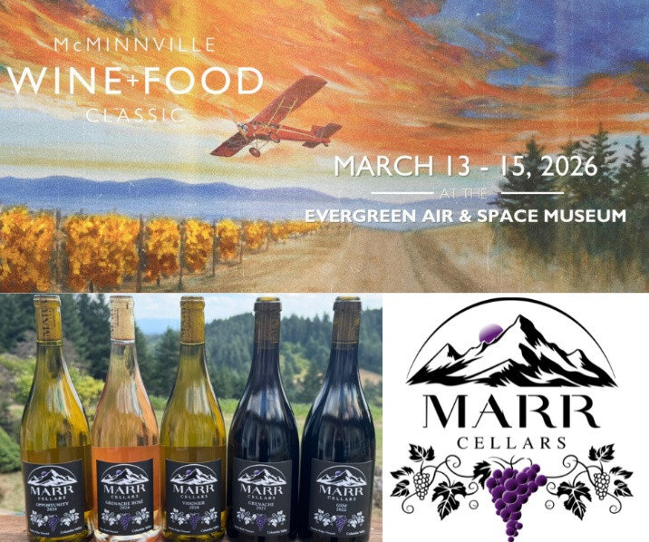
McMinnville Wine + Food Classic
﻿Join us at the Evergreen Air and Space Museum March 13-15th for the McMinnville Wine + Food Classic. Each year, the McMinnville Wine + Food Classic gathers Oregon’s best wineries, as well as local chefs, bakers, breweries, distilleries, artisans and musicians, to celebrate 33 years of incredible wine and food.

Get Tickets

  Marr Estates Vineyard
  We have had some amazing sunrises the past few weeks. Winter weather can be raining and foggy on the mountain, but we have been spoiled lately. Our inaugural estate sparkling wine has been inspired by these beautiful sunrises. We have numerous deer that call our property home including 3 bucks. This big boy has been trying to figure out how to get into the garden.
  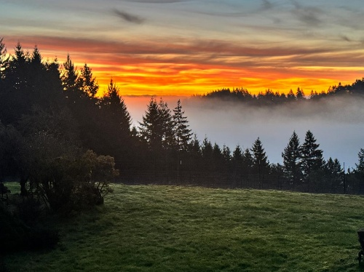
  

Need Wine?
Visit our website to purchase wine for pickup or shipping. We also offer free local delivery to Sherwood/Newberg and surrounding areas. For updates and upcoming wine events check out our website and follow us on social media!
﻿

Website



Marr Cellars | Ladd Hill Road | Sherwood, OR 97140 US

Unsubscribe | Update Profile | Constant Contact Data Notice

