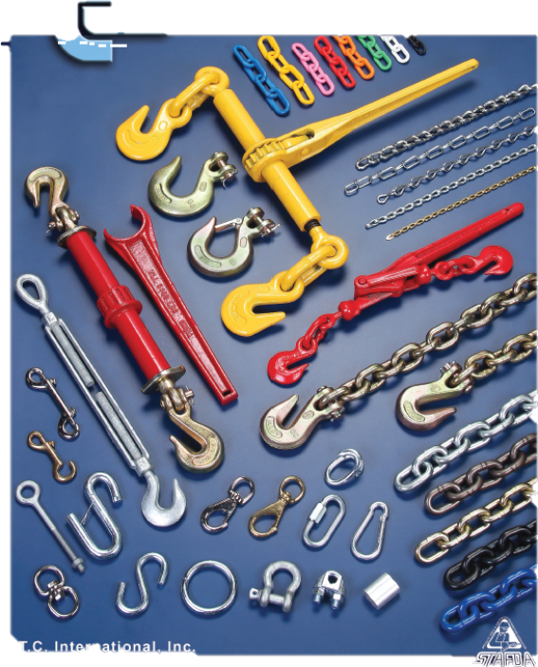

**(909) 357–4953 www.FThydraulics.com**