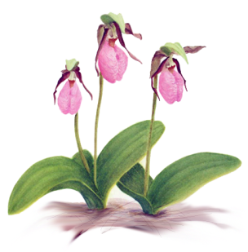

**SANDOWN**

**GARDEN**

**CLUB**

**Our club symbol is the pink Lady’s Slipper Orchid**

**(*Cypripedium acaule*), which grows wild in the mixed hardwood**

**and pine forests in Sandown.**

The Sandown Garden Club was founded in April 2008 and is a member of the New Hampshire Federation of Garden Clubs and the National Garden Clubs, Inc.

The purpose of the SGC is to share the knowledge of gardening with each other and the community; to participate in activities that increase the beauty of the town’s public and historic grounds; to encourage the preservation of native plant species; encourage respect for the environment and demonstrate techniques that conserve natural resources.

The Sandown Garden Club Scholarship is awarded to one student* in their senior year at Timberlane Regional High School (TRHS) who meets the following criteria:

* Be expected to graduate at the end of their senior year
* Be accepted to an accredited institution of higher education (either a 2-year or 4-year program)
* Pursue a major or minor in a gardening-related field such as agronomy, agriculture education, floriculture, horticulture, landscape design, plant biology, wildlife science, soil/plant science, city (rural/urban) planning, habitat or forest systems ecology, forestry, environmental concerns, botany, environmental conservation, land management, sustainable agriculture and food systems or earth science

**Application Deadline: May 5, 2023**

**Name _______________________________________________**

**Address ________________________________________________**

**________________________________________________**

**Telephone number or email_________________________________**

On a separate sheet(s) of paper write an essay explaining how your academic choice meets the Sandown Garden Club scholarship criteria.

Please include volunteer activities in the community especially those pertaining to gardening or the environment. Your essay should state the institution of higher learning you plan on attending as well as major or minor areas of study.

Please do not write your name on any sheet other than the coversheet and do not include transcripts.

Mail to: **Sandown Garden Club**

**P.O. Box 209**

**Sandown, NH 03873**

*Preference is given to a student from Sandown, NH