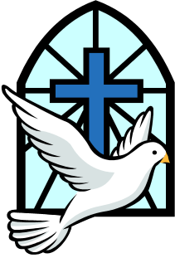
Word and Deed Ministries
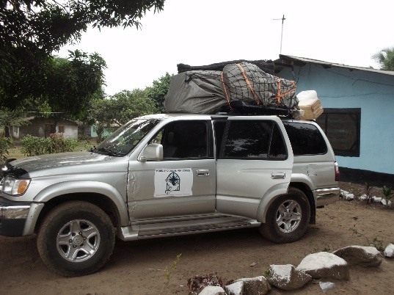
kathrynsears@yahoo.com (216) 870-0936
Bringing Help and Hope to the Nations
through Jesus Christ our Lord
January 2018 Newsletter

Website: wordanddeedministries.com

And having spent some time in Antioch, the Apostle Paul left and passed through the region of Galatia and Phrygia, strengthening all the disciples. Acts 18:23
We are to follow the example of the Apostles and do all we can to bring souls to Christ and to strengthen the disciples. Thank you for your financial and prayer support. Thank you for helping to send me to teach young Christians in Nepal, to preach the gospel in India bringing Hindus to salvation; and thank you for your help and prayers enabling me to minister in the interior of Liberia.
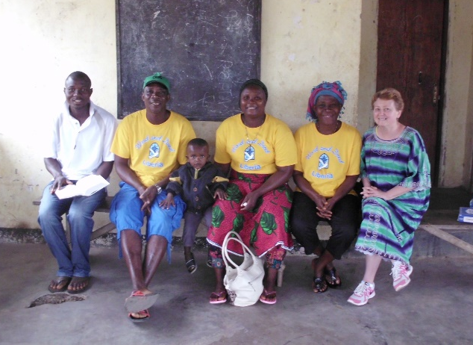
Back to Liberia February 3, 2018
Go then and make disciples of all the nations, baptizing them into the name of the Father and of the Son and of the Holy Spirit, teaching them to observe everything that I have commanded you… Amen. Matthew 28:19 & 20a (AMP)
Only two weeks to go before I return to Liberia. I will be leaving February 3 and returning February 26. Your prayers are vital. I will be traveling from village to village, spending two or three days in each place, preaching the gospel, praying for the sick, feeding the hungry and baptizing and teaching the new believers.
Kathryn and her Liberian Evangelism Team

What to Pray for: Local Ministry and Trip to Liberia
Every other Saturday – Menlo Road Bible Club
The second Monday of each month – Euclid Hill Villa outreach
Every Wednesday Bible study/prayer mtg. Indian Hills Apts.
After School Bible Club under Ruth Powel
(Local ministries will continue while I’m out of the country)
For the Lord to help me to pray and fast for the trip.
For anointing to set the captives free.
February 3-4 Flight: No delays, no missing of planes, no theft of suitcase items.
Good health for me, my Liberian team and our families.
For our rugged long drive from the capital up to Lofa County.
For our Jesus movie equipment to work well.
For hearts to be moved to donate to a much-needed Motorbike for Pastor Daniel.
For the traveling between towns - No vehicle breakdowns or accidents.
For protection – both from the demonic & those who would try to bring us harm.
For the Holy Spirit to prepare hearts to receive the word of God and for the people to turn from their idols to the true and living God.
Wisdom to raise up those who are to lead the new churches.
February 26 Flight: No delays, no missing of planes, no theft of suitcase items.
Post trip prayer against jet lag, backlash and retaliation

Some of the Towns:
I am never sure until we get up there which villages we will return to and which new villages we will go to. Some of them I don’t know the names of yet.

Soul Clinic Church
Balakpalasue
Tubugizizu
Litisue
Zango
Barzewan
Zulu
Beteba
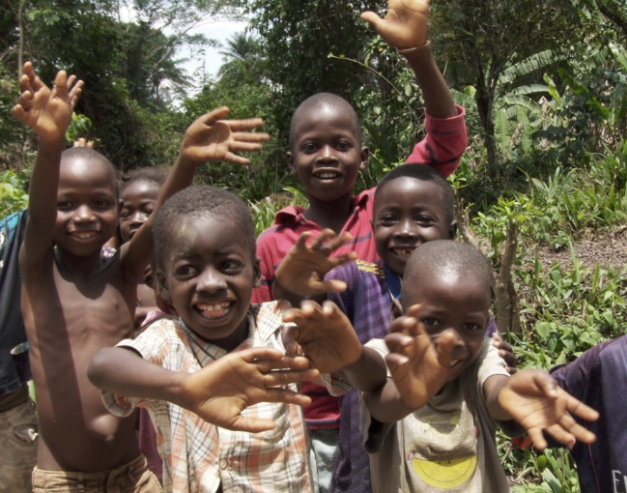
Lisco
Wozi
BeA
Boi
Libliby
Nicabuzu
Badazu
Luima

Thank you so much for your love and prayers for the lost and the hurting. Your financial help is very much needed and appreciated.

For More information, please call: 216-870-0936
Or, visit our new website: wordanddeedministries.com

