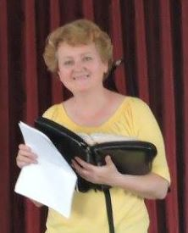
Word and Deed Ministries
kathrynsears@yahoo.com (216) 870-0936
Bringing Help and Hope to the Nations
through Jesus Christ our Lord
June 2017 Newsletter

“Grace to you and peace, from Him who is and who was and who is to come…” Rev.1:4
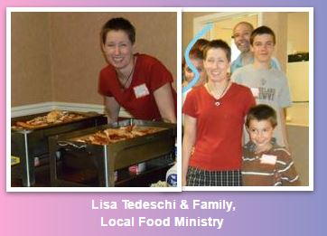
The Lord is getting His Bride ready for His coming. What a wonderful time that will be for us who believe. To those who do not know Him, however, it will be a different story. Surely this is why the Lord is stirring up the body of Christ to be more active in evangelism and missions. He wants the world to have the opportunity to hear about Him and receive Him. John 1:12 says, “But as many as received Him, to them He gave the right to become children of God, even to those who believe in His name, v.13 who were born not of blood nor of the will of the flesh nor of the will of man, but of God.”
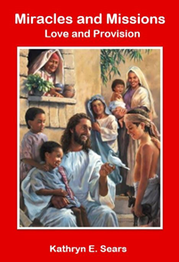
I’m excited about the opportunities I have to preach the gospel in word and deed and to teach others to do the same. It’s fun to hear of how God has answered prayer as periodically someone will come up to us and say, “Do you remember you prayed for me last month? Well, let me tell you how God answered our prayers.” One of the ladies at the Euclid Villa luncheon (one of our monthly outreaches) received prayer for several things including her health. As I prayed, her face was drenched in tears. She said, “You are the first person who has ever prayed for me and really meant it.” One of her problems was her kidneys. One kidney had no function and the other very little. The doctors had been recommending dialysis. She had hesitated and the doctors wondered how she was still standing. One month later she told me her urine sample was clear for the first time in eighteen years. This month, which was 2 weeks ago, she gave me the low down on the doctor’s report. He said, “Whatever you’re doing, keep on doing it. You are going to live a lot longer than we originally thought and you do not need to go on dialysis.” It’s testimonies like these and of lives changed that makes the work of an evangelist enjoyable.
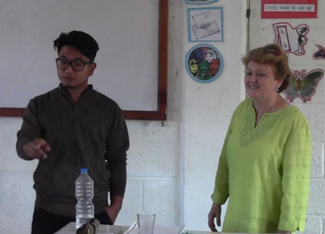
The above testimony and many others are in my new book, “Miracles and Missions”. It should be available in a few weeks, just in time for my next mission trip to England and Nepal in August. The Lord does such amazing things. He has put me in contact with a Nepali Pastor in Richmond Heights who is linking me with a printer in Kathmandu. By the time I arrive in Nepal, my books will be translated and printed into Nepalese and will be used as curriculum for my 2 weeks of teaching in the YWAM Bible school. I thank the Lord for Helen Happ who is on summer break from teaching and has been diligently working behind the scenes on getting the book published on CreateSpace. She is also building a website for the ministry. You can visit the website at www.wordanddeedministries.com. Thank you, Helen!
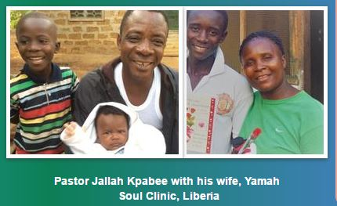
Thank you for your prayers for our ministry in Liberia. The vehicle is once again up and running with it’s new transmission and other repairs now completed, enabling Jallah to minister more effectively in Monrovia. Even though Pastor Jallah’s equipment was stolen (our Word and Deed Ministries Pastor), and he would not be able to show the Jesus movie up in Lofa County, we still financed the mission trip for him and his wife, Yamah to go up into the interior (Lofa). As the vehicle would have got stuck in the mud, they went on a motorcycle in the rainy season. It is a 2-day ride. I heard from him a couple of days ago. The roads were very, very bad and they actually came off the bike twice, but praise God without serious injuries and the bike only needed minor repairs. They will start back to the capital on Monday, June 26. One of the reasons for their trip was to prepare and plan for my mission in December. We have been able to raise funds to purchase a new laptop and other equipment to replace some of what was stolen, so at least he will be able to continue to show the movies all over Monrovia. The laptop is also loaded with Bible study materials, music, and teaching videos to assist him in his ministry. The Lord also gave us someone who is traveling to Liberia and has agreed to take it when she flies next week. OUR GOD IS AWESOME!
Teaching at YWAM in Kathmandu
Your prayers and financial help are urgently needed and very much appreciated! We thank you so much for your support in the past. I assure you it is used to share the gospel, bringing souls to Christ and providing humanitarian aid for those in need. Thank you so much for your love and care.
Please continue to support Word and Deed Ministries. Together we are making a difference.

Kathryn Sears
Word and Deed Ministries
216-870-0936

