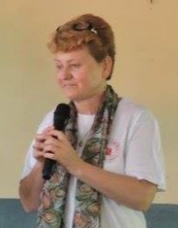
Word and Deed Ministries
Bringing Help and Hope to the Nations through Jesus Christ our Lord
Newsflash - May 2019

website: wordanddeedministries.com

“This fast that I choose, is it not to share your bread with the hungry, to bring the homeless poor into the house, when you see the naked to cover him… and your healing shall spring up speedily; your righteousness shall go before you; the glory of the Lord shall be your rear guard” Isaiah 58:6-8 (ESV)

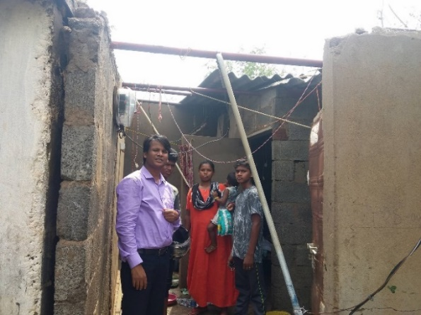
When I was in the state of Odisha, India in January of this year, the sincerity and spiritual hunger of the people touched my heart. Many of them are risking their lives to be Christians, and as I wrote in my last newsletter, some of Pastor Sevak’s people were martyred only a few weeks after I left.
Just last week a devastating cyclone swept through their state. The high powerful winds and heavy torrential rains brought flooding and destruction. Fifteen of the families in Pastor Sevak’s congregations are now homeless after homes were essentially blown away.
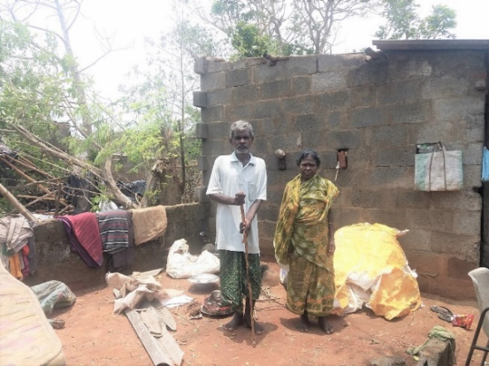
Like most of us, when I hear about a national disaster, or even a regional one, I see the needs and I want to help. We know the Lord cares about the poor and wants us to help where we can – but how? So often when we send a donation to large disaster organizations such as ‘The Red Cross’, we’re finding out that a lot of that money goes to huge overheads, salaries for CEO’s and employee incomes and benefits. I’m happy to say I’m in a position where I can send my donations straight to the affected area and it goes directly to the people who so desperately need it.
The pictures are of Pastor Sevak visiting the families that have been badly affected by the cyclone. Please pray for these precious people. They need clean water, clothing, blankets and the materials to start re-building their homes and lives. I believe the Lord has blessed America to be a blessing! Please join me in giving sacrificially to our brothers and sisters in need in Odisha.

Thank you so much for your love and prayers.
Your financial help is very much needed and appreciated.
For More information, please call 216-870-0936

