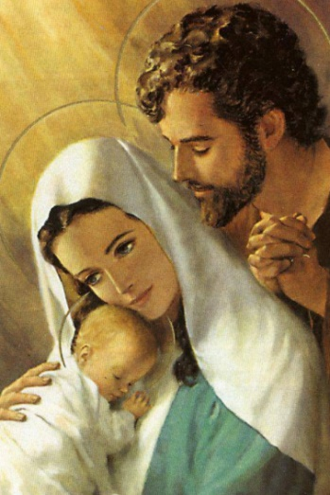
Word and Deed Ministries
kathrynsears@yahoo.com (216) 870-0936
Bringing Help and Hope to the Nations
through Jesus Christ our Lord

December 2017 Newsletter
wordanddeedministries.com

“For with God nothing will be impossible.” Then Mary said, “Behold the maidservant of the Lord! Let it be to me according to your word.” And the angel departed from her. Luke 1:37 & 38
Traditionally, this is the time we celebrate the birth of Jesus and remember Mary’s surrender to God. In spite of the shame it would bring upon her in her community, she said yes to the Lord. She wasn’t to know the angel would also visit Joseph. This undoubtedly made things easier, nevertheless, her trust had to be in the Lord!
Thank you for your prayers and support of this ministry. I pray blessings upon you and your family for the holidays and the year to come.
This Christmas season, let’s live sacrificially as Mary did and trust God implicitly. Please pray for me as by faith, I’m making plans to go back into the bush of Liberia. For the month of January, I will be evangelizing, praying for the sick, teaching, training and starting churches in Lofa county. It is a tough assignment, but with God and your prayers, nothing will be impossible.
Besides my trip, we have local outreaches that need your prayer coverage.
The children’s ministry in my home. We are practicing a Christmas program to minister at Harbor Lights, which is a large homeless shelter in down town Cleveland. Pray for love and unity among the children and love and patience for me and the other adults who help. We would like to take hats, gloves and toys to the shelter with us. Your help would be most appreciated.
The after-school program. I am helping Ruth Power with child evangelism. We need more volunteers so that we can get into as many schools as possible. If you can give of your time between 3:30 and 5 pm. one day a week, Please call me.
Please pray for the outreach to Euclid Villa Apts. For souls to be saved and for spiritual growth.

Please pray for my February trip:
- For protection for us and our families from sickness, disease and satanic attack.
- For supernatural wisdom and discernment for me and my team.
- For unity and good health on the team.
- For hearts to be prepared ahead of time to be receptive to the gospel.
- For the Holy Spirit to sovereignly point out those who are to be leaders in the new churches.
- For Bibles and humanitarian aid.
- For the finances to come in:
  - Plane ticket, vehicle repairs, gasoline, food for the villages we enter, finances for the building materials for the churches already started, and for support for the Pastors.

Thank you so much for your love and prayers for the lost and the hurting. Your help is very much needed and appreciated.
Mailing address: 3451 Menlo Road Shaker Hts OH 44120

For More information, please call – 216-870-0936
Or, visit our new website: wordanddeedministries.com

