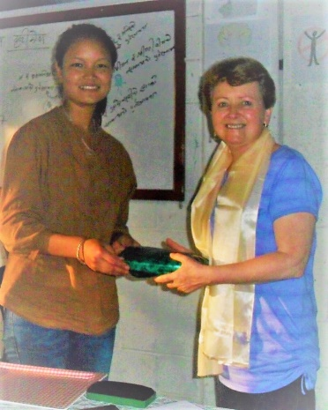
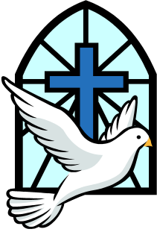
Word and Deed Ministries
kathrynsears@yahoo.com (216) 870-0936
Bringing Help and Hope to the Nations
through Jesus Christ our Lord
March 21, 2018 Newsletter

Check out our website: wordanddeedministries.com

And He said to them, “Go into all the world and preach the gospel to every creature…” Mark 16:15. This is a command from the Lord. It is not a suggestion but a mandate! My eyes were opened to see how urgent this call to “GO!” really is.
I believe the Lord strategically seated me beside a Catholic evangelist on one plane and a Muslim evangelist on another. It quickly became obvious that even the Catholic evangelist was not preaching the same gospel that I was. The Muslim boasted of having a team of 200 men who travel all over the world digging wells, building clinics, erecting mosques and giving away radios that can only be tune in to Islamic stations. He was delighted to tell me that he was the one to introduce Islam into the country of Poppa New Guinea. He went on and on – trying to persuade me that Islam is a loving religion. I was stuck with him for many hours and even though I did get some witnessing in for our true Messiah, I could not wait to get away from him. This experience made me feel sick, to think how the enemy is spreading his lies and deception across the globe. My friends, there is no time to spare. The false religions are wasting no time! Please pray for more “laborers for the harvest” Luke 10:2 – and if you are unable to go, please give sacrificially to send those of us who can.
Do not set your mind on high things, but associate with the humble. Romans 13:8
Ministering to the people of Liberia, West Africa, has been such a blessing. These precious people are very poor in material things but are rich in many other ways. They are so receptive and ready to hear about Jesus. My first five days was spent in Soul Clinic. This is just a few miles outside the capital, an area where there had been a refugee camp during the civil war (ending in 2003). Many of the people who live there came from Lofa County. I taught in their church for three days and on the third day many of them were delivered of evil spirits and seventeen people were baptized. We then set out for Lofa County. We showed the Jesus movie in laid hands on the sick and cast out demons in six towns. Each time I taught on the love of Jesus, the baptism in the Holy Spirit, healing and deliverance. We saw several healed of aches and pains in knees and necks. One lady said she had never been able to sweat and had pain all over her body. After a corporate deliverance session, she came forward to tell us she had started to sweat and all of her pain had gone. The town chief at Nicabuzue was healed of a painful gunshot wound in his leg and was able to not only walk without limping but even ran! After the healings and teachings, we baptized twelve in that town.
I believe the Lord is about to bring us to another level of faith. My prayer is for the Lord to use us to see the paraplegic walk, the deaf hear and the blind see!
Thanks to a very generous friend of the ministry, Pastor Daniel of Balakpalasue now has a new motorbike and $500.00 towards the building of “Word and Deed Ministries church”. He and his congregation have made 4,000 bricks and cut and prepared the lumber, and the roof should be on before the next rainy season. Praise the Lord for His wonderful provision! We also praise God for the fifteen people from his congregation who we took to the river and baptized while I was there.
Through the generous giving of Word and Deed Ministry supporters, I’m happy to report we were able to lead hundreds of men, women and children to the Lord, feed the poor, give out humanitarian aid and help several new churches financially with their building projects. Some of these churches are the first in their towns and have sprang up as a result of our evangelism over the last seven years. Your donations to Word and Deed Ministries have made and continue to make a difference!

Thank you so much for your love and prayers for the lost and the hurting. Your financial help is very much needed and appreciated.

For More information, please call – 216-870-0936
Or, visit our new website: wordanddeedministries.com

