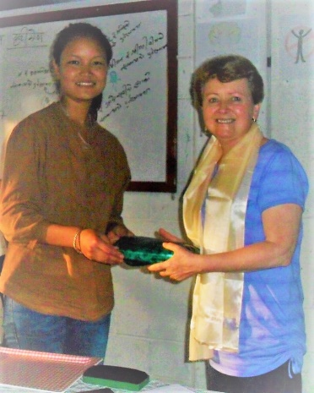
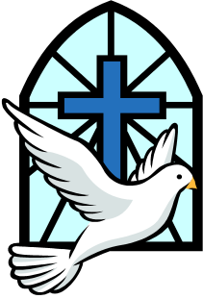
Word and Deed Ministries
kathrynsears@yahoo.com (216) 870-0936
Bringing Help and Hope to the Nations
through Jesus Christ our Lord
October 2017 Newsletter

Check out our website: wordanddeedministries.com

Before Me there was no God formed, nor shall there be after Me. I, even I, am the LORD, and besides Me there is no savior. Isaiah 43:10b, 11a
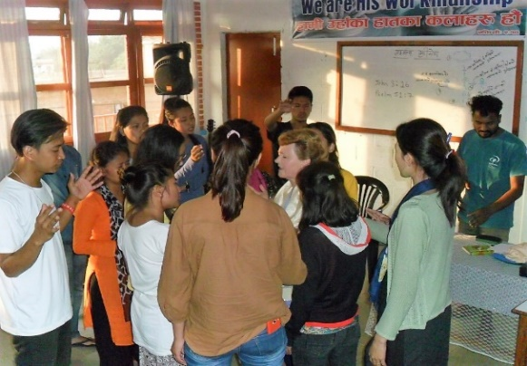
Ministering in Nepal and India to Hindus was a different experience. Hinduism claims to worship three million gods.
After two weeks in England, I flew straight to Nepal to spend two and a half weeks at a YWAM base in Kathmandu. It is such a privilege to teach the word of God to these young people. For three hours a day, we looked at scriptures on the Holy Spirit from Genesis to the new testament. We spent some time waiting on the Holy Spirit and operating in the gifts of the Spirit as we saw them in 1 Corinthians chapters 12 through 14. The students ministered to one another and some prophesied and spoke in tongues for the first time. The subject for the second week of teaching was spiritual warfare. Many of them received deliverance and shared how their faith had been strengthened.
YWAM students praying for Kathryn and saying their goodbyes.
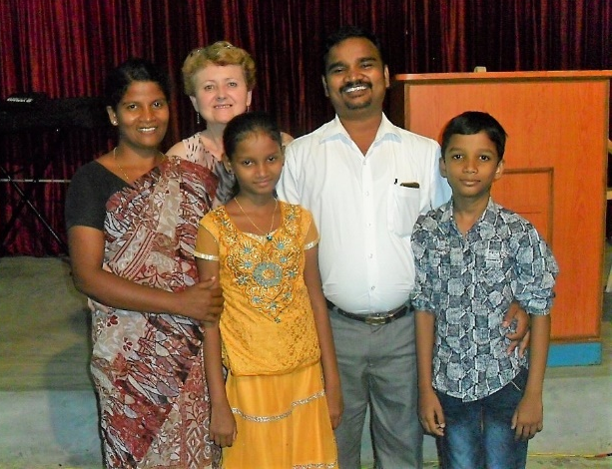
I flew from Kathmandu, Nepal to Chennai, South India. Word and Deed rented a car and the next day Pastor Barnabas drove nine hours until we reached the town of Mettupalam. There I preached and ministered for two days of meetings. The Pastor of this church shared an amazing testimony that had occurred only a week earlier. As they were in the church praying and fasting for the success of these two days of meetings, the Hindus were marching towards the church intending to do some damage. With their big old god being carried in front of them, suddenly a heavy electric cable broke and came crashing down beheading their statue/god. They got scared and ran away – not to be seen again.
Pastor and family of the church at Mettupalam India.
Our meetings were powerful. There was high praises and great expectations. A number of the congregation testified to knees and stomach problems being healed and one lady had an improvement in her vision. Her cloudy old eyes became bright and clear. I think she was healed of cataracts, but with the language barrier, it was hard to determine. Some were delivered of demons and many of them received the Holy Spirit with the evidence of speaking in tongues.
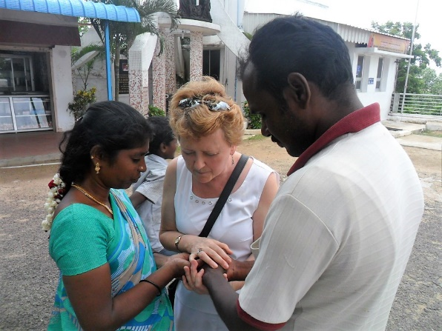
We then drove about three hours to a small town called Salem. This was a new church Pastor Barnabas had planted. The few members didn’t have anything but faith and love. Our ministry paid for the advertising, bought the food, rented the building and the chairs, and the sound equipment. Half of the people gathered were Hindus who heard the gospel loud and clear for the first time, praise be to God! Three young people travelled 20 kilometers because they had herd there was going to be a healing meeting with a visiting speaker from America. One of them was healed of a torn rotator cuff and a damaged knee and another was baptized in the Holy Spirit. A number of others were healed, and several Hindus gave their hearts to the Lord that night. I loved ministering to these beautiful Christian, joy filled tribal people.
God is so good! During three days of meetings in the city of Chennai, one Hindu man had come to the church after hearing of people being healed the night before. He had hurt his knee at work six months earlier and had been in a lot of pain. He was healed when I laid hands on him and then gave his life to Christ. A few days later this new convert insisted on having the mid-week meeting at his home. His wife was so excited she made food for everyone. He invited his Hindu sister and she came to Christ that evening. Glory to God!
Unsaved Indian couple receive prayer.
Back to Liberia in January
Go then and make disciples of all the nations, baptizing them into the name of the Father and of the Son and of the Holy Spirit, teaching them to observe everything that I have commanded you… Amen. Matthew 28:19 & 20a (AMP)
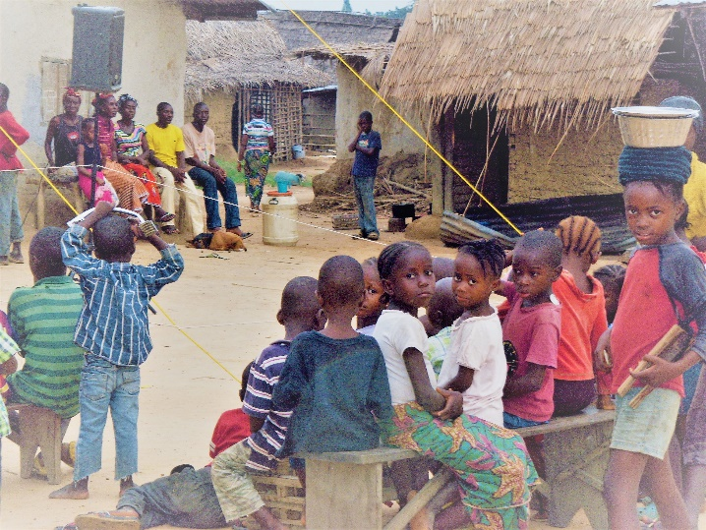
Please pray! The above scripture is exactly what we are endeavoring to do in Liberia
I am making plans to go back for the month of January; and with my Liberian team, we will be traveling the ten to twelve hours of very rugged road up into the interior. We will be evangelizing, baptizing, teaching the new believers and strengthening the new churches we have just started.
Currently we are in need of financial help for repairs for the Toyota 4Runner (the vehicle we shipped over two years ago for our Monrovia Pastor, Jallah). We desperately need a motorcycle for Daniel (our Lofa County Pastor and Evangelist). We also need to buy building materials for the new churches, Bibles for the new believers, reading glasses, and other humanitarian aid, and we need help with the shipping costs to send these things.
A crowd starts to gather to watch the Jesus Film.

Local Outreaches, Cleveland, Ohio
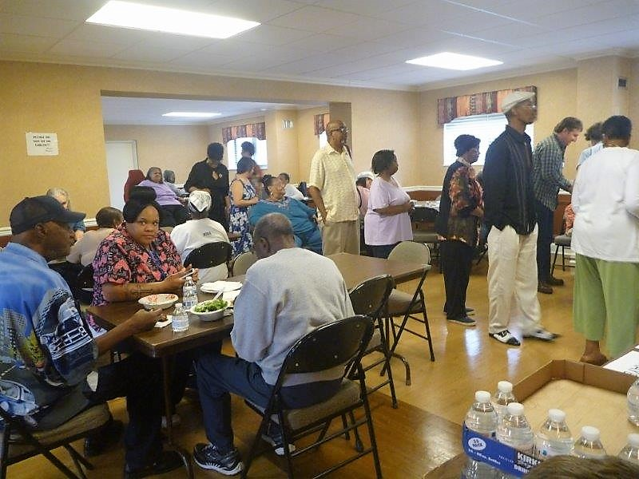
Please continue to pray for our local outreaches. On September 10, Gayle Ozene and I joined forces with Tom and Lisa Tedeschi of Christian Assembly. We fed over 100 people, shared scripture and testimony and prayed for the sick. One man told us his back was healed, one lady expressed improvement in her vision and others felt a touch from the Lord.
On the second Saturday of each month, Helen Happ and I minister to the children on our street. We serve lunch, teach a Bible lesson and show Christian movies. The Lord has blessed us with two wonderful ladies who have just volunteered to help, Alicia Reid and Cheryl Polk. Please pray for true salvations as the world is enticing and deceiving our young people like never before. We will be meeting with the children each Friday night to practice for Christmas outreaches to homeless shelters and nursing homes.

Thank you so much for your love and prayers for the lost and the hurting. Your financial help is very much needed and appreciated.

For More information, please call – 216-870-0936
Or, visit our new website: wordanddeedministries.com

