INFORMATION, SCHEDULE AND REGULATIONS
FOR EXHIBITING

REGISTRATION
1. Doors will open Saturday, March 7, 2020 at 6:30 a.m. for registration and entry of blooms and flower arrangements, and will close at 10:30 a.m. The exhibit area will be cleared of all persons except officials connected with the show at this time. Judging will commence at 11:00 a.m.

2. Entry cards may be obtained in advance of the show from Don Lesmeister, 4512 Marble Way, Carmichael, CA 95608, Phone: (916) 742-3443, and they are also available at the show. Cards must be filled out properly with the correct identification of the bloom and placed with each entry. Attention must be given to placing the card in a manner so that the exhibitor’s name is not visible. Cards must be typed or written in pencil. Do not use ink, as it will blur if water-spotted.

3. Pink ACS entry cards will be used for all seedling entries. Seedling entries, to be eligible for ACS Commended Seedling Certificates, shall indicate on the inside of the folded entry card the bloom name or code and certification that the entry has bloomed true for at least three consecutive years. Sports or Mutants should be entered in the seedling class using pink sport card entry cards provided by the show committee.

4. FLOWER ARRANGEMENTS ~ For information and space reservations, contact Arrangement Chairperson, Frankie Raymond, 916-995-2550.

CLASSIFICATION
5. “Camellia Nomenclature” 1981 and 2020 Editions will be the official guides for classification and description.

6. Each named cultivar of Camellia Japonica, Reticulata or Hybrid shall constitute a class in J-1, J-3, J-5, J-11, B-1, B-3,
B-5, RH-1, RH-3, RH-5, H-1, H-3, H-5 and H-11; other classes are listed under classification of Horticultural exhibits.

7. No exhibitor shall place more than one entry in a class except in Sections OT, SAC, F, Y, JR., I, seedlings and sports, and specified multiple classes.

8. Blooms will be placed by the exhibitor and he or she is responsible for placing them on the proper table with the proper entry card. Only one cup per bloom is permitted. No stacking of cups. Miniature and small cups not taller than 1-1/4”, larger blooms not taller than 2-1/2” high. Material such as perlite, cotton, and collars are allowed so long as the material is not significantly over the cup top and is not readily observable. Non complying entries will be set aside and not considered for trophy awards. The Show Committee reserves the right to move blooms for better placement and to exclude unfit entries.

9. Junior Class: 16 years maximum age and 5 YEARS MINIMUM AGE; one bloom of each variety. Junior’s should fill their own entry cards out and place their blooms themselves.

10. The Spray class will constitute the display of one Camellia spray or branch, with flowers and foliage; stems should not be less than 8” or more than 15” in length. Exhibitors may enter more than one spray but entries must be of different varieties.

11. Entries in the “Old Timers” class are limited to single blooms of C. Japonica introduced prior to 1950. Exhibitors will be limited to five (5) entries but of different varieties. If you are unsure of when your older camellia was introduced, please see the Information Table where a 2020 Nomenclature book will be available.

12. The Sacramento Camellia Society member’s class is open to members who have not won “Best of Show” at any Show. Maximum of five (5) different entries.

**Sacramento members are the local members who reside within the Sacramento and surrounding counties only.

13. Beginner’s Class-Section I. Limited to exhibitors who have not received a trophy award in the regular class at any ACS sanctioned show. Previous winners in the Junior Class are allowed. Exhibitors will be limited to a total of five (5) entries. Any size or any class.

14. The Judges will consider three awards in all classes. If the entries do not justify an award, none will be made.

15. Decision of the judges shall be final.
16. The judging scale awards no points for foliage. One or two leaves, with color and vigor characteristic of the variety, must be shown with each bloom. The length of the stem should not be less than ¾” nor more than 1-1/4” in length.

17. Sweepstakes trophies, for winner and runner-up will be awarded on a basis of the greatest number of first awards. In the case of ties, second awards will be counted in addition.

18. Bloom size will be determined by measurement.
Miniature blooms – Under 2-1/2”
Small blooms – 2-1/2” to 3-1/2”
Medium blooms – 3-1/2” to 4-1/2”
Large blooms – 4-1/2” to 5-1/2”
Very Large blooms – Over 5-1/2”

19. All miniature and small blooms of any species must be entered in the Boutonniere classes, B-1, B-3, B-5, BC5.

JUDGING SCALES
20. Judging will be in strict accordance with the following scales:

FOR ALL BLOOMS FOR SEEDLINGS & SPORTS
Color 25% Distinctiveness &
Form 25% unusual qualities 50%
Condition 25% Color & markings 10% Size 25% Form 10%
Foliage 10%
Substance & texture 20%

FOR SPRAY OR STEM EXHIBITS FOR FRAGRANT CLASS
Flower: Typical form & color 30% Fragrance 50%
Floriferousness 10% Bloom 50%
Foliage and stem 20% CLASS OF BLOOMS WITH YELLOW
Leaves and flowers on stem 20% Amount of yellow & saturation 50%
Condition 20% Bloom 50%

GENERAL
21. Judges may compete in all sections.

22. Exhibitors need not be members of a Camellia Society.

23. The Show Committee will make every effort to properly care
for entries but disclaim all liability for loss or damage to any
exhibit or property.

24. Labeled entries will only be permitted in Classes C-3, C-9,
and BC5.

25. Space will be provided where individuals are encouraged to
exhibit blooms which they are unable to identify by name.
Certified Judges will review and provide names for these blooms,
where possible. These blooms will be eligible for ribbon
awards, but not trophy awards.

26. Prepared containers will be supplied by the Show
Committee in all classes except the Flower Arrangement
Division.

27. All exhibits will be dismantled after 5:00 p.m., Sunday,
March 8th, 2020.

CLASSIFICATION OF HORTICULTURAL EXHIBITS

Section J-1 Single Bloom Japonica
Section J-3 Three Blooms Japonica-One Variety
Section J-5 Five Blooms Japonica-One Variety
Section J-11 Eleven Blooms Japonica-One Variety
Section B-1 Single Bloom Miniature or Small
Section B-3 Three Blooms Miniature or Small
Section B-5 Five Blooms Miniature or Small
Section BC5 Collection of 5 Different Named Boutonniere Camellias, each labeled, one entry only.
Section RH-1 Single Bloom Reticulata or Reticulata Hybrid
Section RH-3 Three Blooms Reticulata or Reticulata Hybrid
Section RH-5 Five Blooms Reticulata or Reticulata Hybrid
Section H-1 Single Bloom Hybrid, other than Reticulata Parentage
Section H-3 Three Blooms Hybrid, other than Reticulata Parentage
Section H-5 Five Blooms Hybrid, other than Reticulata Parentage
Section H-11 Eleven Blooms Other than Japonica-One Variety
Section C-3 Collection of 3 Named Camellias, each labeled
(1 Boutonniere, 1 Medium & 1 Large) One entry only
Section C-5 Collection of 5 Different Named Camellias,
each labeled – One entry only
Section S-1 Seedling and Sports – any class
Section JR Junior Classes
Section S Spray or Stem Exhibit
Section F Fragrant Blooms
Section Y Yellow or Cream Blooms
Section OT Single Bloom Japonica, introduced prior to 1950
Section SAC Single Bloom-any class, Sacramento Members
Section I Beginner’s Class, first time trophy winner-any class

TROPHY AWARDS

- Outstanding Flower of the Show
- Sweepstakes
- Runner-Up Sweepstakes
- Best Japonica – Very Large
- Runner-Up Japonica – Very Large
- Best Japonica – Large
- Runner-Up Japonica – Large
- Best Japonica – Medium
- Runner-Up Japonica – Medium
- Best Small Bloom
- Runner-Up Small Bloom
- Best Miniature Bloom
- Runner-Up Miniature Bloom
- Best 3 Japonicas – Very Large
- Best 3 Japonicas – Large
- Best 3 Japonicas – Medium
- Best 3 Small Blooms
- Best 3 Miniature Blooms
- Best 5 Boutonnieres
- Best 5 Japonicas – Under 4-1/2”
- Best 5 Japonicas – Over 4-1/2”
- Best 11 Japonicas
- Best 11 Camellias Other Than Japonica
- Best Reticulata or Reticulata Hybrid – Very Large
- Runner-Up Reticulata or Reticulata Hybrid – Very Large
- Best Reticulata or Reticulata Hybrid – Large
- Runner-Up Reticulata or Reticulata Hybrid – Large
- Best 3 Reticulatas or Reticulata Hybrids
- Best 5 Reticulatas or Reticulata Hybrids
- Best Hybrid – Large, without Reticulata Parentage
- Runner-Up Large Hybrid, without Reticulata Parentage
- Best Hybrid – Medium, without Reticulata Parentage
- Runner-Up Medium Hybrid, without Reticulata Parentage
- Best 3 Hybrids, without Reticulata Parentage
- Best 5 Hybrids, without Reticulata Parentage
- Best Collection of 5 Different Named Boutonnieres
- Best Collection of 5 Different Named Camellias
- Best Collection of 3 Different Named Camellias
- Best Seedling or Sport
- Runner-Up Seeding or Sport
- Best Blooms, Junior Class (4 awards)
- Best Spray or Stem Exhibit
- Best Fragrant Bloom
- Best Yellow or Cream Bloom
- Best, Sacramento Members
- Best “Old Timer” Bloom (Japonica Prior to 1950)
- Beginner’s Class – 1st Time Trophy Winner
- Beginner’s Class, 1st Time trophy Winner-Runner-Up
- Most Outstanding Arrangement – Experienced Arrangers
- First Runner-Up – Experienced Arrangers
- Second Runner-Up – Experienced Arrangers

THE CAMELLIA SOCIETY OF SACRAMENTO

Presents

OUR 96th ANNUAL
CAMELLIA SHOW

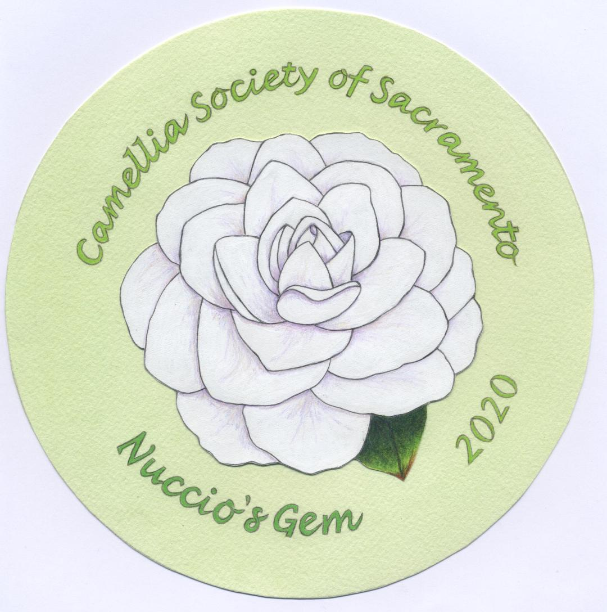

To Be Presented at the

Sacramento Elks Lodge #6

6446 Riverside Boulevard
Sacramento, CA 95831

SATURDAY AND SUNDAY
March 7th and March 8th, 2020

Show Hours
Saturday……….... 3:00 p.m. – 6:00 p.m.
Sunday…………..10:00 a.m. – 5:00 p.m.

ADMISSION FREE
(Donations Gladly Accepted!)

Co-Show Chairpersons
Don Lesmeister
Julie Vierra

camelliasocietyofsacramento.org

