YOU ARE INVITED TO JOIN THE

CAMELLIA SOCIETY OF SACRAMENTO!

www.camelliasocietyofsacramento.org

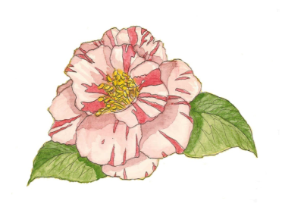

The Society, founded in 1943, meets once a month to study camellia culture, care and growth, and share in the enjoyment of raising these beautiful flowers. **The meetings are held Tuesday evenings (7 pm) at the Sacramento Elks Lodge No. 6 in the Emblem Room.** There is always an authority on camellias to ask questions of, and during the blooming season members bring camellia blooms for display (and you are entered to win a camellia plant if you bring your blooms to the meeting). A hospitality break after the program is a fun time to meet others who enjoy the art of growing camellias.

The dues are $20.00 if you like the newsletter sent e-mail, $25.00 if you want it sent US Mail, or if you prefer to add a little extra for a sustaining membership, it is $30.00 per year, which entitles you to all the privileges the Society offers. If you attend the first meeting of the year next October, you will receive a free camellia for joining! For additional information, visit the **Welcome Table** at our Show or please make checks out to: **Camellia Society of Sacramento**, and mail them to:

LuAnn Lantsberger

2960 Brenda Way

West Sacramento, CA 95691-4803

The last meeting of the year will be held on Tuesday, March 22nd at the Elks Lodge, 6446 Riverside Blvd., Sacramento, CA 95831. Meeting starts at 7 p.m. Please feel free to attend!

We will also be having our annual end of the year dinner on Saturday, April 23rd at the Club Pheasant in West Sacramento. Please call Rosemary Cooper if you would like to join us. You will need to fill out a luncheon reservation. Her telephone number is 559-779-1197. We will have a Silent Auction, plant raffle, delicious meal and lots of laughs!

*Please join us and come see what we are about!*

Starting next year our meetings will be held on the 4th Sunday (Oct.-March)

*Meetings for the 2022-2023 Camellia Season*

Sunday, October 23rdSunday, January 22nd

MEETINGS WILL START AT 2:30

Sunday, November 20th** Sunday, February 26th

Sunday, December 18th** Sunday, March 26th

(**date change because of holidays)

(**keep *this* page** for your information)

**Camellia Society of Sacramento Membership**

***2022-2023 Membership (please print clearly)***

Name(s)

Address including city & zip

Telephone Number or Cell #

Email address:

*I choose*:

* Regular Membership ($20) (sent via email address)
* U.S. Post Office ($25) (sent snail mail)
* Sustaining Membership ($30) (*Thank you!)*

Make Check out to:

CAMELLIA SOCIETY OF SACRAMENTO

Mail to LuAnn Lantsberger

(address on page 1)

***(Fill out this second page and send back with dues, keeping the first page for information on meetings. Hope to see you soon!)***

Thank you for joining!

