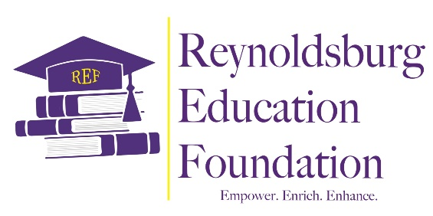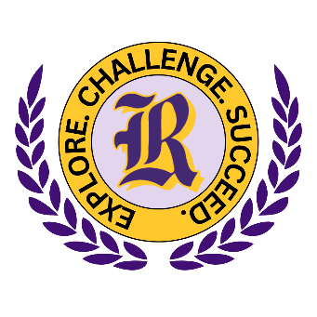

REF Payroll Deduction Pledge Form
Established in 2019, the Reynoldsburg Education Foundation’s mission is to empower RCSD students and educators by enhancing and enriching educational opportunities through charitable donations, community engagement, and support that develops and nurtures the whole child. The REF is an independent, non-profit organization that works in tandem with the RCSD to award mini-grants to classroom teachers and scholarships to Reynoldsburg students. Your donation goes a long way in helping us achieve our mission. Check us out at www.reynoldsburgeducationfoundation.org.

Your PLEDGE can help!

By signing below, I authorize Reynoldsburg City School District to deduct the selected amount from my paycheck each pay period. I understand that this deduction is ongoing until I give written notification to discontinue the deduction to the RCSD Payroll Department.

☐ $1.00/pay ☐ $2.00/pay ☐ $5.00/pay

Employee Name_______________________________ Email___________________________________
Signature_____________________________________________________ Date__________________
Please share my name with the REF for recognition purposes
I prefer that my gift remain anonymous

The Reynoldsburg Education Foundation is a 501(c)3 charitable organization. Your contribution may be tax deductible. Please consult your tax advisor. (No goods or services have been provided in exchange for this pledge.)

Thank you
Please send form to 7244 E. Main Street, Reynoldsburg, OH 43068, or email it to payroll@reyn.org

