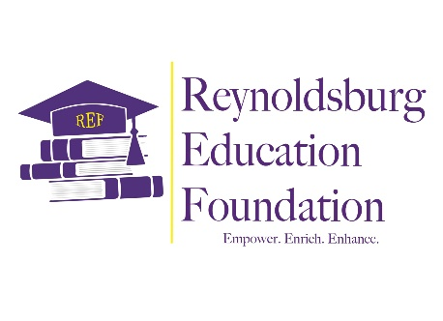
September 22, 2025

Dear Reynoldsburg Educators,
The Reynoldsburg Education Foundation (REF) Board of Directors, along with the Grants and Scholarships Committee, is pleased to announce our sixth round of Mini-Grant applications! Reynoldsburg City School District teachers can now apply for a $500 mini-grant for the 2025-2026 school year. We are excited to be able to award at least one grant to each school (two at the high school).
To date, the REF has been able to award over $35,000 in grants and scholarships, and has invested $30,000 with the Columbus Foundation in order to prepare for future giving. We are blessed to have the support of our community to help bring you these grants, and we look forward to continuing to grow the funds as we aspire to mature as an organization.
The grant application is currently available on the REF website at https://reynoldsburgeducationfoundation.org/grant-opportunities. Scroll to the bottom of the page to find our easy-to-use Google Form along with other helpful information. Please review the following documents before completing your application:
- REF Grant Guidelines/Procedures
- Application Instructions
- Grant Scoring Rubric
- District Strategic Plan/Portrait of a Graduate

For general questions about grant procedures or specific questions about your grant project, contact:
- Debbie Dunlap, ddunlap@live.com
For specific questions about filling out the online application, please contact the following:
- Isabel Bozada-Jones, isabel.bozadajones@reyn.org

The application deadline is November 14, 2025, at midnight. Every year, we are wowed and inspired by your proposals, and we look forward to another year of innovative and inspirational ideas!

Sincerely,
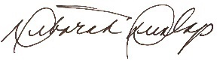
Deborah Dunlap
Chair, Reynoldsburg Education Foundation

Empower. Enrich. Enhance

