Contact: Debbie Dunlap  Reynoldsburg Education Foundation  Phone:(614) 581-2870  ReynoldsburgEdFoundation@gmail.com  www.reynoldsburgeducationfoundation.org |  | Reynoldsburg Education Foundatioin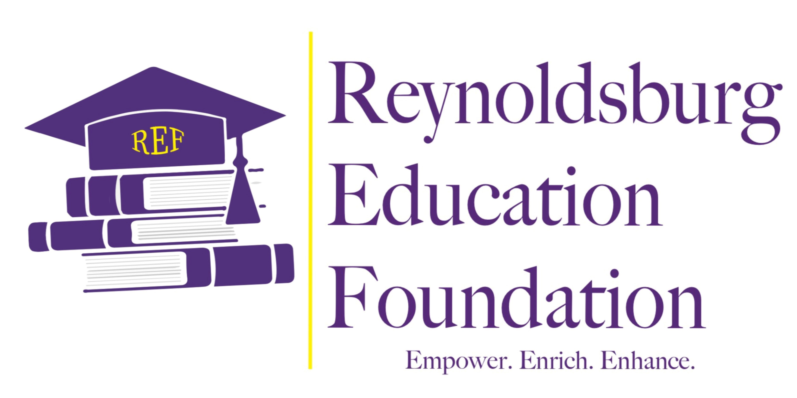

Press Release

Reynoldsburg Education Foundation Announces Partnership with the Columbus Foundation
Investment Opens Doors to Numerous Opportunities for Reynoldsburg Students and Staff
For Immediate Release
Reynoldsburg, OH -- The Reynoldsburg Education Foundation (REF) announced Friday, February 18, 2022, that it has entered into partnership with The Columbus Foundation as it works to advance its goals to empower, enrich and enhance educational opportunities within the Reynoldsburg City School District.
The REF’s partnership with The Columbus Foundation is the next step in the nonprofit’s journey toward establishing a viable organization that will support students and staff through independent funding, offering a sustainable and long-lasting source of fiscal support through grants and scholarships that uplift Reynoldsburg students and staff.
Founded in 2019, the REF is an independent, nonprofit organization that works in tandem with the Reynoldsburg City School District to provide grants and scholarships to students and classroom teachers where school funding cannot reach. The REF strives to empower Reynoldsburg City School District students and educators by enhancing and enriching educational opportunities through charitable donations, community engagement, and support that develops and nurtures the whole child.
“This partnership will allow the REF to reach new levels of support, a goal we established early in our inception in order to best serve the students and staff in our district,” said REF Chair Debbie Dunlap. “There are so many financial roadblocks in education, roadblocks the REF knows it can remove as a strong organization. By partnering with The Columbus Foundation, not only are we investing donated dollars wisely, but we are also tapping into a long-standing champion of philanthropic giving that will help guide us in our next steps as an organization.”
REF Treasurer Jon Harmacek agreed. “Partnering with The Columbus Foundation gives the Reynoldsburg Education Foundation a chance to responsibly invest our contribution dollars and maximize returns. This will enable us to provide even greater support to Reynoldsburg schools.”
Established in 1943 by Columbus businessman Harrison M. Sayre, The Columbus Foundation has provided thousands of individuals, families, and businesses the opportunity to create unique funds to support the causes they are most passionate about. Grants made from these funds support a wide range of initiatives, programs, and nonprofit organizations that help communities flourish for generations to come. As one of the 10 largest community foundations in the United States, The Columbus Foundation’s generous donors honor the past, give in the present, and ensure a solid future through both current and planned giving.
For more information about the REF, visit www.reynoldsburgeducationfoundation.org. The organization hosts an annual Gala each fall, while partnering with the Mid-Ohio Market at HEART in Reynoldsburg in hosting the Mulligan Golf Classic each summer. Dollars raised through these and other events help fund annual grants awarded to educators, supporting innovative and creative programs in Reynoldsburg classrooms.

-30-

