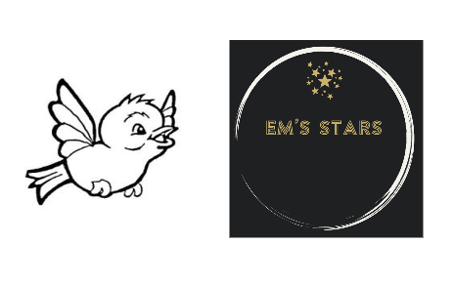

**28 Key Person**

Each child will be assigned a key person that the child will see regularly. This is an EYFS learning and development requirement and an EYFS safeguarding and welfare requirement. Providers must inform parents and/or carers of the name of the key person, and explain their role, when a child starts attending a setting. The key person may change if there is a change in working hours or if the child forms a special bond with another staff member. Parents will be informed of any changes. The key person must help ensure that every child’s learning and care is tailored to meet their individual needs. The key person must seek to engage and support parents and/or carers in guiding their child’s development at home. They should also help families engage with more specialist support if appropriate.

There are named deputy key workers for all children for in the event that the main key worker is absent for a long period of time.

*Observation, assessment and planning*

Observation, assessment and planning are central to tailoring every child’s learning to meet their individual needs. The Development Matters document can be used throughout the early years as a guide to making best-fit judgements about whether a child is showing typical development for their age, may be at risk of delay or is ahead for their age.

Development Matters supports practitioners in planning ways to extend children’s learning and encourages a cycle of action:

• Observation: Look, listen and note. Describing.

• Assessment: Analysing observations and deciding what they tell us about children.

• Planning: What next? Experiences and opportunities, learning environment, resources, routines, practitioners’ role.

*Formative Assessment*

On-going formative assessment is at the heart of effective early years practice. Practitioners must:

Observe children as they act and interact in their play, everyday activities and planned activities, and learn from parents about what the child does at home (observation).

Consider the examples of development in the Unique Child column: observing what children can do to help identify where the child may be in their own developmental pathway (assessment).

Consider ways to support the child to strengthen and deepen their current learning and development, reflecting on guidance in columns headed Positive Relationships and Enabling Environments (planning). These columns contain some examples of what practitioners might do to support learning. Practitioners will develop many other approaches in response to the children with whom they work.

Where appropriate, use the development statements to identify possible areas in which to challenge and extend the child’s current learning and development (planning).

All staff are to complete children’s development tracking via tapestry. This data will be submitted to the local authority for all funded children when requested.

*SEND support for key workers*

SEN Support is designed to provide a graduated approach based on a cycle of action that can be revisited with increasing detail, increasing frequency and with the increased involvement of parents.

Throughout the graduated approach, the practitioner, usually the child’s key person, remains responsible for working with the child on a daily basis and implements agreed interventions.

The SENCO supports individual practitioners and leads and co-ordinates the graduated approach across the setting. All settings should adopt a graduated approach with four stages of action: assess, plan, do and review.

This cycle of action:

• Is usually led by the key person, supported by the setting SENCO

• Parents are engaged throughout

• Action is informed by the child’s views throughout

• The cycle can be revisited in order to identify the best way of securing good progress

References used:

DfE (2014) Statutory Framework for Early Years Foundation Stage