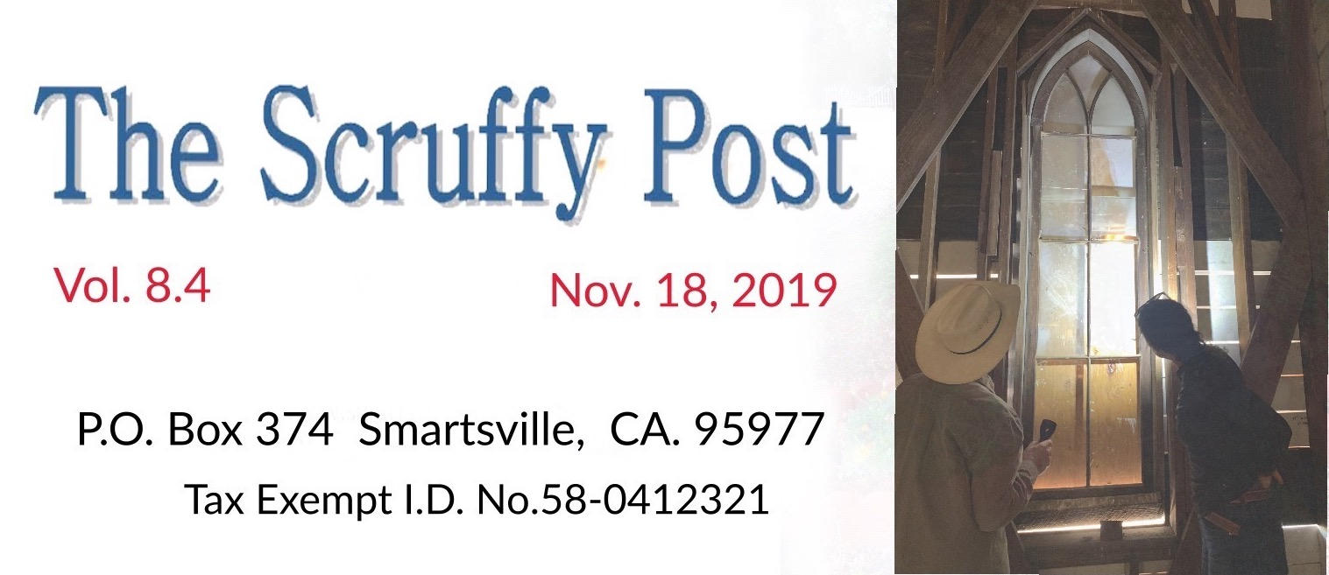
http://www.smartsvillehistoricchurch.org www.pioneerday.info

A Special Donation

We were blessed to be given a remarkable model of the historic Catholic Church to be used for the purposes of fund-raising. Kathy Smith, our vice-president, was contacted via our website by Lee Klassy last May, who offered to make and deliver it. Our plan is to take the model on a monthly “tour” throughout the area with the intent to sell raffle tickets with a winner to be chosen next Pioneer Day. The second-place prize is an 8 X 10 signed print of an original painting of the church in a 1950’s style displayed last Pioneer Day by local artist Nick Vogt.

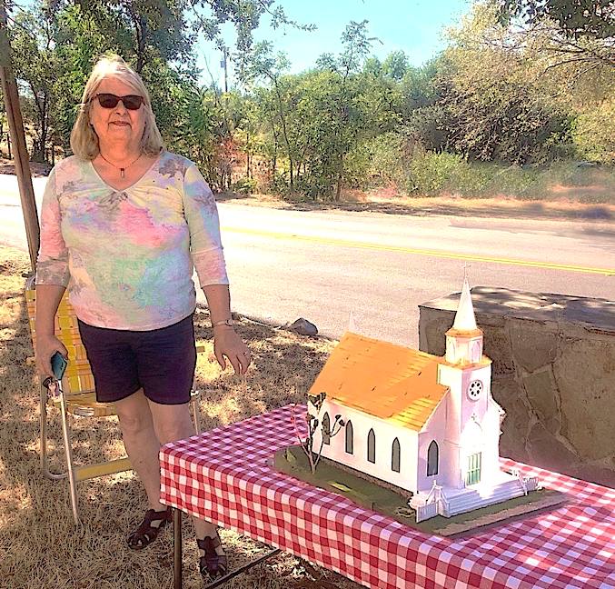 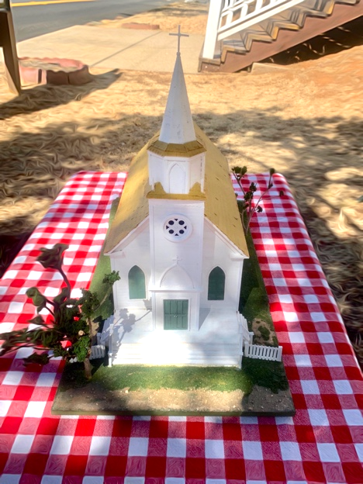 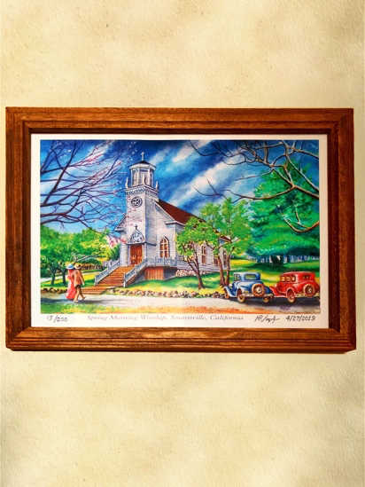 Shelly, Lee Klassy’s wife, delivered the model to Smartsville. Lee made it as a fund-raiser. Nick Vogt signed the print.

Portrait of a Smartsville Pioneer

We were happily surprised in September by the delivery of an oil painting of Thomas Mooney (1823 - 1888), namesake for Mooney Flat, once a community on Mooney Flat Road, painted by his daughter Jessie Mooney. It reminds us that our mission is to both restore the church and to form a museum and visitors center. Two sisters had been caring for this rare keepsake and knew it needed the right home. A photo of the portrait is in Kathleen Smith and Lane Parker’s book, Smartsville and Timbuctoo. The actual oil painting is a work of art.

Sally Knutson and Charle Lennon were touched by our restoration efforts when they attended Pioneer Day and are quite knowledgable about the local history of their family here. Their mother was able to save several items from the old ranch home, no longer there, including the portrait. Thomas Mooney’s wife, Mary Jane, was their great-grandmother’s sister. Sally tells of his prominent role as the Empire Ranch owner, a main stage-stop, trading post and hotel beginning in 1851, and also of his friendly relations with the Native Americans, who he assisted as well. Thomas and Mary Jane had two boys and six girls; none of them married. Jessie was a Smartsville deputy assessor and an artist who gave free art lessons to local children.

The painting needs some restoration work and we’re looking for a qualified person who can fix it. It will have to be stored until the interior of the church is completed, but the sooner it’s fixed, the better.

Sally and Charle also participate in a national event called Wreaths Across America and have volunteered to bring a Christmas wreath to honor Smartsville’s fallen WWI hero whose memorial plaque rests on the church grounds. Please continue reading about this December event on our church grounds in the next article.
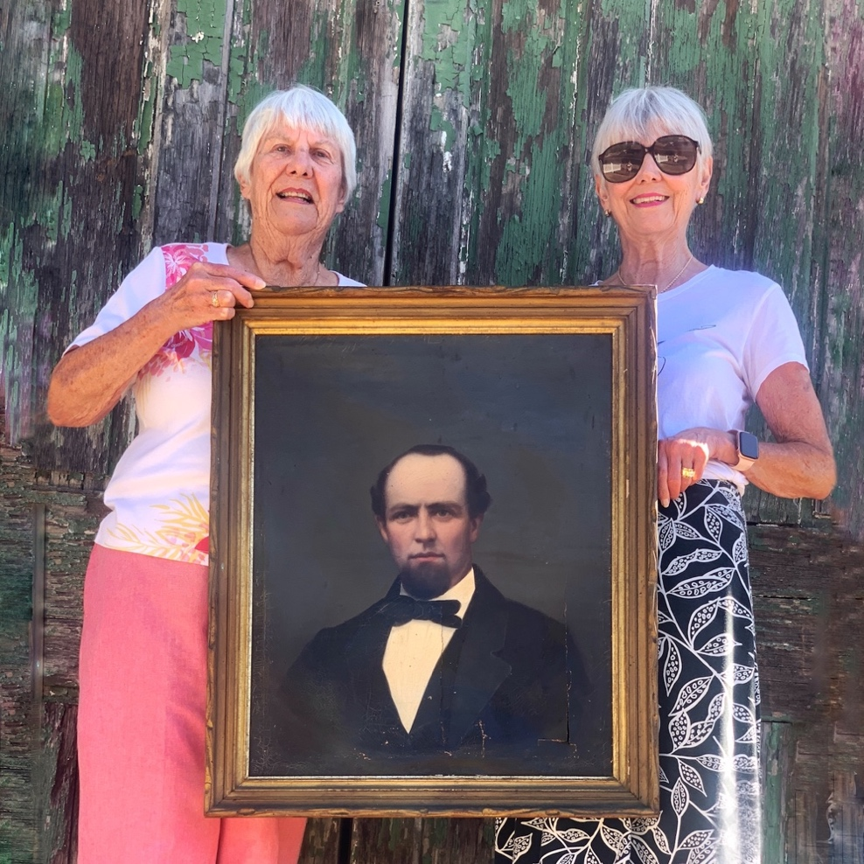

Sally Knutson and Charle Lennon with the Thomas Mooney portrait

Wreaths Across America Event

When Sally and Charle visited Smartsville they were impressed by our plaque of Edward James McGanney under the redwood tree on our church grounds. “Ned,” as he was known around town, was buried in France at the end of WWI, but a plaque still lies under a huge tree that was planted 100 years ago during a ceremony to honor him in 1919.

The sisters have been involved with a national non-profit group called Wreaths Across America, honoring thousands of graves of military men and women on December 14. The following day, Sunday, December 15th the Sally and Charle will lay a Christmas wreath at the McGanney plaque. We’re thrilled with the idea and will hold a lunchtime event to honor our local fallen hero and welcome in the holiday season.

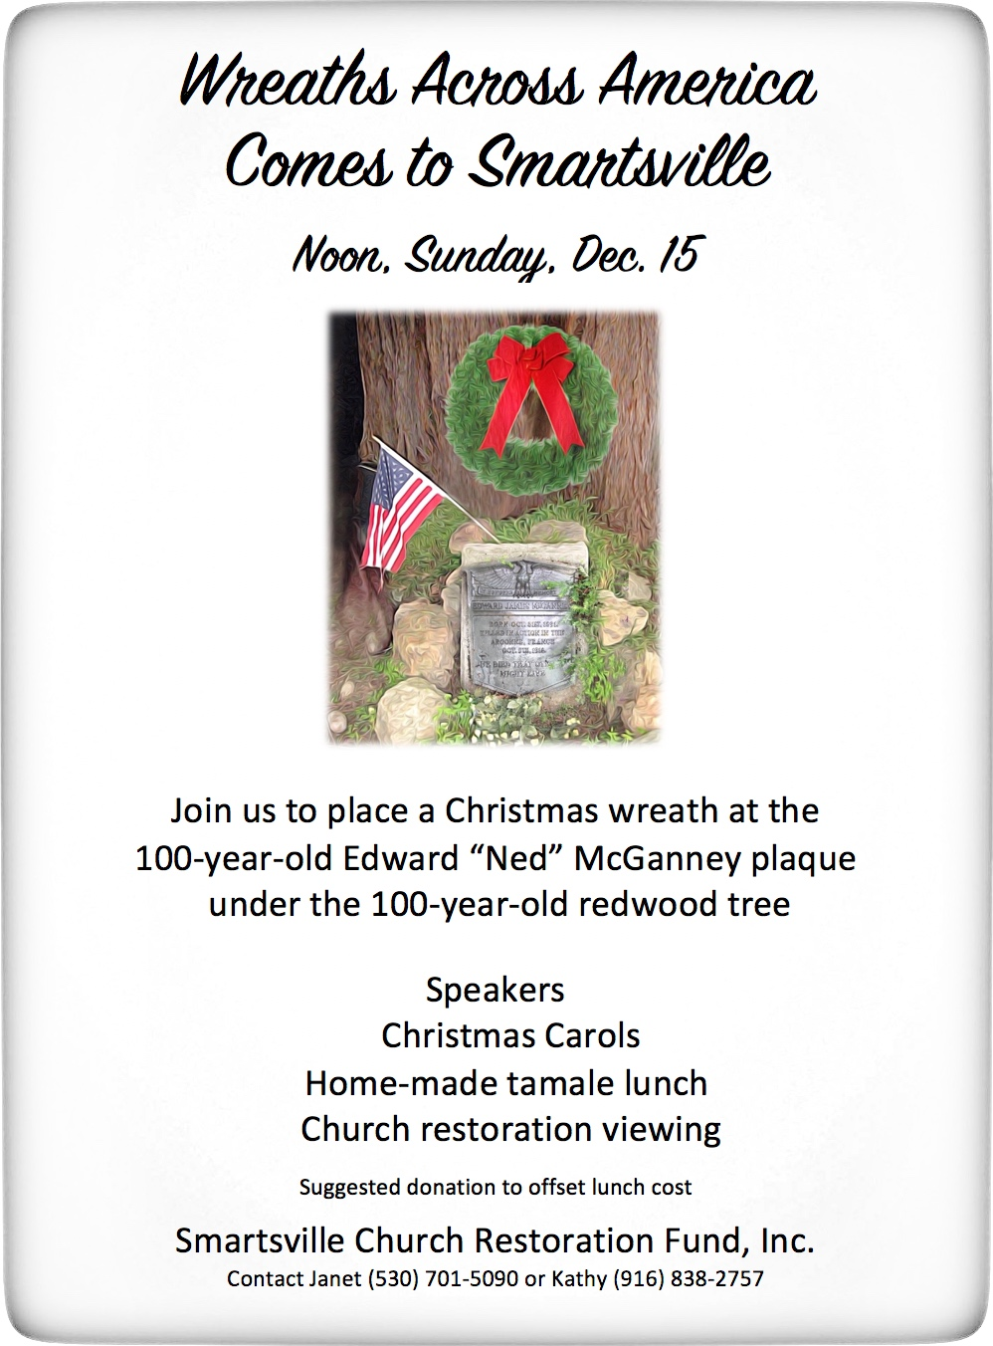

“IN HONORED MEMORY, EDWARD JAMES MCGANNEY, BORN OCT. 31st, 1891.
KILLED IN ACTION IN THE ARGONNE, FRANCE, OCT.5TH, 1918, HE DIED THAT OTHERS MIGHT LIVE.”
The Best Little Parade

Every year on Veteran’s Day local residents Tim and Mary Clark have driven their antique red firetruck through town to honor our veterans. This year Tim drove another truck from his collection and honked to announce their coming. As we waved, the small contingent of Smartsvillagers who watched felt most grateful for this expression of patriotism by the Clarks. We also rang the historic church bell in honor of the occasion.

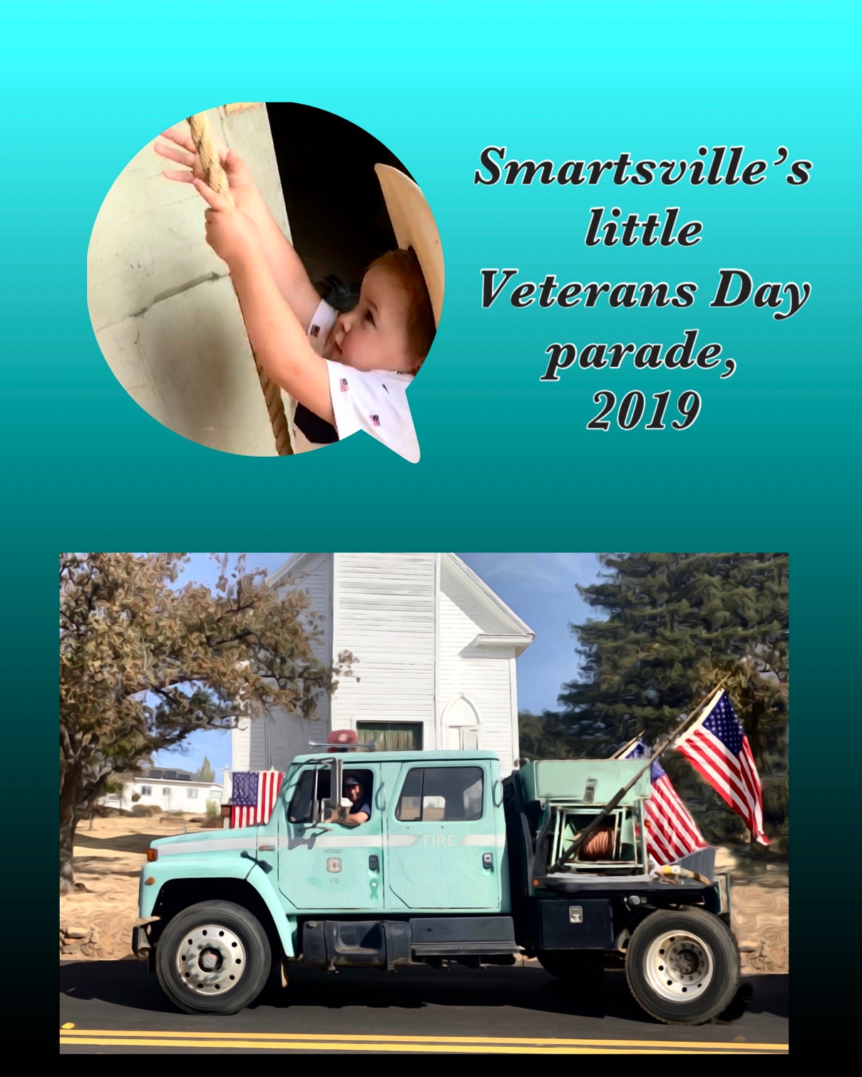

HistoriCorps May Return!

Last, but indeed not least in this newsletter, we won’t soon forget the valiant work of the non-profit group HistoriCorps, who climbed 50’ scaffolding to repair our bell tower last Spring. In October we asked their window specialist, Maia DiLorenzo, to evaluate our window restoration needs and she shared her thorough and expert advice. We have eleven windows, each with varying repair conditions. She felt the bulk of the work can be done at the site. Her report will generate an estimate for repair and added to our work list to complete the church building restoration.

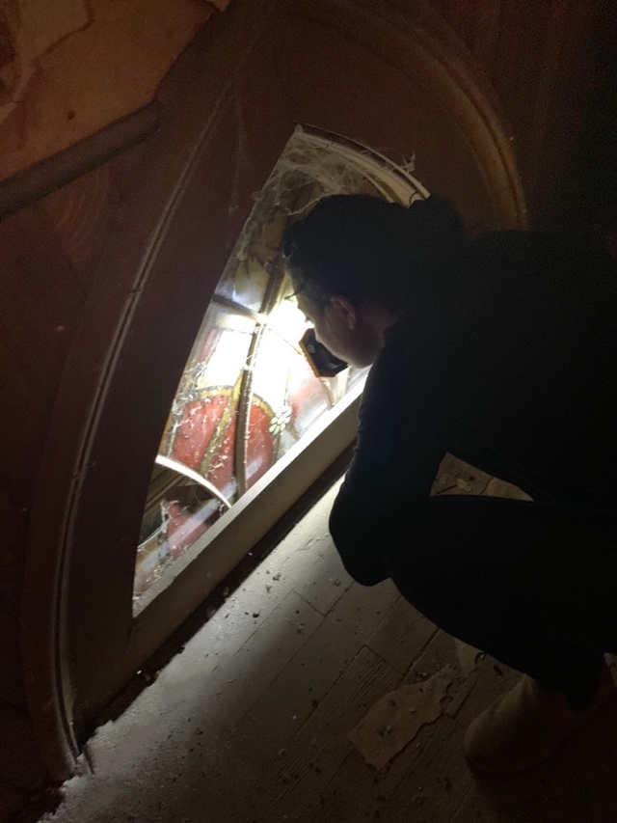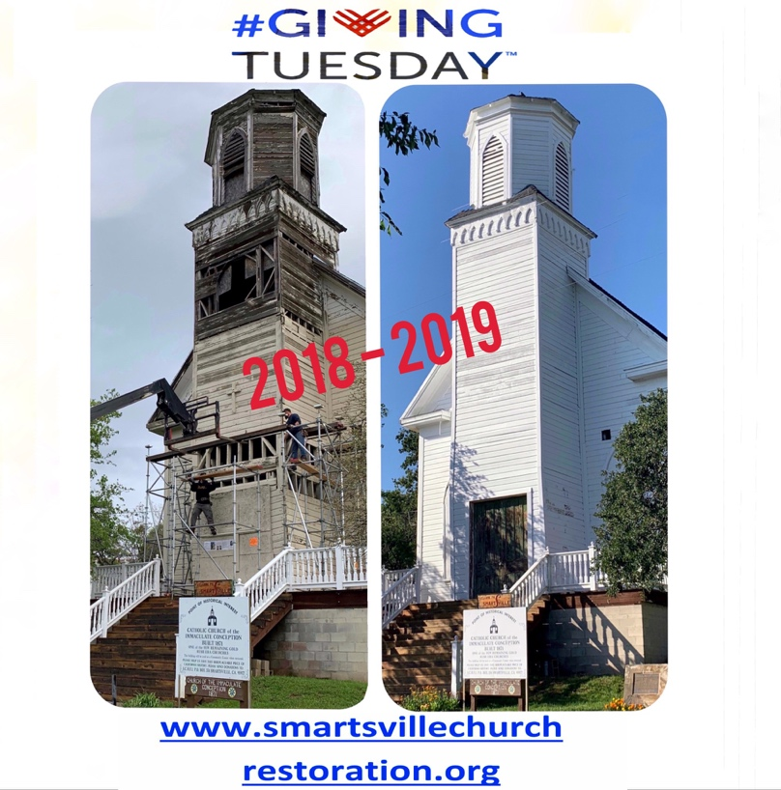
Maia DiLorenzo examines a window. The results of last year’s fund-raising were
on the second floor of the choir loft. phenomenal!

3rd Annual Giving Tuesday
We’re gearing up for an annual fund-raising event that happens through Facebook and our website. #GivingTuesday is an international movement that comes the Tuesday after Black Friday, which is the day after Thanksgiving. The intent in its formation was to focus on non-profit groups. We’ve been successful the last two years raising funds for our restoration work and will be promoting Giving Tuesday again this year on December 3rd. Thanks in advance!

Stay tuned to information on our Facebook page Smartsville Church Restoration Fund, Inc.

