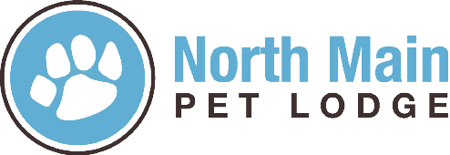

Pet’s Name_____________________________________
Pet Guardian ___________________________________
Emergency Contact: ______________________________
The North Main Pet Lodge policy is to have on file a Rainbow Protocol for senior dogs or cats( 10 or older) and/or dogs with medical/physical condition that could be life threatening.
This is a precautionary measure to assist us in following your wishes in the unlikely event your pet passes away while in our care. You can provide us with an emergency contact who will assume the responsibility to pick up your loved one and follow thru on your arrangements. Or you can you can give North Main Pet Lodge the responsibility of making arrangements for your with your local veterinary office or Sage Emergency Pet Hospital in concord. We will arrange transportation there and pick up ashes for you if needed.
Please check of your wishes below:
Yes
No
I want my emergency contact to be called and to pick up my pet if they pass first
(however if my emergency contact is unreachable I understand that North Main Pet Lodge Services will transport my pet as stated above.
Yes
I authorize North Main Pet Lodge to transport my pet to my vet or Sage animal hospital in concord for cremation and wish to have my ashes returned
No
Yes
I authorize North Main Pet Lodge to transport my pet to my vet or Sage animal hospital in concord for cremation and do NOT wish to have my ashes returned
No

Do you want us to contact you in the unlikely event your dog passes away while in our care? If yes please give us a number to reach you.
Number:_______________________

By signing below, you understand the North Main Pet Lodge Rainbow Protocol, and you give North Main Pet Lodge permission to follow your directions as stated above.
Signature: ________________________________________________ Date:____________
Witness:___________________________________________

